Supplementary file 1. Study time-lapse.
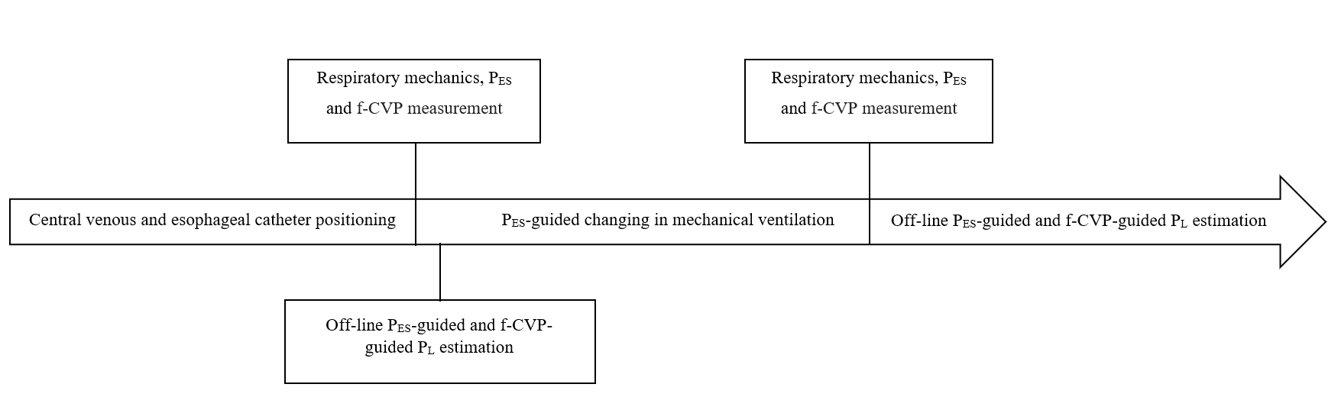
f-CVP, filtered central venous pressure (the filter applied was a dedicated low pass digital filter aiming to remove the cardiac component of the CVP curve); P_{ES}, esophageal pressure; P_{L}, transpulmonary pressure.

