Supplementary Information:
Dual-band polarized photodetector based on van der Waals heterojunction
Shukui Zhang^{1,2,6}, Hanxue Jiao^{2,6}, Yan Chen^{2,3,*}, Ruotong Yin², Xinning Huang², Qianru Zhao², Chong Tan², Shenyang Huang⁵, Hugen Yan⁵, Tie Lin², Hong Shen², Jun Ge², Xiangjian Meng², Weida Hu^{1,2}, Ning Dai^{1,2}, Xudong Wang^{2,*}, Junhao Chu^{2,3}, Jianlu Wang^{1,2,3,4,*}

¹Hangzhou Institute for Advanced Study, University of Chinese Academy of Sciences, Hangzhou, Zhejiang 310024, China;
²State Key Laboratory of Infrared Physics, Shanghai Institute of Technical Physics, Chinese Academy of Sciences, 500 Yu Tian Road, Shanghai 200083, China;
³Institute of Optoelectronics, Shanghai Frontier Base of Intelligent Optoelectronics and Perception, Fudan University, Shanghai 200433, China;
⁴Frontier Institute of Chip and System, Fudan University, Shanghai 200433, China
⁵State Key Laboratory of Surface Physics and Department of Physics, Fudan University, Shanghai 200438, China.
⁶These authors contributed equally: Shukui Zhang, Hanxue Jiao

^{a)}Corresponding authors.
Yan Chen: yanchen_@fudan.edu.cn;
Xudong Wang: wxd0130@mail.sitp.ac.cn;
Jianlu Wang: jianluwang@mail.sitp.ac.cn

S1: Transition states and opening voltage V_{op}. Under the condition of zero bias, each junction region generates photogenerated electron hole pairs under illumination, and the photogenerated electron hole pairs are separated and collected to form photocurrent under the action of the built-in electric field. Because the E_{in1} and E_{in2} are in opposite directions, the photocurrent formed by junction 1 and junction 2 under their respective internal electric fields is also in opposite directions, as shown in Fig. S4e. The polarity of the photocurrent produced by region Ⅰ and region Ⅱ is opposite, and the polarity of the current generated in region Ⅲ is determined by the greater absolute value of the photocurrent generated in junction 1 and junction 2. The photocurrents corresponding to regions Ⅰ, Ⅱ, and Ⅲ are shown below:
$I_{Ⅰ}=-p_{1}qμ_{1}E_{in1}A_{Ⅰ}$ (1)
$I_{Ⅱ}=p_{2}qμ_{2}E_{in2}A_{Ⅱ}$ (2)
$I_{Ⅲ}=-p_{1}qμ_{1}E_{in1}A_{Ⅲ}+p_{2}qμ_{2}E_{in2}A_{Ⅲ}$ (3)
$$I_{total}= I_{Ⅰ}+ I_{Ⅱ}+I_{Ⅲ}$$
$=-p_{1}qμ_{1}E_{in1}\left(A_{Ⅰ}+A_{Ⅲ}\right)+p_{2}qμ_{2}E_{in2}\left(A_{Ⅱ}+A_{Ⅲ}\right)$ (4)
Where q is the unit charge, p₁, μ₁, p₂ and μ₂ are the hole concentration and hole mobility of b-AsP and bP, respectively. A_{Ⅰ}, A_{Ⅱ}, and A_{Ⅲ} are the areas of regions Ⅰ, Ⅱ, and Ⅲ respectively. The current in region Ⅲ in Fig. S4e is negative (I_{Ⅲ} < 0), that means |p₁μ₁E_{in1}A_{Ⅲ}| > |p₂μ₂E_{in2}A_{Ⅲ}|, indicating that the current in region Ⅲ at this time is dominated by the current generated by b-AsP.
Figure S4a shows the photocurrent mapping when 0.1 V forward bias is applied, the current expression for each region is shown below:
$I_{Ⅰ}=p_{1}qμ_{1}(E_{ex}-E_{in1})A_{Ⅰ}$ (5)
$I_{Ⅱ}=p_{2}qμ_{2}(E_{ex}+E_{in2})A_{Ⅱ}$ (6)
$I_{Ⅲ}=p_{1}qμ_{1}(E_{ex}-E_{in1})A_{Ⅲ}+p_{2}qμ_{2}(E_{ex}+E_{in2})A_{Ⅲ}$ (7)
$I_{total}= I_{Ⅰ}+ I_{Ⅱ}+I_{Ⅲ}$
$=p_{1}qμ_{1}(E_{ex}-E_{in1})\left(A_{Ⅰ}+A_{Ⅲ}\right)+p_{2}qμ_{2}(E_{ex}+E_{in2})\left(A_{Ⅱ}+A_{Ⅲ}\right)$ (8)
Compared with zero bias, the reverse photocurrent value of region Ⅰ becomes smaller (maximum value decreased from 2.2 μA to 1.3 μA, as shown in Figure S4e and S4a), while the forward photocurrent of region Ⅱ becomes larger (maximum value increased from 0.5 μA to 1.1 μA, as shown in Figure S4e and S4a), indicating that junction 1 is suppressed, while junction 2 is enhanced. Since the current in region Ⅰ is still negative at this time, the value of E_{ex} is less than E_{in1}, indicating that the voltage required to open the BP channel is not reached.
When the bias voltage is gradually applied to E_{ex} > E_{in1}, junction 1 is in the OFF state. Under the action of bias voltage, the holes generated by junction 1 should transport to the right, as shown in Fig. 3f. Because of the existence of the hole barrier layer, the electron hole pairs generated by both photoexcitation and thermal excitation in the b-AsP layer are quickly recombined due to the hole obstruction, which means that the barrier layer can not only reduce the electrical crosstalk but also inhibit the dark current. The current of each junction is shown as follows:
$I_{Ⅰ}≈0$ (9)
$I_{Ⅱ}=p_{2}qμ_{2}(E_{ex}+E_{in2})A_{Ⅱ}$ (10)
$I_{Ⅲ}=p_{2}qμ_{2}(E_{ex}+E_{in2})A_{Ⅲ}$ (11)
$I_{total}= I_{Ⅰ}+I_{Ⅱ}+I_{Ⅲ}=p_{2}qμ_{2}(E_{ex}+E_{in2})\left(A_{Ⅱ}+A_{Ⅲ}\right)$ (12)
Only the electron holes generated by the bP layer can be collected to form current, indicating that the opening working voltage V_{op-J1} of the junction 1 is reached. The operating voltage V_{op} = E_{ex}d, where d is the thickness of the heterojunction, since the OFF state condition of the junction 1 is E_{ex} > E_{in1}, the operating voltage of Junction 2 can be obtained to meet V_{op-J2} > E_{in1}d. In contrast, the operating voltage of junction 1 must meet the condition V_{op-J1} > E_{in2}d. After many experiments, it has been shown that junction 1 and junction 2 can usually be opened at the reverse bias of -0.4 V and the forward bias of 0.4 V, respectively.
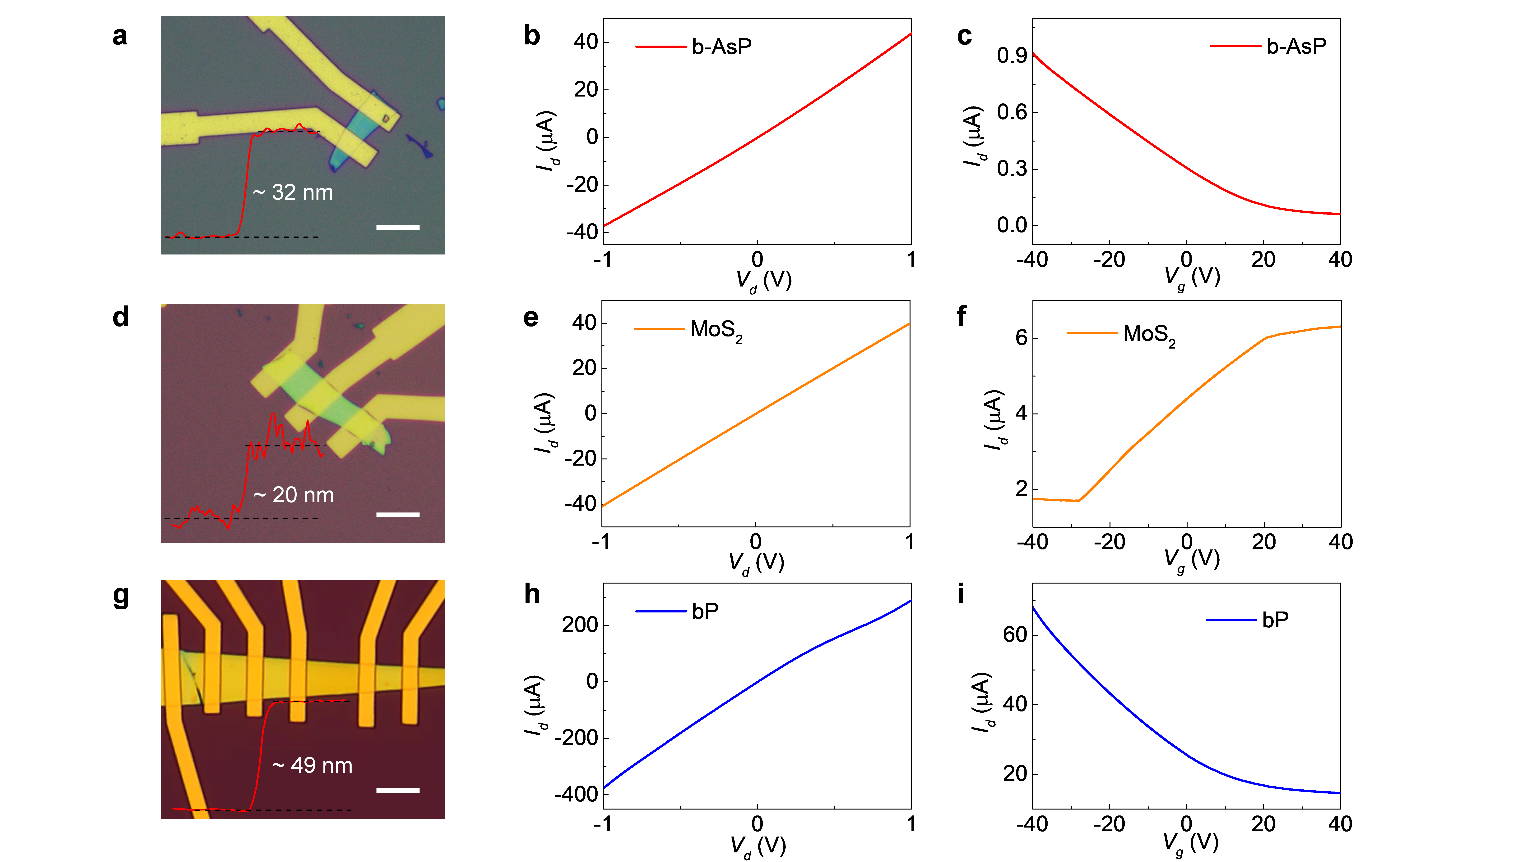
Fig. S1. Transfer and output characteristic curves of b-AsP, MoS₂, and bP FETs. a-c, Optical photo, material thickness, output characteristic curve and transfer characteristic curve of b-AsP FETs. d-f, Optical photo, material thickness, output characteristic curve and transfer characteristic curve of MoS₂ FETs. g-i, Optical photo, material thickness, output characteristic curve and transfer characteristic curve of bP FETs.

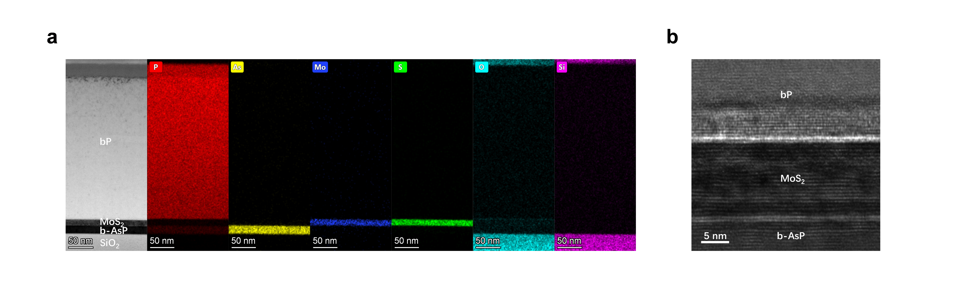
Fig. S2. Cross-sectional TEM image and EDS mapping of the b-AsP/MoS₂/bP heterostructure. Elements P, As, Mo, S, O, and Si are marked with different colors.

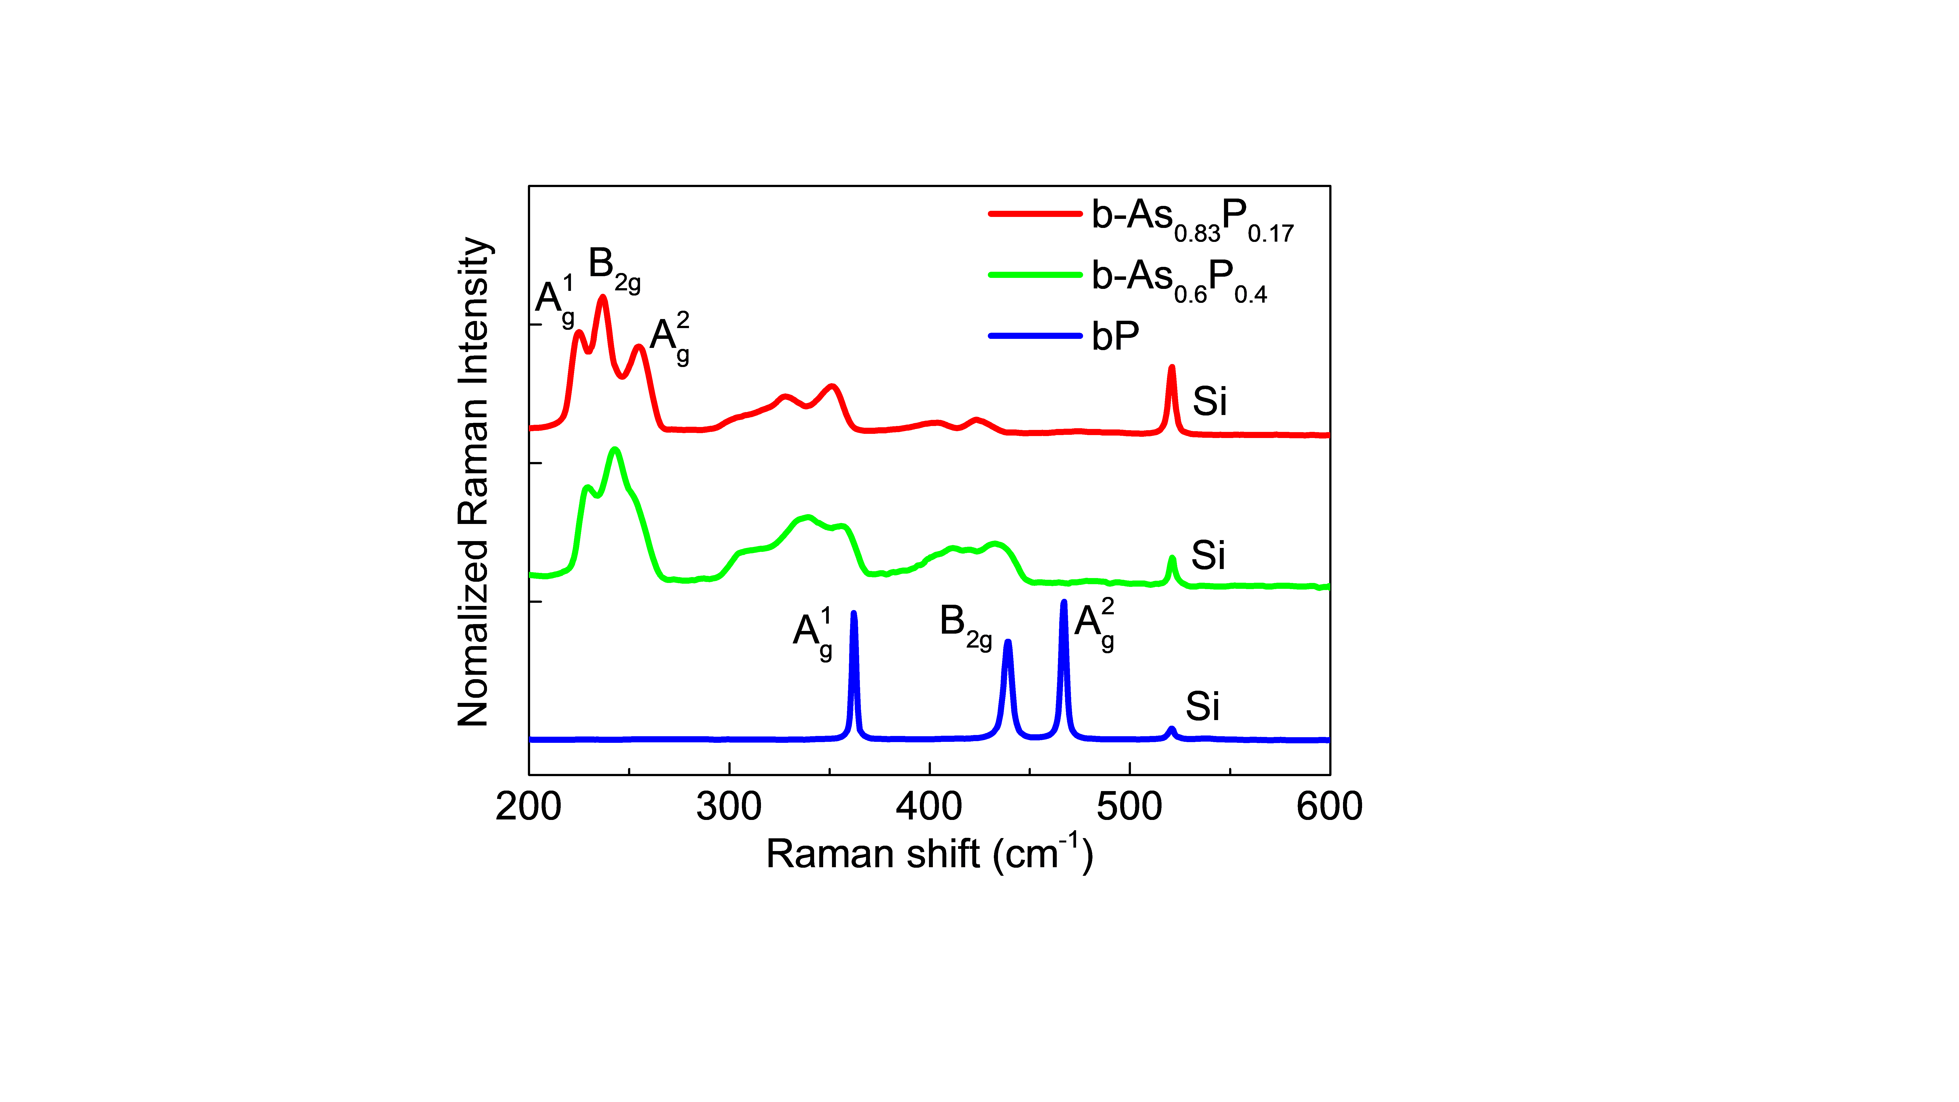
Fig. S3. Raman spectra measured for pure bP as well as b-AsP alloys.

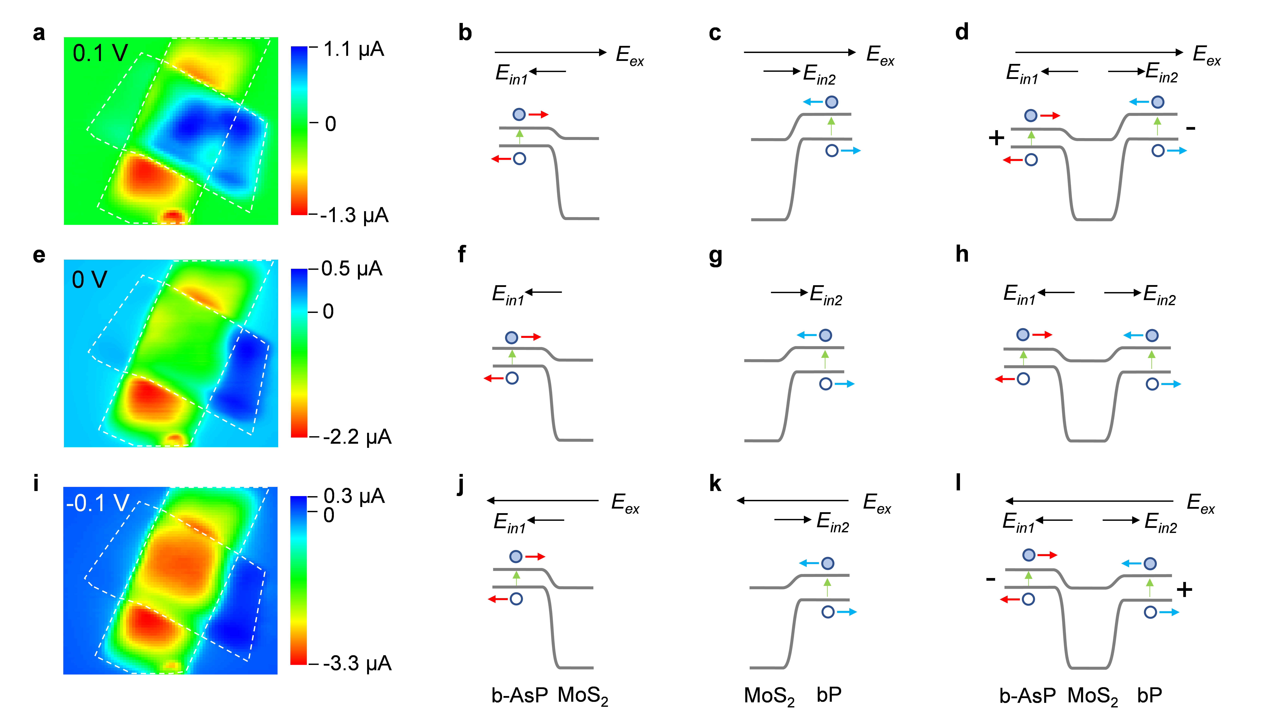
Fig. S4. The transition states before reaching the operating voltage. a-d, Photocurrent mapping and schematic diagram of band structure of corresponding regions Ⅰ, Ⅱ, and Ⅲ at positive bias voltage of 0.1 V. e-h, Photocurrent mapping and schematic diagram of band structure of corresponding regions Ⅰ, Ⅱ, and Ⅲ at bias voltage of 0 V. i-l, Photocurrent mapping and schematic diagram of band structure of corresponding regions Ⅰ, Ⅱ, and Ⅲ at negative bias voltage of - 0.1 V.

Fig. S5. The optical photo and photocurrent mapping images of device 2 at bias voltages of 0.4 V, 0.1 V, 0 V, - 0.1V, and - 0.4 V.

Fig. S6. The optical photo and photocurrent mapping images of device 3 at bias voltages of 0.5 V, 0.1 V, 0 V, - 0.1V, and - 0.5 V.

Fig. S7. Setup of the blackbody test system and the photoresponse of photodetector. a, Schematic of the setup of the blackbody test system for the blackbody response measurements at room temperature. b, I–V curve of the photodetector under dark and light conditions.

Fig. S8. Time-resolved photocurrent of the dual-band polarized photodetector under modulated laser with a wavelength of 1550 nm.

Fig. S9. a, Blackbody radiation spectra at different temperatures calculated according to Planck's law. b, MWIR2/MWIR1 ratio depends on the operation frequency under different blackbody temperatures.

Fig. S10. The relationship between the responsivity and blackbody radiation power.

