Supplementary Figure 1: Growth rate assesment for the EcN strains and spot assay for the EcN 13 and 22
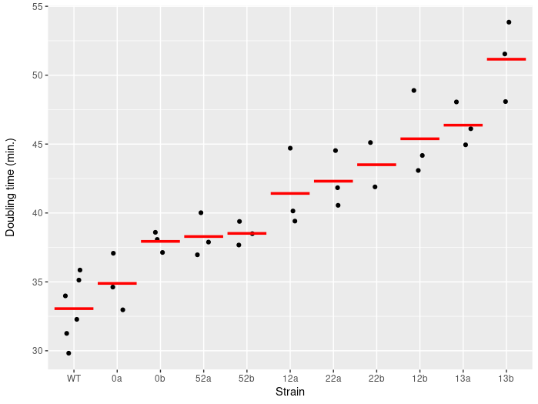

The doubling time was assessed for the EcN strains producing the bacteriocins 12, 13, 22 and 55 and compared to the growth rates of an EcN strain containing the plasmid without a bacteriocins (0) and the EcN_WT. The experiment was performed with 2 biological replicates and 3 technical replicates. The doubling times were assessed during exponential growth phase.

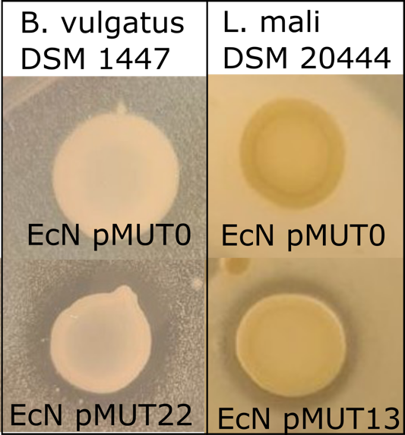
The inhibitory potential of the EcN strains were assessed before conducting the in vivo study. Inhibition zones can be detected for the EcN-pMUT22 producing bacteroidetocinA as well as for the EcN-pMUT13 producing actifencin.

