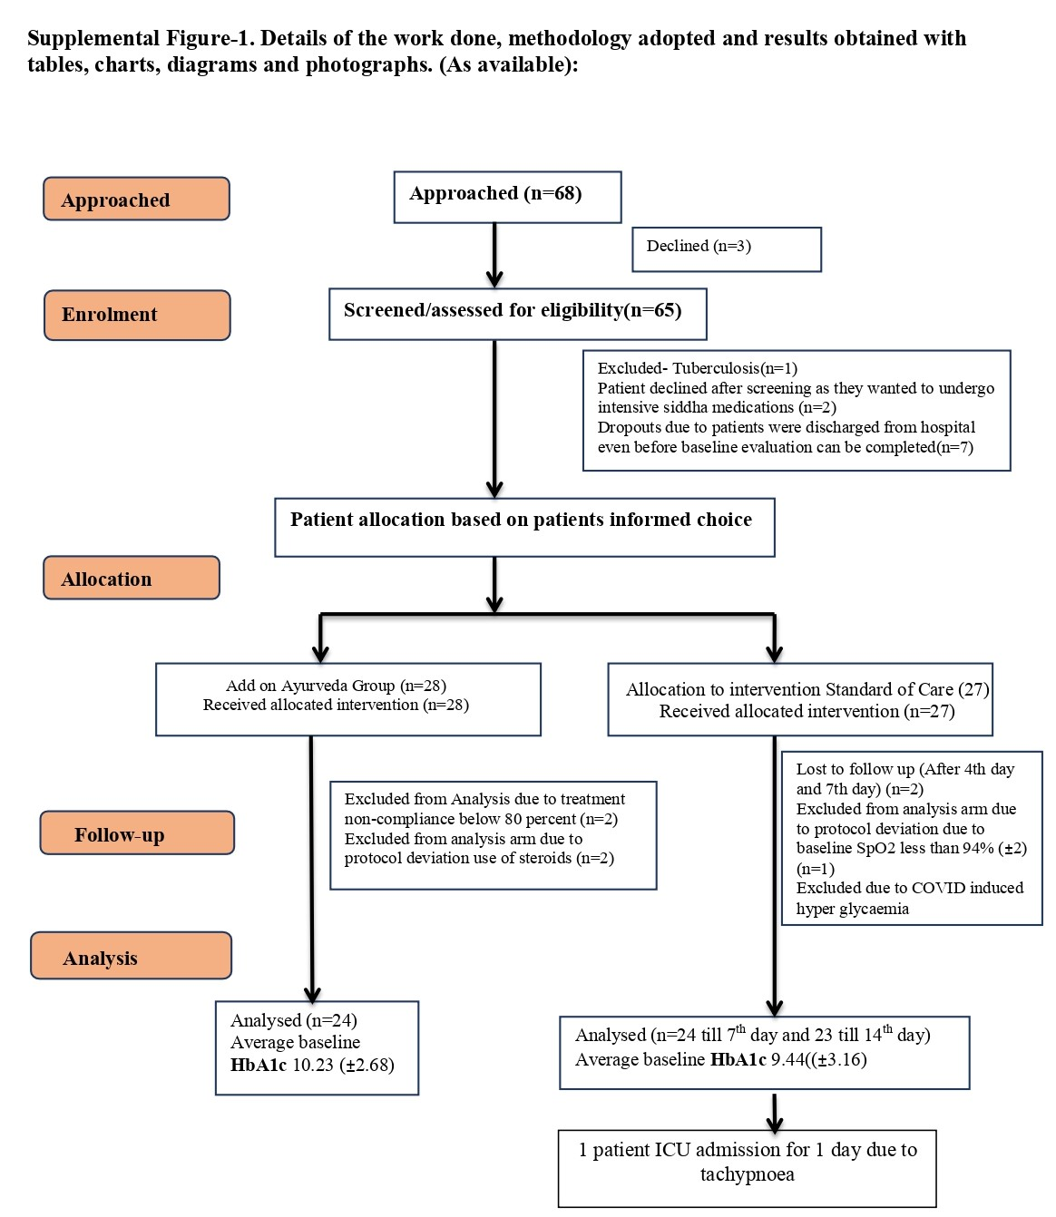

Supplemental Table-1. Patient Demography and basic Clinical Data
 | Add on Ayurveda Group (n=24) | Standard of Care (n=24(7th day) & n=23(15th day))
Total Subjects | 24 | 24
Male | 12 (50%) | 14 (58.3%)
Female | 12(50%) | 10(41.7%)
Avg (all the age groups) | 54.6 (±9.93) | 56.21 (±9.28)
Average Number of days of Hospitalisation | Mean =7.13 (±4.73)  days (n=24) Median: 6 days  Minimum =3 days  Maximum=22 days | Mean = 5.87(±2.92) days (n=24) Median : 5 days  Minimum= 3 days Maximum=12 days
Supplementary Tables:

Supplementary Table 2: Details of Adverse Events

Clinical findings of Adverse Events | Total Number of patients with adverse events
Clinical findings of Adverse Events | Add on Ayurveda (n=3) |  |  | Standard of care(n=4)
Clinical findings of Adverse Events | Freq |  | Grade | Freq | Grade
Itching sensation in throat(ENT) | 1 |  | Mild | 1 | Mild
Pedal edema(CV) |  |  |  | 1 | Moderate
constipation(GI) | 1 |  | Mild
Irritation in throat(GI) | 1 |  | Mild | 1 | Mild
Burning sensation in anal region(GI) | 1 |  | Mild
Gastritis(GI) | 1 |  | Mild
Burning sensation in throat and chest region(GI) | 1 |  | Mild
Increased body heat(GEN) | 1 |  | Mild
Serious Adverse Events
Tachypnoea(RES) |  |  |  | 1 | Severe
Death | Nil |  |  | Nil

Supplementary Table 3: A Robust regression model with Treatment Group as the interacting variable at 95% confidence Interval

variable | label | Degrees of freedom | Parameter Estimate | Standard Error | P-value
Intercept | Intercept | 1 | 4.8632 | 0.7309 | 0.01*
x1 | Baseline IL6 | 1 | -0.9985 | 0.0223 | 0.01*
x2 | Add on Ayurveda | 1 | -1.3635 | 0.9024 | 0.13
x3₁ | Delta Absolute Monocytes*Add on Ayurveda | 1 | -8.9723 | 4.4556 | 0.04*
X3₂ | Delta Absolute Monocytes*SOC | 1 | -6.9667 | 3.7352 | 0.06
X4₁ | Delta Absolute Neutrophils*Add on Ayurveda | 1 | -0.2002 | 0.5647 | 0.72
X4₂ | Delta Absolute Neutrophils*SOC | 1 | 0.9454 | 0.2648 | 0.01*
 | Adj R-Sq |  | 0.60

Supplementary Table 4: Details of Vitals

Assessed Parameter | Add on Ayurveda Group |  |  |  |  |  | Standard of Care |  |  |  |  | P value between the groups
Assessed Parameter | Day | n | Mean | SD | P value versus baseline | P value versus 7th day | n | Mean | SD | P value versus baseline | P value versus 7th day | P value between the groups
O2  saturation | 0 | 24 | 96.91 | 1.41 | - | 0.833 | 24 | 97.0 | 1.53 | - | 0.910 | 0.912
O2  saturation | 7 | 24 | 96.83 | 1.29 | 0.833 | - | 24 | 96.96 | 0.99 | 0.910 | - | 0.912
O2  saturation | 15 | 24 | 96.83 | 1.29 | 0.775 | 1.000 | 24 | 97 | 0.88 | 1.000 | 0.890 | 0.912
Dystolic blood pressure | 0 | 24 | 86.87 | 11.84 | - | 0.349 | 24 | 85.92 | 14.86 | - | 0.504 | 0.984
Dystolic blood pressure | 7 | 24 | 89.20 | 8.32 | 0.349 | - | 24 | 87.92 | 13.44 | 0.504 | - | 0.984
Dystolic blood pressure | 15 | 24 | 90.62 | 13.51 | 0.092 | 0.650 | 24 | 90.17 | 11.68 | 0.256 | 0.469 | 0.984
Systolic blood pressure | 0 | 24 | 141.30 | 16.39 | - | 0.042* | 24 | 134.96 | 21.10 | - | 0.071 | 0.072
Systolic blood pressure | 7 | 24 | 135.78 | 11.72 | 0.042* | - | 24 | 142.55 | 20.84 | 0.071 | - | 0.072
Systolic blood pressure | 15 | 24 | 139.75 | 13.97 | 0.618 | 0.197 | 24 | 138.67 | 16.21 | 0.245 | 0.327 | 0.072
Respiratory rate | 0 | 24 | 23.83 | 3.22 | - | 0.011* | 24 | 22.88 | 1.85 | - | 0.002* | 0.294
Respiratory rate | 7 | 24 | 25.67 | 0.96 | 0.011* | - | 24 | 24.92 | 2.21 | 0.002* | - | 0.294
Respiratory rate | 15 | 24 | 25.37 | 1.40 | 0.030* | 0.404 | 24 | 24.92 | 1.44 | 0.000* | 1.000 | 0.294
Pulse | 0 | 24 | 90.71 | 9.68 | - | 0.267 | 24 | 95.67 | 12.14 | - | 0.927 | 0.463
Pulse | 7 | 24 | 93.54 | 10.86 | 0.267 | - | 24 | 95.92 | 10.20 | 0.927 | - | 0.463
Pulse | 15 | 24 | 95.13 | 7.75 | 0.028* | 0.443 | 23 | 96.96 | 16.64 | 0.666 | 0.759 | 0.463
Temp | 0 | 24 | 36.17 | .19 | - | 0.465 | 24 | 36.27 | 0.20 | - | 0.165 | 0.345
Temp | 7 | 24 | 36.12 | .31 | 0.465 | - | 24 | 36.18 | 0.23 | 0.165 | - | 0.345
Temp | 15 | 24 | 36.13 | .09 | 0.387 | 0.865 | 23 | 36.13 | 0.16 | 0.008* | 0.052 | 0.345
*Values at 95% Confidence Interval where the level of significance, α= 0.05.
The above dataset has been log transformed for further analysis since the data followed log normal distribution (Transformed Mean and SD). Repeated Measures Analysis of Variance has been used for getting values within the treatment groups, the method of Least Significant Difference has been used for pair wise comparison. The method of Multivariate analysis of variance with Treatment group as fixed factor has been used for testing differences between the treatment groups.

Supplementary Table 5: Changes in Safety Parameters for liver and renal functions
Assessed Parameter | Add on Ayurveda Group |  |  |  |  | Standard of Care |  |  |  | P value
Assessed Parameter | Day | n | Mean | Transformed Mean | Transformed SD | n | Mean | Transformed Mean | Transformed SD | P value
Aspartate Aminotransferase(AST)(<40 IU/L) | 0 | 24 | 25.62 | 1.37 | 0.21 | 24 | 21.04 | 1.28 | 0.19 | 0.316
Aspartate Aminotransferase(AST)(<40 IU/L) | 7 | 24 | 21.19 | 1.31 | 0.15 | 24 | 24.4 | 1.33 | 0.21 | 0.316
Aspartate Aminotransferase(AST)(<40 IU/L) | 15 | 24 | 18.21 | 1.25 | 0.1 | 23 | 17.43 | 1.23 | 0.09 | 0.316
Creatinine(0.7-1.2 mg/dL) | 0 | 24 | 0.79 | -0.11 | 0.12 | 24 | 0.72 | -0.15 | 0.11 | 0.312
Creatinine(0.7-1.2 mg/dL) | 7 | 24 | 0.72 | -0.15 | 0.12 | 24 | 0.76 | -0.14 | 0.16 | 0.312
Creatinine(0.7-1.2 mg/dL) | 15 | 24 | 0.65 | -0.21 | 0.14 | 23 | 0.64 | -0.2 | 0.09 | 0.312
Urea(15-40 mg/dL) | 0 | 24 | 20.5 | 1.29 | 0.14 | 24 | 23.91 | 1.34 | 0.18 | 0.377
Urea(15-40 mg/dL) | 7 | 24 | 19.41 | 1.26 | 0.15 | 24 | 22.95 | 1.34 | 0.16 | 0.377
Urea(15-40 mg/dL) | 15 | 24 | 20.29 | 1.27 | 0.17 | 23 | 23.04 | 1.34 | 0.13 | 0.377
Alkaline phosphatase(ALP)(40-129 IU/L) | 0 | 24 | 85.88 | 1.91 | 0.16 | 24 | 78.83 | 1.85 | 0.2 | 0.757
Alkaline phosphatase(ALP)(40-129 IU/L) | 7 | 24 | 86.83 | 1.91 | 0.15 | 24 | 77.8 | 1.88 | 0.12 | 0.757
Alkaline phosphatase(ALP)(40-129 IU/L) | 15 | 24 | 85.33 | 1.91 | 0.15 | 23 | 76.21 | 1.87 | 0.13 | 0.757
Alanine Transaminase(ALT) (<40I/L) | 0 | 24 | 26.43 | 1.35 | 0.25 | 24 | 20.12 | 1.24 | 0.23 | 0.401
Alanine Transaminase(ALT) (<40I/L) | 7 | 24 | 26.6 | 1.37 | 0.26 | 24 | 21.29 | 1.27 | 0.24 | 0.401
Alanine Transaminase(ALT) (<40I/L) | 15 | 24 | 19.33 | 1.24 | 0.2 | 23 | 18.3 | 1.2 | 0.2 | 0.401
*Values at 95% Confidence Interval where the level of significance, α= 0.05.
The above dataset has been log transformed for further analysis since the data followed log normal distribution (Transformed Mean and SD). The method of Multivariate analysis of variance with Treatment group as fixed factor has been used for testing differences between the treatment groups.

Supplementary Table-6. Baseline and change in Haematological and Biochemical parameters
Assessed  Parameter | Add on Ayurveda Group |  |  |  |  |  |  | Standard of Care |  |  |  |  |  | P value between the groups
Assessed  Parameter | Day | n | Mean | Transformed Mean | Transformed SD | P value versus baseline | P value versus 7th day | n | Mean | Transformed Mean | Transformed SD | P value versus baseline | P value versus 7th day | P value between the groups
Hematocrit | 0 | 24 | 38.34 | 1.58 | 0.04 | - | 0.849 | 24 | 36.03 | 1.55 | 0.06 | - | 0.886 | 0.335
Hematocrit | 7 | 24 | 38.24 | 1.58 | 0.04 | 0.849 | - | 24 | 36.23 | 1.55 | 0.06 | 0.886 | - | 0.335
Hematocrit | 15 | 24 | 38.7 | 1.59 | 0.04 | 0.555 | 0.334 | 23 | 36.47 | 1.56 | 0.06 | 0.470 | 0.496 | 0.335
Lymphocyte-Absolute | 0 | 24 | 29.98 | 0.29 | 0.19 | - | 0.011* | 24 | 29.1 | 0.27 | 0.18 | - | 0.009* | 0.792
Lymphocyte-Absolute | 7 | 24 | 31.42 | 0.34 | 0.17 | 0.011* | - | 24 | 28.9 | 0.36 | 0.13 | 0.009* | - | 0.792
Lymphocyte-Absolute | 15 | 24 | 32.43 | 0.38 | 0.14 | 0.001* | 0.152 | 23 | 28.97 | 0.37 | 0.18 | 0.008* | 0.640 | 0.792
Eosinophil-Absolute | 0 | 24 | 1.3 | -1.14 | 0.41 | - |  | 24 | 1.35 | -1.22 | 0.51 | - | 0.011* | 0.599
Eosinophil-Absolute | 7 | 24 | 1.8 | -0.98 | 0.36 | 0.089 |  | 23 | 1.8 | -0.91 | 0.42 | 0.011* | - | 0.599
Eosinophil-Absolute | 15 | 24 | 2.12 | -0.87 | 0.35 | 0.005* | 0.093 | 23 | 2.02 | -0.82 | 0.27 | 0.001* | 0.285 | 0.599
D Dimer | 0 | 24 | 480.9 | 2.35 | 0.42 | - | 0.469 | 23 | 647.24 | 2.38 | 0.58 | - | 0.420 | 0.392
D Dimer | 7 | 23 | 288.01 | 2.42 | 0.40 | 0.469 | - | 20 | 268.83 | 2.28 | 0.41 | 0.420 | - | 0.392
D Dimer | 15 | 24 | 251.78 | 2.25 | 0.33 | 0.435 | 0.078 | 23 | 378.15 | 2.33 | 0.45 | 0.735 | 0.605 | 0.392
Prothrombin Time | 0 | 23 | 13.63 | 2.35 | 0.16 | - | 0.001* | 19 | 13.1 | 2.35 | 0.14 | - | 0.003* | 0.912
Prothrombin Time | 7 | 20 | 14.55 | 2.47 | 0.16 | 0.001* | - | 16 | 14.47 | 2.48 | 0.19 | 0.003* | - | 0.912
Prothrombin Time | 15 | 23 | 14.3 | 2.47 | 0.17 | 0.01* | 0.837 | 22 | 13.78 | 2.49 | 0.14 | 0.014* | 0.511 | 0.912
Direct Bilirubin(0.1-0.4 mg/dL) | 0 | 24 | 0.2 | -0.77 | 0.23 | - | 0.769 | 24 | 0.19 | -0.77 | 0.19 | - | 0.751 | 0.937
Direct Bilirubin(0.1-0.4 mg/dL) | 7 | 24 | 0.19 | -0.75 | 0.18 | 0.769 | - | 24 | 0.22 | -0.75 | 0.25 | 0.751 | - | 0.937
Direct Bilirubin(0.1-0.4 mg/dL) | 15 | 24 | 0.19 | -0.78 | 0.21 | 0.830 | 0.615 | 23 | 0.2 | -0.75 | 0.21 | 0.581 | 0.895 | 0.937
Total Bilirubin(0.2-1 mg/dL) | 0 | 24 | 0.38 | -0.47 | 0.19 | - | 0.489 | 24 | 0.42 | -0.43 | 0.21 | - | 0.212 | 0.657
Total Bilirubin(0.2-1 mg/dL) | 7 | 24 | 0.39 | -0.44 | 0.16 | 0.489 | - | 24 | 0.5 | -0.37 | 0.21 | 0.212 | - | 0.657
Total Bilirubin(0.2-1 mg/dL) | 15 | 24 | 0.41 | -0.44 | 0.20 | 0.301 | 0.940 | 23 | 0.43 | -0.40 | 0.16 | 0.338 | 0.381 | 0.657
Total Protein(6-8 gm/dL) | 0 | 24 | 6.86 | 0.8 | 0.04 | - | 0.05* | 24 | 6.48 | 0.81 | 0.03 | - | 0.079 | 0.208
Total Protein(6-8 gm/dL) | 7 | 24 | 7.3 | 0.82 | 0.02 | 0.05* | - | 23 | 6.41 | 0.82 | 0.04 | 0.079 | - | 0.208
Total Protein(6-8 gm/dL) | 15 | 24 | 6.75 | 0.83 | 0.03 | 0.10* | 0.375 | 23 | 6.5 | 0.81 | 0.03 | 0.254 | 0.318 | 0.208
LDH | 0 | 24 | 414.42 | 2.59 | 0.14 | - | 0.285 | 24 | 379.17 | 2.56 | 0.13 | - | 0.337 | 0.165
LDH | 7 | 24 | 377.21 | 2.55 | 0.14 | 0.285 | - | 23 | 434.21 | 2.60 | 0.17 | 0.337 | - | 0.165
LDH | 15 | 24 | 391.12 | 2.57 | 0.12 | 0.573 | 0.482 | 23 | 345.28 | 2.51 | 0.17 | 0.240 | 0.039 | 0.165
*Values at 95% Confidence Interval where the level of significance, α= 0.05.
The above dataset has been log transformed for further analysis since the data followed log normal distribution (Transformed Mean and SD). Repeated Measures Analysis of Variance has been used for getting values within the treatment groups, the method of Least Significant Difference has been used for pair wise comparison. The method of Multivariate analysis of variance with Treatment group as fixed factor has been used for testing differences between the treatment groups.

Supplementary Table 7 - Rationality behind the used formulation in COVID-19 along with frequency in patients used for a minimum of 3 days
Medicine | Rationality behind prescription based on permutations and combinations of symptomatology seen in patients with COVID-19 | Number of people receiving the medication for atleast 3 days during the study
Indukantham | Vata predominant type of fever associated with cough, breathing difficulty and fluid accumulation. | 21
Bharangyadi | Sannipataja jwara(complicated fevers involving all three doshas), vishamajwara(intermittent fever), jeerna jwara(chronic fever), shirograha(headache), parshwashoola (pain in the flanks of the chest), hrith shola(chest pain around the heart), kasa(cough), shwasa(dyspnea) , tandra(semi-comatose condition) and agnimandhya(low metabolism). | 24
Panchathikthakam | All eight type of fever as classified in Ayurveda associated with Kasa swasa. | 12
Drakshadi | In Chronic fever and Vomiting | 10
Guduchyadi | In fever, vomiting, renal disorders, migraine, and diabetes. | 12
Patola katurohinyadi | In Kapha Pitta type of fever associated with Vomiting, Loss of appetite, skin rashes and symptoms of toxicity. | 1
Vilwadi | In Vata Kapha fever associated with indigestion, loose motion, vomiting and symptoms of toxicity. | 6
Swasanandam Gulika | Acute dyspnea. | 1
Pravalabhasmam | Acute dyspnea associated with hyperacidity and to iniate innate immune response. | 1
Gorochanadi | Fever associated with giddiness, nausea, breathlessness, General weakness, headache, Asthma, hiccups, cough, Hemiplegia and Ansomia. | 3
Ashtanga Choornam | Given along with Honey or Betel leaf juice or Tulasi juice or Ginger juice frequently in small doses to address acute dyspnea, cough and throat discomfort in people not having any acidity or pitta imbalance. | 4
Agasthyarasayanam | Given both in acute and chronic condition of Cough, Dyspnoea, Rhinitis, Hiccup, Fever, Lack of appetite in COVID patients. | 1
Swarnamuktadi | Fever, vertigo, fatigue, loss of smell, and semi-comatose conditions. | 1

Supplementary Table 8: Annexure I – Medication details of Add on Ayurveda Group patient-wise
Medicine | Subject ID 0002 |  |  | Subject ID 0012 |  |  | Subject ID 0015 |  |  | Subject ID 0020
Medicine | Dose | Frequency | Days | Dose | Frequency | Days | Dose | Frequency | Days | Dose | Frequency | Days
Indukantham | 10ml/  7.5ml | once / twice | 14 days /  11 days | 10 ml | once | 14 days | x | x | x | 15 ml | twice | 14 days
Bharangyadi | 7.5ml | twice | 3 days | 7.5 | twice | 14 days | 7.5 | twice | 14 days | 15 ml/  7.5ml | twice / twice | 14days / 9 days
Panchathikthakam | 7.5 ml | twice | 14 days | 7.5 | twice | 14 days | 7.5 | twice | 14 days | x | x | x
Drakshadi | x | x | x | x | x | x | 7.5 | twice | 14 days | 7.5 ml | twice | 9 days
Guduchyadi | x | x | x | x | x | x | 7.5 | twice | 14 days | x | x | x
patolakaturohinyadi | x | x | x | x | x | x | x | x | x | x | x | x
Vilwadi | x | x | x | x | x | x | 0.5 | twice | 14 days | x | x | x
Swasanandam Gulika | x | x | x | x | x | x | x | x | x | x | x | x
Pravalabhasmam | x | x | x | x | x | x | x | x | x | x | x | x
Gorochanadi | x | x | x | x | x | x | x | x | x | x | x | x
Ashtanga Choornma | x | x | x | x | x | x | x | x | x | x | x | x
Honey | x | x | x | x | x | x | x | x | x | x | x | x
Agasthyarasayanam | x | x | x | x | x | x | x | x | x | x | x | x
Swarnamuktadi | x | x | x | x | x | x | x | x | x | x | x | x
TamboolaSwarasam | x | x | x | x | x | x | x | x | x | x | x | x
ArdrakaSwarasam | x | x | x | x | x | x | x | x | x | x | x | x
Rasnadi + Ardraka  swarasam( l/a) | x | x | x | x | x | x | x | x | x | x | x | x

Medicine | Subject ID 0025 |  |  | Subject ID 0044 |  |  | Subject ID 0021 |  |  | Subject ID 0039
Medicine | Dose | Frequency | Days | Dose | Frequency | Days | Dose | Frequency | Days | Dose | Frequency | Days
Indukantham | 10 ml | once / twice | 9 days /  5 days | 7.5 ml | four / twice | 4 days/  10days | 15 ml | twice | 14 days | 15 ml /  15 ml | once / n& t | 8 days / 1 day
Bharangyadi | 7.5 ml | twice | 14 days | 7.5 ml | twice | 14 days | 15 ml | twice | 14 days | 7.5 ml / 15 ml | twice / n& t | 14 days /  1 day
Panchathikthakam | x | x | x | x | x | x | x | x | x | x | x | x
Drakshadi | x | x | x | 7.5 ml | twice | 10 days | x | x | x | 7.5 ml | twice | 14 days
Guduchyadi | 7.5 ml | twice | 14 days | x | x | x | 30 ml | n & t | 3 days | 10ml | once | 6 days
patolakaturohinyadi | x | x | x | x | x | x | x | x | x | x | x | x
Vilwadi | x | x | x | x | x | x | 1 | n & t | 3 days | 0.5 | once | 6 days
SwasanandamGulika | x | x | x | x | x | x | x | x | x | 2 | n&t | 1 day
Pravalabhasmam | x | x | x | x | x | x | x | x | x | x | x | x
Gorochanadi | x | x | x | 1 | twice | 4 days | x | x | x | 1 | n&t | 1 day
Ashtanga Choornma | x | x | x | x | x | x | x | x | x | x | x | x
honey | x | x | x | x | x | x | x | x | x | x | x | x
Agasthyarasayanam | x | x | x | x | x | x | x | x | x | x | x | x
Swarnamuktadi | x | x | x | x | x | x | x | x | x | x | x | x
TamboolaSwarasam | x | x | x | x | x | x | x | x | x | x | x | x
ArdrakaSwarasam | x | x | x | x | x | x | x | x | x | x | x | x
Rasnadi + Ardraka  Swarasam( l/a) | x | x | x | x | x | x | x | x | x | x | x | x

Medicine | Subject ID 0040 |  |  | Subject ID 0051 |  |  | Subject ID 0001 |  |  | Subject ID 0008
Medicine | Dose | Frequency | Days | Dose | Frequency | Days | Dose | Frequency | Days | Dose | Frequency | Days
Indukantham | 7.5 ml | once | 14 days | 7.5 ml | four | 14 | 7.5 ml | once | 14 days | 7.5 ml /7.5ml /10 ml | four / twice / twice | 10 days /4 days / 4 days
Bharangyadi | 7.5 ml | twice | 14 days | 7.5 ml | twice | 14 | 7.5 ml | thrice | 14 days | 7.5 ml /  7.5 ml | four / twice | 10 days /4 days
Panchathikthakam | 7.5 ml | twice | 14 days | 7.5 ml | twice | 14 | 7.5 ml | twice | 14 days | x | x | x
Drakshadi | x | x | x | x | x | x | x | x | x | x | x | x
Guduchyadi | 7.5 ml | twice | 14 days | x | x | x | x | x | x | x | x | x
patolakaturohinyadi | x | x | x | x | x | x | x | x | x | x | x | x
Vilwadi | x | x | x | x | x | x | x | x | x | x | x | x
Swasanandam Gulika | x | x | x | x | x | x | x | x | x | x | x | x
Pravalabhasmam | x | x | x | a pinch | n & t | 4 days | x | x | x | x | x | x
Gorochanadi | 1 | twice | 14 days | x | x | x | x | x | x | x | x | x
Ashtanga Choornma | x | x | x | 1 tsp | n & t | 4 days | .5 tsp | once | 14 days | 1 tsp | n&t | 2 days
Honey | x | x | x | As required | n & t | 4 days | x | x | x | x | x | x
Agasthyarasayanam | x | x | x | x | x | x | x | x | x | x | x | x
Swarnamuktadi | x | x | x | x | x | x | x | x | x | x | x | x
TamboolaSwarasam | x | x | x | x | x | x | x | x | x | as req | n&t | 2 days
ArdrakaSwarasam | x | x | x | x | x | x | x | x | x | as req | n&t | 2 days
Rasnadi + Ardraka  Swarasam( l/a) | x | x | x | x | x | x | x | x | x | x | x | x

Medicine | Subject ID 0011 |  |  | Subject ID 0022 |  |  | Subject ID 0017 |  |  | Subject ID 0004
Medicine | Dose | Frequency | Days | Dose | Frequency | Days | Dose | Frequency | Days | Dose | Frequency | Days
Indukantham | 7.5 ml / 15ml | twice / n& t | 14 days /  1 day | x | x | x | x | x | x | 15 ml | once | 6 days
Bharangyadi | 15 ml/  7.5ml | twice / n& t | 14 days /  1 day | 15 ml | twice | 14 days | 7.5 ml | twice | 14 days | 7.5 ml / 15ml | four / twice | 6 days / 8 days
Panchathikthakam | x | x | x | x | x | x | 7.5 ml | twice | 7 days | 7.5 ml | four | 6 days
Drakshadi | x | x | x | x | x | x | 7.5 ml / 15 ml | twice | 2 days/  12days | 5 ml | once | 8 days
Guduchyadi | x | x | x | 15 ml | twice | 14 days | 7.5 ml | twice | 9 days | x | x | x
Patolakaturohinyadi |  |  |  |  |  |  | x | x | x | 5 ml | once | 8 days
Vilwadi | x | x | x | 1 | twice | 14 days | x | x | x | 0.5 | four | 6 days
Swasanandam Gulika | 1 | n&t | 1 day | x | x | x | x | x | x | x | x | x
Pravalabhasmam | x | x | x | x | x | x | x | x | x | x | x | x
Gorochanadi | 1 | n&t | 1 day | x | x | x | x | x | x | x | x | x
Ashtanga Choornma | x | x | x | x | x | x | 1 tsp | n & t | 1 day | 1 tsp | n&t | 2 days
Honey | x | x | x | x | x | x | x | x | x | x | x | x
Agasthyarasayanam | x | x | x | x | x | x | 1 tsp | twice | 7 days | x | x | x
Swarnamuktadi | 1 | twice | 14 days | x | x | x | x | x | x | x | x | x
TamboolaSwarasam | x | x | x | x | x | x | as req | n & t | 1 day | as req | n & t | 2 day
ArdrakaSwarasam | x | x | x | x | x | x | as req | n & t | 1 day | as req | n & t | 2 day
Rasnadi + Ardraka  Swarasam( l/a) | x | x | x | x | x | x | x | x | x | as req | 1 | 1 day

Medicine | Subject ID 0016 |  |  | Subject ID 0024 |  |  | Subject ID 0013 |  |  | Subject ID 0050
Medicine | Dose | Frequency | Days | Dose | Frequency | Days | Dose | Frequency | Days | Dose | Frequency | Days
Indukantham | 10 ml | once | 14 days | 7.5 ml | twice | 14  days | 15 ml  / 30 ml | twice / n & t | 14days  /1day | 7.5  ml | four | 14 days
Bharangyadi | 5ml | twice | 14 days | 7.5 ml | twice | 14  days | 7.5 ml | twice | 14 days | 7.5 | twice | 14 days
Panchathikthakam | x | x | x | 7.5 ml | twice | 6 days | x | x | x | x | x | x
Drakshadi | 5 ml | twice | 14 days | 7.5 ml | once | 8 days | 7.5 ml | twice | 14 days | x | x | x
Guduchyadi | 10 ml | once | 14 days | 7.5 ml | twice / once | 6 days  / 8 days | x | x | x | 7.5 | twice | 14 days
PatolaKaturohinyadi | x | x | x | x | x | x | x | x | x | x | x | x
Vilwadi | x | x | x | x | x | x | x | x | x | x | x | x
Swasanandam Gulika | x | x | x | x | x | x | x | x | x | x | x | x
Pravalabhasmam | x | x | x | x | x | x | x | x | x | x | x | x
Gorochanadi | x | x | x | x | x | x | 2 | n&t | 1 day | 1 | twice | 14 days
Ashtanga Choornma | x | x | x | x | x | x | x | x | x | x | x | x
Honey | x | x | x | x | x | x | x | x | x | x | x | x
Agasthyarasayanam | x | x | x | x | x | x | x | x | x | x | x | x
Swarnamuktadi | x | x | x | x | x | x | x | x | x | x | x | x
TamboolaSwarasam | x | x | x | x | x | x | x | x | x | x | x | x
ArdrakaSwarasam | x | x | x | x | x | x | x | x | x | x | x | x
Rasnadi+Ardraka Swarasam( l/a) | x | x | x | x | x | x | x | x | x | x | x | x

Medicine | Subject ID 0054 |  |  | Subject ID 0014 |  |  | Subject ID 0003 |  |  | Subject ID 0053
Medicine | Dose | Frequency | Days | Dose | Frequency | Days | Dose | Frequency | Days | Dose | Frequency | Days
Indukantham | 7.5 | twice | 14  days | 7.5 ml / 15 ml | twice / n&t | 14  days / 1 day | 15 ml | 8 | 14 days | 7.5  ml | twice | 14 days
Bharangyadi | 7.5 | twice | 14  days | 15 ml /  15 ml | twice /n& t | 14  days / 1 day | 7.5 ml  / 15 ml | twice / twice | 8 days /  6 days | 7.5  ml | twice | 14 days
Panchathikthakam | 7.5 | twice | 14  days | 7.5 ml | twice | 14  days | 7.5 ml | twice | 8 days | x | x | x
Drakshadi | x | x | x | x | x | x | x | x | x | 7.5  ml | twice | 14 days
Guduchyadi | 7.5 | twice | 14  days | x | x | x | x | x | x | 7.5  ml | twice | 14 days
patolakaturohinyadi | x | x | x | x | x | x | x | x | x | x | x | x
Vilwadi | x | x | x | x | x | x | 0.5 | twice | 8 days | x | x | x
SwasanandamGulika | x | x | x | 1 | n&t | 1 day | x | x | x | x | x | x
Pravalabhasmam | x | x | x | x | x | x | x | x | x | x | x | x
Gorochanadi | x | x | x | 1 | n&t | 1 day | x | x | x | x | x | x
Ashtanga Choornma | x | x | x | 1 tsp | n & t | 4 days | 1 tsp | n & t | 8 days | x | x | x
Honey | x | x | x | as req | n & t | 4 days | x | x | x | x | x | x
Agasthyarasayanam | x | x | x | x | x | x | x | x | x | x | x | x
Swarnamuktadi | x | x | x | x | x | x | x | x | x | x | x | x
TamboolaSwarasam | x | x | x | x | x | x | as req | n & t | 8 days | x | x | x
ArdrakaSwarasam | x | x | x | x | x | x | as req | n & t | 8 days | x | x | x
Rasnadi+Ardraka Swarasam( l/a) | x | x | x | x | x | x | x | x | x | x | x | x
x = ‘not prescribed’; n & t- now and then; mg-Milligram; ml-Milliliter; tsp-teaspoon

Medicines | Subject ID 0002 | Subject ID 0001 | Subject ID 0003 | Subject ID 0004 | Subject ID 0012 | Subject ID 0008 | Subject ID 0011 | Subject ID 0013
T. Azithromycin (500mg) | 1-0-0 | 1-0-0 | 1-0-0 | 1-0-0 | 1-0-0 | 1-0-0 | 2-0-0 | x
T.Ivermectin (12mg) | 1-0-0 | 1-0-0 | 1-0-0 | 1-0-0 | 1-0-0 | x | x | x
T.BCT | 1-0-0 | 1-0-0 | 1-0-0 | 1-0-0 | 1-0-0 | x | 1-0-1 | 1-0-0
T.Vit c (100mg) | 1-0-1 | 1-0-1 | 1-0-1 | 1-0-0 | 1-0-1 | 1-0-1 | 1-0-1 | 1-0-1
T.Zinc (20mg) | 1-0-1 | 1-0-1 | 1-0-1 | 1-0-1 | 1-0-1 | 1-0-1 | 1-0-1 | 1-0-1
T.Paracetamol (500mg) | 1-0-1 | x | 1-0-1 | 1-1-1 | x | 1-0-1 | 1-1-1 | x
T.Rantac | x | x | 1-0-1 | 1-0-1 | x | x | x | x
T.Metformin Hydrochoride(500mg) | 1-0-1 | 1-0-0 | 1-0-1 | x | 1-0-1 | x | 1-0-0 | 1-0-1
T.Glipizide (5mg) | x | YES | x | x | x | x | YES | x
C.Omeprazole (20mg) | x | x | x | x | 1-0-1 | x | 1-0-1 | 1-0-1
T Dexa. 8 mg | x | x | 1-0-0 | x | 1-0-0 | x | x | x
T.Tenefit (20mg) | x | x | x | x | x | x | 1-0-1 | x
T.Piosys (20mg) | x | x | x | x | x | x | YES | x
T.Glibenclamide (5mg) | x | x | x | x | x | x | x | x
T. Glimepiride (1mg) | 1-0-1 | x | x | x | x | 1-0-1 | 1-0-1 | x
T. Atorvastatin (10mg) | x | x | x | x | x | x | x | 0-0-1
T. Atenolol (50 mg) | x | x | x | 1-0-1 | 0-0-1 | x | x | x
I. Xone | x | x | x | 1mg IVOD | x | x | x | x
T Diazepam | x | x | x | 0-0-1 | x | x | x | x
C.Amoxy | x | x | x | x | x | x | x | x
T.Clonazepam | x | x | YES | x | x | x | x | x
T.AnqiPlat | x | x | x | x | x | x | x | YES
T.Ranitidin (150 mg) | 1-0-1 | x | x | x | x | x | x | x
Inj.Taxim (1gm) | x | x | x | x | x | x | x | x
T.Furosemide (40mg) | x | x | x | x | x | x | x | x
Inj.Methylprednisolone | x | x | 1 day | x | x | x | x | x
T.Ambroxol | x | x | x | x | x | x | x | x
Inj.Ceftriaxone (2gm) | x | x | x | x | x | x | x | x
T.thyroxine | x | x | x | x | x | YES | x | x
T.Azilsartan (40mg) | x | x | x | x | x | x | x | x
Inj.Insulin | x | x | 10-10-8-8 | x | x | x | x | x
T. Folic acid (200mg) | x | x | x | x | x | 0-0-1 | x | x
Erythromycin (250mg) | x | x | x | x | x | YES | x | x
T.Enpalitazone | x | x | x | x | x | x | x | YES

Medicines | Subject ID 0017 | Subject ID 0014 | Subject ID 0015 | Subject ID 0016 | Subject ID 0020 | Subject ID 0021 | Subject ID 0022
T. Azithromycin (500mg) | 1-0-0 | 1-0-0 | 12mg(1-0-  0)for 1day | 1-0-0 | 1-0-0 | 250mg 2-0-  0 | 1-0-0
T.Ivermectin (12mg) | 1-0-0 | 1-0-0 | 2g 2-0-2  for 1 day | 1-0-0 | 1-0-0 | 1-0-0 | 1-0-0
T.BCT | 1-0-0 | 1-0-0 | 1-0-0 | 1-0-0 | 1-0-0 | 1-0-0 | 1-0-0
T.vit c (100mg) | 1-0-1 | 1-0-1 | 1-0-1 | 1-0-0 | 1-0-1 |  | 1-0-1
T.Zinc (20mg) | 1-0-1 | 1-0-1 | 1-0-1 | 1-0-1 | 1-0-1 | 1-0-1 | 1-0-1
T.Paracetamol (500mg) | x | 1-0-1 | 1-0-1 | x | 1-0-1 | 1-1-1 | x
T.Rantac | x | x | x | x | x | x | x
T.Metformin Hydrochoride(500mg) | 1-0-1 | 1-0-1 | 1-0-1 | 1-0-1 | 1-0-1 | 1-0-1 | 1-0-1
T.Amlodipine (2.5mg) | x | x | x | x | x | x | 2-0-0
T.Glipizide (5mg) | x | x | x | x | x | x | YES
C.Omeprazole (20mg) | x | 1-0-1 | x | x | 1-0-1 | 20mg 1-0-1 | x
T Dexa. 8 mg | x | x | 1 day | x | x | 0.5mg 2-2-2  1 day | x
T.teneligliptin (20mg) | x | 1-0-0 | x | x | x | x | x
T.Tenefit (20mg) | x | x | x | x | x | x | x
T.Glibenclamide (5mg) | x | x | x | x | x | 1mg (1-0-1) | x
T. Glimepiride (1mg) | x | x | x | 1-0-1 | x | x | x
T.Vildagliptin | x | x | x | YES | x | x | x
T.Deriphyllin (100g) | x | x | x | x | x | 1-0-1 | x
Inj.LMWH(heparin) 40v | x | x | x | x | x | 0.4 | x
T Pioglitazone | x | x | x | x | x | 0.5-0-0.5 | x
I. Xone | x | x | x | x | x | 12 IVOD 2mg | x
T.Amlog (2.5mg) | x | 1-0-0 | x | x | x | x | 2-0-0

Medicines | Subject ID 0024 | Subject ID 0025 | Subject ID 0039 | Subject ID 0040 | Subject ID 0044 | Subject ID 0051 | Subject ID 0050 | Subject ID 0053 | Subject ID 0054
T. Azithromycin (500mg) | 1-0-0 | 1-0-0 | 1-0-0 | 1-0-0 | 1-0-0 | 1-0-0 | 1-0-0 | 1-0-0 | 1-0-0
T.Ivermectin (12mg) | 1-0-0 | 1-0-0 | 1-0-0 | 1-0-0 | 1-0-0 | 1-0-0 | 1-0-0 | 1-0-0 | 1-0-0
T.BCT | 1-0-0 | 1-0-0 | 1-0-0 | 1-0-0 | 1-0-0 | 1-0-0 | 1-0-0 | 1-0-0 | x
T.vit c (100mg) | 1-0-1 | 1-0-1 | x | 1-0-1 | x | 1-0-1 | x | 1-0-1 | x
T.Zinc (20mg) | 1-0-1 | 1-0-1 | 1-0-1 | 1-0-1 | 1-0-1 | 1-0-1 | 1-0-1 | 1-0-1 | 1-0-1
T.Paracetamol (500mg) | x | x | x | x | 1-0-1 | x | x | x | 1-0-1
T.Rantac | x | x | x | x | 1-0-1 | 1-0-1 | x | x | x
T.Metformin Hydrochoride(500mg) | 1-0-1 | 1.5-0-1 | 1-0-1 | x | 1-0-1 | x | x | 1-0-1 | x
T.Amlodipine (2.5mg) | x | x | x | 4-0-0 | x | x | x | x | x
T.CPM | YES | x | x | YES | x | x | x | x | YES
T.Glipizide (5mg) | x | x | x | x | x | x | x | x | x
C.omeprazole (20mg) | 1-0-1 | x | x | x | 1-0-1 | x | x | x | x
T Dexa. 8 mg | x | x | 1 day | 1 day | x | x | 1-0-0 | x | x
Inj.Dexa(8mg) | x | x | x | 1 day | x | x | x | x | x
T.Levocetirizine | x | x | x | x | x | x | YES | x | x
Inj.LMWH(heparin) 40v s/c | x | x | x | x | x | x | YES | x | x
Inj.Ceftriaxone (2gm) | 0-0-1 | x | x | x | x | x | 0-0-1 | x | x
T.Azilsartan (40mg) | x | x | x | x | x | x | x | x | x
Inj.Insulin | x | x | x | x | R6 | x | x | x | x
T.Salbutomol | x | x | x | YES | x | x | x | x | x
T. Norflox | x | x | x | x | x | x | x | x | YES
T. Bifilac | x | x | x | x | x | x | 1-0-1 | x | x
T. Folic acid (200mg) | x | x | x | x | x | x | x | x | x
T.Voglibose | x | x | x | x | x | x | 1-0-1 | x | x
T.Deriphyllin (100g) | x | x | x | x | x | x | x | x | 1-0-1
T Voglibose (0.3mg) | YES | x | x | x | x | YES | x | x | x
T. OHA | x | x | YES | x | x | x | x | x | x
T.Pantoprazole | 1-0-0 | x | x | x | 1-0-0 | x | x | x | x
T.teneligliptin (20mg) | YES | x | x | x | x | x | x | x | x
T.Piosys (20mg) | 1-0-1 | x | 1-0-1 | x | 1-0-1 | x | x | x | 1-0-1
T. Glimepiride (1mg) | x | x | x | x | x | x | x | x | x
T.Vildagliptin | x | 20mg (1-0-1) | x | x | x | x | x | x | x
T. Teneben | x | 80mg 1-0-1  20mg 1-0-1 | x | x | x | x | x | x | x
x-not given; IVOD-Intravenous once in a day; mg-Milligram; g-Grams; SOS- If necessary; R-Rapid Action

Supplementary Table 9: Annexure – II – Medication details of Standard of Care patient wise
Medicines | Subject ID 0005 | Subject  ID 0018 | Subject ID 0027 | Subject ID 0023 | Subject ID 0026 | Subject ID 0028 | Subject ID 0029 | Subject ID 0031
T. Azithromycin (500mg) | 1-0-0 | 1-0-0 | 1-0-0 | 1-0-0 | 1-0-0 | 1-0-0 | 1-0-0 | 1-0-0
T.Ivermectin (12mg) | 1-0-0 | 1-0-0 | 1-0-0 | 1-0-0 | 1-0-0 | 1-0-0 | 1-0-0 | 1-0-0
T.BCT | 1-0-0 | 1-0-0 | 1-0-0 | 1-0-0 | 1-0-0 | 1-0-0 | 1-0-0 | 1-0-0
T.vit c (100mg) | 1-0-1 | 1-0-1 | 1-0-1 | 1-0-1 | 1-0-1 | 1-0-1 | 1-0-1 | 1-0-1
T.Zinc (20mg) | 1-0-1 | 1-0-1 | 1-0-1 | 1-0-1 | 1-0-1 | 1-0-1 | 1-0-1 | 1-0-1
T.Paracetamol (500mg) | x | x | x | 1-0-1 | 1-0-1 | 1-0-1 | x | x
T.Rantac | x | x | x | x | 1-0-1 | x | x | x
T.Metformin Hydrochoride(500mg) | 1-0-1 | 1-0-1 | 1-0-1 | 1-0-1 | 1-0-1 | 1-0-1 | 1-0-1 | 1-0-1/2
T.Amlodipine (2.5mg) | 1-0-0 | x | x | 1-0-0 | 1-0-0 | 1-0-0 | x | x
T Dexa. 8 mg | x | 1-0-0 | x | x | x | x | x | x
Inj.Dexa(8mg) | x | 1-0-0 | x | x | x | x | x | x
T.Glibenclamide (5mg) | x |  | x | x | x | x | x | x
T. Glimepiride (1mg) | 1-0-0 | 1-0-1 | x | x | x | x | x | x
T. Gliclazide (60mg) | x | x | x | x | x | x | x | 1-0-1/2
T Aspirin (150MG) | 0-1-0 | x | x | x | x | x | x | x
T. Atorvastatin (10mg) | x | x | x | x | x | 0-0-1 | x | x
T Voglibose (0.3mg) | x | x | 1-0-1 | 1-0-1 | x | x | x | x
T Ramipril (2.5mg) | x | 1-0-0 | x | x | x | x | x | x
T.Proglutrol G2 | x | x | x | x | x | 1-0-1 | x | x
T.Losartan (25mg) | x | x | x | x | x | 0-0-1 | x | x
T.Amlog (2.5mg) | 1-0-0 | x | x | x | x | 1-0-0 | x | x
T.Enalapril (2.5mg) | 1-0-1 | x | x | x | x | x | x | x
T.Ranitidin (150 mg) | 1-0-1 | x | x | x | x | x | x | x
Inj.Taxim (1gm) | IV BD | x | x | x | x | x | x | x
T.Furosemide (40mg) | 1/2 OD | x | x | x | x | x | x | x
T.Azilsartan (40mg) | x | x | 1-0-0 | x | x | x | x | x
T.Amitriptyline(10mg) | YES | x | x | x | x | x | x | x
Inj.Insulin | YES | x | x | x | x | x | x | x
T. Nifedipine (20mg) | YES | x | x | x | x | x | x | x
Inj. Lasix (2omg) | IV | x | x | x | x | x | x | x
IV Fluids NS | YES | x | x | x | x | x | x | x
T.MVT | x | x | x | YES | x | x | x | x

Medicines | Subject ID 0030 | Subject ID 0033 | Subject ID 0012 | Subject ID 0034 | Subject ID 0035 | Subject ID 0036 | Subject ID 0038 | Subject ID 0041
T. Azithromycin (500mg) | 1-0-0 | 1-0-0 | 1-0-0 | 1-0-0 | 1-0-0 | 1-0-0 | 1-0-0 | 1-0-0
T.Ivermectin (12mg) | 1-0-0 | 1-0-0 | 1-0-0 | 1-0-0 | 1-0-0 | 1-0-0 | 1-0-0 | 1-0-0
T.BCT | 1-0-0 | 1-0-0 | 1-0-0 | 1-0-0 | 1-0-0 | 1-0-0 | 1-0-0 | 1-0-0
T.vit c (100mg) | 1-0-1 | 1-0-1 | 1-0-1 | 1-0-1 | 1-0-1 | 1-0-1 | 1-0-1 | 1-0-1
T.Zinc (20mg) | 1-0-1 | 1-0-1 | 1-0-1 | 1-0-1 | 1-0-1 | 1-0-1 | 1-0-1 | 1-0-1
T.Paracetamol (500mg) | 1-0-1 | x | x | x | x | 1-0-1 | 1-0-1 | x
T.Rantac | 50mg 1-0-1 | x | x | 1-0-1 | x | x | x | 1-0-1
T.Metformin Hydrochoride(500mg) | 1-0-1 | 1-0-1 | 1-0-1 | 1-0-1 | x | 1-0-1 | 1-0-0 | 1-0-1
T.Amlodipine (2.5mg) | 2-0-2 | x | x | 1-0-0 | x | x | x | x
T.Glipizide (5mg) | x | x | x | YES | x | x | x | YES
C.omeprazole (20mg) | x | x | 1-0-1 | x | x | x | x | x
T Dexa. 8 mg | x | x | 1-0-0  ( 5 days) | 1-0-0 4 mg  (2days) | x | x | 1-0-  0(2days) | x
T. Glimepiride (1mg) | x |  | 1-0-1 | 1-0-1 | x | x | x | x
T.Eltroxin (50 mg) | x | 1-0-0 | x | x | x | x | x | x
T Aspirin (150MG) | x | x | x | x | x | x | 0-1-0 | x
T. Atorvastatin (10mg) | x | x | x | x | x | x | 0-0-1 | x
T.Emas | x | x | x | x | x | x | 1-0-0 | x
T.Clopilet | x | x | x | x | x | x | 1-0-0 | x
T.eltroxin | x | YES | x | x | x | x | x | x
T.ISDN | x | x | x | x | x | x | 0-0-1 | x
T.ENVAS | x | x | x | x | x | x | YES | x

Medicines | Subject ID 0043 | Subject ID 0042 | Subject  ID 0047 | Subject ID 0045 | Subject ID 0051 | Subject ID 0049 | Subject ID 0046 | Subject ID 0052
T.Vildagliptin | x | x | x | x | YES | x | x | x
T. OHA | x | x | x | YES | YES | x | x | YES
T.Pantoprazole | x | x | x | x | x | x | YES | x
Inj.Actrapid | x | x | x | 10-10-10 | x | x | x | x
T.Sertraline | 1-0-0 | x | x | x | x | x | x | x
T.Clonazepam | YES | x | x | x | x | x | x | x
Inj.Methylprednisolone | x | x | x | x | x | x | YES | x
T.Thyroxine | x | x | x | x | (125) | x | x | x
Inj.Insulin | 25-0-25 | x | x | x | 30/70 | x | YES | x
Inj.Mono |  | x | x | YES | x | x | x | x
T.Voglister | 1-0-1 | x | x | x | x | x | x | x
T. Piaglitazone | x | x | x | x | YES | x | x | x
T. Azithromycin (500mg) | 1-0-0 | 1-0-0 | 1-0-0 | 1-0-0 | 1-0-0 | 1-0-0 | 1-0-0 | 1-0-0
T.Ivermectin (12mg) | 1-0-0 | 1-0-0 | 1-0-0 | 1-0-0 | 1-0-0 | 1-0-0 | 1-0-0 | 1-0-0
T.BCT | 1-0-0 | 1-0-0 | 1-0-0 | 1-0-0 | 1-0-0 | 1-0-0 | 1-0-0 | 1-0-0
T.Vit c (100mg) | 1-0-1 | 1-0-1 | 1-0-1 | 1-0-1 | 1-0-1 | 1-0-1 | 1-0-1 | 1-0-1
T.Zinc (20mg) | 1-0-1 | 1-0-1 | 1-0-1 | 1-0-1 | 1-0-1 | 1-0-1 | 1-0-1 | 1-0-1
T.Paracetamol (500mg) | x | x | 1-0-1 | x | x | x | 1-0-0 | 1-0-0
T.Metformin Hydrochoride(500mg) | x | x | 1-0-1 | x | x | x | 1-0-1 | x
C.Omeprazole (20mg) | x | x | 1-0-1 | x | 1-0-1 | x | 1-0-1 | x
T Dexa. 8 mg | x | x | (3 days) | x | x | x | x | x
Inj.Dexa(8mg) | x | x | 1-0-0 | x | x | 1-0-0  ( 2 days) | x | x
x-not given; IVOD-Intravenous once in a day; mg-Milligram; g-Grams; SOS- If necessary; R-Rapid Action; OD-Once daily; BD-Twice daily

Supplementary Figure 2: Changes in Safety Markers for liver and renal functions
B
A
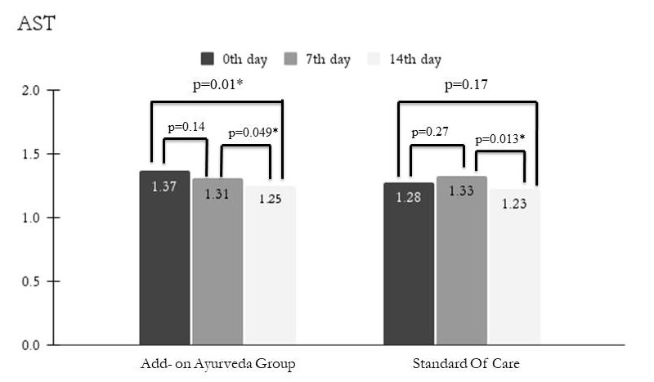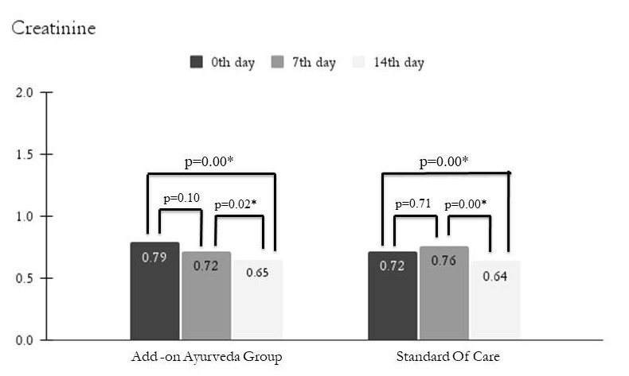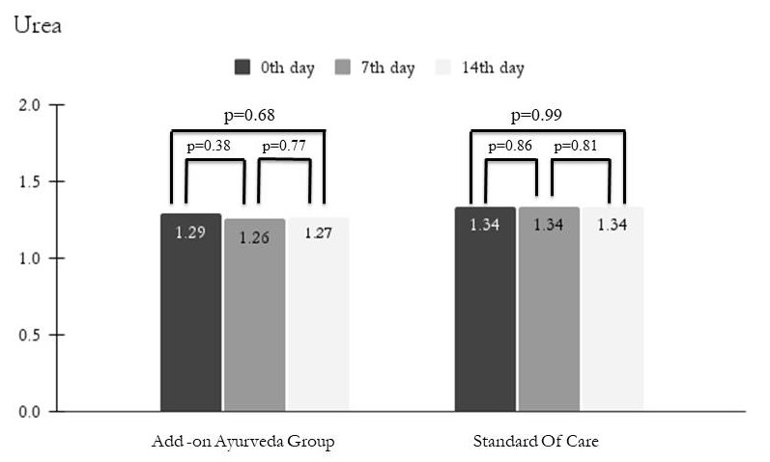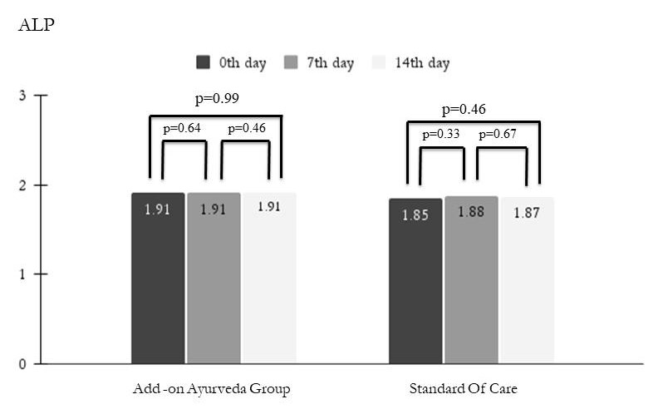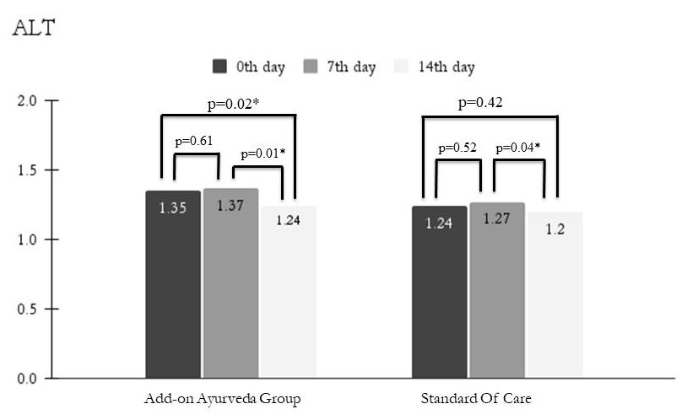
D
C
A,B,C,D,E Depicts mean values of patients over time in Add-on Ayurveda group and Standard of care for AST, Creatinine, Urea, ALP and ALT.
*p values significant at 95% CI using Repeated Measures Analysis of Variance with the method of Least Significant Difference for pair wise comparison on log-transformed data.

E

