Product Name: GOROCHANADI GULIKA
Batch Number: BGA - 063
Contents:
Botanical Name | Part Used | Each 5gms contain | Plant List based trinomial name
Cuminum cyminum | Flower | 0.02 gms | Cuminum cyminum L.
Solanum indicum | Root | 0.002 gms | Solanum violaceum Blume
Cow bile | Extract | 0.004 gms | NA
Rhubarb | Extract | 0.002 gms | NA
Pearl | Extract | 0.002 gms | NA
Coral | Extract | 0.002 gms | NA
Ambergis | Extract | 0.002 gms | NA
Orpiment | Extract | 0.002 gms | NA
Mesua ferrea | Flower | 0.002 gms | Mesua ferrea L.
Glycyrrhiza glabra | Root | 0.002 gms | Glycyrrhiza glabra L.
Garcinia morelia | NA | 0.05 gms | Morelia A.Rich. ex DC.
Elettaria cardamomum | Seed | 0.002 gms | Elettaria cardamomum (L.) Maton
Elaeocarpus sphaericus | NA | 0.002 gms | Elaeocarpus angustifolius Blume
Cyperus rotundus | Tuber | 0.002 gms | Cyperus rotundus L.
Crocus sativus | Dried stigma | 0.004 gms | Crocus sativus L.
Cinnamomum zeylanicum | Bark | 0.002 gms | Cinnamomum verum J.Presl
Cinnamomum tamala | Leaf | 0.002 gms | Cinnamomum tamala T.Nees & Eberm.
Cinnamomum camphora | Deposits in the oil cells | 0.004 gms | Cinnamomum camphora (L.) J.Presl
Andrographis paniculata | NA | 0.002 gms | Andrographis paniculata (Burm.f.) Wall.
Anacyclus pyrethrum | Root | 0.002 gms | Anacyclus pyrethrum (L.) Lag.
Abrus precatorius | NA | 0.002 gms | Abrus precatorius L.
Rosa centifolia | NA | 0.002 ml | Rosa centifolia L.
Cow's milk | Extraxt | 0.017 ml | NA
Plectranthus vettiveroides | Whole plant | 0.625gms | Plectranthus vettiveroides (Jacob) N.P.Singh & B.D.Sharma
Vitis vinifera | Flower | 0.625gms | Vitis vinifera L.
Cyperus rotundus | Root | 0.625gms | Cyperus rotundus L.
Hemidesmus indicus | Root | 0.625gms | Hemidesmus indicus
Emblica officinalis | Flower | 0.625gms | Phyllanthus emblica L.
Symplocos racemosa | Bark | 0.625gms | Symplocos racemosa Roxb.
Caesalpinia sappan | wd | 0.625gms | Biancaea sappan (L.) Tod.
Vetiveria zizanioides | Root | 0.625gms | Chrysopogon zizanioides (L.) Roberty
Nelumbo nucifera | Stem | 0.625gms | Nelumbo nucifera Gaertn.
Phoenix pusilla | Root | 0.625gms | Phoenix pusilla Gaertn.
Madhuca indica | Whole plant | 0.625gms | Madhuca longifolia J.F.Macbr.
Monochoria vaginalis | Tub. Root | 0.625gms | Pontederia vaginalis Burm.f.
Gmelina arborea | Root | 0.625gms | Gmelina arborea Roxb.
Inula racemosa | Stem | 0.625gms | Inula racemosa Hook.f.

Method of Extraction: As mentioned in the AFI
Preparation of formulation: As mentioned in the AFI
1.1. Request for the specific BMR and get the same issued from QA.
1.2. Indent the materials as per the BMR.
1.3. Weigh the approved materials, as per the SOP.
1.4. Transfer to the production area.
1.5. Shred the RM in a pulverize machine.
1.6 Grind the RM to a powdery consistency.
1.7. Inform to QC for sample.
1.8. Prepare decoction in a jacket vessel by boiling water with RM needed for the decoction.
1.9. In some Gulikas, add juice instead of decoction. Procedure for making juice:
1.9.1. Put the RM in the Juice expeller machine.
1.9.2. Add some water if required and grind in the Juice expeller machine.
1.9.3. Take the juice and filter it.
1.10. Grind the RM along with decoction/juice for 400 hrs .
1.11. Add RM like Crocus sativa, Gold Bhasma and Cinnamomum camphora are added 2 days before finishing the grinding.
1.12. Take 2 samples of the product, one before and one after adding the above RM. Send these samples to QC department for checking moisture.
1.13. Weigh the product after the grinding process is completed.
1.14. Add the binder accruing to the active then grind.
1.15. Dry the product in a drier at a temperature of 60 degrees (+/- 5 deg.C).
1.16. After drying powder than Inform to QC / QA for checking moisture of powder.
1.17. After approval compress the few tablets as per the standard and inform to QA / QC for sample.
1.18. After QA/ QC approval compress the tablets and pack the tablets as per the standard.
Quality Control reports:
Physico-chemical parameters:
Loss on drying: | No reference | 5.57 %
Total ash: | No reference | 11.72%
Acid-insoluble ash: | No reference | 2.95%
Alcohol-soluble extractive: | No reference | 7.64%
Water-solubleextractive: | No reference | 26.48%
pH.(1% aqueous solution); | No reference | 6.64

TLC Profile:
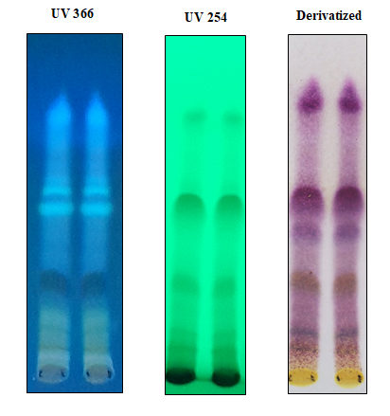

Sample: Alcohol Extract of Gorochanam gulika
Solvent: Toluene:Ethyl acetate:Chloroform:Methanol:formic acid(7:1:2:0.1:0.2)
Visualization: Anisaldehyde Sulphuric acid spray reagent

Product name: PANCATHIKTHAKAM KASHAYAM
Batch Number: Research Batch - 1
Contents:
Sanskrit Name | Botanical Name | Part Used | Each 5ml contains | Plant List based trinomial name
Kantakari | Solanum Xanthocarpum | Root | 2.000 gms | Solanum virginianum L.
Guduchi | Tinospora cordifolia | Stem | 2.000 gms | Tinospora cordifolia (Willd.) Miers ex Hook.f. & Thomson
Sunthi | Zingiber officinale | Root | 2.000 gms | Zingiber officinale Roscoe
Pushkarmoola | Inula racemosa | Root | 2.0000 gms | Inula racemosa Hook.f.
Kiratthiktha | Andrographis paniculata | Whole Plant | 2.000 gms | Andrographis paniculata (Burm.f.) Wall.

Method of Extraction: As mentioned in the AFI
Preparation of formulation: As mentioned in the AFI
1.1. Request for the specific BMR and get the same issued from QA.

1.2. Indent the materials as per the BMR.

1.3. Weigh the approved materials, as per the SOP.

1.4. Transfer to the production area.

1.5. Shred the RM using pulverize.

1.6. Transfer the RM to Steam hall. Boil the RM with water and reduce it. Then add water and again boil and reduce. Repeat the process 3 times.

1.7. Concentrate the Kashyams in a jacket vessel.

1.8. Add Sodium Benzoate in liquid form after cooling.

1.9. Inform to QC for sample for approval.

1.10. After “Approval” transfers the Kashyam for quarantine / storage room

1.11. Pack the Kashyam as per the standard packs.

1.12. After packing keep these bottles in quarantine, then inform for QA through test request form.

1.13. After QA clearance transfer to FG stores with FINISH GOODS TEST REQUEST MEMO.

Quality Control report:

S.No | Physicochemical parameters | Observed Values
S.No | Physicochemical parameters | Sample 1 | Sample 2 | Sample3
1 | PH | 7.31 | 6.74 | 7.26
2 | Specific gravity | 1.043 | 1.044 | 1.035
3 | Total Solids | 10.14 % | 10.35 % | 7.8 %
4 | Phenolic Content | 0.03 %

TLC PROFILE:
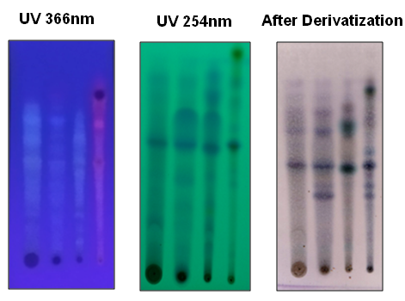
Spotting 1: Hydrolysed Extract of sample 1
Spotting 2: Hydrolysed Extract of sample 2
Spotting 3: Hydrolysed Extract of sample 3
Spotting 4: Ethyl acetate Extract of Andrographis paniculate
Solvent : Chloroform:Ethyl acetate:Methanol:Acetic acid(5:5:1:0.2)
After Derivatizarion: Vanillin Sulphuric acid heated at 110⁰C Oven

Solvent:Toluene:Ethyl acetate:formic acid(5:4:1)
Spray :Vanillin sulphuric acid heated at 110⁰ oven

Product Name: SWARNAMUKTHADI GULIKA
Batch Number: BFI – 035
Contents:
Botanical Name | Part Used | Each 5gms contain | Plant List based trinomial name
Vitis vinifera | Dry fruit | 0.001 gms | Vitis vinifera L.
Terminalia chebula | Fruit | 0.001 gms | Terminalia chebula Retz.
Terminalia bellirica | Fruit bark | 0.001 gms | Terminalia bellirica (Gaertn.) Roxb.
Strychnos potatorum | Fruit | 0.001 gms | Strychnos potatorum L.f.
Saussurea lappa | Root | 0.001 gms | Aucklandia costus Falc.
Pseudarthria viscida | Root | 0.001 gms | Pseudarthria viscida (L.) Wight & Arn.
Piper longum | Dried spikes | 0.001 gms | Piper longum L.
Phoenix dactylifera | NA | 0.001 gms | Phoenix dactylifera L.
Orpiment | Extract | 0.001 gms | NA
Cow bile | Extract | 0.001 gms | NA
Pearl | Extract | 0.001 gms | NA
Coral | Extract | 0.001 gms | NA
Conch shell | Extract | 0.001 gms | NA
Gold nanoparticles | Extract | 0.001 gms | NA
Mimusops elengi | Extract | 0.001 gms | Manilkara kauki Dubard
Madhuca indica | wd | 0.001 gms | Madhuca longifolia J.F.Macbr.
Emblica officinalis | Root | 0.001 gms | Phyllanthus emblica L.
Elaeocarpus sphaericus | NA | 0.001 gms | Elaeocarpus angustifolius Blume
Crocus sativus | Dried stigma | 0.001 gms | Crocus sativus L.
Boerhavia diffusa | Whole plant | 0.002 gms | Boerhavia diffusa L.
Azadirachta indica | Root | 0.001 gms | Azadirachta indica A.Juss.
Aegle marmelos | Root | 0.001 gms | Aegle marmelos (L.) Corrêa
Acorus calamus | Rz | 0.001 gms | Acorus calamus L.
Achyranthes aspera | Whole plant | 0.001 gms | Achyranthes aspera L.
Silver nanoparticles | Extract | 0.001 gms | NA
Cow's milk | NA | 0.012 gms | NA

Method of Extraction: As mentioned in the AFI
Preparation of formulation: As mentioned in the AFI
1.1. Request for the specific BMR and get the same issued from QA.
1.2. Indent the materials as per the BMR.
1.3. Weigh the approved materials, as per the SOP.
1.4. Transfer to the production area.
1.5. Shred the RM in a pulverize machine.
1.6. Grind the RM to a powdery consistency.
1.7. Inform to QC for sample.
1.8. Prepare decoction in a jacket vessel by boiling water with RM needed for the decoction.
1.9. In some Gulikas, add juice instead of decoction. Procedure for making juice:
1.9.1. Put the RM in the Juice expeller machine.
1.9.2. Add some water if required and grind in the Juice expeller machine.
1.9.3. Take the juice and filter it.
1.10. Grind the RM along with decoction/juice for 400 hrs .
1.11. Add RM like Crocus sativa, Gold Bhasma and Cinnamomum camphora are added 2 days before finishing the grinding.
1.12. Take 2 samples of the product, one before and one after adding the above RM. Send these samples to QC department for checking moisture.
1.13. Weigh the product after the grinding process is completed.
1.14. Add the binder accruing to the active then grind.
1.15. Dry the product in a drier at a temperature of 60 degrees (+/- 5 deg.C).
1.16. After drying powder than Inform to QC / QA for checking moisture of powder.
1.17. After approval compress the few tablets as per the standard and inform to QA / QC for sample.
1.18. After QA/ QC approval compress the tablets and pack the tablets as per the standard.
Physico-chemical parameters:
Loss on drying: | No reference | 9.05%
Total ash: | No reference | 17.21%
Acid-insoluble ash: | No reference | 8.03%
Alcohol-soluble extractive: | No reference | 2.73%
Water-solubleextractive: | No reference | 29.0%
pH.(1% aqueous solution); | No reference | 6.86

TLC Profile:
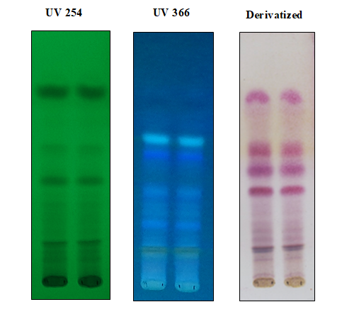
Sample: Alcohol Extract of Swarnamukthadi gulika
Solvent: Hexane:Ethyl acetate:Methanol:Acetic acid(7:3:0.2:0.1)
Visualization: Anisaldehyde Sulphuric acid spray heated at 110⁰C

Product Name: VILWADI GULIKA
Batch Number: BFK– 035, BGF – 016, BGA – 008
Contents:
Botanical Name | Part Used | Each 5gms contain | Plant List based trinomial name
Zingiber officinale | Rhizome | 0.050gms | Zingiber officinale Roscoe
Valeriana wallichii | Root | 0.050gms | Valeriana jatamansi Jones
Terminalia chebula | Fruit rind | 0.050gms | Terminalia chebula Retz.
Terminalia bellirica | Fruit Bark | 0.050gms | Terminalia bellirica (Gaertn.) Roxb.
Pongamia pinnata | NA | 0.050gms | Pongamia pinnata (L.) Pierre
Piper nigrum | Fruit | 0.050gms | Piper nigrum L.
Piper longum | Dried spikes | 0.050gms | Piper longum L.
Ocimum sanctum | Leaf | 0.050gms | Ocimum tenuiflorum L.
Emblica officinalis | Root | 0.050gms | Phyllanthus emblica L.
Curcuma longa | Rhizome | 0.050gms | Curcuma longa L.
Cedrus deodara | Heartwood | 0.050gms | Cedrus deodara (Roxb. ex D.Don) G.Don
Berberis aristata | Stem | 0.050gms | Berberis umbellata Wall. ex G.Don
Aegle marmelos | Root | 0.050gms | Aegle marmelos (L.) Corrêa
Zingiber officinale | Seed | 0.050gms | Zingiber officinale Roscoe
Inula racemosa | Root | 0.050gms | Inula racemosa Hook.f.
Andrographis paniculata | Whole plant | 0.050gms | Andrographis paniculata (Burm.f.) Wall.

Method of Extraction: As mentioned in the AFI
Preparation of formulation: As mentioned in the AFI
1.1. Request for the specific BMR and get the same issued from QA.
1.2. Indent the materials as per the BMR.
1.3. Weigh the approved materials, as per the SOP.
1.4. Transfer to the production area.
1.5. Shred the RM in a pulverize machine.
1.6. Grind the RM to a powdery consistency.
1.7. Inform to QC for sample.
1.8. Prepare decoction in a jacket vessel by boiling water with RM needed for the decoction.
1.9. In some Gulikas, add juice instead of decoction. Procedure for making juice:
1.9.1. Put the RM in the Juice expeller machine.
1.9.2. Add some water if required and grind in the Juice expeller machine.
1.9.3. Take the juice and filter it.
1.10. Grind the RM along with decoction/juice for 400 hrs .
1.11. Add RM like Crocus sativa, Gold Bhasma and Cinnamomum camphora are added 2 days before finishing the grinding.
1.12. Take 2 samples of the product, one before and one after adding the above RM. Send these samples to QC department for checking moisture.
1.13. Weigh the product after the grinding process is completed.
1.14. Add the binder accruing to the active then grind.
1.15. Dry the product in a drier at a temperature of 60 degrees (+/- 5 deg.C).
1.16. After drying powder than Inform to QC / QA for checking moisture of powder.
1.17. After approval compress the few tablets as per the standard and inform to QA / QC for sample.
1.18. After QA/ QC approval compress the tablets and pack the tablets as per the standard.
Physico-chemical parameters:
Loss on drying: | No reference | 10.12%
Total ash: | No reference | 15.8%
Acid-insoluble ash: | No reference | 0.84 %
Alcohol-soluble extractive: | No reference | 7.95%
Water-solubleextractive: | No reference | 30.78%
pH.(1% aqueous solution); | No reference | 5.53

TLC Profile:
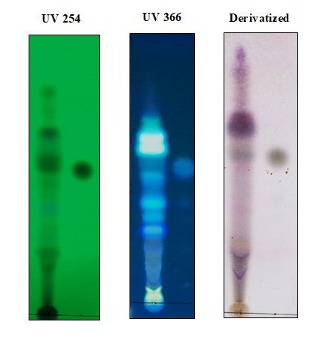

Track1: Alcohol Extract of Vilwadi gulika
Track2: Piperine
Solvent: Toluene:Ethyl acetate:Methanol(5:2:0.5)
Visualization: Anisaldehyde Sulphuric acid spray reagent

Product Name: SWASANANDA GULIKA
Batch Number: BGA – 007
Contents:
Botanical Name | Part Used | Each 5gms contain | Plant List based trinomial name
Cuminum cyminum | Fruit | 0.042 gms | Cuminum cyminum L.
Red Sulphide of Mercury | Mineral | 0.013 gms | NA
Cinnamomum camphora | Deposits in the oil cells | 0.025gms | Cinnamomum camphora (L.) J.Presl
Aconitum heterophyllum | Root | 0.013 gms | Aconitum heterophyllum Wall.

Method of Extraction: As mentioned in the AFI
Preparation of formulation: As mentioned in the AFI
1.1. Request for the specific BMR and get the same issued from QA.
1.2. Indent the materials as per the BMR.
1.3. Weigh the approved materials, as per the SOP.
1.4. Transfer to the production area.
1.5. Shred the RM in a pulverize machine.
1.6. Grind the RM to a powdery consistency.
1.7. Inform to QC for sample.
1.8. Prepare decoction in a jacket vessel by boiling water with RM needed for the decoction.
1.9. In some Gulikas, add juice instead of decoction. Procedure for making juice:
1.9.1. Put the RM in the Juice expeller machine.
1.9.2. Add some water if required and grind in the Juice expeller machine.
1.9.3. Take the juice and filter it.
1.10. Grind the RM along with decoction/juice for 400 hrs .
1.11. Add RM like Crocus sativa, Gold Bhasma and Cinnamomum camphora are added 2 days before finishing the grinding.
1.12. Take 2 samples of the product, one before and one after adding the above RM. Send these samples to QC department for checking moisture.
1.13. Weigh the product after the grinding process is completed.
1.14. Add the binder accruing to the active then grind.
1.15. Dry the product in a drier at a temperature of 60 degrees (+/- 5 deg.C).
1.16. After drying powder than Inform to QC / QA for checking moisture of powder.
1.17. After approval compress the few tablets as per the standard and inform to QA / QC for sample.
1.18. After QA/ QC approval compress the tablets and pack the tablets as per the standard.

Quality control report:
Physico-chemical parameters:
Loss on drying: | No reference | 25.8%
Alcohol-soluble extractive: | No reference | API (Solvent removal by evaporating metnod)-1.5%  IIA (Solvent removal by Distillation method)-25.1%
Ash | No reference | Omitted due to presence of mercury sulphide
Water-soluble extractive: | No reference | 15.5%
pH.(1% aqueous solution); | No reference | 4.53
Mercury | No reference | 6070 ppm

TLC Profile:
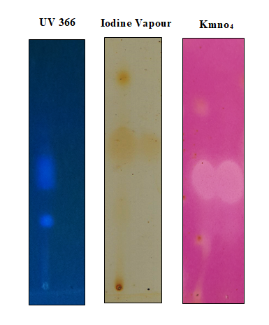

Sample: Alcohol Extract of Swasananda gulika
Solvent: Hexane:Ethyl acetate:Methanol(8:2:0.5)
Visualization: 1% aqueous potassium permagnate&5% aqueous sodium carbonate (Kmno4spray reagent) solution

Product Name: AGASTYA HARITAKI RASAYANA (AFI-PART-1,3:1)
Batch number: AGE - 080
Contents:
Botanical name | Part used | Each 5 gm contains | Trinomial Name
Aegle marmelos | (Rt./St. Bk.) | 0.26 g | Aegle marmelos (L.) Corrêa
Oroxylum indicum | (Rt./St. Bk.) | 0.26 g | Oroxylum indicum (L.) Benth. ex Kurz
Gmelina arborea | (Rt./St. Bk.) | 0.26 g | Gmelina arborea Roxb.
Stereospermum suaveolens | (Rt./St. Bk.) | 0.26 g | Stereospermum suaveolens DC.
Premna integrifolia | (Rt./St. Bk.) | 0.26 g | Premna integrifolia L.
Desmodium gangeticum | (Rt.) | 0.26 g | Desmodium gangeticum (L.) DC.
Uraria picta | (Rt.) | 0.26 g | Uraria picta (Jacq.) Desv. ex DC.
Solanum indicum | (Rt.) | 0.26 g | Solanum indicum Roxb.
Solanum surattense | (Rt.) | 0.26 g | Solanum surattense Burm.f.
Tribulus terrestris | (Fr.) | 0.26 g | Tribulus terrestris L.
Mucuna prupripa | (Sd.) | 0.26 g | Mucuna papuana Adema
Convolvulus pluricaulis | (Rt.) | 0.26 g | Convolvulus pluricaulis Choisy
Hedychium spicatum | (Rz.) | 0.26 g | Hedychium spicatum Buch.-Ham. ex Sm.
Sida cordifolia | (Rt.) | 0.26 g | Sida cordifolia .L
Scindapsus officinalis | (Fr.) | 0.26 g | Scindapsus officinalis Schott
Achyrantheres aspera | (Rt.) | 0.26 g | NA
Piper longum | (Rt.) | 0.26 g | Piper longum L.
Plumbago zeylanicum | (Rt.) | 0.26 g | Trichodesma zeylanicum subsp. eu-zeylanicum Brand
Clerodendrum serratum | (Rt.) | 0.26 g | Clerodendrum serratum Moon
Inula racemosa | (Rt.) | 0.26 g | Inula racemosa Hook.f.
Hordeum vulgare | (Sd.) | 0.26 g | Hordeum vulgare L.
Terminalia chebula | (Fr.) | 0.26 g | Terminalia chebula Retz.
Water for Decoction | - | 0.26 g | NA
Jaggery | - | 0.26 g | NA
Clarified butter from cow's milk | - | 0.26 g | NA
Sesamum indicum | (Ol.) | 0.26 g | Sesamum indicum L.
Honey | - | 0.26 g | NA

Method of Preparation:
- Take all the ingredients of pharmacopoeial quality
- Clean , wash and dry the ingrdients 1-11(Kvatha dravya) of the formulation composition,powder separately and pass through 355 µm IS sieve(sieve no 44) to obtain coarse powder
- Clean , wash and dry the ingredient no 18 of the formulation composition,powder and pass through 180 µm IS sieve(sieve no 85) to obtain fine powder
- Add specified amount of water to the kvatha dravya.Suspend Haritaki and Yava bundled in a piece of cloth in water containing kvatha dravya.Thereafter, boil the contents till haritaki and yava become soft.Remove haritaki from bundle.Filter the kvatha to muslin cloth.
- .Add jiggery to filtrate kvatha, boil to dissolve and filter through muslin cloth.
- Add the boiled haritaki along with Ghrta, Taila and Pippali curna to the filtrate and boil the contents to thicker consistency to attain Avaleha Paka characteristics.
- Allow it to cool to room temperature.Add madhu and mix thoroughly to obtain a homogenious blend.
- Store in containers and make them air tight to protect from light and moisture
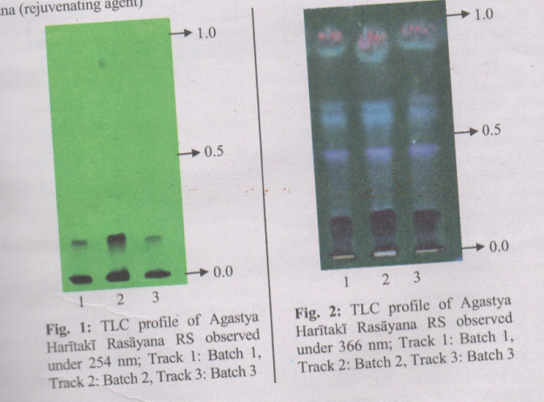
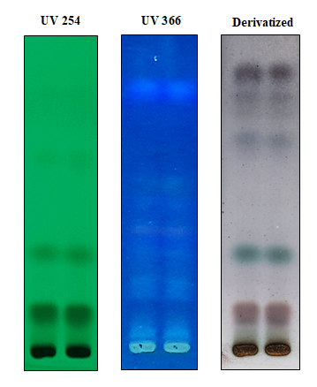

Physico-Chemical parameters:
Total Ash: Not more than 2.0 percent(Appendix 2.2.3);Acid insoluble ash:Not more than 0.06 percent(Appendix 2.2.4);Alcohol –soluble extractive: Not less than12.0 percent(Appendix 2.2.5);Water-soluble extractive :Not less than 57 percent(Appendix 2.2.6); Total sugar 34-42 percent (Appendix 5.1) reducing sugar 6-8 percent(Appendix 5.1) Non reducing sugar 28-34percent (Appendix 5.1): pH(5% aqueous solution ) 4-5 (Appendix 3.3).
Parameters | API Values | AVP Values
Loss on drying | - | 20.09 %
Total ash | Not more than 2.0 percent | 2.10 %
Acid-insoluble ash | Not more than 0.06 percent | 0.02 %
Alcohol – soluble extrative | Not less than12.0 percent | 20.64 %
Water – soluble extractive | Not less than 57 percent | 65.36 %
pH (5% aqueous solution) | 4-5 | 5.73
Reducing Sugar | 6-8 percent | 2.80 %
Non-Reducing Sugar | 28-34 percent | 45.31 %

Product Name: Drakshadi Kashayam
Batch Number: AGD – 090, AFI – 235
Contents:
Botanical Name | Part Used | Each 5ml is contains | Plant List based trinomial name
Santalum album | Wood | 0.625ml | Santalum album L.
Glycyrrhiza glabra | Root | 0.625ml | Glycyrrhiza glabra L.
Plectranthus vettiveroides | Whole Plant | 0.625ml | Plectranthus vettiveroides (Jacob) N.P.Singh & B.D.Sharma
Vitis vinifera | Fruit | 0.625ml | Vitis vinifera L.
Cyperus rotundus | Rhizome | 0.625ml | Cyperus rotundus L.
Hemidesmus indicus | Root | 0.625ml | Hemidesmus indicus
Emblica officinalis | Fruit | 0.625ml | Phyllanthus emblica L.
Symplocos racemosa | Bark | 0.625ml | Symplocos racemosa Roxb.
Caesalpinia sappan | Wood | 0.625ml | Biancaea sappan (L.) Tod.
Vetiveria zizanioides | Root | 0.625ml | Chrysopogon zizanioides (L.) Roberty
Nelumbo nucifera | Stem | 0.625ml | Nelumbo nucifera Gaertn.
Phoenix pusilla | Root | 0.625ml | Phoenix pusilla Gaertn.
Madhuca indica | Wood | 0.625ml | Madhuca longifolia J.F.Macbr.
Monochoria vaginalis | Tub.Root | 0.625ml | Pontederia vaginalis Burm.f.
Gmelina arborea | Root | 0.625ml | Gmelina arborea Roxb.
Inula racemosa | Stem | 0.625ml | Inula racemosa Hook.f.

Method of Extraction: As mentioned in the AFI

Preparation of formulation: As mentioned in the AFI
1.1. Request for the specific BMR and get the same issued from QA.
1.2. Indent the materials as per the BMR.
1.3. Weigh the approved materials, as per the SOP.
1.4. Transfer to the production area.
1.5. Shred the RM using pulverize.
1.6. Transfer the RM to Steam hall. Boil the RM with water and reduce it. Then add water and again boil and reduce. Repeat the process 3 times.
1.7. Concentrate the Kashyams in a jacket vessel.
1.8. Add Sodium Benzoate in liquid form after cooling.
1.9. Inform to QC for sample for approval.
1.10. After “Approval” transfers the Kashyam for quarantine / storage room
1.11. Pack the Kashyam as per the standard packs.
1.12. After packing keep these bottles in quarantine, then inform for QA through test request form.
1.13. After QA clearance transfer to FG stores with FINISH GOODS TEST REQUEST MEMO.
Physico-chemical parameters:
Parameters | API Values | AVP Values
TDS(Total Dissolved Solids): | No Reference | 21 %
Specific gravity: | No Reference | 1.0854
pH (10% aqueous soluion): | No Reference | 4.30
Phenolic Content | No Reference | 0.058%

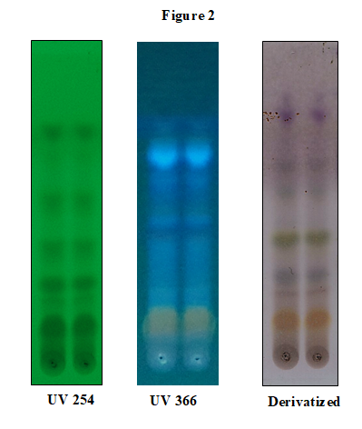
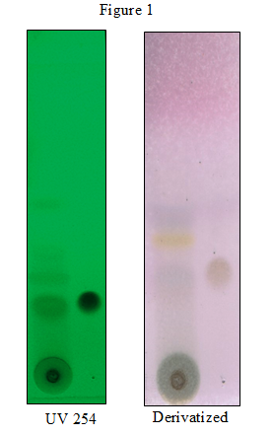
TLC Profile:

Figure 1
Track1: Alcohol Extract of Drakshadi kashayam
Track2: Alcohol Extract of Drakshadi kashayam
Track3: Gallic acid
Solvent:Toluene: Ethyl acetate:Methanol :Formic acid(3:3:0.2:0.2)

Figure 2
Track1: Acid hydrolysed Extract of Drakshadi kashayam
Track2: Acid hydrolysed Extract of Drakshadi kashayam
Solvent: Toluene: Ethyl acetate:Methanol (4:2:0.3)

Product name: Indukantha Kashayam
Batch Number: AGD – 093, AGE – 113, AFE-016
Contents:
Botanical Name | Part Used | Each 5ml contains | Plant List based trinomial name
Zingiber officinale | Rhizome | 0.588 ml | Zingiber officinale Roscoe
Cedrus deodara | Wood | 0.588 ml | Cedrus deodara (Roxb. ex D.Don) G.Don
Piper longum | Fruit | 0.588 ml | Piper longum L.
Aerva lanata | Root | 0.588 ml | Aerva lanata (L.) Juss.
Solanum indicum | Root | 0.588 ml | Solanum violaceum Blume
Piper brachystachyum | Root | 0.588 ml | Peperomia filiformis Ruiz & Pav.
Aegle marmelos | Root | 0.588 ml | Aegle marmelos (L.) Corrêa
Gmelina arborea | Root | 0.588 ml | Gmelina arborea Roxb.
Premna corymbosa | Root | 0.588 ml | Premna corymbosa Rottler & Willd.
Pseudarthria viscida | Root | 0.588 ml | Pseudarthria viscida (L.) Wight & Arn.
Tribulus terrestris | Fruit | 0.588 ml | Tribulus terrestris L.
Holoptelea integrifolia | Bark | 0.588 ml | Holoptelea integrifolia (Roxb.) Planch.
Desmodium gangeticum | Root | 0.588 ml | Pleurolobus gangeticus (L.) J.St.-Hil. ex H.Ohashi & K.Ohashi
Oroxylum indicum | Root | 0.588 ml | Oroxylum indicum (L.) Benth. ex Kurz
Stereospermum suaveolens | Root | 0.588 ml | Stereospermum chelonoides DC.
Plumbago zeylanica | Rhizome | 0.588 ml | Plumbago zeylanica L.

Method of Extraction: As mentioned in the AFI

Preparation of formulation: As mentioned in the AFI
1.1. Request for the specific BMR and get the same issued from QA.
1.2. Indent the materials as per the BMR.
1.3. Weigh the approved materials, as per the SOP.
1.4. Transfer to the production area.
1.5. Shred the RM using pulverize.
1.6. Transfer the RM to Steam hall. Boil the RM with water and reduce it. Then add water and again boil and reduce. Repeat the process 3 times.
1.7. Concentrate the Kashyams in a jacket vessel.
1.8. Add Sodium Benzoate in liquid form after cooling.

1.9. Inform to QC for sample for approval.
1.10. After “Approval” transfers the Kashyam for quarantine / storage room
1.11. Pack the Kashyam as per the standard packs.
1.12. After packing keep these bottles in quarantine, then inform for QA through test request form.
1.13. After QA clearance transfer to FG stores with FINISH GOODS TEST REQUEST MEMO.
Physico-chemical parameters:
Parameters | API Values | AVP Values
TDS(Total Dissolved Solids): | No Reference | 14.19%
Specific gravity: | No Reference | 1.0569(30⁰C)
pH (10% aqueous solution): | No Reference | 5.31

TLC Profile:
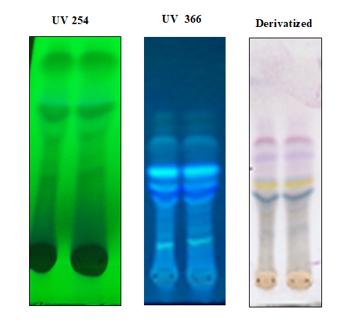

Sample: Alcohol Extract of Indukantha kashayam
Solvent: Toluene:Ethyl acetate:Formic acid:Methanol(5:5:1:0.1)
Visualization: Anisaldehyde Sulphuric acid spray reagent

Product Name: Guduchyadi Kashayam
Batch Number: AGD – 090, AFI – 235
Contents:
Botanical Name | Part Used | Each 5ml contains | Plant List based trinomial name
Coriandrum sativum | Flower | 2.00ml | Coriandrum sativum L.
Caesalpinia sappan | Wood | 2.00ml | Biancaea sappan (L.) Tod.
Pterocarpus santalinus | Wood | 2.00ml | Pterocarpus santalinus L.f.
Tinospora cordifolia | Stem | 2.00ml | Tinospora cordifolia (Willd.) Miers ex Hook.f. & Thomson
Azadirachta indica | Bark | 2.00ml | Azadirachta indica A.Juss.

Method of Extraction: As mentioned in the AFI

Preparation of formulation: As mentioned in the AFI
1.1. Request for the specific BMR and get the same issued from QA.
1.2. Indent the materials as per the BMR.
1.3. Weigh the approved materials, as per the SOP.
1.4. Transfer to the production area.
1.5. Shred the RM using pulverize.
1.6. Transfer the RM to Steam hall. Boil the RM with water and reduce it. Then add water and again boil and reduce. Repeat the process 3 times.
1.7. Concentrate the Kashyams in a jacket vessel.
1.8. Add Sodium Benzoate in liquid form after cooling.
1.9. Inform to QC for sample for approval.
1.10. After “Approval” transfers the Kashyam for quarantine / storage room
1.11. Pack the Kashyam as per the standard packs.
1.12. After packing keep these bottles in quarantine, then inform for QA through test request form.
1.13. After QA clearance transfer to FG stores with FINISH GOODS TEST REQUEST MEMO.

Quality Control report:
Physicochemical parameters:
Parameters | API Values | AVP Values
TDS(Total Dissolved Solids): | No Reference | 13.51%
Specific gravity: | No Reference | 1.0513(30⁰C)
pH (10% aqueous solution): | No Reference | 4.44

TLC Profile:

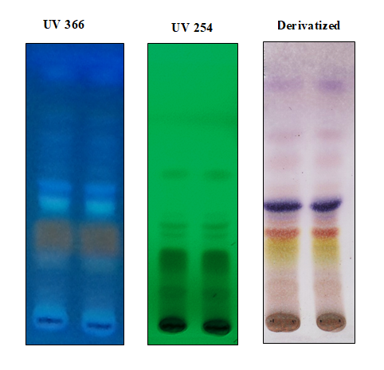

Sample: Alcohol Extract of Guduchyadi kashayam
Solvent: Toluene:Ethyl acetate:Formic acid:Methanol(5:5:0.6:0.2)
Visualization: Anisaldehyde Sulphuric acid spray reagent

Product Name: Bharangyadi Kashayam
Batch Number: Research Batch – 1
Contents:
Botanical Name | Part Used | Each 5ml contains | Plant List based trinomial name
Zingiber officinale | Rhizome | 0.588 ml | Zingiber officinale Roscoe
Terminalia chebula | Fruit rind | 0.588 ml | Terminalia chebula Retz.
Cyperus rotundus | Rhizome | 0.588 ml | Cyperus rotundus L.
Piper longum | Fruit | 0.588 ml | Piper longum L.
Clerodendranserratum | Root | 0.588 ml | Rotheca serrata (L.) Steane & Mabb.
Inula racemosa | Root | 0.588 ml | Inula racemosa Hook.f.
Oldenlandia corymbosa | Whole Plant | 0.588 ml | NA
Aerva lanata | Root | 0.588 ml | Solanum violaceum Blume
Solanum indicum | Root | 0.588 ml | Solanum violaceum Blume
Aegle marmelos | Root | 0.588 ml | Aegle marmelos (L.) Corrêa
Gmelina arborea | Root | 0.588 ml | Gmelina arborea Roxb.
Premna corymbosa | Root | 0.588 ml | Premna serratifolia L.
Pseudarthria viscida | Root | 0.588 ml | Pleurolobus gangeticus (L.) J.St.-Hil. ex H.Ohashi & K.Ohashi
Tribulus terrestris | Root | 0.588 ml | Tribulus terrestris L.
Desmodium gangeticum | Root | 0.588 ml | Uraria picta (Jacq.) Desv. ex DC.
Oroxylum indicum | Root | 0.588 ml | Oroxylum indicum (L.) Benth. ex Kurz
Stereospermum suaveolens | Root | 0.588 ml | Stereospermum chelonoides DC.

Method of Extraction: As mentioned in the AFI

Preparation of formulation: As mentioned in the AFI
1.1. Request for the specific BMR and get the same issued from QA.
1.2. Indent the materials as per the BMR.
1.3. Weigh the approved materials, as per the SOP.
1.4. Transfer to the production area.
1.5. Shred the RM using pulverize.
1.6. Transfer the RM to Steam hall. Boil the RM with water and reduce it. Then add water and again boil and reduce. Repeat the process 3 times.
1.7. Concentrate the Kashyams in a jacket vessel.
1.8. Add Sodium Benzoate in liquid form after cooling.
1.9. Inform to QC for sample for approval.
1.10. After “Approval” transfers the Kashyam for quarantine / storage room
1.11. Pack the Kashyam as per the standard packs.
1.12. After packing keep these bottles in quarantine, then inform for QA through test request form.
1.13. After QA clearance transfer to FG stores with FINISH GOODS TEST REQUEST MEMO.
Physicochemical parameters:
Parameters | API Values | AVPRF Values
TDS(Total Dissolved Solids): | No Reference | 24.31%
Specific gravity: | No Reference | 1.1068
pH (10% aqueous soluion): | No Reference | 4.81
Phenolic content | No Reference | 0.01%

TLC Profile:
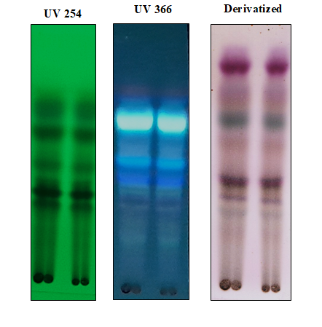

Sample: Hydrolysed Alcohol Extract of bharangangyadi kashayam
Solvent: Chloroform:Ethyl acetate:Methanol:Formic acid(2:2:0.2:0.2)
Visualization:Anisaldehyde sulphuric acid spray heated at 110⁰ C

Product Name: Pravala Bhasmam
Batch Number: Research Batch – 1
Contents:
Botanical Name | Part Used | Each 1g contains | Plant List based trinomial name
Coral | NA | 1g | NA

Method of Extraction: As mentioned in the AFI
Preparation of formulation: As mentioned in the AFI
Bhasmas are prepared from purified minerals, metals and marine and animal products. In Ayurveda, the process of purifiction is called áodhana. Chemical purification is different from medicinal purification. In chemical purification it is only elimination of foreign matters. In medicinal purification the objects aimed are (a) elimination of harmful matter from the drug; (b) Modification of undesirable physical properties of the drug; (c) conversion of some of the characteristics of the drugs; (d) the enhancement of the therapeutic action, thereby potentizing the drug.
The second stage is the preparation of Bhasma. The purified drug is put into a khalva (stone mortar and pestle) and ground with juices of the specified plants or KaÀ¡yas of drugs mentioned for a particular mineral or metal. It is ground for the specified period of time. Then small cakes (cakrik¡s) are made. The size and thickness of the cakes depend on the heaviness of the drug, The heavier the drug, the thinner are the cakes. These cakes are dried well under sunlight and placed in one single layer in a shallow earthen plate (áar¡va) and closed with another plate. The edge is sealed with clay-smeared cloth in seven consecutive layers and dried.
Physicochemical parameters:
SI.No | Tests | Results | Standard Limits | Reference to reading and calculations | Reference to procedure of test
1 | Organoleptic characters
 | Color | Grey | Grey |  | IHS
 | Smell | Characteristic | Characteristic |  | IHS
 | Taste | Tasteless | Tasteless |  | IHS
 | Nature | Fine Powder | Fine Powder |  | IHS
2 | Loss on Drying (% w/w) | 0.05 | NMT 1 | AVP/Q/BHA-004 | API
3 | Ash value (% w/w) | 88.69 | NLT 70 | AVP/Q/BHA-004 | API
4 | Acid Insoluble Ash (% w/w) | 11.21 | NLT 8.0 | AVP/Q/BHA-004 | API
5 | Bulk Density | 1.21 | NMT 2 | AVP/Q/BHA-004 | API
6 | pH | 9.90 | 8.5-11.0 | AVP/Q/BHA-004 | API
Product Name: Ashtanga Choornam
Batch Number: Research Batch – 1
Contents:
Botanical Name | Part Used | Each 5g contains | Plant List based trinomial name
Myrica esculenta | Fruit | 0.625 g | Myrica esculenta Buch.-Ham. ex D.Don
Inula racemosa | Root | 0.625 g | Inula racemosa Hook.f.
Pistacia integerrima | Gall | 0.625 g | Pistacia chinensis Bunge
Piper nigrum | Fruit | 0.625 g | Piper nigrum L.
Piper longum | Fruit | 0.625 g | Piper longum L.
Zingiber officinale | Rhizome | 0.625 g | Zingiber officinale Roscoe
Solanum Xanthocarpum | Root | 0.625 g | Solanum virginianum L.
Nigella sativa | Seed | 0.625 g | Nigella sativa L.

Method of Extraction: As mentioned in the AFI

Preparation of formulation: As mentioned in the AFI
- Request for the specific BMR and get the same issued from QA.
- Indent the materials as per the BMR.
- Weigh the approved materials, as per the SOP.
- Transfer to the production area.
- Prepare decoction by boiling RM with water.
- Take the decoction in 3 Jacket vessels and boil them in these vessels.
- Procedure for making syrup.

    - Boil Jaggery / Sugar with water and make syrup. Percentage of Jaggery / Sugar I n water varies according to the Lehyams prepared.
    - Filter this syrup 2 times with a cotton cloth.
- Add this syrup to the decoction.
- Boil and concentrate the decoction for 6 hours.
- Choornam (medicated powder) is added to this concentrated decoction when it achieves thread like consistency.
- Ghee / honey added to the concentrate according to the Lehyams prepared.
- Transfer the Lehyams to the quarantine.
Physicochemical parameters:

SI.No | Tests | Results | Reference to procedure of test
1 | pH | 6.73 | IHS
2 | Moisture | A – 6.57%  B – 6.86% | IHS
3 | Ash Content | 5.41% | IHS
4 | Acid Insoluble Ash | 0.74% | IHS
5 | Alcohol Extractive | 14.70% | IHS
6 | Water Extractive | 20.10% | IHS
7 | Bulk Density | 0.4181 g/ml | IHS

