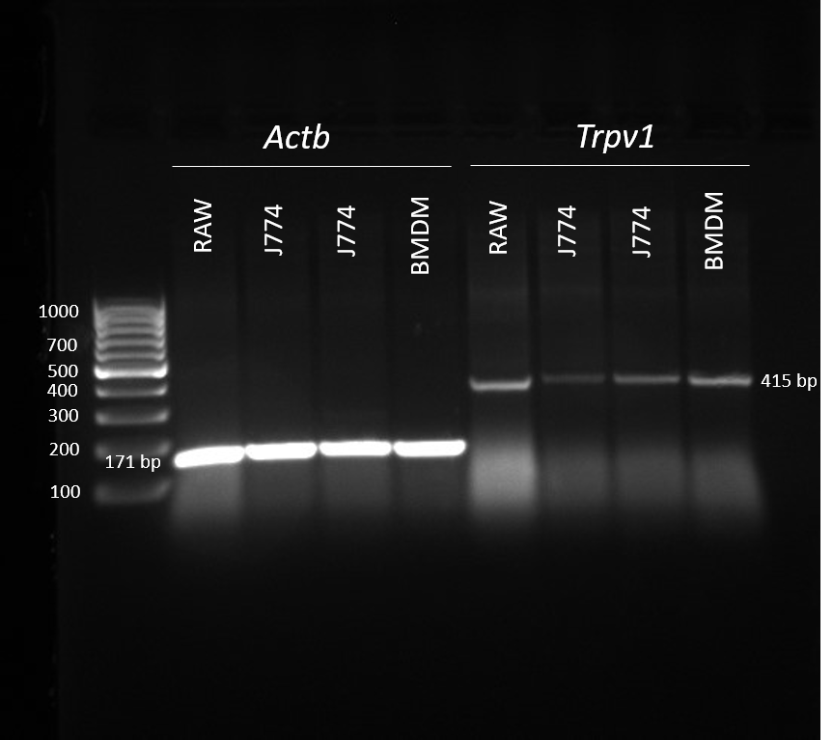
Figure S8 Trpv1 gene expression. Full-length gel image of Trpv1 and Actb expression. Total RNA was isolated from the J774.2 cell line (J774), bone marrow-derived macrophages (BMDM) and RAW 264.7 cell line (RAW), prepared cDNA and the presence of Trpv1 gene expression (415 bp fragment) verified by RT-PCR. Actb expression (171 bp fragment) was used as a control.

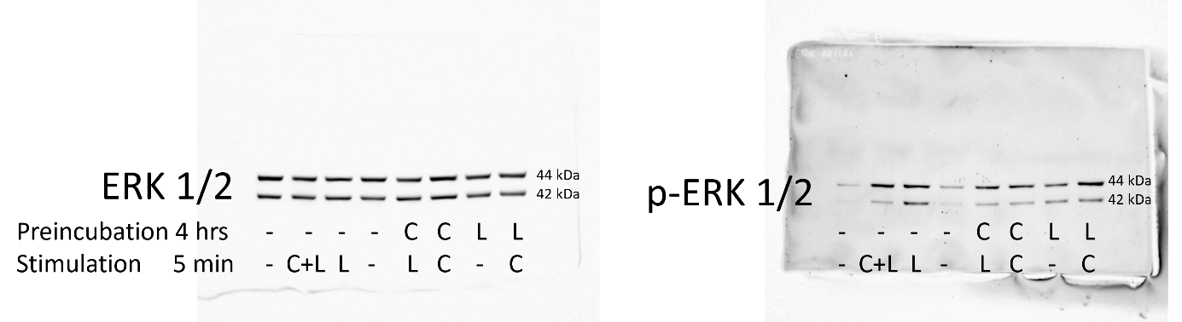

Figure S9 ERK 1/2 protein expression. Representative full-length Western Blot membrane from J774 cell line preincubated for 4 hours and stimulated with capsaicin (C) or LPS (L) for 5 minutes.

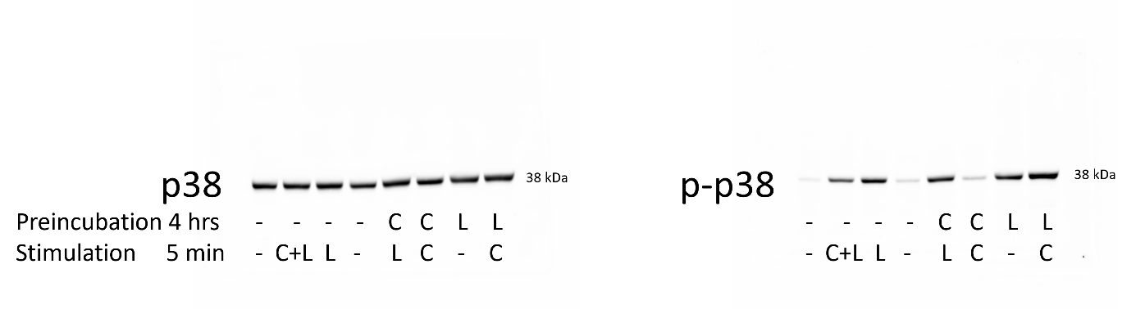
Figure S10 p-38 protein expression. Representative full-length Western Blot membrane from J774 cell line preincubated for 4 hours and stimulated with capsaicin (C) or LPS (L) for 5 minutes.

