Questionnaire ID no:
Circle your choice among the alternatives; write a correct response on blank space for those questions which needs specification.
Part one: Socio-demographic factors
Code | Questions | Response | Remark
SD1 | Sex | - Male  - Female
SD2 | How old are you? | …………in years
SD3 | Marital status | 1. Married 2. Single  3. Divorce 4. widowed  5. Separated 6. . Cohabitated
SD4 | Weight | …….. Kg
SD5 | Height | ………..m………cm
SD6 | What is your level of education? | - No education  - Primary school  - Secondary  - Collage and above
SD 7

Part two: Behavioral factors
BH1 | Do you smoke cigarettes at some time in your life? | - No  - Yes  If you say yes, go to BH2
BH2 | How many cigarettes a day do you smoke or smoked? | Number……………
BH3 | Do you drink alcohols at some time in your life? | - No  - Yes
BH4 | Did you perform any physical activity? | - No  - Yes
BH4.1 | If you say yes for question BH4 how many minute in per week? | ……………min

Part three: Questions related musculoskeletal disorders

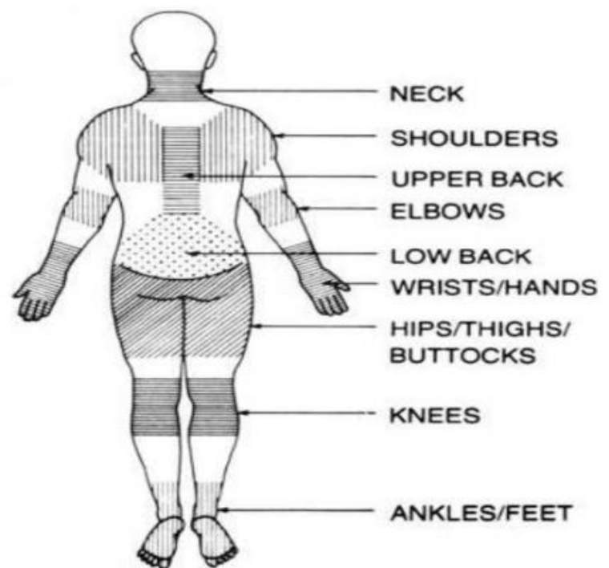

Figure 2: Body parts expected to develop MSDs [48]
MS1 | Have you at any time during  The last 12 months had pain or discomfort in any part of a  Body?  - No  - Yes | Have you had trouble at  Any time during the last  7 days?  - No  - Yes | Have you at any time during the last 12 Months been prevented from doing your normal work at home or at the workplace because of the pain?  1. No  2. Yes
MS2 | Neck  - No  - Yes | Neck  - No  - Yes | Neck  - No  - Yes
MS3 | Shoulder  - No  - Yes in right Shoulder  - Yes in left Shoulder  - Yes on both Shoulders | Shoulder  - No  - Yes | Shoulder  - No  - Yes
MS4 | Elbow  - No  - Yes in right elbow  - Yes in left elbow  - Yes on both elbow | Elbow  - No  - Yes | Elbow  - No  - Yes
MS5 | Wrist/hand  1.No  2.Yes in right wrist/hand  3.Yes in left wrist/hand  4.Yes on both wrist/hand | Wrist/hand  1.No  2.Yes | Wrist/hand  1.No  2.Yes
MS6 | Upper back  1.No  2.Yes | Upper back  1.No  2.Yes | Upper back  1.No  2.Yes
MS7 | Lower back  1.No  2.Yes | Lower back  1.No  2.Yes | Lower back  1.No  2.Yes
MS8 | Hip/thigh  1.No  2. Yes in right Hip/thigh  3. Yes in left Hip/thigh  4. Yes On both Hip/thigh | Hip/thigh  1.No  2.Yes | Hip/thigh  1.No  2.Yes
MS9 | Knee  1.No  2. Yes in right knee  3. Yes in left knee  4. Yes On both knees | Knee  1.No  2.Yes | Knee  1.No  2.Yes
MS10 | Ankle  1.No  2. Yes in right ankle  3. Yes in left ankle  4. Yes On both ankles | Ankle  1.No  2.Yes | Ankle  1.No  2.Yes

Part four: Clinical factors
Code
C1 | Stage of the disease? | 1. First  2. Second  3. Third  4. Forth  5. Fifth
C2 | Are you taking Hemodialysis? | 1. No  2. Yes  If you say NO, skip C3 and C4
C3 | Duration of Hemodialysis | ……………….Month/year
C4 | CRP | ≤ 5 mg/dL
 | CRP | > 5 mg/dL

Comorbidities related questions?
C1.Do you have or have had any of the following diseases?
Disease | NO | Yes
diabetes mellitus
Hypertension
Heart diseases
Hyperuricemia

Part five: HEALTH ASSESSMENT QUESTIONNAIRE (HAQ-DI)

Please place an “x” in the box which best describes your abilities OVER THE PAST WEEK:

DRESSING & GROOMING

Are you able to:
WITHOUT ANY DIFFICULTY
WITH SOME DIFFICULTY
WITH MUCH DIFFICULTY
UNABLE TO DO

Dress yourself, including shoelaces and buttons?

Shampoo your hair?

ARISING

Are you able to:

Stand up from a straight chair?

Get in and out of bed?

EATING

Are you able to

Cut your own meat?

Lift a full cup or glass to your mouth?

Open a new milk carton?

WALKING

Are you able to:

Walk outdoors on flat ground? Climb up five steps?

Please check any AIDS OR DEVICES that you usually use for any of the above activities:

Devices used for Dressing (button hook, zipper pull, etc.)
Built up or special utensils
Cane
Crutches
Wheelchair

Special or built up chair Walker

Please check any categories for which you usually need HELP FROM ANOTHER PERSON:

Dressing and grooming
Arising
Eating
Walking

Please place an “x” in the box which best describes your abilities OVER THE PAST WEEK:

HYGIENE

Are you able to:
WITHOUT ANY DIFFICULTY
WITH SOME DIFFICULTY
WITH MUCH DIFFICULTY
UNABLE TO DO

Wash and dry your body?

Take a tub bath?

Get on and off the toilet?

REACH

Are you able to:

Reach and get down a 5 pound object (such as a bag of sugar) from above your head?

Bend down to pick up clothing from the floor?

GRIP

Are you able to:

Open car doors?

Open previously opened jars?

Turn faucets on and off?

ACTIVITIES

Are you able to?

Run errands and shop?

Get in and out of a car?

Do chores such as vacuuming or yard work?

Please check any AIDS OR DEVICES that you usually use for any of the above activities:

Raised toilet seat
Bathtub bar
Long-handled appliances for reach

Bathtub seat
Long-handled appliances in bathroom
Jar opener (for jars previously opened)

Please check any categories for which you usually need HELP FROM ANOTHER PERSON:

Hygiene
Reach
Gripping and opening things
Errands and chores

Your ACTIVITIES: To what extent are you able to carry out your everyday physical activities such as walking, climbing stairs, carrying groceries, or moving a chair?

COMPLETELY MOSTLY MODERATELY A LITTLE NOT AT ALL

Your PAIN: How much pain have you had IN THE PAST WEEK?
On a scale of 0 to 100 (where zero represents “no pain” and 100 represents “severe pain”), please record the number below.

Your HEALTH: Please rate how well you are doing on a scale of 0 to 100 (0 represents “very well” and 100 represents “very poor” health), please record the number below.

