Supplementary figures and table for
Structural insights into the mechanism of phosphate recognition and transport by human XPR1
Wenhui Zhang^{1,#}, Yanke Chen^{1,#}, Zeyuan Guan^{1,#}, Yong Wang^{2,#}, Meng Tang¹, Zhangmeng Du¹, Jie Zhang¹, Meng Cheng¹, Jiaqi Zuo¹, Yan Liu¹, Qiang Wang¹, Yanjun Liu¹, Delin Zhang¹, Ping Yin¹, Ling Ma¹, Zhu Liu^{1*}
¹National Key Laboratory of Crop Genetic Improvement, Hubei Hongshan Laboratory, Huazhong Agricultural University, Wuhan 430070, China.
²College of Life Sciences, Zhejiang University, Hangzhou, 310027, China.
#These authors contributed equally to this work.
*Corresponding author: liuzhu@mail.hzau.edu.cn (Z. L.).
This file includes:
Supplementary Figs. 1-11
Supplementary Tables 1,2

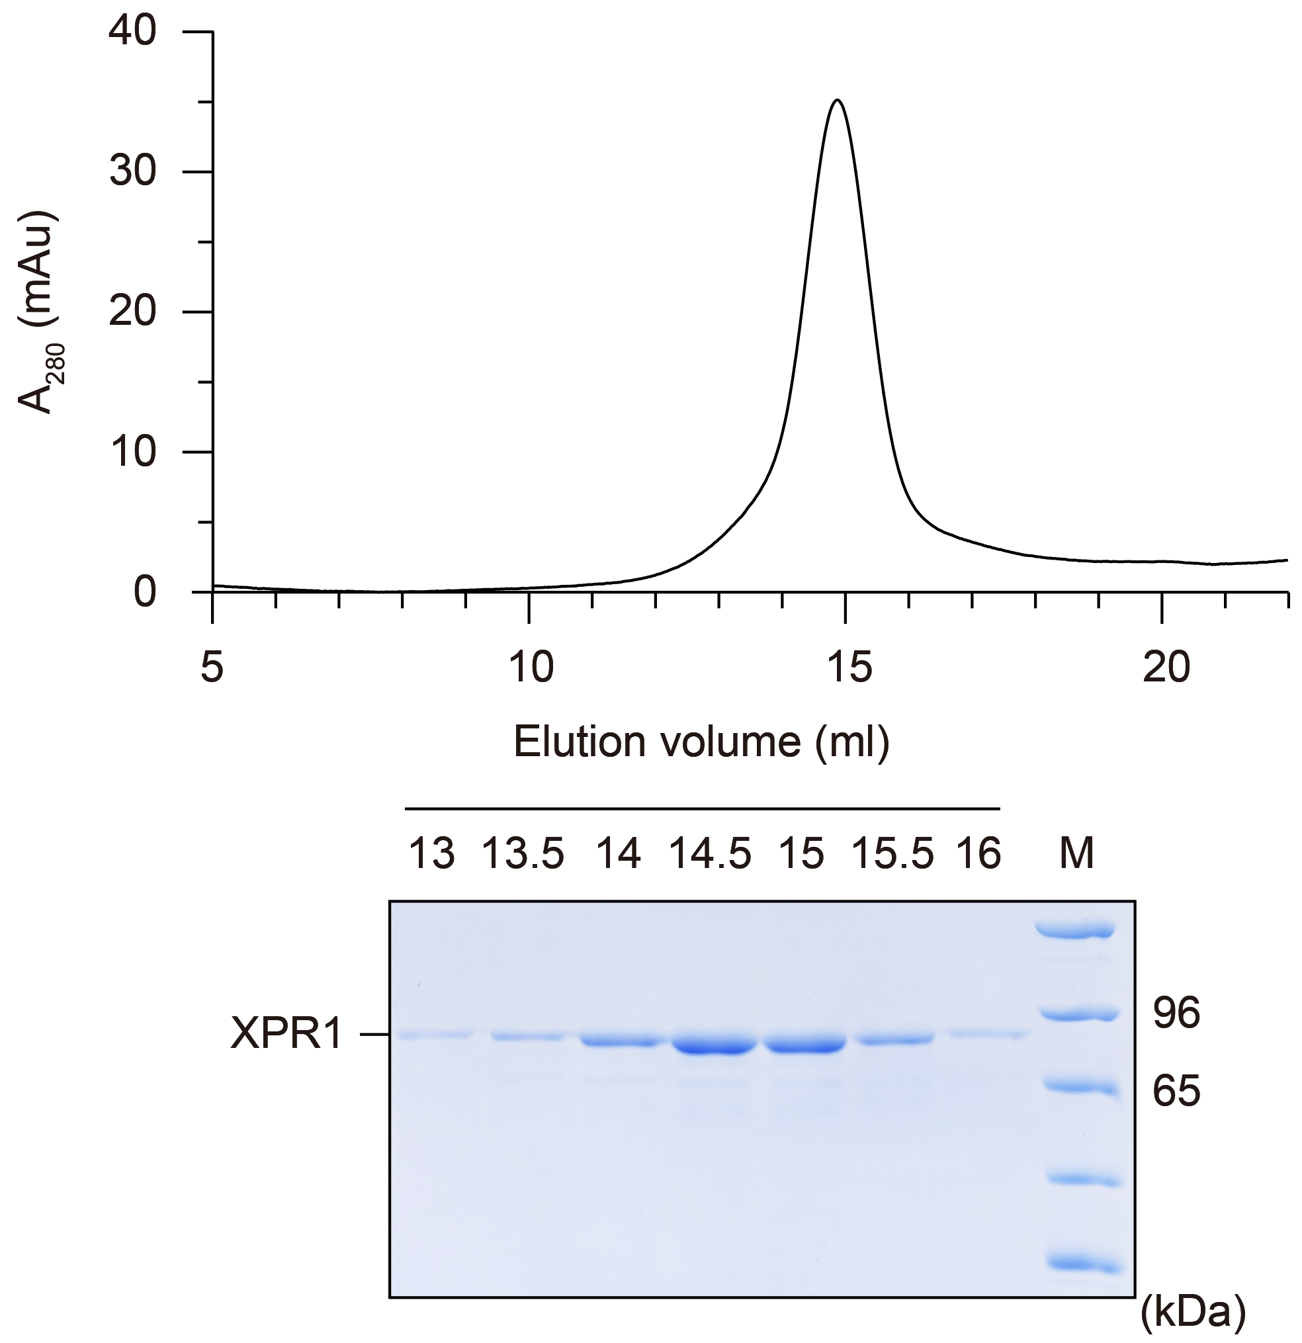
Supplementary Fig. 1. XPR1 purification for cryo-EM analysis. Representative size-exclusion chromatography (SEC) purification of XPR1 in the presence of InsP₆. Fractions were resolved by 7% SDS-PAGE and the peak fractions were collected and concentrated to prepare cryo-EM grids.

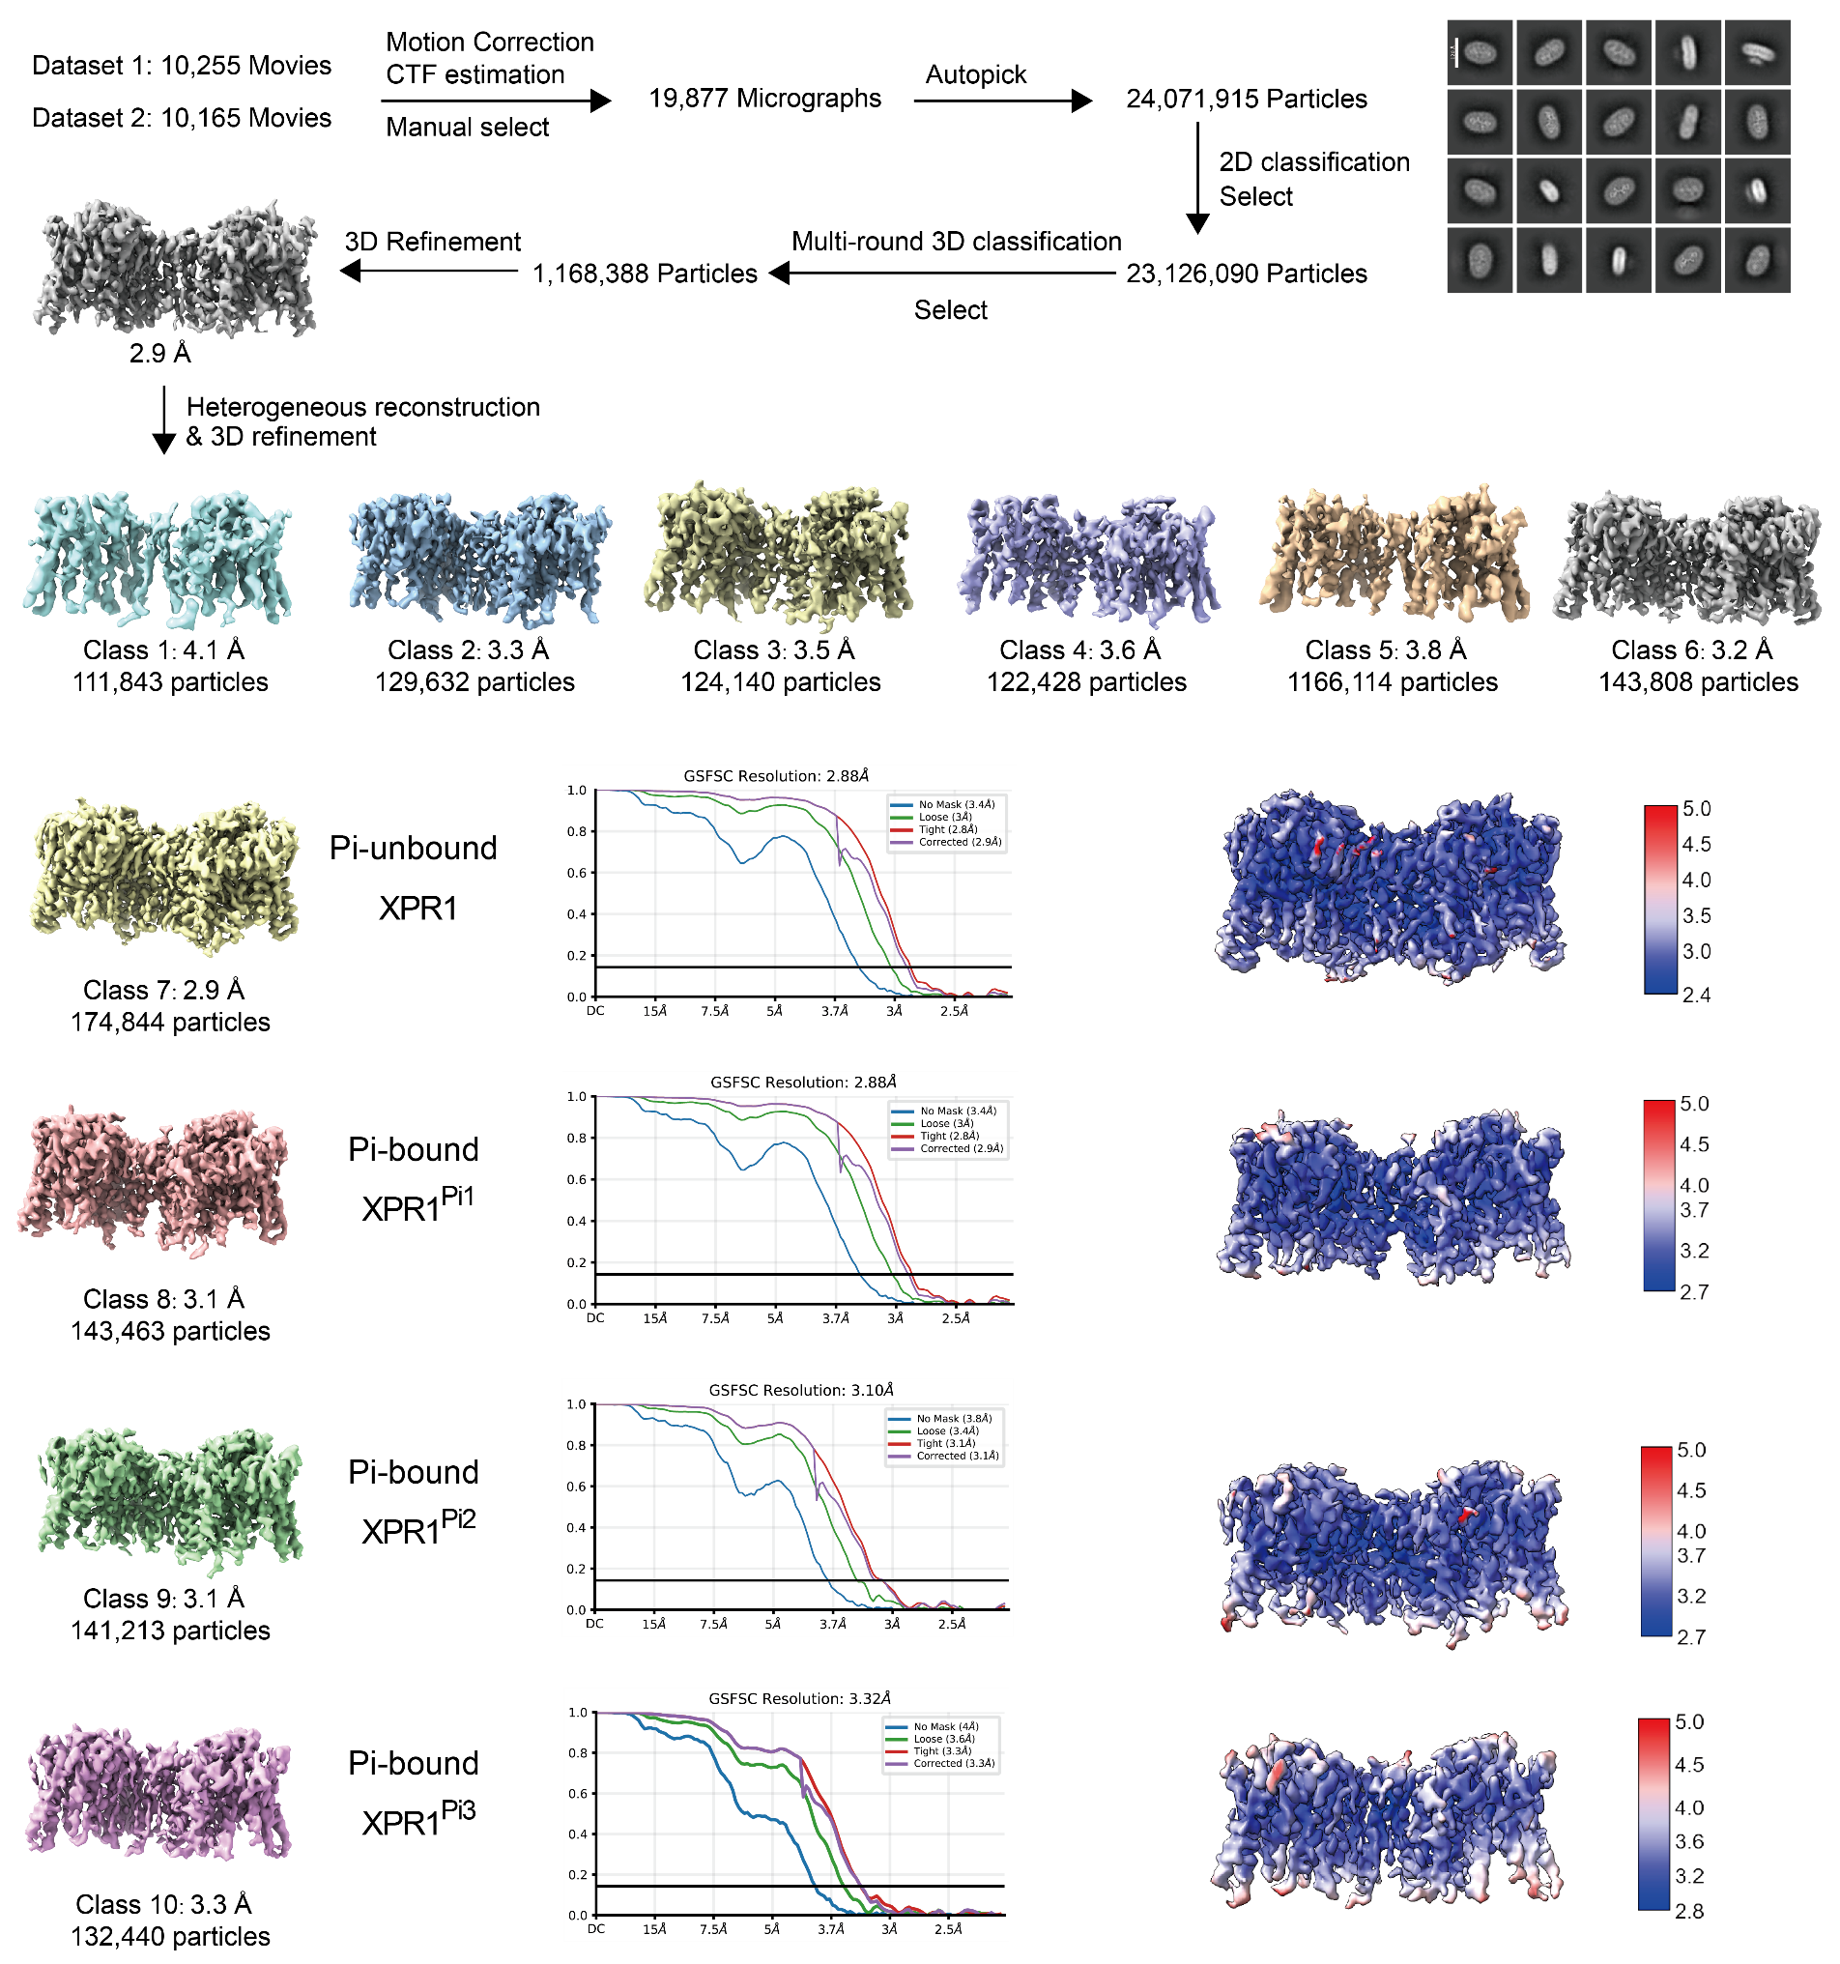

Supplementary Fig. 2. Cryo-EM data processing workflow of XPR1. The final reconstructed maps (left panel), gold standard Fourier shell correlation (FSC) curves (middle panel) and local resolution (right panel) are represented from the 3D refinement for the final reconstructions.
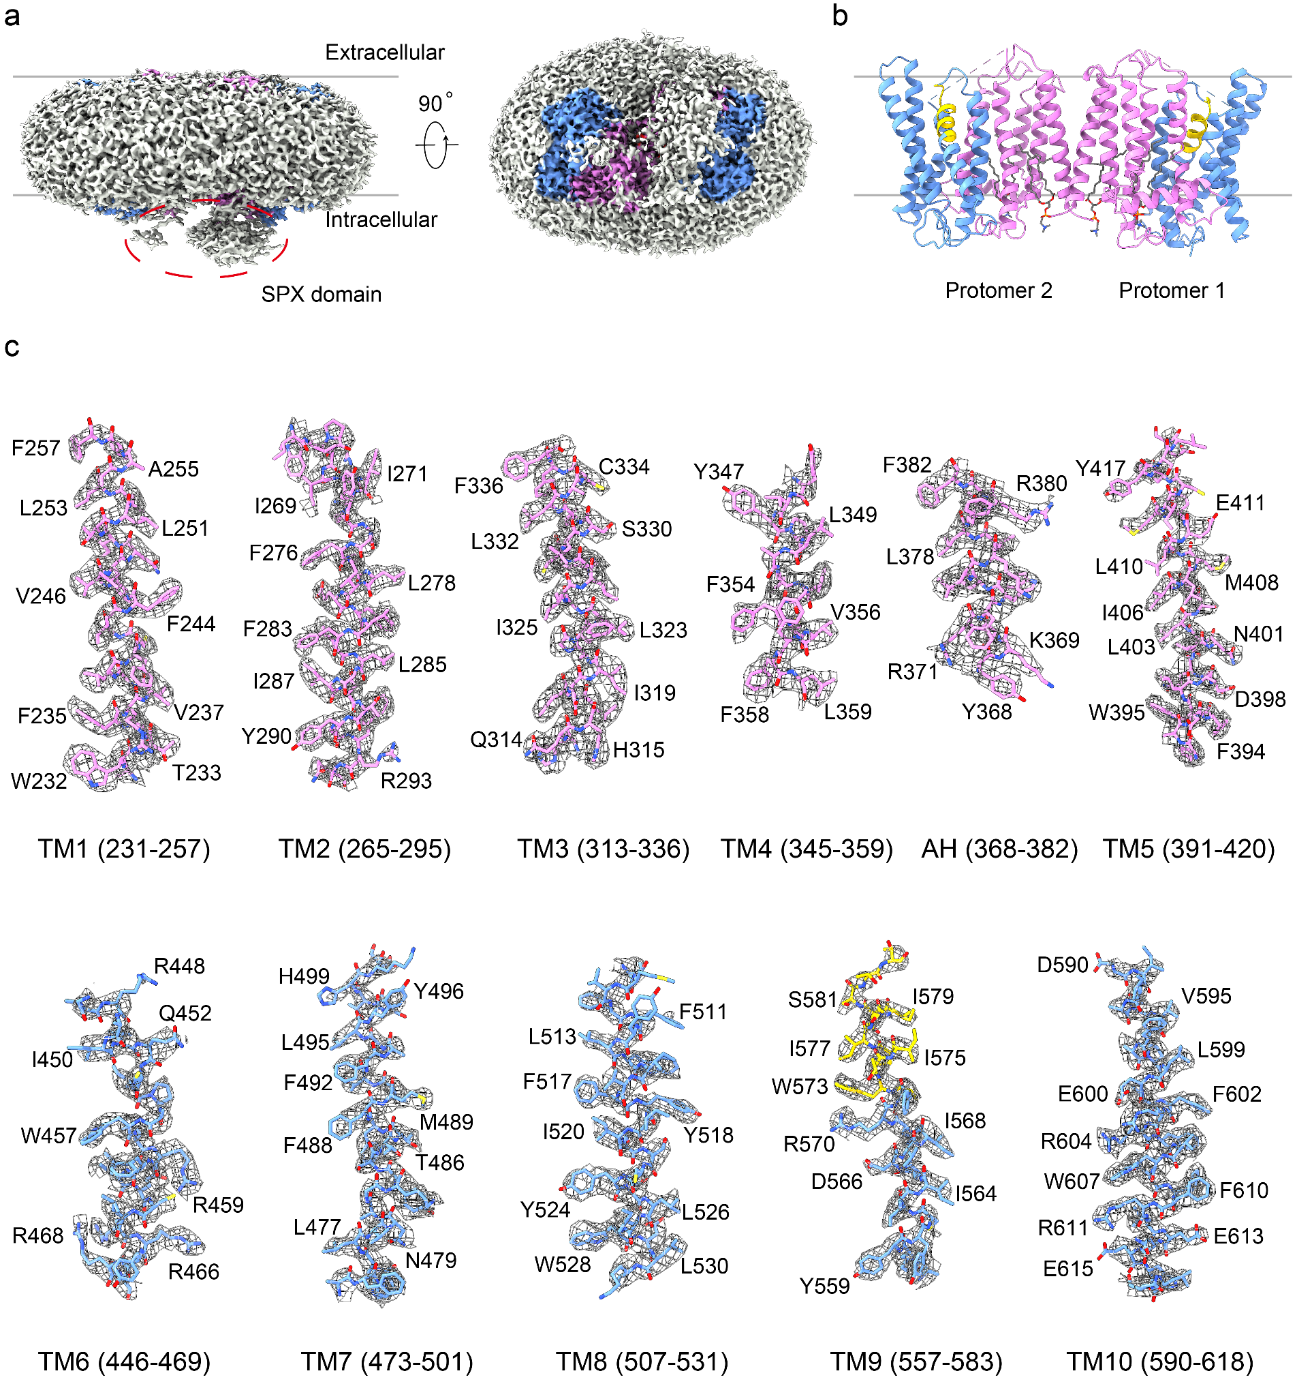
Supplementary Fig. 3. EM densities and representative elements of XPR1 (Pi-unbound). a EM density map with low display threshold reveals the signals of the cytoplasmic SPX domain and detergent. The transmembrane domain of XPR1 is colored in the same scheme as Fig. 1a in the main text. XPR1 presents as a dimer in the EM map. b Cartoon representation of the resolved dimeric transmembrane domain of XPR1. The two protomers adopt similar structure with an overall RMSD of 0.26 Å . Protomer 1 (chain A) is used for further analysis and discussion in this manuscript. Lipid-like densities have been modeled using phosphatidylcholine molecules and are shown as sticks. c EM density maps for the indicated transmembrane α-helices. Map contour level = 1.0 in ChimeraX.

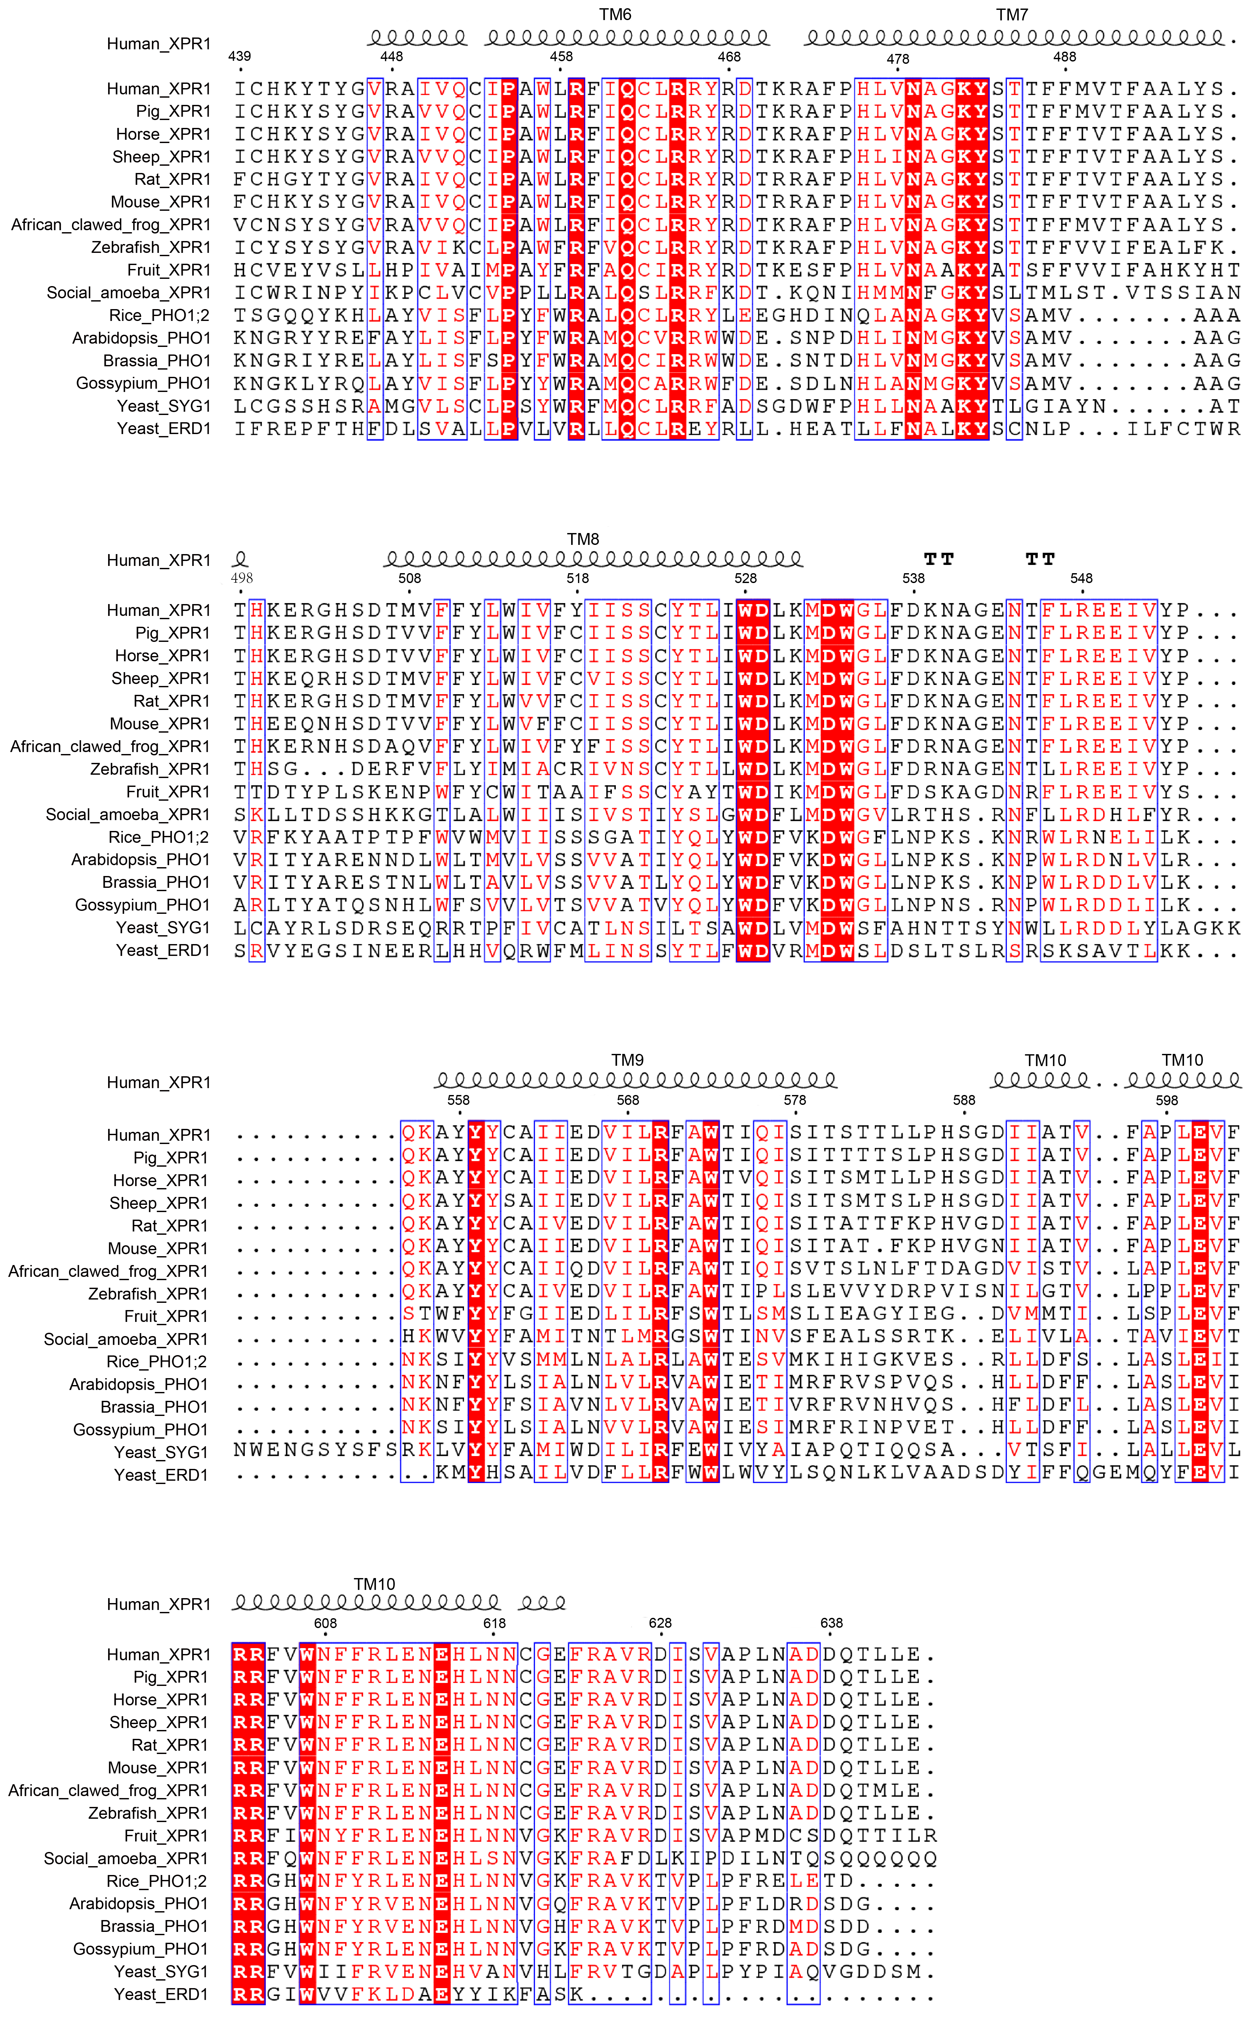
Supplementary Fig. 4. Sequence alignment of EXS domain-containing proteins. The sequence of EXS domain from human XPR1 is aligned with other orthologues. Structure-based alignment was performed by ESPript (3.0). The sequence identity is indicated by white letters against a red background, and the sequence of a similarity over 90% is indicated by red letters. The secondary elements of EXS domain from human XPR1 are labeled at the top of the alignment.

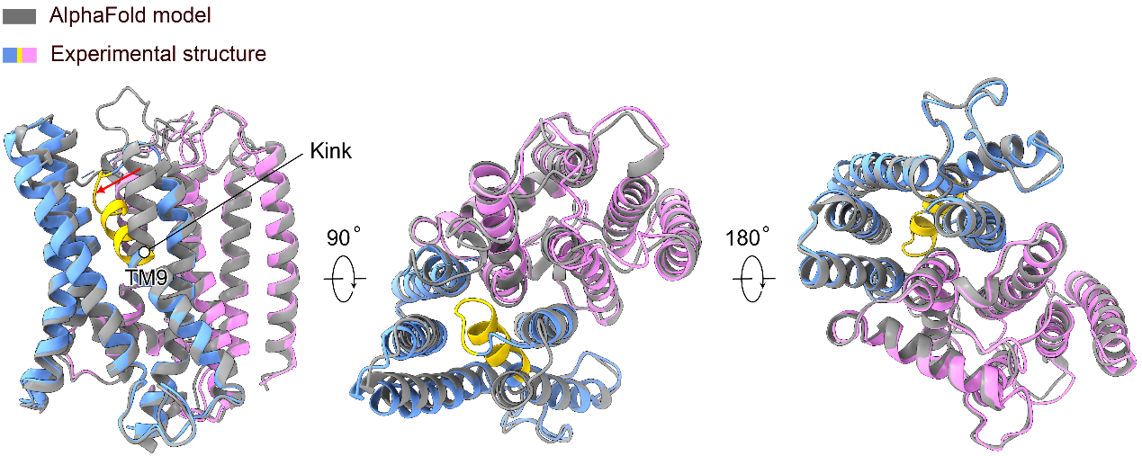
Supplementary Fig. 5. Comparison between the experimental structure of XPR1 transmembrane domain and the predicted model by AlphaFold2. The experimental structure is colored in the same scheme as Fig. 1a in the main text. The AlphaFold2 model (AF-Q9UBH6-F1) is superposed and colored in gray. A red arrow indicates the bending of the extracellular half of TM9 observed in the experimental structure.

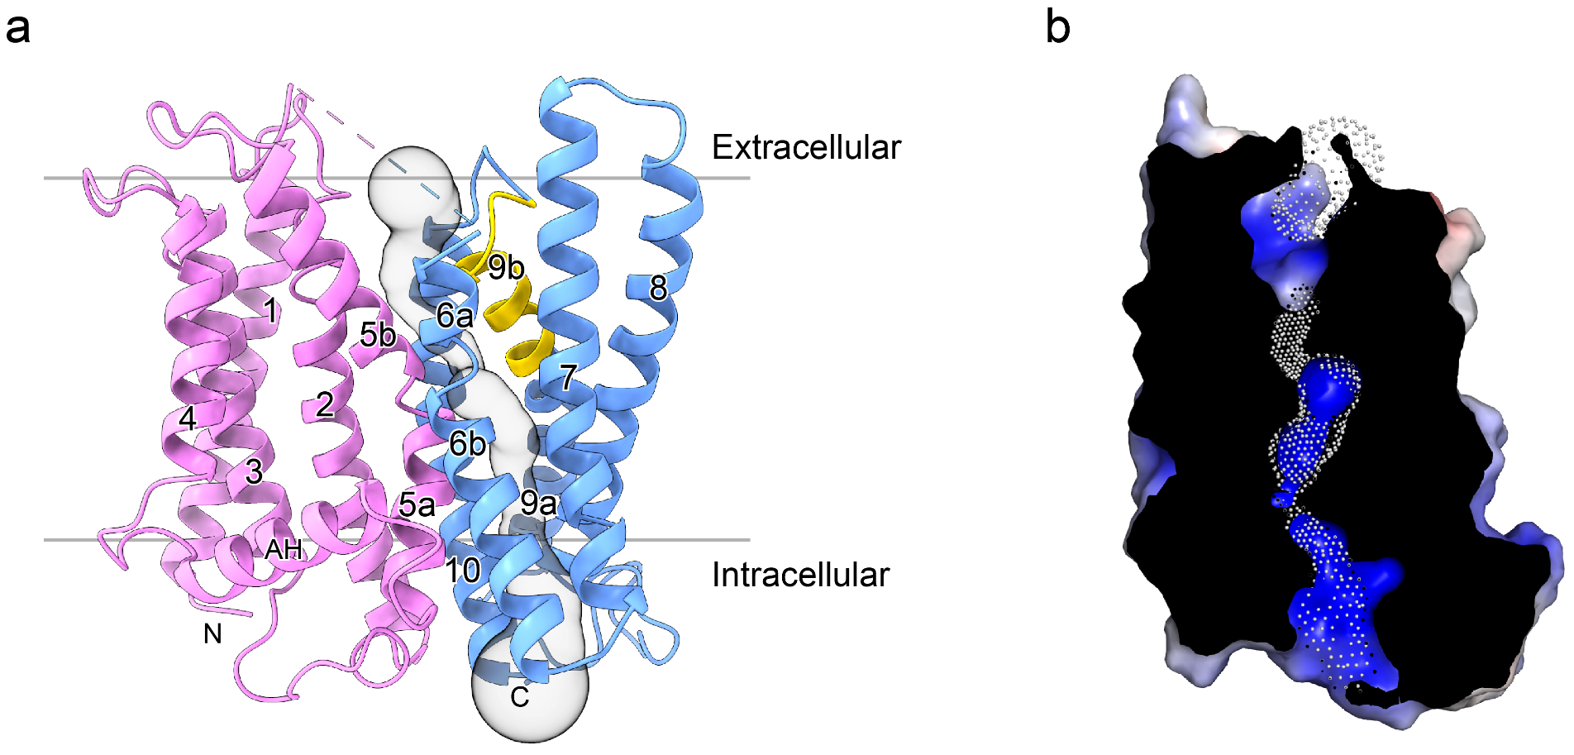
Supplementary Fig. 6. Transmembrane channel. a Solvent-accessible pathway (gray surface representation) within the XPR1 transmembrane domain. The structure is represented in the same scheme as Fig. 1a in the main text. b A cut-open electrostatic surface representation of the channel. It is colored in terms of electrostatic potential, and displayed in a scale from red (−5 kT/e) to blue (+5 kT/e). For clarity, only the surface of channel-forming transmembrane α-helices are represented. The dots indicate the solvent-accessible pathway.

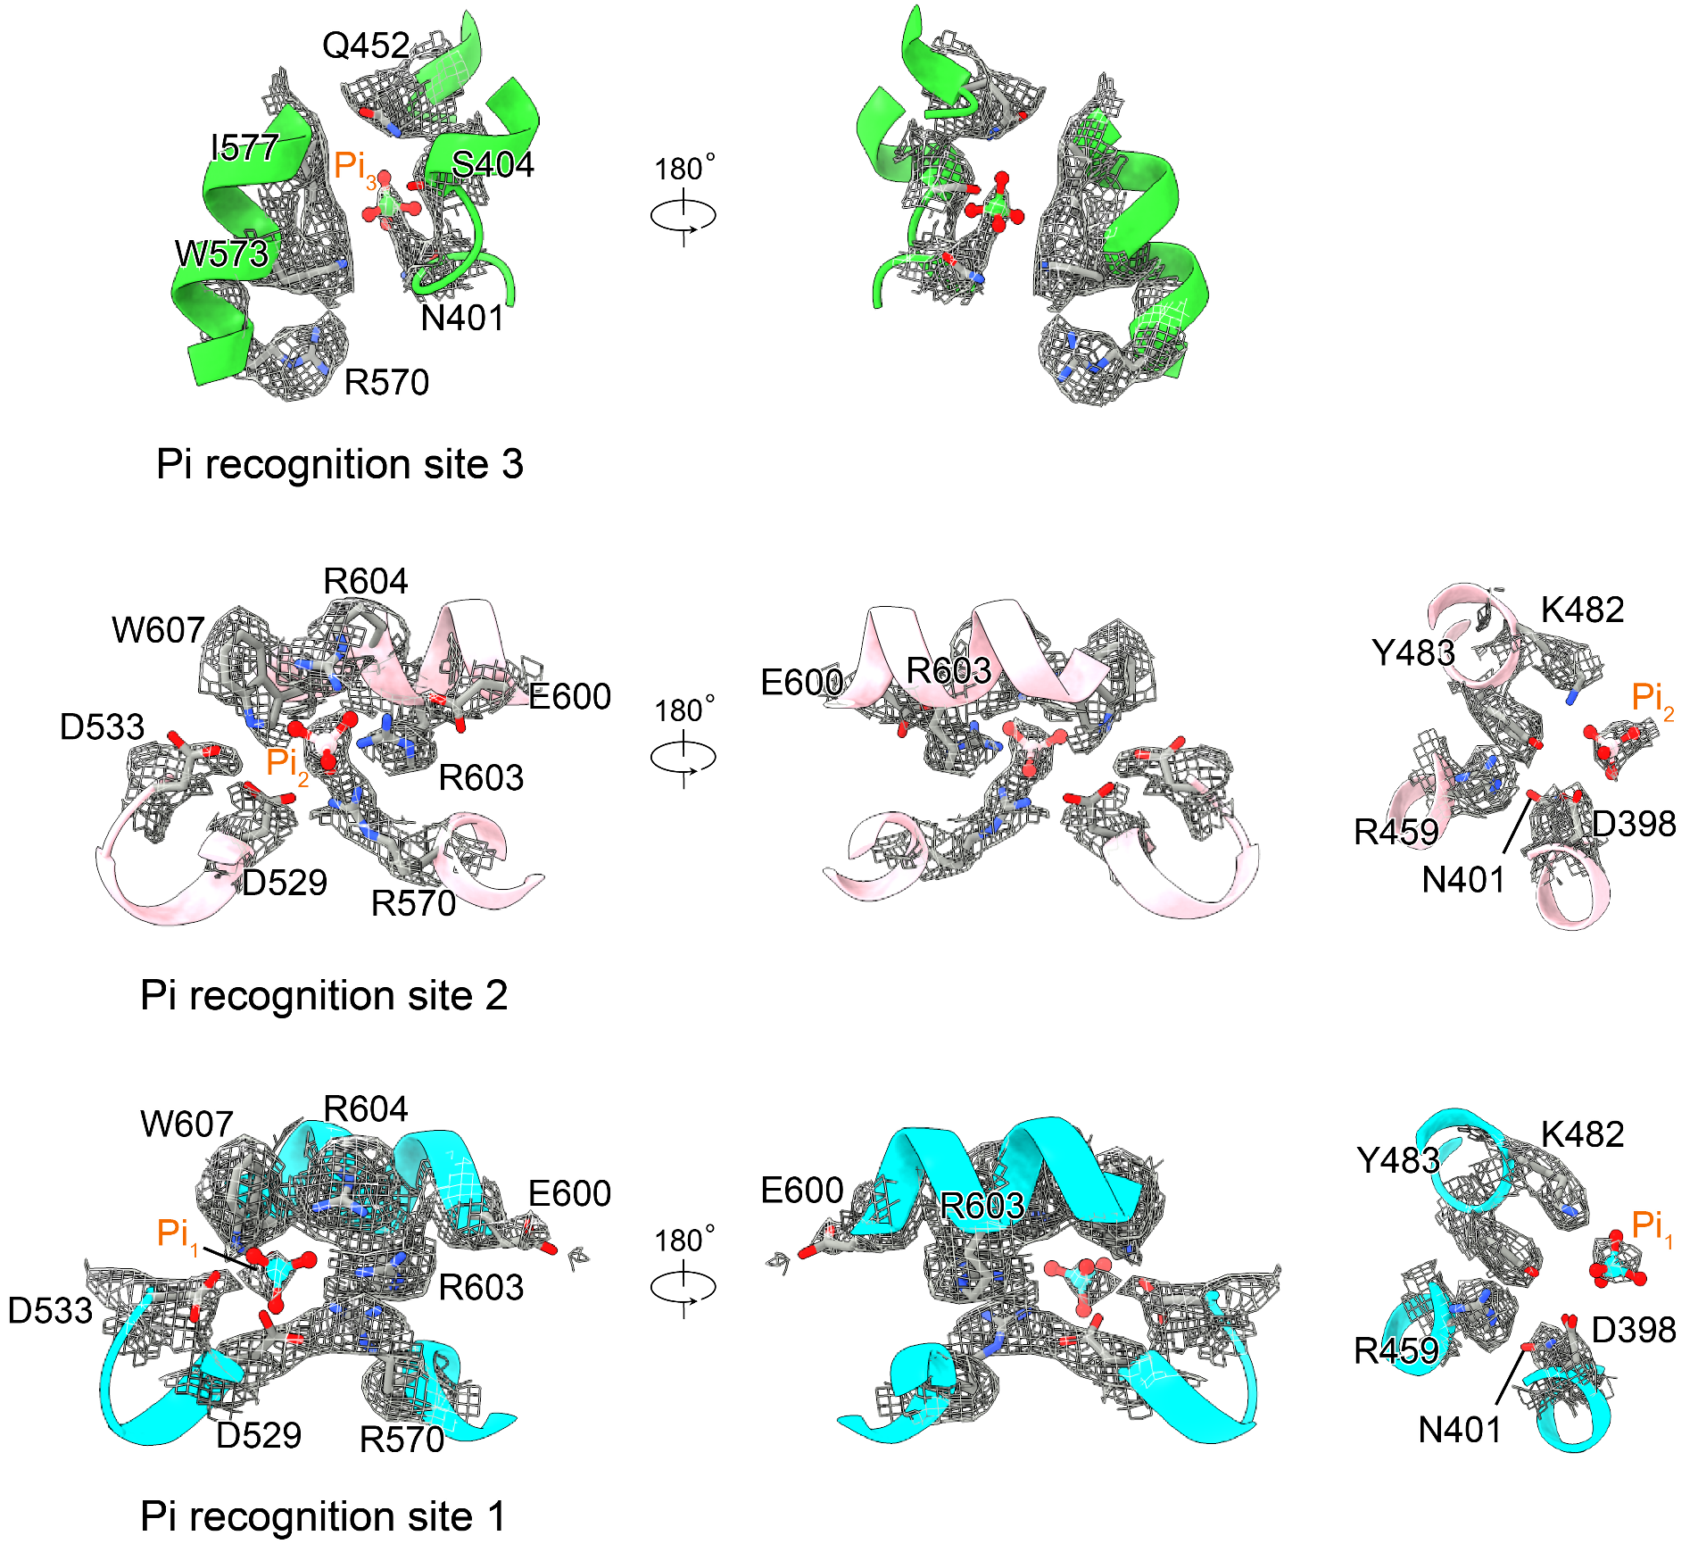
Supplementary Fig. 7. EM density maps of the Pi recognition sites 1-3. This figure corresponds to Fig. 2d-f in the main text. The densities derived from XPR1^{Pi1}, XPR1^{Pi2} and XP1^{Pi3} structures are represented with contour levels of 0.841, 0.655 and 0.586, respectively, in ChimeraX.

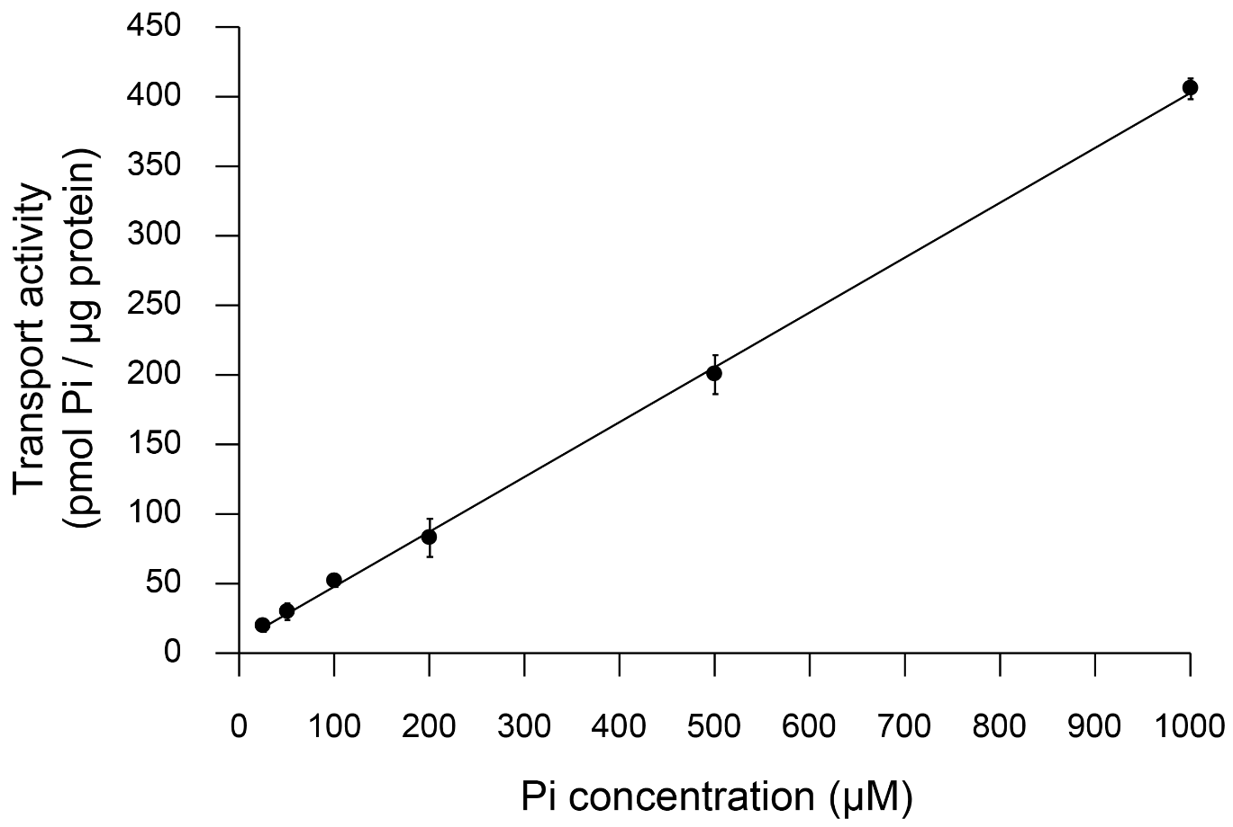
Supplementary Fig. 8. Proteoliposome-based Pi transport assay of XPR1. The transport reactions were allowed for 6 minutes with external Pi concentrations of 25, 50, 100, 200, 500 and 1000 μM, respectively. The data presented are the average of three independent assays, each with technical triplicates. The error bars indicates the SD.

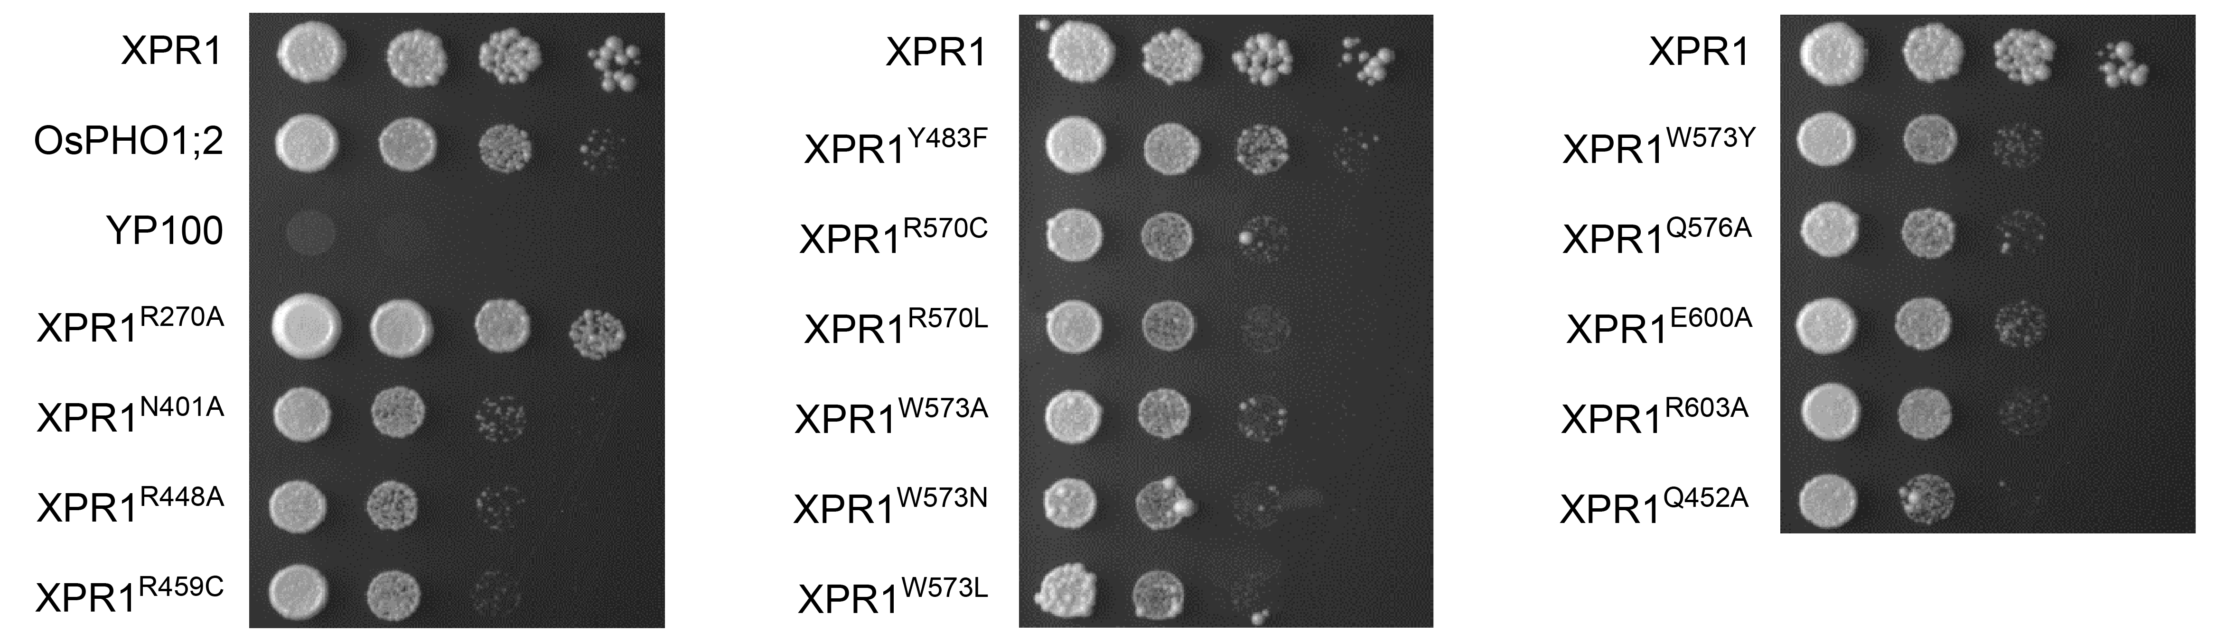
Supplementary Fig. 9. Complementation assays of the yeast mutant YP100. All yeast cells were grown on YNB medium for 7 days, and equal volumes of 5-fold serial dilutions were spotted onto the medium. The experiments were repeated independently at least three times with similar results.

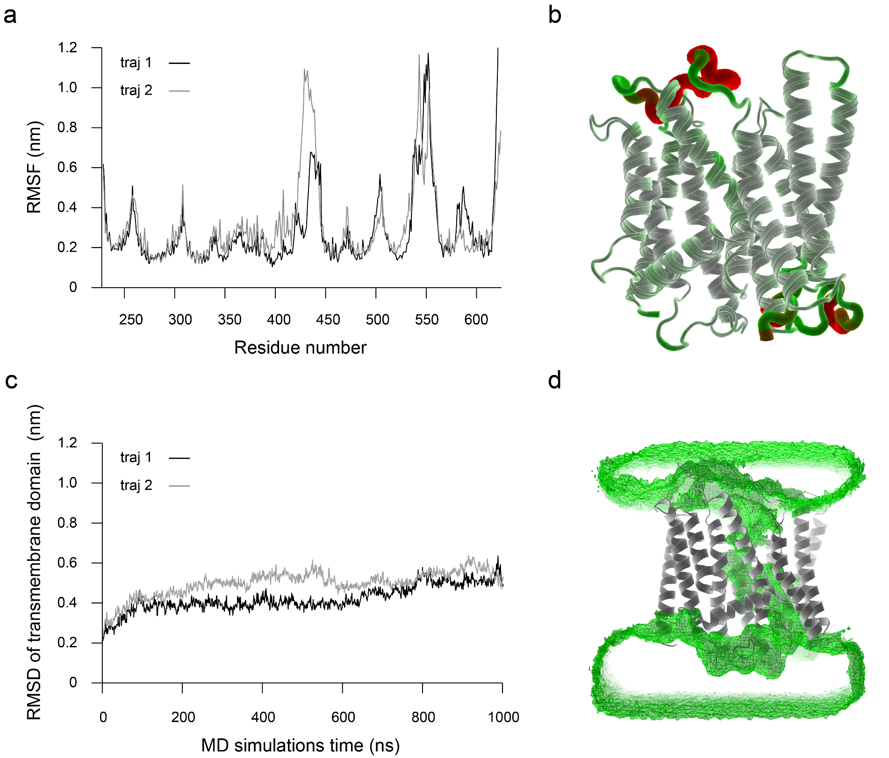
Supplementary Fig. 10. MD simulations of the cryo-EM structure of Pi-unbound XPR1. a RMS fluctuations of XPR1 residues during the simulations, calculated from two independent 1000-ns MD trajectories. b RMSF values per residue mapped onto the XPR1 structure from the final frame of the MD simulations. c RMSD trajectories of the heavy atoms in the transmembrane helices of XPR1 relative to the energy-minimized cryo-EM structure of Pi-unbound XPR1. d Consistent hydration observed in the transmembrane pore of XPR1 during one of the MD simulations, with average water density shown as green meshes.
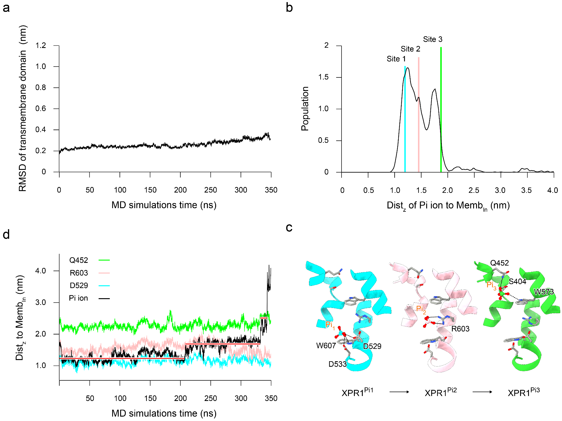

Supplementary Fig. 11. MD simulations and analysis of the cryo-EM structure of Pi-bound XPR1^{Pi1}. a RMSD trajectories of the heavy atoms in the transmembrane helices of XPR1 relative to the energy-minimized cryo-EM structure of Pi-bound XPR1^{Pi1}. b Distribution of the distance (Dist_{z}) between the Pi ion and the center of mass of the phosphate head groups of lipids in the inner leaflet along the membrane's normal direction (Z-axis). The positions of the three Pi recognition sites observed in the cryo-EM structures of XPR1^{Pi1}, XPR1^{Pi2} and XPR1^{Pi3} are marked with cyan, pink, and green lines, respectively. c Side view of the channel highlighting specific residues involved in Pi coordination at the recognition sites 1, 2, and 3. This figure relates to Fig. 2d-f in the main text and focuses on site-specific interactions for clarity. d Correlation between the positions of the Pi ion and representative site-specific residues during the simulations. The red lines indicate the stepwise interactions with D529, R603, and Q452.

Supplementary Table 1.
Cryo-EM data collection, refinement and validation statistics
 | Pi-unbound form of XPR1  (EMD-61138)  (PDB 9J4X) | Pi-bound form of XPR1 (XPR1^{Pi1})  (EMD-61139)  (PDB 9J51) | Pi-bound form of XPR1 (XPR1^{Pi2})  (EMD-1140)  (PDB 9J52) | Pi-bound form of XPR1 (XPR1^{Pi3})  (EMD-1141)  (PDB 9J53)
Data collection and processing
Magnification | 81,000
Voltage (kV) | 300
Electron exposure (e–/Å²) | 50
Defocus range (μm) | -1.2~-2.2
Pixel size (Å) | 1.07
Micrographs collected (no.) | 20,420
Micrographs used (no.) | 19,877
Total extracted particles (no.) | 24,071,915
Symmetry imposed | C1 | C1 | C1 | C1
Refined particle images (no.) | 174,844 | 143,463 | 141,213 | 132,440
Map resolution (Å)  FSC threshold | 2.9  0.143 | 3.1  0.143 | 3.1  0.143 | 3.3  0.143
Map resolution range (Å) | 2.4-5.0 | 2.7-5.0 | 2.7-5.0 | 2.8-5.0
Refinement
Initial model used | Alphafold2 | Pi-unbound form of XPR1 | Pi-unbound form of XPR1 | Pi-unbound form of XPR1
Model resolution (Å)  FSC threshold | 2.83/2.97  0.143/0.5 | 3.08/3.4  0.143/0.5 | 3.07/3.42  0.143/0.5 | 3.27/3.63  0.143/0.5
Map sharpening B factor (Å²) | 110.3 | 121.8 | 124.9 | 134.2
Model composition  Non-hydrogen atoms  Protein residues  Ligands | 6,590  764  4 | 6,583  762  5 | 6,595  764  5 | 6,600  764  6
B factors (Å²)  Protein  Ligand | 60.91  59.76 | 72.31  63.87 | 82.56  68.69 | 101.42  88.01
R.m.s. deviations  Bond lengths (Å)  Bond angles (°) | 0.003  0.516 | 0.003  0.545 | 0.004  0.552 | 0.003  0.574
Validation  MolProbity score  Clashscore  Poor rotamers (%) | 1.85  7.96  1.33 | 2.19  9.85  2.66 | 2.24  10.21  2.36 | 2.54  11.26  4.13
Ramachandran plot  Favored (%)  Allowed (%)  Disallowed (%) | 95.37  4.63  0 | 94.96  5.04  0 | 93.39  6.48  0.13 | 91.40  8.60  0

Supplementary Table 2.
Plausible interactions between the Pi ions and protein
Atom of phosphate |  | Atom of protein | Distance (Å)
Pi1 | O1 | K482 NZ2 | 2.6
Pi1 | O1 | D529 OD1 | 2.9
Pi1 | O2 | D533 OD2 | 2.8
Pi1 | O2 | R570 NH2 | 3.7
Pi1 | O2 | R604 NH1 | 3.1
Pi1 | O2 | W607 NE1 | 2.9
Pi1 | O3 | D398 OD1 | 2.8
Pi1 | O3 | Y483 OH | 3.6
Pi1 | O3 | R604 NH2 | 3.8
Pi1 | O4 | D398 OD2 | 2.8
Pi1 | O4 | K482 NZ | 2.6
Pi2 | O1 | K482 NZ | 2.3
Pi2 | O2 | R570 NH1 | 2.2
Pi2 | O2 | R603 NH1 | 3.9
Pi2 | O3 | R603 NH2 | 3.5
Pi2 | O3 | N401 ND2 | 3.9
Pi2 | O3 | R604 NH2 | 2.3
Pi2 | O4 | D398 OD1 | 3.4
Pi2 | O4 | D398 OD2 | 4.0
Pi2 | O4 | Y483 OH | 3.8
Pi2 | O4 | R604 NH1 | 3.9
Pi2 | O1 | N401 OD1 | 3.2
Pi2 | O1 | S404 OG | 3.9
Pi3 | O2 | Q452 NE2 | 3.9
Pi3 | O3 | N401 ND2 | 3.0
Pi3 | O4 | W573 NE1 | 3.6

