Establishment of in vitro pollen germination system in C4 model plant Foxtail Millet
Min Su¹, Dan Wang¹, Zidong Li¹, Jianhong Hao¹, Shuqi Dong^{1,3}, Xiangyang Yuan^{1,3}, Xiaorui Li^{1,3}, Lulu Gao¹, Guanghui Yang^{1*}, Xiaoqian Chu^{1*}, Jiagang Wang^{1,2*}
1College of Agriculture, Shanxi Agricultural University, Taigu, 030801, China.
2Hou Ji Laboratory in Shanxi Province, Shanxi Agricultural University, Taigu, 030801, China
3State Key Laboratory of Sustainable Dryland Agriculture (in Preparation), Shanxi Agricultural University, Taigu, 030801, China
*Address correspondence to wjg@sxau.edu.cn, chuxiaoqian@sxau.edu.cn or yanggh1991@163.com.
The author responsible for distribution of materials integral to the findings presented in this article in accordance with the policy described in the Instructions for Authors is: Jia-Gang Wang (wjg@sxau.edu.cn).
Supporting Informations
Supplementary Table 1 Formula of foxtail millet pollen germination medium in vitro
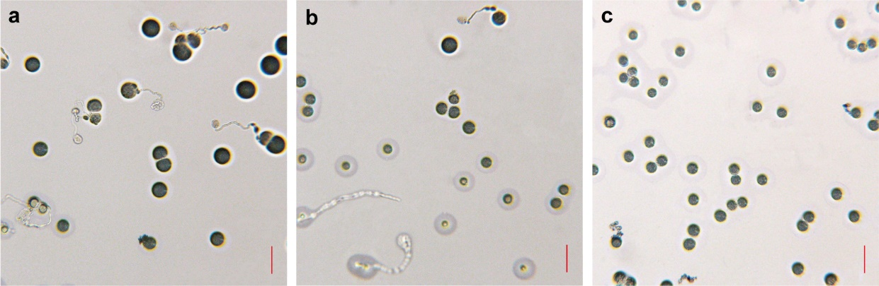
Supplementary Figure 1 Germination diagram of stale pollen in foxtail millet spikelet
Supplementary Figure 2 Diagram of the abnormal growth of the pollen tube
(a-d) Pollen tubes with normal growth, apical enlargement, growth rupture and ungerminated. Scale bar, 10 μm.
Supplementary Movie 1 Growth of pollen tube of foxtail millet in 2 min

