Title: Genome-wide analysis of the harbour porpoise (Phocoena phocoena) indicates isolation-by-distance across the North Atlantic and local adaptation in adjacent waters

Authors: Marijke Autenrieth¹, Katja Havenstein¹, Binia De Cahsan Westbury^{1,2}, Julia Canitz^{1,3}, Harald Benke⁴, Anna Roos⁵, Christophe Pampoulie⁶, Guðjón Már Sigurðsson⁶, Ursula Siebert⁷, Morten Tange Olsen⁸, Vincent Biard^{8,9,10}, Mads Peter Heide-Jørgensen⁹, A. Amaha Özturk¹¹, Bayram Özturk¹¹, John W. Lawson¹², Ralph Tiedemann¹

Supplemental Figures
Supplemental Figure 1: Venn diagram showing the overlap of called SNPs, identified by different pipelines. Purple: called by bcftools, green: called by stacks with gstacks and populations tools, orange: angsd called with model ‘samtools’, yellow: angsd called with model ‘gatk’.

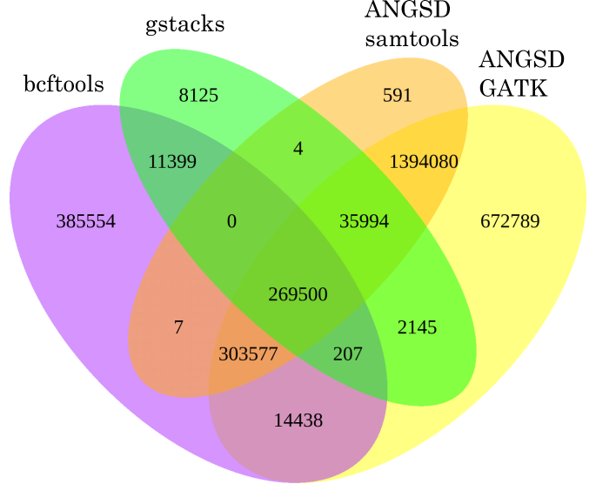

Supplemental Figure 2: Number of SNPs per scaffold, relative to the size of a scaffold (based on setA). A linear regression line is included. mbp=million base pairs.

Supplemental Figure 3: SNP-wise F_{ST} distributed along the 34 largest scaffolds. Each panel represents one scaffold, the x-axis is relaxed to the respective length of the scaffold, the y-axis is fixed for all panels and gives the F_{ST} calculated by vcftools.

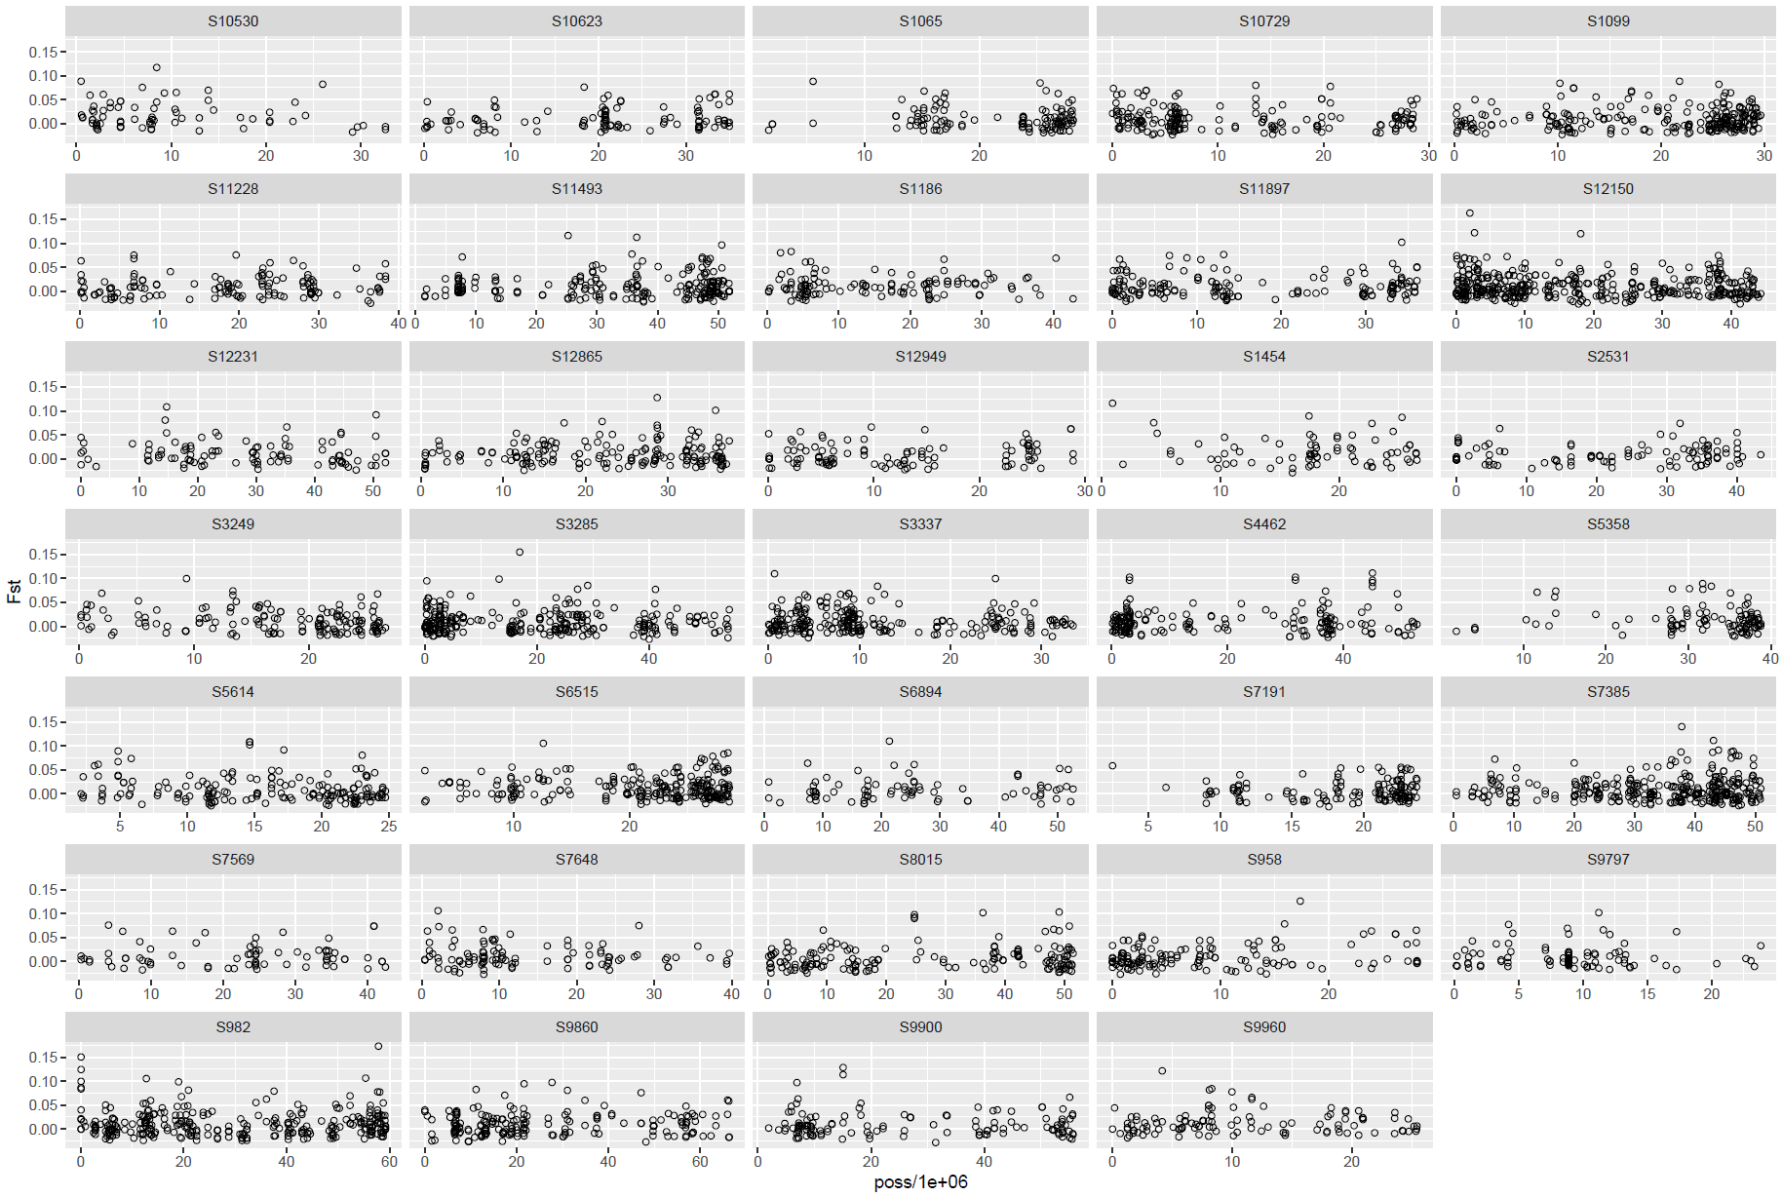
Supplemental Figure 4: Admixture plot based on SNP setA 100% (150 samples) including all eight sampling areas. Each bar represents one individual, while the colour indicates genetic identity to the respective cluster. K3, k4 and k5 are shown. For k3 the clusters are coloured in black, blue and yellow. K4 adds skyblue and k5 adds orange. Sampling areas are Black Sea (BS), Canada (CA), Iceland (ICE), North Sea (NOS), Skagerrak (SKA), Kattegat (KAT), Belt Sea (BES), Inner Baltic Sea (IBS).

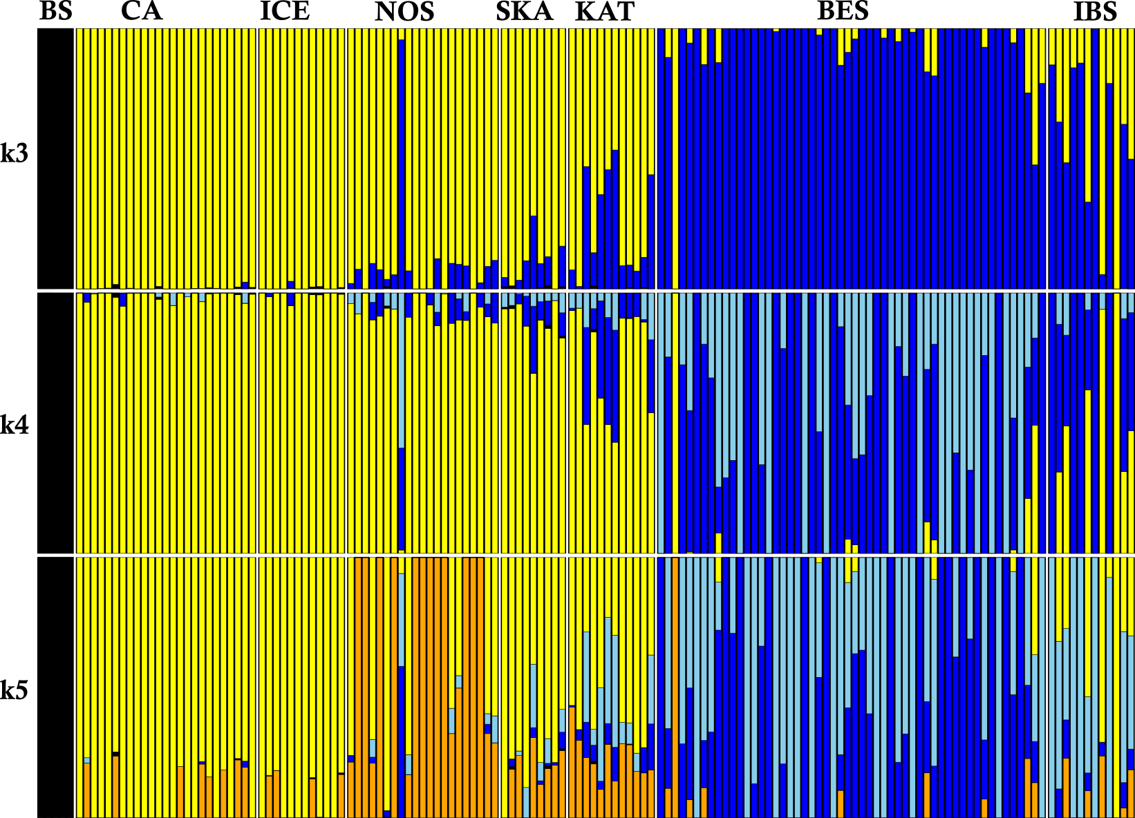

Supplemental Figure 5: Principal Component Analyses: PC1 vs. PC2 of SNP setB (100%) for seven sampling areas, excluding the five Black Sea samples as well as two potential migrants indicated by admixture (Figure 5): sample Pool3-189 and sample Pool2-145, (CA= Canada, ICE= Iceland, NOS= Nord Sea, SKA= Skagerrak, KAT= Kattegat, BES= Belt Sea, IBS= Inner Baltic Sea).
