Supporting Information
For
Chemical Constituents from the Medicinal Herb-derived Fungus Chaetomium globosum Km1226

Chia-Hao Chang¹, George Hsiao^{2,3}, Shih-Wei Wang^{4,5,6}, Juei-Yu Yen^{5,7}, Shu-Jung Huang¹, Wei-Chiung Chi^{7*}, Tzong-Huei Lee1*

¹Institute of Fisheries Science, College of Life Science, National Taiwan University, Taipei 10617, Taiwan.
²Department of Pharmacology, School of Medicine, College of Medicine, Taipei Medical University, Taipei 11031, Taiwan.
³Graduate Institute of Medical Sciences, College of Medicine, Taipei Medical University, Taipei 11031, Taiwan.
⁴Department of Medicine, MacKay Medical College, New Taipei City 25245, Taiwan. ⁵Institute of Biomedical Sciences, Mackay Medical College, New Taipei City 25245, Taiwan.
⁶School of Pharmacy, College of Pharmacy, Kaohsiung 807378, Taiwan.
⁷Department of Chinese Medicine, MacKay Memorial Hospital, Taipei 10491, Taiwan.
⁸Department of Food Science, National Quemoy University, Kinmen 89250, Taiwan.

Corresponding Author
*Phone: +886-82-313-576. Email: joan@nqu.edu.tw.
*Phone: +886-2-3366-1828. Email: thlee1@ntu.edu.tw.

Table of Contents

Fig. S1 | ¹H NMR (600 MHz, methanol-d₄) spectrum of compound 1…. | 3
Fig. S2 | ¹³C NMR (150 MHz, methanol-d₄) spectrum of compound 1… | 4
Fig. S3 | HSQC spectrum of compound 1………………………………. | 5
Fig. S4 | COSY spectrum of compound 1……..………………………... | 6
Fig. S5 | HMBC spectrum of compound 1……………………………... | 7
Fig. S6 | NOESY spectrum of compound 1…..………………….……... | 8
Fig. S7 | IR (ZnSe) spectrum of compound 1….………………………... | 9
Fig. S8 | HRESIMS spectrum of compound 1…….…………….……… | 9
Fig. S9 | UV spectrum of compound 1 in MeOH………..……………… | 10
Fig. S10 | ECD spectra of compounds 1and 4……………………………. | 10
Fig. S11 | ¹H NMR (600 MHz, methanol-d₄) spectrum of compound 2…. | 11
Fig. S12 | ¹³C NMR (150 MHz, methanol-d₄) spectrum of compound 2… | 12
Fig. S13 | HSQC spectrum of compound 2………………………………. | 13
Fig. S14 | COSY spectrum of compound 2…………………..…………... | 14
Fig. S15 | HMBC spectrum of compound 2……………..………………. | 15
Fig. S16 | NOESY spectrum of compound 2………………..…………... | 16
Fig. S17 | IR (ZnSe) spectrum of compound 2……………………….…... | 17
Fig. S18 | HRESIMS spectrum of compound 2…………………..……… | 17
Fig. S19 | UV spectrum of compound 2 in MeOH………..……………… | 18
Fig. S20 | ¹H NMR (600 MHz, methanol-d₄) spectrum of compound 3…. | 19
Fig. S21 | ¹³C NMR (150 MHz, methanol-d₄) spectrum of compound 3… | 20
Fig. S22 | HSQC spectrum of compound 3………………………………. | 21
Fig. S23 | COSY spectrum of compound 3……..………………………... | 22
Fig. S24 | HMBC spectrum of compound 3……………………………... | 23
Fig. S25 | IR (ZnSe) spectrum of compound 3….………………………... | 24
Fig. S26 | HRESIMS spectrum of compound 3…….…………….……… | 24
Fig. S27 | UV spectrum of compound 3 in MeOH………..……………… | 25
Fig. S28 | ECD spectra of compounds 2, 3 and 5………………………… | 25

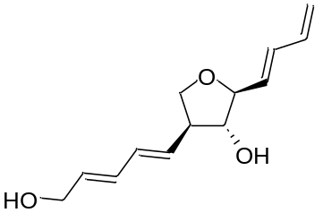

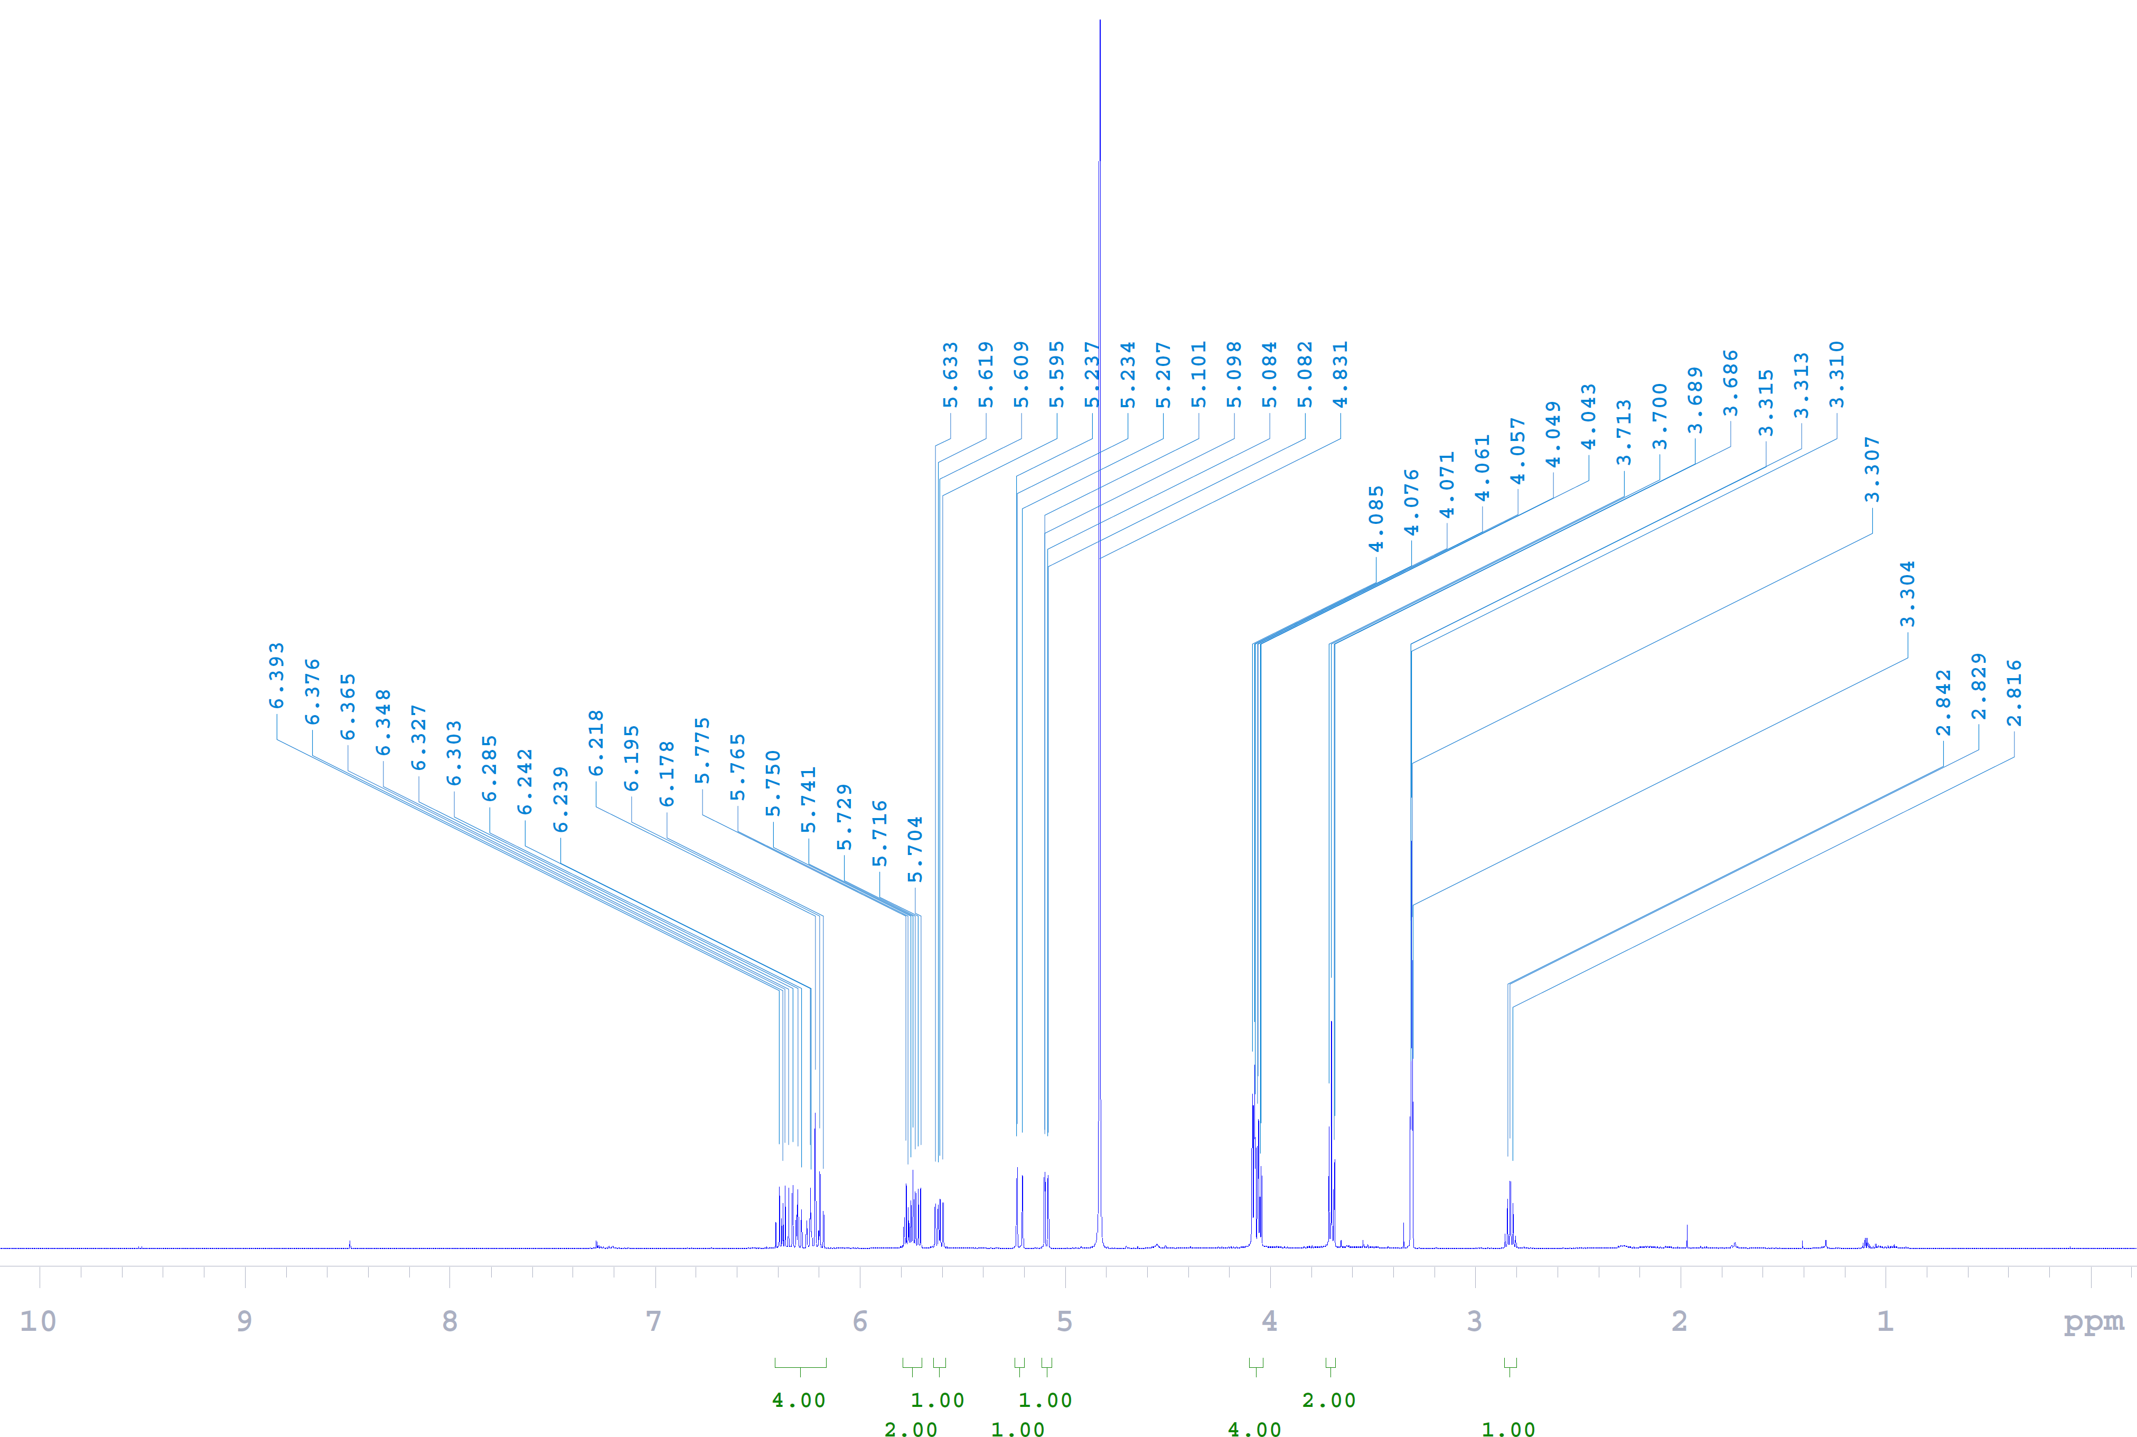
Fig. S1 ¹H NMR (600 MHz, methanol-d₄) spectrum of compound 1.

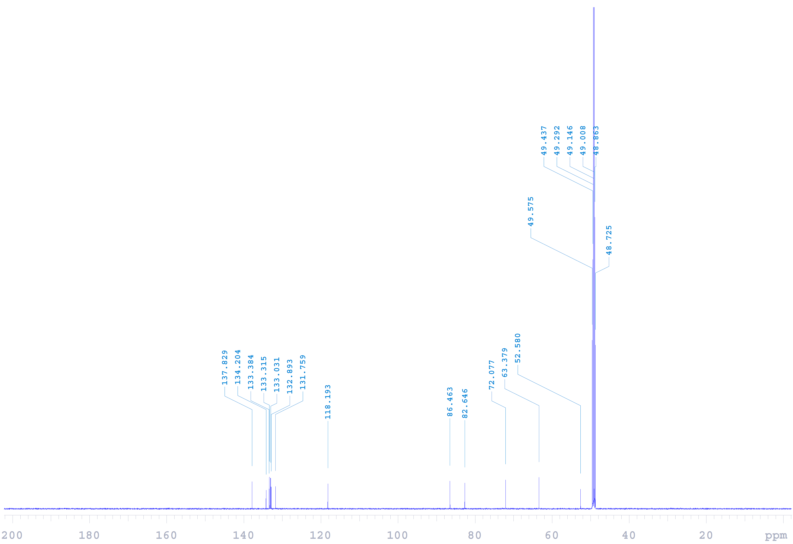
Fig. S2 ¹³C NMR (150 MHz, methanol-d₄) spectrum of compound 1.
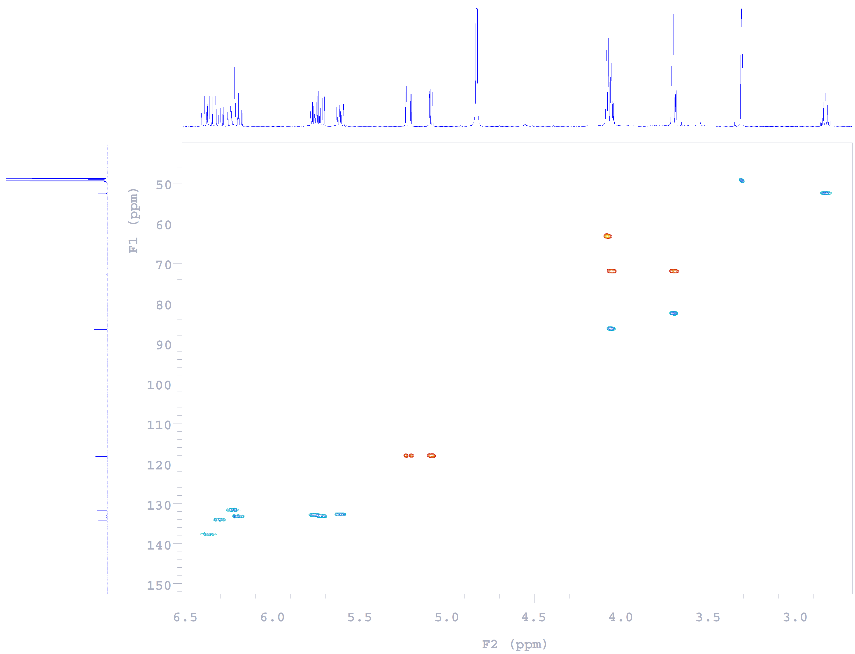
Fig. S3 HSQC spectrum of compound 1.

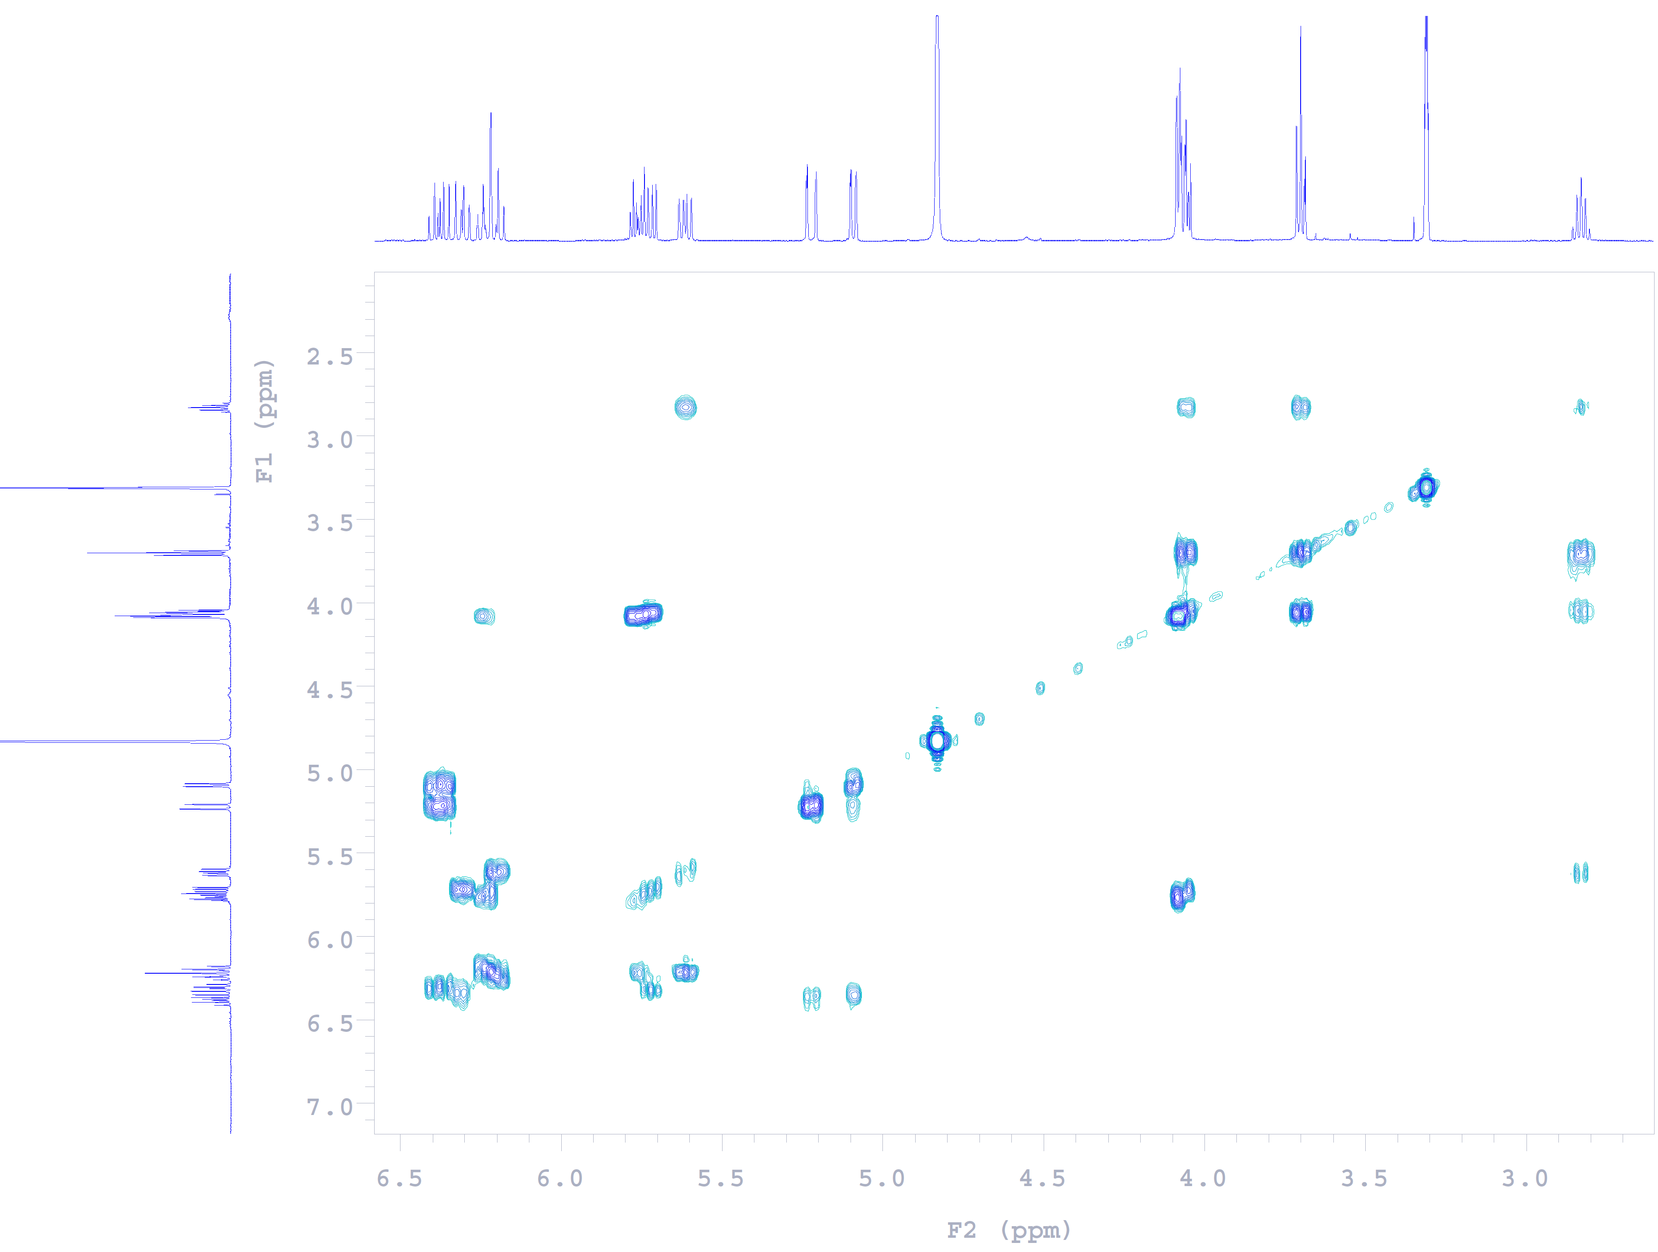
Fig. S4 COSY spectrum of compound 1.
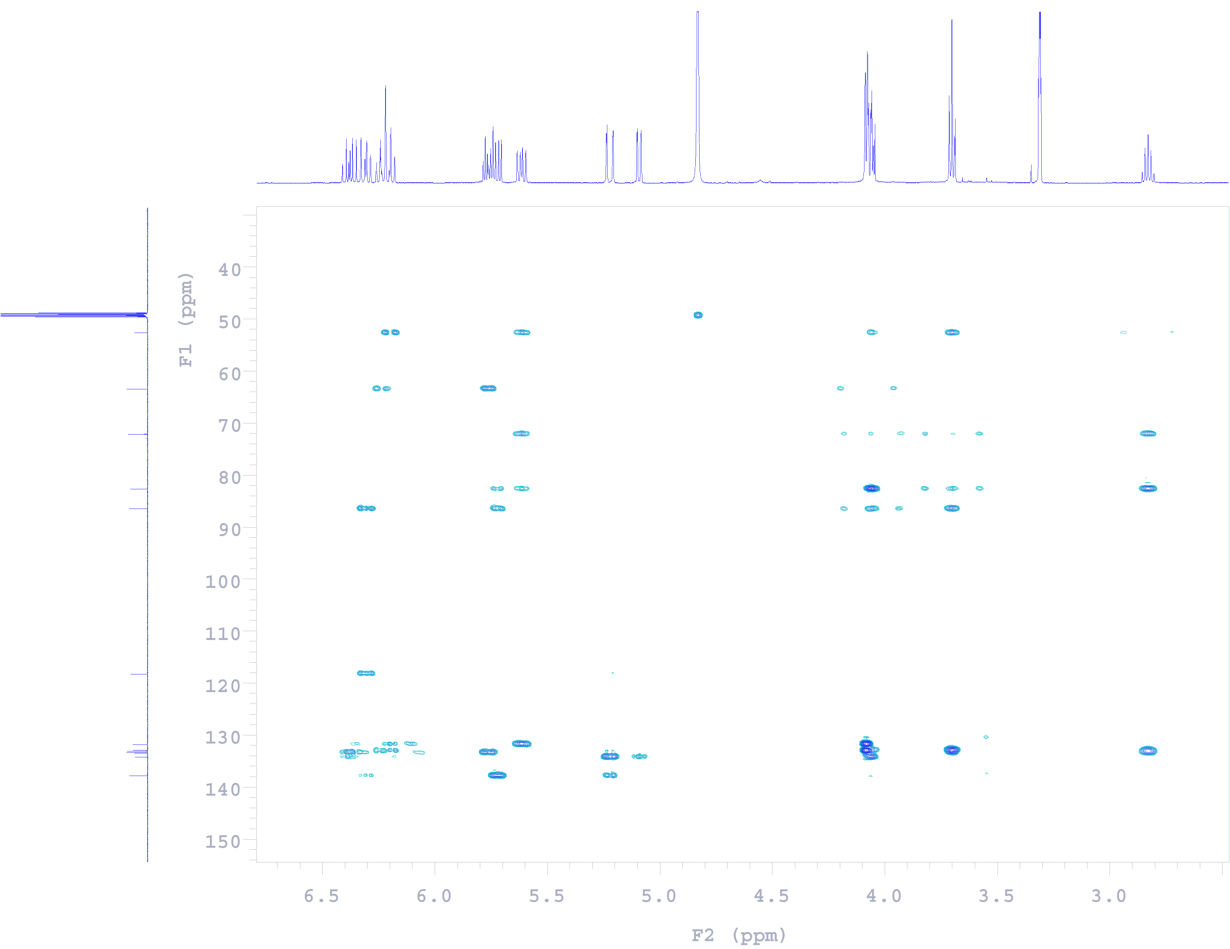
Fig. S5 HMBC spectrum of compound 1.

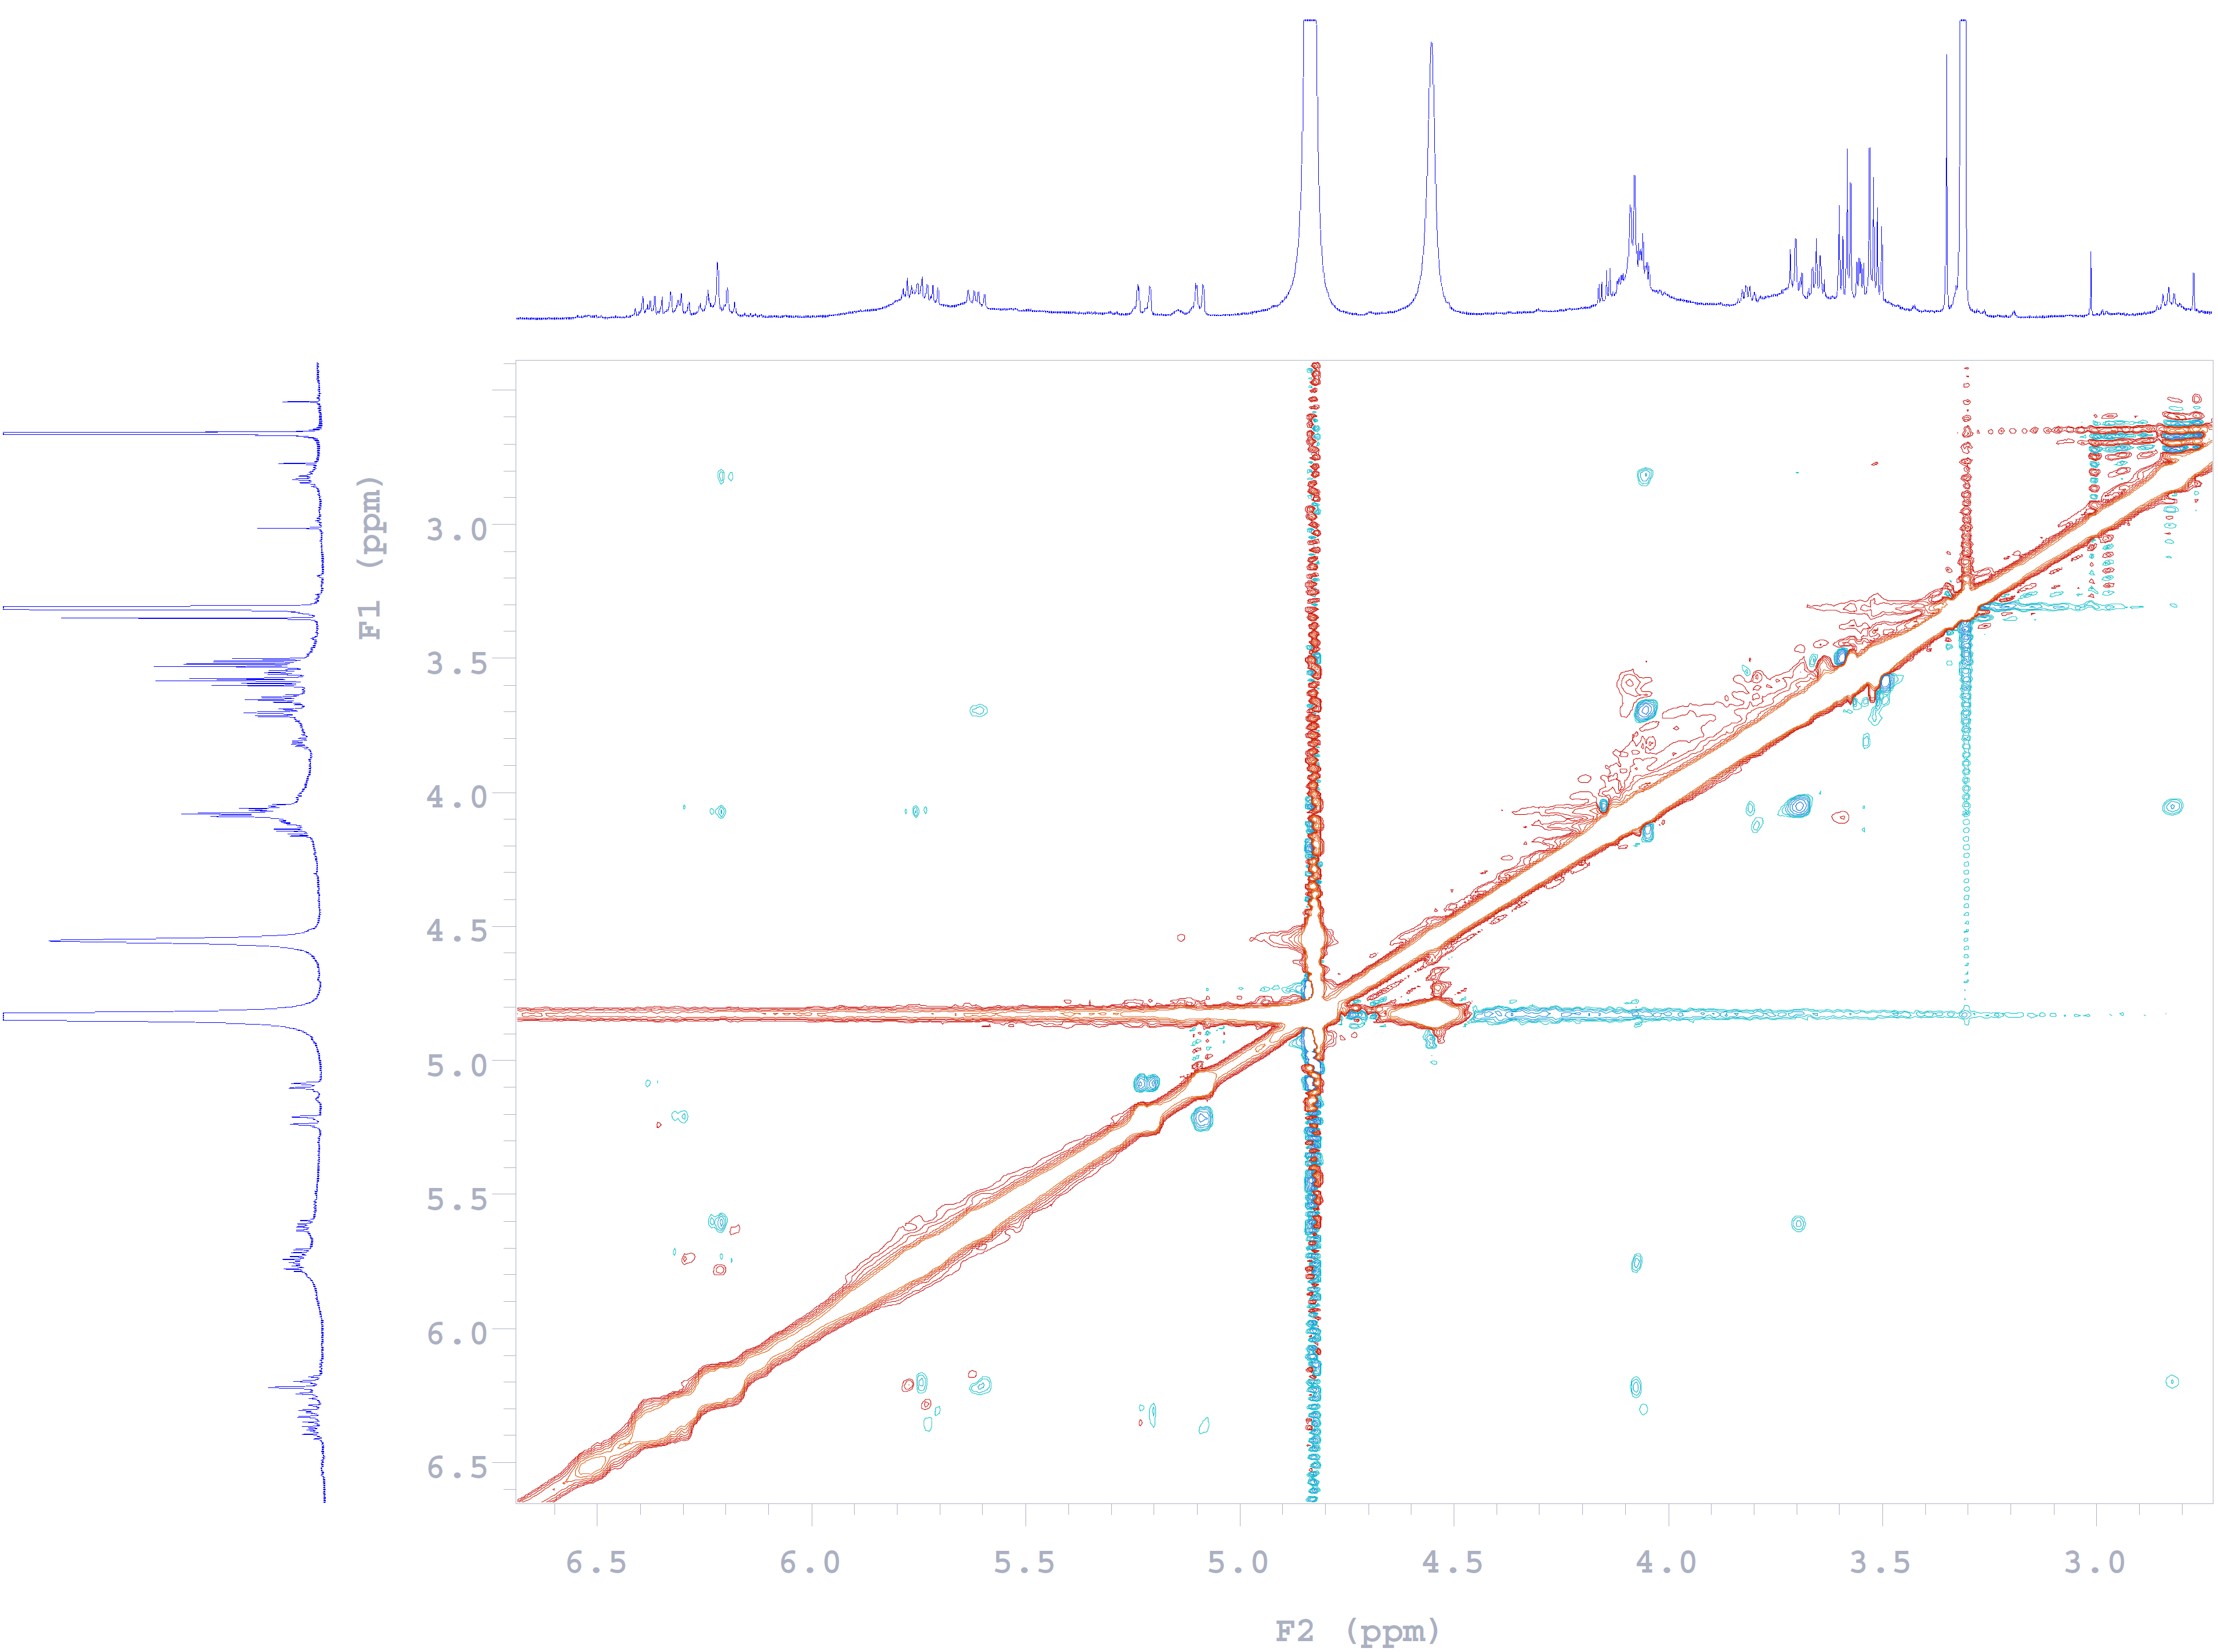
Fig. S6 NOESY spectrum of compound 1.
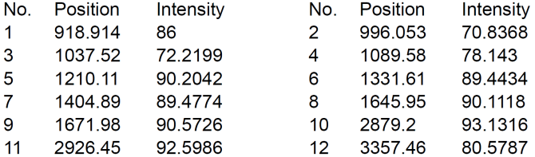

Fig. S7 IR (ZnSe) spectrum of compound 1.

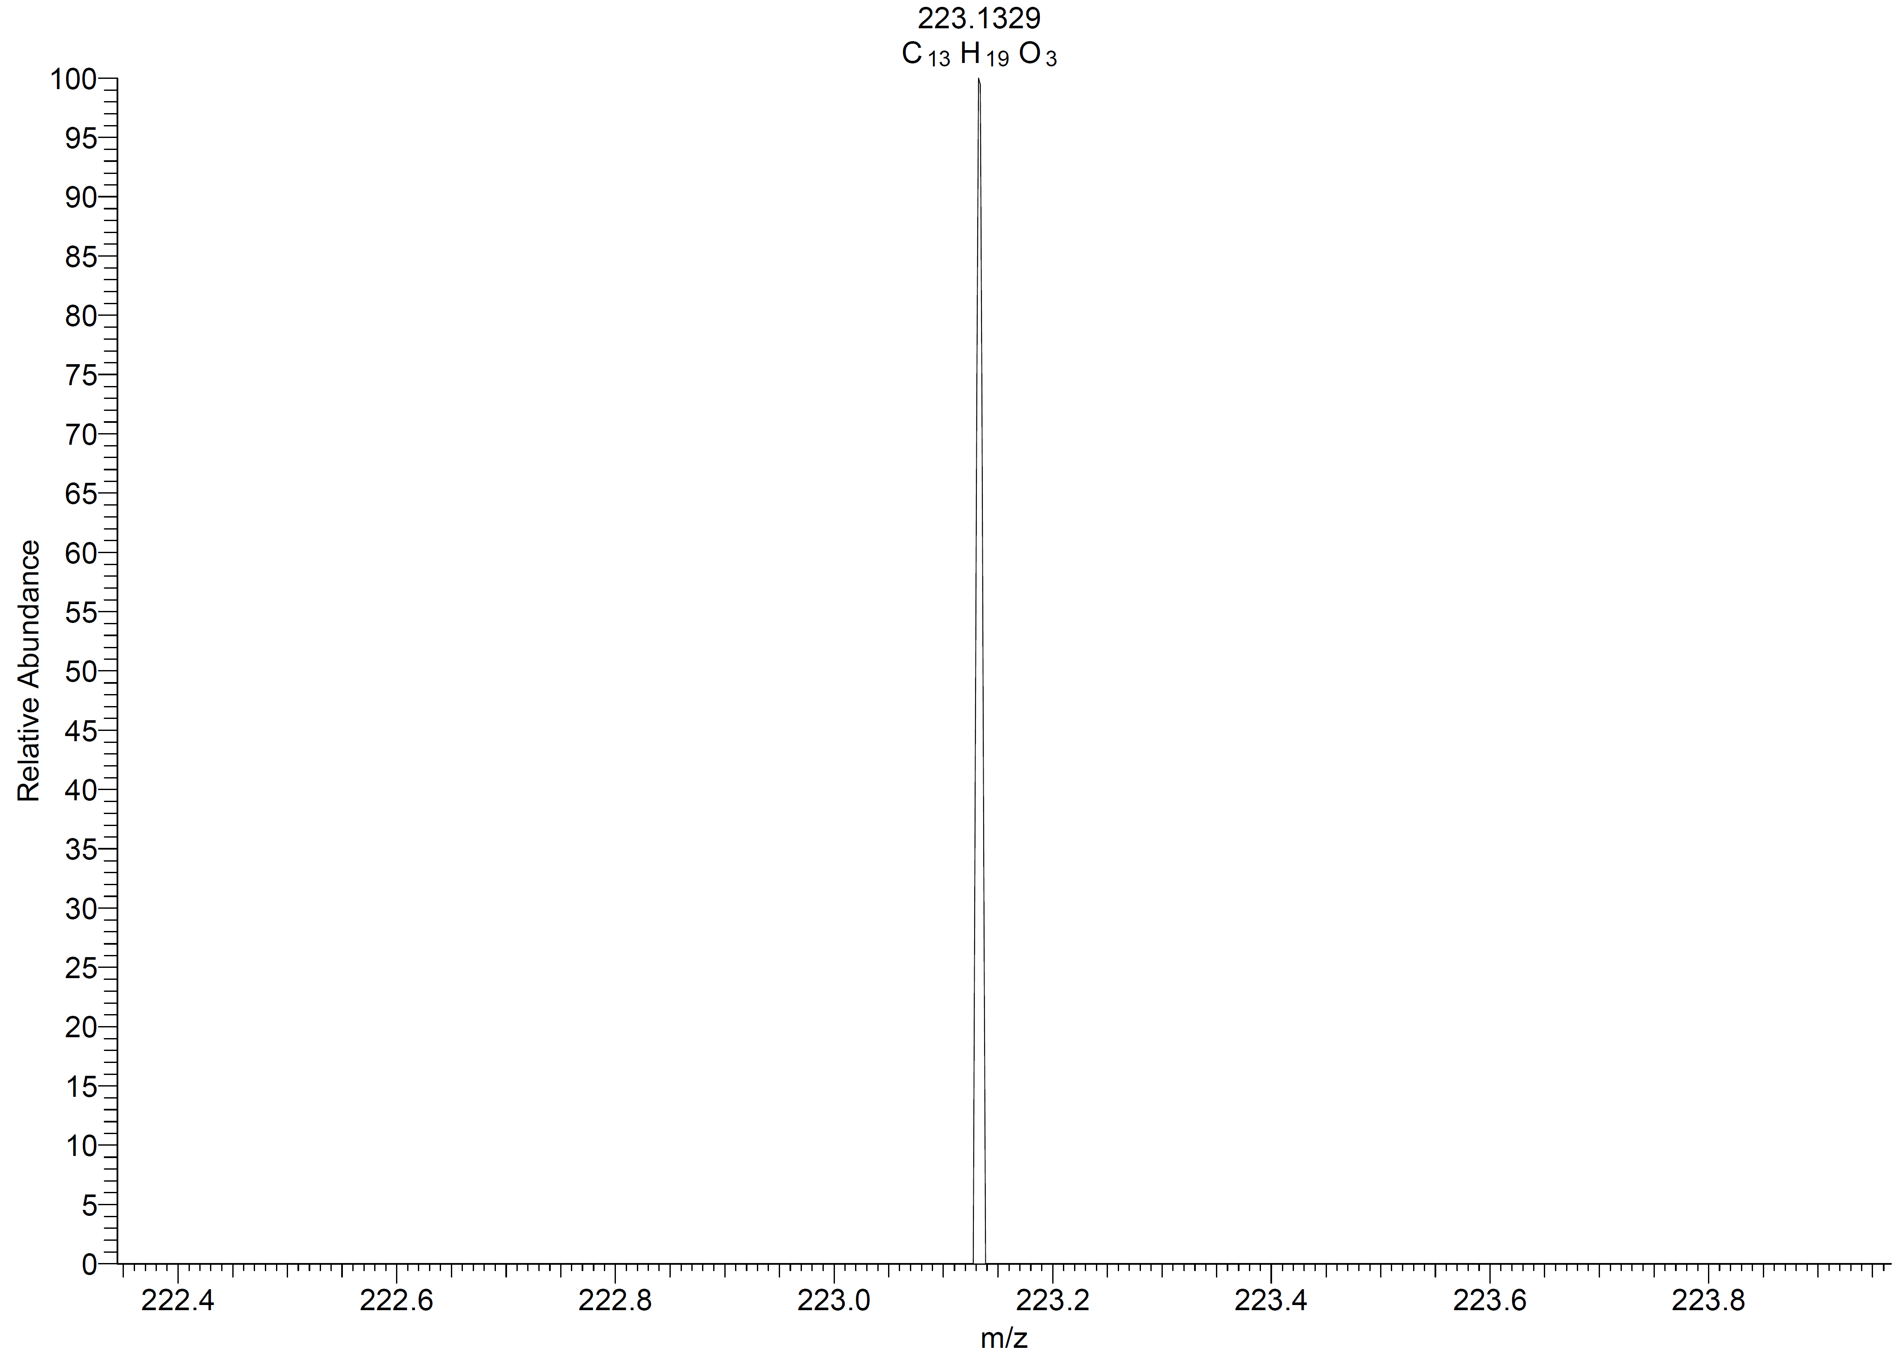

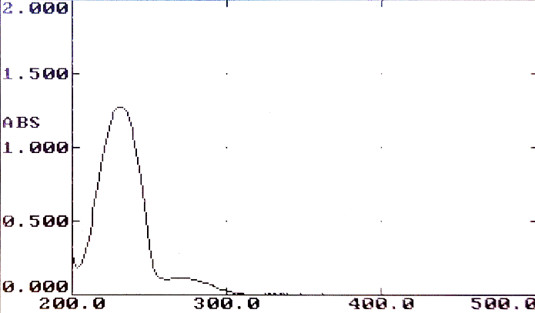

Fig. S8 HRESIMS spectrum of compound 1.

Fig. S9 UV spectrum of compound 1 in MeOH.

Fig. S10 ECD spectra of compounds 1and 4.

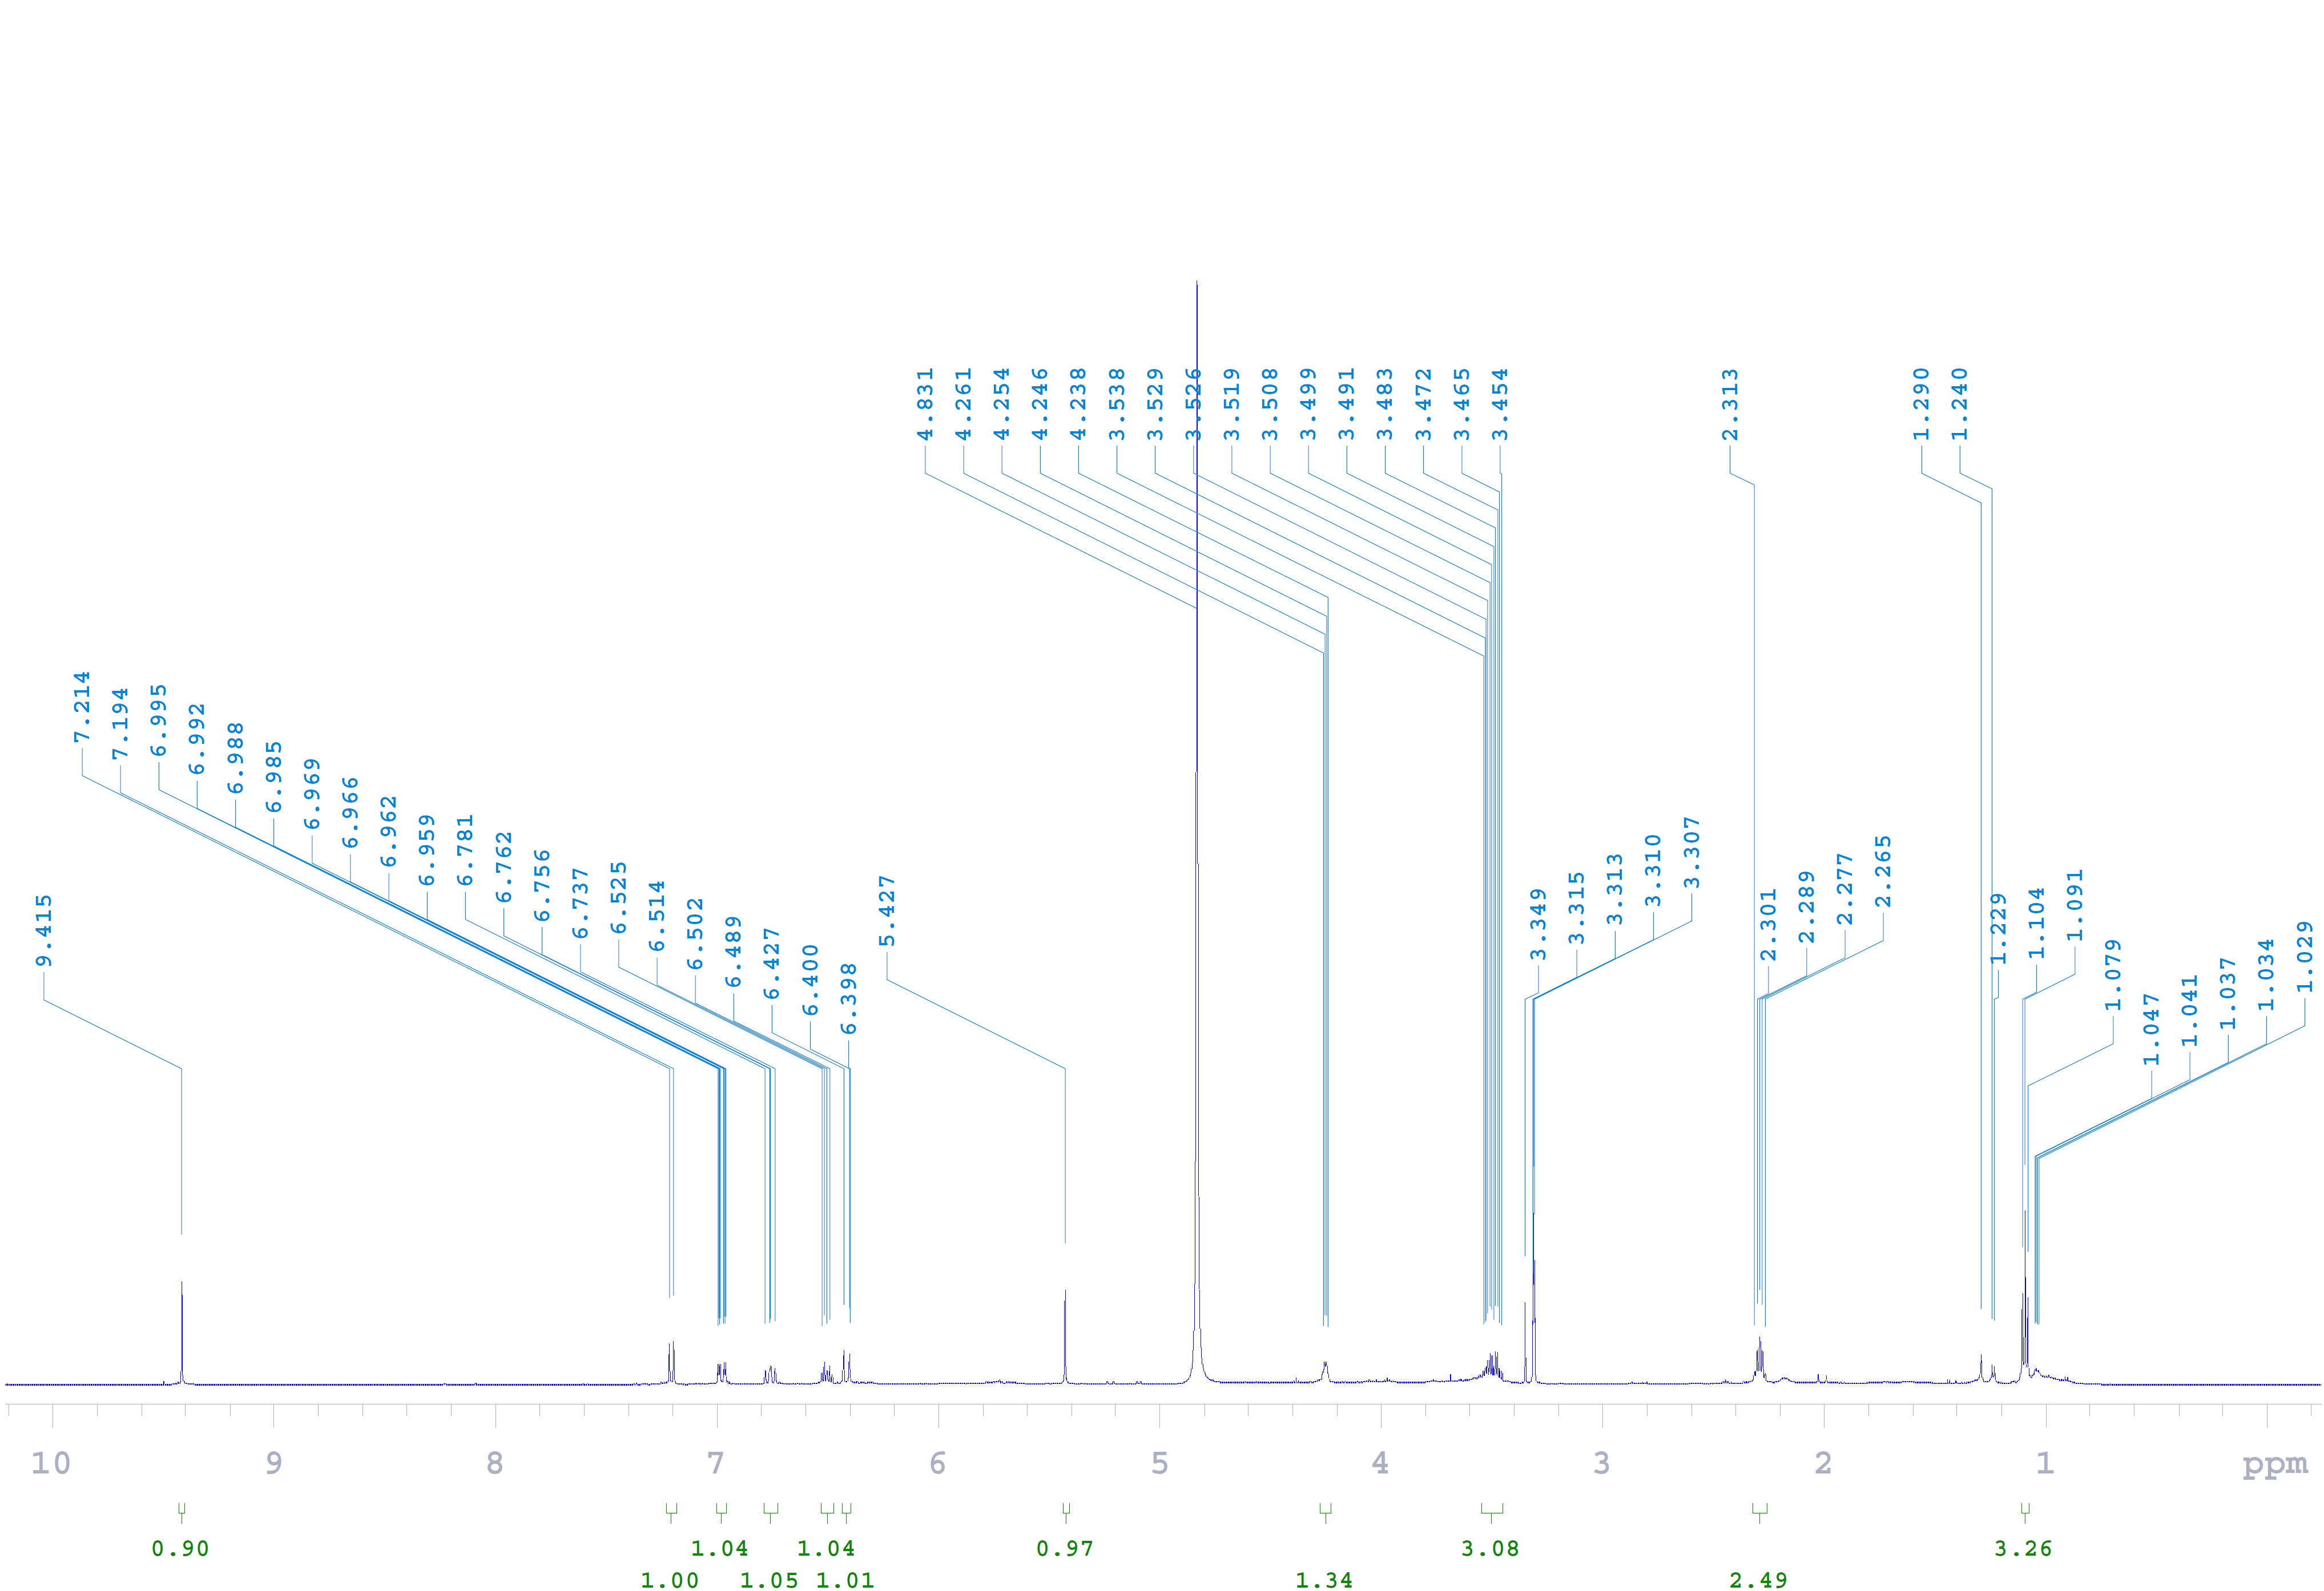
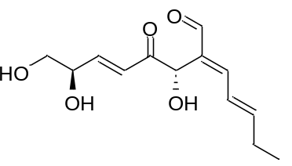Fig. S11 ¹H NMR (600 MHz, methanol-d₄) spectrum of compound 2.
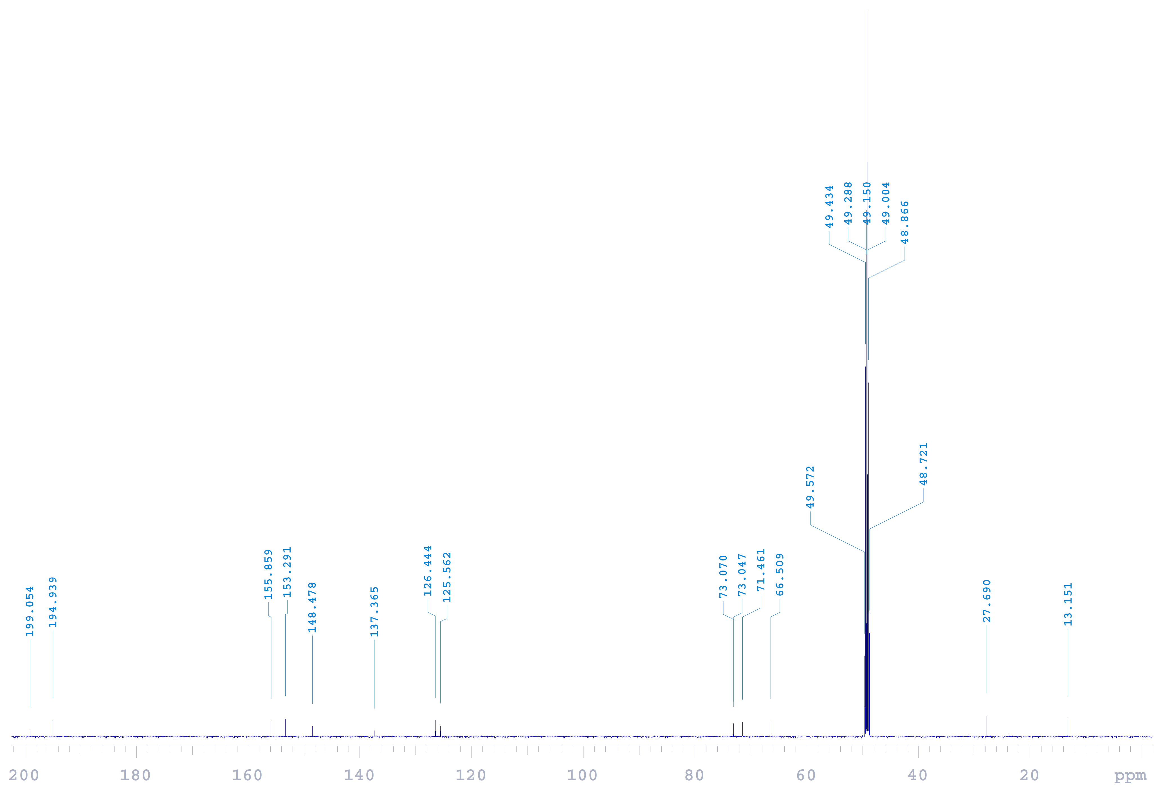
Fig. S12 ¹³C NMR (150 MHz, methanol-d₄) spectrum of compound 2.

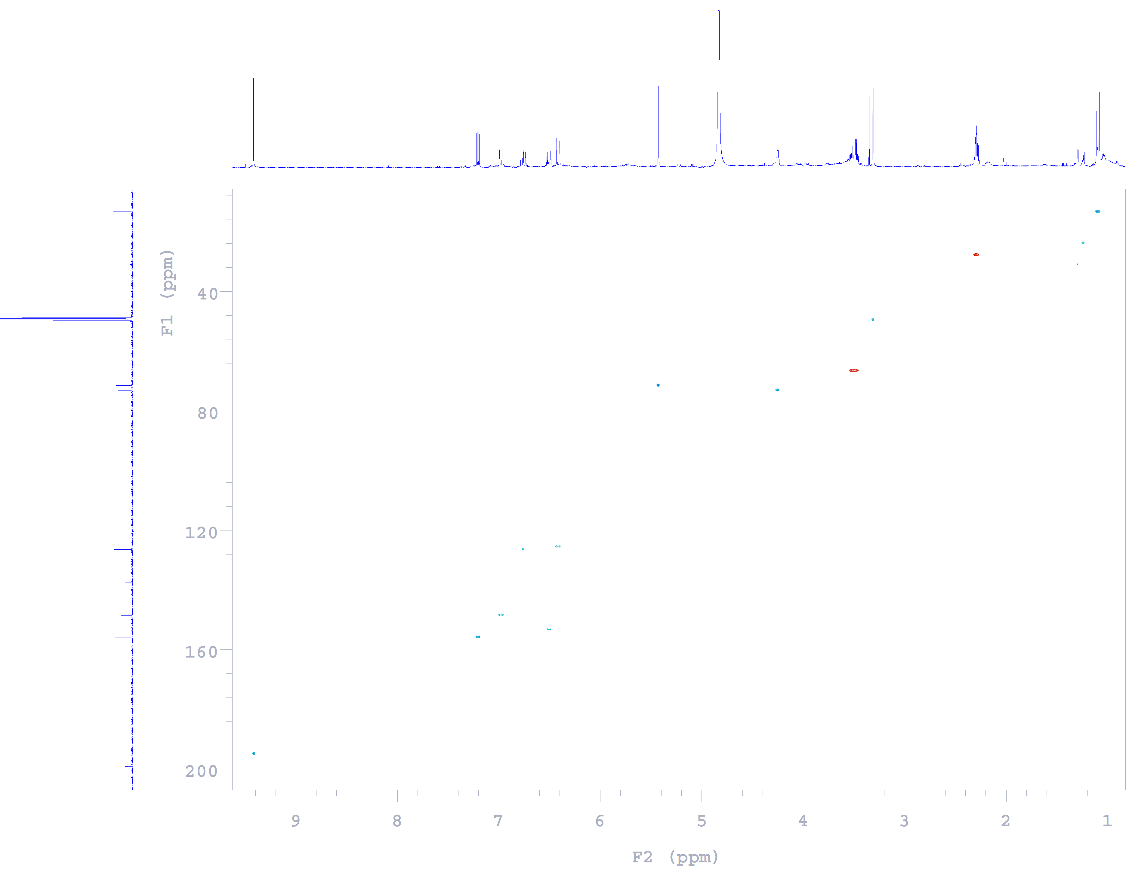
Fig. S13 HSQC spectrum of compound 2.
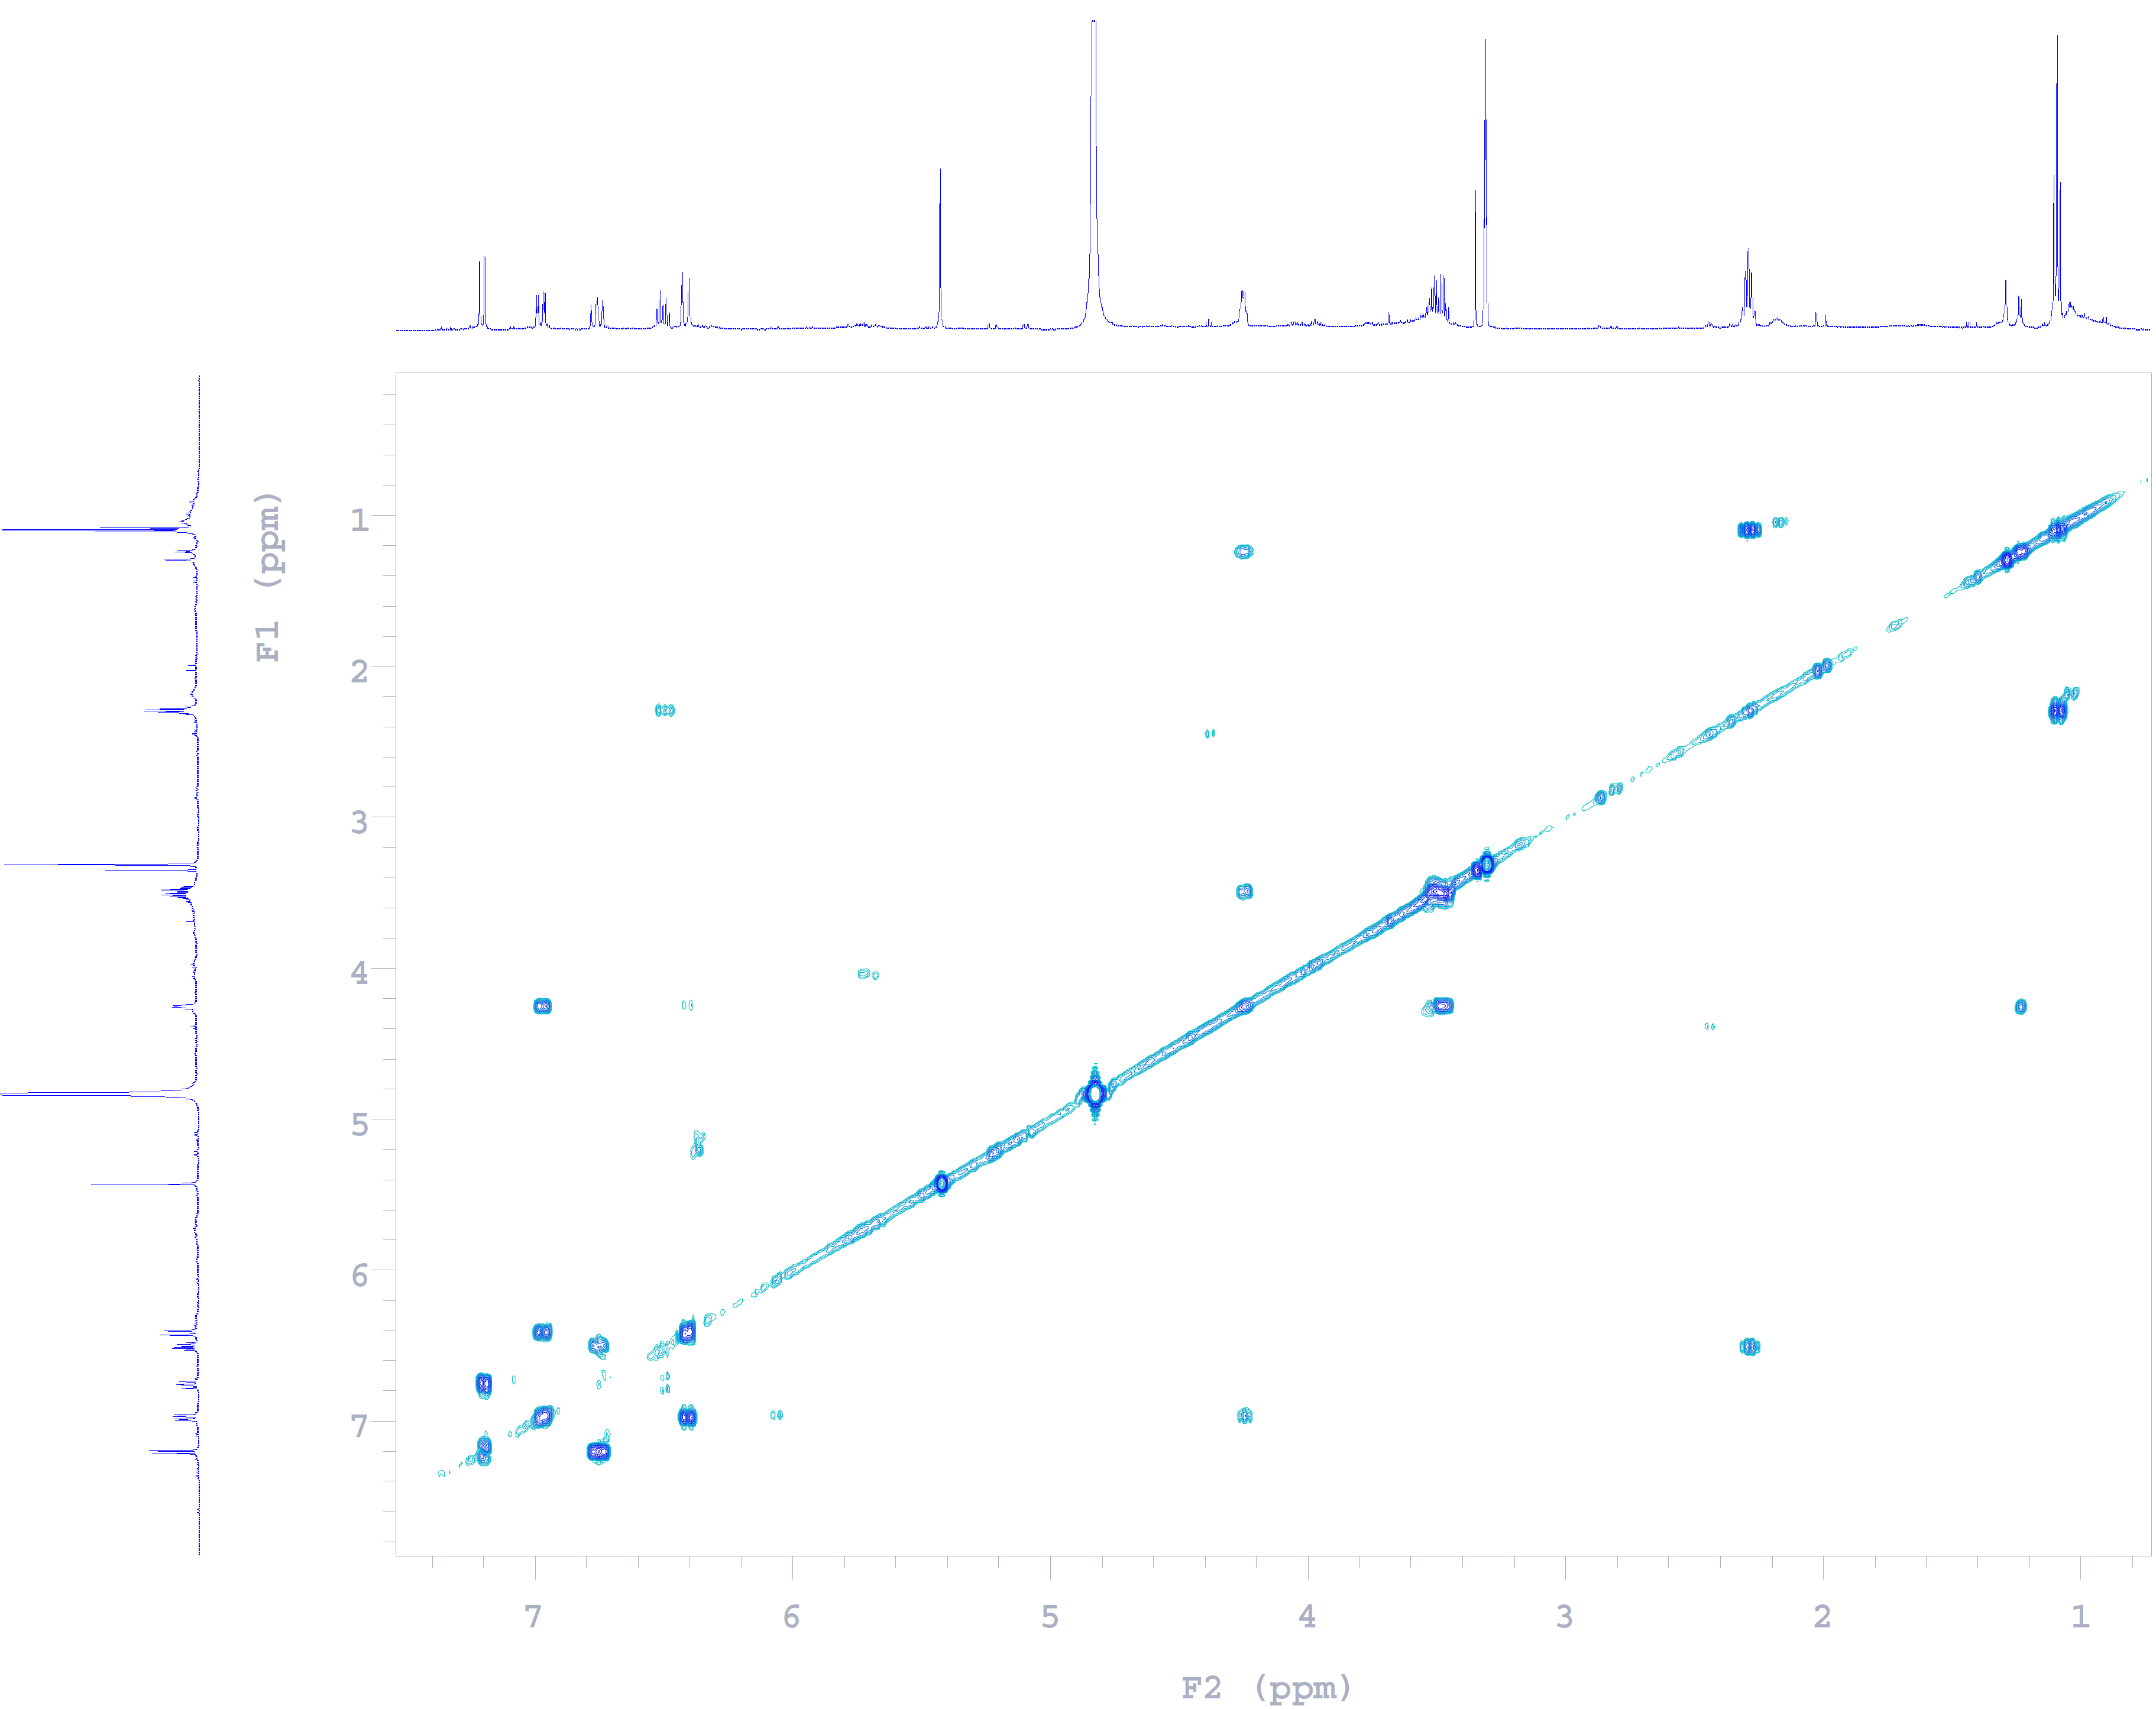
Fig. S14 COSY spectrum of compound 2.

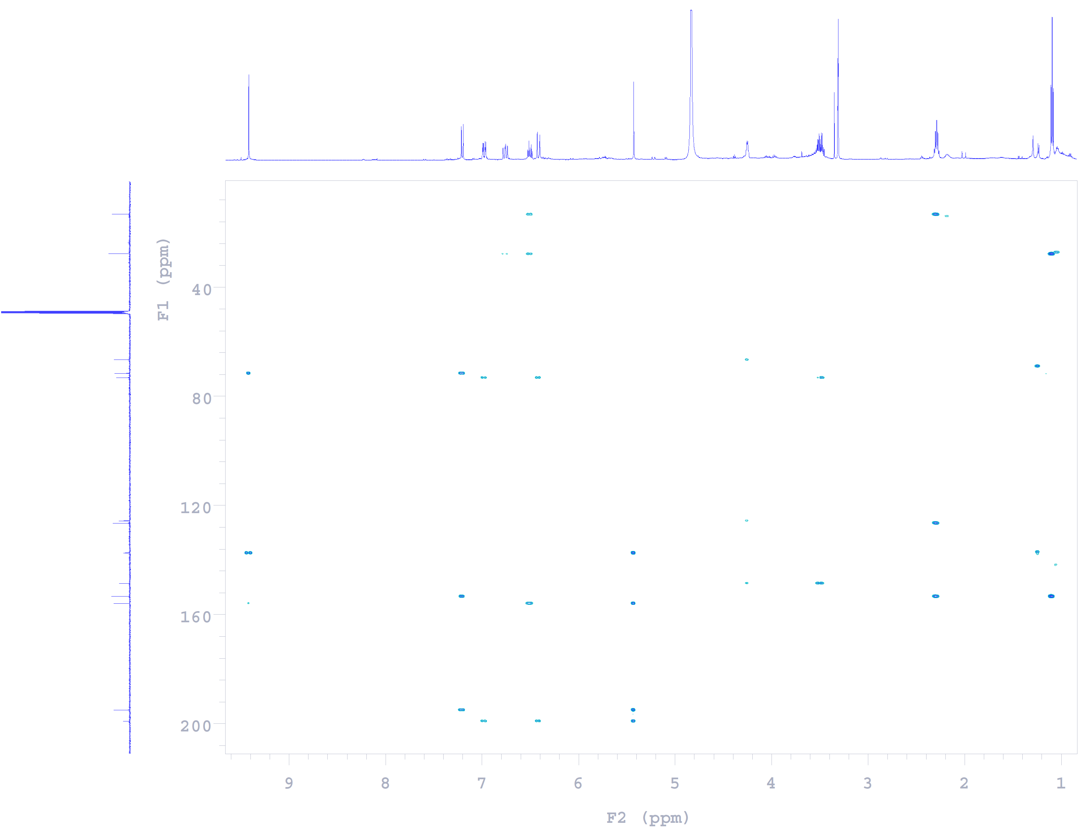
Fig. S15 HMBC spectrum of compound 2.

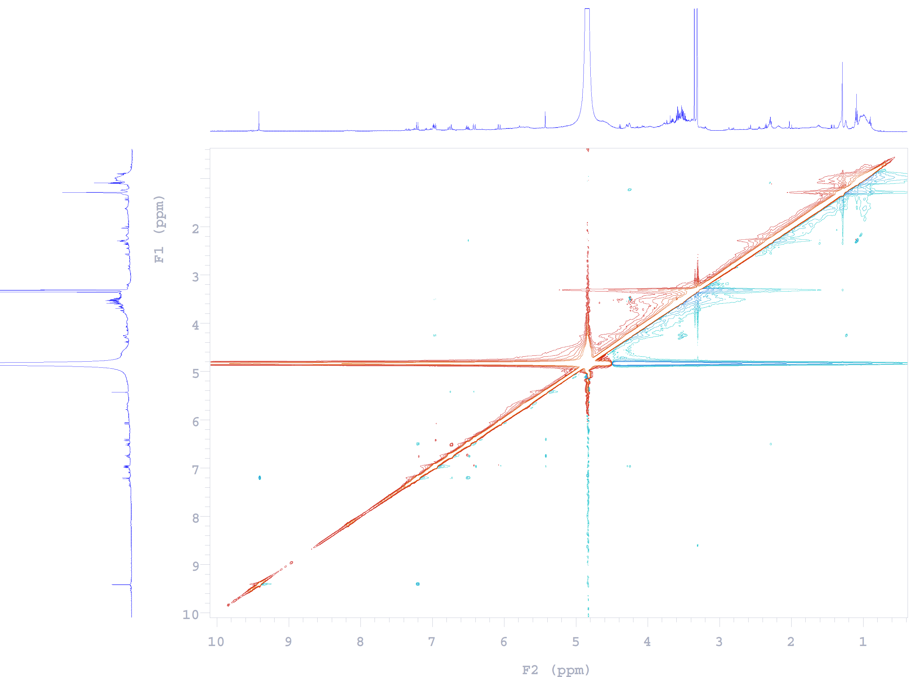
Fig. S16 NOESY spectrum of compound 2.

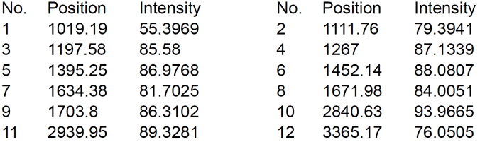

Fig. S17 IR (ZnSe) spectrum of compound 2.

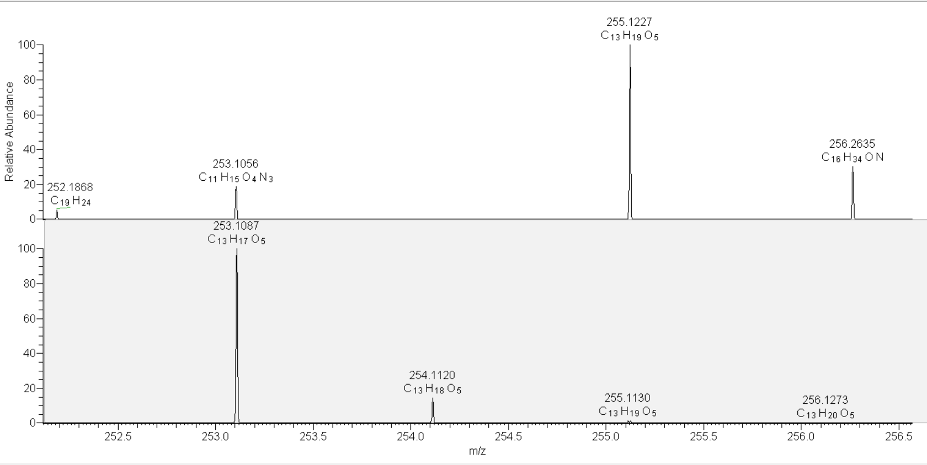

Fig. S18 HRESIMS spectrum of compound 2.

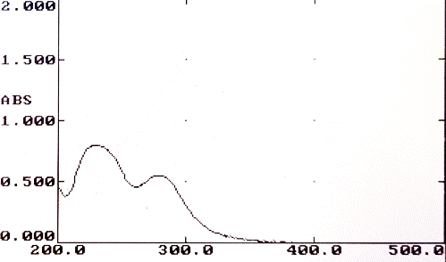

Fig. S19 UV spectrum of compound 2 in MeOH.
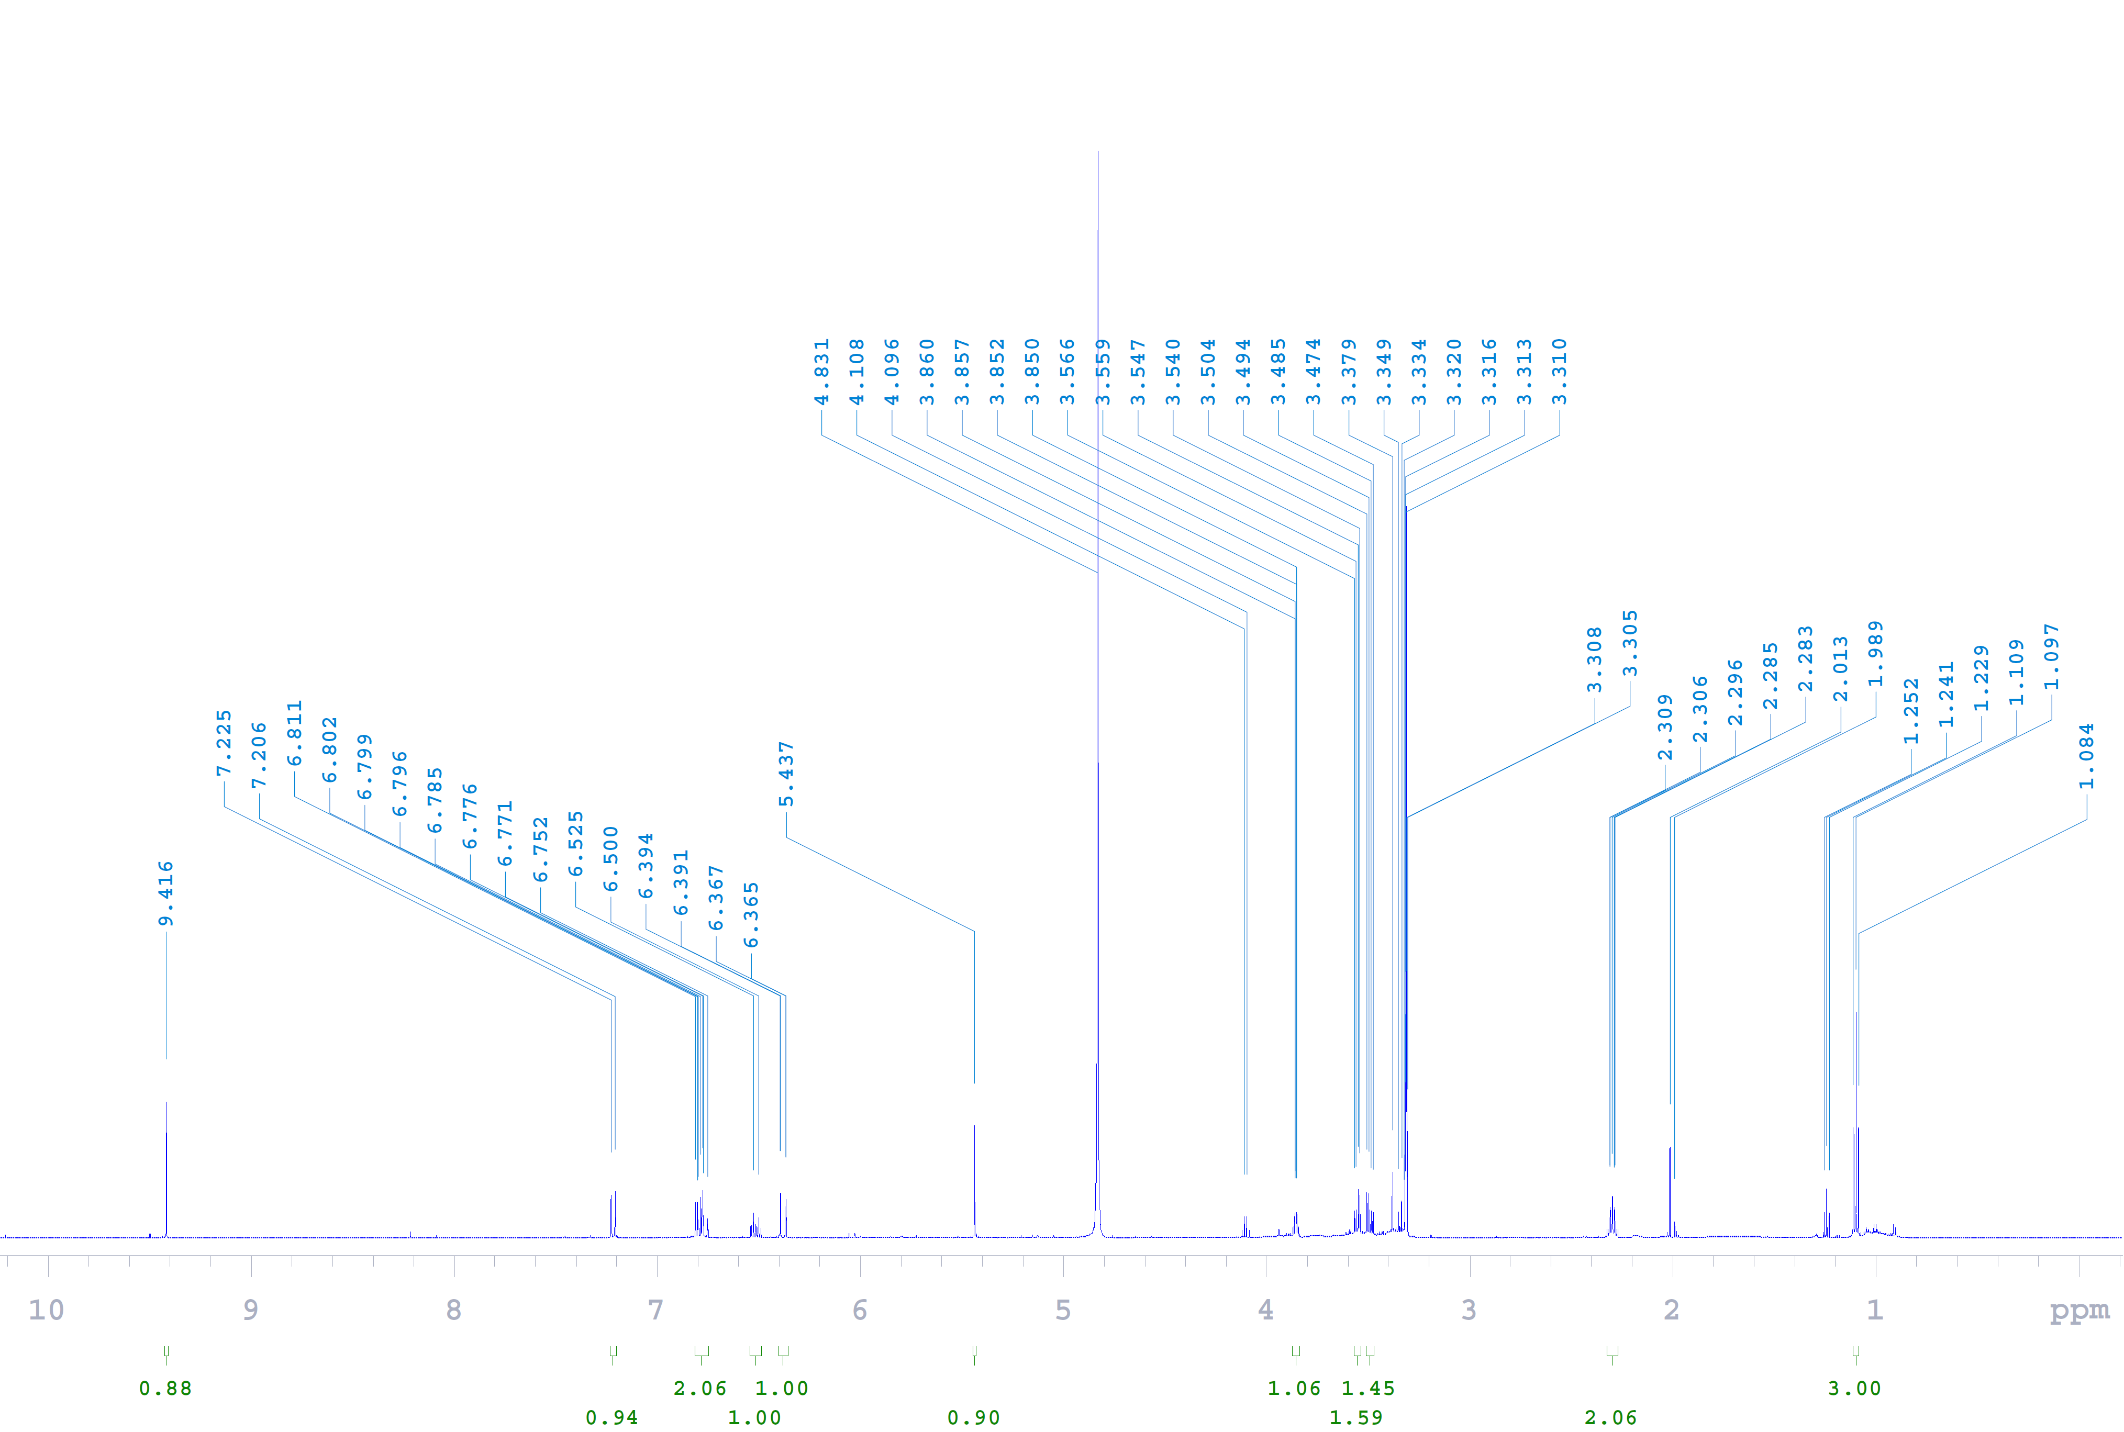
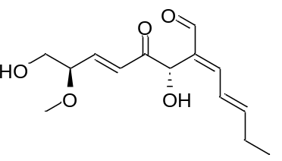Fig. S20 ¹H NMR (600 MHz, methanol-d₄) spectrum of compound 3.
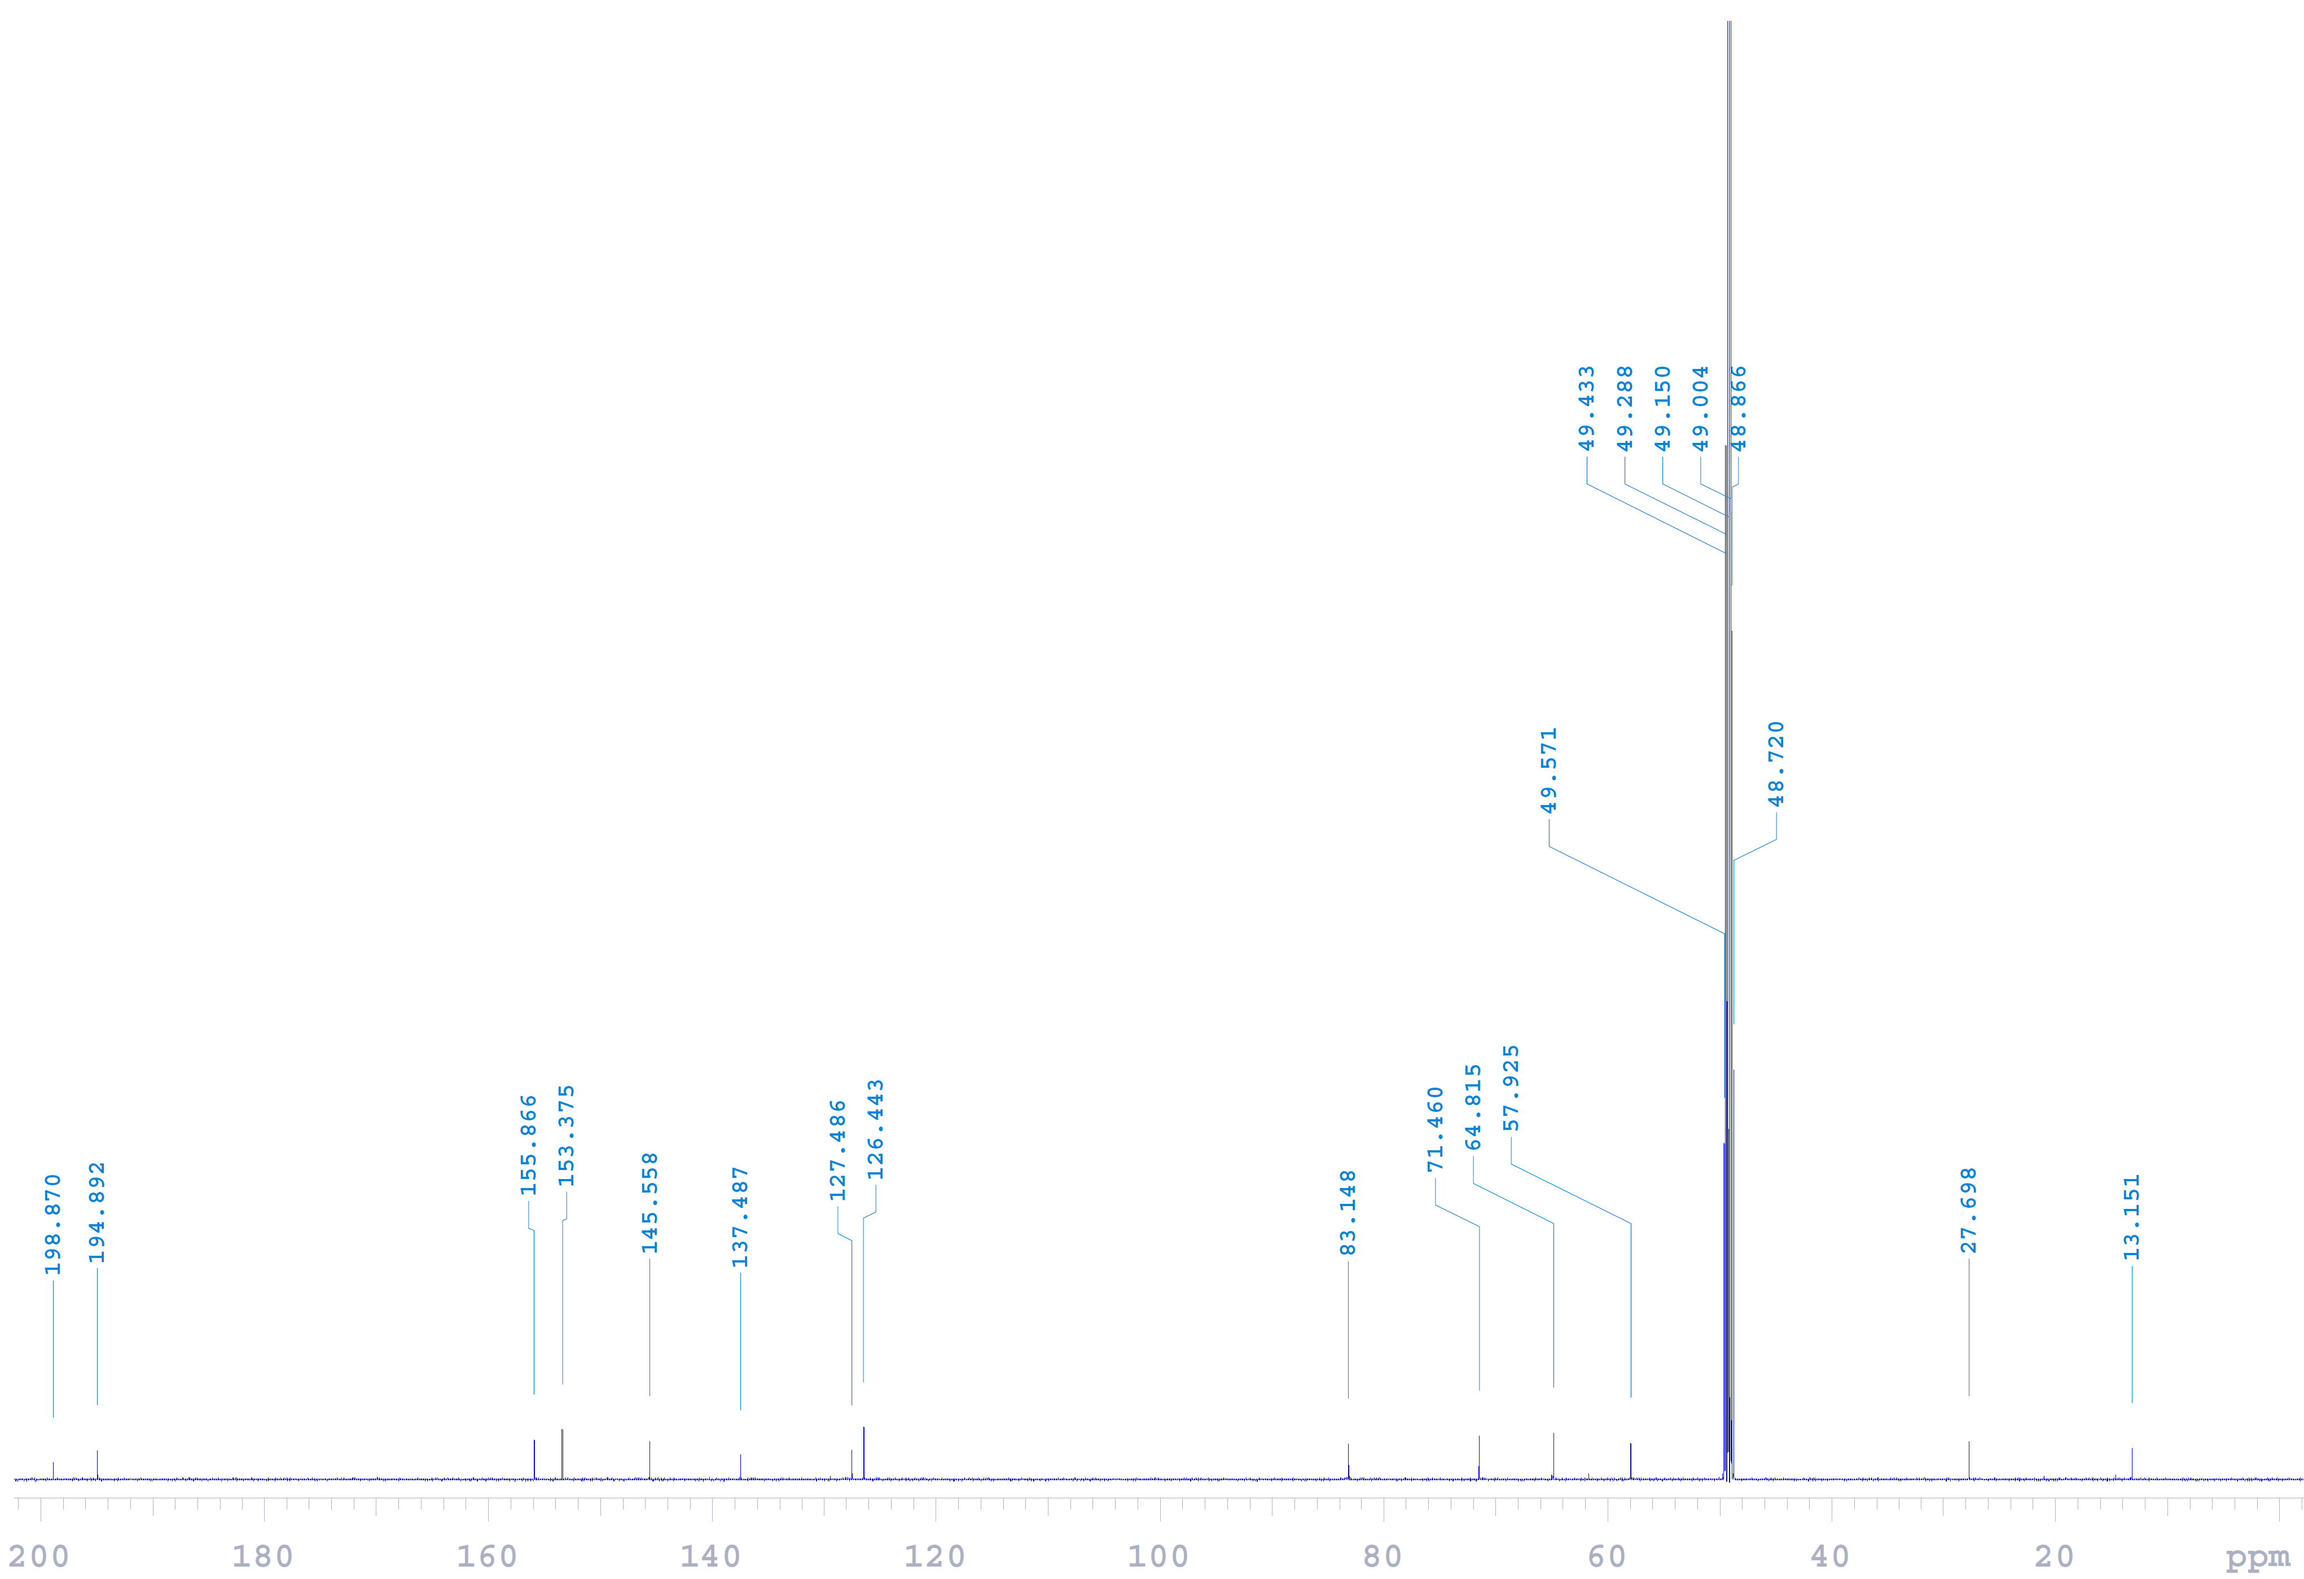
Fig. S21 ¹³C NMR (150 MHz, methanol-d₄) spectrum of compound 3.
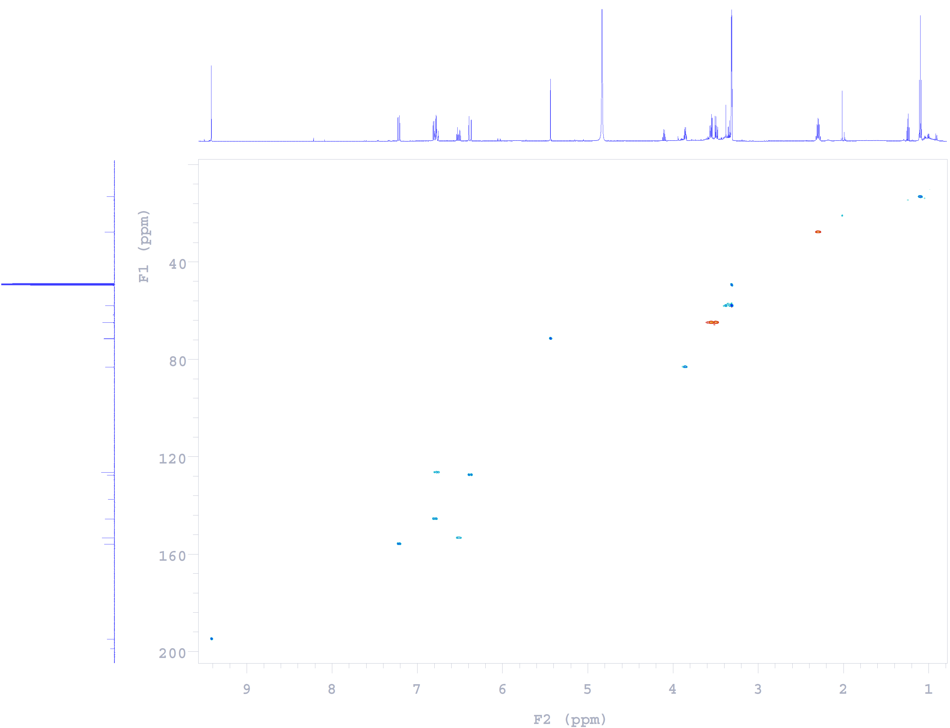
Fig. S22 HSQC spectrum of compound 3.
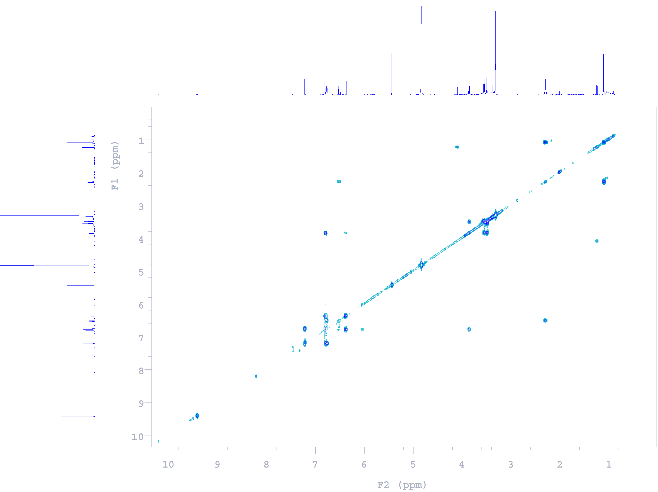
Fig. S23 COSY spectrum of compound 3.
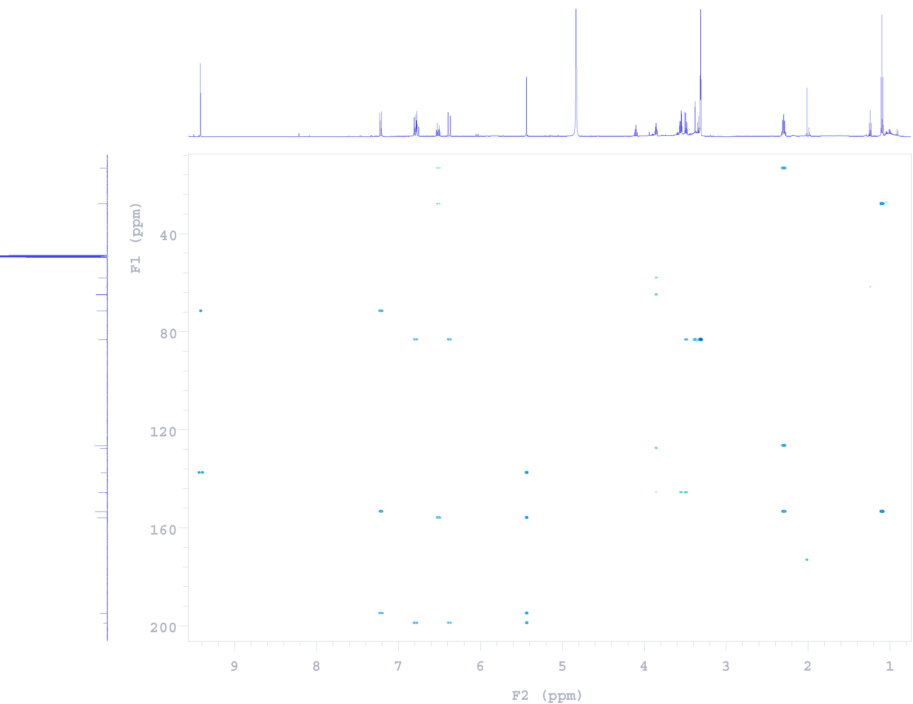
Fig. S24 HMBC spectrum of compound 3.

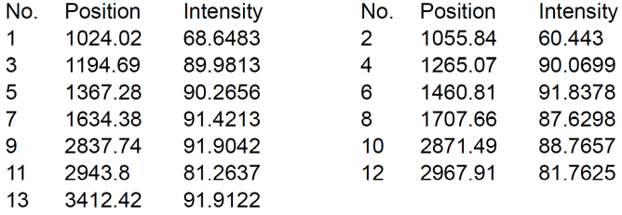

Fig. S25 IR (ZnSe) spectrum of 3.

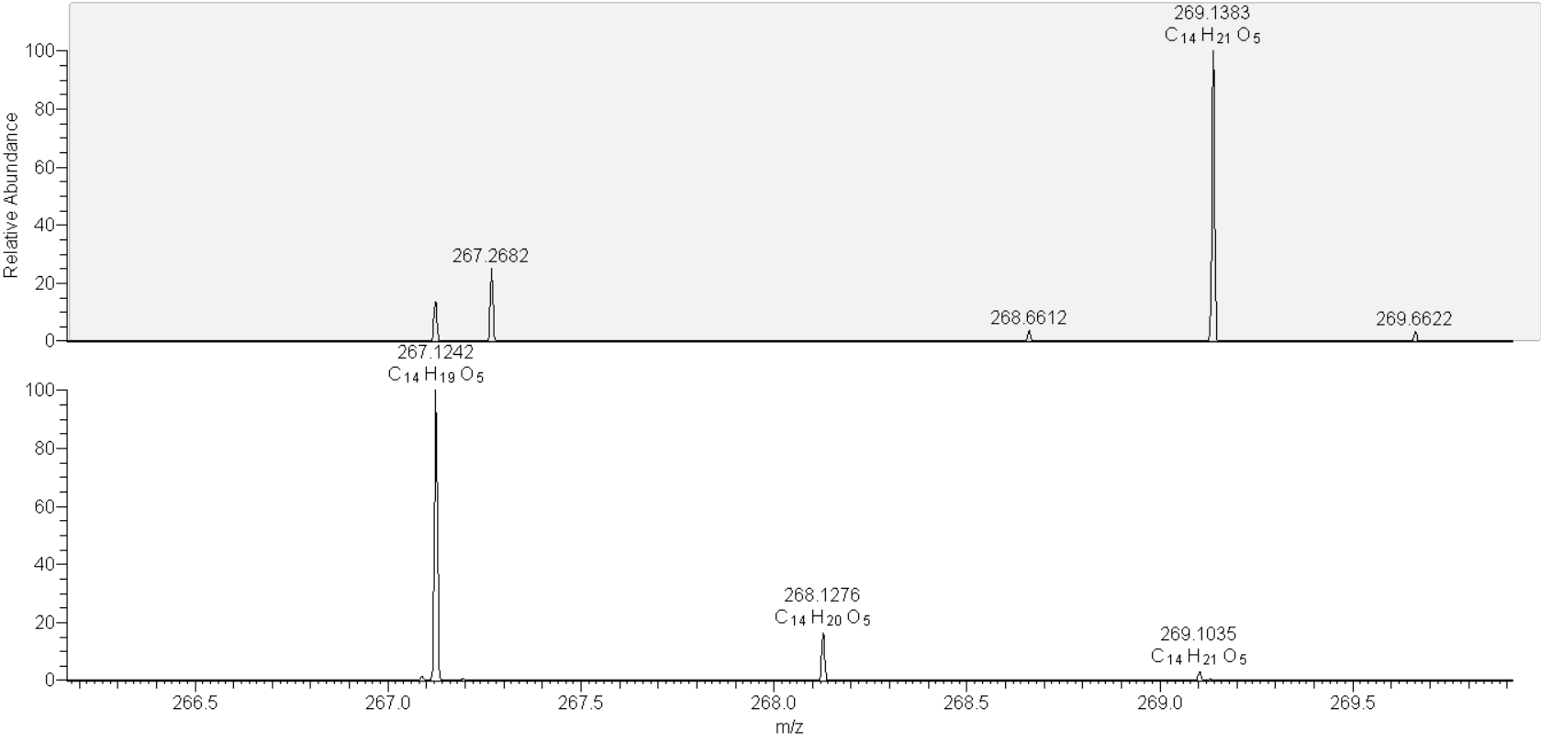

Fig. S26 HRESIMS spectrum of 3.

Fig. S27 UV spectrum of compound 3 in MeOH.

Fig. S28 ECD spectra of compounds 2, 3 and 5.

