Supplementary Figures
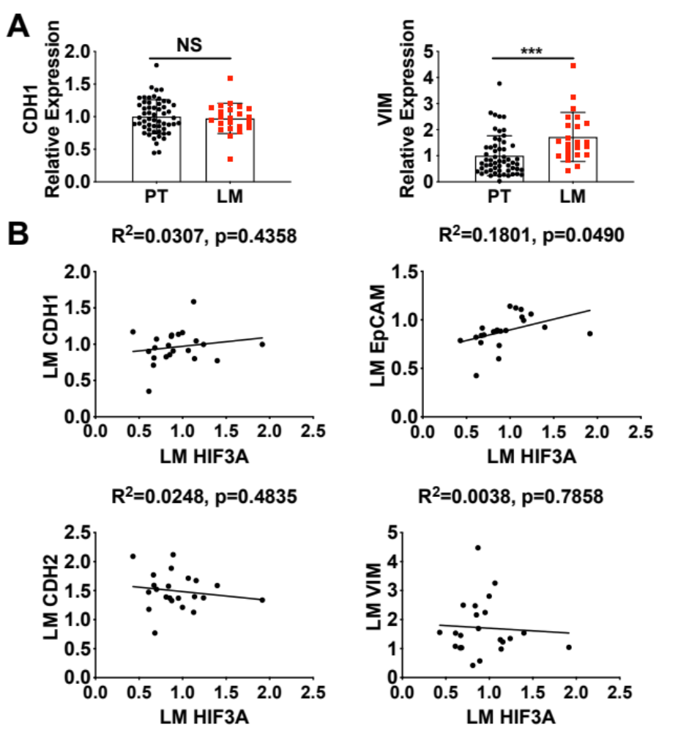
Fig. S1 HIF3A does not positively correlate with mesenchymal markers CDH2 or VIM in CRC liver metastasis. (A) Relative gene expression of CDH1 and VIM in CRC patient samples of primary (PT) and liver metastasized (LM) tumors. (B) Correlation analysis relating gene expression levels of CDH1, EpCAM, CDH2, and VIM to HIF3A in CRC patient LM samples. Gene expression was extracted from GSE28702. NS, not significant, ***p<0.001.
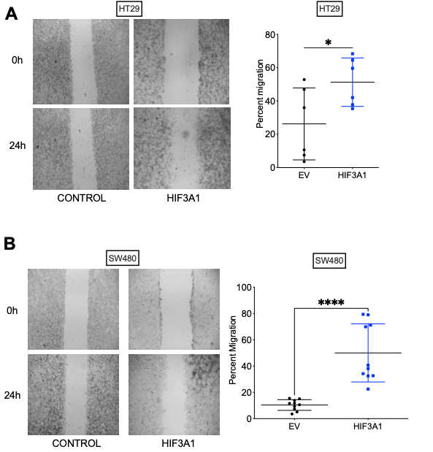
Fig. S2 Overexpression of HIF3A1 in colon cancer cells promotes invasion in a scratch/would healing assay.
HIF3A1 overexpressing and control HT29 (A) and SW480 (B) colon cancer cells were seeded into 24-well plates and allowed to adhere overnight. The following day a scratch (“wound”) was created using a 200µL pipette tip. Following a 24-hour incubation, percent invasion was calculated by subtracting the area without cells at 24h from 0h and dividing by 0h. *p<0.05 and ****p<0.0001. Student’s t-test.

Fig. S3 HIF3A1 drives cell migration in an ZEB2 dependent manner. (A) HT29 colon cancer cells were seeded into 24-well plates and allowed to adhere overnight. The next day cells were transfected with control plasmid or esiZEB2 plasmid (540 ng). The following day a scratch (“wound”) was created using a 200µL pipette tip. Following a 24-hour incubation, percent invasion was calculated by subtracting the area without cells at 24h from 0h and dividing by 0h. (B) Graph of percent invasion of HT29 EV and HIF3A1 cells treated with control or esiZEB2. ****p<0.0001.

