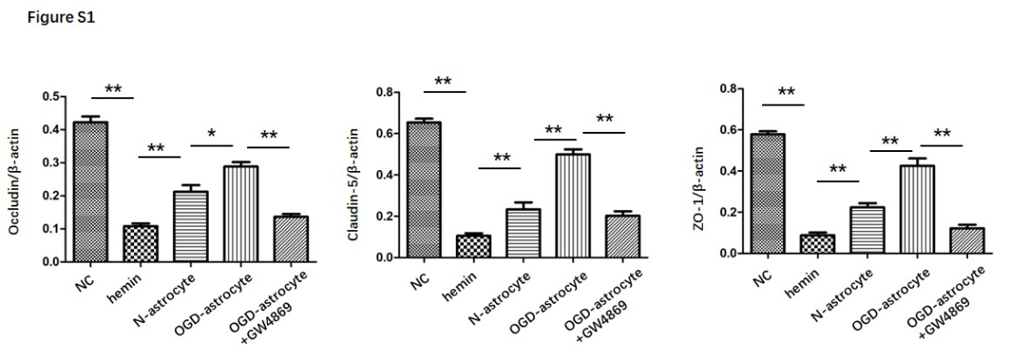 Figure S1. Extracellular vesicles released by astrocytes restored the decrease of TJPs in bEnd.3 cells. A. Quantification of immunoblot of occludin, B. Quantification of immunoblot of Claudin-5, and C. Quantification of immunoblot of ZO-1. All data were expressed as mean ± SEM of at least 3 independent experiments. *P < 0.05, **P < 0.01

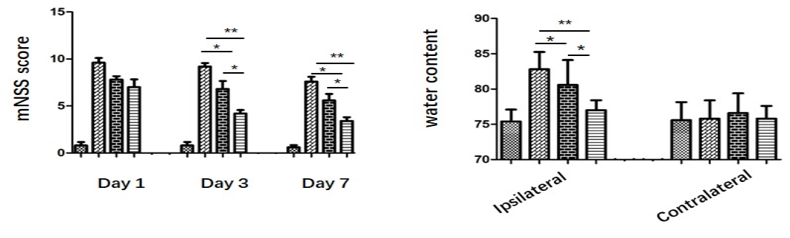
Figure S2 ADEVs treatment ameliorated neurological deficits and reduced brain water content after ICH. A. mNSS score at days 1, 3, and 7 in the sham, ICH, ICH+ N-ADEVs and ICH+ OGD-ADEVs groups. B. Brain water content of ipsilateral and contralateral hemisphere 24h after ICH. All data were expressed as mean ± SEM of at least 3 independent experiments. *P < 0.05, **P < 0.01

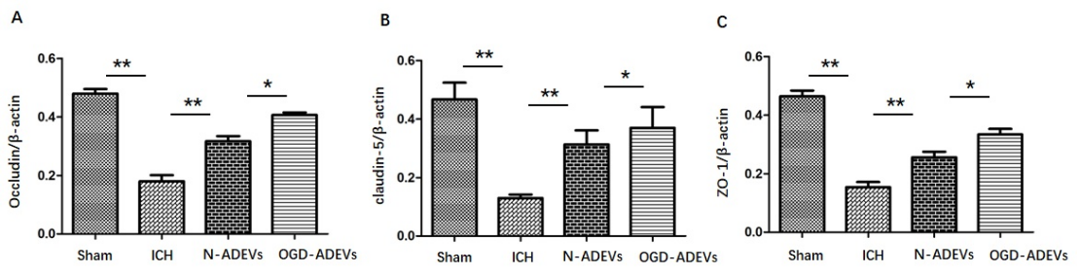
Figure S3 ADEVs reversed the downregulated expression of TJPs after ICH. A. Quantification of immunoblot of occludin, B. Quantification of immunoblot of Claudin-5, and C. Quantification of immunoblot of ZO-1. All data were expressed as mean ± SEM of at least 3 independent experiments. *P < 0.05, **P < 0.01

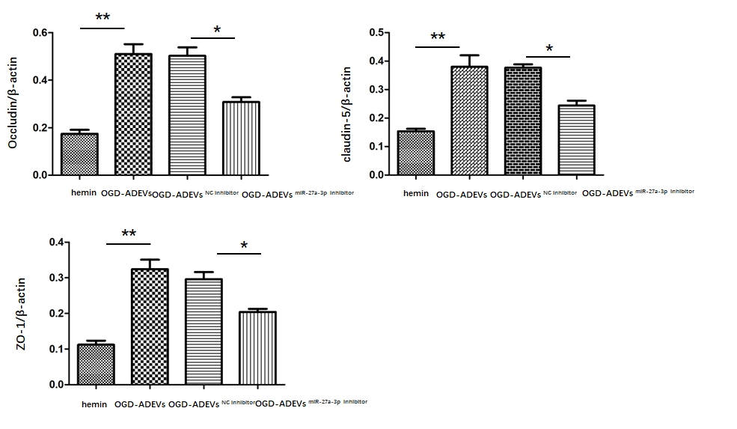

Figure S4 OGD-ADEVs miR-27a-3p attenuated the decrease in TJP levels. A. Quantification of immunoblot of occludin, B. Quantification of immunoblot of Claudin-5, and C. Quantification of immunoblot of ZO-1. All data were expressed as mean ± SEM of at least 3 independent experiments. *P < 0.05, **P < 0.01.

