Effect of video clips on patient comprehension of atrial fibrillation and deep vein thrombosis in the emergency setting

A randomised clinical trial

Secondary Analyses

Per-protocol analysis for the primary outcome “Knowledge of the medical condition and its main complication”
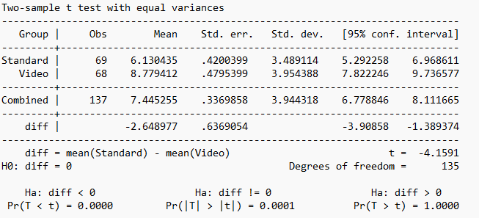

Per-protocol analysis for the secondary outcome “Knowledge of the prescribed therapy”
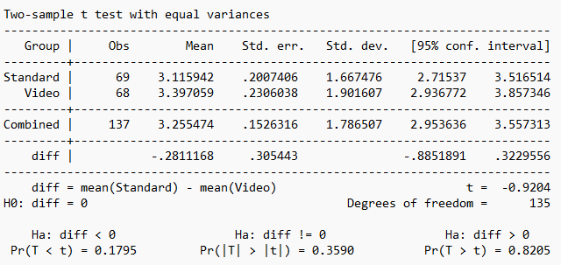

Per-protocol analysis for the secondary outcome “Patient satisfaction”
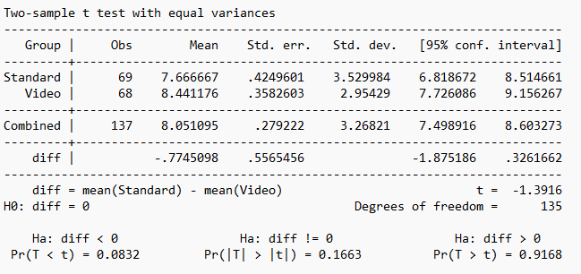

Sensitivity analysis for the primary outcome “Knowledge of the medical condition and its main complication”
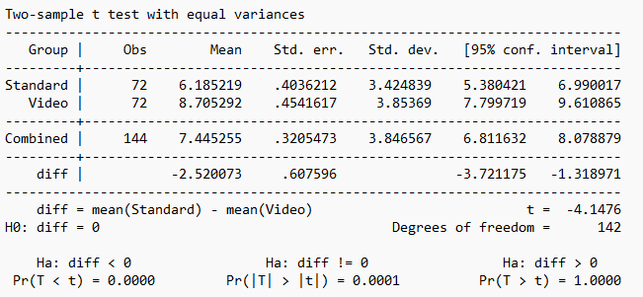

Sensitivity analysis for the secondary outcome “Knowledge of the prescribed therapy”
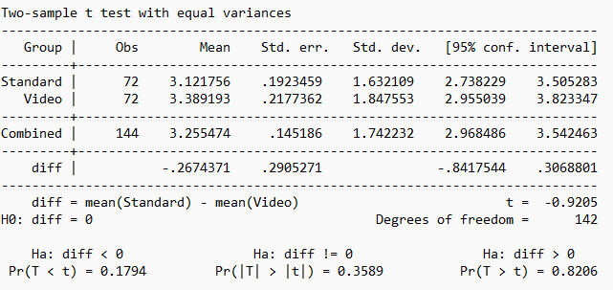

Sensitivity analysis for the secondary outcome “Patient satisfaction”
