Appendices 1: Descriptive statistics of wet and dry years across southwestern Ghana (1976-2018)
 | Sunyani | Kumasi | Abetifi | Sefwi Bekwai | Akim Oda | Saltpond | Takoradi | Axim | Averages across stations (1976-2018)
Number of wet years (+) | 20 | 22 | 20 | 17 | 19 | 23 | 23 | 20.00 | 20.5
Max wet years | 1987 | 2007 | 1984 | 2018 | 2002 | 1997 | 2017 | 1979
Max wet years intensity |  | 5.36 | 6.50 | 5.41 | 5.15 | 5.72 | 6.00 | 5.66 | 5.53
Min wet years | 2011 | 2015 | 2017 | 2006 | 1997 | 1999 | 2001 | 2005
Min wet years intensity | 0.15 | 0.00 | 0.16 | 0.48 | 0.32 | 0.19 | 0.07 | 0.39 | 0.22
Number of dry years (-) | 23.00 | 21 | 23 | 26 | 24 | 20 | 20 | 23 | 22.50
Max dry years | 2016 | 1982 | 1992 | 1977 | 1983 | 1983 | 1983 | 1983
Max dry years intensity | -4.82 | -4.82 | -4.30 | -5.19 | -4.59 | -4.60 | -5.71 | -4.24 | -5.71
Min dry years | 1999 | 2016 | 1996 | 1978 | 2016 | 2002 | 1988 | 1999
Min dry years intensity | -0.02 | -0.02 | -0.02 | -0.21 | -0.42 | -0.04 | -0.26 | -0.12 | -0.14

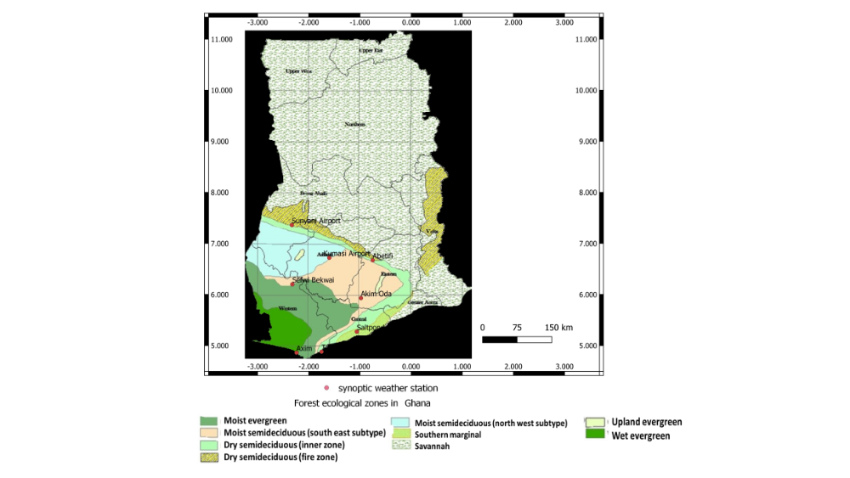

Appendix 2: Forest vegetation types in Ghana (source: Hall and Swaine, 1981)

