Table 1: Microbial population with time for Control, Control S+H, bioaugmentation, Biostimulation microcosm
Microcosm | 0 Day | 10 Day | 20 Day | 30 Day | 40 Day
1. Control | 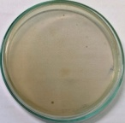  Cfu/ml=7×10² | 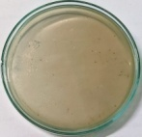  Cfu/ml=9.0×10² | 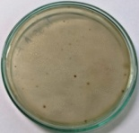  Cfu/ml=2.2×10³ | 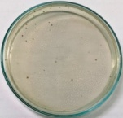  Cfu/ml=2.9×10³ | 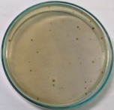  Cfu/ml=5.0×10³
2. Control S+H | 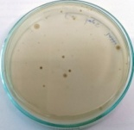  Cfu/ml=1.3×10² | 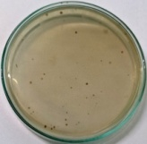  Cfu/ml=3.4×10² | 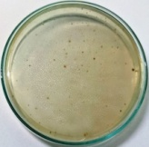  Cfu/ml=7.4×10² | 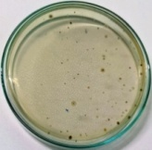  Cfu/ml=7.6×10³ | 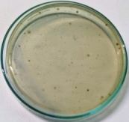  Cfu/ml=9.6×10³
Bioaugmentation | 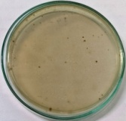  Cfu/ml=4.0×10³ | 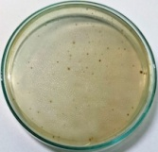  Cfu/ml=5.0×10⁴ | 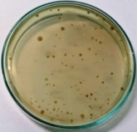  Cfu/ml=3.7×10⁵ | 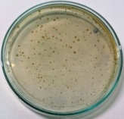  Cfu/ml=2.1×10⁶ | 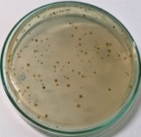  Cfu/ml=7.1×10⁵
Biostimulation | 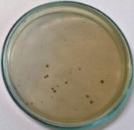  Cfu/ml=6.6×10³ | 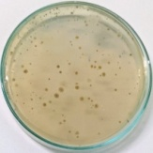  Cfu/ml=9.6×10⁵ | 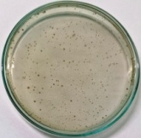  Cfu/ml=7.6×10⁶ | 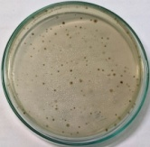  Cfu/ml=8.4×10⁵ | 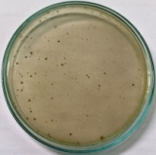  Cfu/ml=5.4×10⁴

