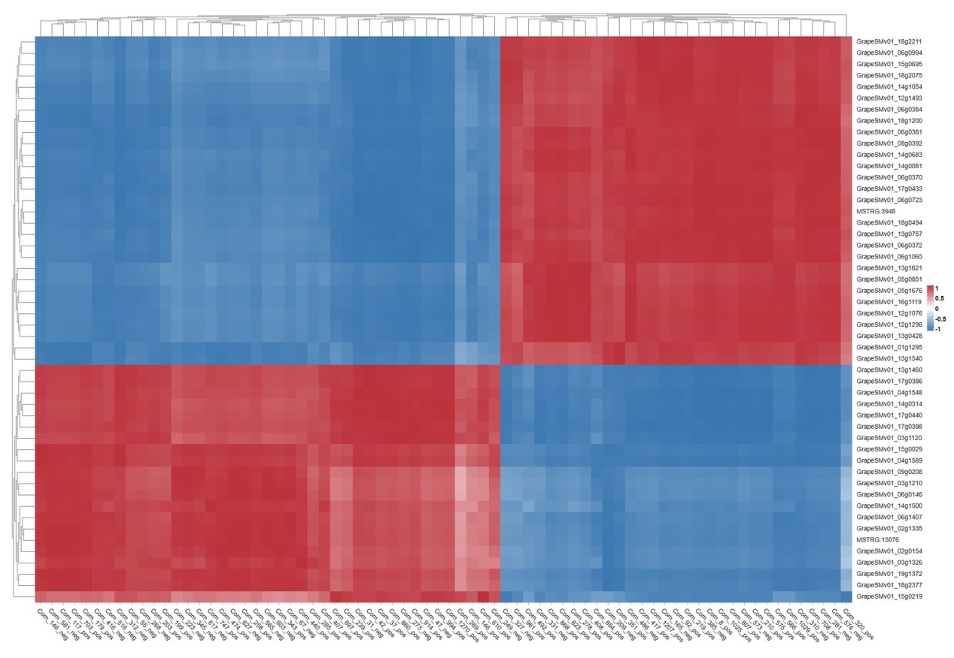
Fig. S1. Correlation among comparison groups based on the top 50 DEGs and all DAMs (72 DAMs). Heat map of the correlations between the top 50 DEGs and all DAMs. Pearson’s coefficient of gene expression and metabolite abundance was used to evaluate the correlation between genes and metabolites.

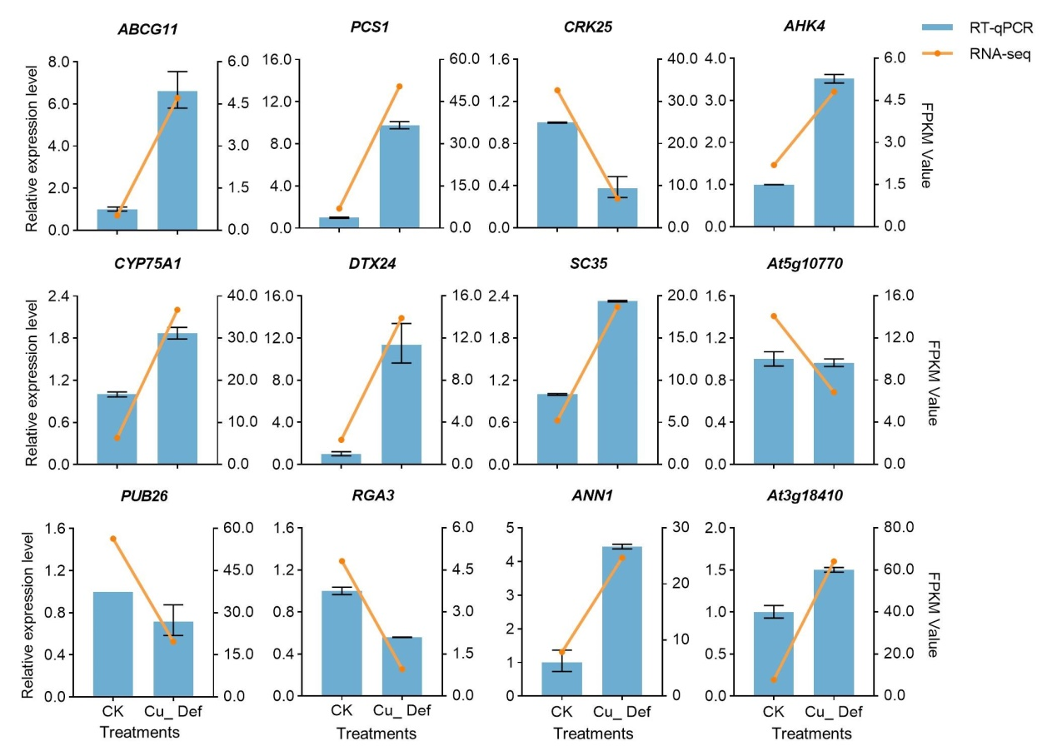
Fig. S2. Validation of RNA-seq by qRT-PCR. Verification of single gene between RNA-seq results and qRT-PCR results. The bar chart represents the relative expression level of qRT-PCR, while the broken line chart represents the FPKM value of RNA-seq.

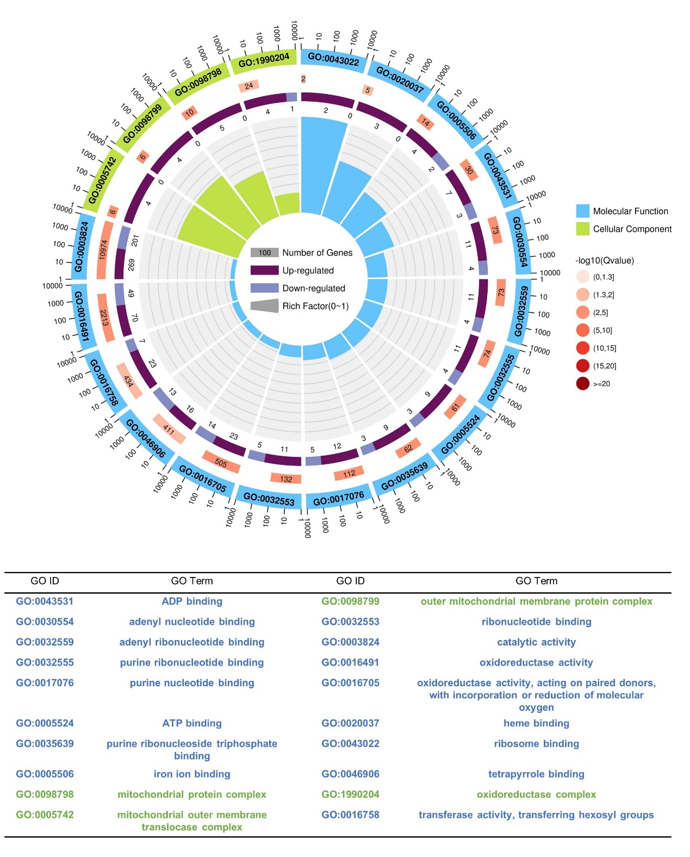
Fig. S3. Functional annotations of the DEGs GO terms in transcriptome. The information about the top 20 GO terms of all transcriptome GO terms in both control and Cu_Def. The graph above represents the enrichment cycle. The first layer of the circle represents the top 20 GO enriched GO terms, and the numbers outside the circle represent the scale of the number of genes. Blue and green represent molecular function and cellular component ontology, respectively. The second circle represents the number and Q-value of the GO terms in the background gene. The more genes there are, the longer the bar; the smaller the Q-value, the redder the color. The third circle represents a bar chart showing the proportion of up-regulated and down-regulated genes. Dark and light purple represent the proportion of up-regulated and down-regulated genes, respectively. And the specific values are shown there. The fourth circle represents the rich factor value for each GO term (the number of differential genes in the GO term divided by all the numbers), and each grid of the background grid lines represents 0.1. The following diagram shows specific GO terms that correspond to GO ID.

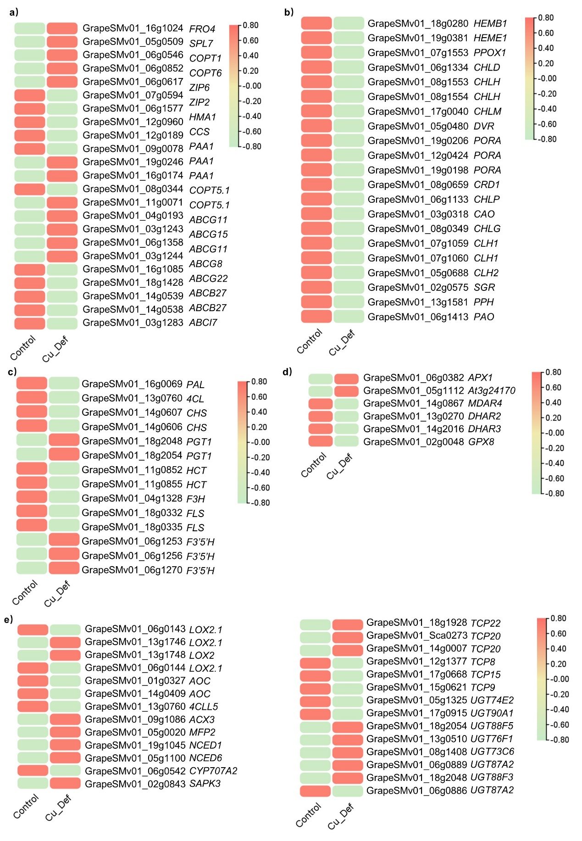
Fig. S4. Key genes related to copper uptake and transport, chlorophyll metabolism, flavonoid biosynthesis pathway, AsA-GSH cycle, and phytohormones balance. (a) Key genes related to copper uptake and transport between control and copper deficiency (Cu_Def) treatment. Light green and orange represent up-regulated and down-regulated genes, respectively. (b) Key genes related to chlorophyll metabolism between control and copper deficiency (Cu_Def) treatment. (c) Key genes related to flavonoid biosynthesis pathway between control and copper deficiency (Cu_Def) treatment. (d) Key genes related to AsA-GSH cycle between control and copper deficiency (Cu_Def) treatment. (e) Key genes related to phytohormones balance between control and copper deficiency (Cu_Def) treatment.

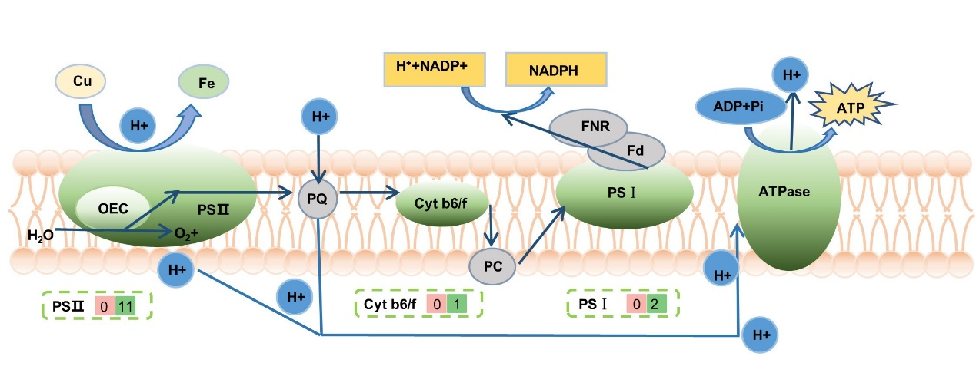
Fig. S5. The model of photosynthesis in grapevine leaves under control and copper deficiency treatment (Cu_Def). The numbers in the pink and green boxes represent the number of key genes up-regulated and down-regulated, respectively.

