Supplementary Information

A skin-conformal and breathable humidity sensor for emotional mode recognition and non-contact human-machine interface

Author List: Tongkuai Li, Hao Zhang, Li Yuan, Congcong Cheng, Junshuai Dai, Longwei Xue, Jixing Zhou, Hai Liu, Luqiao Yin, Jianhua Zhang* and Tingting Zhao*
Key Laboratory of Advanced Display and System Application, Ministry of Education, Shanghai University, 149 Yanchang Road, Shanghai, 200072, China.
E-mail: jhzhang@oa.shu.edu.cn, ttzhao@shu.edu.cn

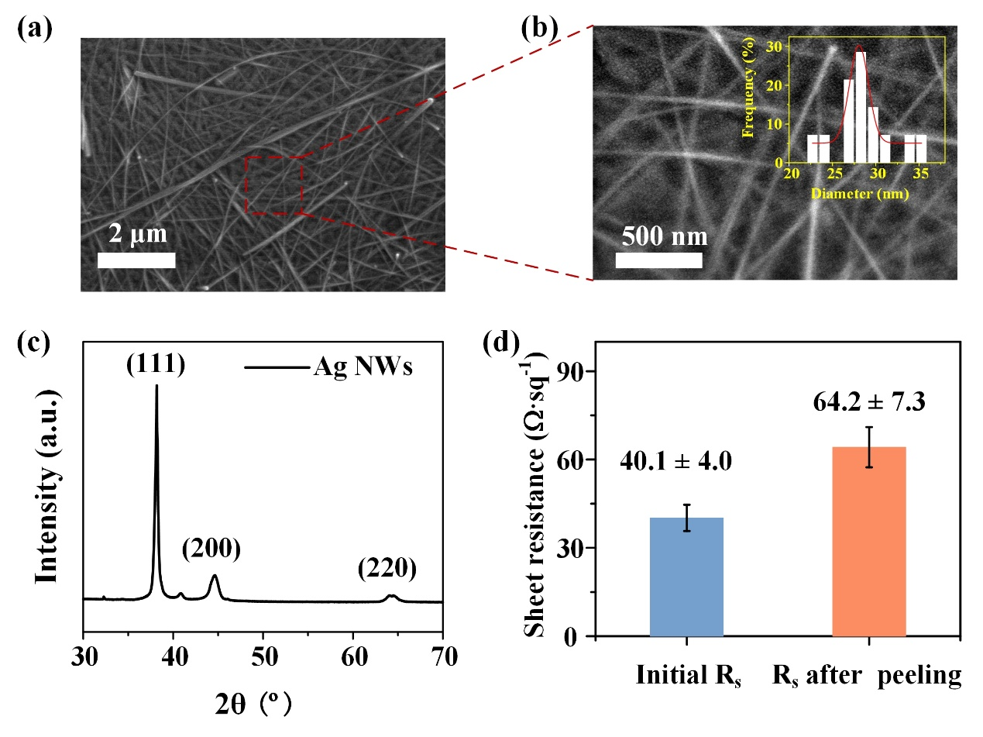

Figure S1 (a) SEM images of Ag NWs. (b) Magnified image of (a). (c) XRD spectrum of Ag NWs. (d) Sheet resistance of SBS NFs/Ag NWs before and after peeling.

As can been shown in Fig. S1(a, b), the high aspect ratio of Ag NWs with a diameter of ~29 nm and a length of ~20 μm. As can been seen in Fig. S1 (c), three diffraction peaks of 38.18°, 44.62° and 64.46° in the XRD spectrum were observed, corresponding to (111), (200) and (220) diffraction crystal planes, respectively, indicating that the silver elemental with face-centered cubic (fcc) structure was present. There were almost no other miscellaneous peaks in the spectrum, indicating that it was Ag NWs with good purity and crystallinity. Silicone-coated paper/SBS NFs/Ag NWs showed excellent electrical conductivity (sheet resistance = 40.1 ± 4.0 Ω·sq⁻¹, Fig. S1 (d)). Since SBS NFs/Ag NWs needs to be peeled off from the silicone-coated paper and transferres to other surfaces, the sheet resistance of SBS NFs/Ag NWs after peeling is measured and increased to 64.2 ± 7.3 Ω·sq⁻¹, which still has good conductivity and can be used as conductive material for IDEs.

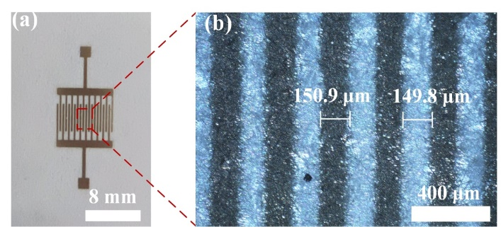

Figure S2 Photograph of IDEs (a). (b) Enlarged Optical microscopic image of (a).

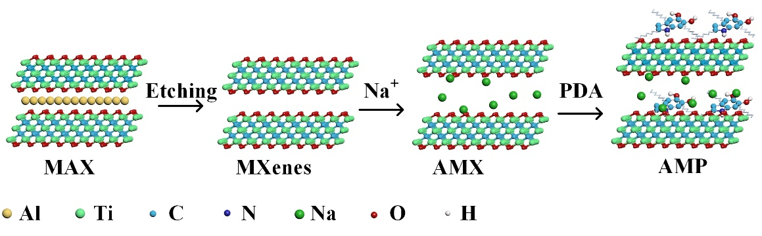

Figure S3 Schematic illustration of the fabrication process of AMP composite.

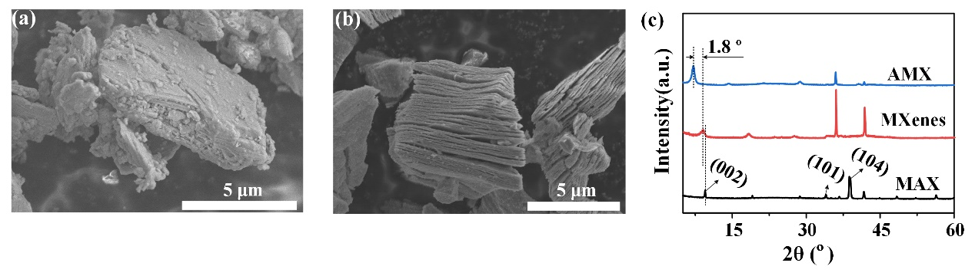

Figure S4 SEM images of (a) MAX and (b) AMX. (c) XRD spectrum of MAX, MXenes and AMX

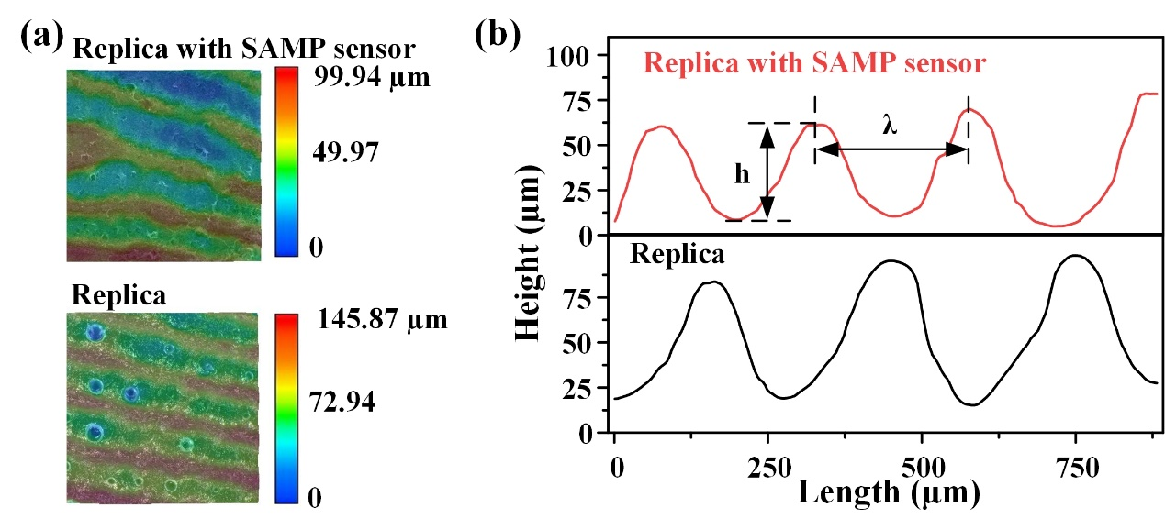

Figure S5 (a) Ultra-depth three-dimensional microscope images and (b) Surface topography profiles of the fingertip replica with (top) and without (bottom) the SAMP sensor attached.

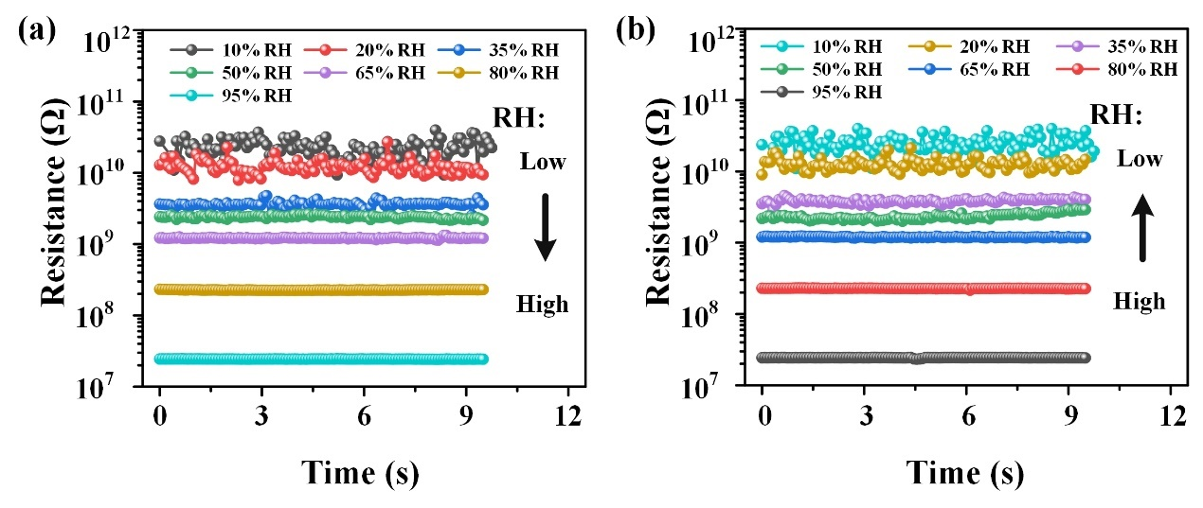

Figure S6 The resistance curves of the SAMP3 sensor in the humidity range of 10 – 95 %RH during (a) absorption process and (b) desorption process.

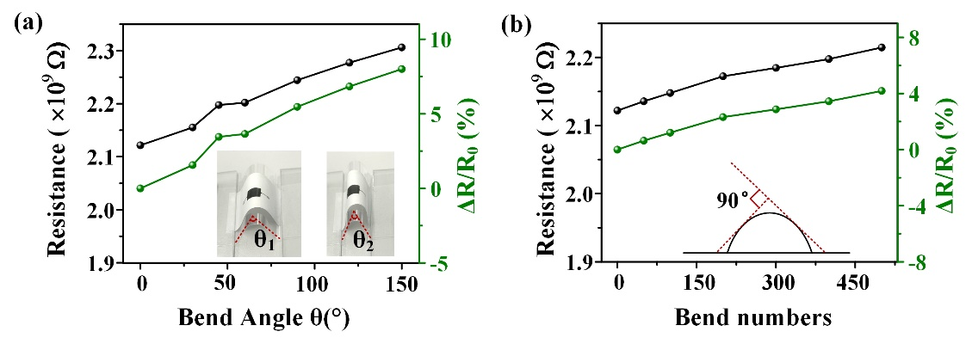

Figure S7 Resistance stability of SAMP3 sensor within the bending angles range from 0 - 150° (a) and bending times at 90° bending angle (b).

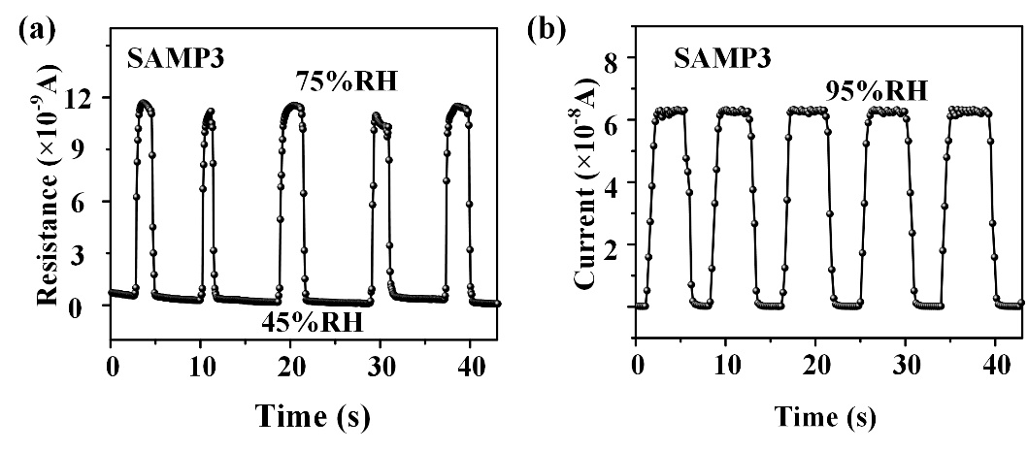

Figure S8 Repeatability test of 5 cycles for SAMP3 humidity sensor at 75%RH (a) and 95%RH (b), respectively.

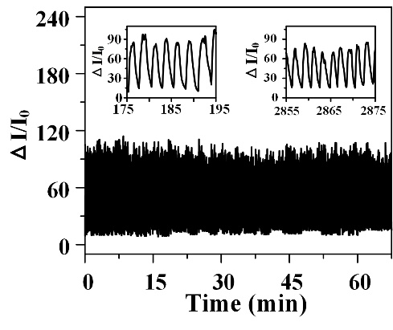

Figure S9 Durability tested of the SAMP3-based sensor to monitoring the breathing for 65 minutes.

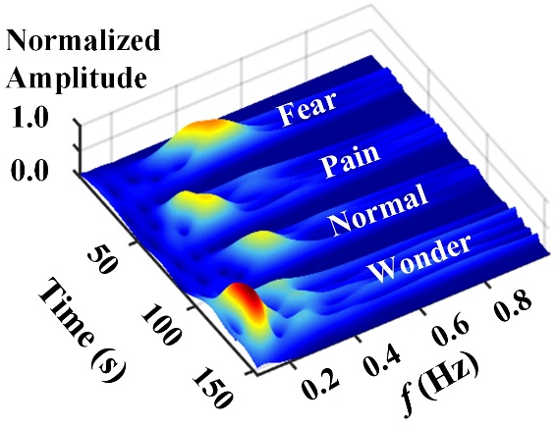

Figure S10 CWT results for the breath frequency versus time curves under fear, pain, normal and wonder emotional state.

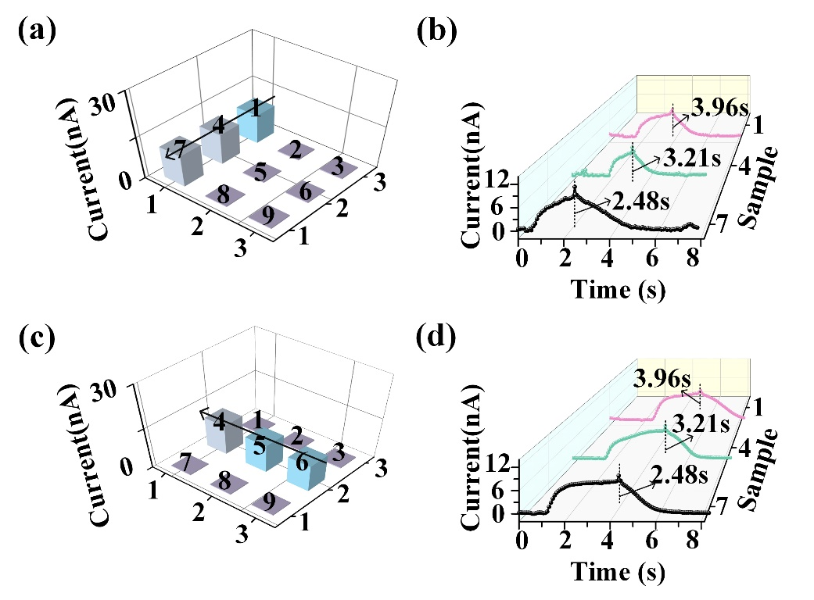

Figure S11 (a, c) Diagram of the current value distribution of the HMI. The response current-time curve of (b) the 1-4-7 sensing pixels and (d) the 6-5-4 sensing pixels.

Movie S1: Demonstration of HMI in controlling a robot car to transfer a medical kit.

Table S1. Comparison of the sensing performance of some previously reported ones with that of our SAMP3-based humidity sensor.
Sensing material | Substrate | Measurement range | Sensitivity | Time(s) |  | Thickness  (μm) | Air  permeability | Reference
 |  |  |  | Response | Recovery | Thickness  (μm) | Air  permeability | Reference
alkalized Ti₃C₂/PDA | PI | 5-95%RH | ~17875 | 0.4 | 0.5 | / | N | ³¹
alkalized Ti₃C₂T_{x} | Al₂O₃ ceramic | 11-98%RH | 300 | 1 | 201 | / | N | ³⁷
Ti₃C₂T_{x}/  chitosan-quercetin | PI | 1-90%RH | 317% | 0.75 | 1.6 | >20 | N | ⁸
Ti₃C₂T_{x}/  PDAC | PET | 10-70%RH | 46% | 0.11 | 0.22 | / | N | ³⁴
MoO₃ nanosheets | PET | 0-100%RH | 100000 | 0.3 | 0.5 | / | N | ³⁸
Paper | Paper | 30-90%RH | 10000 | / | / | ~340 | Y | ²⁰
MXenes | Fabric | 20-80%RH | ~25% | 1.15 | 8.71 | / | Y/  ~0.320 g·cm⁻²·d⁻¹ | ²³
PVA NFs/Au | Au/PVA NFs | 25-97 %RH | ~30% | 148 | 110 | <10 | Y/  ~0.113 g·cm⁻²·d⁻¹ | ²⁴
PVA NFs/graphene | Glass | 10-80 %RH | ~66.4% | 11 | 35 | / | N | ²⁹
PA66 NFs/MG | PA66 NFs/MG | 0.1-90 %RH | ~34% | / | / | / | Y | ³
alkalized MXenes/PDA | SBS NFs | 10-95 %RH | 704 | 0.9 | 0.9 | ~26 | Y/  0.078 g·cm⁻²·d⁻¹ | This work

