Supplemental Material
1. Bioenzyme selection
Macromolecules in stains are mainly composed of proteins, lipids, and polysaccharides. The laundry detergents in daily life contain enzymes that include protease that can breaks down proteins, lipase that can breaks down lipids, and amylase and cellulase that can break down sugar stains and small fuzz balls on clothes. Because lipase, amylase, and cellulase can easily cause ink removal and degradation of the fibrous structure of paper, enzymes for cleaning paper artifacts will be selected from proteases.
Protease in microbial detergents is screened by evaluating the content and composition of amino acids in mold-stained paper mockup samples. Extract 1g of mold-stained paper mockup samples, add 5ml of 6mol/L HCl, then add 3-4 drops of octanol, perform a vacuum in an ice bath, and place it at 105°C for 24 hours. Cool the sample to room temperature and transfer it to a volumetric flask. Neutralize the hydrolysate with a 6 mol/L NaOH solution, fix the volume with 0.02 mol/L HCl, and then filter and measure. The standard feed volume for both the amino acid mixture and the mold-stainedpaper mockup sample are 50uL. Based on the retention time of standard components, establish the upper and lower time limits for each amino acid peak, and then measure the sample. Compare and characterize the retention times of component peaks in standard reference samples and actual samples, and automatically calculate the area of component peaks in standard samples. The content of each amino acid component in the sample is calculated using the absolute standard curve method.

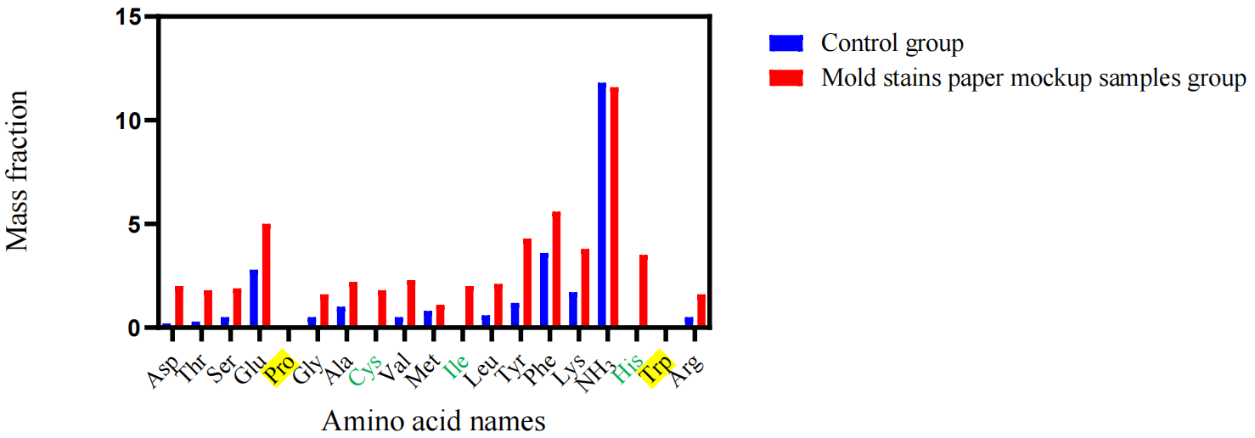

Fig. 1 Amino acid composition and content in the mold-stained paper mockup samples
The mold-stained paper mockup samples and the control group together contained up to 14 amino acids. The amino acid contents in the mold-stained paper mockup samples were about 20-30 times that of the samples in the control group. Additionally, cysteine, isoleucine, and histidine were detected only in the mold-stained paper mockup samples, while neither group had proline and tryptophan (Fig.1). Based on the amino acid composition and content, papain, alkaline protease, and trypsin were selected as the main protease components. Papain is a cysteine protease of the peptidase C1 family and acts on peptide bonds formed by L-arginine, L-lysine, and glycine in proteins. It can break down proteins in acidic, neutral, and alkaline environments and is heat resistant, even able to remain active at 90°C. Alkaline protease accounts for more than 50% of the world's total enzyme production. Its catalytic site is serine, and it works best under pH 9-11 alkaline conditions at 40-55°C. Outside this range, the enzyme's activity decreases. Both heavy metal ions and cationic surfactants have inhibitory effects on its activity. Trypsin is a serine protein hydrolase. It specifically hydrolyzes peptide bonds composed of basic amino acids (arginine and lysine) and is also an endopeptidase with strong protein hydrolysis ability. Upon visual inspection, all three enzymes showed good cleaning effects for removing mold stains from paper mockup samples. However, the tensile strength of the paper samples cleaned with alkaline protease significantly decreased (by 19.03% and 15.79% respectively), and its whiteness was lower than that of paper samples treated with the other two enzymes. Its acidity value was also higher and alkaline (with a pH between 9-10), which is not conducive to the long-term preservation of cleaned paper samples. The operating conditions for trypsin and papain are mild, safe, and stable. Therefore, trypsin and papain were selected as the enzymatic components in the bio-based cleaning agent.

2. Selection of solvent
Water used as solvent was selected between deionized water, distilled water, purified water, tap water, and hard water. Systematic review of each type of water is summarized in Table 1 after extensive literature review.

Name | Characteristic | Post-cleaning pH | Impurities,  Ion Content | Cleaning Performance | Preparation Cost
Deionized water | The conductive medium has been almost entirely removed. Colloidal particles, microorganisms, dissolved gases, and organic substances in the water have also been reduced to the minimum. Strong ability to clean contaminants from paper. | Increased  by 1.40 | Lowest | Strong | High
Distilled water | The most popular type of water used in laboratories. High purity, free from impurities, low ion content. Has the ability to absorb and dissolve other ions. Effective for removing contaminants and products of fiber aging from paper. | Increased  by 1.37 | No impurities, Low ion content | Good | Relatively low
Purified water | After multiple layers of filtration, it is equivalent to pure water and is considered extremely soft water. Also slightly acidic. | Increased  by 1.05 | Low | Insignificant | Relatively high
Tap water | It is water used in daily lives. The water has a high degree of hardness, and it contains impurities and bacteria. | Increased  by 1.66 | High impurity content | Bad | Low
Hard water | It contains a certain concentration of carbonate ions, which causes alkalinity. However, the calcium and magnesium ions in hard water can affect cleaning, making the rinsing process more difficult after cleaning. | Increased  by 1.90 | High ion content | Bad | Relatively low

Table 1 Cleaning Water Screening

According to Table 1, purified water cannot achieve optimal cleaning effect. Tap water and hard water both contain considerable impurities this resulting in poor cleaning quality. Deionized water and distilled water are suitable for cleaning mold stains on paper. Considering distilled water as the popular lab-use water, which are easy to access and have low production cost, it was selected as the cleaning water component.
3. Application Condition (enzyme concentration, temperature, and time duration) Selection
（1）Construct enzyme solution at different concentrations using distilled water and infiltrate the mold-stained paper mockup sample inside for 30 minutes at 35℃. The enzyme solution was removed using distilled water siphoning. After air dried, the paper's properties were tested. The results can be seen in Fig.2.

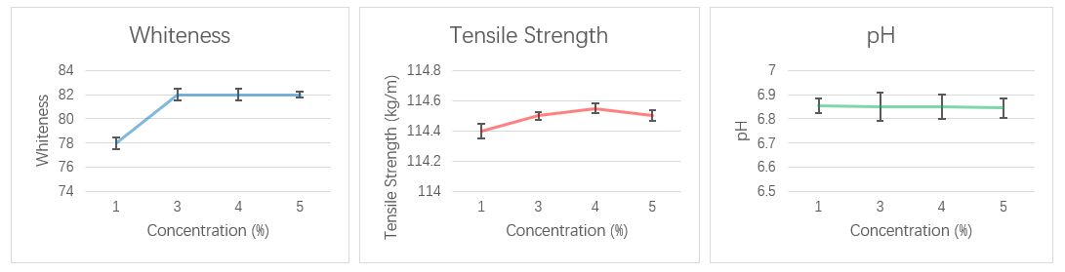
Fig. 2 Change curves of three evaluation metrics of mold-stained paper mockup samples after different concentrations of enzyme treatment
As seen from the Fig.2, with the increase in enzyme solution concentration, there is no significant change in mechanical strength and the pH level of the paper sample. However, the whiteness noticeably increased, when increasing concentration from 1% to 3%, and it remains almost unchanged when further increase the concentration. When the concentration of enzyme exceeds 4%, a slight white powdery substance precipitates after the cleaned paper sample is air dried, affecting its glossiness. Therefore, the optimal concentration is chosen to be 3%.
（2）Using enzyme solution at 3% concentration to submerge mold-stained paper mockup samples at different temperatures for 30 minutes. Remove the enzyme solution using distilled water siphoning, air dried, and test for papers’ quality. Results can be seen in Fig.3.
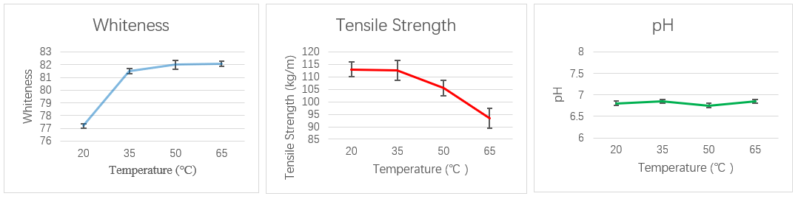
Fig. 3 Change curves of three evaluation metrics of mold-stained paper mockup samples after different infiltration temperature
According to Fig.3, the whiteness shows notable increase when increasing temperature to 35°C and did not further increase when further increasing the temperature. The pH level show no significant changes. However, the tensile strength significantly decreases; at 65°C, the tensile strength drops by 35.6% compared to 35°C. After comprehensive analysis, the optimal infiltration temperature is chosen to be 35°C.
（3）Submerge mold-stained paper mockup samples in 3% enzyme solution at 35°C for different time durations. Remove the enzyme solution using distilled water siphoning, air dried, and test for papers’ quality. Results can be seen in Fig.4.
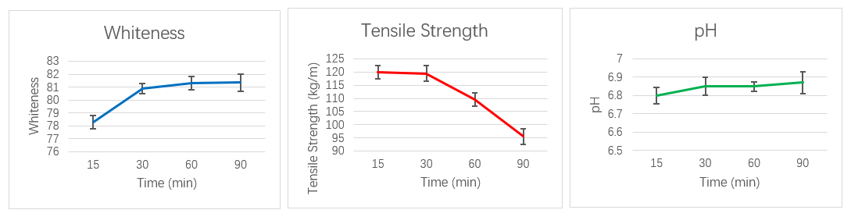
Fig. 4 Change curves of three evaluation metrics of mold-stained paper mockup samples after different infiltration time
According to Fig.4, when the infiltration time is extended from 15 minutes to 30 minutes, the paper's whiteness increases by 2.6 units, while the tensile strength show no significant differences. After 30 minutes, the increase in whiteness plateaued while the tensile strength showed noticeable decrease. The pH is not affected by the Infiltration time. After comprehensive analysis, 30 minutes is chosen as the optimal cleaning condition.

