Supporting Information

High-quality HfO₂/HfSe₂ gate stack for low-power steep-switching computing devices
Taeho Kang^{1,2}, Joonho Park³, Hanggyo Jung⁴, Haeju Choi^{1,2}, Nayeong Lee^{1,2}, Jongwook Jeon⁵, Yong-Hoon Kim³*, and Sungjoo Lee^{1,2,6}*
¹SKKU Advanced Institute of Nanotechnology (SAINT), Sungkyunkwan University, Suwon 16419, Korea
²Department of Nano Science and Technology, Sungkyunkwan University, Suwon 16419, Korea
³School of Electrical Engineering, Korea Advanced Institute of Science and Technology (KAIST), Daejeon 34141, Korea
⁴Department of Semiconductor Convergence Engineering), Sungkyunkwan University, Suwon 16419, Korea
⁵School of Electronic and Electrical Engineering), Sungkyunkwan University, Suwon 16419, Korea
⁶Department of Nano Engineering, Sungkyunkwan University, Suwon 16419, Korea

E-mail: leesj@skku.edu

Contents
Supplementary section 1: Device fabrication process

Supplementary section 2: Characterization of the HfO₂/HfSe₂ heterostructure
a. Characterization of oxidation rate
b. Structural analysis of the HfO₂/HfSe₂ heterostructure
c. XPS depth profiling of the HfO₂/HfSe₂ heterostructure
d. Stoichiometry of the converted HfO₂

Supplementary section 3: Mechanistic study based on density functional theory
a. HfO₂/HfSe₂ interface models
b. HfSe₂ oxidation mechanism at deep HfO₂/HfSe₂ interface

Supplementary section 4: HfO₂/HfSe₂ FET
a. Structure and electrical characteristic of HfO₂/HfSe₂ based FET
b. Reproducibility of HfO₂/HfSe₂ based FETs
c. Dielectric properties of the converted HfO₂ at various thickness
d. Field effect mobility
e. TCAD device simulation environments
f. SS characteristics and gate leakage current w.r.t. various D_{it}
g. Intrinsic RC delay according to various D_{it}
h. Plasma power dependency of HfO₂/HfSe₂ interface quality
Supplementary section 5: HfO₂/HfSe₂ I²-FET
a. OM/SEM image of I²-FET
b. Multiplication factor within steep switching transition
c. Steep switching behavior at various operating and supply voltage
d. Further scaling of the operating voltage by adjusting device dimensions
e. TCAD device simulation environments
f. Exploring further supply voltage scaling

Supplementary section 1: Device fabrication process
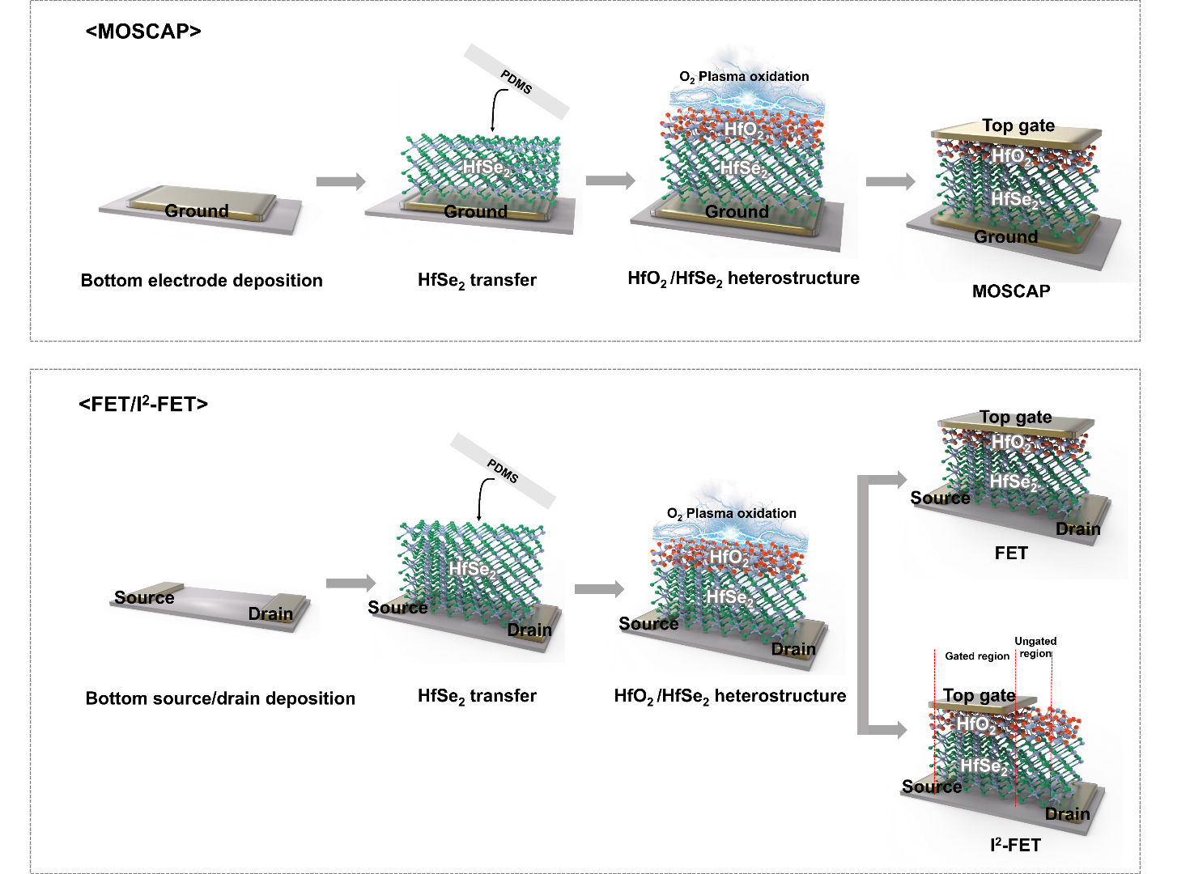
Figure S1. Schematic illustrations of the HfO₂/HfSe₂ based MOSCAP, FET, and I²-FET fabrication process.
Figure S1 illustrates the MOSCAP, FET, and I²-FET fabrication processes using an HfO₂/HfSe₂ gate stack. To fabricate the bottom electrodes, we spin-coated electron resistor layers in poly (methyl methacrylate) (PMMA) at 450 K and 2000 rpm for 5 s and at 950 K and 4000 rpm for 35 s on the SiO₂/Si substrate. Each layer was baked at 180 °C for 2 min on a hot plate. Subsequently, we defined the source and drain electrode patterns using electron beam lithography (EBL), and Au (~10 nm) was deposited in a high-vacuum chamber (5 × 10⁻⁷ Torr) using an electron beam evaporator. And the multilayer HfSe₂ films were mechanically exfoliated using the scotch tape method and dry-transferred onto a source/drain using PDMS. These processes were performed in a glove box (both O₂ and H₂O concentrations were below 0.1 ppm) to avoid unwanted oxidation of HfSe₂ during the transfer process. Then, we carried out O₂ plasma oxidation using an RIE plasma reactor (power of 10–30 W, O₂ flow rate of 5 sccm, and pressure of 470 mTorr) to form an HfO₂ layer on the top surface of HfSe₂, thereby fabricating the HfO₂/HfSe₂ heterostructure. Subsequently, the EBL/EBD processes were carried out again for the top-gate electrode (Au, ~50 nm). Unlike the FET in which the channel was fully covered by the top-gate electrode, the I²-FET was fabricated with a locally gated region closer to the source, whereas the side close to the drain formed an ungated region where impact ionization occurred under a critical electric field.
Supplementary Section 2: Characterization of the HfO₂/HfSe₂ heterostructure
a. Characterization of oxidation rate
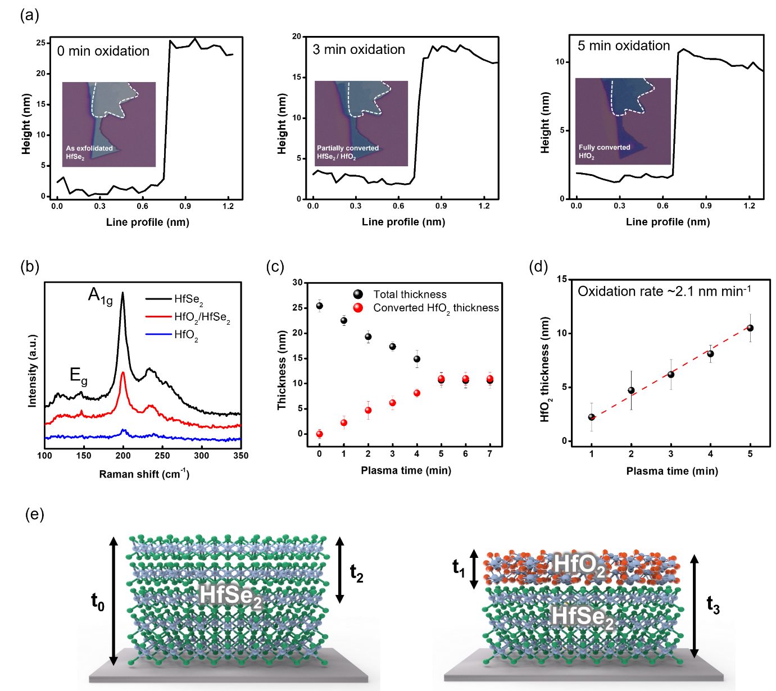
Figure S2. (a) Height profiles (inset: corresponding OM images varying with plasma time). (b) Raman spectrum of the as-exfoliated HfSe₂, a partially converted HfO₂/HfSe₂, and fully converted HfO₂. (c) Total thickness of the HfSe₂ flake and the converted HfO₂ thickness as a function of the plasma time. (d) Conversion rate of HfO₂ from HfSe₂ under the given plasma oxidation conditions (power of 10 W, flow rate of 5 sccm, and pressure of 470 mTorr). (e) Schematic diagram for the definition of several parameters in the converted HfO₂ thickness calculation.

The thicknesses of the as-exfoliated HfSe₂, partially converted to HfO₂/HfSe₂, and fully oxidized HfO₂ with increasing plasma treatment time are shown in Fig. S2a. Considering the molecular mass (336.41/210.5) and density (6.54/9.68 g cm⁻³) of HfO₂/HfSe₂, the volume ratio of HfO₂ converted from HfSe₂ was estimated to be 1:2.3, which resulted in the difference between the thicknesses of as-exfoliated HfSe₂ (∼25 nm) and fully converted HfO₂ (~11 nm) exhibiting the total thickness decrease (Fig. S2c). Each step was confirmed using Raman spectroscopy, as shown in Fig. S2b. The reduced A_{1g} Raman peak (red curve) after 3 min of plasma treatment indicates the presence of unconverted single-crystalline HfSe₂ layers under the converted HfO₂ after plasma treatment. The A_{1g} Raman peak disappeared after full oxidation (blue curve) once HfSe₂ was converted to amorphous HfO₂. However, we could not directly obtain the thickness of converted HfO₂ by AFM in the HfO₂/HfSe₂ heterostructure because the measured thickness included both unconverted HfSe₂ and converted HfO₂. Therefore, we applied an indirect approach to determine the thickness of the converted HfO₂ thickness as discussed below.
We first define the relevant factors, as marked by the black arrows in Fig. S2e. The thickness of the as-exfoliated HfSe₂: t₀, thickness of the converted HfO₂: t₁, thickness of the original HfSe₂ converted to HfO2: t₂, and total thickness of the HfO₂/HfSe₂ heterostructure: t₃. The quantitative relationships between these factors are as follows: The thickness difference between the as-exfoliated HfSe₂ (t₀) and HfO₂/HfSe₂ heterostructures (t₃) is the same as the thickness difference between the original HfSe₂ converted to HfO₂ (t₂) and the converted HfO₂ (t₁), with the following relationship: t₀- t₃ = t₂- t₁. Furthermore, as mentioned above, the thickness of the original HfSe₂ converted to HfO₂ (t₂) is 2.3 times thicker than that of the converted HfO₂ (t₁): t₂ = 1.8 t₁.
Considering the two equations (t₀–t₃ = t₂–t₁ and t₂ = 1.8 t₁), we derived the equations t₀–t₃ = 1.8 t₁- t₁ = 0.8 t₁. The thicknesses of the as-exfoliated HfSe₂ (t₀) and HfO₂/HfSe₂ heterostructures (t₃) can be directly determined using AFM. Thus, the thickness of the converted HfO₂ (t₁) layer in the HfO₂/HfSe₂ heterostructure can be extracted using the above quantitative relation (Fig. S2d). From thickness information of converted HfO₂, we extracted the oxidation rate (2.19 nm/ min), and a constant oxidation rate was observed in various 25 nm flake. This result confirmed the high controllability of the plasma oxidation process.

b. Structural analysis of the HfO₂/HfSe₂ heterostructure
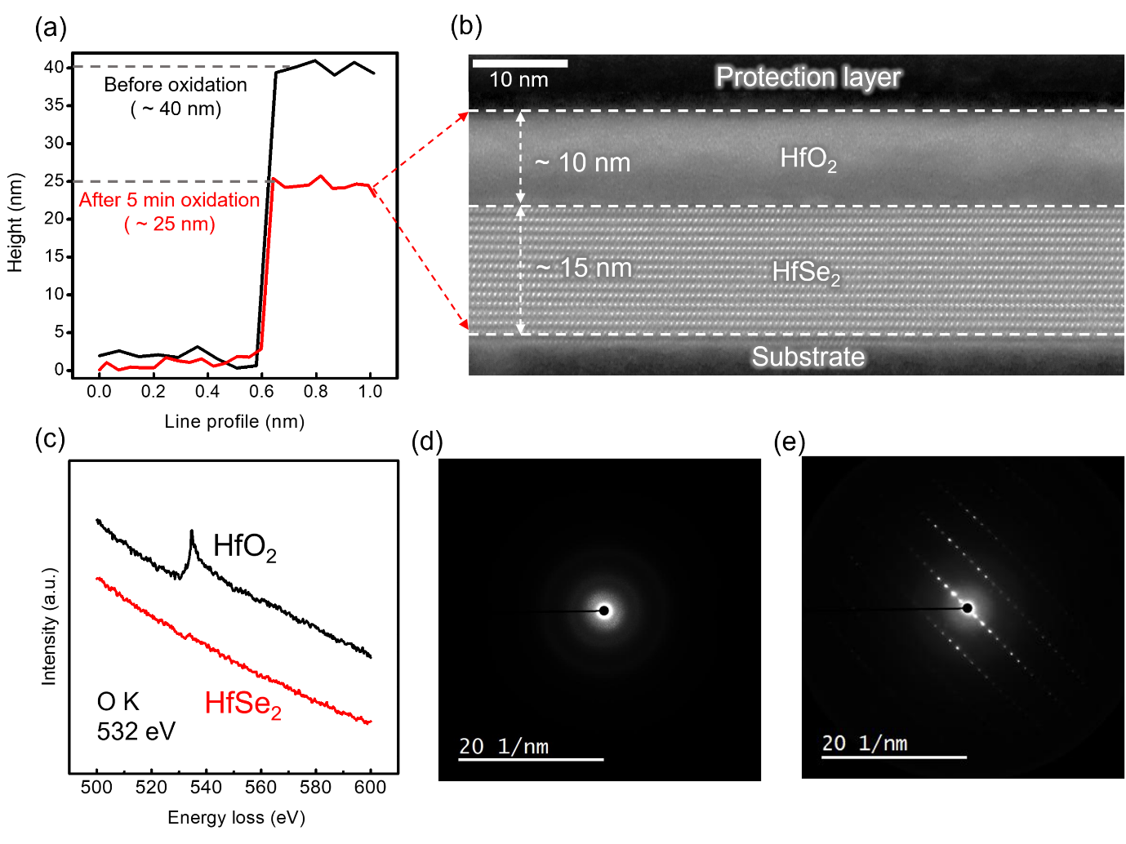
Figure S3. (a) Height profile of the pristine HfSe₂ before oxidation and HfO₂/HfSe₂ heterostructure after 5 min plasma oxidation corresponding to (b) STEM image exhibiting 10 nm HfO₂ and 15 nm HfSe₂ layer. (c) EELS spectrum of HfO₂/HfSe₂ heterostructure. SAED patterns of (d) converted HfO₂ and (e) unconverted HfSe₂ layer.

c. XPS depth profiling of the HfO₂/HfSe₂ heterostructure
The XPS depth-profiling analysis of the HfO₂/HfSe₂ heterostructure is shown in Fig. S4. We prepared the sample by converting ~10.5 nm HfO₂ (5 min plasma treatment at a power of 10 W, flow rate of 5 sccm, and pressure of 470 mTorr) from the top surface of the multilayer HfSe₂. We reduced the HfO₂/HfSe₂ heterostructure thickness by ∼2.5 nm for each thinning step with a sputtering rate of 0.5 nm min⁻¹, and the XPS spectra were monitored after each thinning step.
We investigated the XPS spectrum at 5 different positions: after 2.5 nm thinning (P1), 5 nm thinning (P2), 7.5 nm thinning (P3), 10 nm thinning (P4), and 12.5 nm thinning (P5). At position P1, no Se 3d spectrum was detected, which indicated the complete removal of selenide, exhibiting two O 1s peaks at 532 and 531 eV, corresponding to the typical O 1s peaks of HfO₂ and oxide impurities that may have been introduced during the sample preparation process. This indicates that HfSe₂ was completely converted to HfO_{2,} and the same results were observed at position P2. For position P3, HfO₂ was almost completely removed, resulting in the XPS detection of the unconverted HfSe₂ region. The Se 3d spectrum was also observed. For position P4, the HfO₂ was completely removed, and the Se 3d spectrum had a higher intensity than position P3, with no HfO₂ component in the O 1s spectrum (same for Position P5).
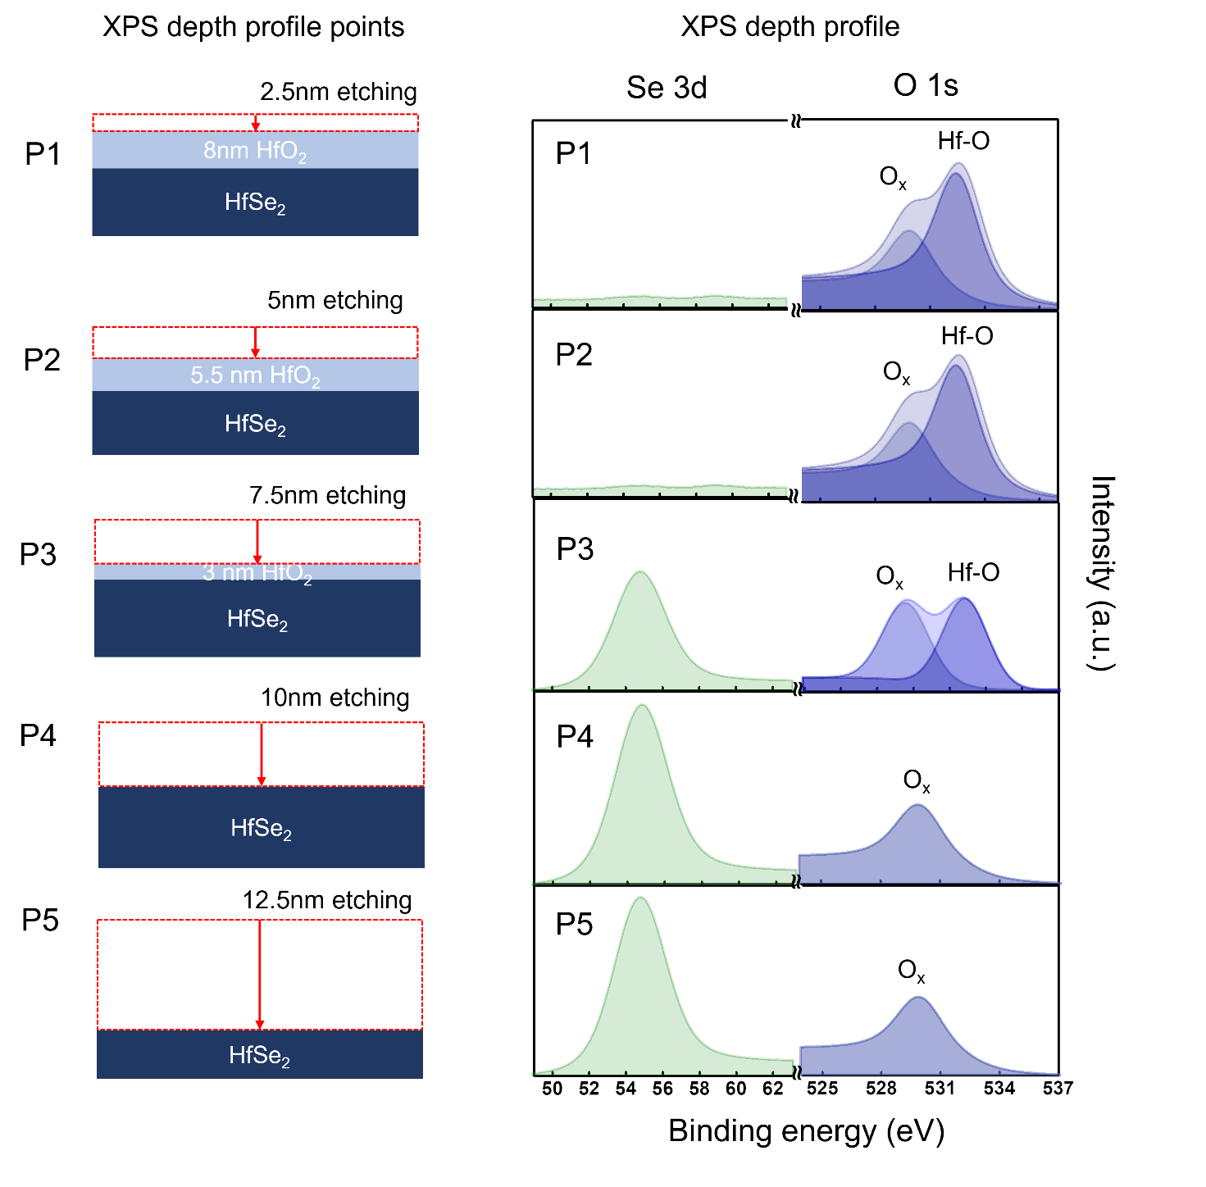
Figure S4. XPS depth profiling of the HfO₂/HfSe₂ heterostructure.
d. Stoichiometry of the converted HfO₂
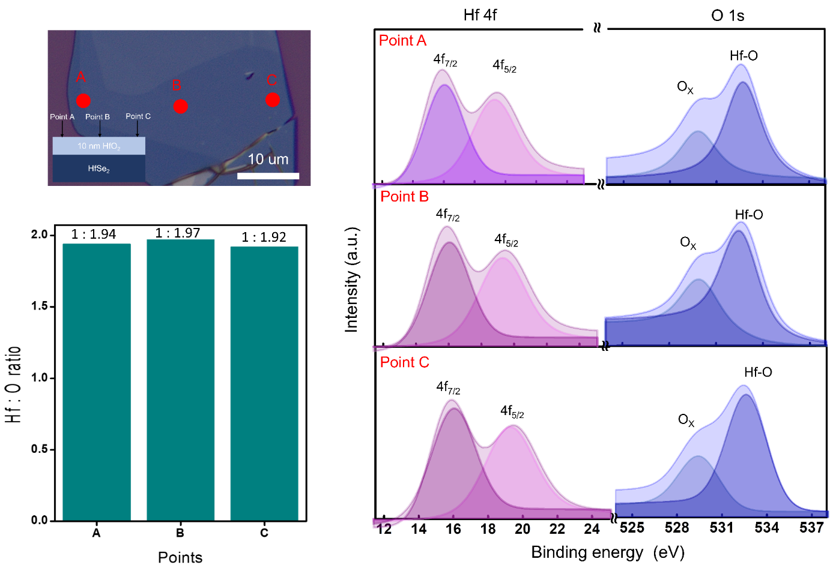
Figure S5. Ratio of Hf and O based on XPS analysis measured at different 3 points (A, B, and C in the OM image) on the converted HfO₂.
FigureS5 shows the Hf:O ratio obtained from the XPS analysis. To calculate the atomic percentage, we considered the atomic sensitivity factors¹ that are satisfactory for quantitative work using the following equation (Eq. 1):
Atomic % of elemental composition = $\frac{\frac{I_{x}}{sx}}{Σ_{i}\frac{I_{i}}{s_{i}}}×100\%$ (1)
where I_{x} is the relative peak area of photoelectrons from element x, S_{x} is the atomic sensitivity factor of element x, $Σ_{i}\frac{I_{i}}{s_{i}}$ is the peak area/sensitivity factor of all other elements. The peak area of each element x was calculated from the survey scan XPS patterns obtained using Avantage software. For example, calculating the atomic % of Hf:O = 1:1.97, we obtained a relative peak area of Hf and O (I_{Hf} = 3138.46 and I_{O} = 1977.22, respectively) using the Avantage software.
From Eq. (1), we calculated the atomic concentration as follows:
Hf % = $\frac{\frac{3138.46}{2.221}}{\frac{3138.46}{2.221}+\frac{1977.22}{0.711}}$ x 100 = $\frac{1413.8}{4193.9}$ x 100 = 33.7 %
O % = $\frac{\frac{1977.22}{0.711}}{\frac{3138.46}{2.221}+\frac{1977.22}{0.711}}$ x 100 = $\frac{2780.9}{4193.9}$ x 100 = 66.3 %

Supplementary section 3: Mechanistic study based on density functional theory
a. HfO₂/HfSe₂ interface models
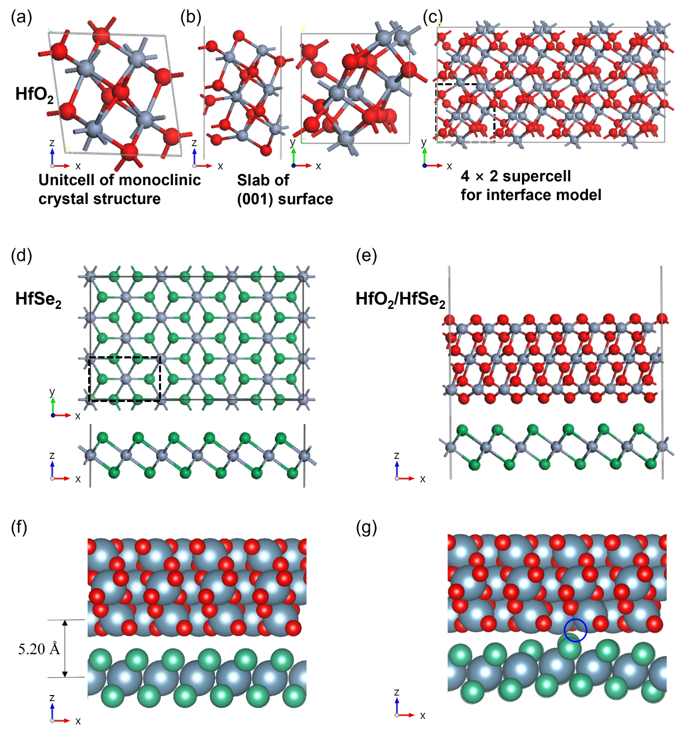
Figure S6. Construction of the HfO₂/HfSe₂ interface and introduction of oxygen vacancies (V_{O}). (a) From the monoclinic HfO₂ crystal structure, (b) the (001) surface was constructed. (c) (4 × 2) supercell of the slab structure is made for the interface model. (d) Top and bottom side view of the (3 × 3) supercell of two-dimensional HfSe₂ monolayer is displayed. (e) The interface model was obtained by stacking both slab structures of (c) and (d). The black dashed lines denote the unit cell of both slab structures. The relaxed structures of (f) the pristine and (g) interfacial single V_{O}-introduced HfO₂/HfSe₂ interface model. The blue circle denotes the position of the V_{O} site. (Color scheme: Hf, grey; Se, green; O, red)

The computational models were prepared as shown in Figs. S6a–e. As for the oxide layer, the (001) surface of monoclinic HfO₂ (m-HfO₂) was made, which is the most prominent surface during HfO₂ growth². By fully relaxing m-HfO₂, we obtained the lattice parameters (a = 5.112 Å, b = 5.171 Å, c = 5.295 Å, β = 99.6°), which are in good agreement with previous reports^{3,4}. Then, we constructed the (001) HfO₂ surface model by introducing a vacuum space along the z direction. . As for HfSe₂ layer, the hexagonal crystal structure (a = 3.717 Å, c = 6.106 Å) was converted into a slab structure (a = 6.439 Å, b = 3.717 Å). Reflecting the experimental condition in which the oxide layer was grown on the underlying HfSe₂ layers, the (4 × 2) supercell of the HfO₂ layer (a = 20.448 Å, b = 10.342 Å) was adjusted to the (3 × 3) supercell of the HfSe₂ monolayer (a = 19.317 Å, b = 11.151 Å). The HfO₂ slab was modeled with three HfO₂ layers, so, because one HfO₂ layer is composed a Hf layer made of 16 Hf atoms and accompanying top and bottom O layers each of which made of the same number of O atoms, the oxide layer contains 48 Hf atoms and 96 O atoms. In the HfSe₂ monolayer, there are 18 Hf atoms and 36 O atoms, with half on top and the other half beneath the Hf layer. After the energy relaxation of the interface model as shown in Fig. S6f, the top Hf layer of HfO₂ was fixed in the consecutive calculations where defects and oxygen adatoms are introduced. In Fig. S6 g, we show the case where a single oxygen vacancy (V_{O}) is introduced on the interfacial HfO₂ layer. In this case, the energy relaxation shows that the V_{O} site attracts Se atoms, making the HfSe₂ layer bends toward the HfO₂ V_{O} site.

b. HfSe₂ oxidation mechanism at deep HfO₂/HfSe₂ interface
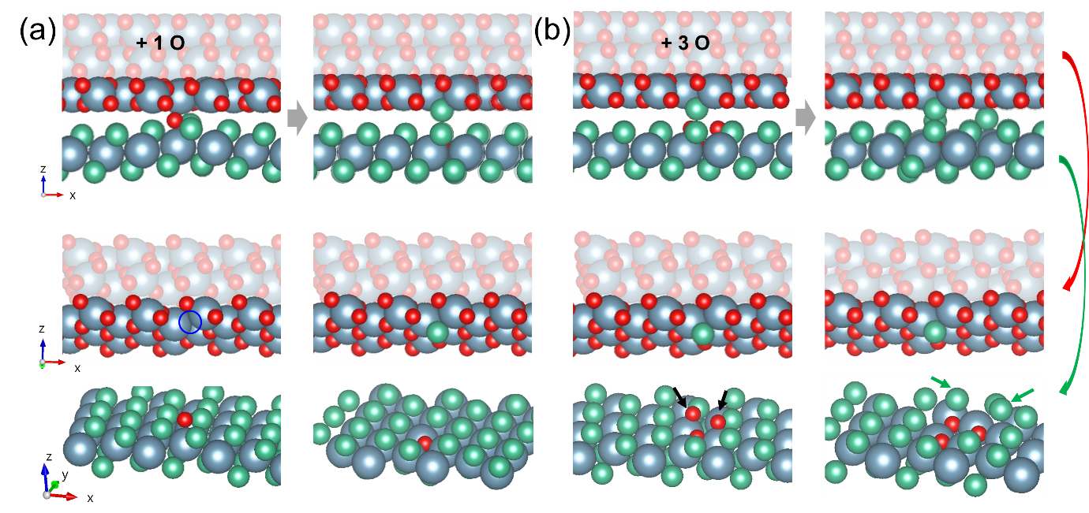
Figure S7. Oxidation mechanism of HfSe₂ at the HfO₂/HfSe₂ interface. (a) A single O atom is inserted (left) below the V_{O} site and fully optimized with the fixed constraint of the top Hf layer (right). The blue circle in the middle figure indicates the V_{O} site. (b) Following the optimized structure of (a), two more O atoms (black arrows) are inserted near the V_{O} site (left) and then fully relaxed (right). The green arrows designate the extracted Se atoms. Middle and bottom figures are the perspective view with respect to the interface. Note that a Se atom is attached to V_{O} site of HfO₂ interfacial surface. (Color scheme: Hf, grey; Se, green; O, red)

The detailed structures of Fig. 2a, and b are presented in Fig. S7. When an O atom was dropped from the vacancy channel (Fig. S7a, left), it was located on the Hf atom below the V_{O} site. It then approached and replaced a Se atom. The extracted Se atoms were attracted to the vacancy channel. In these figures, one Se atom was attached to a V_{O} site. During oxidation, the vacancy channel functions as an excretion channel for the Se atoms. In Figure S7b, two more O atoms are consecutively inserted into the nearby Hf atoms, as indicated by the black arrows. Each O atom expels an adjacent Se atom and occupies a triple-bridged site bonded to three Hf atoms. The expelled Se atoms moved to the top site of nearby Hf atoms without forming any bonds with the intruding O atoms. Therefore, the extracted Se atoms are mobile between the top sites of the Hf atoms at the interface.

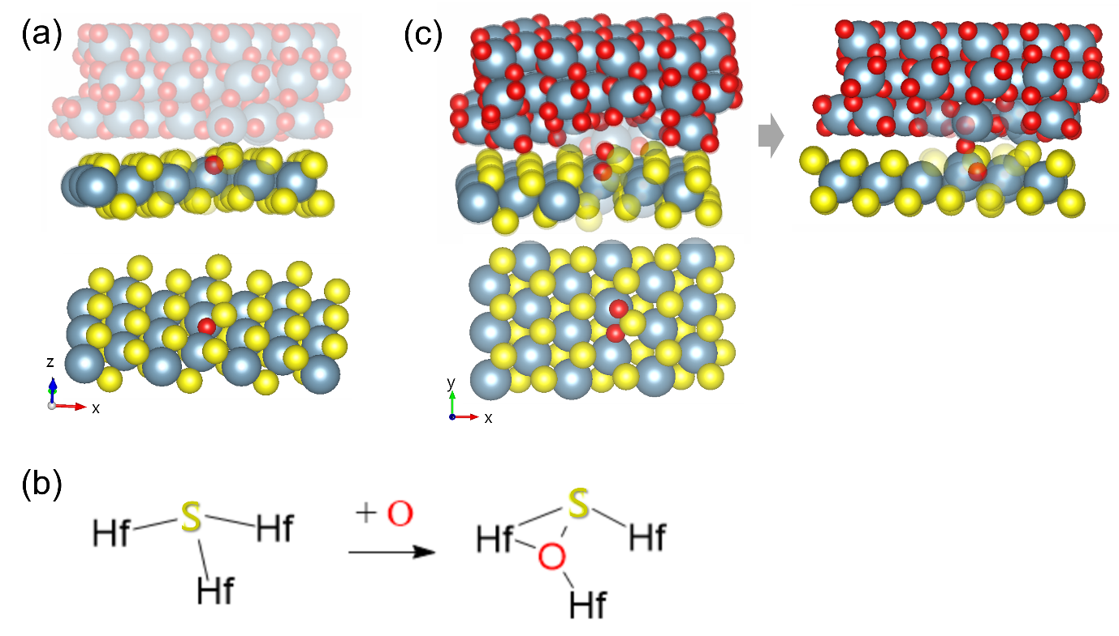
Figure S8. Oxidation mechanism of the HfS₂ monolayer at the deep HfO₂/HfS₂ interface. (a) The first oxidation step with one O atom at the HfO₂/HfS₂ interface and (b) its schematic representation are presented. (c) In the 2nd oxidation step, firstly, the O atom (left) and then the whole system (right) were relaxed. The bottom panel in (a) and (c) are top views of the underlying HfS₂ monolayer (Color scheme: Hf, grey; S, yellow; O, red)
In the first oxidation step with one O atom at the HfO₂/HfS₂ interface in Fig. S8a, the O atom is inserted between two Hf atoms and the S atom and triply bonded to them, breaking a bond between S and Hf as clearly shown in schematic presentation of Fig. S8b. This is exactly the same as the surface oxidation mechanism of HfS₂⁴. However, the S atom is still strongly bonded to the O atom; therefore, considerable energy is required toto extracte S atom from the Hf-O network, which makes the oxidation rate of HfS₂ slower than that of HfSe₂. In the 2nd oxidation step, as shown in Fig. S8c (left), the O atom is preferably connected to the S atom and then located on the top site of the Hf atom of the HfS₂ layer. The oxygen at the top site of the Hf atom is unstable; therefore, in full relaxation, the O atom is pulled to the HfO₂ layer, attracting the HfS₂ monolayer, as shown in Fig. S8c (right). Because local merging can occur with a few O atoms, it is difficult to create a clean surface at the HfO₂/HfS₂ interface.

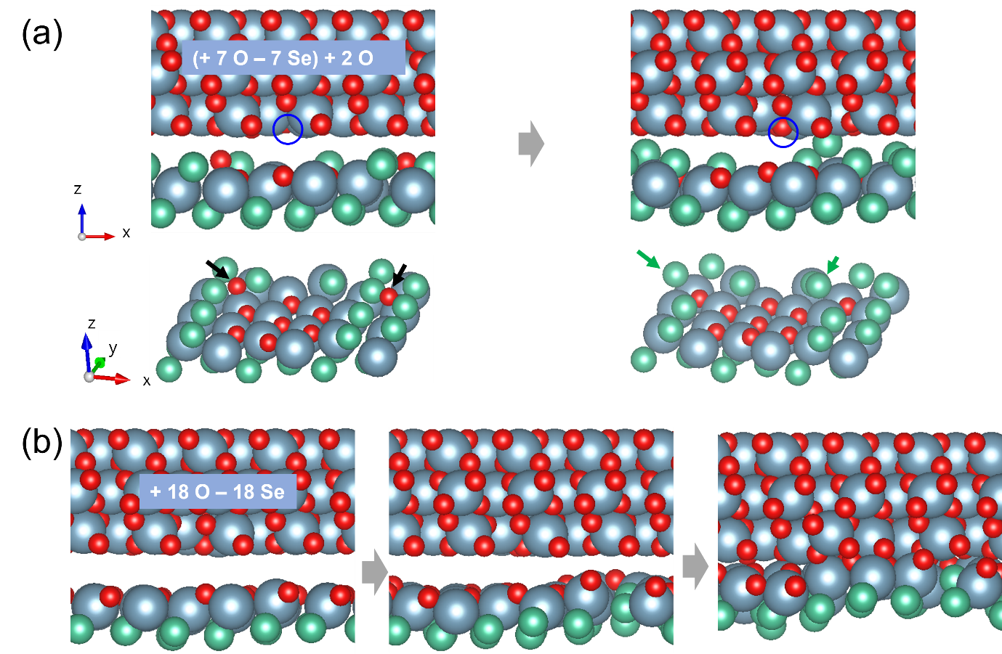
Figure S9. Oxidation mechanism in low oxygen density at a HfO₂/HfSe₂ interface. (a) Initially, seven O atoms replaced seven Se atoms in the shape of a hexagon, vertices and center of which are replaced. The expelled Se atoms are expected to be ejected to the outer surface. Then, two additional O atoms (indicated by black arrows) are inserted outside the oxidized region, which corresponds to low oxygen density. First, the inserted O atoms are relaxed (left), and then, the whole system except the top Hf layer is fully relaxed (right). The green arrows indicate the extracted Se atoms. The HfSe₂ layer is presented as a slanted layer for a clear view in the bottom figures. (b) Initially, top Se layer of HfSe₂ is replaced by O and O atoms are selectively optimized (left). In the full relaxation, HfO₂ and HfSe₂ layers are merged (right). (Color scheme: Hf, grey; Se, green; O, red)

To compare the effect of the oxygen plasma power, we systematically modeled the low and high oxygen density cases. We first discuss the high plasma power experimental condition or the low oxygen density situation defined in our atomistic modeling as the situation when all O atoms are deposited on different Hf sites of the HfSe₂ layer. Considering the case when seven Se atoms were replaced with seven O atoms (Fig. 2d and Fig. S9a), we found that seven O atoms spontaneously replaced seven Se atoms. Then, to model the situation where the Se atoms were ejected through the V_{O} channel, we removed the seven Se atoms. Subsequently, two additional O atoms were inserted outside of the oxidized region (as indicated by the black arrows in Fig. S9a left panel). We then observe that the substitution reaction again proceeds for the two O atoms without energy barriers, displacing two Se atoms on top of the nearby Hf atoms (as indicated by the green arrows in Fig. S9a right panel). In the low O density situation, this substitution reaction should occur uniformly over the HfSe₂ surface, and the extracted Se atoms would diffuse and be ejected to the outside through the V_{O} channel. As shown in Fig. S9b, when no Se atoms are left in th
e interfacial region, the oxidized HfSe₂ layer merges with the upper HfO₂ layer, completing one cycle of the layer-by-layer oxidation process.

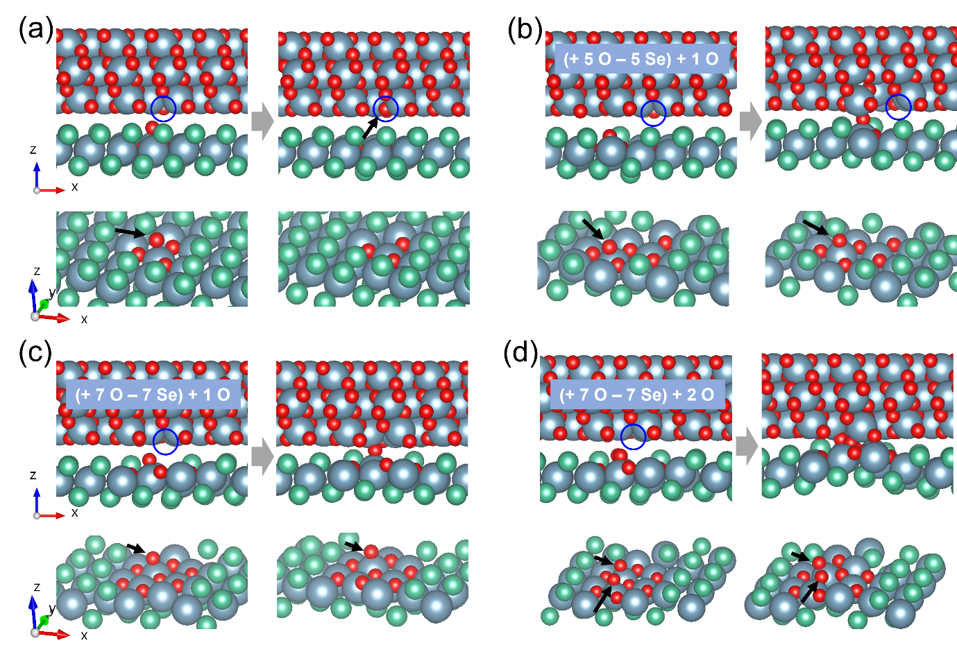
Figure S10. Oxidation mechanism in high oxygen density at the HfO₂/HfSe₂ interface. One O atom is inserted after (a) three, (b) five, and (c) seven O atoms substitute the same number of Se atoms. (d) Two O atoms are inserted after seven O atoms substitute seven Se atoms. The extracted Se atoms are assumed to be extracted to outside. (Color scheme: Hf, grey; Se, green; O, red)

We then systematically examined the high O density situations or the high plasma power experimental condition by employing several partially oxidized HfSe₂ models. Here, it should be noted that at least three O atoms are required to fully oxidize one Hf atom, such that it is triply bridged to three O atoms. First, when the three Se atoms below the V_{O} site are replaced by O atoms (Fig. S10a left panel), we observe that an additional O atom deposited on the oxidized Hf atom moves back to the V_{O} site and recovers the pristine HfO₂ surface (Fig. S10a right panel). Therefore, an extended oxidized region with five O atoms was designed (Fig. S10b left panel), and an additional O atom was placed on top of the oxidized Hf atom away from the V_{O} site. After the additional O atom is stabilized on top of the Hf atom as shown in Fig. S10b left panel, the continued energy relaxation resulted in the upshift of the O adatom toward the upper HfO₂ surface and the accompanying bending of the partially oxidized HfSe₂ layer, resulting in the merged layers that are bridged by the O atom in the fully relaxed structure (Fig. S10b right panel). We finally considered the case when the oxidized region is further extended to seven O atoms (Fig. S10c left panel). Similarly, the O-bridged bending of the (partially oxidized) HfSe₂ layer phenomena were observed with the insertion of a single extra O atom in the oxidized region (Fig. S10c right panel). Finally, when two extra O atoms were on top of two Hf atoms within the oxidized region (Fig. 2e and S10d left panel), we observe a stronger bending of the oxidized HfSe₂ surface and its locally merging with the HfO₂ layer in the fully relaxed structure (Fig. S10d right panel). Therefore, a high O density or the high plasma power expemental condition (Fig. S17) can cause the locally merged or irregular HfSe₂/HfO₂ interfaces, which should be adverse to layer-by-layer oxidation process.

Supplementary section 4: HfO₂/HfSe₂ FET
a. Structure and electrical characteristic of HfO₂/HfSe₂ FET
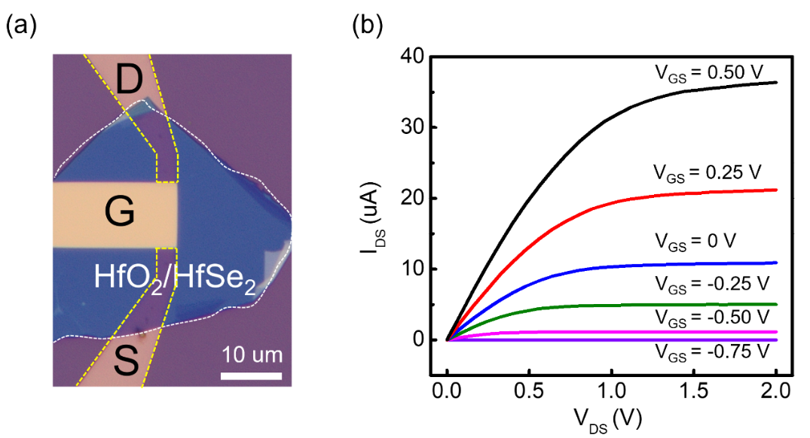
Figure S11. (a) OM image and (b) measured output characteristic (at various gate voltage) of the fabricated HfO₂/HfSe₂ FET.

b. Reproducibility of HfO₂/HfSe2 FET
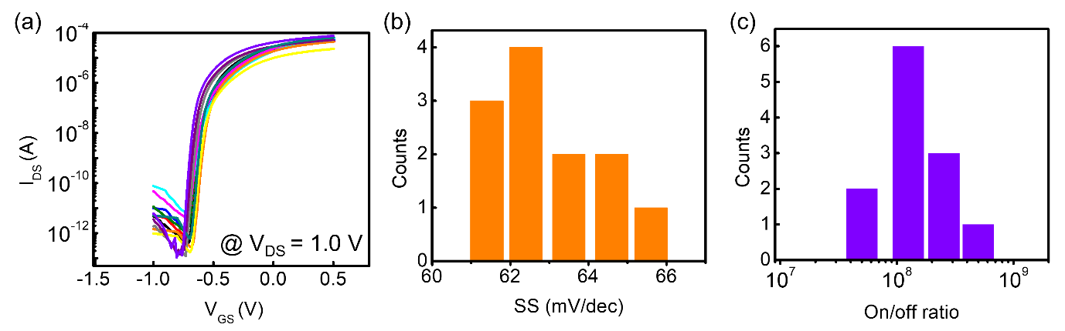
Figure S12. Device-to-device variability of HfO₂/HfSe₂ FETs: (a) transfer characteristics, (b) SS value variation and, (c) on-off ratio.
Twelve HfO₂/HfSe₂ FETs were fabricated using the same fabrication process (HfO₂ ~ 10 nm) to examine the repeatability of the device performance. Consistent transfer characteristics (Fig. S12a) and low SS values (Fig. S12b, ranging from 61 to 65.5 mV dec⁻¹) with a high on-off ratio (Fig. S12c) were observed.

c. Dielectric properties of the converted HfO₂ at various thickness
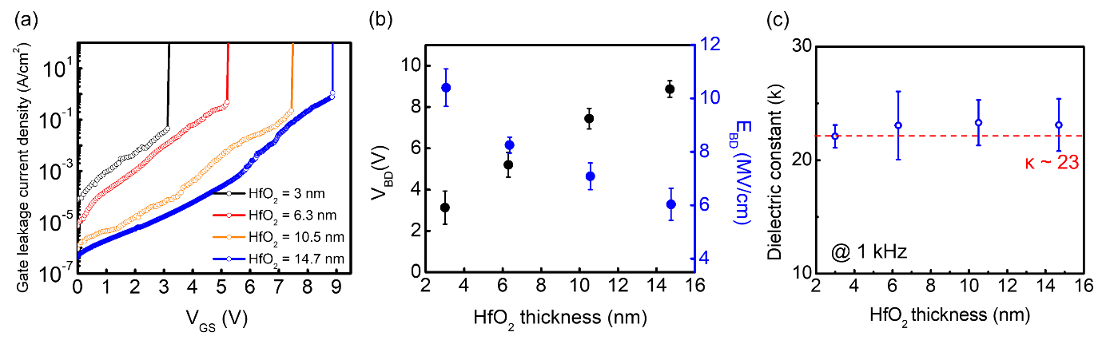
Figure S13. (a) The gate leakage current densities of HfO₂/HfSe₂ FET with HfO₂ of various thicknesses. (b) The breakdown voltage (V_{BD}) and breakdown field (E_{BD}) of HfO₂ with various thicknesses. (c) Thickness independent dielectric constant with various HfO₂ thickness.
The gate leakage current density, which was obtained during the I_{DS}-V_{GS} measurements of the HfO₂/HfSe₂ FET with various HfO₂ thicknesses, is shown in Fig. S13a. Low gate leakage current (~ 10⁻³ A cm⁻² at V_{GS} = 1 V) which indicates high insulating property of our high-κ HfO₂ even in 3 nm HfO₂ (EOT = 0.5 nm) was observed. Figure S13b plots the breakdown voltage and field corresponding to Fig. S13a as a function of the converted HfO₂ thickness. The breakdown voltage clearly increased as the HfO₂ thickness increased. Conversely, the breakdown electric field decreased as the HfO2 thickness increased, which is consistent with previously reported HfO₂ properties^{5,6}. Furthermore, κ always remains at ~ 23 in all thickness ranges exhibiting high quality of HfO₂ layer as shown in Fig. S13c.

d. Filed effect mobility
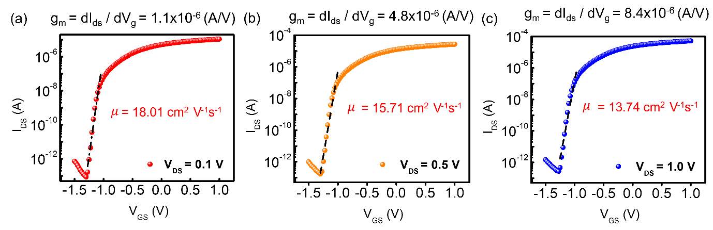
Figure S14. Calculated field effect mobility from I_{DS}-V_{GS} curves at (a) 100 mV, (b) 500 mV, and (c) 1 V. The channel length and width of this FET are 10 µm and 3 µm, respectively. Linear fitting of the conductance is shown for each curve.
We calculated field effect mobility by the following equation, μ = (L/W) (1/C_{g}) (dI_{ds}/dV_{g} V_{ds}), C_{g=} $ε_{r}ε_{0}/d$ where C_{g} is the capacitance of the gate oxide, L is the channel length, and W is the channel width. Based on d = 10 nm (thickness of HfO₂), $ε_{r}$= 23 (Taking from C-V measurement), we can define a C_{g} of 2.03 × 10⁻² F/m² and estimate the maximum μ value of 18.01 cm² V⁻¹s⁻¹.

e. TCAD device simulation environments
Table S1. Key parameters for TCAD simulations.
Type | Parameter | Value
Dimension | Channel length (L_{G}) | 10 [μm]
Dimension | Channel thickness(T_{CH}) / # of layers | 14.7 nm / bulk
Dimension | Oxide thickness(T_{OX}) | 10 [nm]
Dimension | S/D contact length (L_{SD}) | 1.01 [μm]
Dimension | S/D thickness (T_{SD}) | 50 [nm]
Channel (HfSe₂) | Effective mass of electron (m_{e}*/m₀) | 1.1
Channel (HfSe₂) | Effective mass of hole (m_{h}*/m₀) | 1.258
Channel (HfSe₂) | Energy band gap (E_{g}) | 1.13 [eV]
Channel (HfSe₂) | Electron affinity (χ ) | 5.2 [eV]
Channel (HfSe₂) | Dielectric constant of in-plane ( ε∥) | 7.8
Channel (HfSe₂) | Dielectric constant of out-of-plane ( ε⊥) | 20
Oxide (HfO₂) | Oxide permittivity (ε_{r}) | 23
Metal (Au) | Work function | 5 [eV]

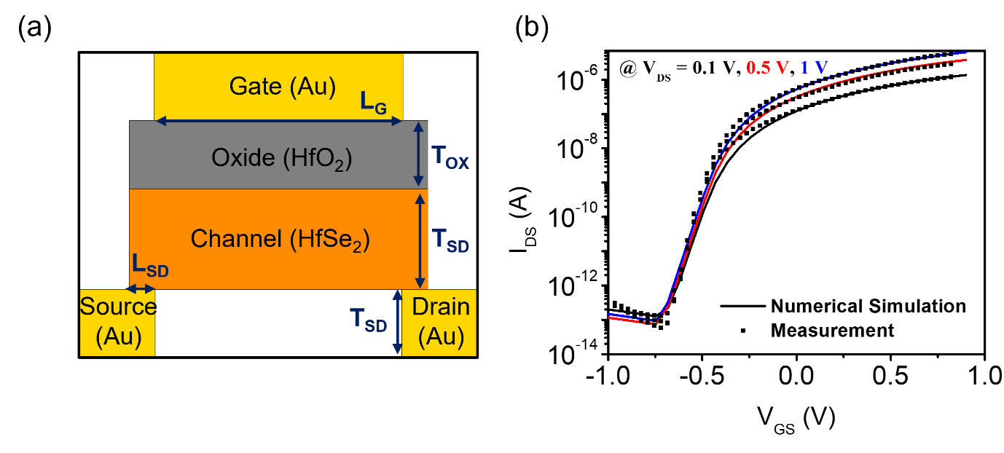
Figure S15. (a) HfO₂/HfSe₂ FET structure for TCAD simulation, (b) TCAD calibration results using the measured transfer curve
To accurately simulate the device by incorporating the characteristics of the fabricated device, we developed a channel material, HfSe₂, based on the results of DFT simulations. The device structure was designed with reference to the fabricated device (Figure S15(a)). The key parameter values used in this study are summarized in Table S1. The carrier transport model used in the TCAD simulation was calibrated using the transfer curve characteristics of the fabricated device, and the result is shown in Figure S15(b).
f. SS characteristics and gate leakage current w.r.t. various D_{it}
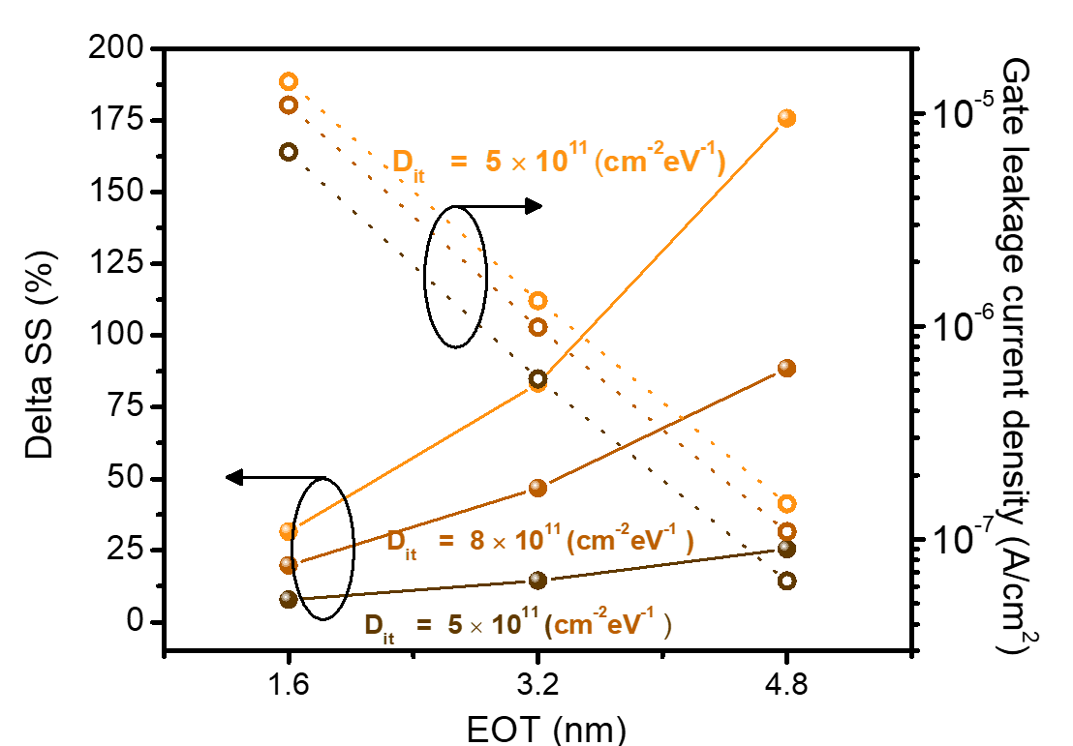
Figure S16. SS characteristics and gate leakage current density as a function of D_{it} and EOT of HfO₂/HfSe₂ FET.
The degradation characteristics of the device due to variations in D_{it} were investigated using TCAD simulations. Figure S16 shows the variations in SS and gate leakage current for the fabricated HfO₂/HfSe₂ FET with respect to the D_{it} and EOT changes. The ideal SS characteristics (~61 mV/dec), close to the Boltzmann limit, achieved with a thin EOT and low D_{it} values, deteriorated significantly with increasing D_{it}. The degradation in SS owing to D_{it} becomes more pronounced as EOT increases. In addition, as D_{it} increased, the gate leakage current increased exponentially as the carriers captured in the trap contributed to oxide tunneling. If EOT is doubled in the case of high D_{it} (e.g., 5 × 10¹¹ cm⁻² eV⁻¹), the gate leakage current can be reduced by 10 times, but the deterioration of SS increases by more than 50% due to the short-channel effect. This means that securing better D_{it} characteristics rather than increasing EOT can improve the performance of HfO₂/HfSe₂ FETs, because when EOT is increased, the leakage current can be gently alleviated while the SS characteristics are severely degraded.

g. Intrinsic RC delay according to various D_{it}
Table S2. On-current (I_{ON}) and on-state total gate capacitance (C_{GG,ON}) according to various D_{it}
D_{it}  (cm⁻²eV⁻¹) | V_{DD} = 0.5 V |  | V_{DD} = 1.0 V
D_{it}  (cm⁻²eV⁻¹) | I_{ON} (A) | C_{GG,ON} (F) | I_{ON} (A) | C_{GG,ON} (F)
5.7×10¹⁰ | 1.97×10⁻⁷  (ref.) | 1.09×10⁻¹³  (ref.) | 2.43×10⁻⁶  (ref.) | 1.30×10⁻¹³  (ref.)
1.0×10¹⁰ | 1.95×10⁻⁷  (- 1%) | 1.09×10⁻¹³  (0%)) | 2.42×10⁻⁶  (0%) | 1.30×10⁻¹³  (0%)
3.0×10¹¹ | 1.77×10⁻⁷  (- 11%) | 1.07×10⁻¹³  (+ 1%) | 2.33×10⁻⁶  (- 4%) | 1.30×10⁻¹³  (0%)
5.0×10¹¹ | 1.59×10⁻⁷  (- 19%) | 1.06×10⁻¹³  (+ 3%) | 2.23×10⁻⁶  (- 8%) | 1.29×10⁻¹³  (+ 1%)
8.0×10¹¹ | 1.34×10⁻⁷  (- 32%) | 1.03×10⁻¹³  (+ 5%) | 2.09×10⁻⁶  (- 14%) | 1.29×10⁻¹³  (+ 1%)
1.0×10¹² | 1.20×10⁻⁷  (- 39%) | 1.01×10⁻¹³  (+ 7%) | 2.00×10⁻⁶  (- 18%) | 1.28×10⁻¹³  (+ 2%)
3.0×10¹² | 2.50×10⁻⁸  (- 87%) | 7.48×10⁻¹⁴  (+ 31%) | 1.21×10⁻⁶  (- 50%) | 1.25×10⁻¹³  (+ 4%)

The on-current (I_{ON}) and on-state total gate capacitance (C_{GG,ON}) of the HfO₂/HfSe₂ FETs were evaluated as a function of the D_{it} levels. For comparison under identical standby power conditions, work-function engineering using metal replacement technology is assumed, where the off-current (I_{OFF}) was set to 10 pA at V_{GS} = 0V, which is suitable for commercial low-power applications. The simulation results show that the total C_{GG,ON} decreased as D_{it} increased because the parasitic capacitance component induced by the interface trap was connected in series with the gate capacitance. In addition, the deterioration of SS characteristics under the same I_{OFF} condition was further reduced by I_{ON}. That is, an increase in D_{it} greatly reduced I_{ON} compared to C_{GG,ON}, and this tendency was more prominent as the used V_{DD} was lower.

h. Plasma power dependency of HfO₂/HfSe₂ interface quality
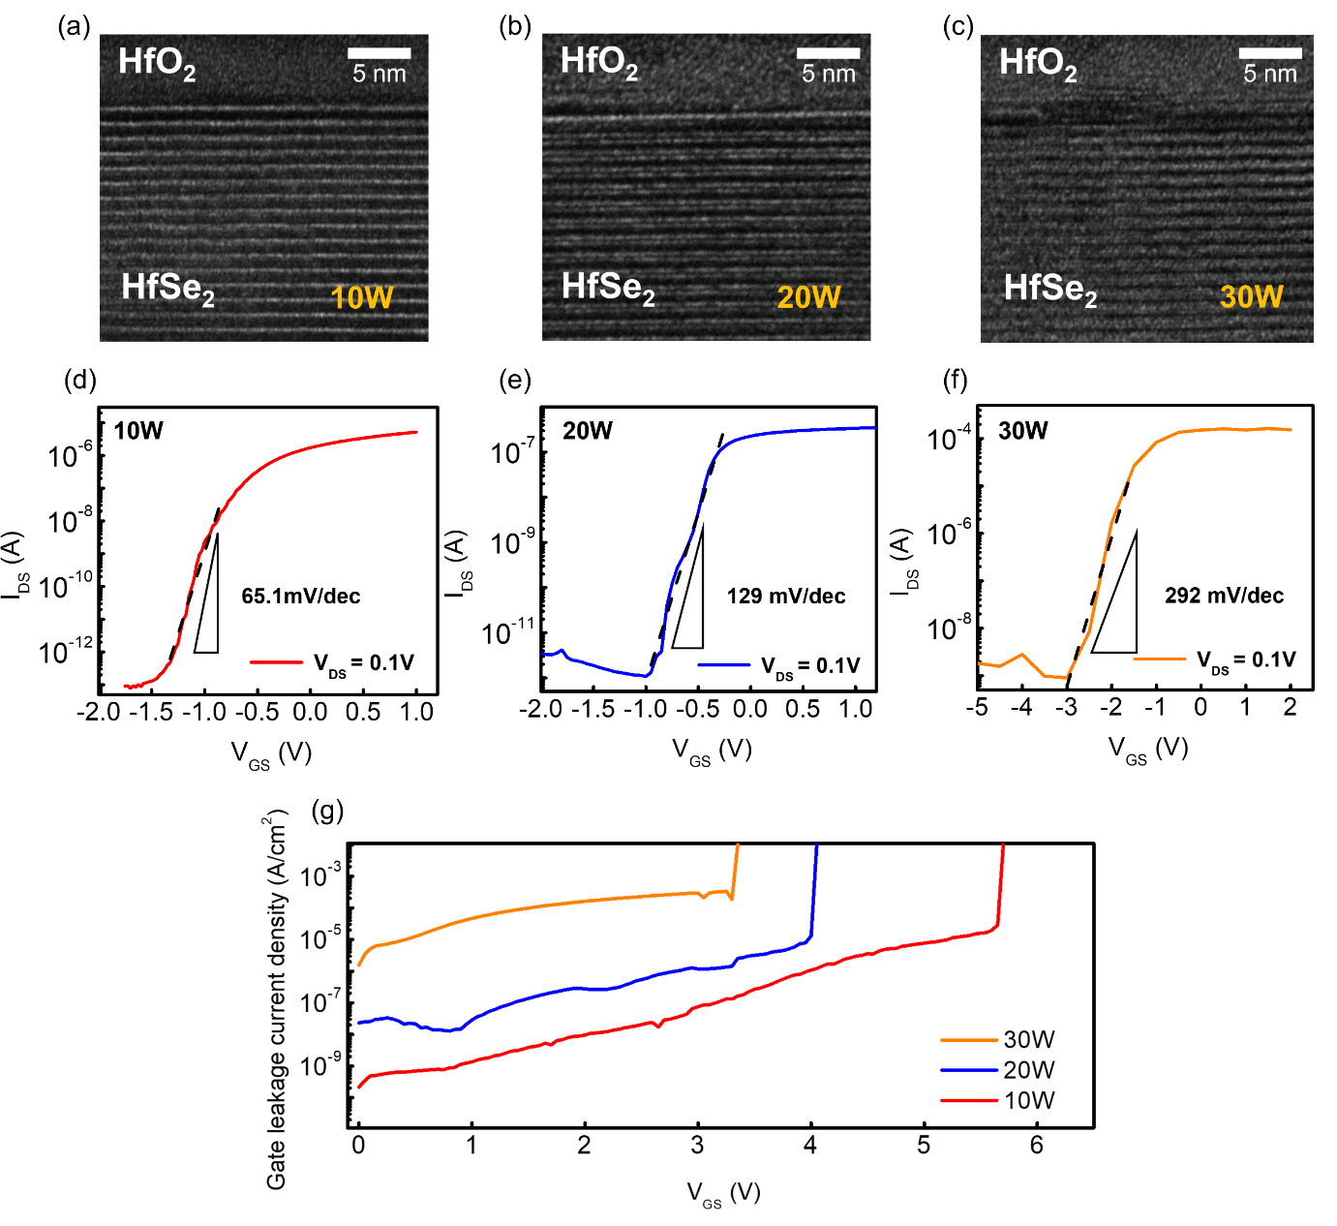
Figure S17. (a-c) TEM images of HfO₂/HfSe₂ gate stack fabricated at different plasma power (10 W, 20 W and 30 W, respectively). Clearly, the occurrence of interface collapse is evident with the increase in plasma power. (d-f) Corresponding transfer curves (at same V_{DS} = 0.1V) showing reduced field effect mobility and increased subthreshold swing value as plasma power increased. (g) The measured leakage current densities at each plasma condition.

Supplementary section 5: HfO₂/HfSe₂ based I²-FET
- OM/SEM image of I²-FET
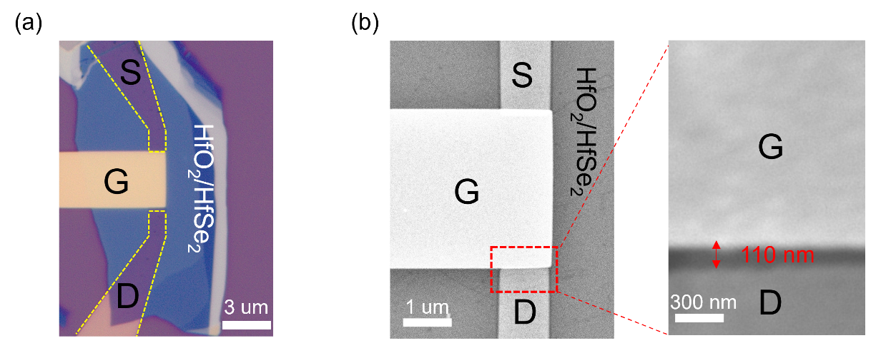
Figure S18. (a) OM image and (b) SEM image of I²-FET fabricated with the 110 nm ungated region (magnified view of ungated region in right panel).
b. Multiplication factor within steep switching transition
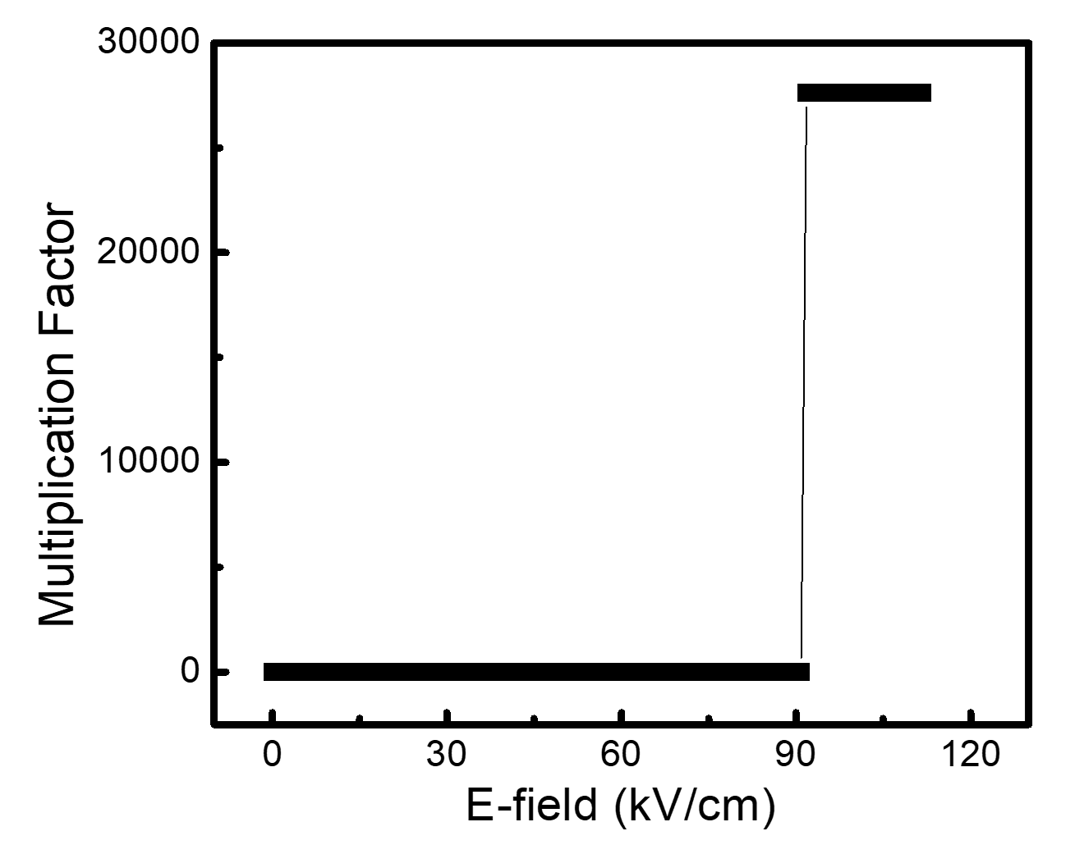
Figure S19. Calculated multiplication factor (M) as a function of electric field.
In Figure S19, we show the multiplication factor obtained from the measured I_{DS}-V_{DS} characteristic, which varies with the electric field (E = V_{DS}/L, where L is the effective channel length). Before permanent breakdown occurred, we observed a significantly high multiplication factor of up to 10⁴, indicating that a large number of carriers were generated by the impact ionization process.

c. Steep switching behavior at various operating and supply voltage
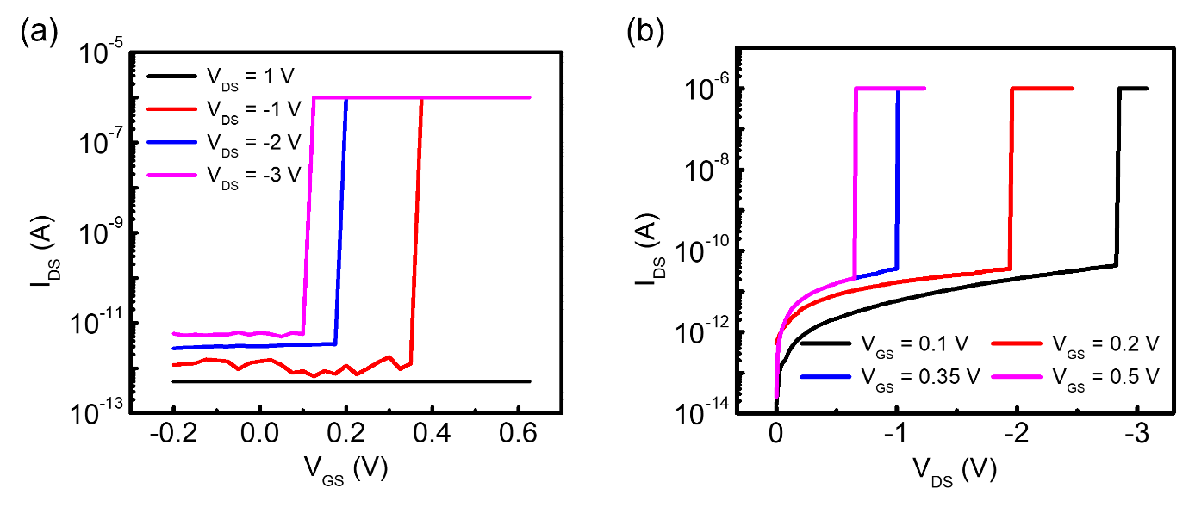
Figure S20. (a) I_{DS}-V_{GS} characteristics of a HfO₂/HfSe₂ I²-FET with various biases from 1 to -3 V. The stronger the applied bias, the lower the V_{TH} where the abrupt current increase occurs. (b) I_{DS}-V_{DS} characteristics of a HfO₂/HfSe₂ based I²-FET at various gate voltages ranging from 0.1 to 0.5 V. When a larger bias is given, the chemical potential acting on the gated region increases so that an impact ionization can be observed with a smaller bias.
The steep switching results for the channel current (I_{DS}) measured via impact ionization are shown in Figs. S20a and S20b as functions of the applied drain (V_{DS}) and gate (V_{GS}) voltages, respectively. As shown in the figures, increasing the V_{DS} reduces the required V_{GS} for impact ionization because a lower chemical potential is required. However, increasing V_{GS} amplifies the chemical potential, which reduces the required V_{DS} for impact ionization.

d. Further scaling of the operating voltage by adjusting device dimensions.
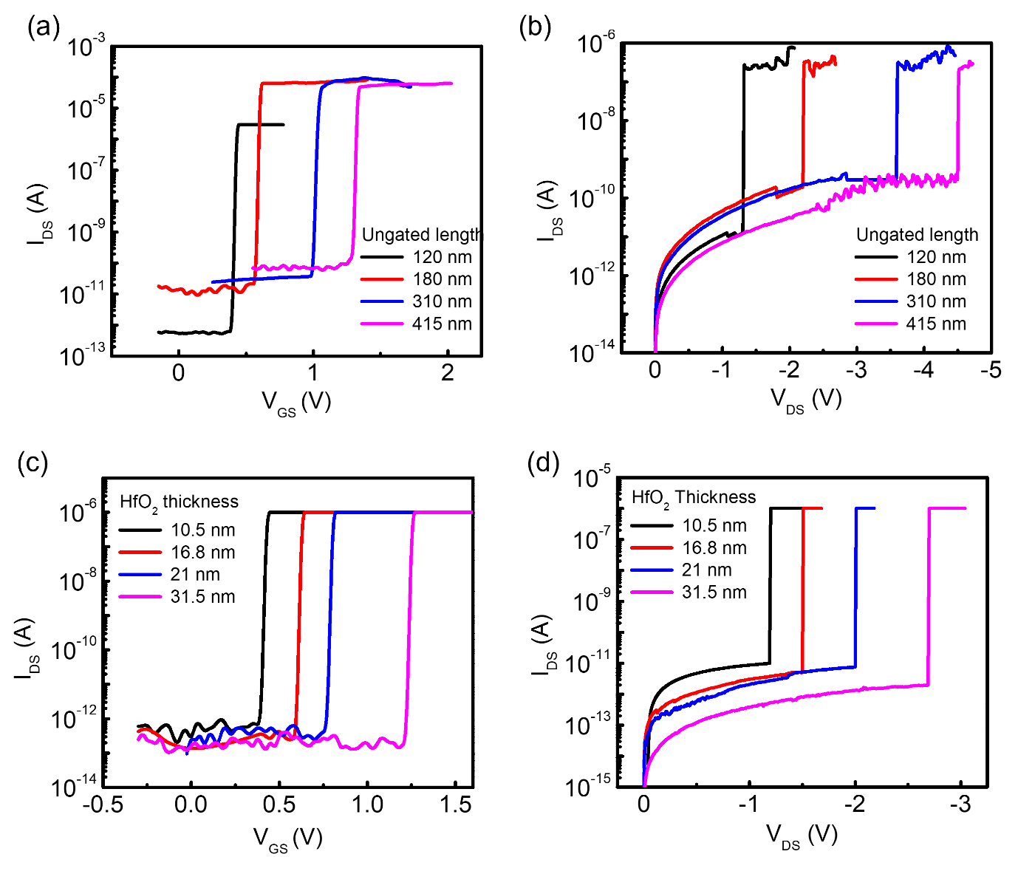
Figure S21. (a) Transfer characteristics (at same V_{DS} = -5 V) and (b) output characteristics (at same V_{GS} = 1.5 V) of the HfO₂/HfSe₂ based I²-FETs with different ungated region lengths (L_{ungated}). As L_{ungated} decreases, the magnitudes of both V_{TH} and V_{BR} decrease. (c) Transfer characteristics (at same V_{DS} = -5 V) and (d) output characteristics (at same V_{GS} = 1.5 V) of the HfO₂/HfSe₂ based I²-FETs with different oxide (HfO₂) thickness. As the oxide thickness decreases, the chemical potential acting on the gated region increases with same V_{GS} so that the magnitude of both V_{TH} and V_{BR} can be decreased in same condition.
The critical biases of the HfO₂/HfSe₂ I²-FET device–the drain voltage initiating impact ionization (V_{BR}) and the gate threshold voltage (V_{TH})–can be adjusted and reduced by modifying the device dimensions, such as the length of the ungated region and the thickness of the dielectric layer. These biases determine the operating voltages of the device and can be controlled by changing the length of the ungated region and the thickness of the dielectric layer, which affect the impact ionization in the ungated region. By manipulating these parameters, it is possible to scale the operating voltage for future device designs.
Figures S21a and S21b demonstrate the transfer and output characteristics of HfO₂/HfSe₂ I²-FETs, where the gated region length was fixed at around 3 µm and the ungated region length was varied between 120, 180, 310, and 415 nm. As the ungated region length decreased, the critical biases V_{BR} and V_{TH} decreased monotonically, suggesting that further scaling of the operating voltages can be achieved using commercial lithography and patterning capabilities. Similarly, the experiment was conducted with different HfO₂ thicknesses of 10.5, 16.8, 21, and 31.5 nm, and Figures S21c and S21d present the transfer and output characteristics of the devices. As expected, decreasing the HfO₂ thickness reduced the V_{BR} and V_{TH} because the chemical potential induced by the gate bias increased when the dielectric thickness was reduced. Therefore, the breakdown voltage can be reduced by scaling down the ungated region length or the dielectric layer thickness, as illustrated in Fig. 5e.

e. TCAD device simulation environments
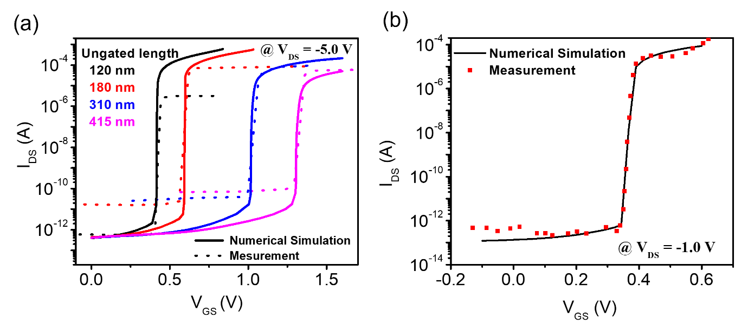

Figure S22. Carrier transport model calibration results for HfO₂/HfSe₂ I²-FET
The I²-FET had an ungated region formed in the HfO₂/HfSe₂-FET TCAD library and was implemented using the avalanche model. Impact ionization occurs when the mean free path is shorter than the space charge region under strong electric field conditions, resulting in the generation of a significant number of electron-hole pairs. This relationship is expressed as follows:
$$G_{ii} =\frac{1}{q}(α_{n}\left|\vec{J_{n}}\right|+α_{p}\left|\vec{J_{p}}\right|)$$
where G_{ii} is the impact ionization generation rate, $\vec{J_{n}}$ and $\vec{J_{p}}$ are the electron and hole current density vectors, respectively, and α is the reciprocal of the mean free path and ionization coefficient. Parameter α is determined by the impact ionization driving force using the University of Bologna Impact Ionization model.
$$α\left(F_{ava},T\right)=\frac{F_{ava}}{a\left(T\right)+b\left(T\right)exp}\left[\frac{d(T)}{F_{ava}+c(T)}\right]$$
where T is temperature (300 K). The parameters a, b, c, and d are the fitting parameters used in the equation. Figure S22 shows the calibration results, depicting the electrical characteristic curves for various ungated lengths in Fig. S21.
f. Exploring further supply voltage scaling
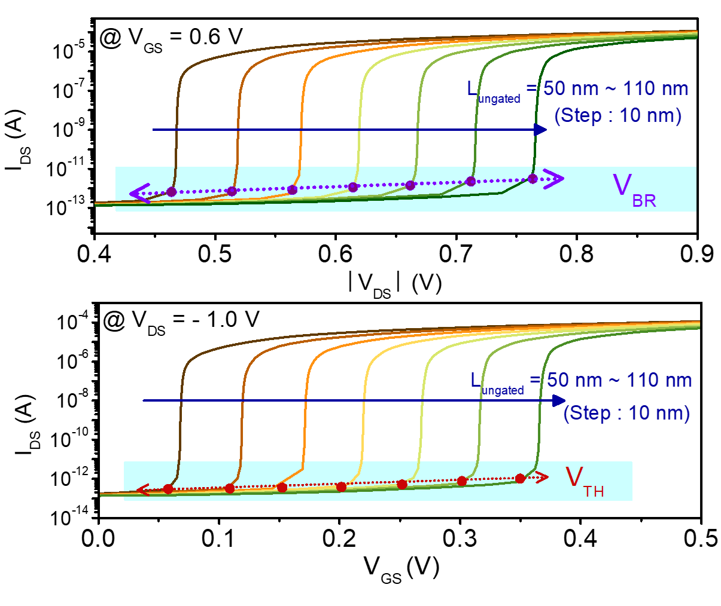
Figure S23. Output characteristic (I_{DS}-V_{DS}) and transfer characteristic (I_{DS}-V_{GS}) of HfO₂/HfSe₂ I²-FET for different ungated length.
The analysis of the output and transfer characteristics of the HfO₂/HfSe₂ I²-FET in Figure S21(a, b) as a function of L_{ungated} reveals that dimension scaling can achieve the scaling of V_{BR} and V_{TH}. This is attributed to the decreased distance between the gate and drain electrodes, leading to an increased electric field and a reduced mean free path, which favors impact ionization. Additionally, as L_{ungated} decreases, lower current levels are required for turn-on. This was because of the stronger electric field, which resulted in a shorter mean free path and triggered impact ionization. Furthermore, this leads to an increase in the carrier concentration, and consequently, an increase in the on-current.
References
1. J.F. Moulder, W.F. Stickle, P.E. Sobol, K.D. Bomben, Handbook of X-ray Photoelectron Spectroscopy, Perkin-Elmer Corp., Eden Prairie (1992)
2. Aarik, J., Aidla, A., Mändar, H., Sammelselg, V. & Uustare, T. Texture development in nanocrystalline hafnium dioxide thin films grown by atomic layer deposition. J. Cryst. Growth. 220, 105-113 (2000).
3. Mukhopadhyay, A. B., Sanz, J. F. & Musgrave, C. B. First-principles calculations of structural and electronic properties of monoclinic hafnia surfaces. Phys. Rev. B. 73, 115330 (2006).
4. Lai, S. et al. HfO₂/HfS₂ hybrid heterostructure fabricated via controllable chemical conversion of two-dimensional HfS₂. Nanoscale 10, 18758-18766 (2018).
5. Tang, W. M., Helander, M., Greiner, M., Ng, W. & Lu, Z. in 2010 IEEE International Conference of Electron Devices and Solid-State Circuits (EDSSC). 1-4 (IEEE).
6. Yota, J., Shen, H. & Ramanathan, R. Characterization of atomic layer deposition HfO₂, Al₂O₃, and plasma-enhanced chemical vapor deposition Si₃N₄ as metal–insulator–metal capacitor dielectric for GaAs HBT technology. J. Vac. Sci. 31 (2013).

