Table 1| Large-scale and structurally controllable synthesis of gangliosides with different glycosyl groups
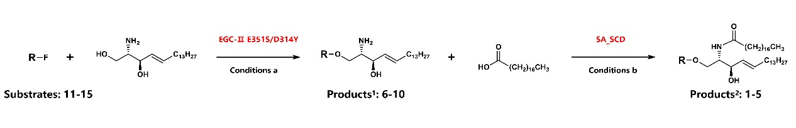
Substrate | Product¹ |  |  | Yield |  | Product² | Yield
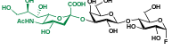 | 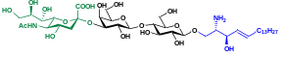 |  |  | 92%  (3.20 g) |  | 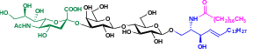 | 69%  (1.63 g)
11, GM3-F | 6, GM3βSph |  |  |  |  | 1, GM3
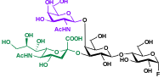 | 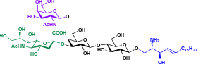 |  |  |  |  | 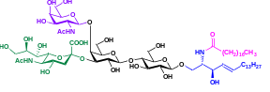
 |  |  |  | 91%  (3.83 g) |  |  | 70%  (1.94 g)
12, GM2-F | 7, GM2βSph |  |  |  |  | 2, GM2
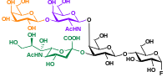 | 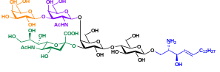 |  |  |  |  | 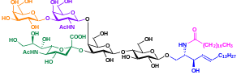
 |  |  |  | 92%  (4.35 g) |  |  | 71%  (2.20 g)
13, GM1-F | 8, GM1βSph  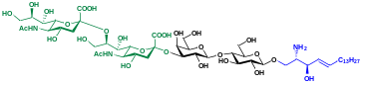 |  |  |  |  | 3, GM1
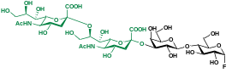 |  |  |  | 86%  (2.76 g) |  | 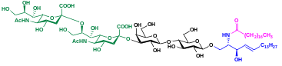 | 65%  (1.95 g)
14, GD3-F  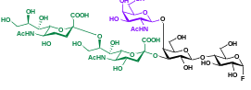 | 9, GD3βSph  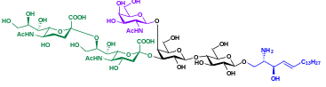 |  |  |  |  | 4, GD3  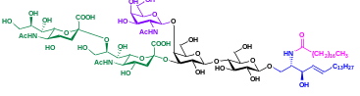
15, GD2-F | 10, GD2βSph |  |  | 84%  (3.03 g) |  | 5, GD2 | 60%  (2.01 g)
Condition a: Substrates 11–15, substrate 16 (2.40 g, 8.00 mmol), and purified EGC-II E351S/D314Y (800 mg) were incubated in 100 mM NaAc buffer (pH 5.3) with 10% ethanol (v/v) at 37 °C for 10 h. Yield after purification using C18 cartridges is shown. Condition b: Substrates 6–10 (2.00 mmol), stearic acid (853 mg, 3.00 mmol), and purified SA_SCD (160 mg) were incubated in 800 mL of Tris-HCl buffer (50 mM, pH 7.5) with 10% DME (v/v) at 37 °C for 6 h. Yield after purification using Sep Pak VAC C18 cartridges and silica gel filtration column is shown. Abbreviations: EGC-Ⅱ E351S/D314Y, endoglycoceramidase Ⅱ E351S/D314Y. SA_SCD, Shewanella alga G8 sphingolipid ceramide N-deacylase (see more details in Supplementary Ⅱ).

Table 2 | Structurally controllable and integrated synthesis of GM1 derivatives with different sphingosines and fatty acids
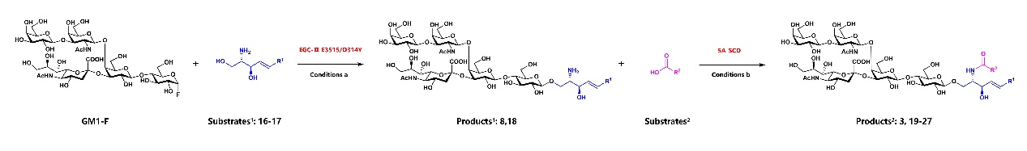
Substrate¹ |  | Product¹ | Yield | Substrate² | Product² | Yield
 |  |  |  | 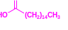 | 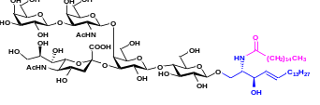 | 73%  (1.38 g)
 |  |  |  |  | 19, GM1 (d18:1/C16:0)
 |  |  |  | 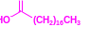 | 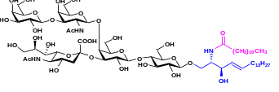 | 71%
 |  |  |  |  | 3, GM1 (d18:1/C18:0) | (113.35 g)
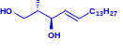  16 |  | 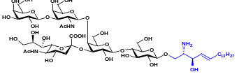 | 92%  (130.31 g) | 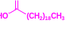 | 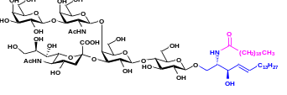 | 66%  (1.29 g)
 |  | 8, GM1βSph (d18:1) |  |  | 20, GM1 (d18:1/C20:0)
 |  |  |  | 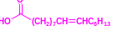 | 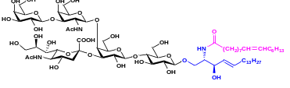 | 82%  (1.54 g)
 |  |  |  |  | 21, GM1 (d18:1/C16:1)
 |  |  |  | 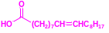 | 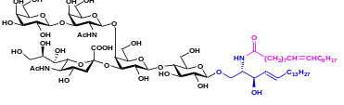 | 79%  (1.51 g)
 |  |  |  |  | 22, GM1 (d18:1/C18:1)
 |  |  |  |  | 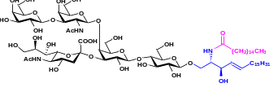 | 70%  (1.32 g)
 |  |  |  |  | 23, GM1 (d20:1/C16:0)
 |  |  |  |  | 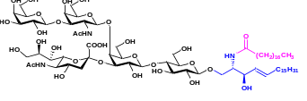 | 69%  (1.33 g)
 |  |  |  |  | 24, GM1 (d20:1/C18:0)
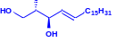  17 |  | 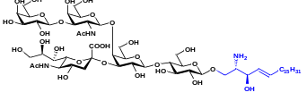 | 91%  (10.98 g) |  | 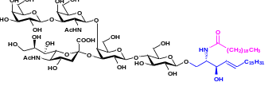 | 64%  (1.25 g)
 |  | 18, GM1βSph (d20:1) |  |  | 25, GM1 (d20:1/C20:0)
 |  |  |  | 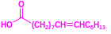 | 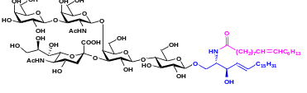 | 79%  (1.49 g)
 |  |  |  |  | 26, GM1 (d20:1/C16:1)
 |  |  |  | 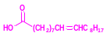 | 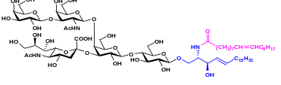 | 76%  (1.46 g)
 |  |  |  |  | 27, GM1 (d20:1/C18:1)
¹Condition a: For industrial preparation of GM1βSph (d18:1), 24 L GM1-F oligosaccharide fluoride, substrates 16 (240 mmol) and purified EGC-II E351S/D314Y (24 g) were incubated in 100 mM NaAc buffer (pH 5.3) with 10% ethanol (v/v) at 37 °C overnight. For GM1βSph (d20:1) preparation at the 10-gram scale, 2 L GM1-F oligosaccharide fluoride, substrates 17 (20 mmol) and purified EGC-II E351S/D314Y (2 g) were incubated in 100 mM NaAc buffer (pH 5.3) with 10% ethanol (v/v) at 37 °C for 10 h. Yield after purification using Sep Pak VAC C18 cartridges is shown.
²Condition b: For industrial preparation of GM1 (d18:1/C18:0), substrate 8 (101.76 mmol), stearic acid (C18:0) (152.62 mmol) and purified SA_SCD (10 g) were incubated in 50 L of Tris-HCl buffer (10 mM, pH 7.5) with 10% DME (v/v). The whole catalytic system was carried out in a 100 L bioreactor with 120 rpm at 37 ℃ overnight. 1M NaOH and 1M HCl loaded separately into two reservoirs in bioreactor were used for automatic and real-time control of pH value at 7.5. For preparation of other GM1 derivatives, substrate 8 or 18 (1.22 or 1.20 mmol), a fatty acid (1.82 or 1.80 mmol of palmitic acid, stearic acid, arachidic acid, palmitoleic acid, or oleic acid), and purified SA_SCD (160 mg) were incubated in 800 mL of Tris-HCl buffer (20 mM, pH 7.5) with 10% DME (v/v) at 37 °C for 6 h. Yield after purification using Sep Pak VAC C18 cartridges and silica gel filtration columns is shown (see details in Supplementary Ⅱ).

