Characterization of N-methyltransferase for catalyzing the terminus of leucinostatins in Purpureocillium lilacinum

Zixin Li^{1,2}, Yang Jiao¹, Jian Ling¹, Jianlong Zhao¹, Yuhong Yang¹, Zhenchuan Mao¹, Kaixiang Zhou³, Wenzhao Wang⁴, Bingyan Xie^{1,*}, Yan Li^{1,*}

¹State Key Laboratory of Vegetable Biobreeding, Institute of Vegetables and Flowers, Chinese Academy of Agricultural Sciences, Beijing, 100081, China
²Microbial Processes and Interactions (MiPI), TERRA Teaching and Research Centre, Gembloux Agro-Bio Tech, University of Liège, Gembloux, 5030, Belgium
³Center for Advanced Materials Research, Advanced Institute of Natural Sciences, Beijing Normal University at Zhuhai, Zhuhai, 519087, China
⁴State Key Laboratory of Mycology, Institute of Microbiology, Chinese Academy of Sciences, Beijing, 100101, China
These authors contributed equally: Zixin Li, Yang Jiao
* Corresponding authors: B. Xie; Y. Li.
Email: xiebingyan@caas.cn; liyan05@caas.cn.

Contents
Supplementary Tables 3
Table S1. Reference N-methyltransferases (NMTs) and O-methyltransferases (OMTs) used for phylogenetic tree construction 3
Table S2. Comparison of the reported fragment ions (m/z) in ESI-MS-MS spectra of leucinostatins in this study 4
Table S3. Non-ribosomal peptide synthetases (NRPSs) contained terminal modules similar to that of LcsG. 5
Table S4. Plasmids and strains used in this study 6
Table S5. Primers used in this study 7
Supplementary Figures 8
Reference 30

Supplementary Tables
Table S1. Reference N-methyltransferases (NMTs) and O-methyltransferases (OMTs) used for phylogenetic tree construction.
Name | Accession no. | Function | Conserved  domain | Organism | Ref.
LcsG | A0A179H2P2.1 | NMT | Methyltransf_2 | Purpureocillium lilacinum
FgaMT | B6D5I7.1 | NMT | Methyltransf_33 | Aspergillus fumigatus | ¹
DtpB | B8NR70.1 | NMT | Methyltransf_33 | Aspergillus flavus NRRL3357 | ²
FsqC | Q4WD44.1 | NMT | Methyltransf_33 | Aspergillus fumigatus Af293 | ³
GliN | Q4WMJ1.1 | NMT | Methyltransf_23 | Aspergillus fumigatus Af293 | ⁴
ImqF | B8NI23.1 | NMT | Methyltransf_33 | Aspergillus flavus NRRL3357 | ⁵
PfPMT | AAR08195.1 | NMT | Methyltransf_11 | Psilocybe cubensis | ⁶
PsiM | P0DPA9.1 | NMT | Methyltransf_10 | Plasmodium falciparum | ⁷
NRMT | Q9BV86.1 | NMT | Methyltransf_PK | Homo sapiens | ⁸
EgtD | A0R5M8.1 | NMT | Methyltransf_33 | Mycolicibacterium smegmatis | ⁹
FtmD | Q4WAW6.1 | OMT | Methyltransf_2 | Aspergillus fumigatus Af293 | ¹⁰
Bik3 | S0E608.1 | OMT | Methyltransf_2 | Fusarium fujikuroi IMI 58289 | ¹¹
MpaG | F1DBB3.1 | OMT | Methyltransf_2 | Penicillium brevicompactum | ¹²
GedA | Q0CCY5.1 | OMT | Methyltransf_2 | Aspergillus terreus NIH2624 | ¹³
VdtC | A0A443HJY8.1 | OMT | Methyltransf_2 | Paecilomyces variotii | ¹⁴
OpaF | A0A0C1E5J2.1 | OMT | Methyltransf_2 | Aspergillus ustus | ¹⁵
AgiB | B8NY85.1 | OMT | Methyltransf_2 | Aspergillus flavus NRRL3357 | ¹⁶
AurJ | I1RF60.1 | OMT | Methyltransf_2 | Fusarium graminearum PH-1 | ¹⁷
ElcB | Q0UI04.1 | OMT | Methyltransf_2 | Parastagonospora nodorum SN15 | ¹⁸
AflO | Q9UQY0.2 | OMT | Methyltransf_2 | Aspergillus parasiticus SU-1 | ¹⁹
16OMT | B0EXJ8.1 | OMT | Methyltransf_2 | Catharanthus roseus | ²⁰
PhOMT | A0A0N9HMN6.1 | OMT | Methyltransf_2 | Sinopodophyllum hexandrum | ²¹
ROMT | B6VJS4.2 | OMT | Methyltransf_2 | Vitis vinifera | ²²
Fma-MT | A0A067Z9B6.1 | OMT | Methyltransf_2 | Aspergillus fumigatus CEA17  akuBKU80 | ²³
Omt12 | Q54B59.1 | OMT | Methyltransf_2 | Dictyostelium discoideum | ²⁴
Ps6OMT | Q6WUC1.1 | OMT | Methyltransf_2 | Papaver somniferum | ²⁵
AsMT | B3GSH5.1 | OMT | Methyltransf_2 | Rattus norvegicus | ²⁶
TaOMT2 | Q38J50.1 | OMT | Methyltransf_2 | Triticum aestivum | ²⁷
BMT | A8J6X1.1 | OMT | Methyltransf_2 | Glehnia littoralis | ²⁸

Table S2. Comparison of the reported fragment ions (m/z) in ESI-MS-MS spectra of leucinostatins in this study.
 | B1 | A2 | B2 | B3 | B4 | B5 | B6 | B7 | B8 | B9 | C10 | Y5 | Y4 | Y3 | Y2
LeuA | 111 | 194 | 222 | 435 | 564 | 649 | 762 | 875 | 960 | 1045 | 1173 | 457 | 344 | 259 | 174
LeuB | 111 | 194 | 222 | 435 | 564 | 649 | 762 | 875 | 960 | 1045 | 1173 | 443 | 330 | 245 | 160
LeuC | 111 | 194 | 222 | 435 | 564 | 649 | 762 | 875 | 960 | 1045 | 1173
LeuA0 | 111 | 194 | 222 | 435 | 564 | 649 | 762 | 875 | 960 | 1045 | 1173
LeuK0 | 111 | 194 | 222 | 435 | 564 | 649 | 762 | 875 | 960 | 1045 | 1173 | 473 | 360 | 275 | 190
LeuK1 | 111 | 194 | 222 | 435 | 564 | 649 | 762 | 875 | 960 | 1045 | 1173 | 675 | 562 | 477 | 392
LeuK2 | 111 | 194 | 222 | 435 | 564 | 649 | 762 | 875 | 960 | 1045 | 1173 | 487 | 374 | 289 | 204
LeuK3 | 111 | 194 | 222 | 435 | 564 | 649 | 762 | 875 | 960 | 1045 | 1173

Table S3. Non-ribosomal peptide synthetases (NRPSs) contained terminal modules similar to that of LcsG.
Name | Gene cluster | Organism | Coverage  /Identity | Accession No. | Ref.
InpA | Fellutamide B | Aspergillus nidulans FGSC A4 | 100/41.57 | Q5B7I5.1 | ²⁹
ApmA | Asperphenamate | Penicillium brevicompactum | 100/42.35 | A0A1W6BT53.1 | ³⁰
AtnA | Aspercryptin | Aspergillus nidulans FGSC A4 | 100/42.16 | Q5AUZ6.1 | ³¹
NRPS 5 | Fusaoctaxin A | Fusarium graminearum PH-1 | 92/40.69 | I1SAJ7.1 | ³²
PpzA | Pyrrolopyrazine | Metarhizium rileyi RCEF 4871 | 100/40.24 | A0A166YZW0.1 | ³³
PerA | Peramine | Epichloe festucae Fl1 | 96/41.49 | Q4H424.2 | ³⁴
LgrD | Linear gramicidin | Brevibacillus parabrevis | 89/33.62 | Q70LM4.1 | ³⁵

Table S4. Plasmids and strains used in this study.

Plasmids/Strains | Description | Reference
pKOV21 | geneticin (neo) resistance vector | Shen, B. et al. Development of a high- efficiency gene knockout system  for Pochonia chlamydosporia
pEASY | LacZα, T7 promoter, Kanr, Amp | TransGen Biotech
pACYCDuet-1 | lacI, T7 promoter-1, T7 promoter-2, Cmr | Novagen
KSTNP | TrpC terminator and neo contained vector | Wang, G. et al. Biosynthesis of Antibiotic Leucinostatins in Bio-control Fungus Purpureocillium lilacinum and Their Inhibition  on Phytophthora Revealed by Genome  Mining
PCH-sGFP | gpdA(p) contained vector | Liang, L. et al. A high efficiency gene disruption strategy using a positive– negative split selection marker and  electroporation for Fusarium oxysporum
pGNT | neo, TrpC, gpdA(p) in pEASY | This study
pKOV21-kolcsG | lcsG deletion cassette in pKOV21 | This study
pGNT-lcsG | lcsG overexpression cassette in pGNT | This study
pACYC-lcsG | lcsG expression cassette in pACYCDuet-1 | This study
Purpureocillium lilacinum strain PLBJ-1  (CGMCC3.17492) | Wild type | This study
Escherichia coli DH5α |  | Tsingke
Escherichia coli  ArcticExpress (DE3) | – m –) dcm+ Tetr gal  E. coli B F– ompT hsdS(rB B  λ(DE3) endA Hte [cpn10 cpn60 Gentr] | Agilent Technologies
PLBJ-ΔlcsG | ΔlcsG::neo in P. lilacinum PLBJ-1 | This study
PLBJ-OElcsG | neo, gpdA::lcsG::TrpC in P. lilacinum PLBJ-1 | This study
E. coli ArcticExpress  (DE3)-lcsG | E. coli ArcticExpress (DE3) pACYC-lcsG | This study

Table S5. Primers used in this study.
Primers name | Sequence (5ʹ to 3ʹ)
lcsGup-f | TCCCCGCGGAAGTCGGGTAGACAGGGTGAAAT
lcsGup-r | AAGGAAAAAAGCGGCCGCACAGATGAAGCTGCGTTTACGAC
lcsGdown-f | GACTAGTGCTGCGATAGTCGCTACTAAAGC
lcsGdown-r | CGCGGATCCGCCTTGAGCAACATTCTGGC
lcsGup-ne-r | CGTAAAGCACGAGGAAGCG
eo-lcsGdown-f | GACTGGGCACAACAGACAATCG
plcsGKO SCR-f | AAGCTCATCAAACGGTCAAACAT
plcsGKO SCR-r | CACTCACCAAGTCAGTGCTCCTC
lcsGcheck-f | CCCTGAAAGAGCGACTGGAG
lcsGcheck-r | GGCTCAAAGATGCGGTTGCTA
QC-lcsG-f | gatataccatgggcagcagccatcaccatcatcaccacATGGGAGACAACGTTCAGTCC
QC-lcsG-r | gcgccgagctcgaattcggatcctggctTCAGTGGTGGTGGTGGTGGTGGCCACGCCAAACAGCCTC  GA
pEASY-neoTtrpC-f | ttaattaagtttaaacACTTAACGTTACTGAAATCATCAAA
pEASY-neoTtrpC-r | TCTAGATTAACGCTTACAATTTCCA
pGNT-gpdA-f | CATGgggcccGCCATTCAGGCTGCGCAACTGTTGG
Pgnt-gpdA-r | AAGGAAAAAAgcggccgcGGTGATGTCTGCTCAAGCGGGGTAG
OE-lcsG-f | AGCAGACATCACCGCATGGGAGACAACGTTCAGTC
OE-lcsG-r | CAGTAACGTTAAGTgCTAGCCACGCCAAACAGCCTC
OE-lcsG-SCR-f | GTTGACAAGGTCGTTGCGTC
OE-lcsG-SCR-r | GATAGCCTCAACCGCCTCCTG
Actin-f | GCCCTCTGTCCTGGGTCTT
Actin-r | ACAGGGAGGCGAGAATGGA
qp-lcsG-f | CTCGTGTCCTCGTCCTGGATCTG
qp-lcsG-r | GATCATCCGCTGCCTTGAAGAGATC
mutant-D296-F | CAAAGCCACCGTCGTTGcTCTTGGTGGCTCTGGC
mutant-D296-R | GCCAGAGCCACCAAGAgCAACGACGGTGGCTTTG
mutant-D321-F | CAAGATCATCGTCCAGGcTCTGCCTAGTTGCCAA
mutant-D321-R | TTGGCAACTAGGCAGAgCCTGGACGATGATCTTG
mutant-D348-F | TCCTTCCTCGCTCATGcCTTCTTCACCCCTCAG
mutant-D348-R | CTGAGGGGTGAAGAAGgCATGAGCGAGGAAGGA
mutant-K363-F | CGACATCTACCTCTTCgcGTGGGTCTTTTACGACT
mutant-K363-R | AGTCGTAAAAGACCCACgcGAAGAGGTAGATGTCG
mutant-Y367-F | CTTCAAGTGGGTCTTTgcCGACTGGTCCAACAAG
mutant-Y367-R | CTTGTTGGACCAGTCGgcAAAGACCCACTTGAAG
mutant-D368-F | CAAGTGGGTCTTTTACGcCTGGTCCAACAAGGAC
mutant-D368-R | GTCCTTGTTGGACCAGgCGTAAAAGACCCACTTG
mutant-D395-F | CGTGTCCTCGTCCTGGcTCTGATGGTGGACGTC
mutant-D395-R | GACGTCCACCATCAGAgCCAGGACGAGGACACG
mutant-K431-F | GCTGTTTGGACATACCgcGCAGGCGACGAAGAAG
mutant-K431-R | CTTCTTCGTCGCCTGCgcGGTATGTCCAAACAGC

Supplementary Figures

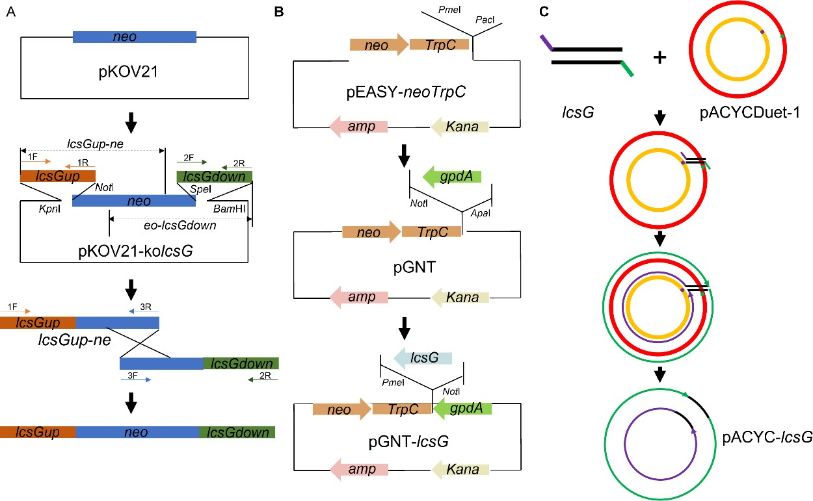
Figure S1. The scheme of plasmids construction. (A) Construction of the lcsG deletion vector pKOV21-kolcsG, and schematic diagram of split-mark to disrupt the gene. 1F: lcsGup-f, 1R: lcsGup-r; 2F: lcsGdown-f, 2R: lcsGdown-r; 3R: lcsGup-ne-r 3F: eo-lcsGdown-f. (B) Construction of the lcsG overexpression vector pGNT-lcsG. (C) Construction of the recombinant protein LcsG expression vector pACYC-lcsG. The recombinant plasmid was constructed by using the quick-change method.

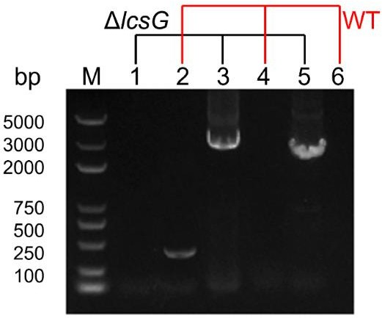

Figure S2. Confirmation of the lcsG deletions in P. lilacinum strain PLBJ-1. Marker was DL2000plus (TransGen Biotech). Lane 1, 3, 5 showed PCR products from the lcsG knock-out strain. Lane 2, 4, 6 showed PCR products from PLBJ-1 (WT). Lane 1, 2 were amplified with primer pair lcsG check-f and lcsG check-r. Lane 3, 4 were amplified with primer pair lcsG up-f and lcsGup-ne-r. Lane 5, 6 were amplified with primer pair eo-lcsGdown-f and lcsGdown-r.

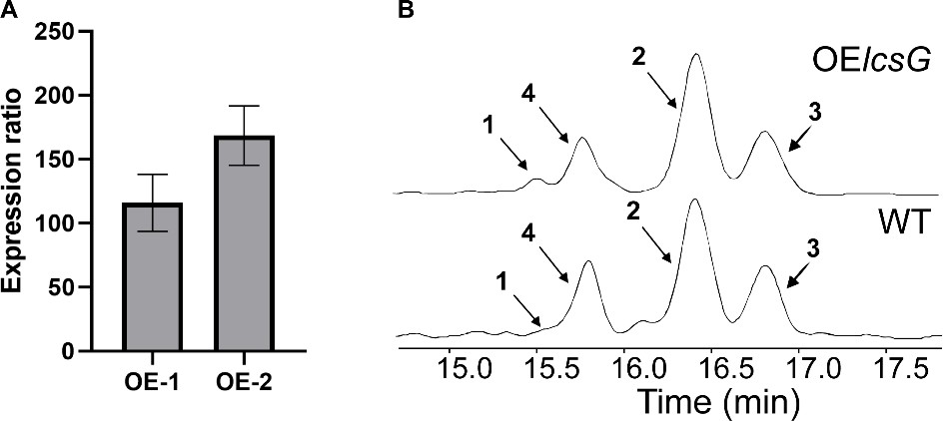

Figure S3. (A) Quantitative analysis of lcsG gene expression in overexpression (OE) mutants by quantitative real- time PCR. The gene expression level of lcsG in OE-1 and OE-2 demonstrate 115.69-fold and 168.56-fold upregulation, respectively. (B) LC-MS analysis of leucinostatin C (LeuC, 1), LeuB (2), LeuA (3), and LeuK0 (4) of the lcsG overexpression (OElcsG) mutant and WT.

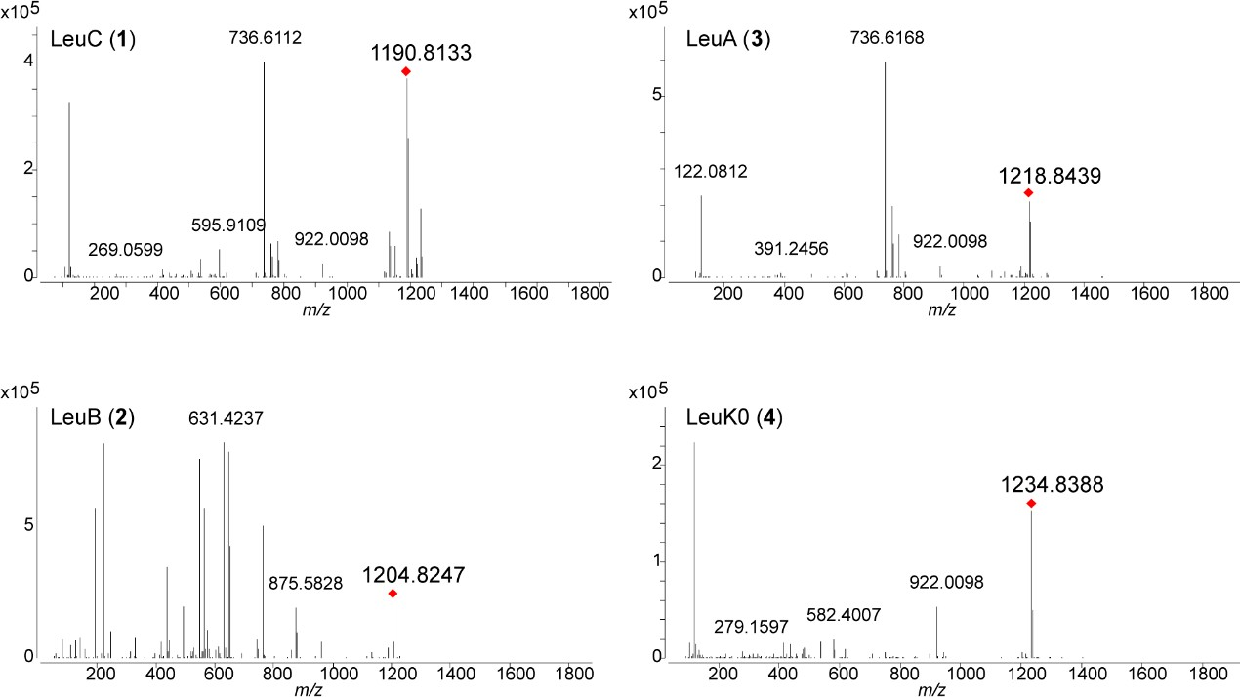

Figure S4. HRESI-MS spectrum of LeuC (1), LeuB (2), LeuA (3), and LeuK0 (4).

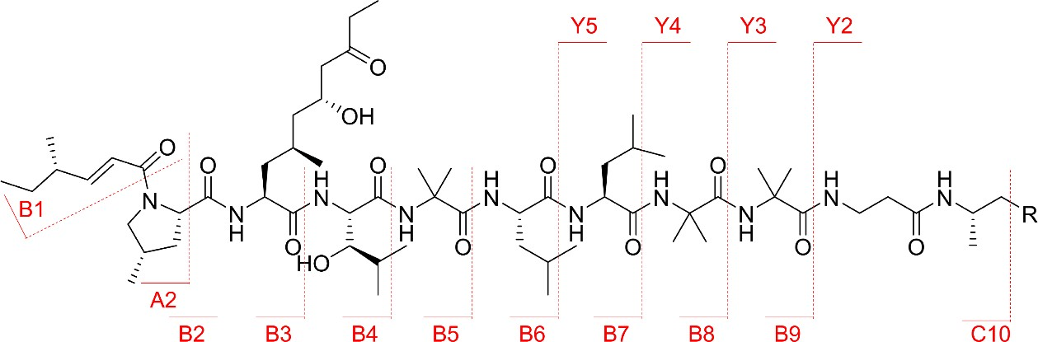

Figure S5. Fragmentation types observed in MS-MS spectra of leucinostatins.

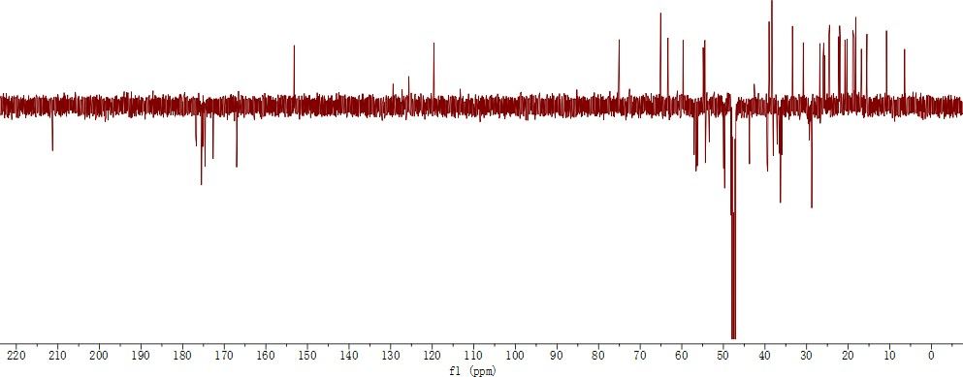

Figure S6. 13C-NMR (APT) of LeuK0 in CD3OD. It revealed that LeuK0 possessed total of 62 carbons, including 18 methyl groups (-CH3), 14 methylenes (-CH2), 16 methines (-CH), and 14 sp3 quaternary carbons.

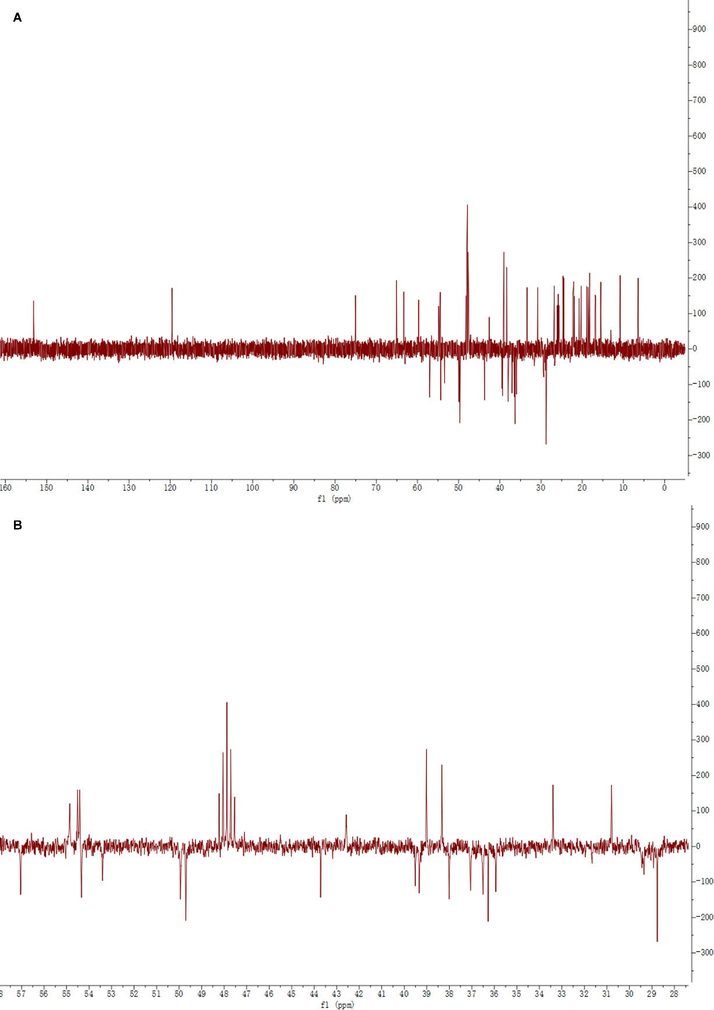
Figure S7. 13C-NMR (DEPT-135) of LeuK0 in CD3OD. (A)The global view of this spectrum. (B) The local view of this spectrum. The 13C-NMR DEPT-135 data of LeuK0 indicated it contains 14 -CH2 units and 34 -CH/CH3 units.

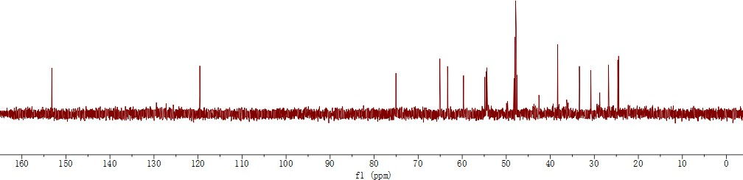
Figure S8. 13C-NMR (DEPT-90) of LeuK0 in CD3OD. The 13C-NMR DEPT-90 spectrum of LeuK0 indicated it contains 16 -CH units.

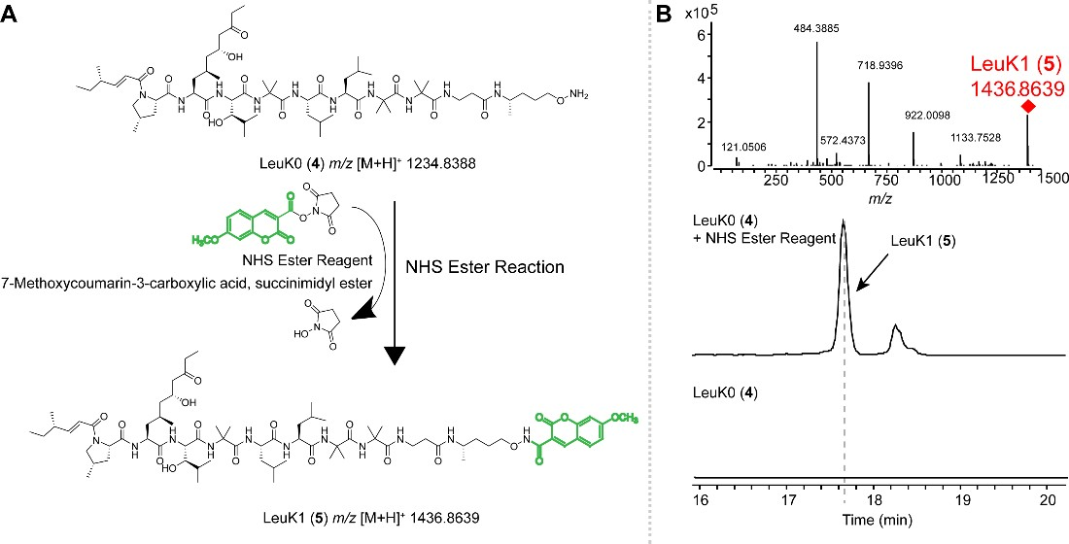
Figure S9. NHS ester reaction scheme (A) NHS ester reaction scheme for chemical conjugation to LeuK0 (4). (B) LC- MS analysis of LeuK0 (4) and NHS ester reaction with LeuK0. EIS at m/z 1236.8469 refers to [M+H]+ ion of product LeuK1 (5).

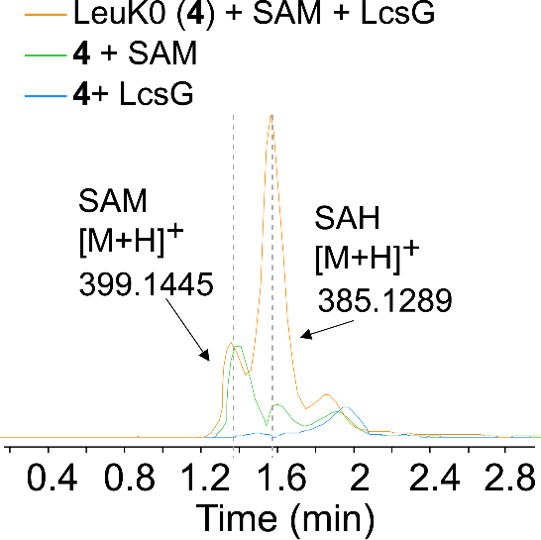
Figure S10. LC-MS detection of SAM and SAH of LcsG-catalyzed reactions.

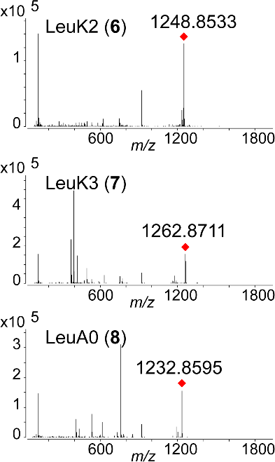

Figure S11. [M+H]+ ions of LeuK2 (6), LeuK3 (7) and LeuA0 (8).

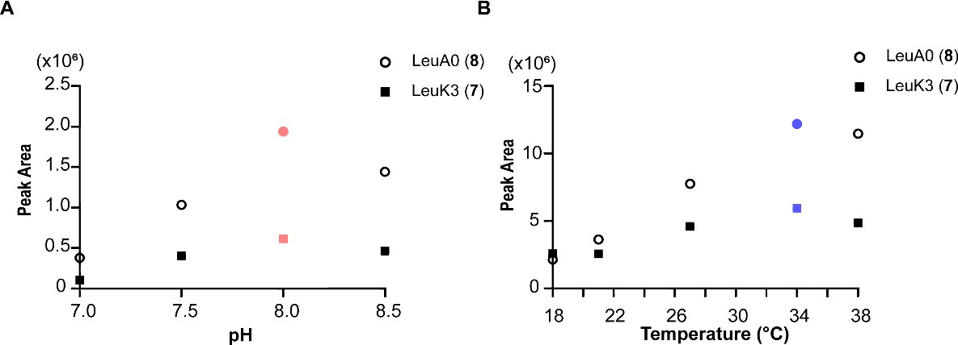

Figure S12. (A) Effect of pH (pH 7.0, pH 7.5. pH 8.0, pH 8.5) on the production of LeuA0 (8) and LeuK3 (7) by LcsG- catalyzed. LcsG showed a pH optimum of 8.0 (labeled in red). (B) Effect of temperature (18°C, 21°C, 27°C, 34°C, 38°C) on the production of LeuA0 (8) and LeuK3 (7) by LcsG-catalyzed. LcsG showed a temperature optimum of 34 °C (labeled in blue).

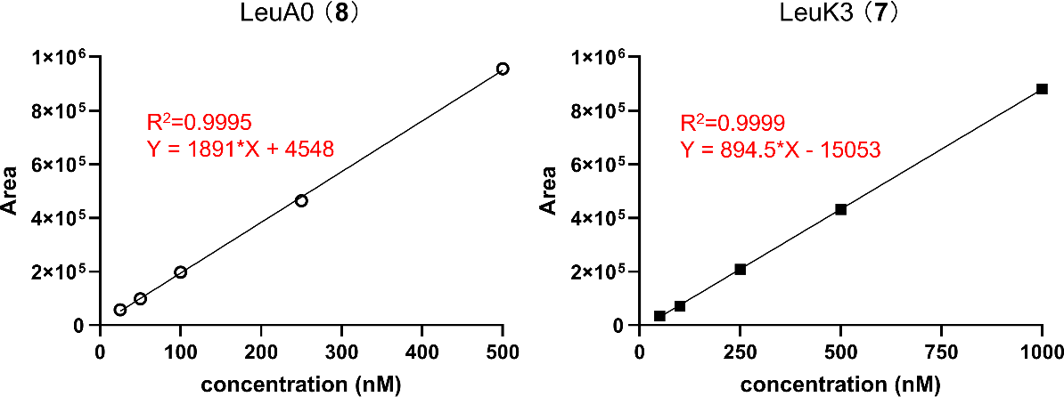

Figure S13. Standard curve of concentration and peak area of LeuA0 (8) and LeuK3 (7) determined by LC-MS.

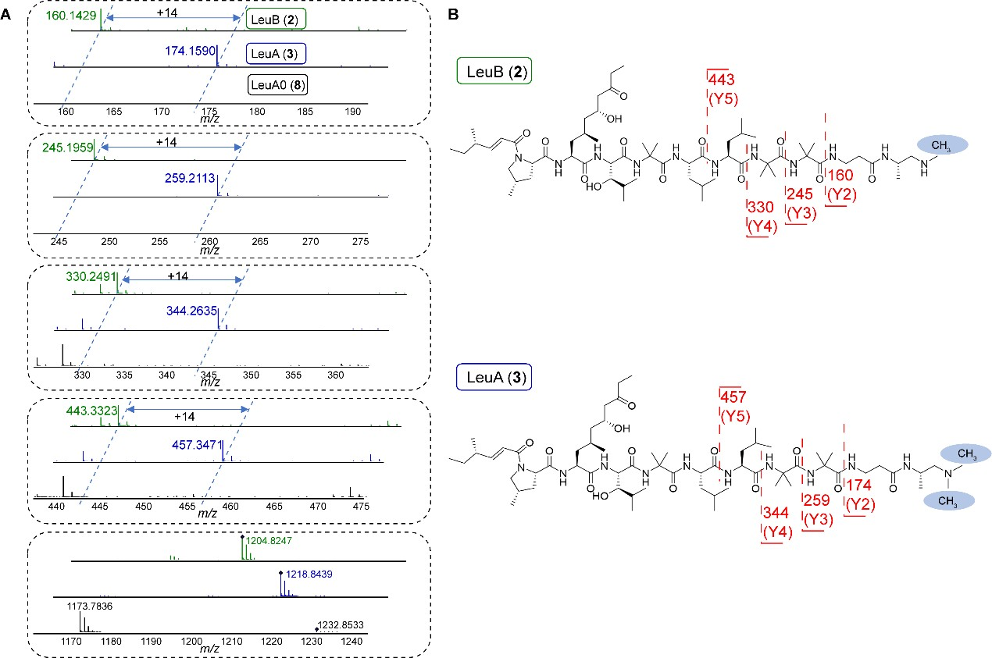
Figure S14. (A) Ions from the HRESI-MS-MS data of LeuB (2, marked in green), LeuA (3, marked in blue), and LeuA0 (8, marked in black). (B) Predicted fragments and their calculated m/z for observed ions got from HRESI- MS-MS of LeuB (2), LeuA (3).

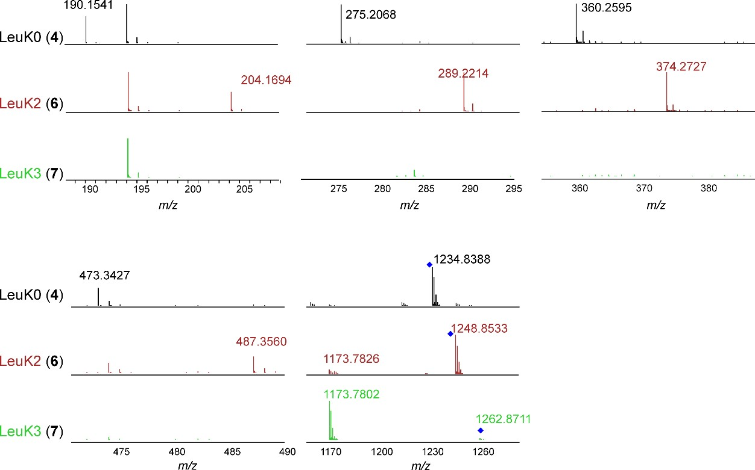
Figure S15. Ions from the HRESI-MS-MS data of LeuK0 (4, marked in black), LeuK2 (6, marked in red), and LeuK3 (7, marked in green).

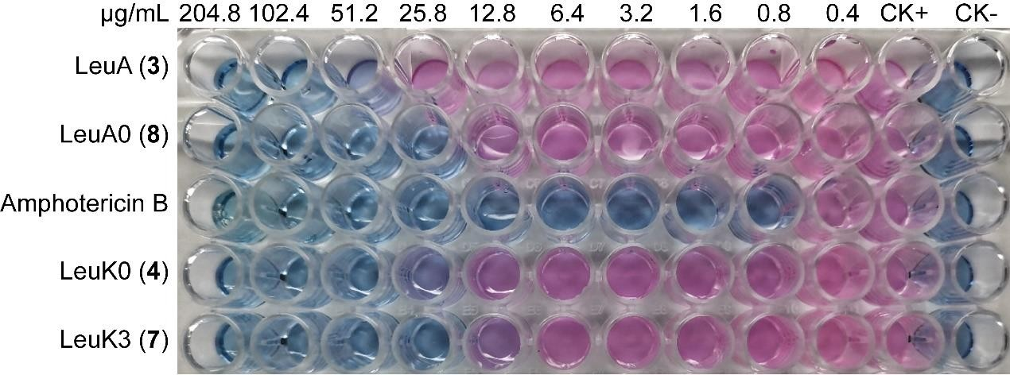
Figure S16. MIC (μg/mL) of leucinostatins (LeuA (3), LeuA0 (8), LeuK0 (4), LeuK3 (7)) against Cryptococcus neoformans strain H99 in a 2-fold liquid dilution assay. The 2-fold serial dilution of leucinostatins from 204.8 to 0.4 μg/mL was tested in 96-well plates. The positive control was amphotericin B at a 2-fold serial dilution from 204.8 to 0.4 μg/mL. The negative controls were medium (CK-) and inoculum (CK+).

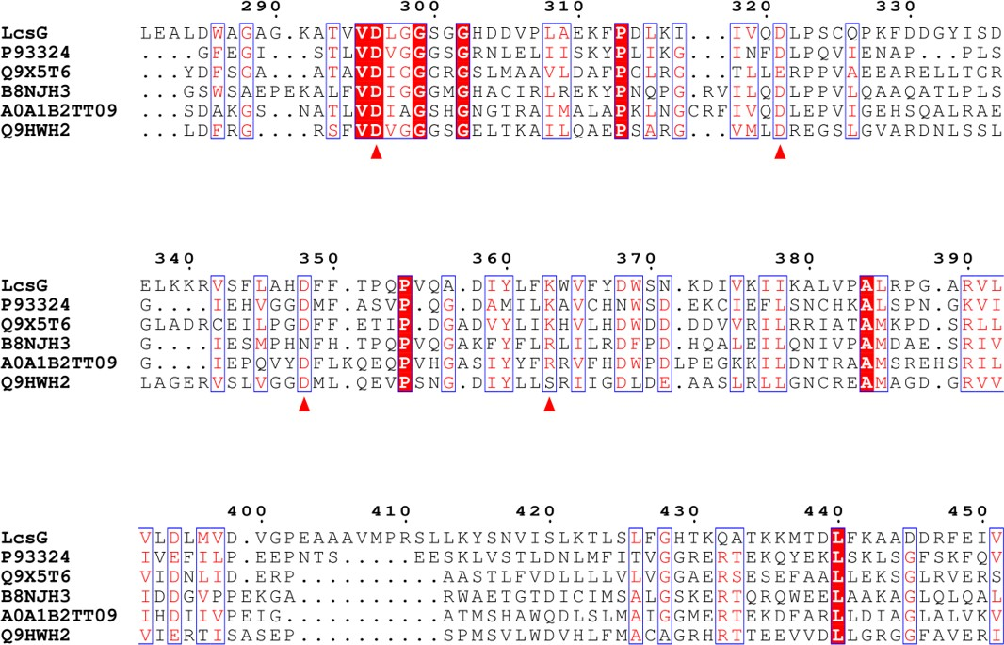

Figure S17. Sequence comparison between the LcsG and a group of MTs whose crystal structures were identified.

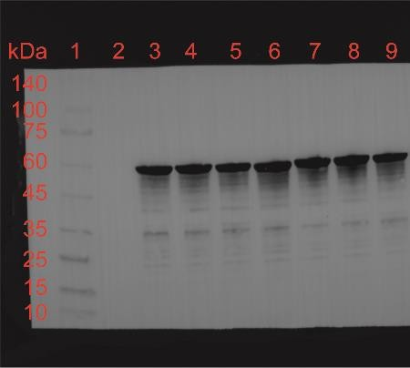
Figure S18. Western blot analysis of LcsG mutated proteins. The expected size of proteins (52kDa) was indicated. Lane 1: Ladder; Lane 2: the negative control strain contained blunt vector; Lane 3: LcsG wild-type protein; Lane 4: LcsG-D296A; Lane 5: LcsG-D321A; Lane 6: LcsG-D348A; Lane 7: LcsG-K363A; Lane 8: LcsG-D368A; Lane 9: LcsG- D395A.

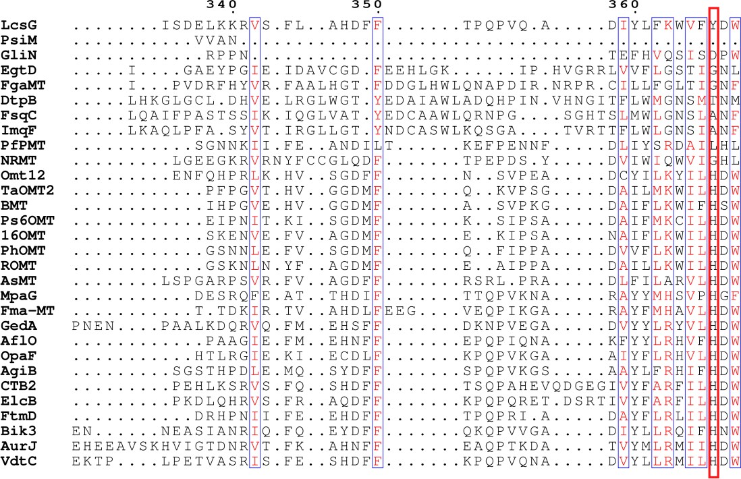

Figure S19. Sequence comparison between the LcsG and other identified NMTs and OMTs. The 367 residues were indicated with the red frame.

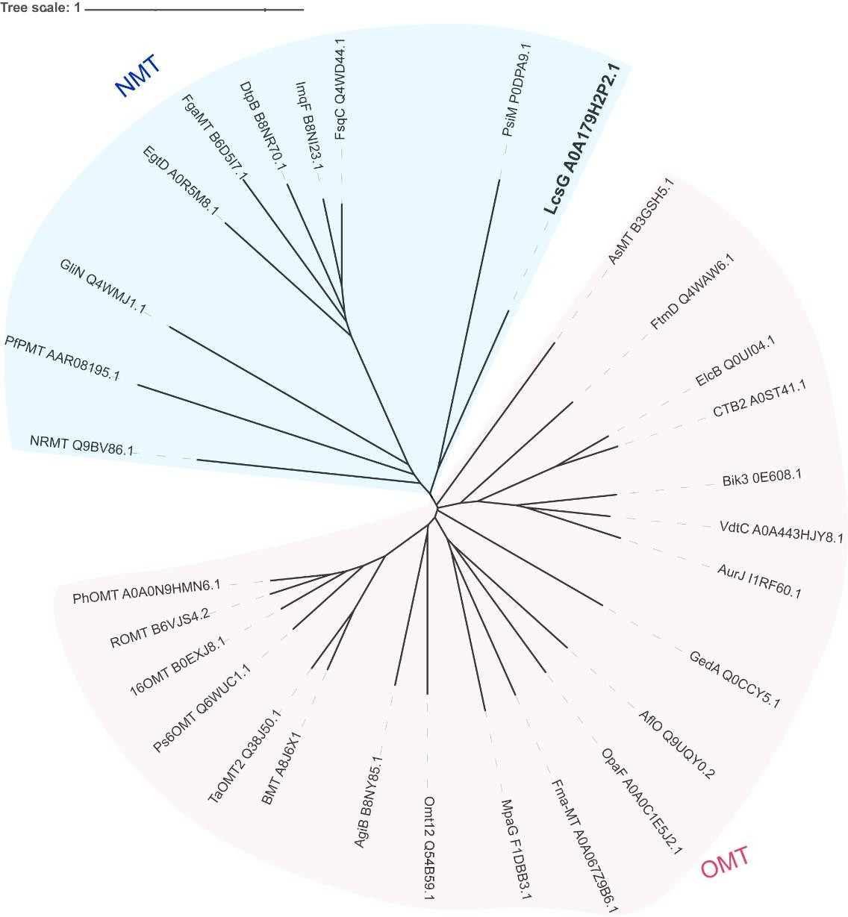
Figure S20. Phylogenetic tree of identified N-methyltransferases (marked in blue), O-methyltransferases (marked in pink), and LcsG.

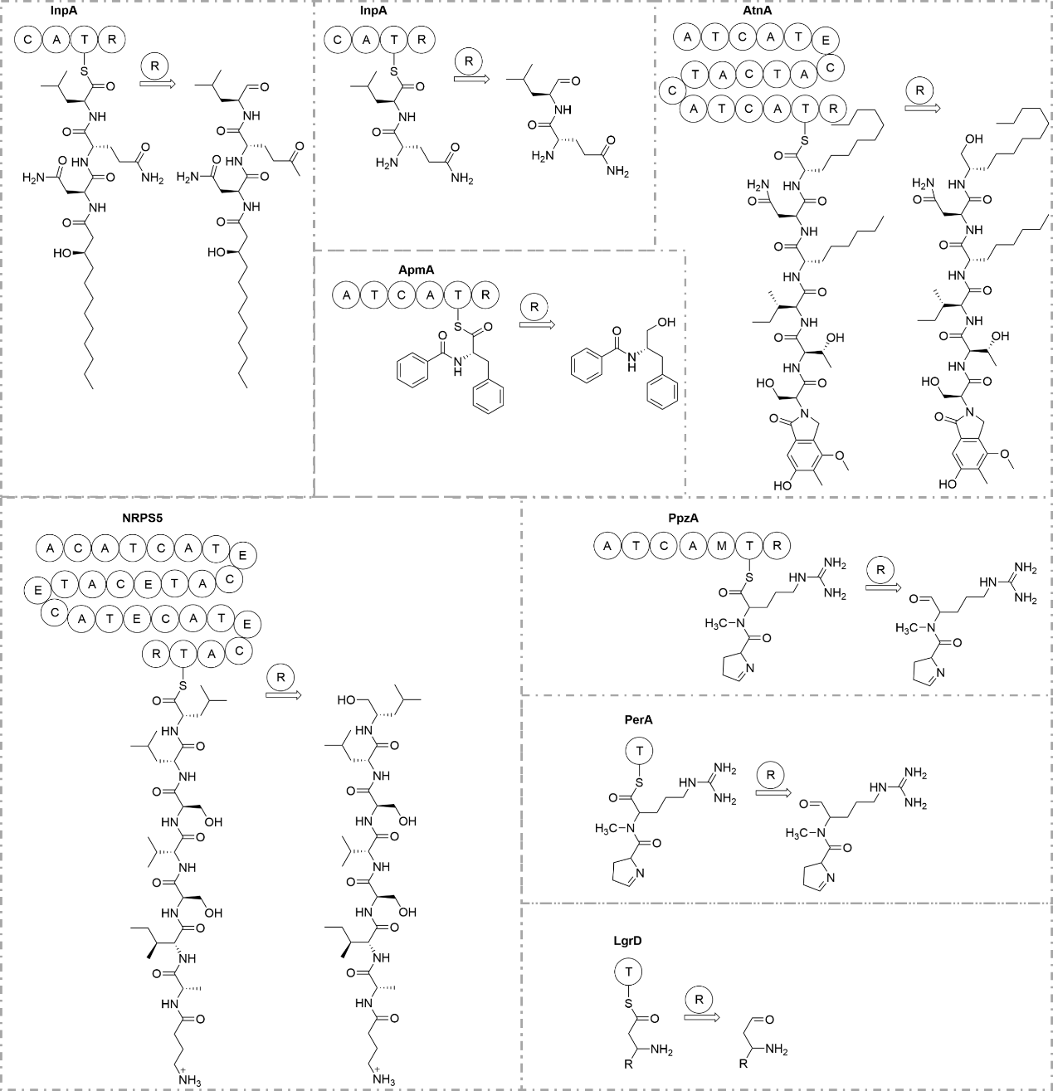
Figure S21. The termination step mediated by the reductase (R) domain in the biosynthesis of NRPs whose gene contained similar terminal modules with that of LcsG.

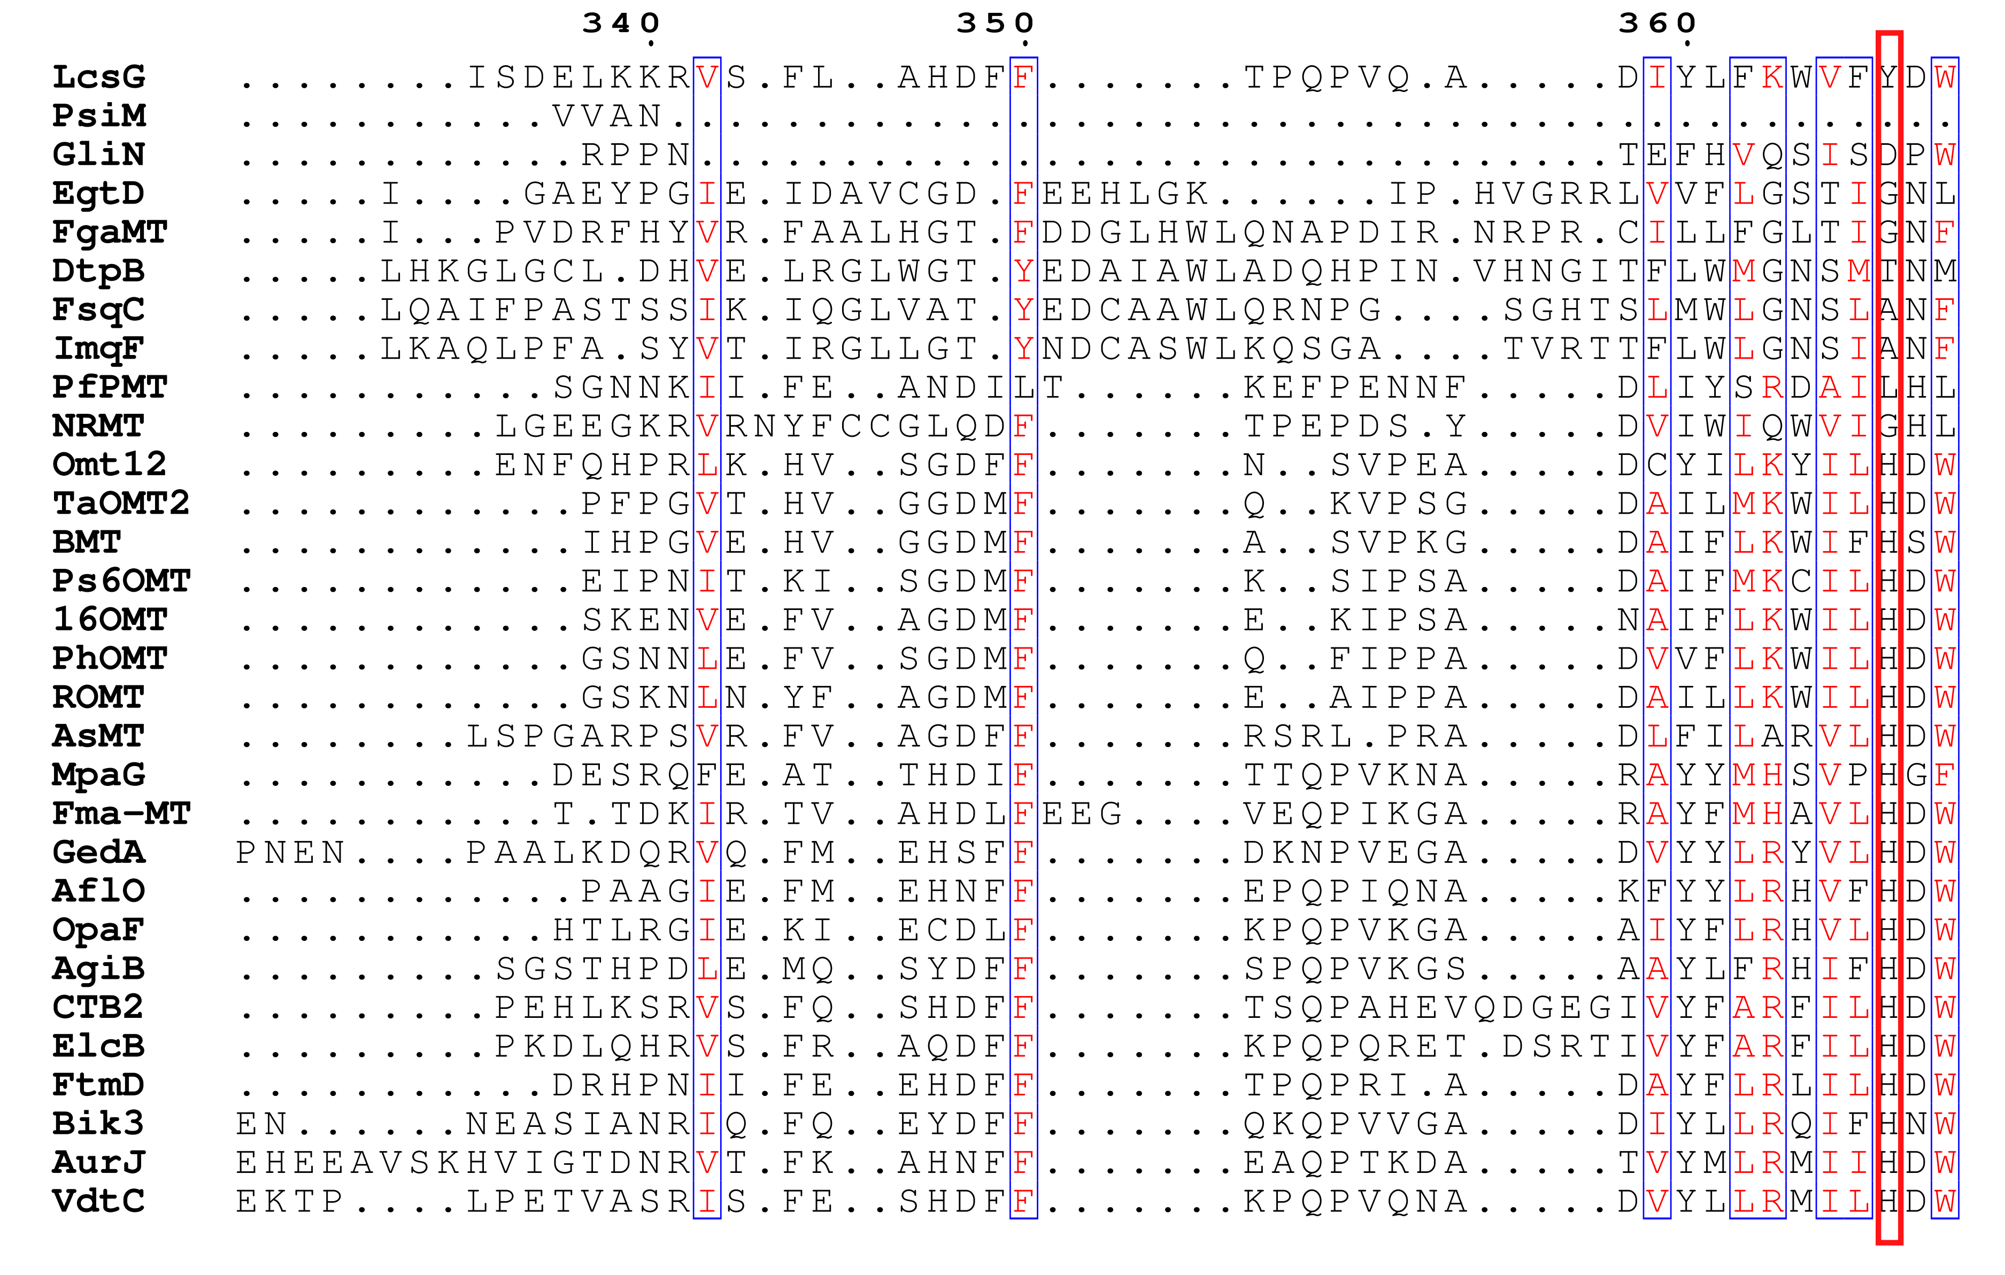
Figure S22. Sequence comparison between the LcsG and other identified NMTs and OMTs. The 367 residues were indicated with the red frame.

Reference
1. Rigbers, O. & Li, S.-M. Ergot alkaloid biosynthesis in Aspergillus fumigatus: Overproduction and biochemical characterization of a 4-dimethylallyltryptophan N-methyltransferase. J. Biol. Chem. 283, 26859–26868 (2008).
2. Saruwatari, T. et al. Cytochrome P450 as dimerization catalyst in diketopiperazine alkaloid biosynthesis. ChemBioChem 15, 656–659 (2014).
3. Lahham, M. et al. Oxidative cyclization of N-methyl-dopa by a fungal flavoenzyme of the amine oxidase family. J. Biol. Chem. 293, 17021–17032 (2018).
4. Scharf, D. H., Habel, A., Heinekamp, T., Brakhage, A. A. & Hertweck, C. Opposed effects of enzymatic gliotoxin N-and S-methylations. J. Am. Chem. Soc. 136, 11674–11679 (2014).
5. Khalid, S. et al. NRPS-derived isoquinolines and lipopetides mediate antagonism between plant pathogenic fungi and bacteria. ACS Chem. Biol. 13, 171–179 (2018).
6. Lee, S. G., Kim, Y., Alpert, T. D., Nagata, A. & Jez, J. M. Structure and Reaction Mechanism of Phosphoethanolamine Methyltransferase from the Malaria Parasite Plasmodium falciparum: an antiparasitic drug target. J. Biol. Chem. 287, 1426–1434 (2012).
7. Fricke, J., Blei, F. & Hoffmeister, D. Enzymatic synthesis of psilocybin. Angew. Chem. Int. Ed. 56, 12352–12355 (2017).
8. Schaner Tooley, C. E. et al. NRMT is an α-N-methyltransferase that methylates RCC1 and retinoblastoma protein. Nature 466, 1125–1128 (2010).
9. Vit, A., Misson, L., Blankenfeldt, W. & Seebeck, F. P. Ergothioneine biosynthetic methyltransferase EgtD reveals the structural basis of aromatic amino acid betaine biosynthesis. ChemBioChem 16, 119–125 (2015).
10. Kato, N., Suzuki, H., Okumura, H., Takahashi, S. & Osada, H. A point mutation in ftmD blocks the fumitremorgin biosynthetic pathway in Aspergillus fumigatus strain Af293. Biosci. Biotechnol. Biochem. 77, 1061–1067 (2013).
11. Arndt, B. et al. Genetic engineering, high resolution mass spectrometry and nuclear magnetic resonance spectroscopy elucidate the bikaverin biosynthetic pathway in Fusarium fujikuroi. Fungal Genet. Biol. 84, 26–36 (2015).
12. Zhang, W. et al. Functional characterization of MpaG′, the O‐methyltransferase involved in the biosynthesis of mycophenolic acid. Chembiochem 16, 565–569 (2015).
13. Chen, Z.-G., Fujii, I., Ebizuka, Y. & Sankawa, U. Emodin O-methyltransferase from Aspergillus terreus. Arch. Microbiol. 158, 29–34 (1992).
14. Urquhart, A. S., Hu, J., Chooi, Y.-H. & Idnurm, A. The fungal gene cluster for biosynthesis of the antibacterial agent viriditoxin. Fungal Biol. Biotechnol. 6, 1–13 (2019).
15. Zheng, L., Wang, H., Fan, A. & Li, S.-M. Oxepinamide F biosynthesis involves enzymatic d-aminoacyl epimerization, 3 H-oxepin formation, and hydroxylation induced double bond migration. Nat. Commun. 11, 4914 (2020).
16. Greco, C., Pfannenstiel, B. T., Liu, J. C. & Keller, N. P. Depsipeptide aspergillicins revealed by chromatin reader protein deletion. ACS Chem. Biol. 14, 1121–1128 (2019).
17. Frandsen, R. J. et al. Two novel classes of enzymes are required for the biosynthesis of aurofusarin in Fusarium graminearum. J. Biol. Chem. 286, 10419–10428 (2011).
18. Hu, J. et al. Heterologous biosynthesis of elsinochrome A sheds light on the formation of the photosensitive perylenequinone system. Chem. Sci. 10, 1457–1465 (2019).
19. Yabe, K., Matsushima, K., Koyama, T. & Hamasaki, T. Purification and characterization of O-methyltransferase I involved in conversion of demethylsterigmatocystin to sterigmatocystin and of dihydrodemethylsterigmatocystin to dihydrosterigmatocystin during aflatoxin biosynthesis. Appl. Environ. Microbiol. 64, 166–171 (1998).
20. Levac, D., Murata, J., Kim, W. S. & De Luca, V. Application of carborundum abrasion for investigating the leaf epidermis: molecular cloning of Catharanthus roseus 16‐hydroxytabersonine‐16‐O‐methyltransferase. Plant J. 53, 225–236 (2008).
21. Lau, W. & Sattely, E. S. Six enzymes from mayapple that complete the biosynthetic pathway to the etoposide aglycone. Science 349, 1224–1228 (2015).
22. Schmidlin, L. et al. A stress-inducible resveratrol O-methyltransferase involved in the biosynthesis of pterostilbene in grapevine. Plant Physiol. 148, 1630–1639 (2008).
23. Lin, H.-C. et al. Generation of complexity in fungal terpene biosynthesis: discovery of a multifunctional cytochrome P450 in the fumagillin pathway. J. Am. Chem. Soc. 136, 4426–4436 (2014).
24. Ghosh, R. et al. Dissecting the functional role of polyketide synthases in Dictyostelium discoideum: biosynthesis of the differentiation regulating factor 4-methyl-5-pentylbenzene-1, 3-diol. J. Biol. Chem. 283, 11348–11354 (2008).
25. Ounaroon, A., Decker, G., Schmidt, J., Lottspeich, F. & Kutchan, T. M. (R, S)‐Reticuline 7‐O‐methyltransferase and (R, S)‐norcoclaurine 6‐O‐methyltransferase of Papaver somniferum–cDNA cloning and characterization of methyl transfer enzymes of alkaloid biosynthesis in opium poppy. Plant J. 36, 808–819 (2003).
26. Gauer, F. & Craft, C. M. Circadian regulation of hydroxyindole-O-methyltransferase mRNA levels in rat pineal and retina. Brain Res. 737, 99–109 (1996).
27. Zhou, J.-M., Gold, N. D., Martin, V. J., Wollenweber, E. & Ibrahim, R. K. Sequential O-methylation of tricetin by a single gene product in wheat. Biochim. Biophys. Acta BBA-Gen. Subj. 1760, 1115–1124 (2006).
28. Ishikawa, A. et al. Constitutive expression of bergaptol O-methyltransferase in Glehnia littoralis cell cultures. Plant Cell Rep. 28, 257–265 (2009).
29. Yeh, H.-H. et al. Resistance gene-guided genome mining: serial promoter exchanges in Aspergillus nidulans reveal the biosynthetic pathway for fellutamide B, a proteasome inhibitor. ACS Chem. Biol. 11, 2275–2284 (2016).
30. Li, W. et al. Asperphenamate biosynthesis reveals a novel two-module NRPS system to synthesize amino acid esters in fungi. Chem. Sci. 9, 2589–2594 (2018).
31. Chiang, Y.-M. et al. Development of genetic dereplication strains in Aspergillus nidulans results in the discovery of aspercryptin. Angew. Chem. Int. Ed. 55, 1662–1665 (2016).
32. Jia, L.-J. et al. A linear nonribosomal octapeptide from Fusarium graminearum facilitates cell-to-cell invasion of wheat. Nat. Commun. 10, 922 (2019).
33. Berry, D. et al. Orthologous peramine and pyrrolopyrazine‐producing biosynthetic gene clusters in Metarhizium rileyi, Metarhizium majus and Cladonia grayi. Environ. Microbiol. 21, 928–939 (2019).
34. Tanaka, A., Tapper, B. A., Popay, A., Parker, E. J. & Scott, B. A symbiosis expressed non‐ribosomal peptide synthetase from a mutualistic fungal endophyte of perennial ryegrass confers protection to the symbiotum from insect herbivory. Mol. Microbiol. 57, 1036–1050 (2005).
35. Schracke, N., Linne, U., Mahlert, C. & Marahiel, M. A. Synthesis of linear gramicidin requires the cooperation of two independent reductases. Biochemistry 44, 8507–8513 (2005).

