Appendix

Supplementary Figure 1a: SHoC-IVC Study Protocol

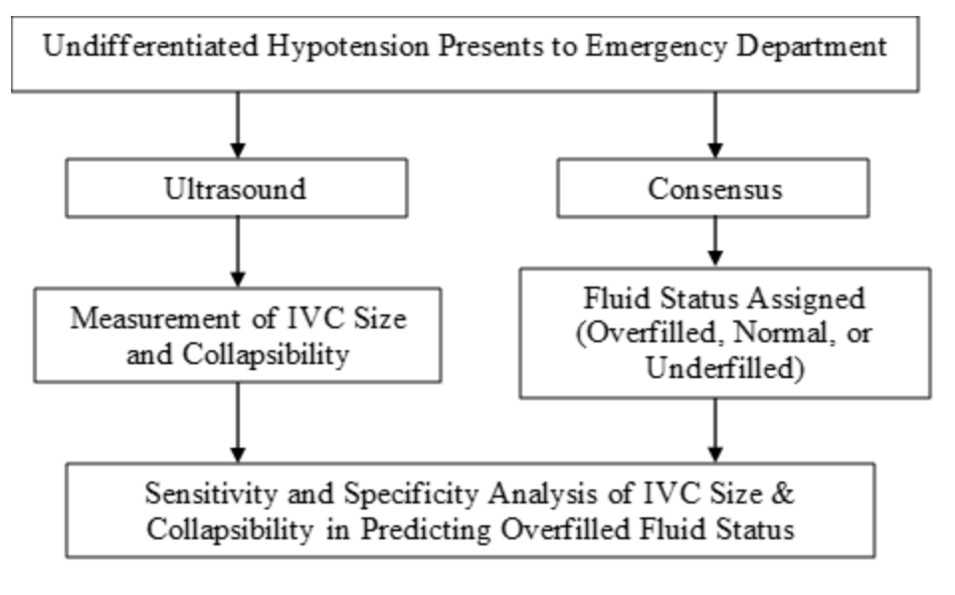

Supplementary Figure 2: CONSORT Diagram
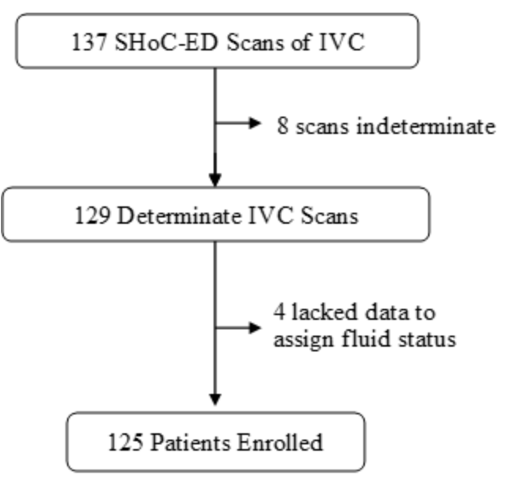

Supplementary Figure 3: Receiver Operating Characteristic (ROC) Curve, IVC Parameters as Predictors of Volume Overloaded Status

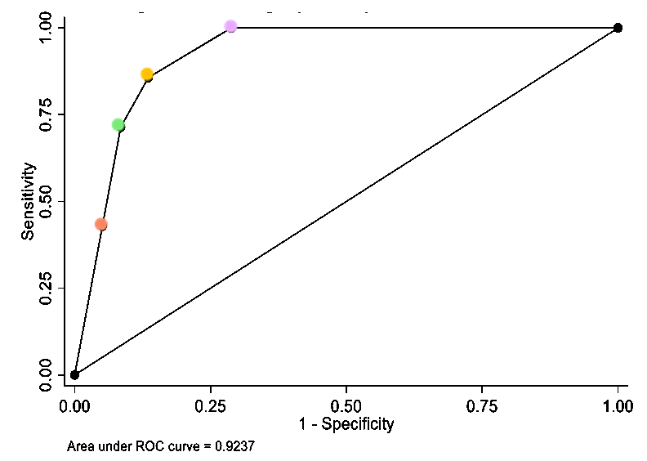
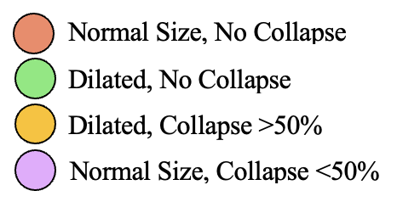

Supplementary Table 5: Frequency of Clinically Volume Overloaded Patients by IVC Size and Collapsibility.

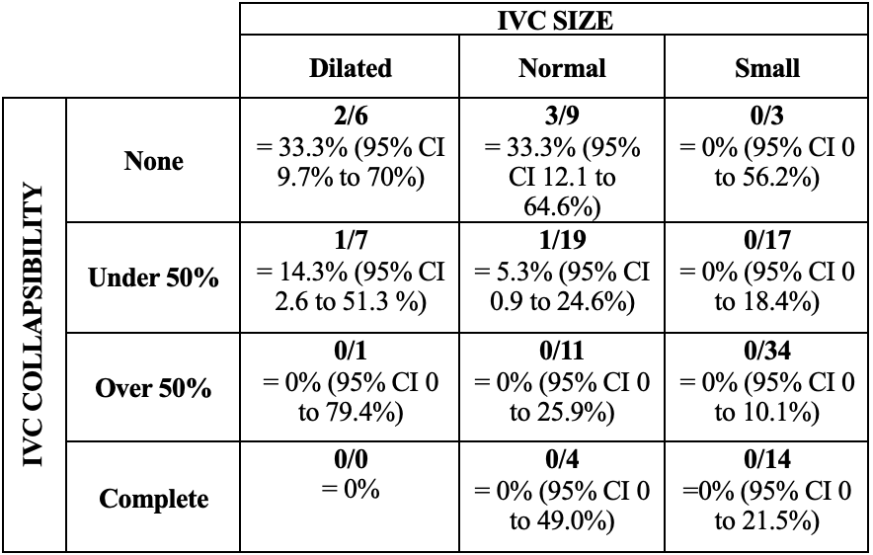

Supplementary Table 6: Performance of various combinations of IVC size and collapsibility as predictors of the Volume Overloaded Status in undifferentiated hypotensive adult patients.

IVC PARAMETER / COMBINATION | Sensitivity | Specificity | % Correctly Classified | Positive Likelihood Ratio | Negative Likelihood Ratio
Size (Max. Diameter >2.5cm) | 100.0% | 95.4% | 95.78% | 21.8 | 0.0
Collapse < 50% | 82.5% | 47.1% | 50.0% | 1.6 | 0.3
Normal Size, No Collapse | 42.9% | 94.9% | 92.0% | 8.4 | 0.6
Dilated, No Collapse | 71.4% | 91.5% | 90.4% | 8.4 | 0.3
Dilated, Collapse <50% | 85.7% | 86.4% | 86.4% | 6.3 | 0.2
Normal Size, Collapse <50% | 100.0% | 71.2% | 72.8% | 3.5 | 0.0000

