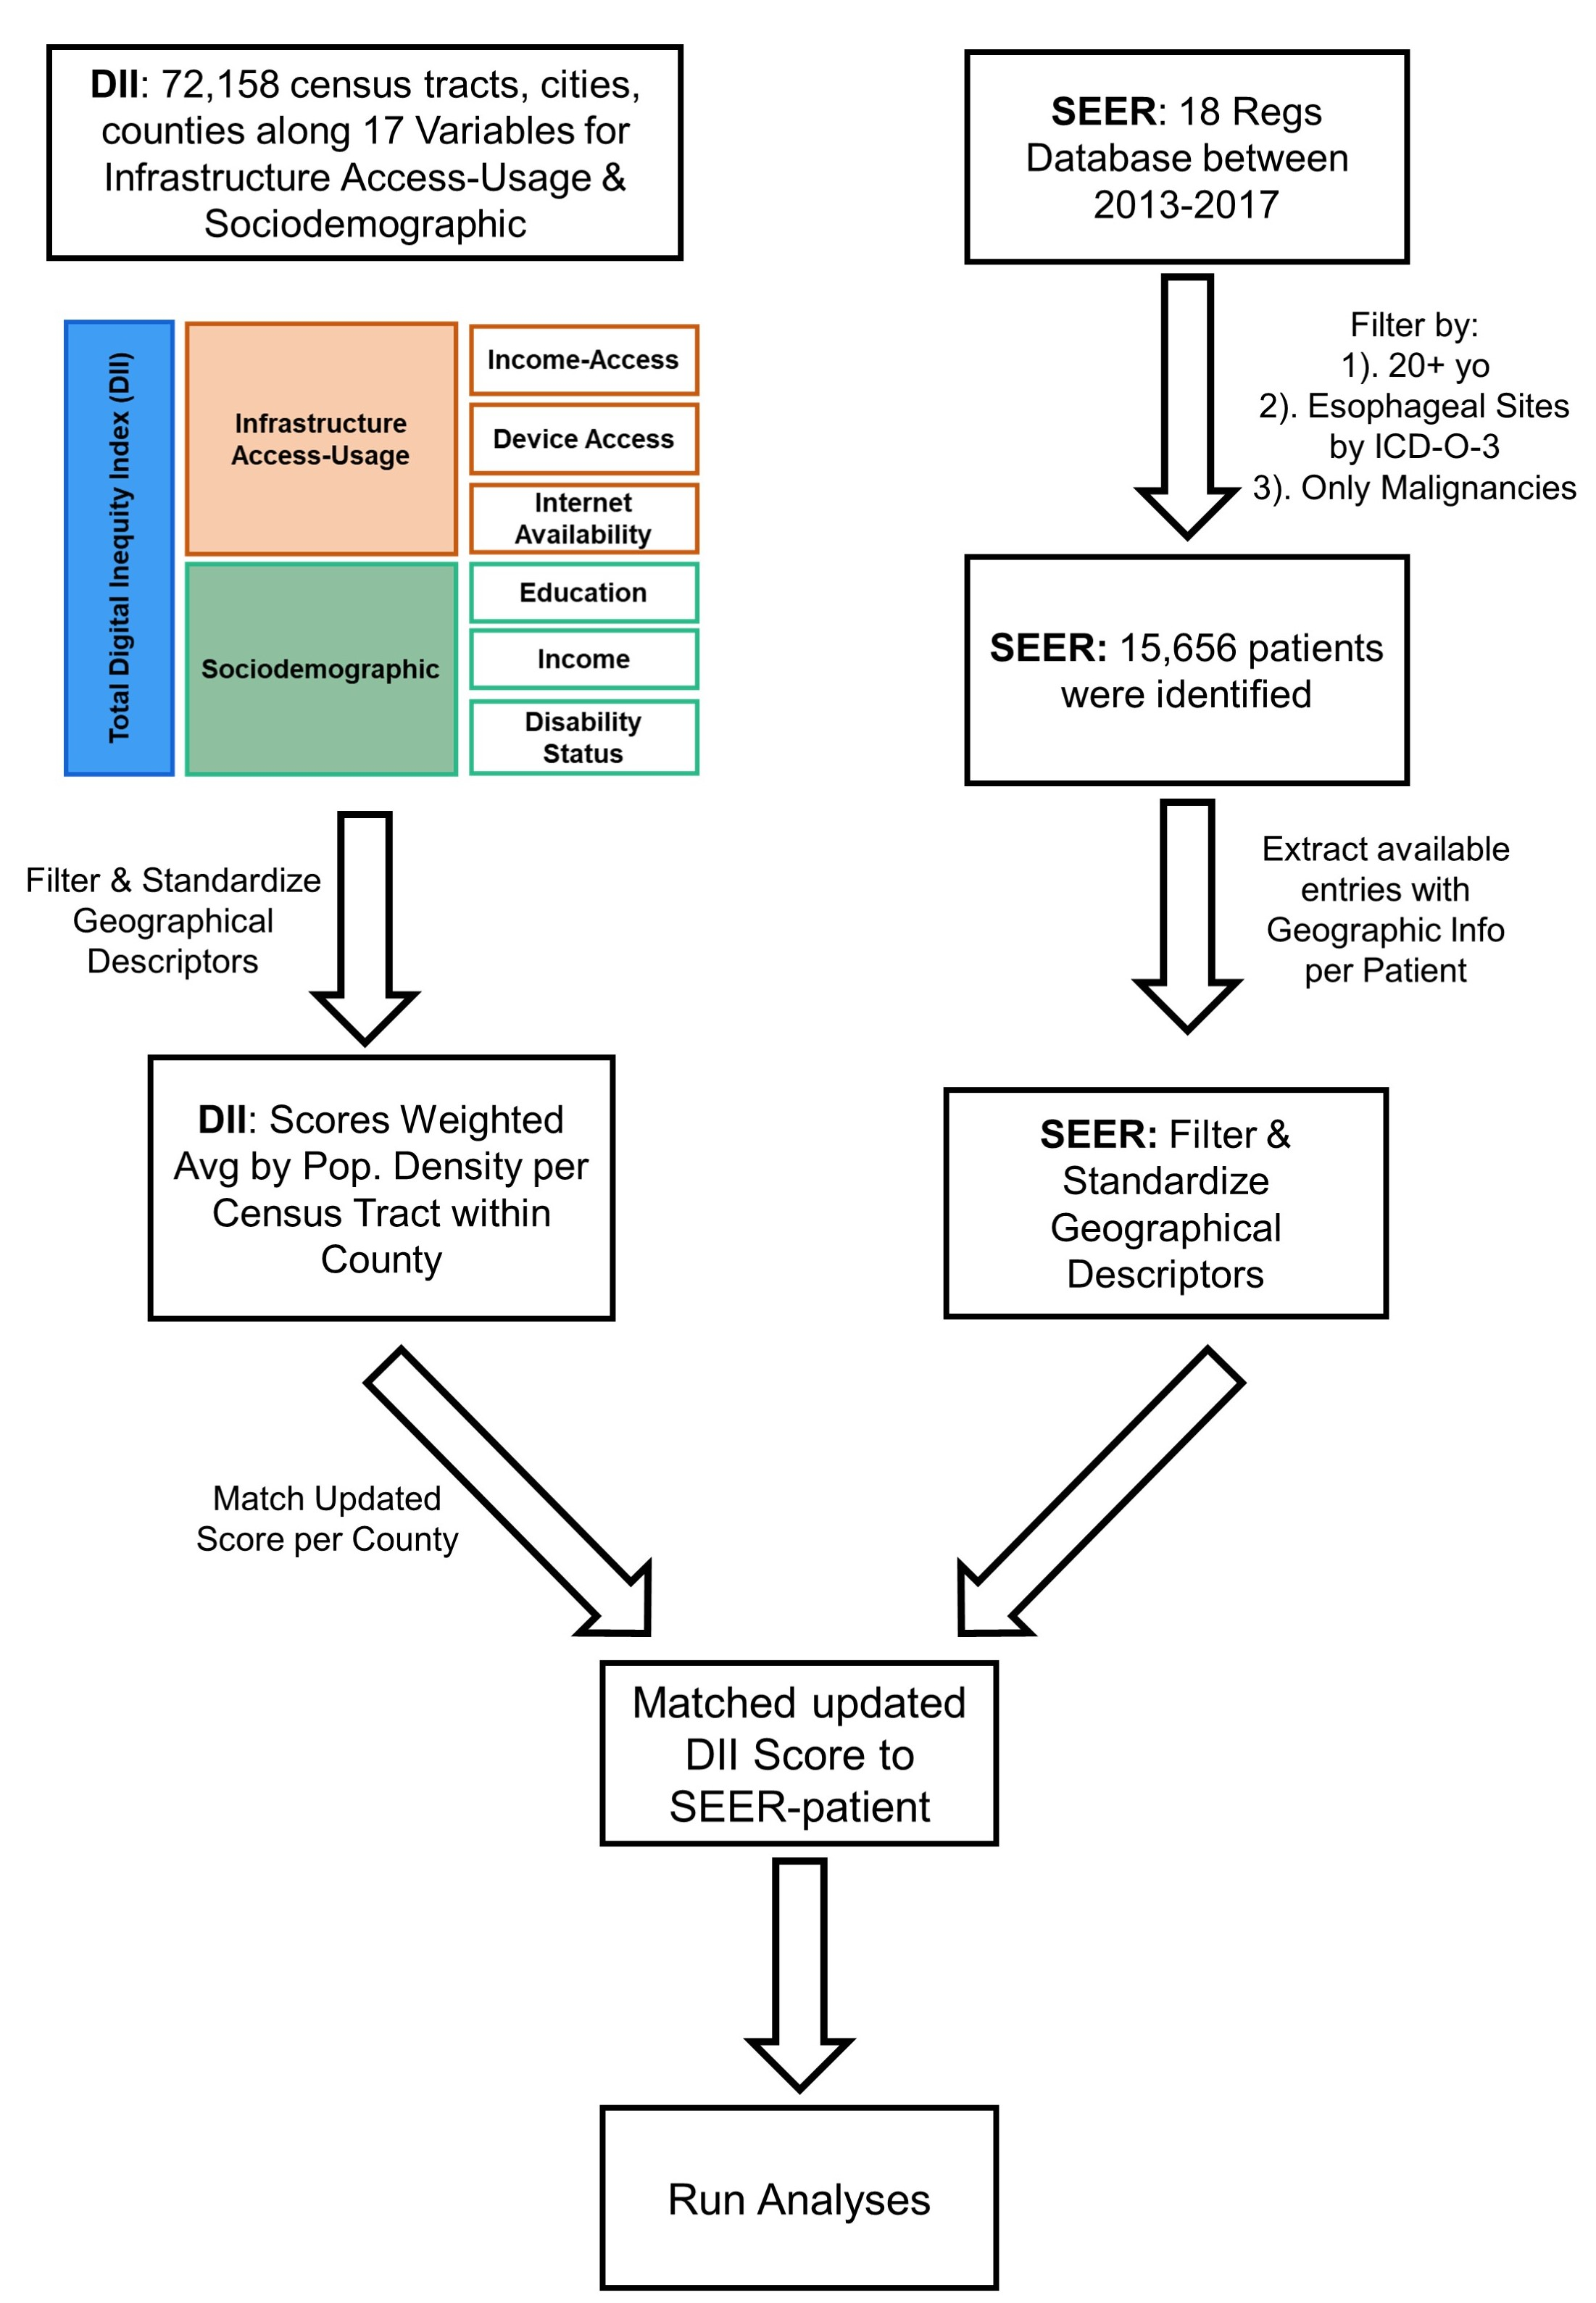 Supplemental Figure 1. Schematic Workflow of DII & SEER Database Manipulation. The Digital Inequity Index was merged with patient data from the SEER database through linked geocodes of County.

