Supplementary Material

Table 3 Comparisons with statistically significant effect under exercise-related treatments
Measurement | Comparison | Effect | 95% CI
Pain Intensity | Manipulation Techniques vs Home Exercise | -6.01 | [-9.13; -2.89]
 | Control vs Exercise | 10.81 | [5.99; 15.64]
 | Qigong vs Exercise | 4.38 | [1.04; 7.72]
Pain Disability | Aerobic Exercise vs Home Exercise | -4.42 | [-7.81; -1.03]
 | Physical Therapy vs Home Exercise | -4.86 | [-8.06; -1.66]
 | Control vs Exercise | 4.80 | [0.06; 9.54]
 | Exercise+CBT vs Exercise | -13.45 | [-14.55; -12.35]
 | Qigong vs Exercise | 0.90 | [0.41, 1.39]

Table 4 Comparisons with statistically significant effect under acupuncture-related treatments
Measurement | Comparison | Effect | 95% CI
Pain Intensity | Acupuncture vs Control | -1.70 | [-2.33; -1.08]

Table 5 showed comparisons with statistically significant effect under CBT-related treatments. Among those treatment with direct comparison with control treatment, CR provided a

Table 5 Comparisons with statistically significant effect under CBT-related treatments
Measurement | Comparison | Effect | 95% CI
Pain Intensity | CR vs Control | 10.27 | [0.84; 19.70]
 | MSCT+STGT vs Control | -3.6 | [-4.12; -3.09]
 | Multimodal Exercise+CBT vs Control | -3.35 | [-3.82; -2.88]

Table 6 Comparisons with statistically significant effect under massage-related treatments
Measurement | Comparison | Effect | 95% CI
Pain Intensity | Massage, 2×30 min/week vs Control | -1.28 | [-1.96; -0.60]
 | Massage, 2×60 min/week vs Control | -1.2 | [-1.88; -0.53]
 | Massage, 3×30 min/week vs Control | -1.21 | [-1.89; -0.53]
 | Massage, 3×60 min/week vs Control | -1.4 | [-2.08; -0.72]
Pain Disability | Cupping Massage vs Control | -3.87 | [-6.14; -1.60]
 | Massage, 2×30 min/week vs Control | -3.14 | [-4.99; -1.30]
 | Massage, 2×60 min/week vs Control | -2.97 | [-4.81; -1.12]
 | Massage, 3×30 min/week vs Control | -2.53 | [-4.38; -0.69]
 | Massage, 3×60 min/week vs Control | -3.55 | [-5.39; -1.70]

Figure 22 Forest plot of pain disability under all exercise-related treatments compared with control treatment in the first subnet

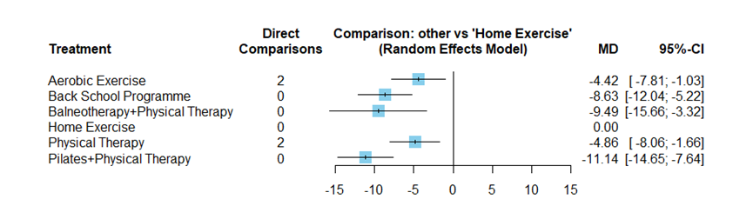

Fig 23 summarized mean differences of pain disability under all treatments in the second subnet directly and indirectly compared with exercise treatment. Among treatments with direct comparisons to exercise treatment, control treatment and qigong treatment provided a statistically significant increase in pain disability, while exercise plus CBT showed a statistically significant decrease (as Table 2). The number of direct comparison with exercise treatment of pharmacological treatment was 0, indicating no direct evidence of statistically significant effect.

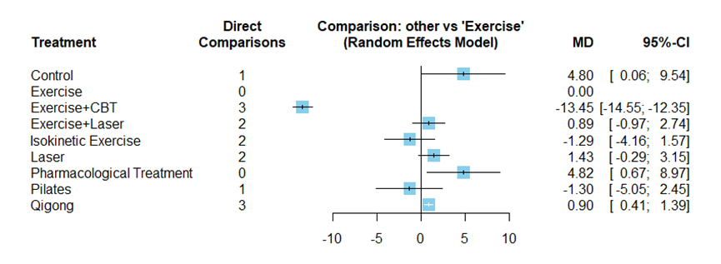
Figure 24 Forest plot of all acupuncture-related treatments compared with control treatment - summarized mean differences of all treatments in the acupuncture related network directly and indirectly compared with control treatment.
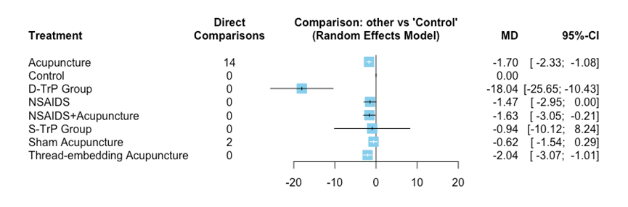

Figure 25 Forest plot of pain intensity under all CBT-related treatments compared with control treatment - summarized mean differences of pain intensity under all treatments in the CBT-related network directly and indirectly compared with control treatment.

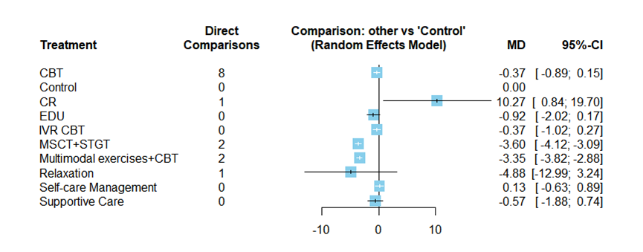

Figure 26 Forest plot of depression under all CBT-related treatments compared with control treatment - summarized mean differences of all treatments in the CBT-related network directly and indirectly compared with control treatment.

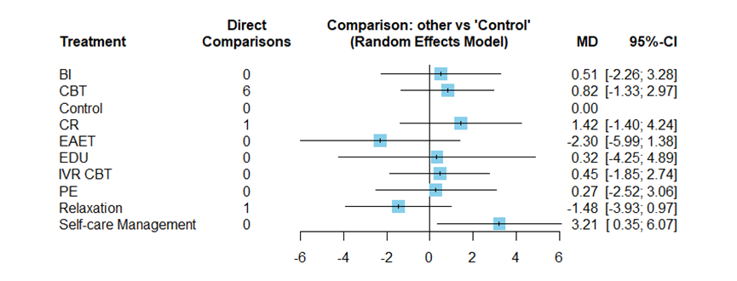

Figure 27 Forest plot pain intensity under all massage-related treatments compared with control treatment - summarized mean differences of all treatments in the massage related network directly and indirectly compared with control treatment.

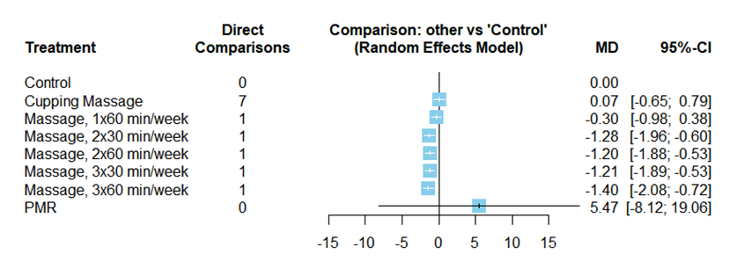

Figure 28 Forest plot pain disability under all massage-related treatments compared with control treatment - summarized mean differences of pain disability under all treatments in the massage related network directly and indirectly compared with control treatment.

