Supplemental Table S1. Sample meta-data, sequence depth, missingness, and notes. Abbreviations: FROH, inbreeding derived from runs of homozygosity; GL, Great Lakes; H, heterozygosity; RM, Rocky Mountains.

See file TableS1.xlsx

Supplemental Table S2. Comparison of F_{ST} distributions with the Two-Sample Kolmogorov-Smirnov test (D values reported). All comparisons have p<10⁻¹⁶. Geographic regions are numbered: 1, northern Canada; 2, western USA and southwestern Canada; 3, northern Quebec; 4, Great Lakes and Ontario.
Geographic comparison | 1 versus 3 | 1 versus 4 | 2 versus 3 | 2 versus 4 | 3 versus 4
1 versus 2 | 0.191 | 0.124 | 0.179 | 0.250 | 0.153
1 versus 3 |  | 0.193 | 0.119 | 0.281 | 0.117
1 versus 4 |  |  | 0.117 | 0.193 | 0.131
2 versus 3 |  |  |  | 0.203 | 0.038
2 versus 4 |  |  |  |  | 0.229

Supplemental Table S3. Effective population size (N_{e}) estimates for Figure 3 inferred from minimally filtered autosomal SNP genotype data. Individuals were partitioned into two levels of demography: regional and distinct population segments.

See file TableS3.xlsx

Supplemental Table S4. Gray wolf population estimates for the northern Rocky Mountain (RM) and western Great Lakes (GL) populations in the United States*. For years 1982-1989, Michigan wolf population estimates are from Isle Royale National Park only. Estimates vary between reporting organization.
Year | RM | GL |  | Year | RM | GL
1982 | 8 | 1272 |  | 1999 | 337 | 2839
1983 | 6 | 1277 |  | 2000 | 437 | 2903
1984 | 6 | 1277 |  | 2001 | 563 | 3497
1985 | 13 | 1271 |  | 2002 | 663 | 3717
1986 | 15 | 1270 |  | 2003 | 761 | 3665
1987 | 10 | 1269 |  | 2004 | 746 | 3768
1988 | 14 | 1273 |  | 2005 | 1020 | 3855
1989 | 12 | 1563 |  | 2006 | 1300 | 3951
1990 | 33 | 1563 |  | 2007 | 1513 | 3967
1991 | 29 | 1570 |  | 2008 | 1655 | 3980
1992 | 41 | 1715 |  | 2009 | 1733 | 4133
1993 | 55 | 1725 |  | 2010 | 1723 | 4312
1994 | 48 | 1754 |  | 2011 | 1804 | 4383
1995 | 101 | 1823 |  | 2012 | 1715 | 3676
1996 | 152 | 1859 |  | 2013 | 1691 | 3882
1997 | 213 | 2734 |  | 2014 | 1787 | 3501
1998 | 275 | 2763 |  | 2015 | 1881 | 3644
* Estimates were found in annual or management reports from MNDNR, WIDNR, and three publications: Peterson RO, Page RE (1988) The rise and fall of Isle Royale wolves, 1975-1986. J Mamm 69(1), 89-99; Peterson RO, Thomas NJ, Thurber JM, Vucetich JA, Waite TA (1998) Population limitation and the wolves of Isle Royale. J Mamm 79(3), 828-841; U.S. Fish and Wildlife Service, Idaho Department of Fish and Game, Montana Fish, Wildlife & Parks, Wyoming Game and Fish Department, Nez Perce Tribe, National Park Service, Blackfeet Nation, Confederated Salish and Kootenai Tribes, Wind River Tribes, Confederated Colville Tribes, Spokane Tribe of Indians, Washington Department of Fish and Wildlife, Oregon Department of Fish and Wildlife, Utah Department of Natural Resources, and USDA Wildlife Services (2016) Northern Rocky Mountain Wolf Recovery Program 2015 Interagency Annual Report. M.D. Jimenez and S.A. Becker, eds. USFWS, Helena, Montana, 59601.

Supplemental Figure S1. Violin jitter plots of sequence coverage on the canine Y chromosome for individuals of female and male from A) field-based assignments, including unknown sexes, and B) distribution of sequence coverage per sex after bioinformatic sex inference.

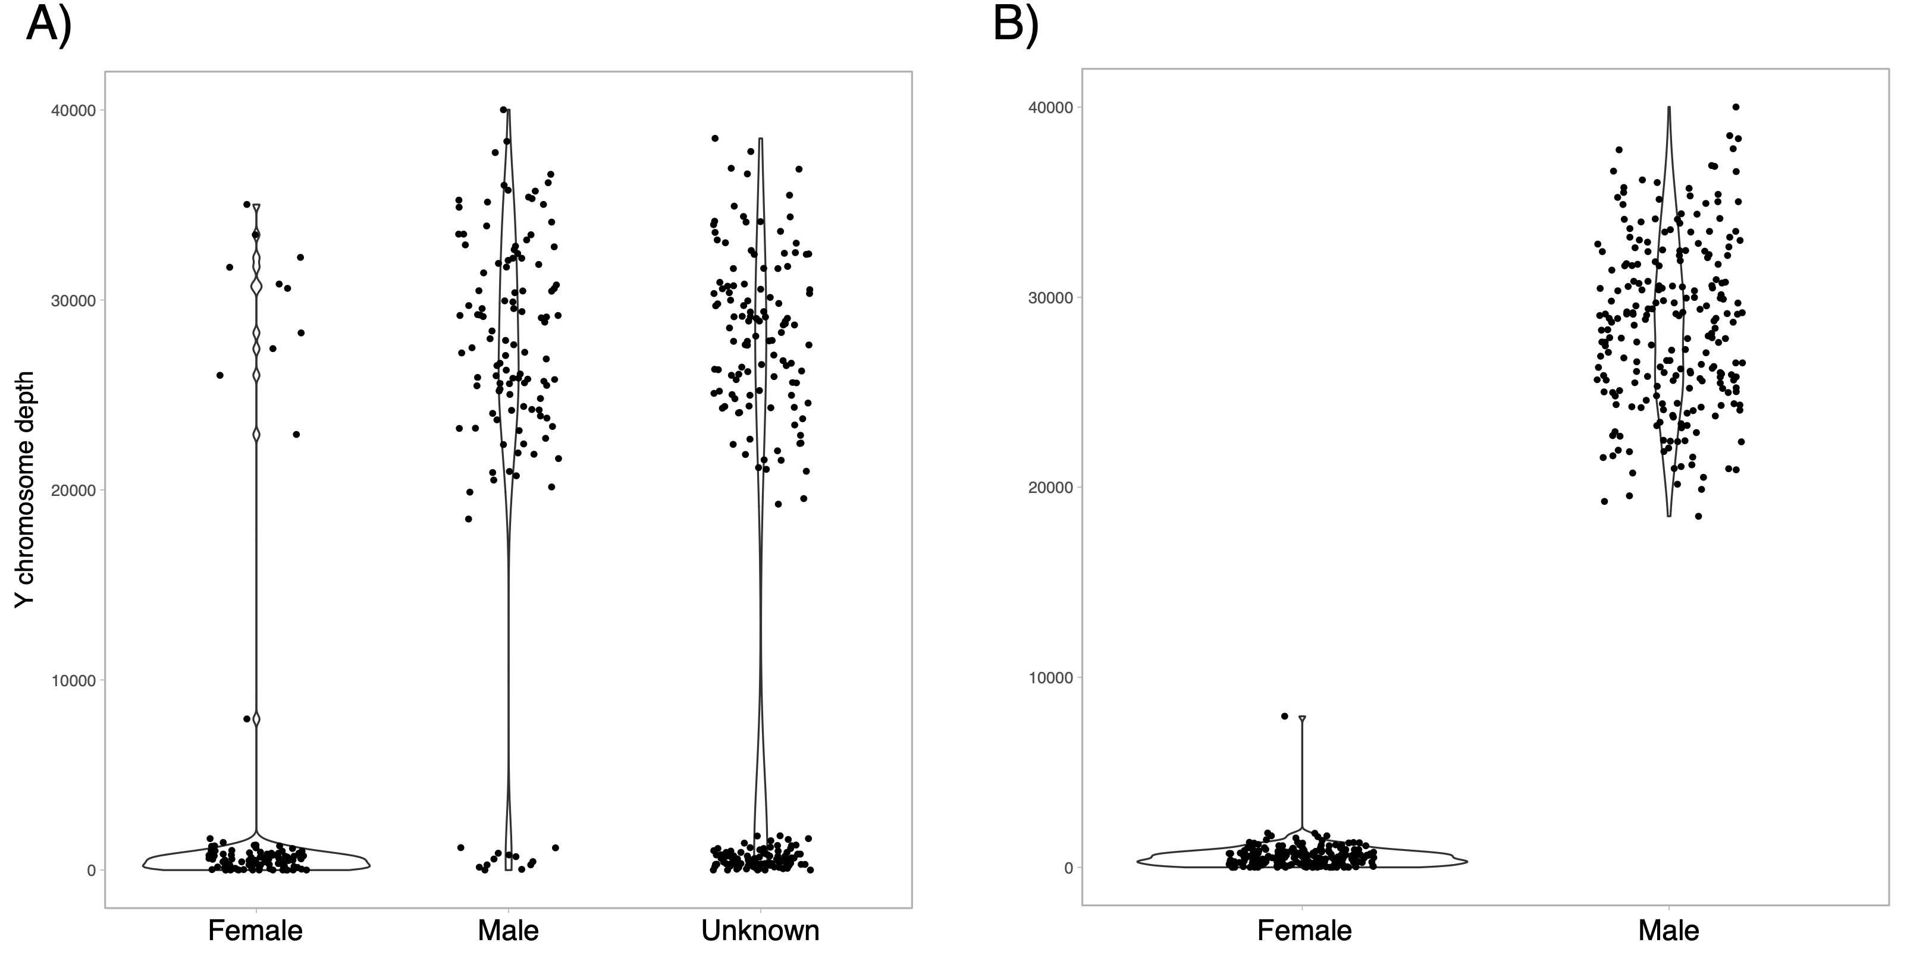

Supplemental Figure S2. Assignment probabilities (Q) for each sample for K=2-10 genetic partitions for 437 gray wolves from North American populations genotyped at 81,595 statistically neutral and unlinked SNPs. Populations are organized from west to east as possible with abbreviations defined in Figure 1A. The cross-validation (cv) errors are provided for partition evaluation.

Supplemental Figure S3. Genome-wide distributions of pairwise Weir and Cockerham’s genetic differentiation (F_{ST}) estimated between four geographical regions of 437 gray wolves from North American populations genotyped at 81,595 statistically neutral and unlinked SNPs. Regional population membership is defined in Table 1.
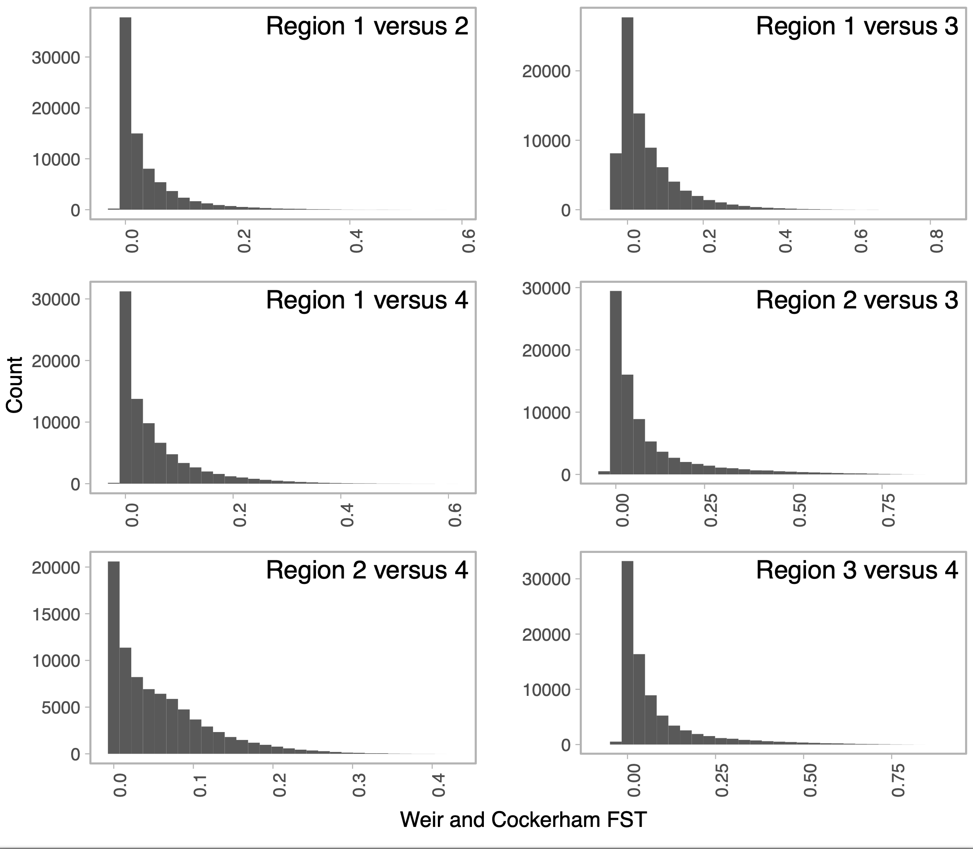

Supplemental Figure S4. Heat map of genome-wide genetic differentiation (F_{ST}) estimates. Above the diagonal are estimates from 81,595 statistically neutral and unlinked SNPs; below the diagonal are from 681 chromosome X SNPs. Females and males were analyzed separately within each region: A) western USA and southwestern Canada, and B) Great Lakes and Ontario. Outlines highlight intra-population sex-specific estimates.
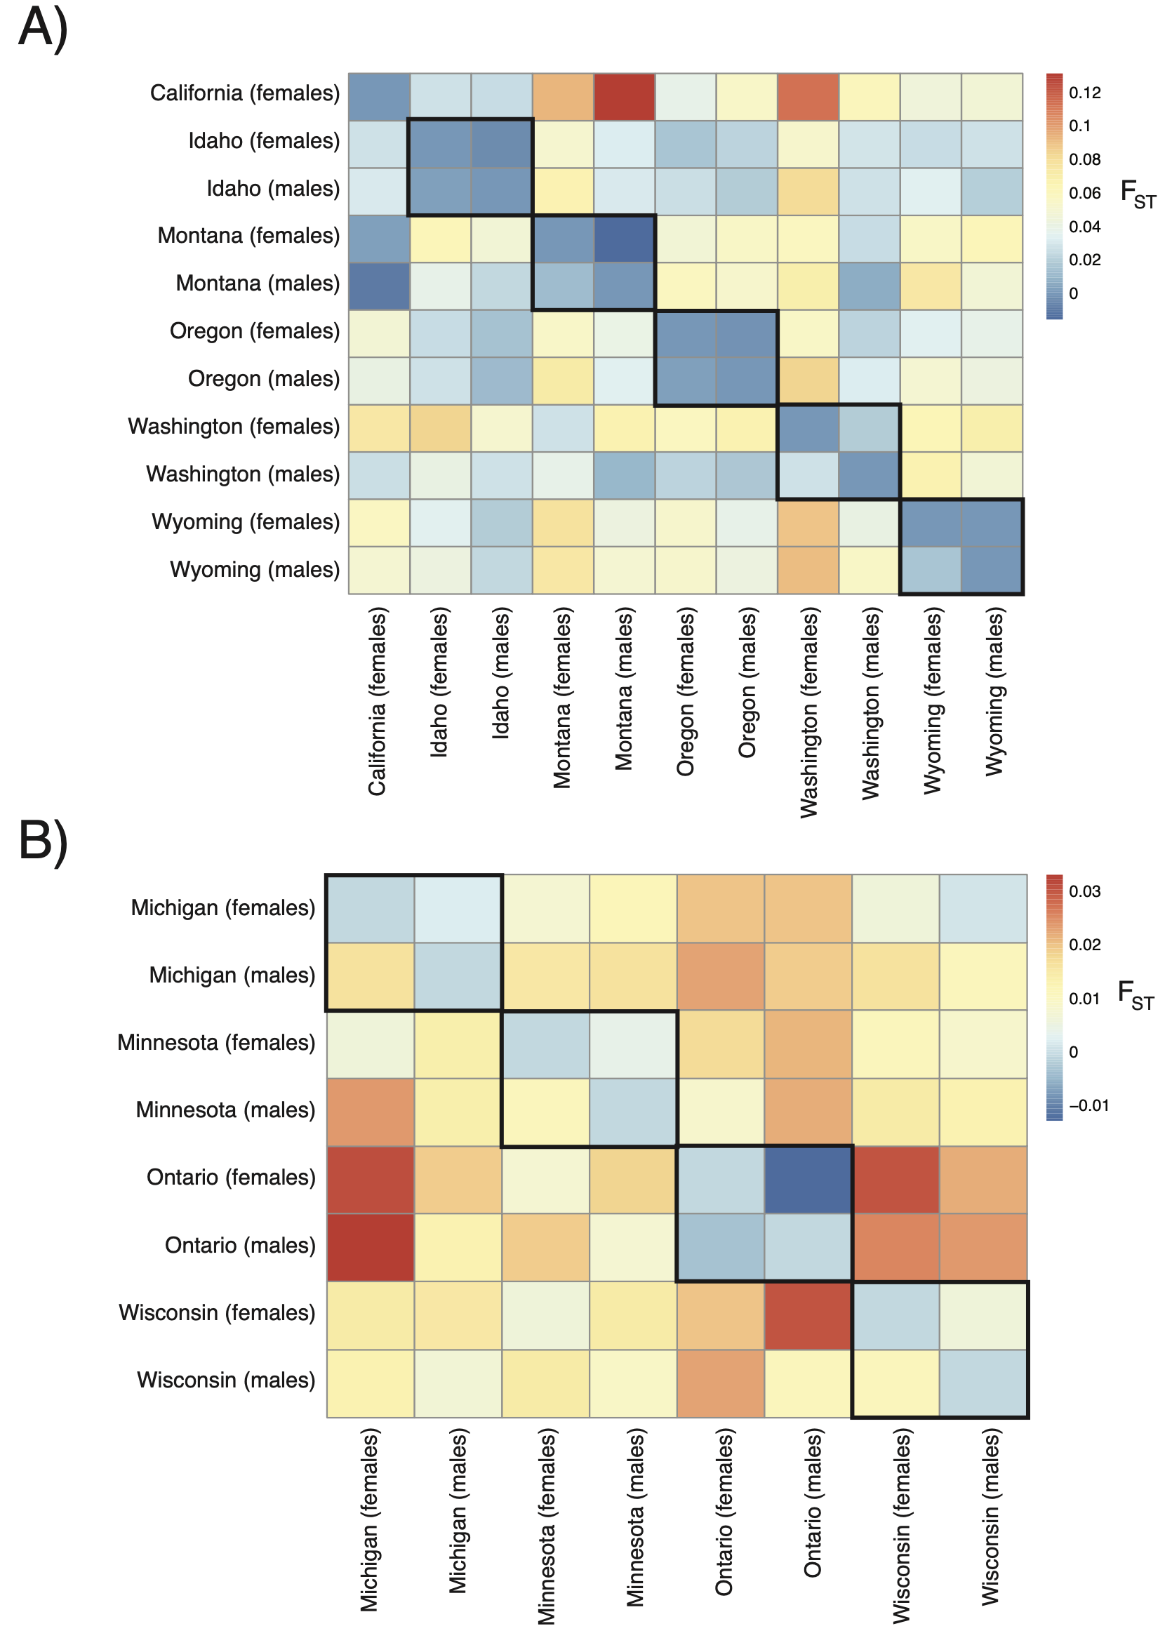

Supplemental Figure S5. Box-and-whisker plots of inbreeding estimates derived from autozygosity (F_{ROH}) across two populations of the United States for each chromosome type.
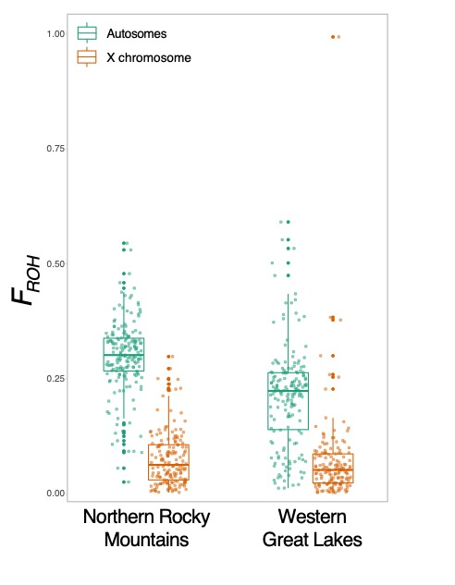

Supplemental Figure S6. Unsupervised cluster assignment probabilities (Q) across K2-10 genetic partitions (K) for 465 canids (179 gray wolves from the northern Rocky Mountains population, 184 from the western Great Lakes population, 74 western coyotes, and 28 eastern wolves) genotyped at 80,655 statistically neutral and unlinked SNP loci.

