Supporting Information
(Research on Chemical Intermediates)
Deep eutectic solvent-assisted fast and green synthesis of benzochromenopyrimidines and pyranopyrimidines

Arezo Monem, Davood Habibi*, Hadis Goudarzi

Department of Organic Chemistry, Faculty of Chemistry, Bu-Ali Sina University, Hamedan 6517838683, Iran
*Corresponding author email: davood.habibi@gmail.com (& dhabibi@basu.ac.ir), Tel: 98 81 38380922; Fax: 98 81 38380709

Content Page
¹H NMR spectrum of methyl triphenylphosphonium-bromide (MTPP-Br) 3
¹H NMR spectrum of 2,5-dihydroxybenzoic acid (2,5-DHBA) 3
FT-IR spectrum of 4a 4
¹H NMR spectrum of 4a 4
¹³C NMR spectrum of 4a 5
Mass spectrum of 4a 5
FT-IR spectrum of 4b 6
¹H NMR spectrum of 4b 6
¹³C NMR spectrum of 4b 7
Mass spectrum of 4b 7
FT-IR spectrum of 4c 8
¹H NMR spectrum of 4c 8
¹³C NMR spectrum of 4c 9
Mass spectrum of 4c 9
FT-IR spectrum of 4d 10
¹H NMR spectrum of 4d 10
¹³C NMR spectrum of 4d 11
Mass spectrum of 4d 11
FT-IR spectrum of 4e 12
¹H NMR spectrum of 4e 12
¹³C NMR spectrum of 4e 13
Mass spectrum of 4e 13
FT-IR spectrum of 4f 14
¹H NMR spectrum of 4f 14
FT-IR spectrum of 4g 15
¹H NMR spectrum of 4g 15
¹H NMR spectrum of 4h 16
FT-IR spectrum of 4i 16
FT-IR spectrum of 8a 17
¹H NMR spectrum of 8a 17
¹³C NMR spectrum of 8a 18
Mass spectrum of 8a 18
FT-IR spectrum of 8b 19
¹H NMR spectrum of 8b 19
FT-IR spectrum of 8c 20
FT-IR spectrum of 8d 20
FT-IR spectrum of 8e 21
FT-IR spectrum of 8f 21
FT-IR spectrum of 8g 22
FT-IR spectrum of 8h 22
FT-IR spectrum of 8i 23
FT-IR spectrum of 8j 23
FT-IR spectrum of 8k 24
FT-IR spectrum of 8l 24

¹H NMR spectrum of methyl triphenylphosphonium-bromide (MTPP-Br)

¹H NMR spectrum of 2,5-dihydroxybenzoic acid (2,5-DHBA)
FT-IR spectrum of 4a
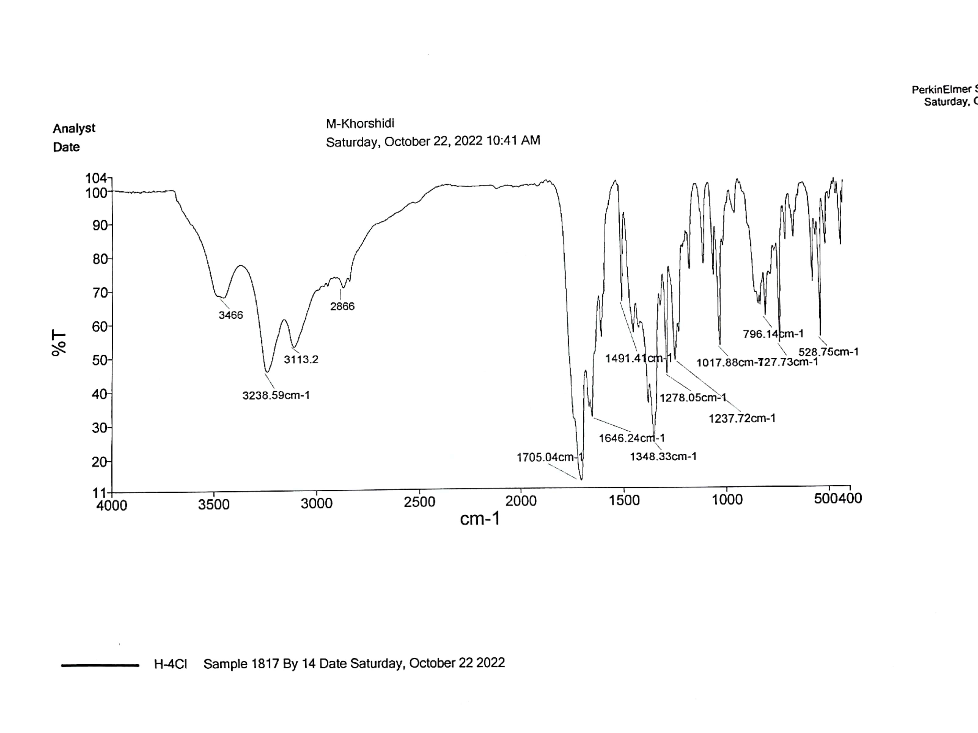

¹H NMR spectrum of 4a
¹³C NMR spectrum of 4a

Mass spectrum of 4a
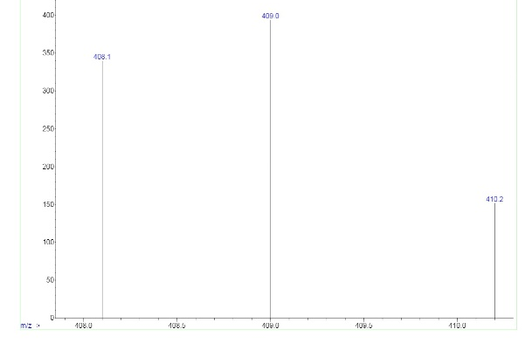
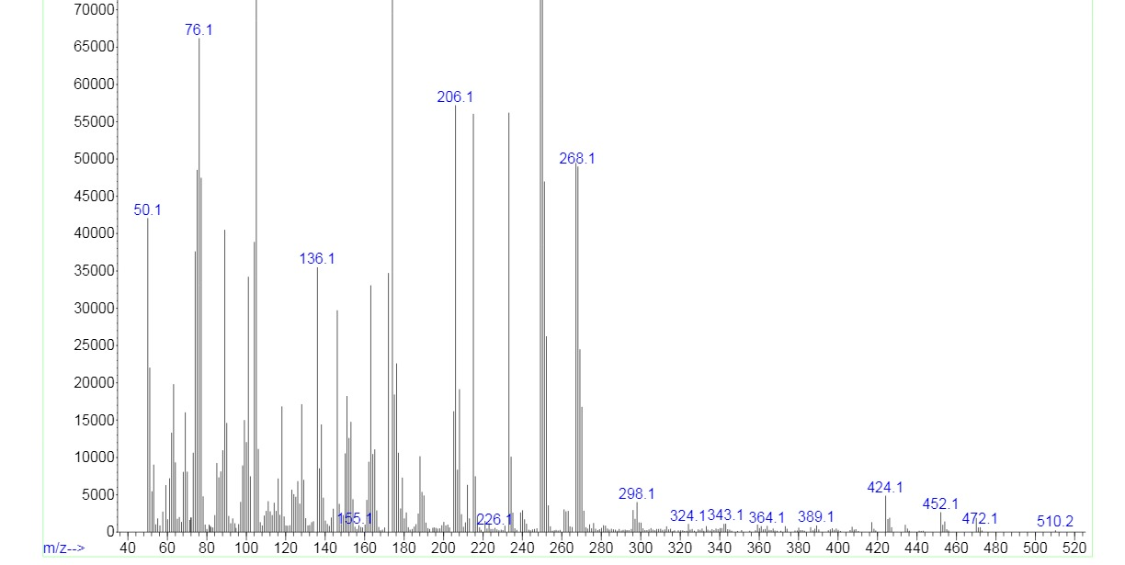
FT-IR spectrum of 4b
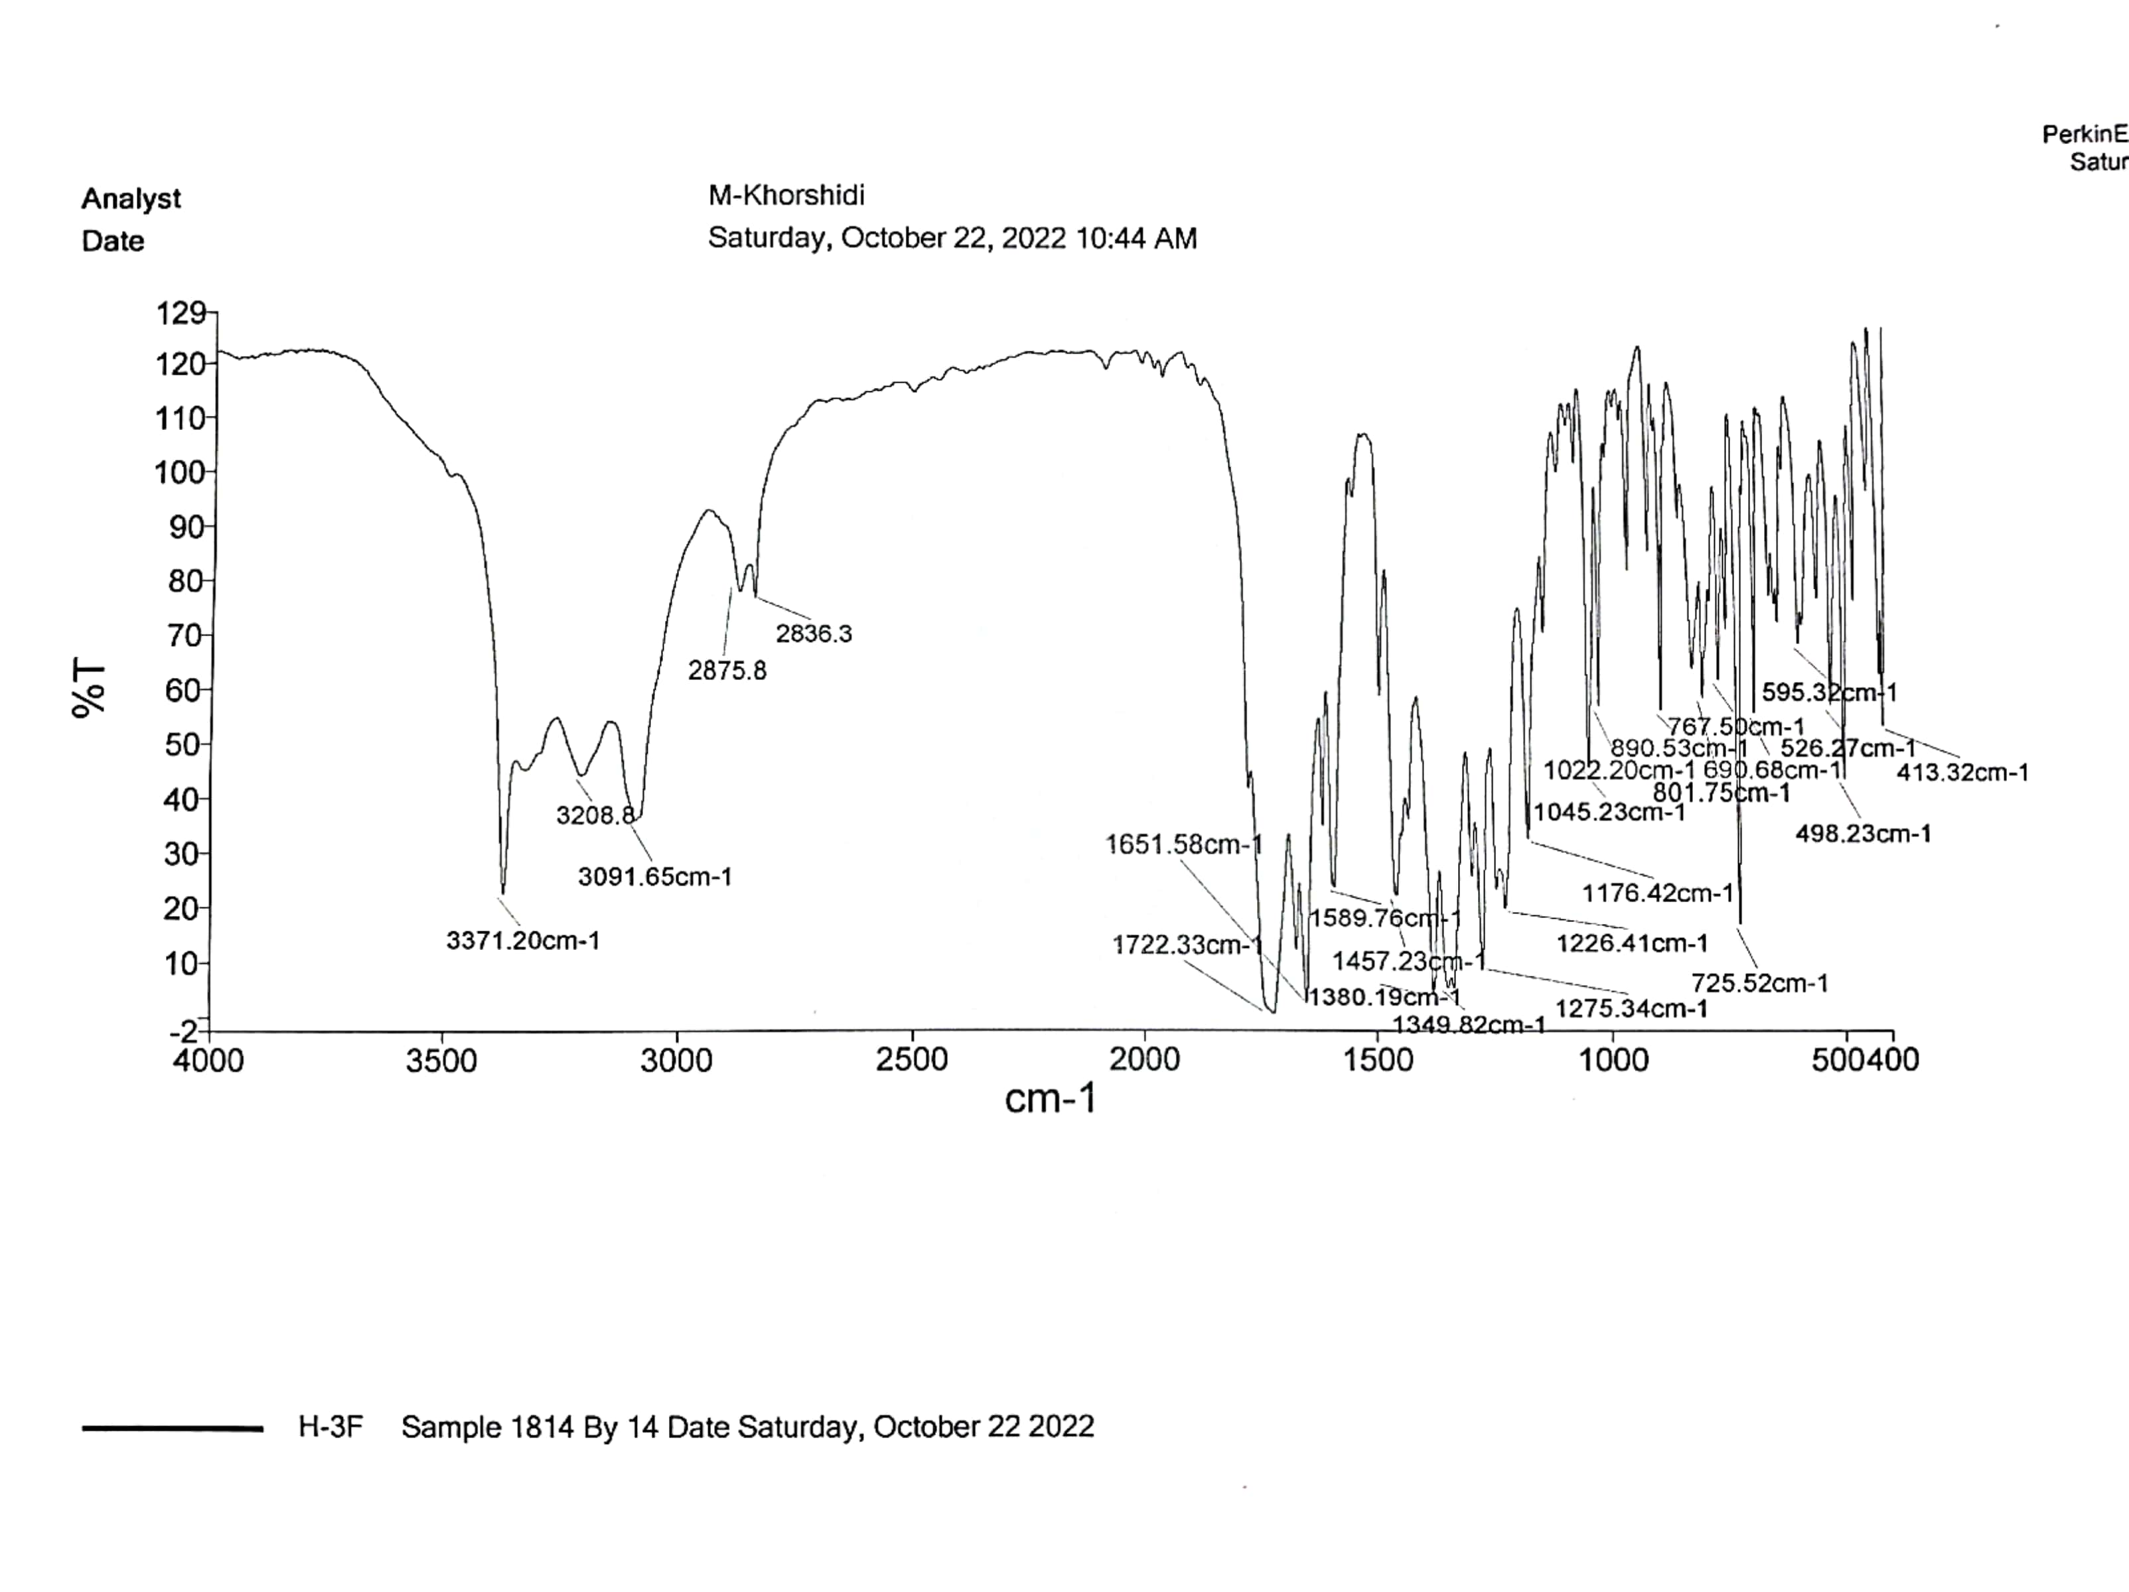

¹H NMR spectrum of 4b
¹³C NMR spectrum of 4b

Mass spectrum of 4b
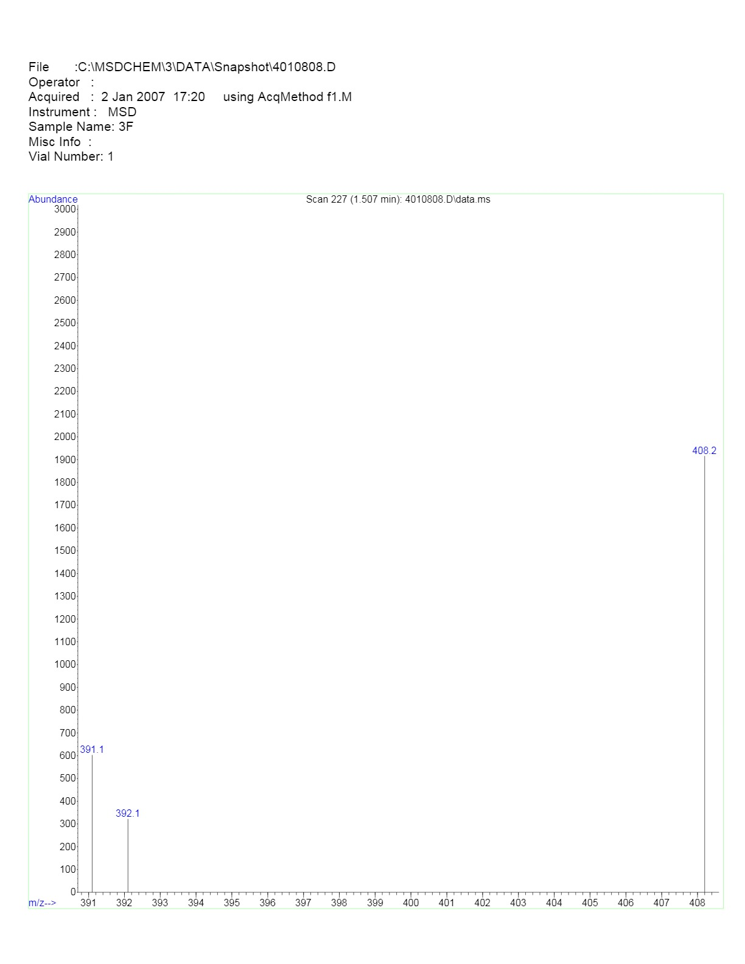
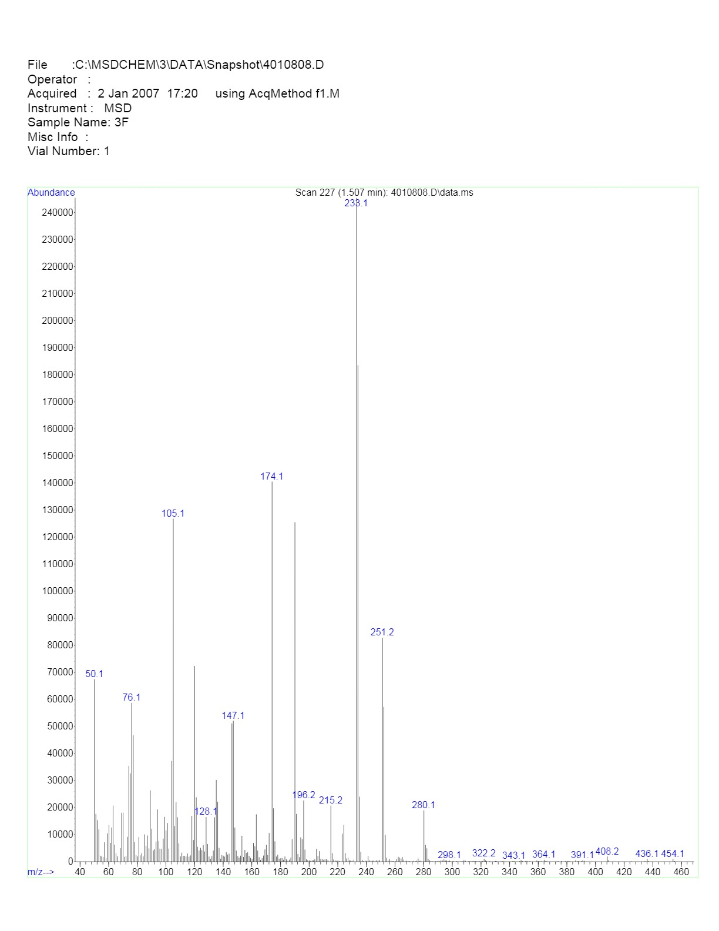

FT-IR spectrum of 4c
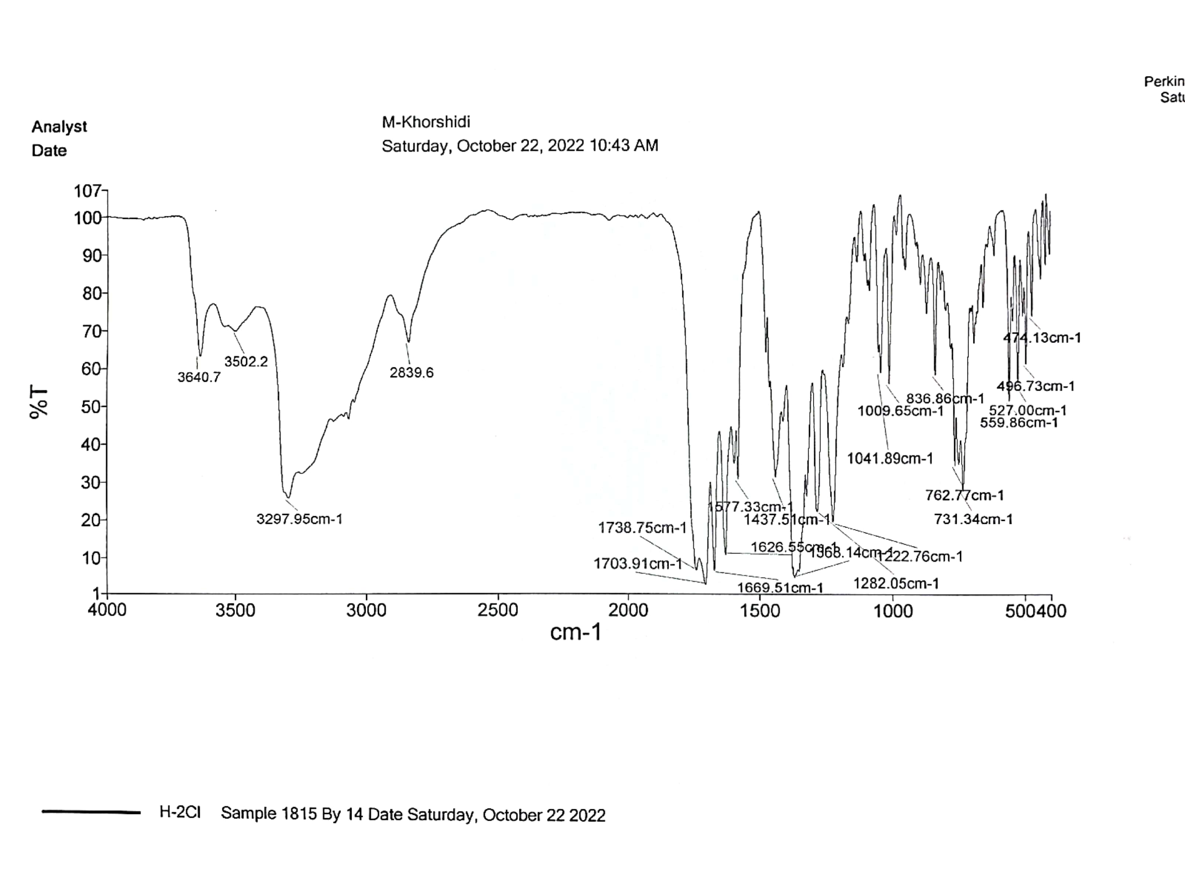

¹H NMR spectrum of 4c
¹³C NMR spectrum of 4c

Mass spectrum of 4c
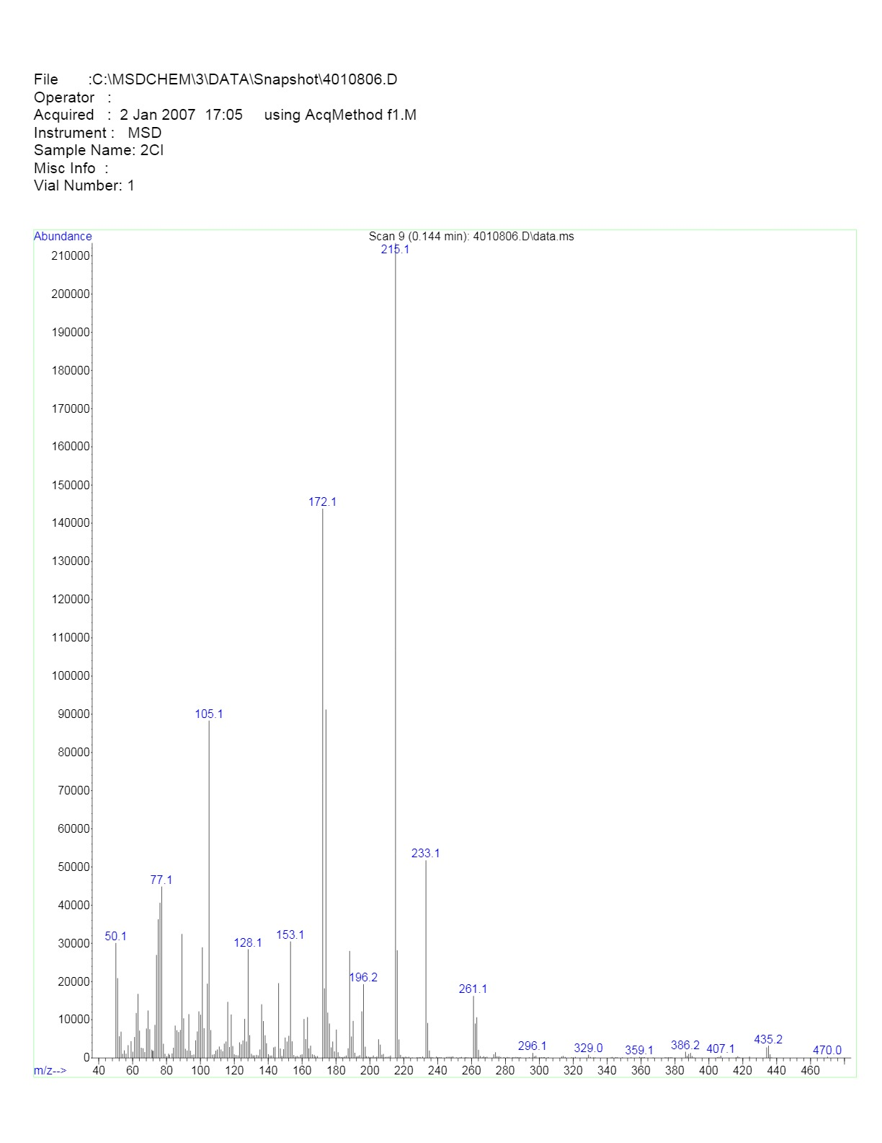
FT-IR spectrum of 4d
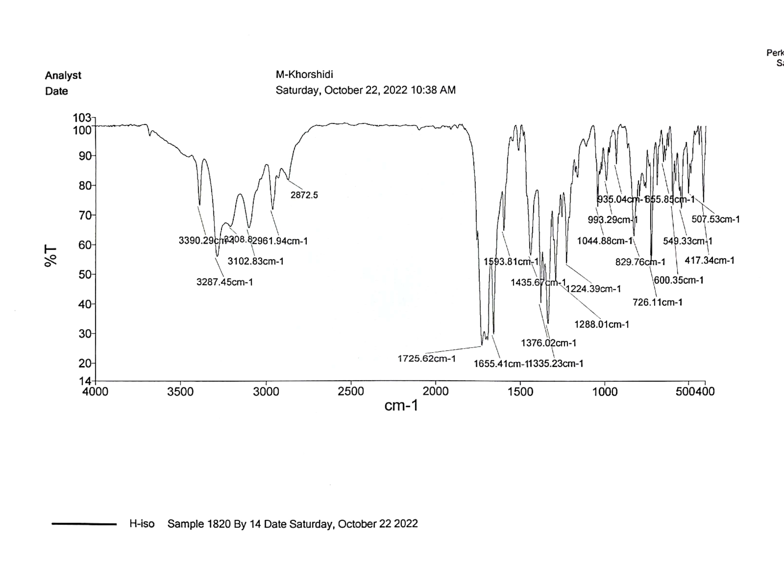

¹H NMR spectrum of 4d

¹³C NMR spectrum of 4d

Mass spectrum of 4d
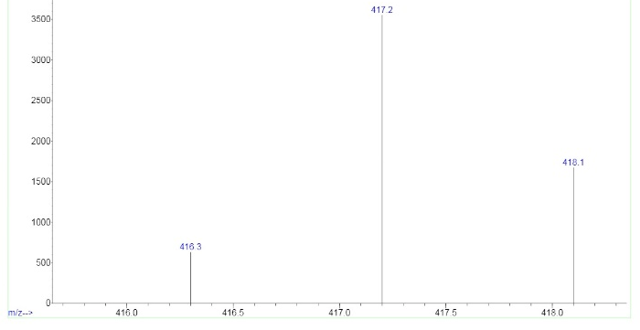
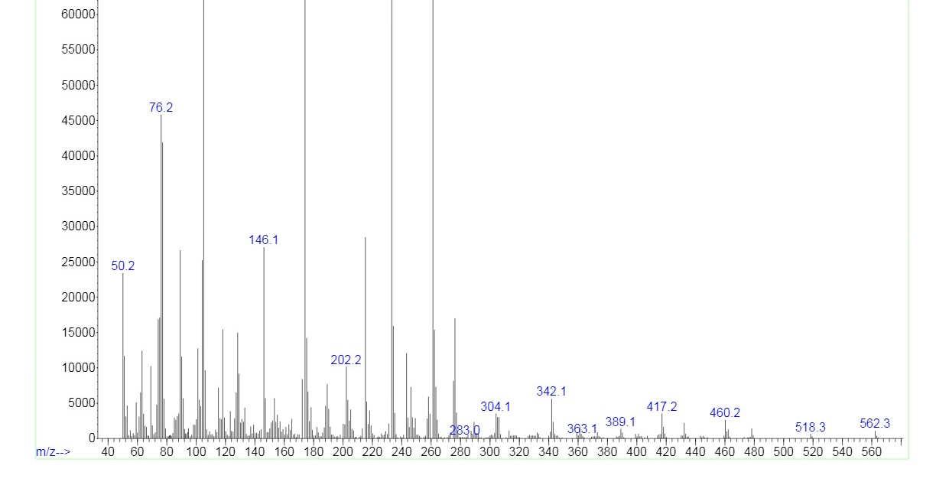

FT-IR spectrum of 4e
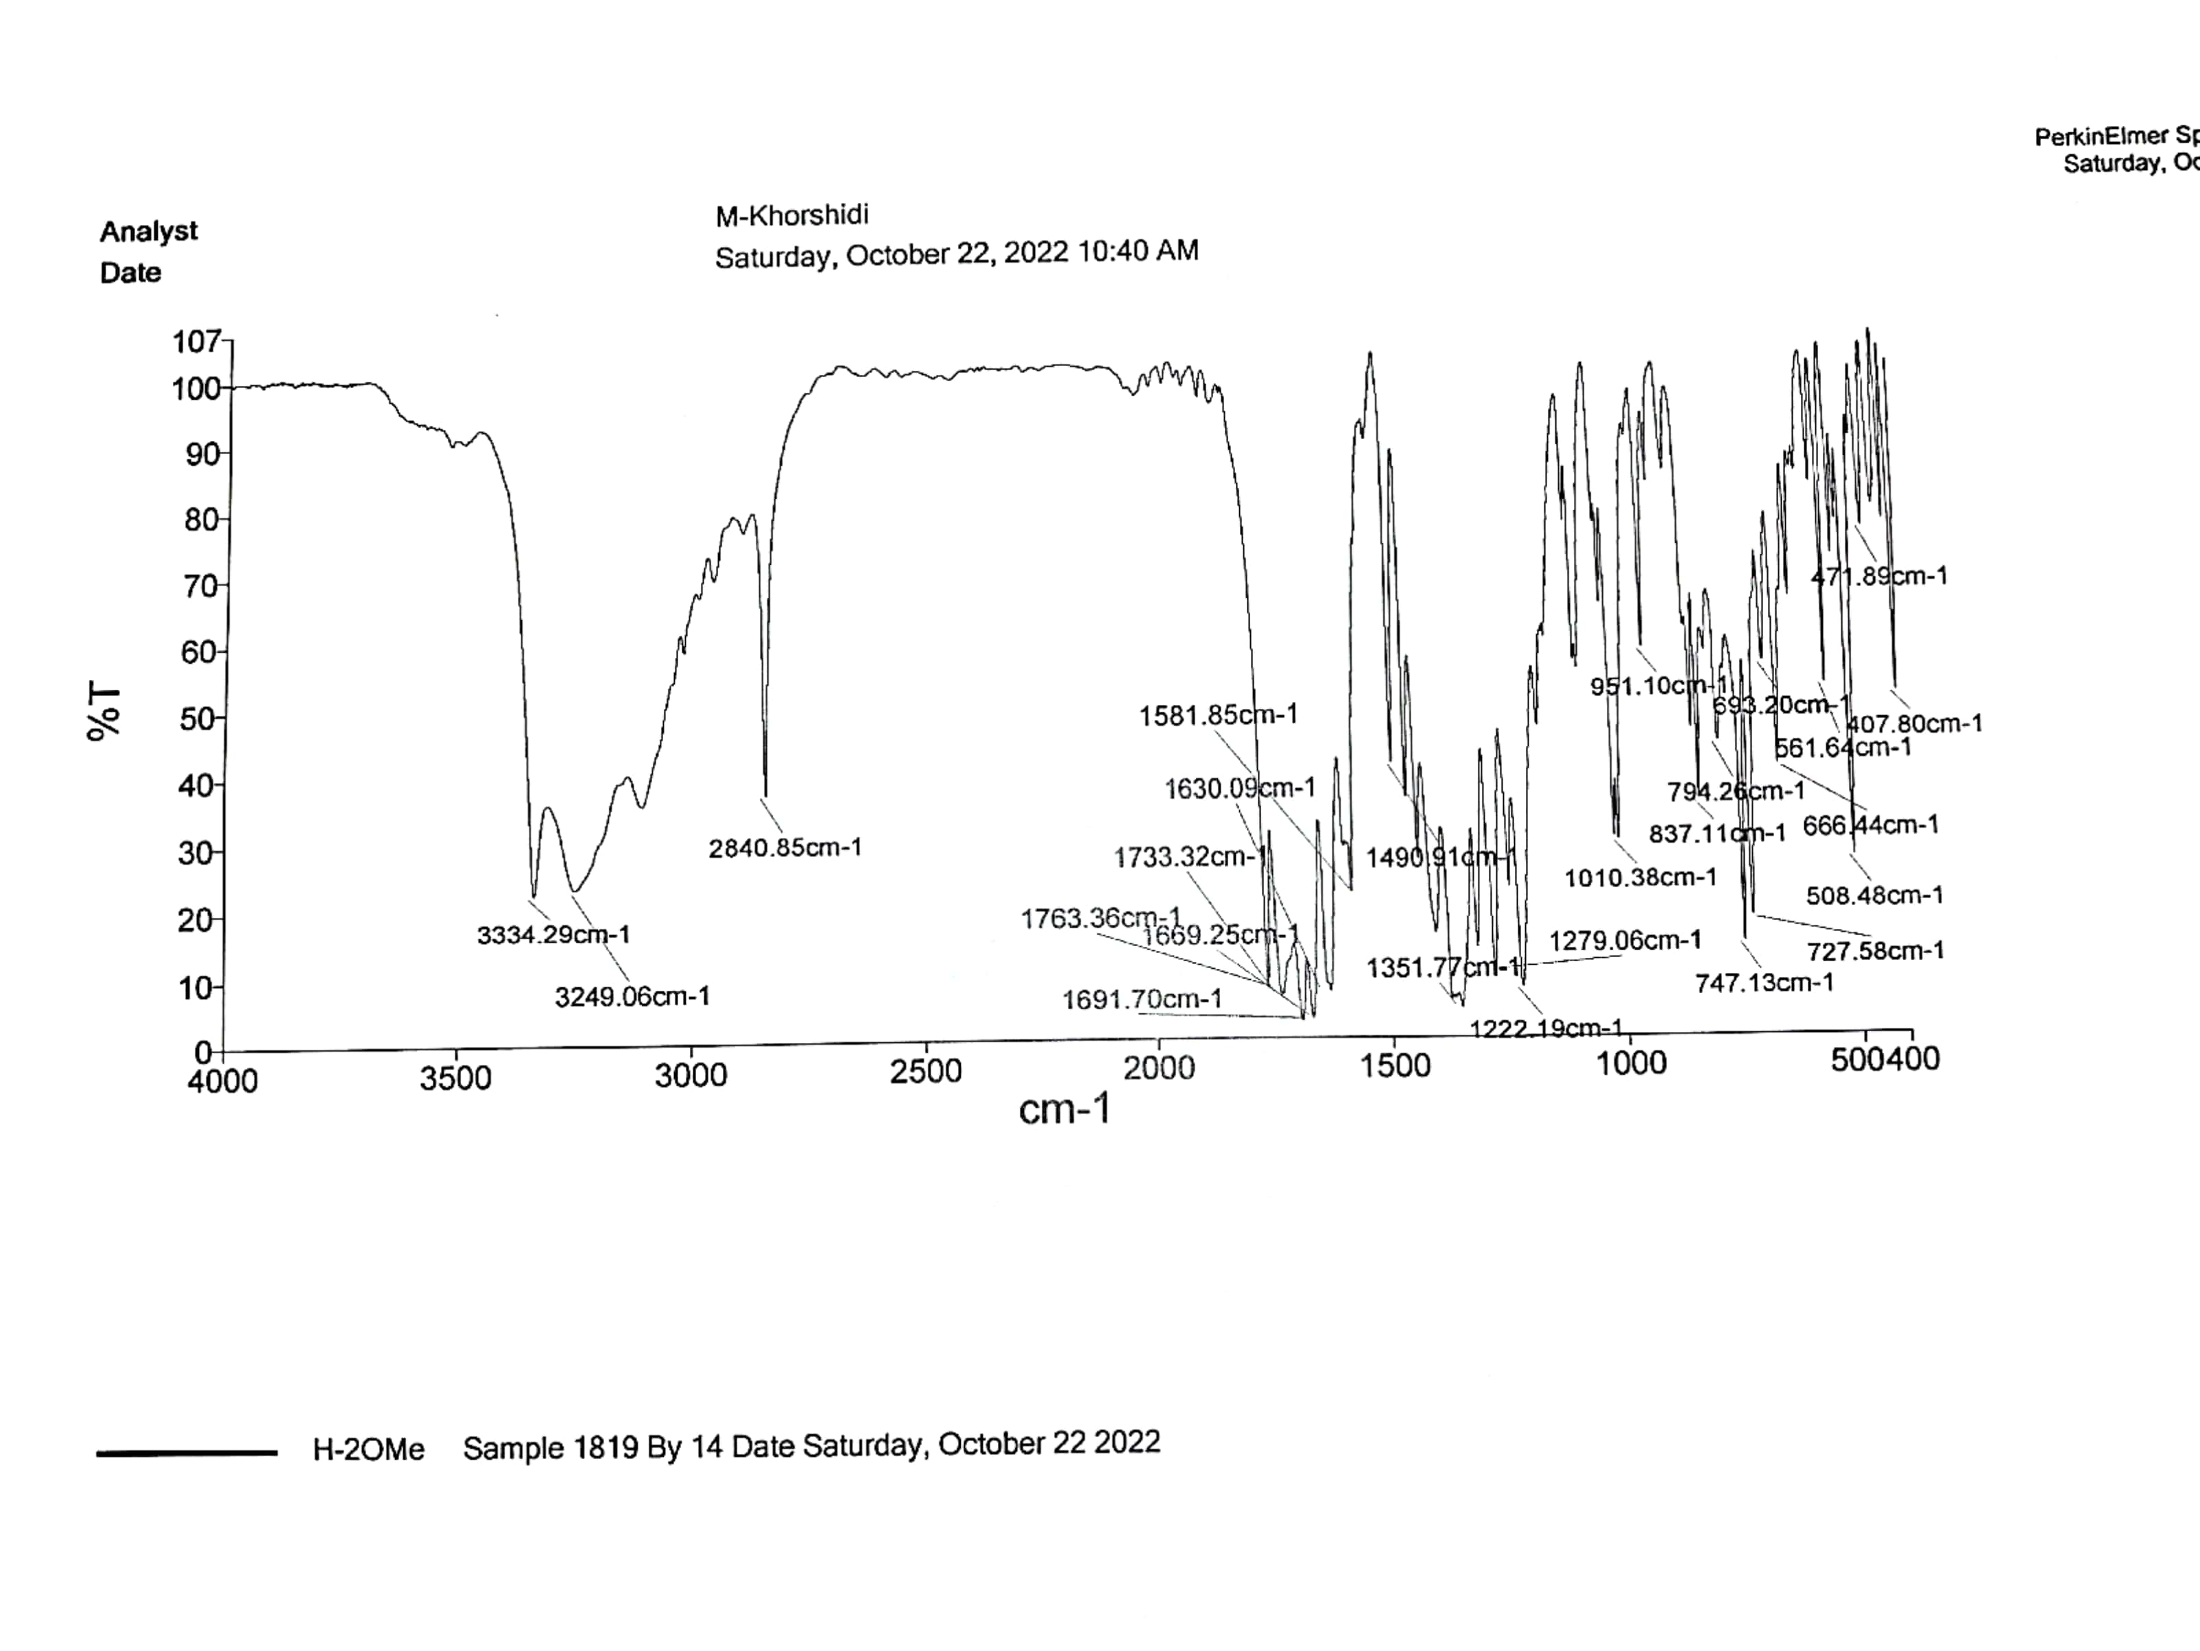

¹H NMR spectrum of 4e

¹³C NMR spectrum of 4e

Mass spectrum of 4e
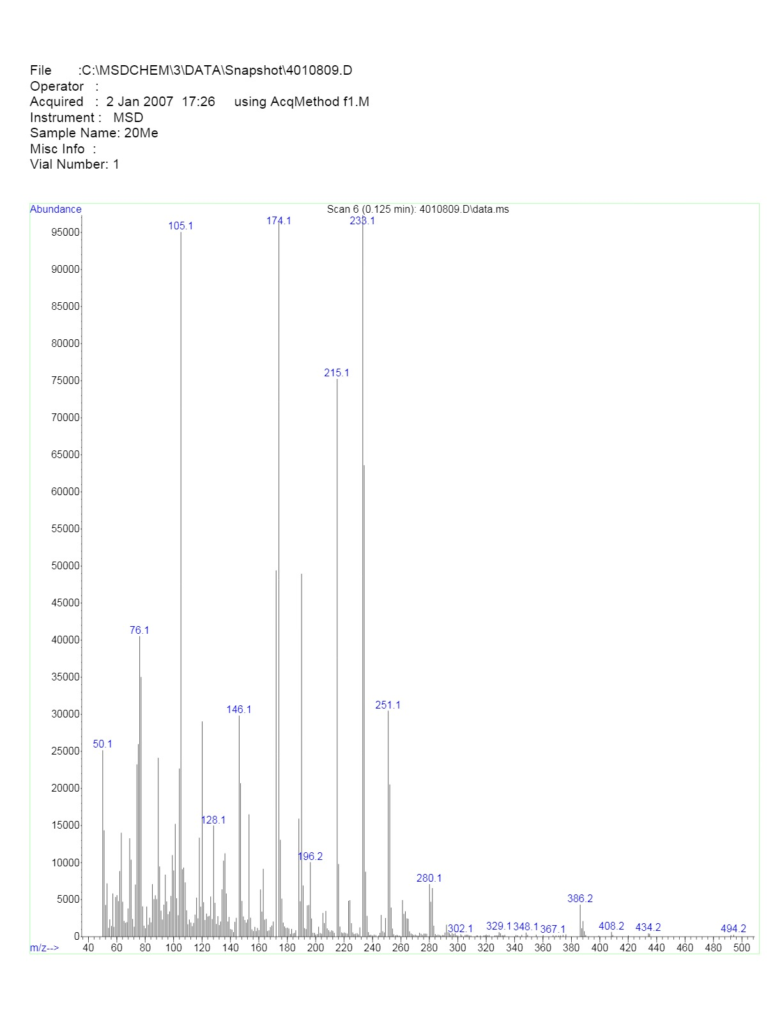

FT-IR spectrum of 4f
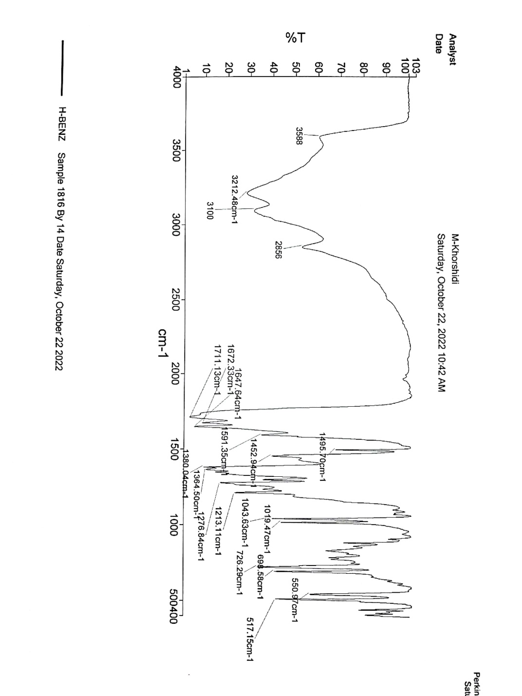

¹H NMR spectrum of 4f
FT-IR spectrum of 4g
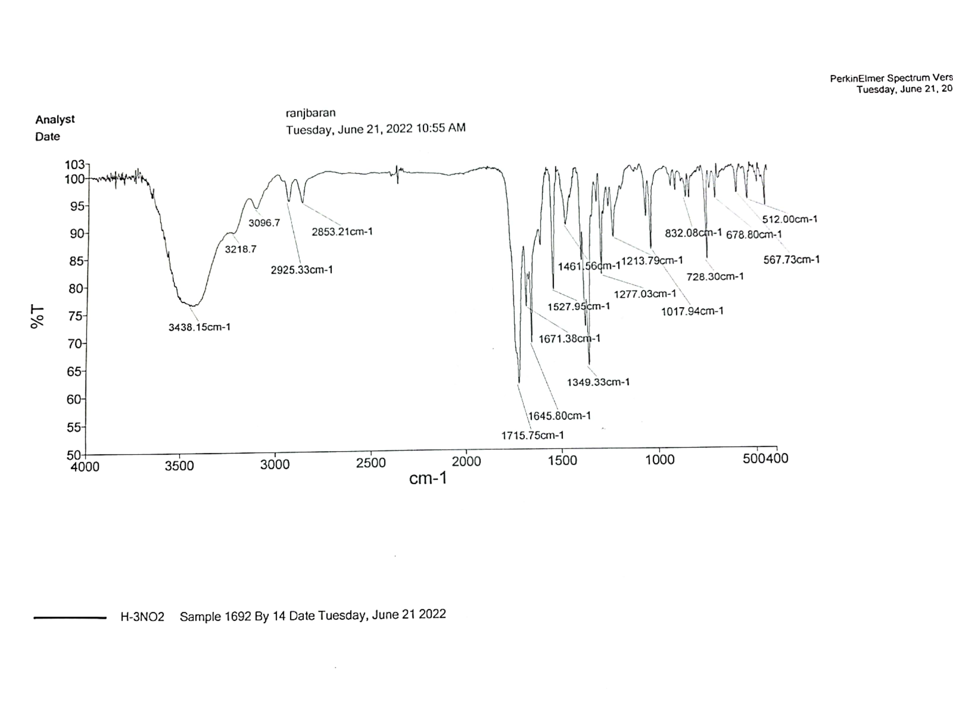

¹H NMR spectrum of 4g

¹H NMR spectrum of 4h

FT-IR spectrum of 4i
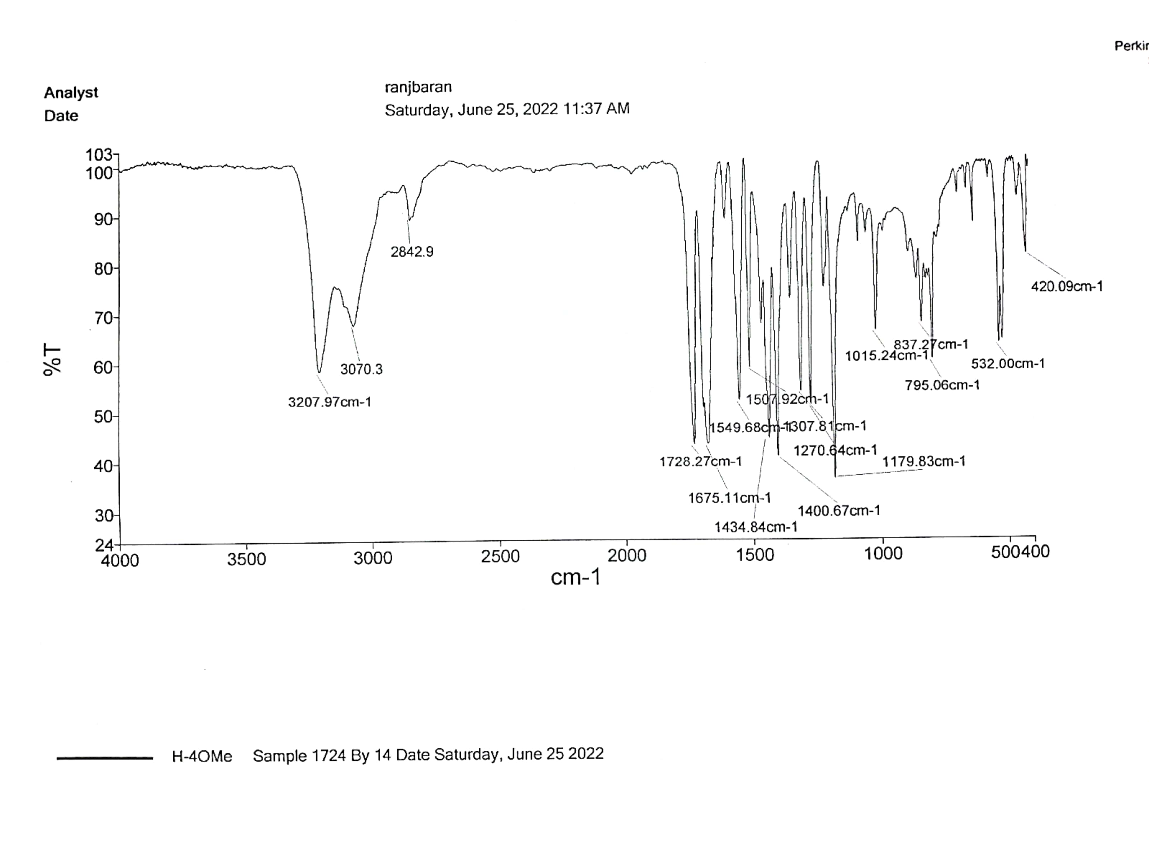

FT-IR spectrum of 8a
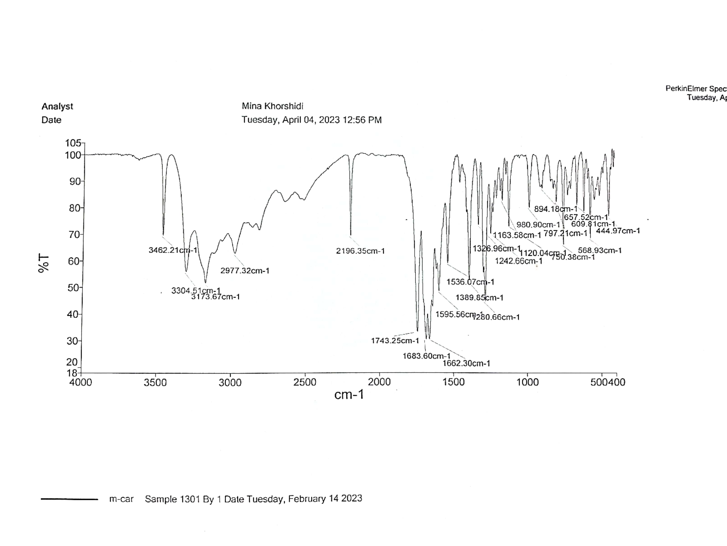

¹H NMR spectrum of 8a
¹³C NMR spectrum of 8a

Mass spectrum of 8a
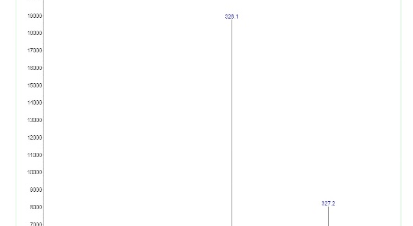
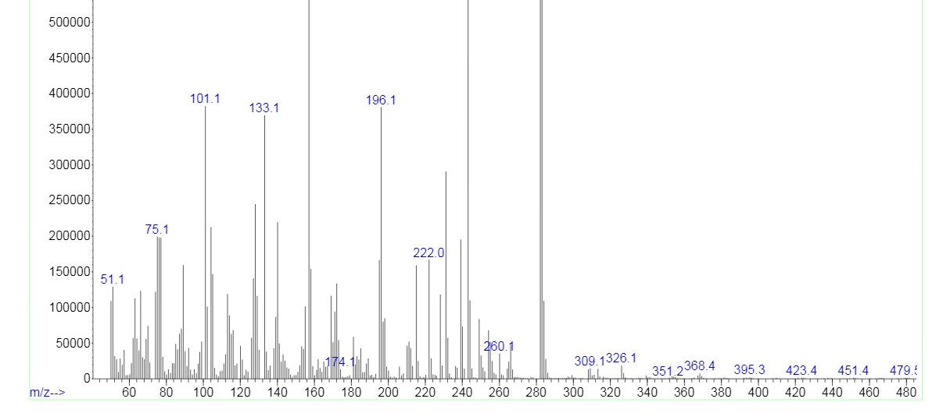

FT-IR spectrum of 8b
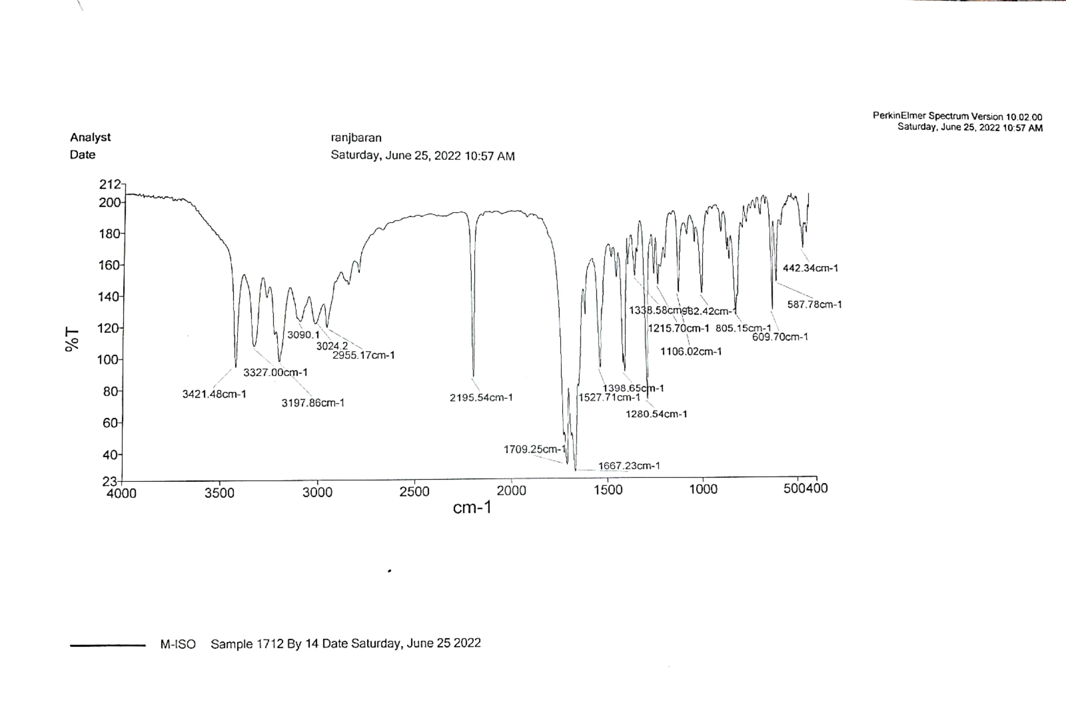

¹H NMR spectrum of 8b

FT-IR spectrum of 8c
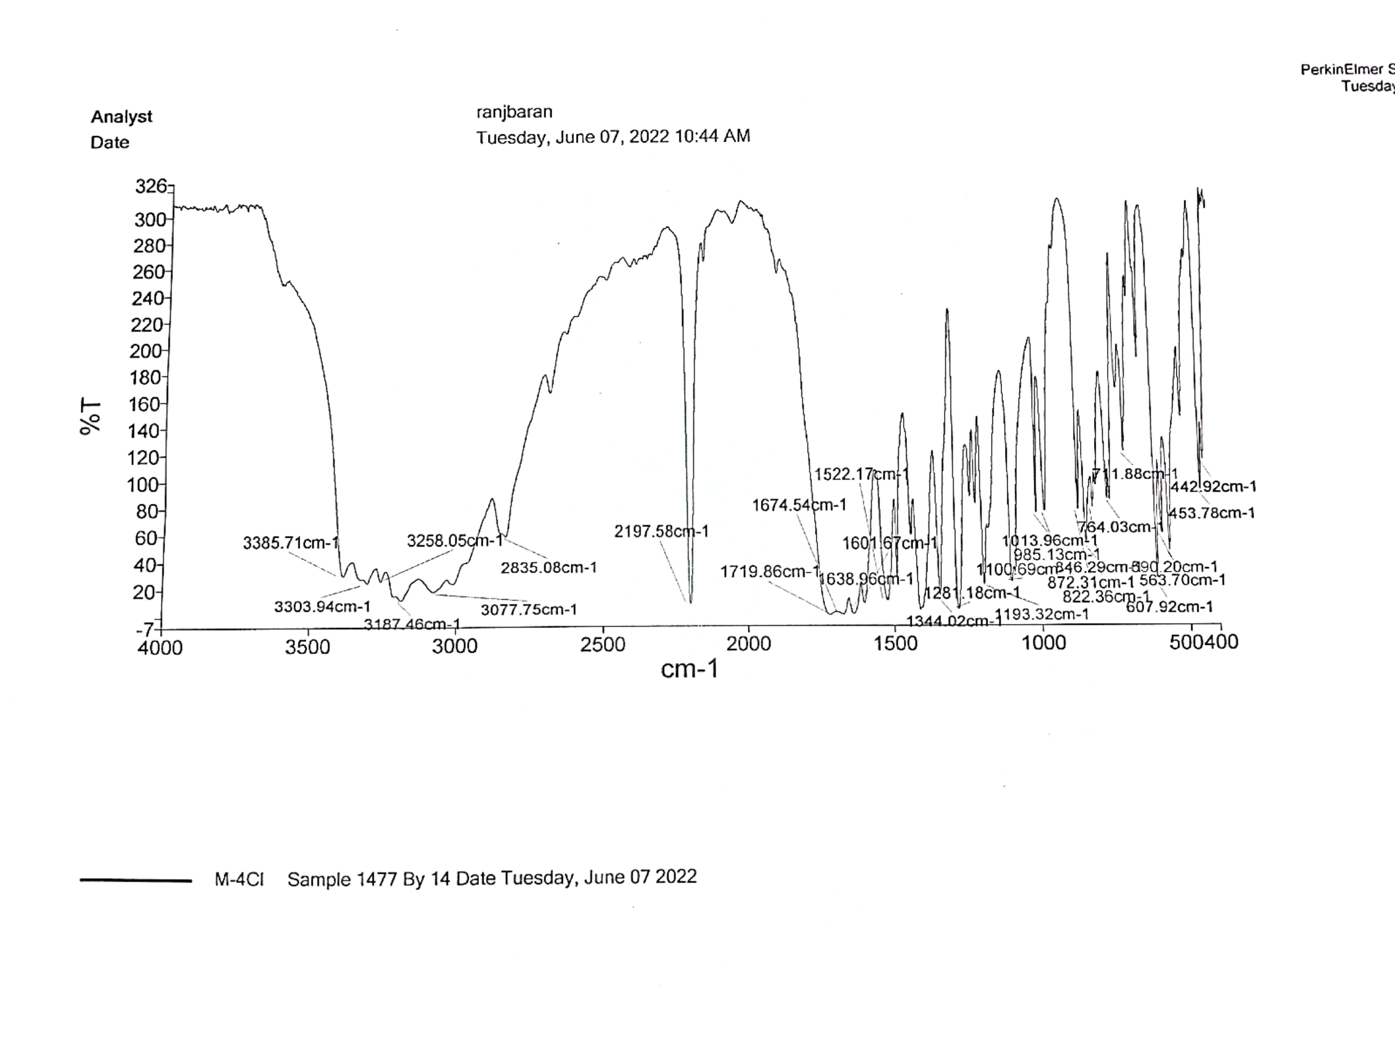

FT-IR spectrum of 8d
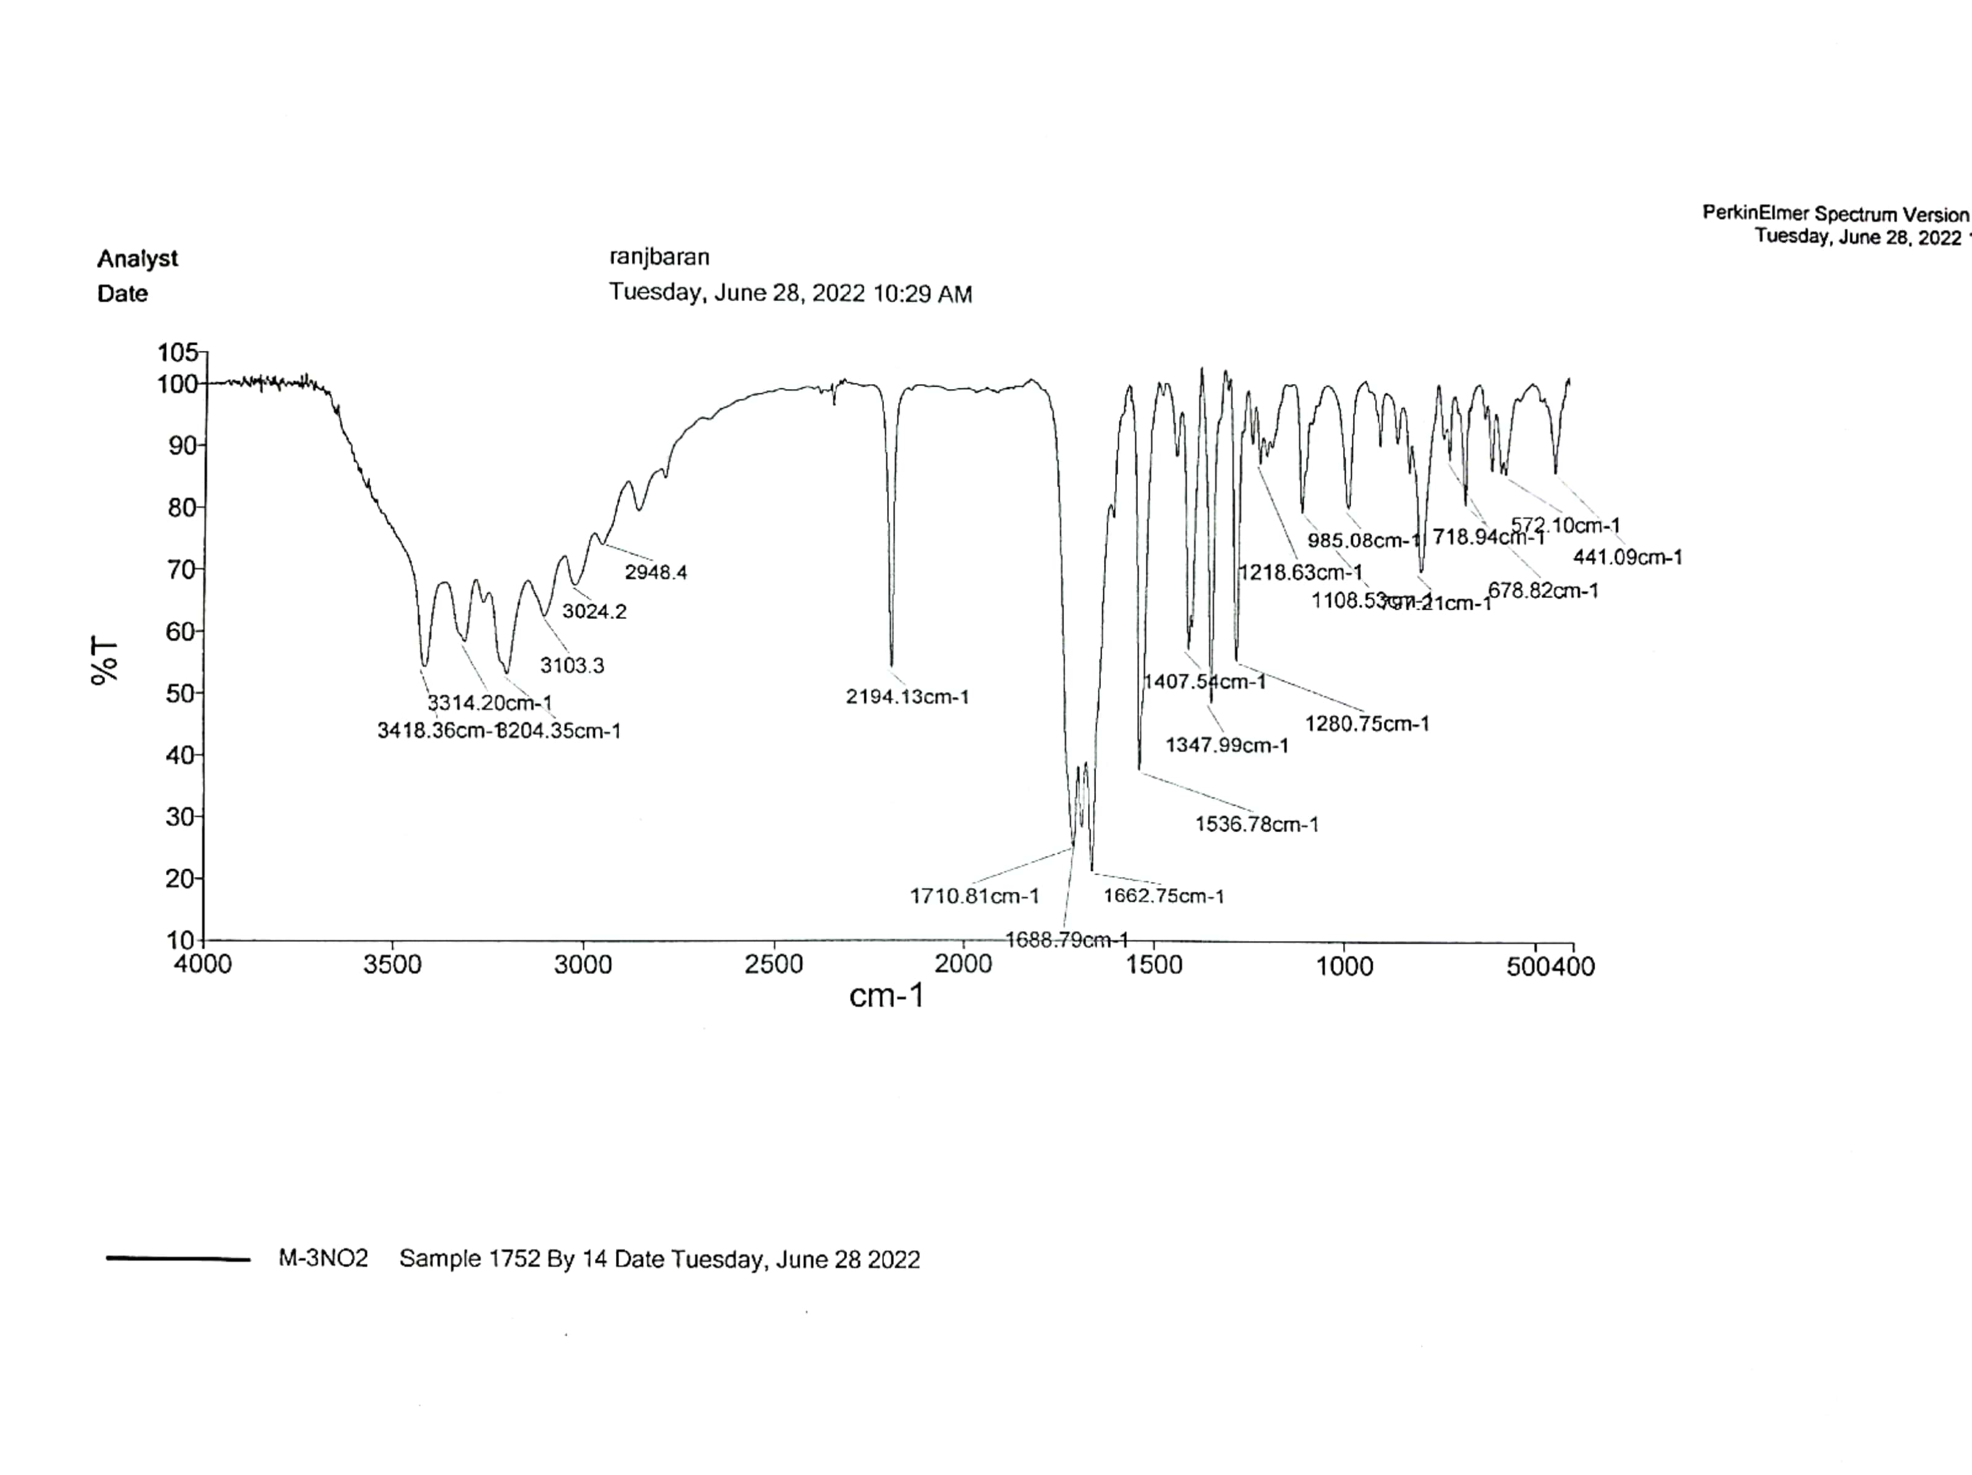

FT-IR spectrum of 8e
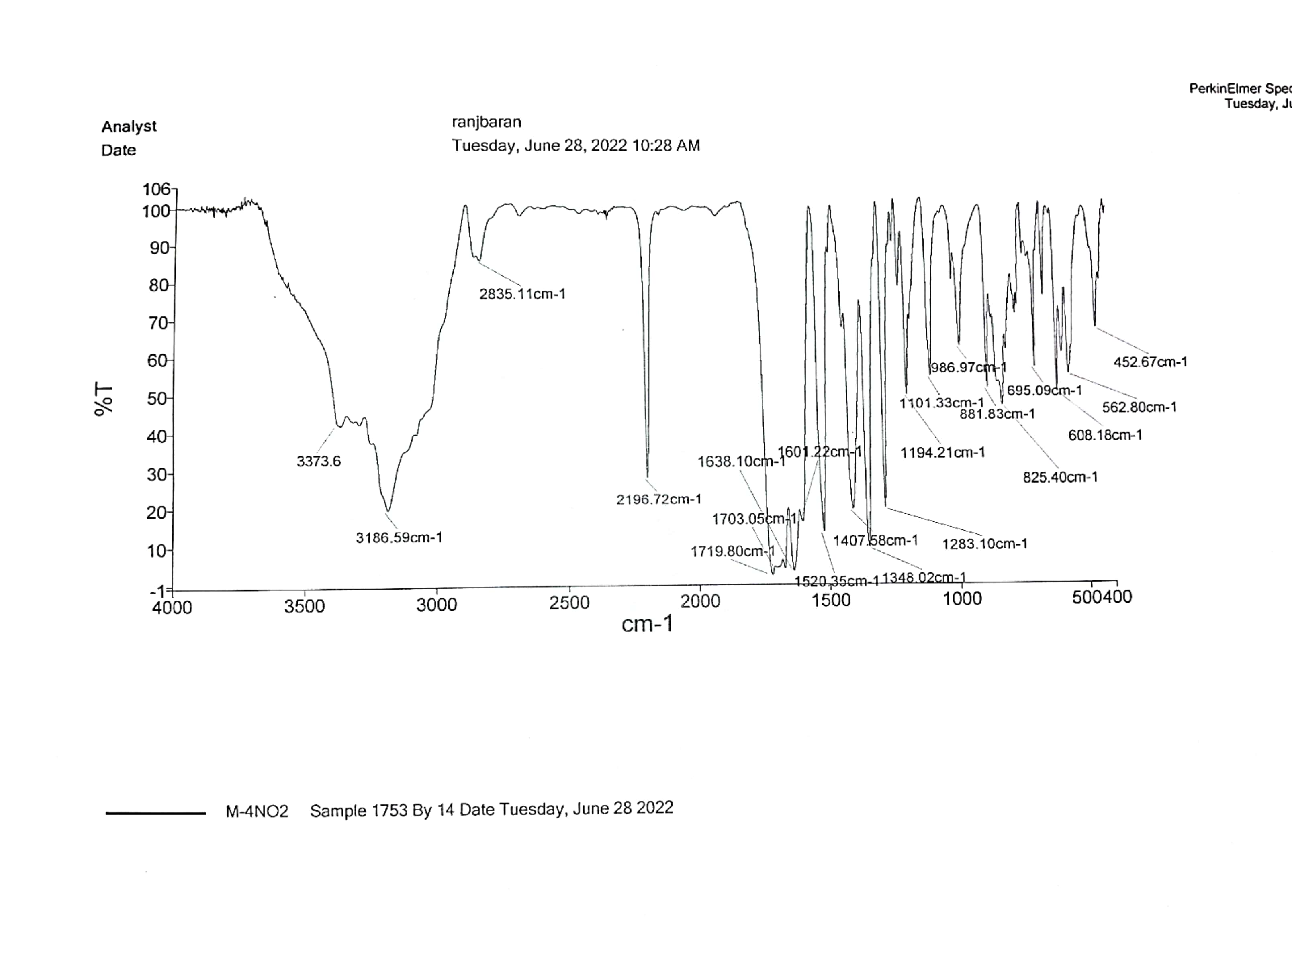

FT-IR spectrum of 8f
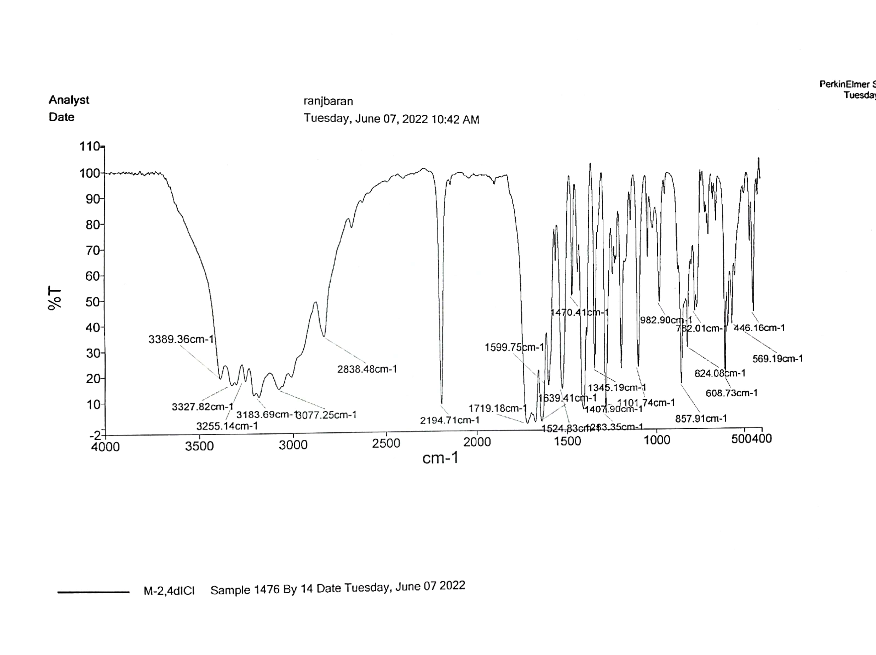

FT-IR spectrum of 8g
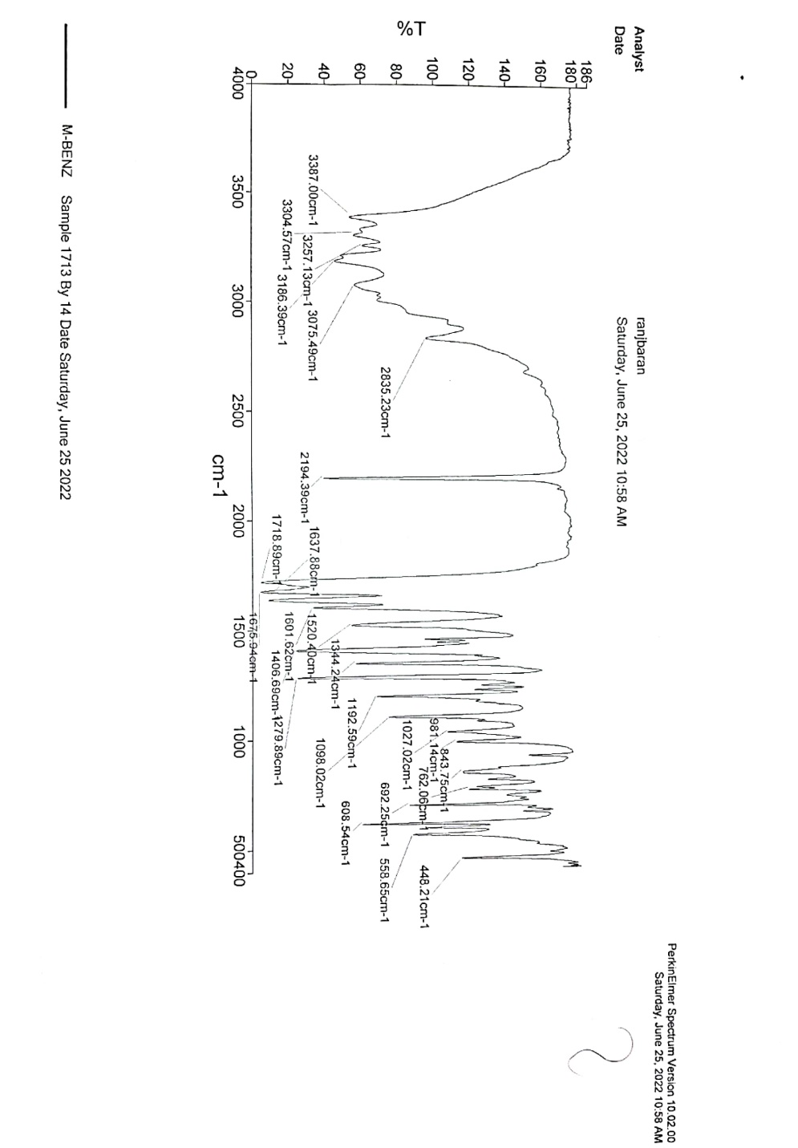

FT-IR spectrum of 8h
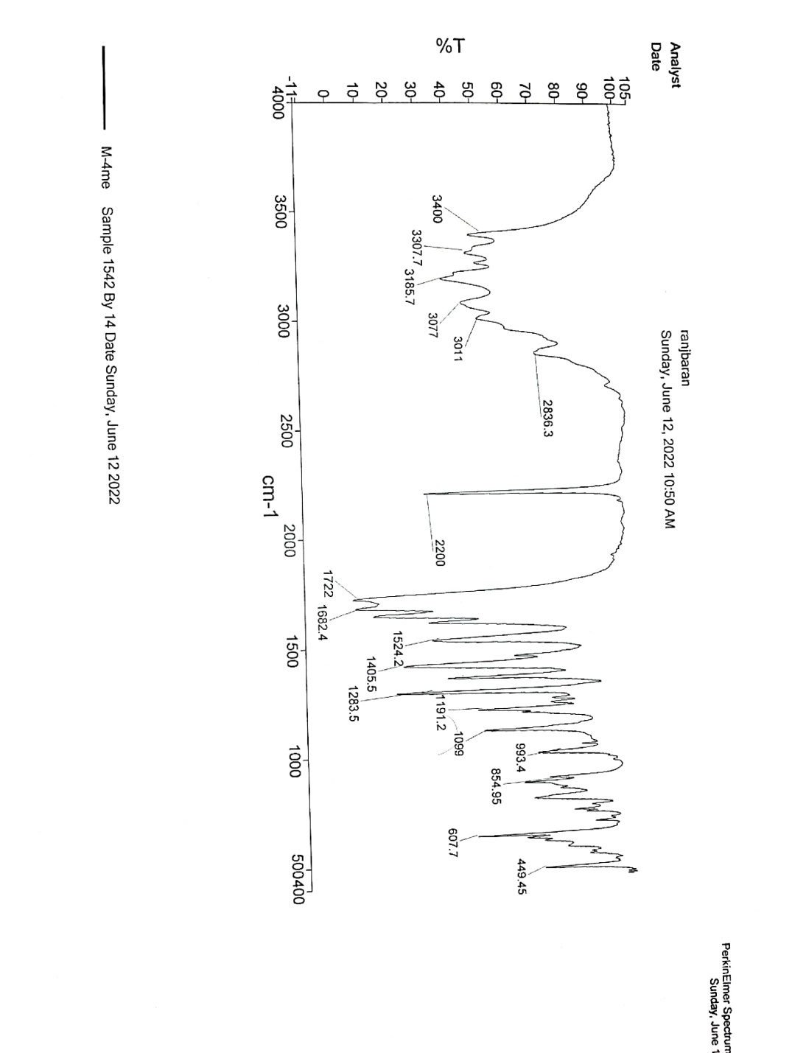

FT-IR spectrum of 8i
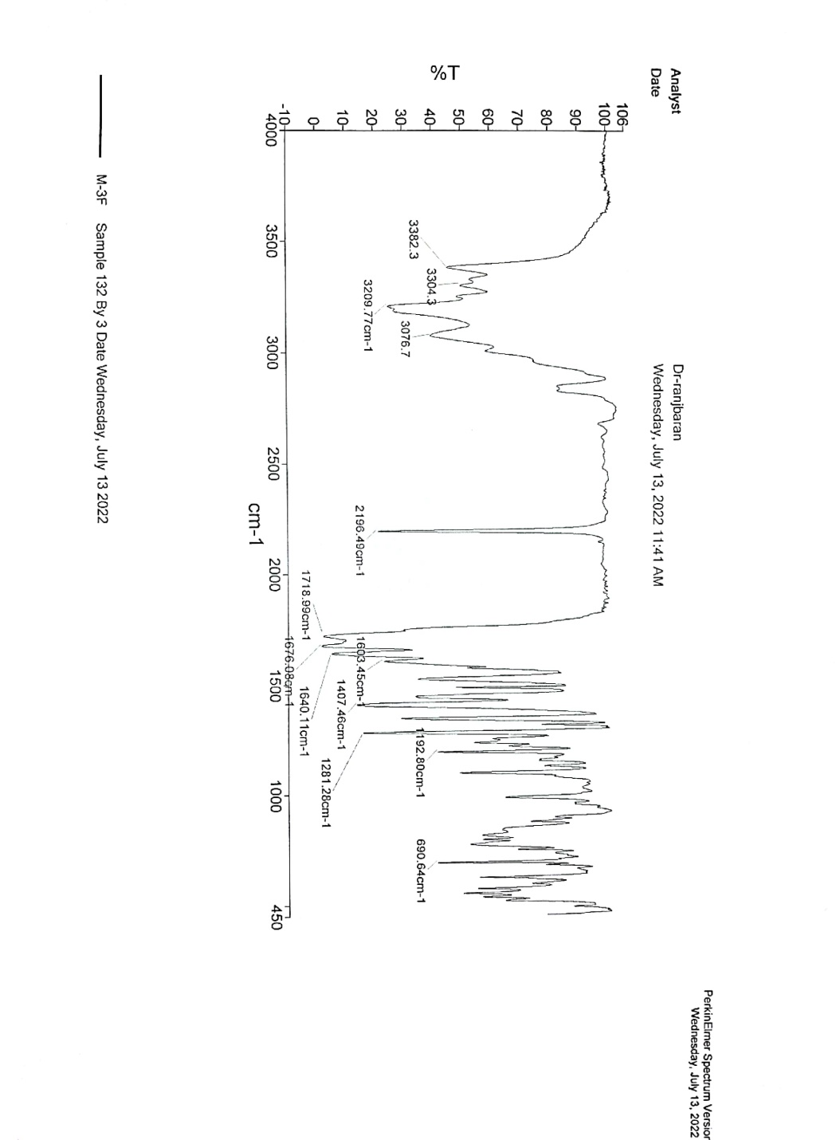

FT-IR spectrum of 8j
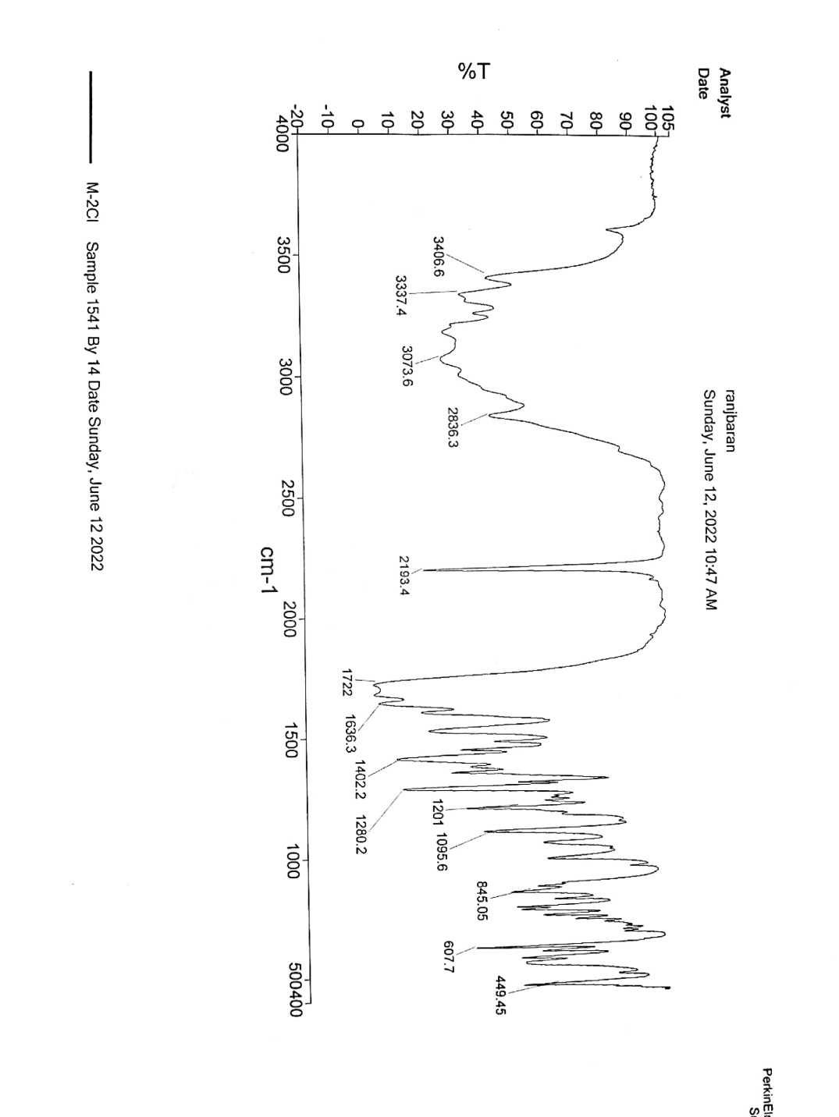

FT-IR spectrum of 8k
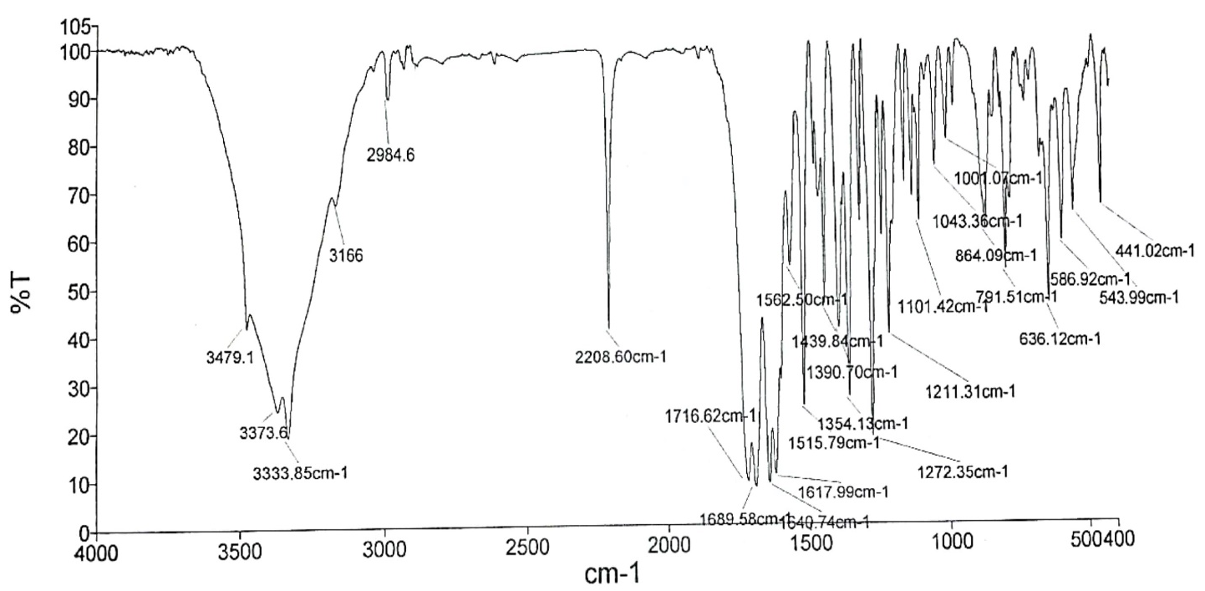

FT-IR spectrum of 8l
