Appendix
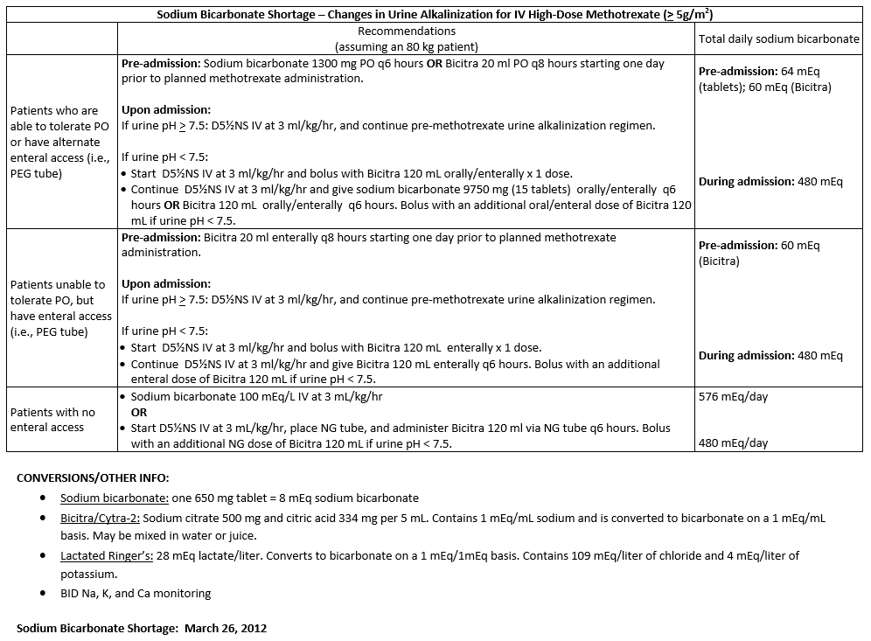
Johns Hopkins Hospital Oral Sodium Bicarbonate Protocol
