Supporting Information

Ultrathin, ultralight dual-scale fibrous networks with high infrared transmittance for high-performance, comfortable and sustainable PM_{0.3} air filter

Yuchen Yang ^{1, 2, 3}, Xiangshun Li ³, Zhiyong Zhou ³, Qiaohua Qiu ^{3, 4}, Wenjing Chen ³, Jianying Huang ^{1, 2}, Weilong Cai ^{1, 2}, Yuekun Lai ^{1, 2, *}, Xiaohong Qin ^{3, *}

¹ Qingyuan Innovation Laboratory, Quanzhou 362801, P. R. China;
² College of Chemical Engineering, Fuzhou University, Fuzhou 350116, P. R. China;
³ Key Laboratory of Textile Science & Technology of Ministry of Education, College of Textiles, Donghua University, Shanghai 201620, P. R. China;
⁴ College of Textile Science and Engineering, Zhejiang Sci-Tech University, Hangzhou 310018, P. R. China

*Corresponding authors. E-mails: yklai@fzu.edu.cn (Yuekun Lai), xhqin@dhu.edu.cn (Xiaohong Qin)

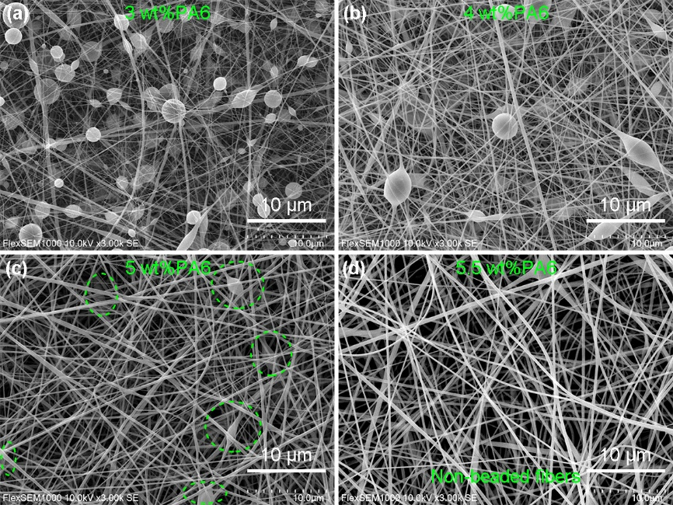
Figure S1. SEM images of PA6 fiber mats produced by (a) 3 wt%, (b) 4 wt%, (c) 5 wt% and (d) 5.5 wt% PA6 solutions.

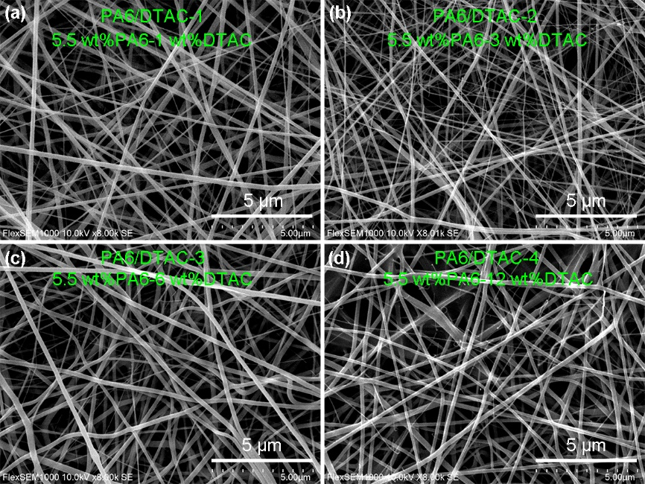

Figure S2. SEM images of PA6/DTAC fiber mats produced by (a) 1 wt%, (b) 3 wt%, (c) 6 wt% and (d) 12 wt% DTAC ratios.

Figure S3. (a) Filtration efficiency, filtration resistance and (b) quality factor of various PA6 and PA6/DTAC fiber filters with different electrospinning time.

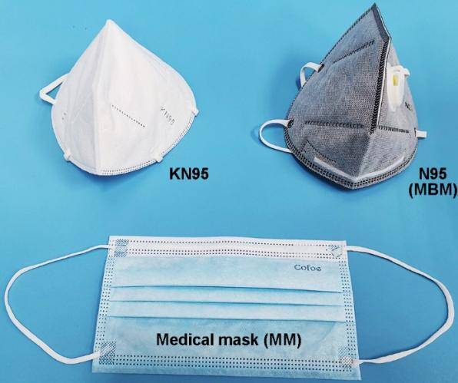
Figure S4. Optical images of KN95, N95 (MBM) and medical (MM) masks.

Table S1. Preparation parameters for various electrospun fiber mats.
Samples | PA6 Concentration  (wt%) | Mass ratio of DTAC to PA6  (wt%) | Voltage  (kV) | Liquid supply rate  (mm/s) | Distance  (cm)
PA6 | 5.5 | 0 | 15 kV | 0.05 | 10
PA6/DTAC-1 | 5.5 | 1 | 20 kV | 0.03 | 10
PA6/DTAC-2 | 5.5 | 3 | 20 kV | 0.018 | 10
PA6/DTAC-3 | 5.5 | 6 | 20 kV | 0.014 | 10
PA6/DTAC-4 | 5.5 | 12 | 20 kV | 0.01 | 10

