Extended Data
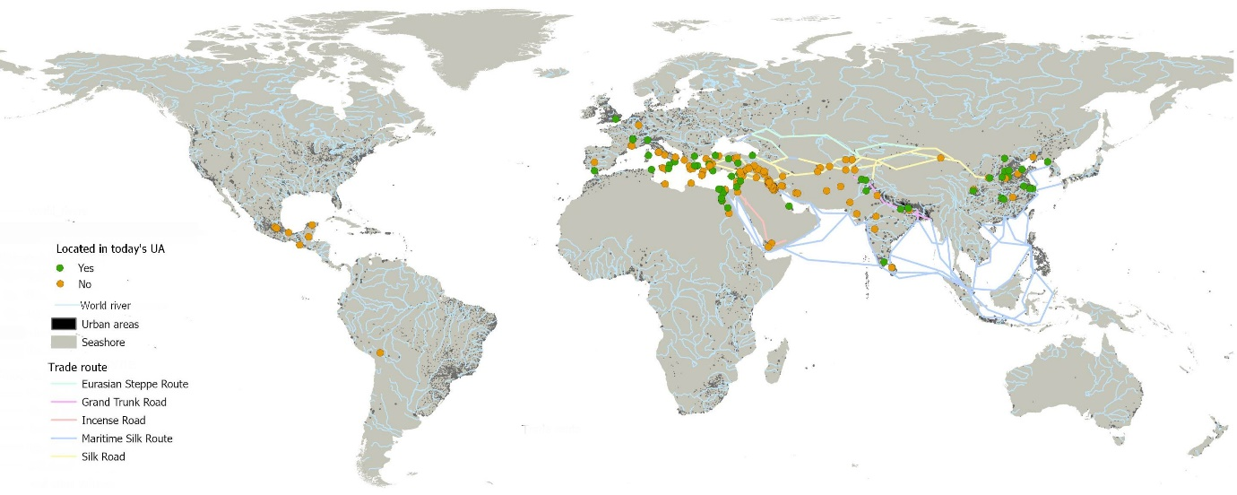
A
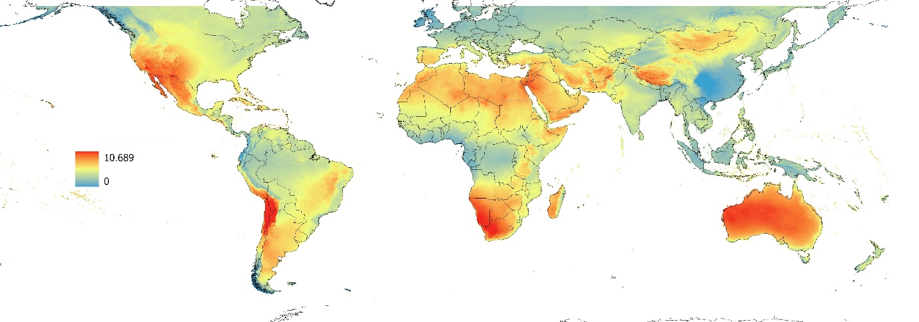
B
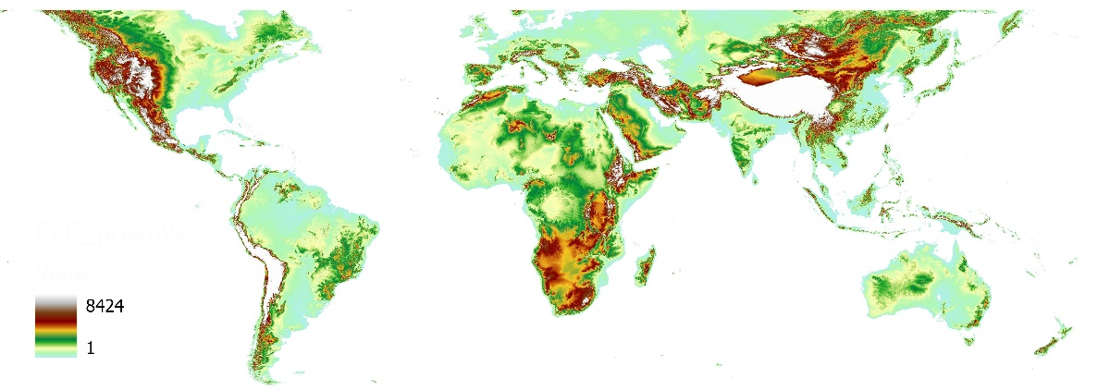
C
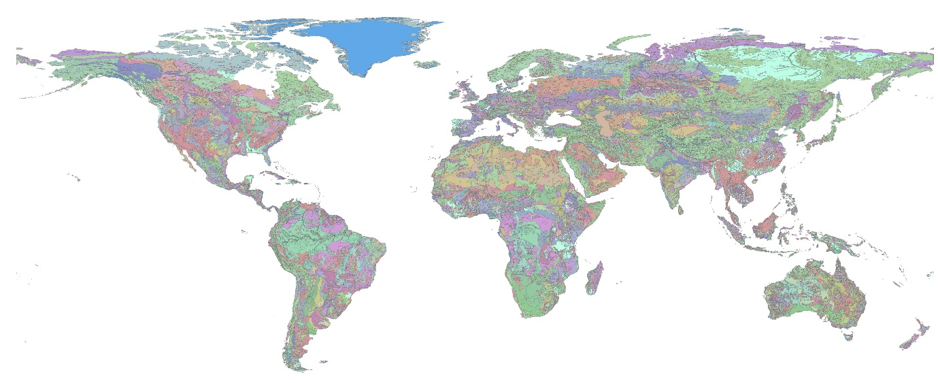
D
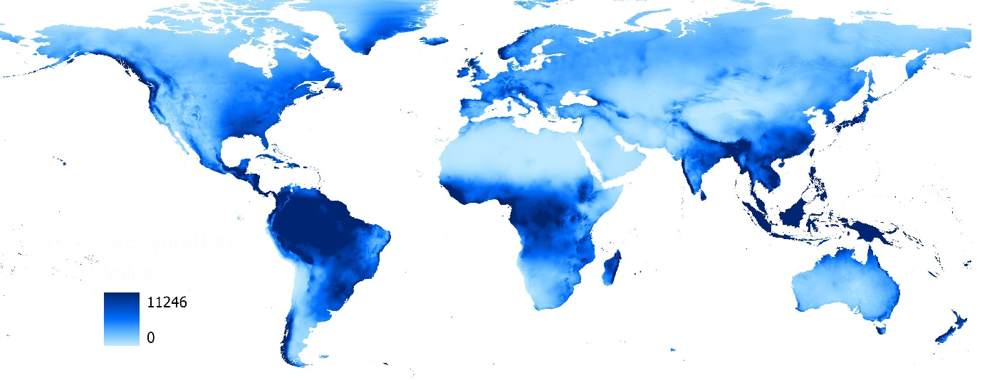
E
Extended Data Fig. 1: Summary of data used in the analysis
A – Physical attributes (world rivers, trade routes, contemporary urban areas (UA) and CoA); B – Direct normal irradiation (kWh/m²); C – Elevation above the sea level (m); D – Soil types; E – Mean annual precipitation (mm)

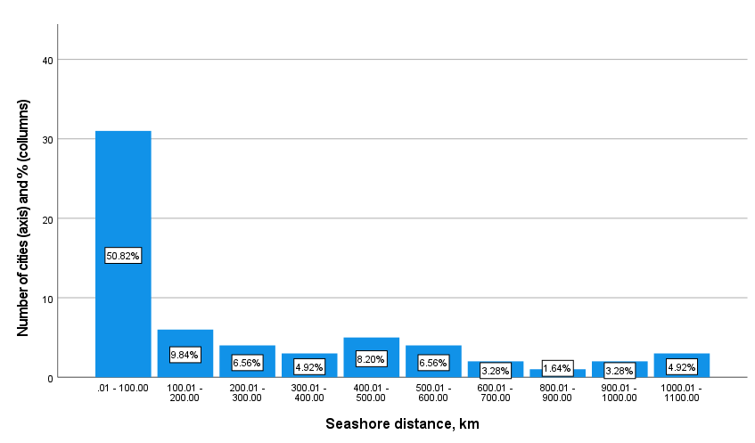 | 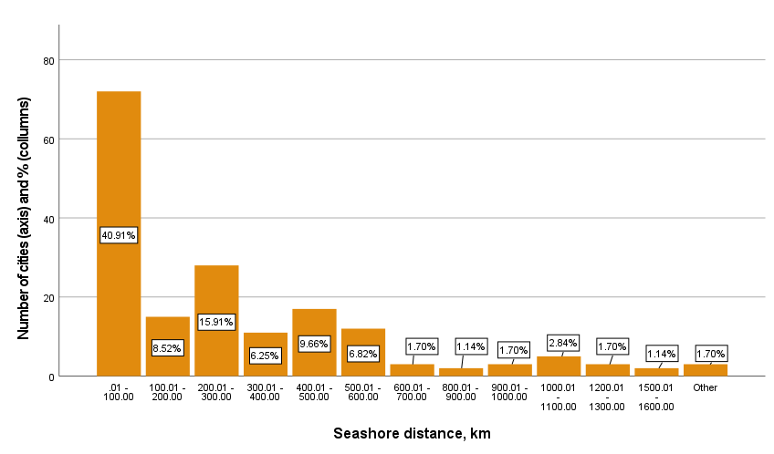
A | B
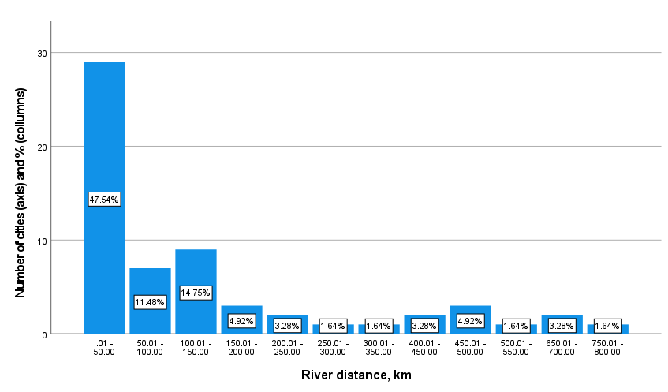 | 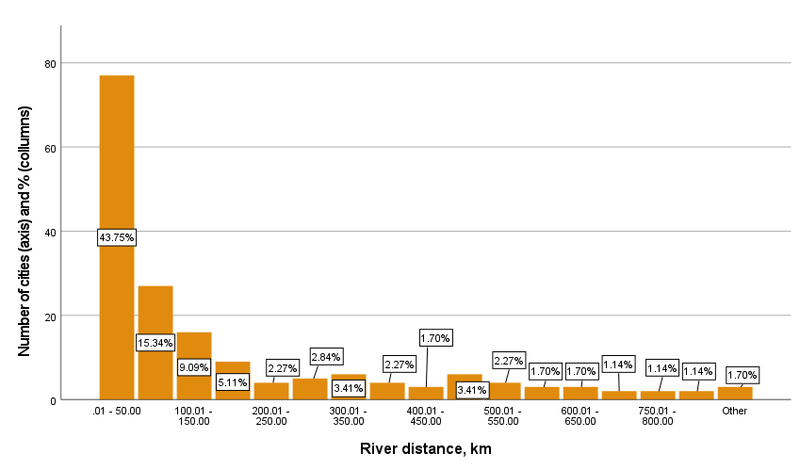
C | D
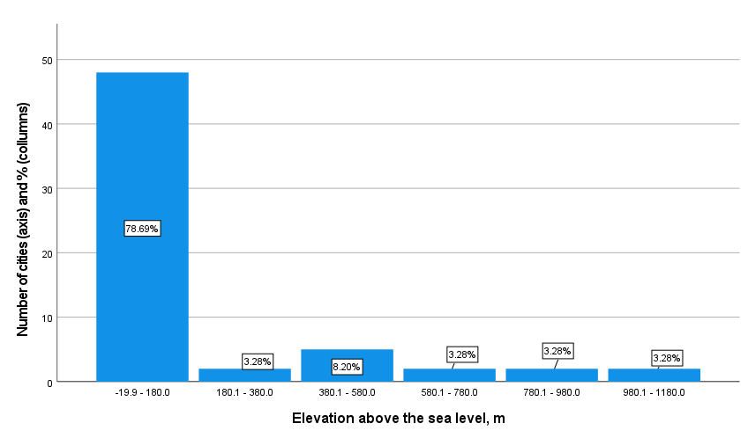 | 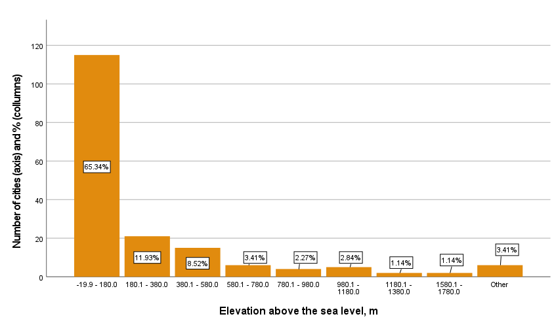
E | F
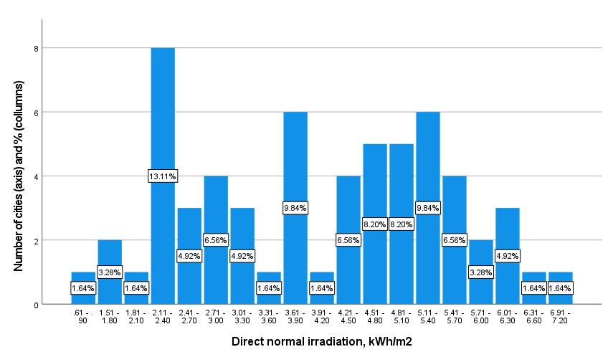 | 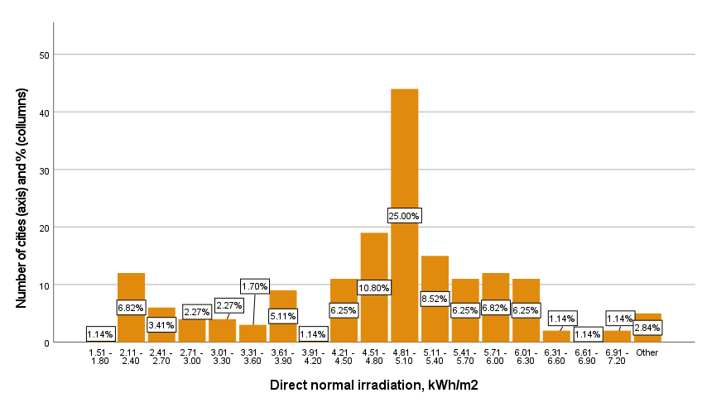
G | I
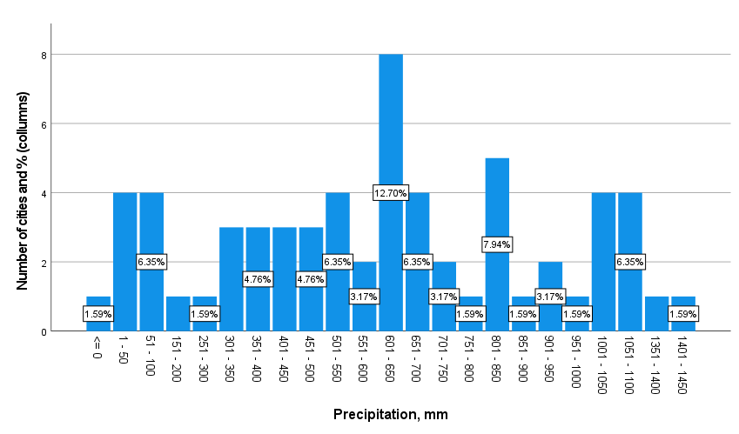  J | 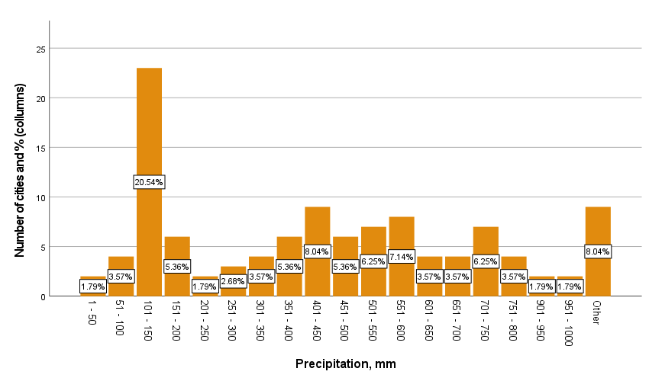  K
Extended Data Fig.2: Locational attributes of CoAs located in today’s urban areas (left panel diagrams; graphs A,C,E, G and J) and CoAs located elsewhere (right panel diagram; graphs B,D,F, I and K); Note: Classification attributes: distance to the seashore (A,B); distance to the river (C,D); elevation above sea level (E,F), DNI (G,I) and precipitation (J,K)

Extended Data Table 1: Major cities of antiquity (50,000 residents or more), destroyed and abandoned by their residents in the course of historyª
City | Population residentsª | Underlying causes |  |  | Comment
City | Population residentsª | WD^{b} | NC^{b} | SC^{b} | Comment
Antioch | 400,000 |  |  |  | Destroyed during the 637 CE conquest by the Rashidun Caliphate, partly rebuilt, destroyed again in 1268 CE by the Mamluks who demolished the city walls and left it defenseless.
Ctesiphon | 400,000 |  |  |  | Destroyed in the 630s CE in the Muslim conquest and further weakened by the establishment of the Abbasid capital in Baghdad in the 760s CE.
Seleucia | 400,000 |  |  |  | Burned down in 117 CE; destroyed by the Romans in 165 CE, followed by the construction of a new city, Veh-Ardashir, across the Tigris River.
Capua | 24,0000 |  |  |  | Partly destroyed by the Vandals under Gaiseric in 456 CE and totally destroyed by the Muslims in the 840s CE.
Anuradhapura | 200,000 |  |  |  | The Sinhalese capital of Sri Lanka from the 4th century BCE to about 1000 CE, when frequent invasions from southern India forced relocation of the capital elsewhere.
Babylon | 200,000 |  |  |  | Reduced in importance by the building of the new capital, Seleucia, and local infighting that followed the death of Alexander the Great, and emptied the city.
Pergamum | 200,000 |  |  |  | Damaged by a major earthquake in 262 CE; destroyed by the Arabs in the 7th century CE; restored and destroyed again by the Ottomans in 13th c. CE.
Ephesus | 200,000 |  |  |  | Abandoned after the harbour was silted up causing difficulties in linking it to the coast; destroyed by the Goths in 263 CE and then later by an earthquake.
Maoling | 180,000 |  |  |  | The capital city of the Western Han Dynasty, destroyed by the Huns following the death of emperor Wu Di of the Western Han Dynasty.
Teotihuacan | 150,000 |  |  |  | Destroyed in civil unrest, power struggles between the elites and, possibly, volcanic eruptions in 546/47 CE that caused summer temperatures to drop.
Caracol | 140,000 |  |  |  | The causes of abandonment in 800-900 CE are unclear, but are believed to be linked to the collapse of the Mayan civilization in the 7th and 9th centuries CE.
Apamea Cibotus | 130,000 |  |  |  | Declined after diversion of the trade routes to Constantinople in the 3rd c. CE; captured by the Turks in 1070 AD and eventually destroyed in an earthquake.
Nineveh | 120,000 |  |  |  | Destroyed in the Babylonian conquest that resulted in the death of the Assyrian king, Sîn-šar-iškun, after the Battle of Nineveh in 612 BCE; diversion of the trade routes.
Xinzheng | 120,000 |  |  |  | The capital city during the Zhou and Qin dynasties; reasons for abandonment are unclear, but apparently attributed to the collapse of the Qin dynasty.
Yin | 120,000 |  |  |  | The last capital of China during the Shang dynasty, declined after the Shang was overthrown by the Zhou dynasty that established its capital elsewhere.
Ecbatana | 100,000 |  |  |  | The city was captured from the Medians by Cyrus the Great in 550 BC, taken from the last Achaemenian ruler by Alexander the Great in 330 BC and eventually destroyed.
Merv | 100,000 |  |  |  | A city in Turkmenistan destroyed by the Mongols in 1221 CE, partly rebuilt in the 15th century CE and apparently abandoned due to the diversion of trade routes.
Anyi | 100,000 |  |  |  | The capital city of the Xia dynasty; apparently abandoned after the battle between the kingdoms of Han and Wei in 205 BC, which the Hans won.
Rajagriha | 100,000 |  |  |  | The capital city of the Magadha kingdom in India until the 5th century BC when King Udayin moved the capital to Pataliputra in 460–440 BC.
Tikal | 100,000 |  |  |  | Located in the tropical forest in Petén, Guatemala, the city was abandoned by the 10th CE, with the desertion of the city apparently linked to the overall decline of the Mayan civilization.
Edessa | 100,000 |  |  |  | A city in Macedonia, Greece, captured by the Rashidun Caliphate, temporarily recovered by the Byzantine Empire and finally it was captured and destroyed by the Ottomans.
Merida | 100,000 |  |  |  | The capital of the Roman province of Lusitania; declined in importance after being conquered by the Umayyad Caliphate.
Tiahuanaco | 100,000 |  |  |  | A major center of the pre-Columbian civilization in western Bolivia, collapsed by 11-12 c. CE with evidence of increased aridity and drought in the area around the time of collapse.
Tollan | 100,000 |  |  |  | Ancient capital of the Toltecs in Mexico; destroyed in the invasion by the nomadic Chichimec tribes in the mid-12th century CE.
Ujjain | 100,000 |  |  |  | One of the seven sacred Hindu cities, partly destroyed by the Muslims in 1235 CE; lost its significance after the transfer of the Sindhia capital to Lashkar and the rise of Indore.
Nicomedia | 100,000 |  |  |  | The eastern capital of the Roman Empire under Emperor Diocletian; fell to the Ottomans and was destroyed in 1326 CE.
Ur | 100,000 |  |  |  | A prosperous city in Mesopotamia till 3rd-4th c. BCE, when the Euphrates River changed its course, thus breaking down the whole irrigation system and turning the area into a desert.
Diyarbakir (Amida) | 80,000 |  |  |  | Destroyed in the wars between the Roman and Persian empires, and once again during the early Arab–Byzantine wars, when the city fell to the armies of the Rashidun Caliphate.
Girsu | 80,000 |  |  |  | The capital of the Lagash kingdom in Sumer; declined in importance and was eventually abandoned after the fall of the city of Ur.
Uruk (Erech) | 80,000 |  |  |  | An ancient city in Sumer that continued to prosper in the Parthian times; reasons for abandonment are a shift in the course of the Euphrates, and soil salination due to irrigation.
Balkh | 75,000 |  |  |  | The capital of Bactrian civilization in Central Asia; attacked by various nomadic invaders, taken by the Arabs in the 8th c. and completely destroyed by the Mongols in 1220 AD.
Sapinuwa | 75,000 |  |  |  | A Hittite city in today’s Turkey, apparently destroyed by the Kaskians who invaded the Hittite territory.
Susa | 70,000 |  |  |  | The former capital of the Achaemenian king Darius I; captured and destroyed by the Sassanids, restored and destroyed again by the Muslims in 642 CE.
Mari | 60,000 |  |  |  | The capital of the king of Mari Zimrilim; captured and destroyed by Hammurabi of Babylon in the 18th c. BCE.
Ẓafār | 60,000 |  |  |  | The capital of the Himyarites; captured by the Persians in 575 CE; fell into decay after the extinction of the Ḥimyar kingdom and the rise of Islam.
Hattusa | 60,000 |  |  |  | The ancient capital of the Hittites, it was captured, burned and destroyed by King Anittas of Kussara in the second millennium BCE.
Lagash | 60,000 |  |  |  | A major Sumerian city located between Tigris and Euphrates in south-eastern Iraq; gradually declined after the fall of the Sumerian civilization.
Paithan | 60,000 |  |  |  | The capital of the Satavahana dynasty in India that ruled from the 2nd century BCE to the 2nd century CE; gradually declined after the fall of the dynasty.
Nishapur | 50,000 |  |  |  | The capital of Sāsānian king Yazdegerd II (5th c. CE); fell into decline before 9th c. CE; in 12th-13th c. experienced earthquakes and the Mongol invasion.
Persepolis | 50,000 |  |  |  | An ancient capital of the Achaemenian kings in Iran; captured by Alexander the Great, and destroyed by fire.
Leptis Magna | 50,000 |  |  |  | A major city of the Carthaginian and Roman empires; captured and partly destroyed by the Vandals in 439CE; fell into ruins after the Arab conquest in 642 CE.
Miletus | 50,000 |  |  |  | Sacked by the Persians in 494 BCE; partly restored; in 6th c. CE, the harbours had silted up and the city was eventually abandoned.
Nimrud (Calah) | 50,000 |  |  |  | The capital of the Assyrian King Ashurnasirpal II (9th c. BCE); declined after moving the capital to Dur Sharrukin, and then to Nineveh; destroyed by invading tribes.
Taluqan | 50,000 |  |  |  | Once an important city on the Silk Road in present day Afghanistan; the reasons for abandonment are unclear.
Knossos | 50,000 |  |  |  | The capital of the Minotians; destroyed in about 1400 BCE by a fire, possibly attributed to a volcano eruption in the neighboring island of Santorini.
Notes: ª Maximum population size reported in the database; ^{b} Known reasons for abandonment: WD = war destruction; NC = natural causes; SC = social causes; the main cause; secondary cause. (Note: assembled from: ^{3,27,47} )

Extended data Table 2: Data sources used in the analysis
Data | Source | Reference in the text
Historical urban population | Reba, M. L., F. Reitsma, and K. C. Seto. 2016. Spatializing 6,000 Years of Global Urbanization from 3700 BC to AD 2000. Scientific Data 3: 160034. https://doi.org/10.1038/sdata.2016.34 | ²⁷
“-“ | Reba, M. L., F. Reitsma, and K. C. Seto. 2018.: 3700 BC - AD 2000. Palisades, New York: NASA Socioeconomic Data and Applications Center (SEDAC). https://doi.org/10.7927/H4ZG6QBX. Accessed in May, 2023. | ⁴⁸
Population count | CIESIN (2023) Global Population Count Grid Time Series Estimates, 1970-2020 (https://sedac.ciesin.columbia.edu/data/set/popdynamics-global-pop-count-time-series-estimates/data-download and https://sedac.ciesin.columbia.edu/data/set/gpw-v4-population-count-rev11), CIESIN—A Center of the Earth Institute at Columbia University Data and Information  https://www.ciesin.org/sub_guide.html (accessed on May, 2023) | ³⁰
Global solar data | Energydata.info (n.d.) https://energydata.info/Global solar atlas https://globalsolaratlas.info/download/world (accessed on May, 2023) | ⁴⁹
Word rivers | World Major Rivers (https://hub.arcgis.com/content/44e8358cf83a4b43bc863646cd695945/about) (accessed on May, 2023) and Major Rivers of the World https://datacatalog.worldbank.org/search/dataset/0042032 (accessed on May, 2023) | ESRI (n.d.)  ⁵⁰
World countries | World Countries (https://www.arcgis.com/home/item.html?id=ac80670eb213440ea5899bbf92a04998) (accessed on May, 2023) | ^{11,51}
Terrain elevation | World - Terrain Elevation Above Sea Level (ELE) GIS Data, (Global Solar Atlas) https://datacatalog.worldbank.org/search/dataset/0037910 (accessed on May, 2023) | ⁵⁰
Soil map | UN Food and Agriculture Organization - Digital Soil Map of the World https://data.apps.fao.org/map/catalog/srv/eng/catalog.search#/metadata/446ed430-8383-11db-b9b2-000d939bc5d8 (accessed on May, 2023) | ¹¹
Mean precipitation | WorldClim Global Mean Precipitation https://www.arcgis.com/home/item.html?id=e6ab693056a9465cbc3b26414f0ddd2c (accessed on May, 2023) | ⁵²
Ancient trade routes | Silk road and maritime spice routes: https://www.arcgis.com/apps/View/index.html?appid=7e0812b70f1d4c8db83b6e759412aa66; https://storymaps.arcgis.com/stories/ddb5a4b391b24042adf6889cc86c3919 | (The Spice Route, n.d.)

Extended data Table 3| Descriptive statistics of the research variables
Variable | Minimum | Maximum | Mean | SD
Cities of antiquity located in today's urban areas
Population, residents (maximum number reported in the database) | 10,000 | 1,200,000 | 161,889 | 218,180
Distance to the seashore, km | 0.20 | 1,558.45 | 268.53 | 349.57
Distance to a major river, km | 0.09 | 772.97 | 142.12 | 190.55
Elevation above the sea level, m | 4.00 | 1,056.00 | 181.06 | 278.21
Direct normal irradiation (DNI), kWh/m² | 0.81 | 7.02 | 4.06 | 1.43
Average annual precipitation, mm | 0.00 | 1,428.00 | 601.95 | 345.49
Number of valid cases listwise | 64
Cities of antiquity located elsewhere
Population, residents (maximum number reported in the database) | 10,000 | 400,000 | 66,973 | 74,101
Distance to the seashore, km | 0.34 | 1,874.84 | 306.72 | 351.86
Distance to a major river, km | 0.21 | 1,105.38 | 180.33 | 240.40
Elevation above the sea level, m | -15.00 | 3,854.00 | 357.14 | 613.70
Direct normal irradiation (DNI), kWh/m² | 0.00 | 7.45 | 4.86 | 1.13
Average annual precipitation, mm | 0.00 | 3,605.00 | 485.20 | 453.13
Number of valid cases listwise | 112

Extended data Table 4| Factors associated with different city groups (Model: Binary logistic regression, forward conditional; dependent variable – Location in today’s urban area (1) or elsewhere (0); only significant variables are included)
Variableª | Model A |  | Model B
Variableª | Exp(B) | Sig. | Exp(B) | Sig.
(Constant) | 0.152 | 0.469 | 0.027 | 0.154
Direct normal irradiation (DNI), kWh/m² | 0.533 | <0.001 | 0.463 | <0.001
Population before 500 CE (ln), residents^{b} | 1.835 | <0.001 | 1.996 | 0.001
Distance to the coast, km (ln) | 0.679 | <0.001 | 0.708 | <0.001
Distance to a major river, km (ln) | 0.800 | 0.031 | - | -
Dominant soil type:^{c}
- Calcaric Fluvisols (Jc) | - | - | 2.964 | 0.023
- Gypsic Xerosols (Xy) | - | - | 23.069 | 0.037
- Calcic Yermosols (Yk) | - | - | 12.315 | 0.014
Number of cases | 176 |  | 176
-2 Log likelihood | 179.688 |  | 173.519
Nagelkerke R² | 0.333 |  | 0.376
χ2 | 6.870 |  | 56.303
% correct | 71.1 |  | 73.7
ª Elevation, precipitation, other soil types were excluded from the final models as insignificant at the accepted significance level (p<0.05); ^{b} Maximum value reported in the database; ^{c} soil types according to the FAO classification ^{11.} Model A: Model without dominant soil type attributes; Model B: Model with soil type attributes.

