Supplementary Materials for
Comparison of Low-cost, Electricity-free, CPAP (OXYJET) with High-Flow Nasal Cannula Treatment Outside Critical Care: A Randomized Clinical Trial
Md. Kawsar Ahmed¹, Kaisar Ahmed Alman¹, Meemnur Rashid¹, Farhan Muhib¹, Saeedur Rahman¹, Nawsabah Noor², Md. Khairul Islam³, Forhad Uddin Hasan Chowdhury³, Md. Mohiuddin Sharif³, Rifat Hossain Ratul³, Sohana Jahan³, Md. Titu Miah³, Robed Amin³, Alain Bernard Labrique⁴, Yasser Khan⁵, and Taufiq Hasan^{1,6,*}.
*Corresponding Author. Email: taufiq@bme.buet.ac.bd, taufiq.hasan@jhu.edu
Contents
Supplementary Figures 4
Supplementary Figure 1. Dimensions and assembly of OxyJet CPAP flow generator. 4
Supplementary Figure 2. An illustration of the step-by-step assembly of the OxyJet CPAP system. 5
Supplementary Figure 3. Photograph of locally made OxyJet devices. 6
Supplementary Figure 4. Device characterization setup for OxyJet CPAP. 7
Supplementary Figure 5. OxyJet CPAP operation chart. 8
Supplementary Figure 6. Setup for testing OxyJet CPAP with an external heated humidifier. 9
Supplementary Figure 7. Respircare HiFent High Flow Nasal Cannula. 10
Supplementary Figure 8. OxyJet CPAP kit used for clinical trials. 11
Supplementary Figure 9. RCT Group C patient treatment flow diagram. 12
Supplementary Figure 10. RCT Group H patient treatment flow diagram. 13
Supplementary Figure 11. Patient management after enrollment. 14
Supplementary Figure 12. Numerical Rating Scale (NRS) of patient discomfort level. 15
Supplementary Figure 13. Testing OxyJet CPAP on a healthy-volunteer in ambulance setting. 16
Supplementary Tables 17
Supplementary Table 1. Comparison of OxyJet CPAP with the most competing CPAP system. 17
Supplementary Table 2. Specifications of the OxyJet CPAP system 18
Supplementary Table 3. Material cost estimate of an OxyJet CPAP system. 19
Supplementary Table 4. Comparison of the flow produced by the OxyJet flow generator using different needle gauges vs PEEP. 20
Supplementary Table 5. The maximum output flow and the minimum FiO₂ generated by the G16 based fixed OxyJet flow generator (n=75) for different PEEP settings. 21
Supplementary Table 6. Supply oxygen versus FiO₂ of the output flow generated by the G16 based fixed OxyJet flow generator (n=75) for different PEEP settings. 22
Supplementary Table 7. Summary of the demographic information of the healthy-volunteers (n=5). 23
Supplementary Table 8. Summary of the expiratory pressure and flow (during inhalation and exhalation) of healthy-volunteers (n=5) on two interfaces. 24
Supplementary Table 9. Summary of comparison of the physiological levels of healthy-volunteers (n=5) before and after administering OxyJet CPAP. 25
Supplementary Table 10. Summary of comparison of the comfort level of healthy-volunteers (n=5) on two types of interfaces. 26
Supplementary Table 11. Summary of the demographic information of the adult mild hypoxemic patients (n=5). 27
Supplementary Table 12. Summary of comparison of the physiological levels of patients (n=5) before and after administering OxyJet CPAP. 28
Supplementary Table 13. Summary of comparison of the comfort-level of patients (n=5) on two interfaces. 29
Supplementary Table 14. Summary of comparison of the physiological levels of the Group C patientsª before and after a day (3rd follow-up) of administering OxyJet CPAP in the RCT trial. 30
Supplementary Table 15. Summary of comparison of the physiological levels of the Group H patientsª before and after a day (3rd follow-up) of administering High Flow Nasal Cannula (HFNC) in the RCT trial. 31
Supplementary Table 16. Summary of comparison of the physiological levels of the Group C patientsª and Group H patients^{b} after a day (3rd follow-up) of treatment in the RCT trial. 32
Supplementary Videos 33
Video 1. Demonstration of OxyJet CPAP system setup and operation 33

Supplementary Figures

Supplementary Figure 1. Dimensions and assembly of OxyJet CPAP flow generator.
(a) Dimensions of OxyJet flow generator. The isometric view of the device with a length of 178 mm, a width of 28 mm and a height of 71 mm. (b) Exploded view of the device. A double-sided connector is used to securely connect the DISS female adapter and the G16 needle with the OxyJet body. (c) Cross-sectional view of the device. The air inlet with a diameter of 22 mm for installation of viral / HEPA filter. The secondary O₂ inlet with burb like structure for attaching an oxygen tube. The outlet port with a diameter of 22 mm for attaching a breathing circuit. The air-inlet and the secondary O₂ inlet port of the OxyJet body is inclined at an angle of 50° to make it 3D printable without support. (d) Double-sided connector and its cross-sectional view. (e) DISS female adapter and its cross-sectional view. The adapter is an off-the-shelf (https://www.madamedical.com/product/1703) component, however we have carved it locally to avoid sourcing delay. (f) Off-the-shelf stainless-steel dispense tip needles with different gauges (https://www.amazon.in/12-Pack-Dispensing-Stainless-18G-25mm-12pcs/dp/B07JRFVV3S). They have a standard needle length of 12.6 mm (approx.) and a hub length of 12.3 mm (approx.).

Supplementary Figure 2. An illustration of the step-by-step assembly of the OxyJet CPAP system.
(i) At first OxyJet flow generator is attached to a standard flowmeter (primary) via the DISS female adapter. Next the secondary O₂ inlet of the flow generator is connected to a second flowmeter with integrated bubble humidifier via an oxygen tube. Next a viral / HEPA filter is attached to the air inlet port of the flow generator. (ii) One end of the breathing circuit is connected to the outlet port of the flow generator. (iii) Other end of the breathing circuit is connected to the inhalation port of the CPAP mask / helmet. Finally, a viral/ HEPA filter followed by an adjustable PEEP valve is attached to the exhalation port of the CPAP mask / helmet.

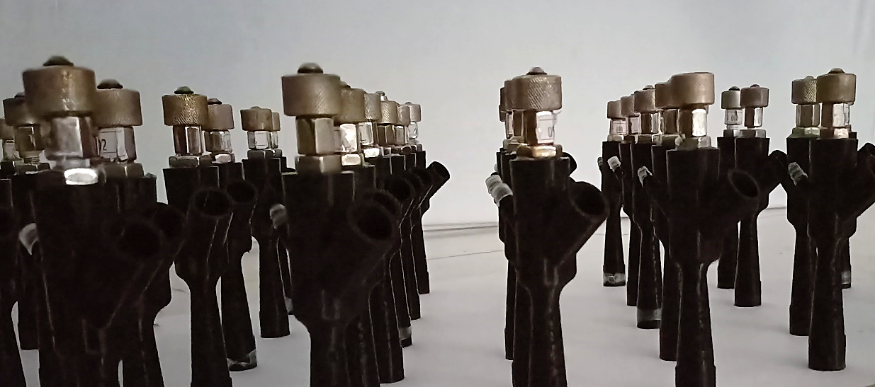

Supplementary Figure 3. Photograph of locally made OxyJet devices.
The devices were rapidly manufactured during the second wave of the COVID-19 pandemic (July 2021) with an intention to provide non-invasive ventilation support to hypoxemic patients in the general hospital ward while awaiting critical care availability.

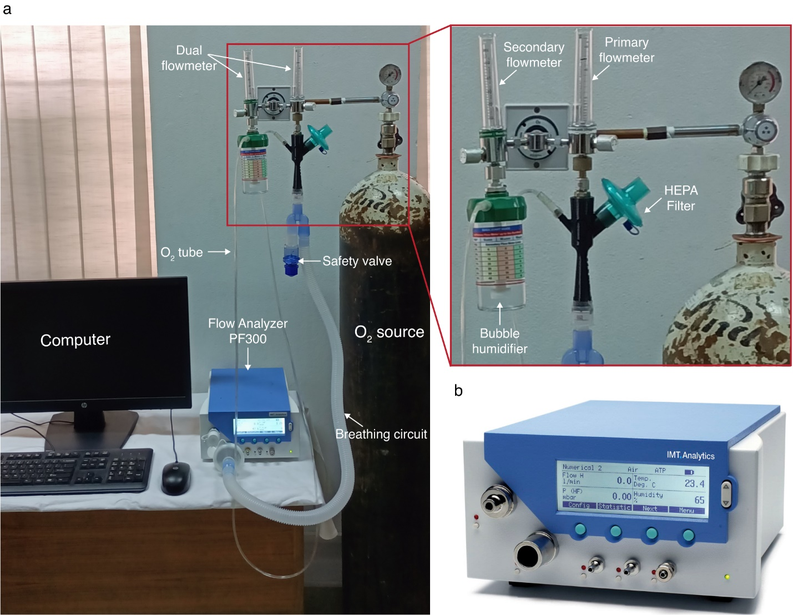

Supplementary Figure 4. Device characterization setup for OxyJet CPAP.
(a) Setup for device characterization. OxyJet CPAP was installed, and the output port of the flow generator was connected to a flow analyzer via a breathing circuit. The output flow (L/min), FiO₂ (%), PEEP (cmH₂O), humidity, and temperature of the system were measured, as described in Methods. (b) Photograph of the IMTAnalytics FlowAnalyser PF-300 (https://www.imtanalytics.com/en/Analyser/FlowAnalyser). All the data were acquired using it.

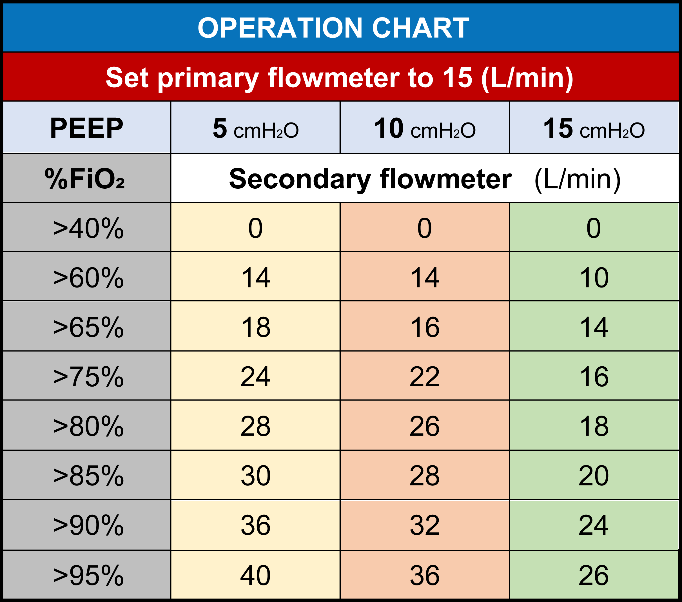

Supplementary Figure 5. OxyJet CPAP operation chart.
The operation chart of OxyJet CPAP system is given to manually control the FiO₂ (%) of the generated high-flow delivered to the patient.
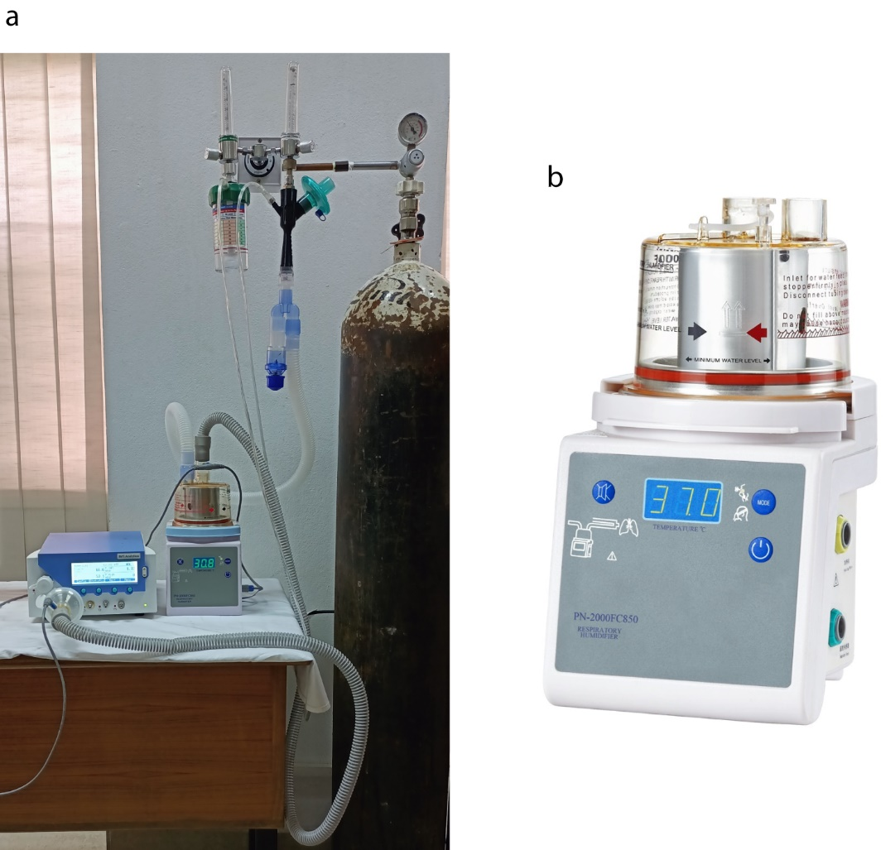

Supplementary Figure 6. Setup for testing OxyJet CPAP with an external heated humidifier.
(a) Setup for testing OxyJet CPAP with an external heated humidifier. (b) Photograph of the heated humidifier PN-2000FC850 (https://www.pigeon-medical.com/products/pn-2000fc850-respiratory-humidifier).

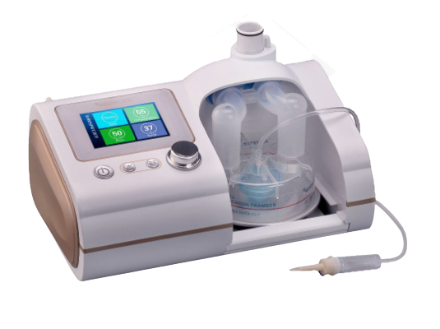

Supplementary Figure 7. Respircare HiFent High Flow Nasal Cannula.
The Respircare HiFent high-flow nasal cannula (https://www.clickpharma.com.bd/product/hifent-high-flow-heated-respiratory-humidifier-hfnc-respircare) was used on the Group H patients (control group) of the randomized controlled trial. It can deliver a flow 2-80L/min, FiO₂ (%) upto 100% and has a heated humidifier. However, it has a very high price (more than 4000 dollars).

Supplementary Figure 8. OxyJet CPAP kit used for clinical trials.
OxyJet CPAP kit consists of a breathing circuit, an oxygen tube, two viral/HEPA filters, one adjustable PEEP valve (5-20 cmH₂O), CPAP masks (S/M/L), a dual flowmeter, a bubble humidifier, and OxyJet flow generator.

Pre-CPAP:
OxyJet CPAP Manual
Initial Settings:

Initial Resuscitation:
Follow-up Observation ⁽¹⁾
Escalation
SpO₂ < 90% & no increased WOB
SpO₂ < 90% & increased WOB
Increase %FiO₂
Increase PEEP
Consider “Treatment Failure” ⁽²⁾
Weaning
Is PEEP > 5 cmH₂O?
Reduce flow 5 L/min at a time
Consider shift to NRM when primary oxygen flow is 15 L/min and secondary flow is 0 L/min

If observations are stable CPAP can be withdrawn
⁽¹⁾ Follow-up Observation:

- CPAP: Continuous Positive Airway Pressure
- RR: Respiration Rate
- BP: Blood Pressure
- SBP: Systolic Blood Pressure
- MBP: Mean Blood Pressure
- NRM: Non-Rebreather Mask
- WOB: Work of breathing present if
  - RR > 30 b/min & use of accessory
muscle of respiration

⁽²⁾ Treatment Failure:
Patient’s Status?
Unstable, despite maximum effort?

Reduce PEEP gradually until PEEP 5 cmH₂O is reached
- Increase Flow 5 L/min at a time
(Depends on Patient’s demand)
- Physician must be present: Until SpO₂ > 94 %

- PEEP: 5 cmH₂O
- FiO₂: 70%
- Flow:
  - Primary flowmeter: 15 L/min
  - Secondary flowmeter: 20 L/min
- BP
- Pulse
- RR
- SpO₂
- Conscious Level
Add NRM with CPAP
- NRM: 2 hours
- CPAP: 4 – 6 hours
Gradually increase NRM & decrease CPAP duration

Take 2nd opinion before declaration
Features:
- Worsening or unbearable dyspnea
- Lack of improvement in oxygenation
- Persistent tachypnea
- Persistent respiratory muscle fatigue
- Neurological deterioration
- Hemodynamic instability
  - SBP < 90 mm of Hg
  - MBP < 65 mm of Hg
- No improvement in initial 30 minutes of resuscitation
- Features of CO₂ retention
  - Flap, full bounding pulse
Yes

No
Unstable
Stable
- SpO₂
- Respiration
  - RR
  - Accessory muscle use
- Pulse
- BP
- Conscious level
Target: SpO₂ > 90%
- Close observation:
  - BP
  - Abdominal distension
- Consult with investigator
- 2.5 cm H₂O at a time
- Max: 10 cm H₂O
- Increase secondary O₂ flow 5 L/min at a time
2 hrs.
Yes

No
2 hrs. stable observation

Supplementary Figure 9. RCT Group C patient treatment flow diagram.
The treatment flow diagram followed by the study physicians to treat Group C patients (n=23) allocated to CPAP treatment using OxyJet during the RCT.
- Reduce FiO₂ 5% at a time
- Followed by Flow 5 L/min at a time
- SpO₂
- Conscious Level
- O₂ requirements
- BP
- Pulse
- RR
- Increase Flow 5 L/min at a time
(Depends on Patient’s demand)
- Physician must be present: Until SpO₂ > 94 %
- Flow: 35 – 40 L/min
- FiO₂: 90 – 100%
- SpO₂
- Respiration
  - RR
  - Accessory muscle use
- Pulse
- BP
- Conscious level
- ROX score
  - 0 hours
  - 2 hours
  - 12 hours
Target: SpO₂ > 90%

Pre-HFNC:
HFNC Manual
Initial Settings:

Initial Resuscitation:

Follow-up Observation ⁽¹⁾
Patient’s Status?
Escalation
SpO₂ < 90% & no increased WOB
SpO₂ < 90% & increased WOB
Increase Flow
Weaning
Consider shift to NRM when
- Flow < 30 L/min
- FiO₂ < 50%
Add NRM with HFNC
- NRM: 2 hours
- HFNC: 4 – 6 hours
Gradually increase NRM & decrease HFNC duration
If observations are stable HFNC can be withdrawn
⁽¹⁾ Follow-up Observation:

Increase FiO₂
Consider “Treatment Failure” ⁽²⁾
Unstable, despite maximum effort?

- 5 L/min at a time
- 5% at a time
⁽²⁾ Treatment Failure:

Take 2nd opinion before declaration
Features:
- ROX score < 3.85
- Worsening or unbearable dyspnea
- Lack of improvement in oxygenation
- Persistent tachypnea
- Persistent respiratory muscle fatigue
- Neurological deterioration
- Hemodynamic instability
  - SBP < 90 mm of Hg
  - MBP < 65 mm of Hg
- No improvement in initial 30 minutes of resuscitation
- Features of CO₂ retention
  - Flap, full bounding pulse

- HFNC : High Flow Nasal Cannula
- RR : Respiration Rate
- BP : Blood Pressure
- SBP : Systolic Blood Pressure
- MBP : Mean Blood Pressure
- NRM : Non Rebreather Mask
- ROX : Ratio of %SpO₂/%FiO₂ to RR
- WOB: Work of breathing present if
  - RR > 30 b/min & use of accessory
muscle of respiration

No

Yes

2 hrs.
Unstable
Stable

Supplementary Figure 10. RCT Group H patient treatment flow diagram.
The treatment flow diagram followed by the study physicians to treat Group H patients (n=22) allocated to HFNC treatment during the RCT.

Supplementary Figure 11. Patient management after enrollment.
The patient management undertaken by the duty physicians based on the patient condition. (a) Patient management of the Group C patients (n=23) allocated to CPAP treatment using OxyJet (b) Patient management of the Group H patients (n=22) allocated to HFNC treatment. Each bar in the plots represents a single patient’s treatment received over time (days).
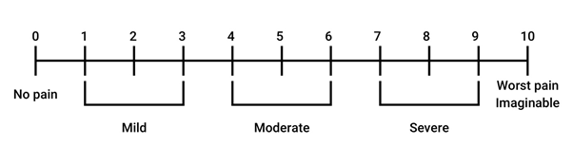

Supplementary Figure 12. Numerical Rating Scale (NRS) of patient discomfort level.
The NRS was used to measure the patient discomfort level of two interfaces (CPAP mask and CPAP helmet).
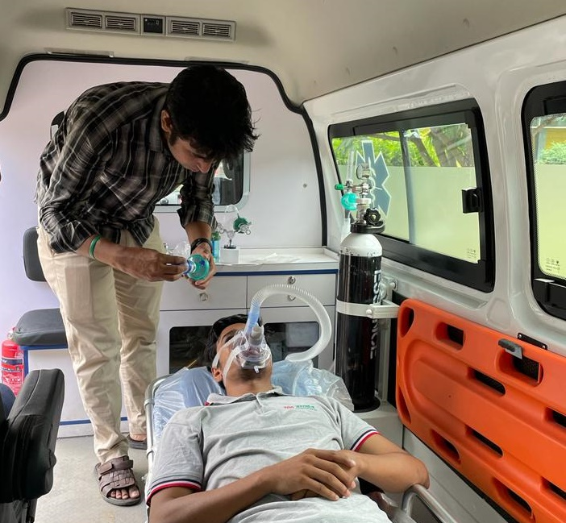

Supplementary Figure 13. Testing OxyJet CPAP on a healthy-volunteer in ambulance setting.

Supplementary Tables

Supplementary Table 1. Comparison of OxyJet CPAP with the most competing CPAP system.
Category | OxyJet CPAP | UCL Ventura¹
Affordable | Estimated material cost of the OxyJet flow generator is $20. The whole CPAP system with all the accessories can cost around $56.81. | Cost of the UCL Ventura CPAP with all the accessories is around $1221.
Dependency on global supply chain | Can be produced from locally available raw materials. | Requires imported raw materials.
Design innovation and manufacturability | OxyJet CPAP has a novel design. It can be produced using off-the-shelf components, 3D printing and CNC machining. Does not require a complex manufacturing infrastructure. | Device is produced by reverse-engineering an FDA approved device (Whispherflow CPAP)¹. It requires a high-precision manufacturing infrastructure.
Clinical evaluation | Passed the randomized controlled trial which prove the efficacy of the system. | As the device is reverse engineered from an FDA approved device, its clinical trial was exempted.
Usability | The device directly fits a standard flowmeter and is operated by regulating the flow of the flowmeters following a device operation chart. Requires minimal training. | The device attaches to a wall-mount oxygen port. It can be operated by regulating the flow and the FiO₂ knobs (no dial scale). However, it needs electronic sensors to measure and display the flow (L/min) and the FiO₂ (%).
Power requirement | OxyJet is completely electricity free, pressure driven CPAP system. | UCL Ventura is pressure driven but not completely electricity free. It requires electricity to power the sensors.
Sensitive and specific | Performance is similar to other predicate devices. It provides a high flow up to 65 L/min with a FiO₂ (%) ranges within 40-100% and can be controlled in steps of 5%. The PEEP can be set between 5-15 cmH₂O. | It can provide a high flow of 0-120 L/min with a FiO₂ (%) between 30-100%. These can be precisely controlled by turning knobs and with visual feedback from the sensors. The PEEP can be set between 5-15 cmH₂O.
Oxygen consumption (L/min) | As the operating flow is limited to 65 (L/min), it can deliver higher level of FiO₂ (%) consuming less oxygen. To deliver a FiO₂ (%) of 60% to patients it draws an oxygen flow of 32 (L/min). | The device specification suggests, to deliver a FiO₂ (%) of 60% to patients with higher work of breathing, it draws an oxygen flow of 46.7 (L/min)². However, it can draw much higher flow of oxygen reaching up to 116 L/min when all valves are fully opened³.

Aspect of CPAP device | Description
Maximum flowrate | 65 L/min (approx.) at 5 cmH₂O PEEP
PEEP settings | 5, 10, 15 cm H₂O
PEEP mechanism | Standard adjustable PEEP valve
FiO₂ (%) | 40% - 100%
Compatible masks | Non-vented cpap mask, or CPAP helmet
Oxygen port | Standard DISS connector
Requirements | Oxygen cylinders or central oxygen lines
Negative-pressure room | Not required
Aerosol generation | Risk is minimized by HEPA filter
Risk of high pressure | Minimized by pressure-relief valve (at 25 cm H₂O)

Supplementary Table 2. Specifications of the OxyJet CPAP system

Supplementary Table 3. Material cost estimate of an OxyJet CPAP system.
Description |  | Supplier |  |  | OxyJet CPAP kit
 |  | Supplier | Quantity | Unit cost (USD) |  | Cost (USD)
OxyJet flow generator |  | Fully assembled deviceª
 | - OxyJet 3D printed body | 3D Printed | 1 | 4.80 |  | 4.80
 | - Needle^{b} |  | 1 | 0.20 |  | 0.20
 | - Double-sided connector | Local workshop | 1 | 5.00 |  | 5.00
 | - DISS female adapter | Local workshop | 1 | 10.00 |  | 10.00
Dual Flowmeter with Humidifier |  | Amcaremed Technology Co. Ltd, China^{c} | 1 | 16.00 |  | 16.00
Breathing Circuit |  | Evereast Medical Products Group Co. Ltd, China^{d} | 1 | 2.13 |  | 2.13
Viral Filter |  | Shandong Zhenfu Medical Device Co. Ltd, China^{e} | 2 | 0.65 |  | 1.30
Secondary Tube |  | Ningbo Greetmed Medical Instruments Co. Ltd, China^{f} | 1 | 0.36 |  | 0.36
Peep Valve with Peep Adaptors |  | Ningbo Finer Medical Instruments Co. Ltd, China^{g} | 2 | 1.50 |  | 3.00
CPAP Mask |  | Evereast Medical Products Group Co. Ltd^{h} | 3 | 4.11 |  | 12.33
Connectors (JS029-6105, JS029-6103) |  | Shaoxing Jenston Medical Co. Ltd^{i} | 1 | 0.06 |  | 0.06
Mask Adaptor |  | 3D Printed^{j}  (Formlabs SLA Printer) | 1 | 2.00 |  | 2.00
Estimated total material cost for a fully equipped OxyJet CPAP system^{k} |  |  |  |  |  | 56.81
- The cost is estimated for producing a fully assembled OxyJet flow generator using in lab-scale fabrication. It’s subjected to reduce when scaled.
- https://www.amazon.in/12-Pack-Dispensing-Stainless-18G-25mm-12pcs/dp/B07JRFVV3S
- https://www.alibaba.com/product-detail/AmcareMed-Aluminum-Body-Oxygen-Flowmeter-with_62007802170.html
Company Link: https://www.amcaremed.com/
- http://en.changdongjituan.com/our-product/our-product6.html
- https://www.alibaba.com/product-detail/Disposable-Bacteria-Viral-Filter-for-CPAP_1600519478099.html?spm=a2700.shop_plgr.41413.39.6d546737ujHnTt
Company Link: http://m.zhenfumedical.cn/product/30.html
- https://greetmed1.en.alibaba.com/search/product?SearchText=medical%20pvc%20oxygen%20connection%20tubing
Company Link: https://www.china-greetmed.com/En/product_d/id/182.html
- https://www.alibaba.com/product-detail/medical-ambu-bag-peep-valve_60741014807.html?spm=a2700.7724857.0.0.6e8a3461AdeHYj
Company Link: http://www.finermed.com/e_products/?big_id=3&small_id=371
- https://www.alibaba.com/product-detail/Disposable-medical-Nasal-CPAP-Face-Mask_62303863868.html
Company Link: https://www.evereastmedical.com/cpap-pvc-mask.html
- https://www.alibaba.com/product-detail/Different-Connectors-for-breathing-circuit_1600054584035.html?spm=a2700.galleryofferlist.normal_offer.d_title.741d26c79vQ0Y2
Company Link: http://www.jstmed.com/
- Mask Adaptors have been printed in our lab facility with 3d printer and the cost is estimated according to the material used for each adaptor manufacturing.
- The estimated cost only covers the raw materials used at the time of submission, which may vary depending on the market. The final estimate for commercialization should include the overall costs comprising transportation cost, vat & tax for importing, human resources, manufacturing cost and miscellaneous items.

Supplementary Table 4. Comparison of the flow produced by the OxyJet flow generator using different needle gauges vs PEEP.
Needle Gauge | PEEP Settings
Needle Gauge | 5 cmH₂O | 10 cmH₂O | 15 cmH₂O
 | Mean output flow (L/min)
G20 | 115 | 107 | 100
G19 | 105 | 99 | 91
G18 | 96 | 91 | 84
G17 | 81 | 75 | 66
G16 | 67 | 60 | 50
G15 | 52 | 44 | 35
* Primary input flow of oxygen was set to 15-16 (L/min).

Supplementary Table 5. The maximum output flow and the minimum FiO₂ generated by the G16 based fixed OxyJet flow generator (n=75) for different PEEP settings.
G16 based OxyJet flow generator | PEEP Settings
G16 based OxyJet flow generator | 5 cmH₂O | 10 cmH₂O | 15 cmH₂O
Flow (L/min) (mean±std) | 65.30±3.74 | 56.11±3.26 | 46.50±2.74
FiO₂ (%) (mean±std) | 40.05±0.63 | 43.00±0.79 | 46.42±0.83
* The primary input flow was set to 15-16 L/min of oxygen and the secondary input flow was kept zero.

Supplementary Table 6. Supply oxygen versus FiO₂ of the output flow generated by the G16 based fixed OxyJet flow generator (n=75) for different PEEP settings.
PEEP Settings | Supply oxygen (L/min) | Measured FiO₂ (%) (mean±std)
5 cmH₂O | 16 | 40.05±0.62
5 cmH₂O | 50 | 81.93±1.51
5 cmH₂O | 61 | 97.77±0.80
10 cmH₂O | 16 | 42.96±0.79
10 cmH₂O | 36 | 70.20±2.22
10 cmH₂O | 52 | 97.90±0.65
15 cmH₂O | 16 | 46.42±0.83
15 cmH₂O | 35 | 80.67±2.14
15 cmH₂O | 43 | 96.80±1.07
* The primary input flow was set to 15-16 L/min of oxygen and additional oxygen was supplied through the secondary inlet.

Supplementary Table 7. Summary of the demographic information of the healthy-volunteers (n=5).
Characteristic |  | No (%) / Value (mean±std)
Age (years) |  | 27.6±5.32
Gender | Male | 5 (100%)
Gender | Female | 0 (0%)
Weight (kg) |  | 76.54±14.7
Height (cm) |  | 169.78±2.99
BMI |  | 26.45±4.28
Respiratory Difficulty | Yes | 0 (0%)
Respiratory Difficulty | No | 5 (100%)
History of acute Illness | Yes | 0 (0%)
History of acute Illness | No | 5 (100%)
Chronic diseases | Yes | 0 (0%)
Chronic diseases | No | 5 (100%)
Hospitalized in last one month | Yes | 0 (0%)
Hospitalized in last one month | No | 5 (100%)
Comorbidity | Yes | 0 (0%)
Comorbidity | No | 5 (100%)
Appearance (Well alert) | Yes | 5 (100%)
Appearance (Well alert) | No | 0 (0%)

Supplementary Table 8. Summary of the expiratory pressure and flow (during inhalation and exhalation) of healthy-volunteers (n=5) on two interfaces.
Set PEEP (cmH₂O) | Interface type | Pressure (cm H₂O) (mean±std) |  | Expiratory flow (L/m) (mean±std)
Set PEEP (cmH₂O) | Interface type | Inhalation | Exhalation | Inhalation | Exhalation
5 | CPAP mask | 4.93±0.34 | 6.95±0.10 | 35.91±3.10 | 62.19±2.18
5 | CPAP helmet | 6.32±0.19 | 7.84±0.09 | 56.68±2.00 | 73.40±1.75
10 | CPAP mask | 12.19±0.31 | 13.50±0.12 | 21.16±3.37 | 41.40±1.54
10 | CPAP helmet | 13.40±0.12 | 14.42±0.14 | 45.54±1.85 | 64.19±0.81

Supplementary Table 9. Summary of comparison of the physiological levels of healthy-volunteers (n=5) before and after administering OxyJet CPAP.
Physiological levels | Before (mean±std) | After (mean±std) | p value* (2-sided t-test) | Significant (p<0.05)
Heat Rate (beats/min) | 88.4±7.27 | 78.8±12.77 | 0.083 | No
Respiratory rate (breaths/min) | 19.6±3.85 | 17.6±2.61 | 0.189 | No
Temperature (°F) | 97.6±0.55 | 97.92±0.18 | 0.195 | No
SpO₂ (%) | 99±0.00 | 99±0.00 | 1.000 | No
Systolic blood pressure (mm Hg) | 130±12.25 | 131.6±14.06 | 0.444 | No
Diastolic blood pressure (mm Hg) | 82±13.04 | 82.2±14.72 | 0.906 | No
* Using “Paired t test”.

Supplementary Table 10. Summary of comparison of the comfort level of healthy-volunteers (n=5) on two types of interfaces.
Interface type | Discomfort level* (mean±std)
CPAP Mask | 4.20±1.30
CPAP Helmet | 2.60±0.89
* The discomfort level was rated based on the numerical rating scale (NRS) shown in Supplementary Fig. 12

Supplementary Table 11. Summary of the demographic information of the adult mild hypoxemic patients (n=5).
Characteristic |  | No (%) / Value (mean±std)
Age (years) |  | 52.6±2.51
Gender | Male | 2 (40%)
Gender | Female | 3 (60%)
Weight (kg) |  | 55.2±10.26
Height (cm) |  | 161.44±5.99
BMI |  | 21.11±3.27
COVID-19 test result | Positive | 0 (0%)
COVID-19 test result | Negative | 5 (100%)
Disease during admission | Severe pneumonia | 1 (20%)
Disease during admission | Pneumonia | 4 (80%)
Cyanosis | Present | 0 (0%)
Cyanosis | Absent | 5 (100%)
Antibiotics started | Yes | 5 (100%)
Antibiotics started | No | 0 (0%)
Oxygenation method | Low flow | 1 (20%)
Oxygenation method | Non-rebreather mask | 4 (80%)
Duration of cough (days) |  | 3.2±2.49
Duration of fever (days) |  | 2.2±3.03
Duration of respiratory difficulty (days) |  | 3.4±2.07
Duration of hospitalization (days) |  | 3.2±1.79

Supplementary Table 12. Summary of comparison of the physiological levels of patients (n=5) before and after administering OxyJet CPAP.
Physiological levels | Before (mean±std) | After (mean±std) | Difference (mean±std) | p value* (2-sided t-test) | Significant (p<0.05)
Heart Rate (beats/min) | 91.6±12.20 | 91±17.00 | -0.6±8.76 | 0.8860 | No
Respiratory rate (breaths/min) | 29±1.73 | 25.4±4.22 | -3.6±3.51 | 0.0830 | No
SpO₂ (%) | 87.8±2.17 | 99±0.71 | 11.2±2.59 | 0.0001 | Yes
Systolic blood pressure (mm Hg) | 137.4±29.13 | 141.2±30.77 | 3.8±13.29 | 0.5570 | No
Diastolic blood pressure (mm Hg) | 82.8±17.22 | 91.6±14.62 | 8.8±7.40 | 0.0560 | No
* Using “Paired t test”.

Supplementary Table 13. Summary of comparison of the comfort-level of patients (n=5) on two interfaces.
Interface type | Discomfort level* (mean±std)
CPAP mask | 1.20±1.10
CPAP helmet | 2.00±1.22
* The patient's discomfort level was rated based on the numerical rating scale (NRS) shown in Supplementary Fig. 12

Supplementary Table 14. Summary of comparison of the physiological levels of the Group C patientsª before and after a day (3rd follow-up) of administering OxyJet CPAP in the RCT trial.
Physiological levels |  | Before (mean±std) | After a day / 3rd follow-up  (mean±std) | Difference (mean±std) | p value* (2-sided t-test) | Significant (p<0.05)
Heart Rate (beats/min) |  | 100.47±16.21 | 89.37±13.11 | -11.11±16.39 | 0.008 | Yes
Respiratory rate (breaths/min) |  | 35.32±3.61 | 32±5.35 | -3.32±5.59 | 0.019 | Yes
SpO₂ (%) |  | 86.26±1.45 | 96±2.13 | 9.74±2.98 | 0.000 | Yes
Systolic blood pressure (mm Hg) |  | 125.68±17.63 | 121.21±17.3 | -4.47±15.2 | 0.216 | No
Diastolic blood pressure (mm Hg) |  | 78.63±12.17 | 73.32±12.03 | -5.31±11.26 | 0.054 | No
ª | 19 out of 23 patients of Group C who received OxyJet CPAP therapy for at least a day are used in the analysis.
* | Using “Paired t test”.

Supplementary Table 15. Summary of comparison of the physiological levels of the Group H patientsª before and after a day (3rd follow-up) of administering High Flow Nasal Cannula (HFNC) in the RCT trial.
Physiological levels |  | Before (mean±std) | After a day / 3rd follow-up  (mean±std) | Difference (mean±std) | p value* (2-sided t-test) | Significant (p<0.05)
Heart Rate (beats/min) |  | 101.8±13.04 | 101.93±17.7 | 0.13 ±17.38 | 0.977 | No
Respiratory rate (breaths/min) |  | 38.67±6.56 | 35.13±6.48 | -3.53±8.20 | 0.117 | No
SpO₂ (%) |  | 85.87±1.25 | 94.07±4.37 | 8.2±4.62 | 0.000 | Yes
Systolic blood pressure (mm Hg) |  | 122.4±15.02 | 122.53±21.21 | 0.13±21.34 | 0.981 | No
Diastolic blood pressure (mm Hg) |  | 73.2±11.77 | 75.93±10.62 | 2.73±7.41 | 0.175 | No
ª | 15 out of 22 patients of Group H who received High Flow Nasal Cannula therapy for at least a day are used in the analysis.
* | Using “Paired t test”.

Supplementary Table 16. Summary of comparison of the physiological levels of the Group C patientsª and Group H patients^{b} after a day (3rd follow-up) of treatment in the RCT trial.
Physiological levels | Group C  (3rd follow-up)  (mean±std) | Group H  (3rd follow-up)  (mean±std) | Difference (95% CI) | p value*  (2-sided t-test) | Significant (p<0.05)
Heart Rate (beats/min) | 89.37±13.11 | 101.93±17.7 | 12.56 (1.30 – 23.83) | 0.030 | Yes
Respiratory rate (breaths/min) | 32±5.35 | 35.13±6.48 | 3.13 (1.13 – 7.39) | 0.143 | No
SpO₂ (%) | 96±2.13 | 94.07±4.37 | -1.93(-4.51 – 0.64) | 0.132 | No
Systolic blood pressure (mm Hg) | 121.21±17.3 | 122.53±21.21 | 1.32(-12.58 – 15.22) | 0.846 | No
Diastolic blood pressure (mm Hg) | 73.32±12.03 | 75.93±10.62 | 2.62(-5.32 – 10.55) | 0.506 | No
ª | 19 out of 23 patients of Group C who received OxyJet CPAP therapy for at least a day are used in the analysis.
^{b} | 15 out of 22 patients of Group H who received High Flow Nasal Cannula therapy for at least a day are used in the analysis.
* | Using “Two sample t test”.

Supplementary Videos
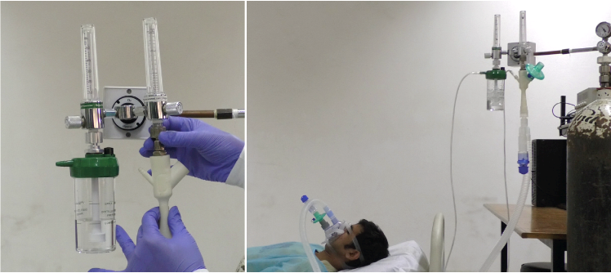

Video 1. Demonstration of OxyJet CPAP system setup and operation
Demonstration of the step-by-step assembly of the OxyJet CPAP (left). First, OxyJet flow generator is attached to a standard flowmeter (primary). Next, the secondary O₂ inlet of the flow generator is connected to a second flowmeter with integrated bubble humidifier via an oxygen tube. Next, a viral / HEPA filter is attached to the air inlet port of the flow generator. A breathing circuit is attached to the outlet port of the flow generator. The other end of the breathing circuit is attached to the inhalation port of a CPAP mask. A mask adapter followed by a viral / HEPA filter is attached to the exhalation port of the CPAP mask. Finally, an adjustable PEEP valve (5-15 cmH₂O) with specified PEEP is attached after the filter at the exhalation port to complete the setup.
Demonstration of the OxyJet CPAP system on a healthy participant (right). OxyJet CPAP is turned on by setting the primary flowmeter’s flow to 15-16 (L/min) approximately. The FiO₂ (%) of the generated high flow is adjusted by supplying an additional amount of oxygen flow (L/min) via a second flowmeter with humidifier following the device operation chart (Supplementary Fig. 5). CPAP therapy is being administered.

References:
1. Singer, M. et al. The UCL Ventura CPAP device for COVID-19. Lancet. Respir. Med. 8, 1076 (2020).
2. Engineering, U. I. of H. Accessing the UCL Ventura CPAP for the NHS. at (2020).
3. Kempley, S., Reeves, J. & Wilkins, A. High oxygen flow rates with the UCL Ventura CPAP device. Lancet Respir. Med. 9, e35 (2021).

