Supplementary materials
Table S1 The regression coefficients for sensitivity of cattle meat yield to climatic and socioeconomic variables given by regression model M3.
Variables | Regression coefficients given by model M3
THI | -0.0174***
THI × Wind | 0.0003***
THI × Cloud | 0.00004***
FRS | -0.0027***
P | 0.00002***
GDPpc | 0.000008***
CerYield | 0.00002***
LPI | 0.0014***
Adjusted R² | 0.36
* THI represents the annual mean temperature humidity index. Wind and Cloud represent the annual average wind speed and cloud cover. P: annual total precipitation, GDPpc: GDP per capita, CerYield: cereal yield, LPI: livestock production index. Stars represent the significant level: *<0.1, **<0.05, ***<0.01.

Table S2 The regression coefficients for sensitivity of cattle meat yield to climatic and socioeconomic variables given by regression model M4.
Variables | Regression coefficients given by model M4
THI¹ | -1.26×10⁻⁶***
THI¹ × Wind | 1.98×10⁻⁷***
THI¹ × Cloud | 2.14×10⁻⁸***
THI² | -6.78×10⁻⁸***
THI² × Wind | 5.17×10⁻⁹***
THI² × Cloud | 8.82×10⁻¹⁰***
FRS | -0.0008***
P | -2.64×10⁻⁶
GDPpc | 8.56×10⁻⁶***
CerYield | 2.14×10⁻⁵***
LPI | 0.0015***
Adjusted R² | 0.33
* THI¹ and THI² represent the cumulative temperature humidity index value over 72 and 79. Wind and Cloud represent the annual average wind speed and cloud cover. FRS: annual total frost day. P: annual total precipitation, GDPpc: GDP per capita, CerYield: cereal yield, LPI: livestock production index. Stars represent the significant level: *<0.1, **<0.05, ***<0.01.

Table S3 The regression coefficients for sensitivity of cattle meat yield to climatic and socioeconomic variables given by regression model M5.
Variables | Regression coefficients given by model M5
T | -0.0062***
T² | -0.0002***
T × Wind | 0.0013***
T × Cloud | 0.0001***
P | 0.00002
GDPpc | 0.000008***
CerYield | 0.00002***
LPI | 0.0014***
Adjusted R² | 0.33
* T represents the annual mean temperature. Wind and Cloud represents the annual average wind speed and cloud cover. P: annual total precipitation, GDPpc: GDP per capita, CerYield: cereal yield, LPI: livestock production index. Stars represent the significant level: *<0.1, **<0.05, ***<0.01.

Table S4 The regression coefficients for sensitivity of cattle meat yield to climatic and socioeconomic variables given by regression model M6.
Variables | Regression coefficients given by model M5
THI | 0.009***
THI² | -0.0001***
THI × Wind | 0.0005***
THI × Cloud | 0.00005***
P | 0.000007
GDPpc | 0.000008***
CerYield | 0.00002***
LPI | 0.0013***
Adjusted R² | 0.34
* THI represents the annual mean temperature and humidity index. Wind and Cloud represents the annual average wind speed and cloud cover. P: annual total precipitation, GDPpc: GDP per capita, CerYield: cereal yield, LPI: livestock production index. Stars represent the significant level: *<0.1, **<0.05, ***<0.01.

Table S5 The regression coefficients for sensitivity of cattle meat yield to climatic and socioeconomic variables given by regression model M7.
Variables | Regression coefficients given by model M5
T | 0.0151***
T² | -0.0005***
T × LWW | 0.0021**
P | 0.00001
GDPpc | 0.000012***
CerYield | 0.000001***
LPI | 0.0017***
Adjusted R² | 0.28
* T represents the annual mean temperature. LWW is Livestock water withdrawal. P: annual total precipitation, GDPpc: GDP per capita, CerYield: cereal yield, LPI: livestock production index. Stars represent the significant level: *<0.1, **<0.05, ***<0.01.

Table S6 The regression coefficients for sensitivity of cattle meat yield to climatic and socioeconomic variables given by regression model M8.
Variables | Regression coefficients given by model M5
THI | 0.0224***
THI² | -0.0002***
THI × LWW | 0.0021**
P | -0.000005
GDPpc | 0.000012***
CerYield | 0.000001
LPI | 0.0016***
Adjusted R² | 0.27
* THI represents the annual mean temperature humidity index. LWW is the livestock water withdrawal. P: annual total precipitation, GDPpc: GDP per capita, CerYield: cereal yield, LPI: livestock production index. Stars represent the significant level: *<0.1, **<0.05, ***<0.01.

Table S7 The regression coefficients for sensitivity of cattle meat yield to climatic and socioeconomic variables across different livestock system split by pasture-cropland ratio (PCR).
Variables | M1 (Warm=T) | M2 (Warm=THI)
PCR > 50%
Warm | 0.0294*** | 0.0691***
Warm² | -0.0013*** | -0.0006***
Warm × Wind | 0.0018*** | 0.0007***
Warm × Cloud | 0.0002*** | 0.00007***
P | 0.00006*** | 0.00008***
GDPpc | 0.000006*** | 0.000005***
CerYield | 0.00002*** | 0.00002***
LPI | 0.0013*** | 0.0011***
Adjusted R² | 0.35 | 0.36
PCR > 70%
Warm | 0.0485*** | 0.0993***
Warm² | -0.0018*** | -0.0009***
Warm × Wind | 0.0008** | 0.0005***
Warm × Cloud | 0.0004*** | 0.00008***
P | -0.000002 | 0.00007***
GDPpc | 0.000003*** | 0.000002***
CerYield | 0.00002*** | 0.00002***
LPI | 0.0017*** | 0.0015***
Adjusted R² | 0.36 | 0.34
* “Warm” represents the climate variables can characterize warming. “Warm” is temperature and THI in regression model M1 and M2, respectively. Wind and Cloud represents the annual average wind speed and cloud cover. P: annual total precipitation, GDPpc: GDP per capita, CerYield: cereal yield, LPI: livestock production index. PCR: pasture and cropland ratio, which quantified by the ratio of pasture area and pasture + cropland area. Stars represent the significant level: *<0.1, **<0.05, ***<0.01.

Table S8 The regression coefficients for sensitivity of cattle meat yield to climatic and socioeconomic variables across different livestock system split by gross primary production (GPP).
Variables | M1 (Warm=T) | M2 (Warm=THI)
GPP > 10g/m²
Warm | 0.0671*** | 0.1277***
Warm² | -0.0023*** | -0.0011***
Warm × Wind | 0.0048*** | 0.0015***
Warm × Cloud | 0.0001*** | 0.00002*
P | 0.00004*** | 0.0001***
GDPpc | 0.000007*** | 0.000006***
CerYield | 0.00004*** | 0.00003***
LPI | 0.0015*** | 0.0014***
Adjusted R² | 0.38 | 0.38
GPP > 20g/m²
Warm | 0.1040*** | 0.1907***
Warm² | -0.0032*** | -0.0016***
Warm × Wind | 0.0041** | 0.0016***
Warm × Cloud | 0.0002*** | 0.00009***
P | 0.00007*** | 0.0001***
GDPpc | 0.000006*** | 0.000006***
CerYield | 0.00002*** | 0.00002***
LPI | 0.0012*** | 0.0009***
Adjusted R² | 0.45 | 0.45
* “Warm” represents the climate variables can characterize warming. “Warm” is temperature and THI in regression model M1 and M2, respectively. Wind and Cloud represents the annual average wind speed and cloud cover. P: annual total precipitation, GDPpc: GDP per capita, CerYield: cereal yield, LPI: livestock production index. PCR: pasture and cropland ratio, which quantified by the ratio of pasture area and pasture + cropland area. Stars represent the significant level: *<0.1, **<0.05, ***<0.01.

Table S9 The regression coefficients for sensitivity of cattle meat yield to climatic and socioeconomic variables across different livestock system split by FAO classification.
Variables | M1 (Warm=T) | M2 (Warm=THI)
Rangeland livestock system
Warm | 0.0069*** | 0.0148***
Warm² | -0.0008*** | -0.0002***
Warm × Wind | 0.0024*** | 0.0008***
Warm × Cloud | -0.0004*** | 0.00003*
P | 0.0002*** | 0.00004*
GDPpc | 0.000005*** | 0.000004***
CerYield | 0.00002*** | 0.00002***
LPI | 0.0008*** | 0.0006**
Adjusted R² | 0.38 | 0.37
Mixed-crop livestock system
Warm | 0.0009*** | 0.0103***
Warm² | -0.0002*** | -0.00009***
Warm × Wind | 0.0011** | 0.0003***
Warm × Cloud | 0.0002*** | 0.00006***
P | -0.00002*** | 0.00003***
GDPpc | 0.00001*** | 0.00001***
CerYield | 0.00003*** | 0.00003***
LPI | 0.0018*** | 0.0017***
Adjusted R² | 0.36 | 0.36
* “Warm” represents the climate variables can characterize warming. “Warm” is temperature and THI in regression model M1 and M2, respectively. Wind and Cloud represents the annual average wind speed and cloud cover. P: annual total precipitation, GDPpc: GDP per capita, CerYield: cereal yield, LPI: livestock production index. PCR: pasture and cropland ratio, which quantified by the ratio of pasture area and pasture + cropland area. Stars represent the significant level: *<0.1, **<0.05, ***<0.01.

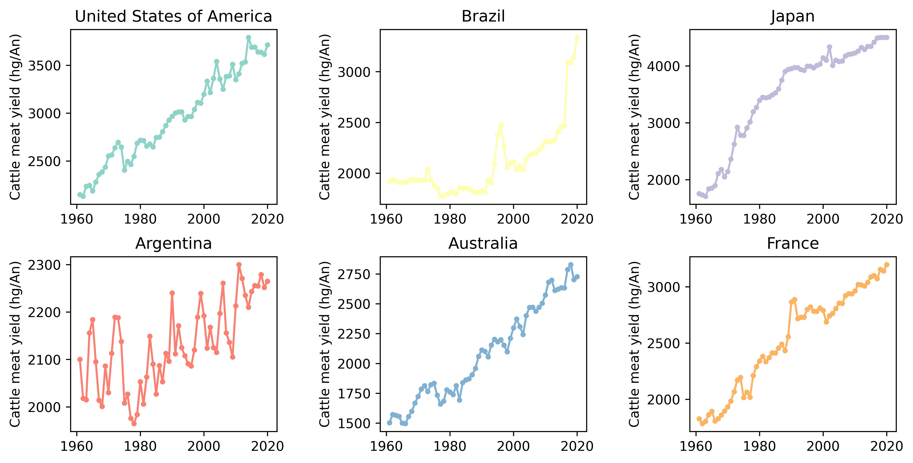
Figure S1 The changes in annual cattle meat yield from 1961 to 2020 for six representative countries.

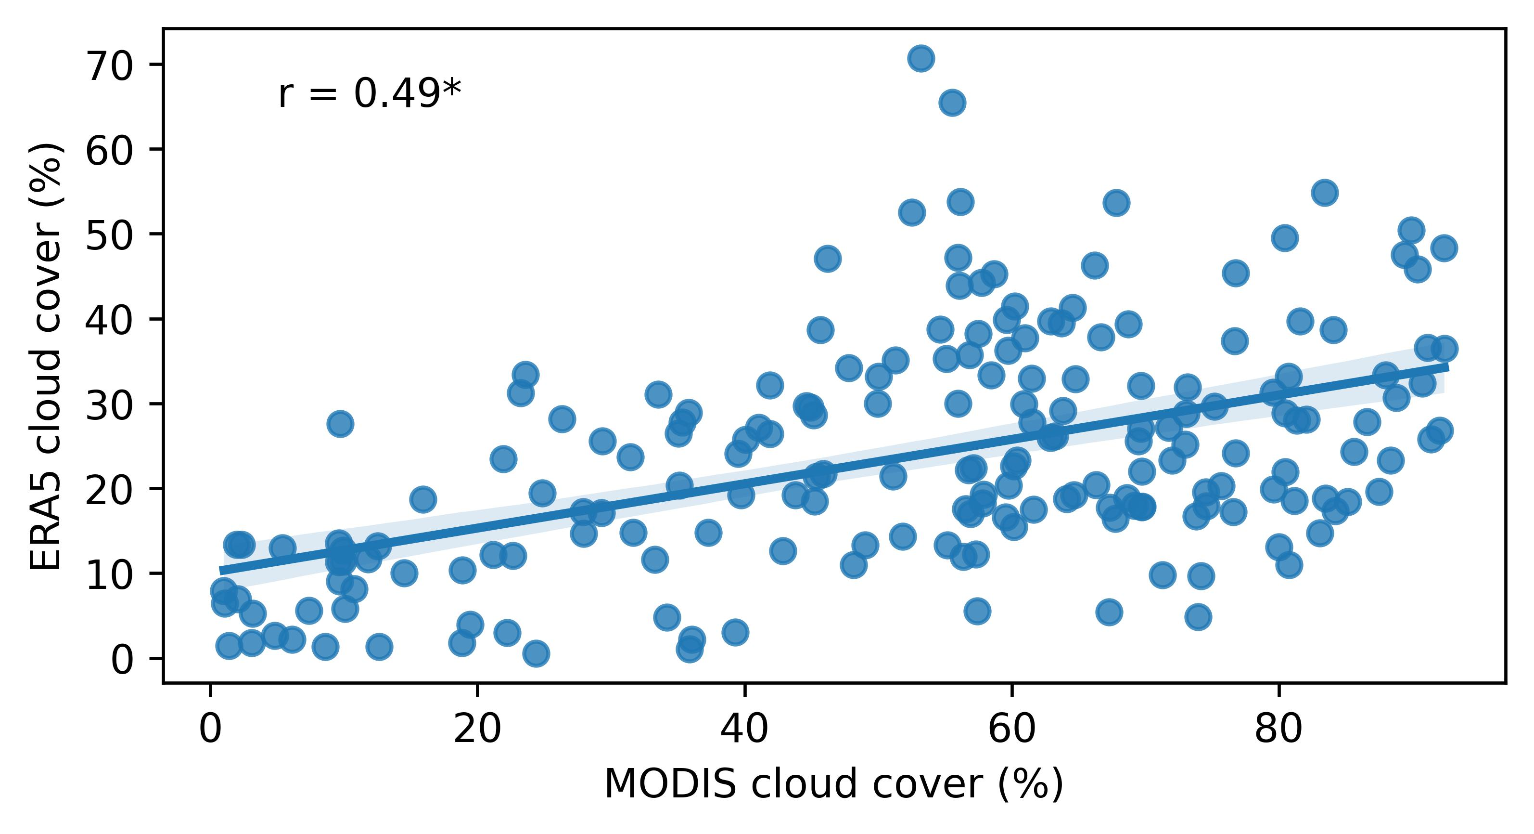
Figure S2 The correlation between MODIS and ERA5 cloud cover fraction from 2002 to 2018. The star denotes 0.05 significant level.

