Table 1 Comparative plots of similarities and differences for samples 1-3
Shoe name | Stitch | Sewing methods | Sole thickness | Material | Sole pattern distribution
Terracotta Warriors Replica Shoes | Vertical seam stitching | Single Needle Diamond Shape | 1.5cm | Ramie | Dense in the front and back, sparse in the middle.
Zhuangyuan Orchid Cloth Shoes | Vertical seam stitching | Single Needle Diamond Shape | 1.5cm | Ramie | The outsole is evenly distributed.
Qinghong Hundred Years of Cloth Shoes | Circular seam stitching | Circular single needle | 1.5cm | Cotton | The outsole is evenly distributed.
Shoe number | The bottom view |  | The side view |  | The front view
Terracotta Warriors Replica Shoes (Sample 1) | 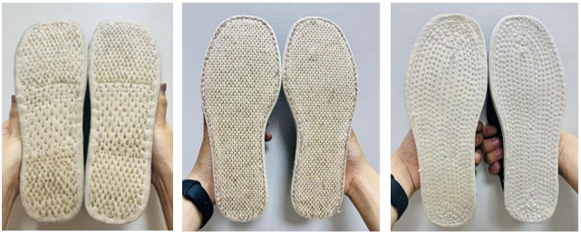 |  | 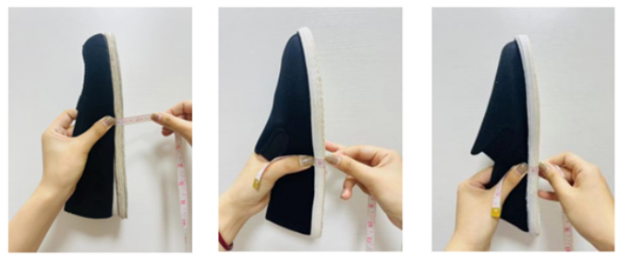 |  | 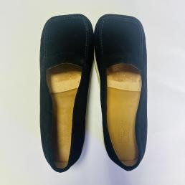
Zhuangyuan Orchid Cloth Shoes (Sample 2) |  |  |  |  | 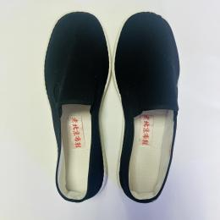
Qinghong Hundred Years of Cloth Shoes (Sample 3) |  |  |  |  | 