A novel peptide analogue of spike glycoprotein shows antiviral properties against SARS-CoV-2: An in silico approach through molecular docking, molecular dynamics simulation and MM-PB/GBSA calculations

Kunal Dutta^{1, *}, Ammar D. Elmezayen³, Anas Alobaidi³, Wei Zhu⁵, Olga Morojava⁶, Sergey Shityakov^{2,7}, Ibrahim Khalifa⁴

SUPPLEMENTARY SECTION

Molecular dynamics (MD) simulation of the antiviral peptides
MD-simulation of peptide analogue of the spike glycoprotein were performed using GROMACS (v2020), [17]. The Pdb2gmx was used to achieve the GROMACS file from protein. The initial protein structure for the simulation was processed using AMBER99SB-ILDN force field and solvated in a cubic box with SPC/E water molecules maintaining the size at least 2.0 nm from all atoms as final. To neutralize the net charge on the protein required Cl- ions were added to the cubic water box. The neutralized systems were further subjected to energy minimization with 500 steps for steepest descent algorithm followed by 100 ps MD simulation with position restraints on the protein non-hydrogen atoms were performed to equilibrate to remove the irregular torsions, and the process was carried out through the steepest descent minimization algorithm for 50000 steps using 1000 kJ/mol/nm as the maximum force. The two steps equilibration, NVT, and NPT were performed for 100 ps before the final MD run. The MD simulations were performed for 50000 ps [30].

Table S1. Binding free energy (ΔG_{bind}) of different AVP-RBD complex systems calculated using MM-GB/PBSA calculated for 50 ns*, #
Systems | MM-GBSA* | MM-PBSA#
Seq12 + RBD | -47.80 | -50.95
Seq12 + RBDm$ | -56.31 | -74.79
Sqe12m + RBD | -60.84 | -62.13
Sqe12m + RBDm$ | -64.18 | -95.47
Seq13m + RBD | -40.04 | -29.22
Seq13m + RBDm$ | -35.51 | -76.08
# MM-PBSA was calculated using CaFE tools with the MD-trajectory generated using NAMD software.
* MM-GBSA was calculated using GROMACS (v2020). Generalized Born ESURF calculated using 'LCPO' surface areas.
$ Combined mutant model of receptor binding domain is manually optimized to best energy model (RBDm).
Energy units are in kcal/mol.

>Seq12
QKQIANQFNK AMSQMQEGFT TTNEALHKVQ DAVNQNAQAL NKLVKEL
>Seq12m
QSQIANQFNK AMSQMQEGFT TTNEALHKVQ DAVNQNAQAL NKLVKEL
>Seq13m
EELILDYFSY PLSMKRDLSV GSAGPISQFN YKQPFSNPTC L

Figure S1. Fasta sequence of antiviral peptides.

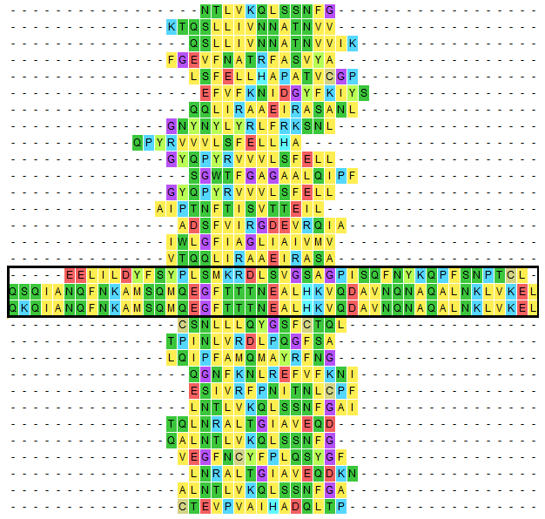
Figure S2. Predicted epitopes for major histocompatibility complex class-II (MHC-II) against the spike glycoprotein. Antiviral peptides (black frame) were mapped within predicted epitopes and presented respectively as Seq12, Seq12m, and Se13m (upwards to downwards).

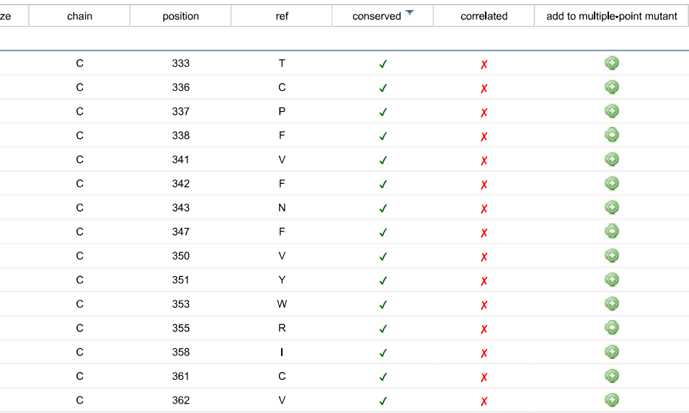

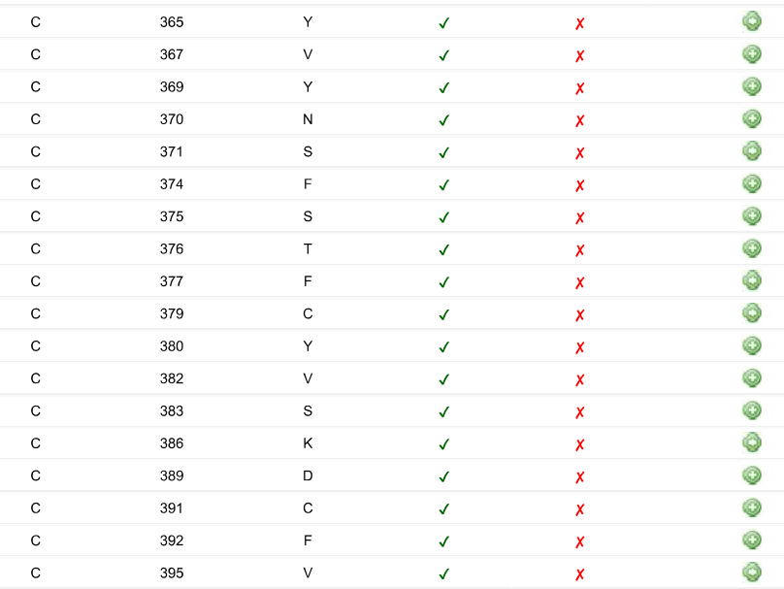
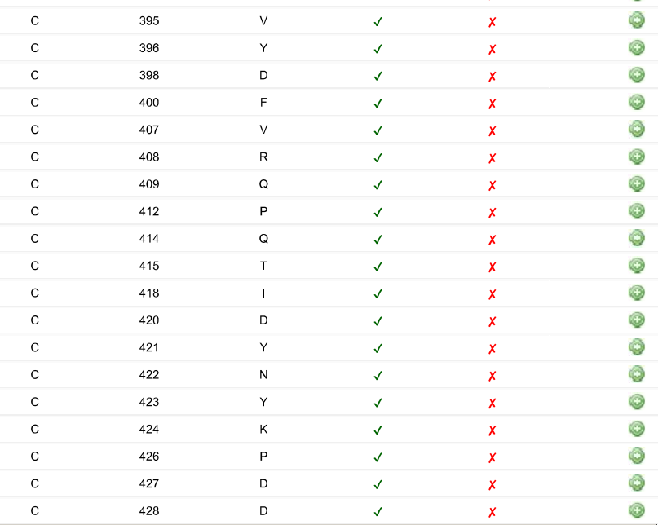
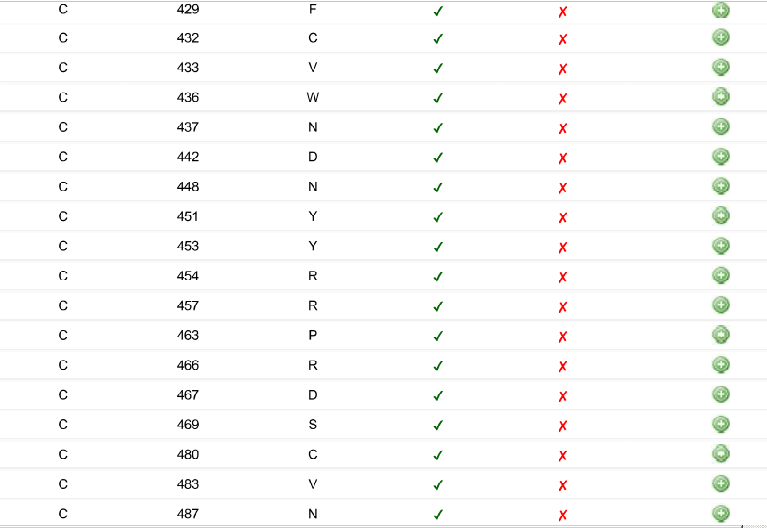
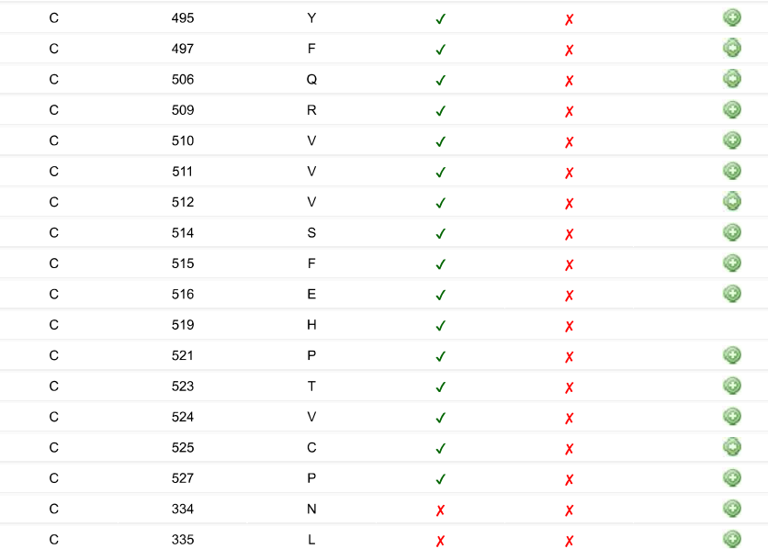
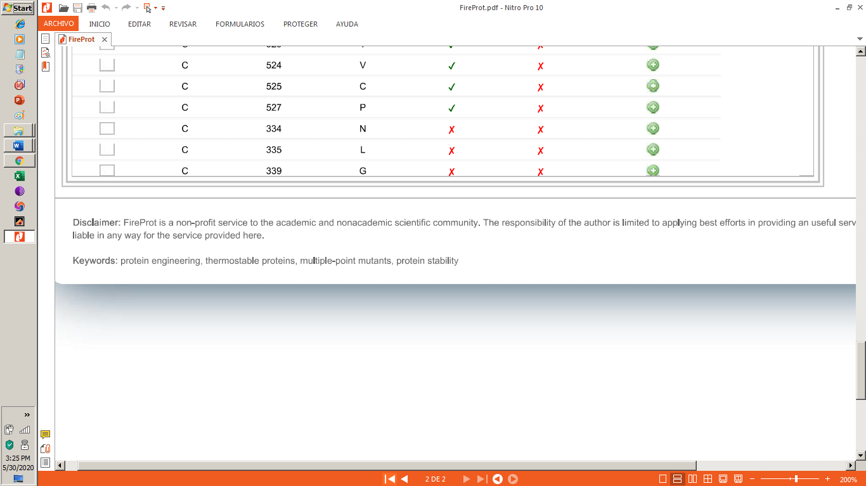

Figure S3. Mutation profile of the receptor binding domain of SARS-CoV-2

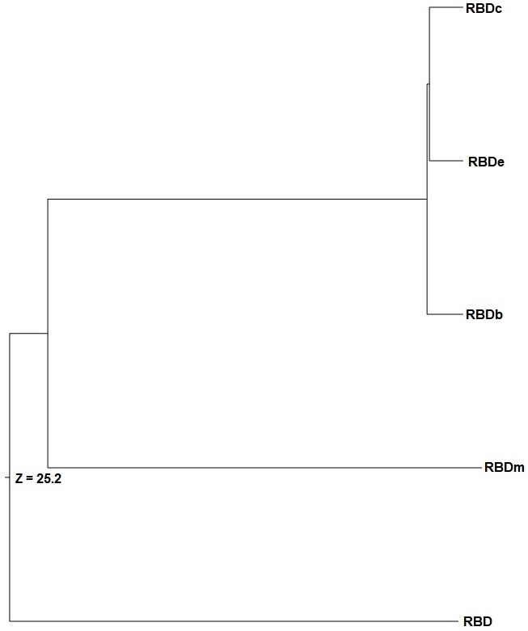

Figure S4. Structural similarity dendrogram. The dendrogram is derived by average linkage clustering of the structural similarities (based on Dali Z-scores).

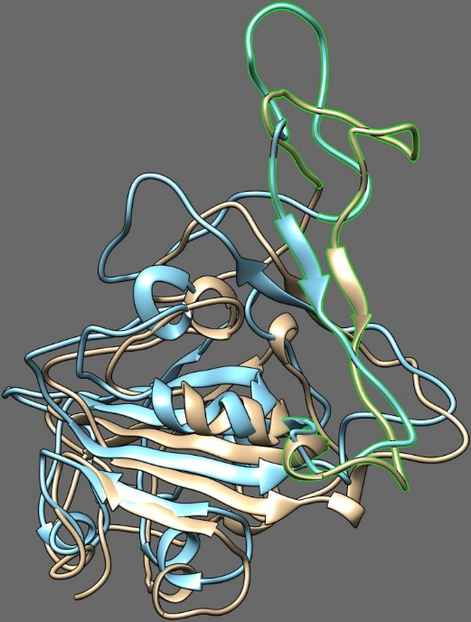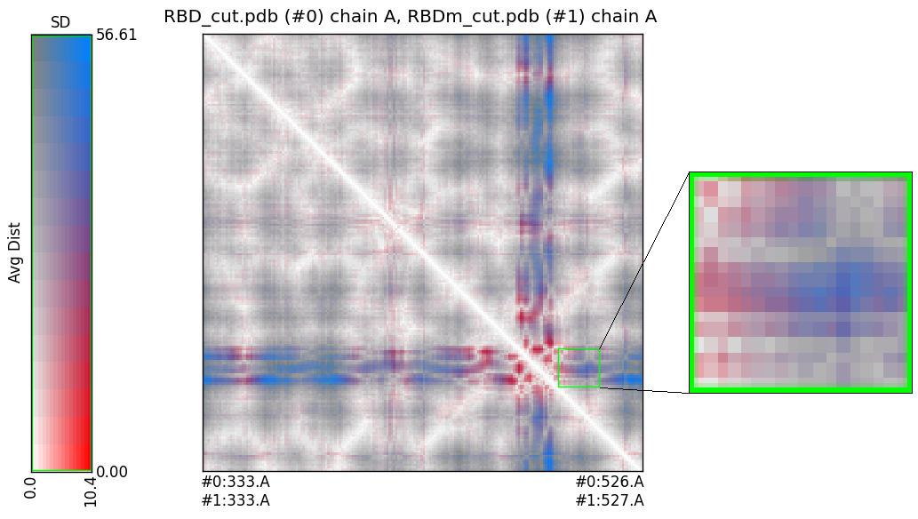
(b)
(a)
(c)
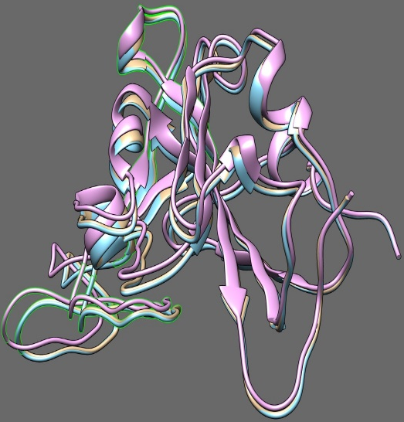
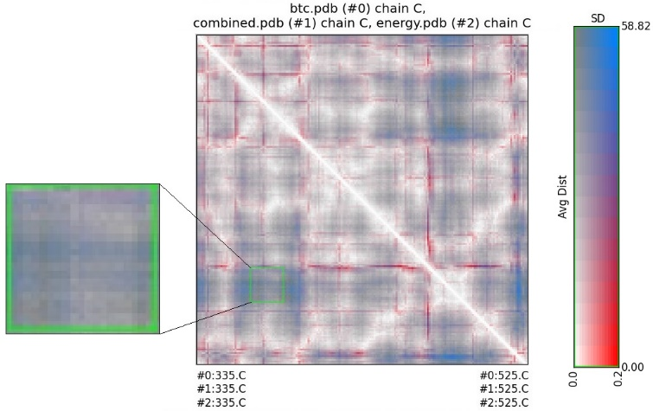
(d)

Figure S5. RRDis Map of different mutant models of the RBD of the SARS-CoV-2. (a) RBD and RBDm overlapping, (b) RRDis Map, (c) RBDb/c/e overlapping, (d) RRDis Map.

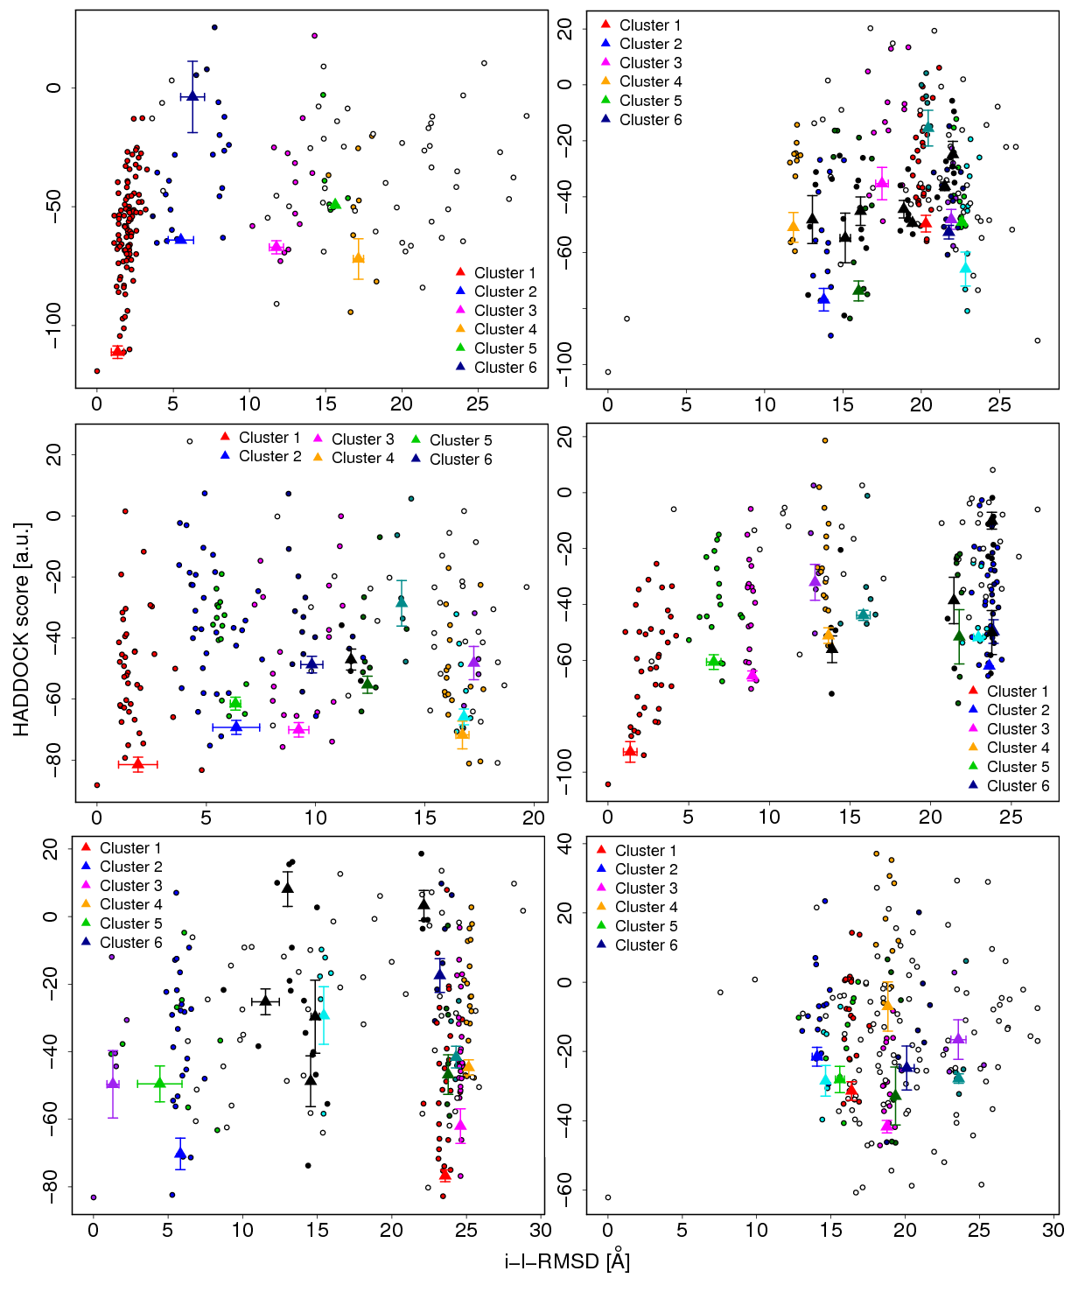
iii
ii
(b) i
iii
ii
(a) i
Figure S6. HADDOCK scores and the i-l-RMSD of the docked clusters. (a) HADDOCK clusters of antiviral peptides with the receptor-binding domain of the SARS-CoV-2, (i) Seq12 + RBD, (ii) Seq12m + RBD, (iii) Seq13m + RBD, (b) HADDOCK clusters with antiviral peptides with mutant receptor binding domain of the SARS-CoV-2, (i) Seq12 + RBDm, (ii) Seq12m + RBDm, (iii) Seq13m + RBDm. The results and graphics presented here are based on water-refined models generated by HADDOCK. The clusters (indicated in color in the graphs) are calculated based on the interface-ligand RMSDs calculated by HADDOCK, with the interface defined automatically based on all observed contacts. RMSD = Root mean square deviation, i-RMSD = Interface RMSD calculated on the backbone (CA, C, N, O, P) atoms of all residues involved in intermolecular contact using a 10 Å cutoff. l-RMSD = Ligand-RMSD calculated on the backbone atoms (CA, C, N, O, P) of all (N>1) molecules after fitting on the backbone atoms of the first (N = 1) molecule. a.u = arbitrary units

References

1. Ting, D.S.W., et al., Digital technology and COVID-19. Nature medicine, 2020. 26(4): p. 459-461.
2. Elmezayen, A.D., et al., Drug repurposing for coronavirus (COVID-19): in silico screening of known drugs against coronavirus 3CL hydrolase and protease enzymes. Journal of Biomolecular Structure and Dynamics, 2020(just-accepted): p. 1-12.
3. Dutta, K., et al., Beclabuvir can inhibit the RNA-dependent RNA polymerase of newly emerged novel coronavirus (SARS-CoV-2). 2020.
4. Khalifa, I., et al., Tannins inhibit SARS‐CoV‐2 through binding with catalytic dyad residues of 3CLpro: An in silico approach with 19 structural different hydrolysable tannins. Journal of food biochemistry, 2020. 44(10): p. e13432.
5. Prompetchara, E., C. Ketloy, and T. Palaga, Immune responses in COVID-19 and potential vaccines: Lessons learned from SARS and MERS epidemic. Asian Pac J Allergy Immunol, 2020. 38(1): p. 1-9.
6. Robson, B., COVID-19 Coronavirus spike protein analysis for synthetic vaccines, a peptidomimetic antagonist, and therapeutic drugs, and analysis of a proposed Achilles’ heel conserved region to minimize probability of escape mutations and drug resistance. Computers in Biology and Medicine, 2020: p. 103749.
7. Peeri, N.C., et al., The SARS, MERS and novel coronavirus (COVID-19) epidemics, the newest and biggest global health threats: what lessons have we learned? International journal of epidemiology, 2020.
8. Zhang, Y., I-TASSER server for protein 3D structure prediction. BMC bioinformatics, 2008. 9(1): p. 40.
9. Guex, N. and M.C. Peitsch, SWISS‐MODEL and the Swiss‐Pdb Viewer: an environment for comparative protein modeling. electrophoresis, 1997. 18(15): p. 2714-2723.
10. Laskowski, R.A., et al., PROCHECK: a program to check the stereochemical quality of protein structures. Journal of applied crystallography, 1993. 26(2): p. 283-291.
11. Bailey, T.L., et al., MEME SUITE: tools for motif discovery and searching. Nucleic acids research, 2009. 37(suppl_2): p. W202-W208.
12. Altschul, S.F., et al., Gapped BLAST and PSI-BLAST: a new generation of protein database search programs. Nucleic acids research, 1997. 25(17): p. 3389-3402.
13. Schaduangrat, N., et al., Meta-iAVP: A sequence-based meta-predictor for improving the prediction of antiviral peptides using effective feature representation. International journal of molecular sciences, 2019. 20(22): p. 5743.
14. Thakur, N., A. Qureshi, and M. Kumar, AVPpred: collection and prediction of highly effective antiviral peptides. Nucleic acids research, 2012. 40(W1): p. W199-W204.
15. Qureshi, A., H. Tandon, and M. Kumar, AVP‐IC50Pred: Multiple machine learning techniques‐based prediction of peptide antiviral activity in terms of half maximal inhibitory concentration (IC50). Peptide Science, 2015. 104(6): p. 753-763.
16. Lamiable, A., et al., PEP-FOLD3: faster de novo structure prediction for linear peptides in solution and in complex. Nucleic acids research, 2016. 44(W1): p. W449-W454.
17. Abraham, M.J., et al., GROMACS: High performance molecular simulations through multi-level parallelism from laptops to supercomputers. SoftwareX, 2015. 1: p. 19-25.
18. Lear, S. and S.L. Cobb, Pep-Calc. com: a set of web utilities for the calculation of peptide and peptoid properties and automatic mass spectral peak assignment. Journal of computer-aided molecular design, 2016. 30(3): p. 271-277.
19. Portal, E.B.R., ProtParam tool, 2011.
20. Saha, S. and G. Raghava, AlgPred: prediction of allergenic proteins and mapping of IgE epitopes. Nucleic acids research, 2006. 34(suppl_2): p. W202-W209.
21. Gupta, S., et al., In silico approach for predicting toxicity of peptides and proteins. PloS one, 2013. 8(9).
22. Win, T.S., et al., HemoPred: a web server for predicting the hemolytic activity of peptides. Future medicinal chemistry, 2017. 9(3): p. 275-291.
23. Yuan, M., et al., A highly conserved cryptic epitope in the receptor binding domains of SARS-CoV-2 and SARS-CoV. Science, 2020. 368(6491): p. 630-633.
24. Musil, M., et al., FireProt: web server for automated design of thermostable proteins. Nucleic acids research, 2017. 45(W1): p. W393-W399.
25. Holm, L., DALI and the persistence of protein shape. Protein Science, 2020. 29(1): p. 128-140.
26. Pettersen, E.F., et al., UCSF Chimera—a visualization system for exploratory research and analysis. Journal of computational chemistry, 2004. 25(13): p. 1605-1612.
27. Rodrigues, J.P., E. Karaca, and A.M. Bonvin, Information-driven structural modelling of protein–protein interactions, in Molecular modeling of proteins2015, Springer. p. 399-424.
28. Dutta, K., et al., Effects of secondary carbon supplement on biofilm-mediated biodegradation of naphthalene by mutated naphthalene 1, 2-dioxygenase encoded by Pseudomonas putida strain KD9. Journal of hazardous materials, 2018. 357: p. 187-197.
29. Kadirvel, P., et al., Molecular Dynamics Simulation Study of Plasmodium falciparum and Escherichia coli SufA: Exploration of Conformational Changes Possibly Involved in Iron-Sulfur Cluster Transfer. Journal of Biomolecular Structure and Dynamics, 2020(just-accepted): p. 1-16.
30. Dutta, K., et al., Paradoxical Bactericidal Effects of Hydrophobic Lung Surfactant Proteins and Their Peptide Mimics Using Liposome Molecular Trojan. Journal of oleo science, 2018: p. ess18026.
31. Liu, H. and T. Hou, CaFE: a tool for binding affinity prediction using end-point free energy methods. Bioinformatics, 2016. 32(14): p. 2216-2218.
32. Case, D., et al., AMBER 2016 (University of California). San Francisco, 2016.
33. Essmann, U., et al., A smooth particle mesh Ewald method. The Journal of chemical physics, 1995. 103(19): p. 8577-8593.
34. Miyamoto, S. and P.A. Kollman, Settle: An analytical version of the SHAKE and RATTLE algorithm for rigid water models. Journal of computational chemistry, 1992. 13(8): p. 952-962.
35. Weng, G., et al., HawkDock: a web server to predict and analyze the protein–protein complex based on computational docking and MM/GBSA. Nucleic acids research, 2019. 47(W1): p. W322-W330.
36. Vita, R., et al., The immune epitope database (IEDB) 3.0. Nucleic acids research, 2015. 43(D1): p. D405-D412.
37. Larsen, M.V., et al., Large-scale validation of methods for cytotoxic T-lymphocyte epitope prediction. BMC bioinformatics, 2007. 8(1): p. 424.
38. Deeks, J.J., et al., Diagnosis of SARS‐CoV‐2 infection and COVID‐19: accuracy of signs and symptoms; molecular, antigen, and antibody tests; and routine laboratory markers. Cochrane Database of Systematic Reviews, 2020(4).
39. Klompas, M., M.A. Baker, and C. Rhee, Airborne transmission of SARS-CoV-2: theoretical considerations and available evidence. Jama, 2020.
40. Pan, H., et al., Repurposed antiviral drugs for COVID-19; interim WHO SOLIDARITY trial results. MedRxiv, 2020.
41. Kodali, P.B., et al., How Indians responded to the Arogya Setu app? Indian Journal of Public Health, 2020. 64(6): p. 228.
42. Azhar, M., et al., Rapid, field-deployable nucleobase detection and identification using FnCas9. bioRxiv, 2020.
43. Dutta, K., et al., Beclabuvir can inhibit the RNA-dependent RNA polymerase of newly emerged novel coronavirus (SARS-CoV-2). 2020.
44. Mahase, E., Covid-19: Moderna vaccine is nearly 95% effective, trial involving high risk and elderly people shows. BMJ: British Medical Journal (Online), 2020. 371.
45. Graham, S.P., et al., Evaluation of the immunogenicity of prime-boost vaccination with the replication-deficient viral vectored COVID-19 vaccine candidate ChAdOx1 nCoV-19. NPJ vaccines, 2020. 5(1): p. 1-6.
46. Amanat, F. and F. Krammer, SARS-CoV-2 vaccines: status report. Immunity, 2020.
47. Boas, L.C.P.V., et al., Antiviral peptides as promising therapeutic drugs. Cellular and Molecular Life Sciences, 2019. 76(18): p. 3525-3542.
48. Mahendran, A.S.K., et al., The Potential of Antiviral Peptides as COVID-19 Therapeutics. Frontiers in pharmacology, 2020. 11: p. 1475.
49. Pant, S., et al., Peptide-like and small-molecule inhibitors against Covid-19. Journal of Biomolecular Structure and Dynamics, 2020(just-accepted): p. 1-15.
50. Du, L., et al., MERS-CoV spike protein: a key target for antivirals. Expert opinion on therapeutic targets, 2017. 21(2): p. 131-143.
51. Zhao, H., et al., A novel peptide with potent and broad-spectrum antiviral activities against multiple respiratory viruses. Scientific reports, 2016. 6: p. 22008.
52. Tourdot, S., et al., Chimeric peptides: a new approach to enhancing the immunogenicity of peptides with low MHC class I affinity: application in antiviral vaccination. The Journal of Immunology, 1997. 159(5): p. 2391-2398.
53. Mahlapuu, M., C. Björn, and J. Ekblom, Antimicrobial peptides as therapeutic agents: opportunities and challenges. Critical reviews in biotechnology, 2020. 40(7): p. 978-992.
54. Manavalan, B., et al., AIPpred: sequence-based prediction of anti-inflammatory peptides using random forest. Frontiers in pharmacology, 2018. 9: p. 276.
55. Karoyan, P., et al., hACE2 peptide mimics block SARS-CoV-2 Pulmonary Cells Infection. bioRxiv, 2020.
56. Beddingfield, B.J., et al., The integrin binding peptide, ATN-161, as a novel therapy for SARS-CoV-2 infection. JACC: Basic to Translational Science, 2020.
57. Bestle, D., et al., TMPRSS2 and furin are both essential for proteolytic activation of SARS-CoV-2 in human airway cells. Life science alliance, 2020. 3(9).
58. Zhang, G., et al., Investigation of ACE2 N-terminal fragments binding to SARS-CoV-2 Spike RBD. bioRxiv, 2020.
59. Zhao, H., et al., A broad-spectrum virus-and host-targeting peptide against respiratory viruses including influenza virus and SARS-CoV-2. Nature communications, 2020. 11(1): p. 1-10.
60. Hoffmann, M., H. Kleine-Weber, and S. Pöhlmann, A multibasic cleavage site in the spike protein of SARS-CoV-2 is essential for infection of human lung cells. Molecular Cell, 2020.
61. Xia, S., et al., A pan-coronavirus fusion inhibitor targeting the HR1 domain of human coronavirus spike. Science advances, 2019. 5(4): p. eaav4580.
62. Xia, S., et al., Inhibition of SARS-CoV-2 (previously 2019-nCoV) infection by a highly potent pan-coronavirus fusion inhibitor targeting its spike protein that harbors a high capacity to mediate membrane fusion. Cell research, 2020. 30(4): p. 343-355.
63. Zhu, Y., et al., Design of potent membrane fusion inhibitors against SARS-CoV-2, an emerging coronavirus with high fusogenic activity. Journal of Virology, 2020.
64. Ling, R., et al., In silico design of antiviral peptides targeting the spike protein of SARS-CoV-2. Peptides, 2020. 130: p. 170328.
65. Forster, P., et al., Phylogenetic network analysis of SARS-CoV-2 genomes. Proceedings of the National Academy of Sciences, 2020. 117(17): p. 9241-9243.
66. Steven, A.C., et al., The making and breaking of symmetry in virus capsid assembly: glimpses of capsid biology from cryoelectron microscopy. The FASEB journal, 1997. 11(10): p. 733-742.
67. Yan, R., et al., Structural basis for the recognition of SARS-CoV-2 by full-length human ACE2. Science, 2020. 367(6485): p. 1444-1448.
68. Lan, J., et al., Structure of the SARS-CoV-2 spike receptor-binding domain bound to the ACE2 receptor. Nature, 2020: p. 1-6.
69. Abdullahi, I.N., et al., Implications of SARS-CoV-2 genetic diversity and mutations on pathogenicity of COVID-19 and biomedical interventions. Journal of Taibah University Medical Sciences, 2020.
70. Luan, J., et al., Spike protein recognition of mammalian ACE2 predicts the host range and an optimized ACE2 for SARS-CoV-2 infection. Biochemical and biophysical research communications, 2020.
71. Bianchi, M., et al., Sars-CoV-2 Envelope and Membrane proteins: differences from closely related proteins linked to cross-species transmission? Preprints, 2020.
72. Islam, R., et al., A molecular modeling approach to identify effective antiviral phytochemicals against the main protease of SARS-CoV-2. Journal of Biomolecular Structure and Dynamics, 2020(just-accepted): p. 1-20.
73. Martínez, L., Automatic identification of mobile and rigid substructures in molecular dynamics simulations and fractional structural fluctuation analysis. PloS one, 2015. 10(3): p. e0119264.

