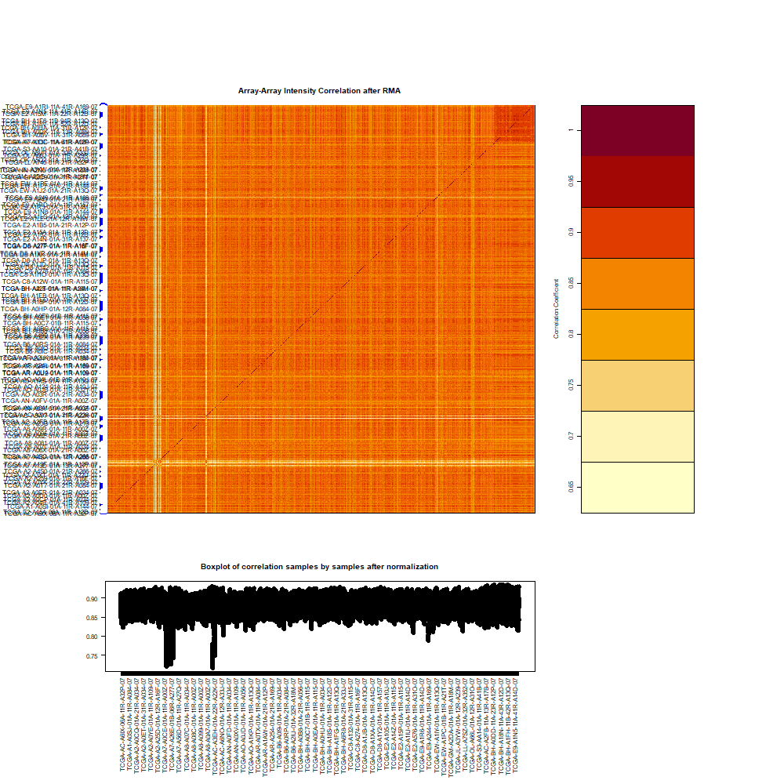

Supplementary Figure 1.The array-array intensity correlation (AAIC) matrix calculates the Spearman rank correlation coefficients between all pairs of TCGA samples, providing a quantitative measure of similarity among the gene expression profiles.

