Supplementary methods

2.2. Synthesis of pH-responsive PLGA coated core-shell magnetic silica nanoparticles
In brief, iron oxide nanoparticles (Fe₃O₄) were prepared by co-precipitation of iron (II) and iron (III) chloride salts under N2 atmosphere using 2M NaOH [20]. Initially, the iron salts were dissolved in the 50 ml of water in the molar ratio of 2:1, then NaOH was added slowly and the reaction temperature was raised to 70°C. After 3h, the reaction was cooled down and the Fe₃O₄ was collected with the help of magnet and vacuum dried.
In the second step, core-shell magnetic-silica nanoparticles were prepared by modified sol-gel homogenous co-precipitation process [21]. Fe₃O₄ NPs were dispersed in a mixture of ethanol and water (80:20). Tetra ethyl ortho silicate (TEOS), 0.1 ml (0.1% w/v) was added to the magnetic nanoparticles and stirred for 10 min at room temperature. Then, 2M NaOH (1 ml) was added slowly and reaction mixture was stirred for 6 h at room temperature. The core-shell magnetic-silica nanoparticles (Fe₃O₄-SiO₂ NPs) were separated using an external magnet, washed with deoxygenated distilled water and vacuum dried. To achieve amine functionalization, Fe₃O₄-SiO₂ NPs were dispersed in pure ethanol and 2 mmol, 3-aminopropyl triethoxysilane (APTES) was added to it, refluxed at 70°C, washed with ethanol two-three times and vacuum dried.
In the third step, PLGA coated Fe₃O₄-SiO₂ nanoparticles were prepared by double emulsion solvent evaporation method [22]. Poly lactic co-glycolic acid (PLGA) was dissolved in dichloromethane (DCM). Fe₃O₄-SiO₂ NPs were dispersed in 0.5 ml of 1% PVA solution and added to PLGA solution with probe sonication (30% amplitude, 20 duty cycles, 2 min) to form primary emulsion (W₁/O). The ratio of Fe₃O₄-SiO₂ nanoparticles to PLGA was optimized as 1:1. Thus formed primary emulsion was then added to 12 ml of 2% PVA solution with sonication (30% amplitude, 20 duty cycles, 3 min) to form double emulsion (W₁/O/W₂) and continuously stirred for 6 h to evaporate DCM. After 6 h, PLGA coated nanoparticles were collected using external magnet, washed and dried.
In the fourth step, in order to fabricate pH sensitive release system, PLGA coated Fe₃O₄-SiO₂ nanoparticles (100 mg) were dispersed in 10 ml of dopamine hydrochloride solution in Tris-HCl buffer (10 mmol/L, pH 8.5) and continuous stirred for 6 h at room temperature. After 6 h, poly dopamine (PDA) capped PLGA-Fe₃O₄-SiO₂ nanoparticles (Blank nanocarrier) were separated with magnet, washed with water, lyophilized and stored for further use.

Supplementary Figure 1
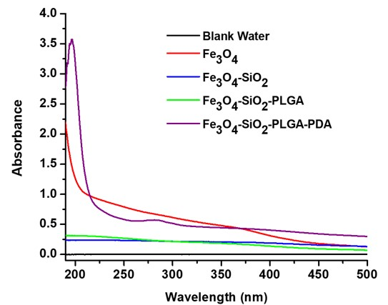
Figure S1: Changes in UV spectra of Fe₃O₄ NPs following coating with silica, PLGA and PDA.
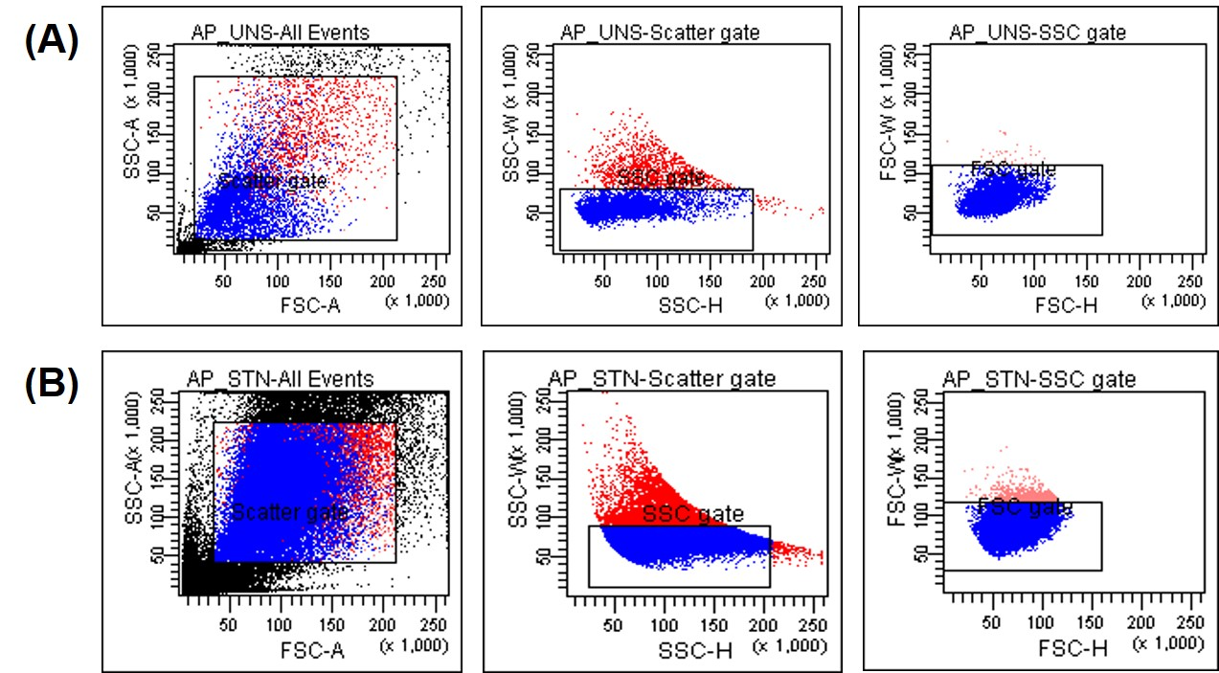
Figure S2: FSC and SSC plot of (A) unstained and (B) stained healthy cells.

