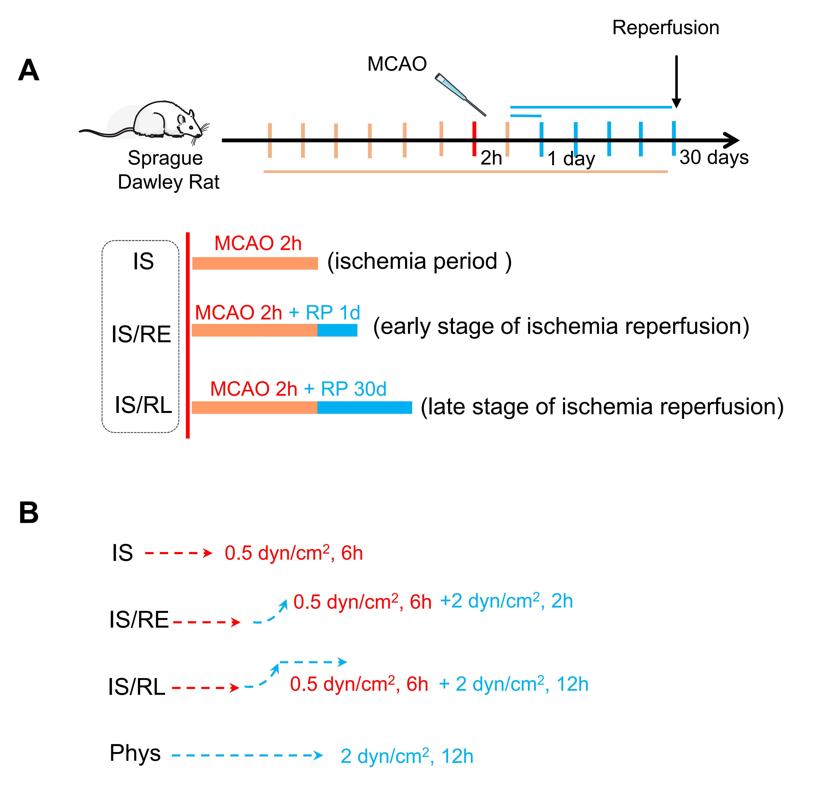
Supplementary Information
Figure S1 In vivo and in vitro experimental groups. (A) Schematic diagram of ischemia-reperfusion duration of MCAO model. MCAO 2h (middle cerebral artery occlusion for 2h, ischemia group, IS), RP 1d (reperfusion for 1d, early stage of ischemia-reperfusion group, IS/RE), RP 30d (reperfusion 30 for days, late stage of ischemia-reperfusion group, IS/RL). (B) Schematic diagram of in vitro cell experimental groups. The rBMECs were exposed to LFSS of 0.5 dyn/cm2 (ischemia period, IS groups) for 6h and subsequently recovered to the normal physiological level of 2 dyn/cm2 for 2h (early stage of ischemia-reperfusion, IS/RE groups) and 12h (late stage of ischemia-reperfusion, IS/RL groups), respectively
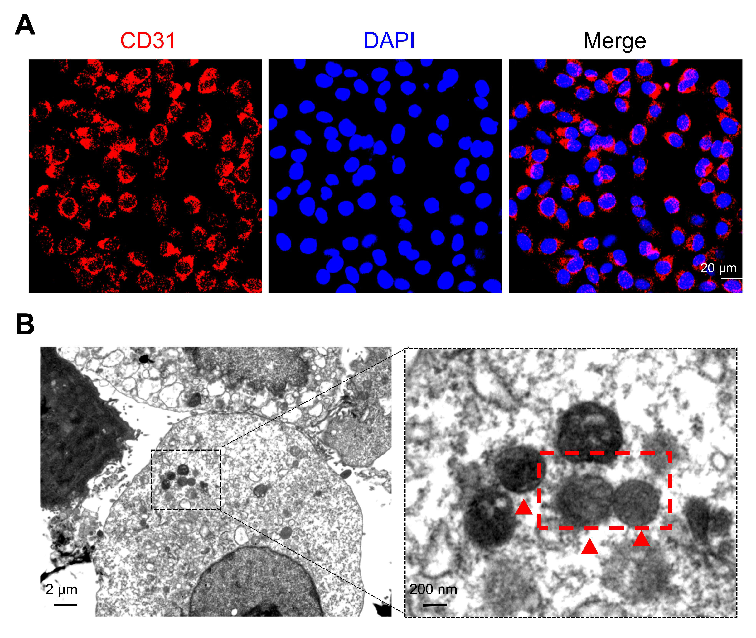
Figure S2 Identification of rBMECs. (A) The typical immunofluorescent image indicated positive expression of CD31 in rBMECs. (red: CD31; blue: nucleus), scale bar = 20 μm. (B) TEM image showed Weibel-Palade body (W-P body), a special organelle in endothelial cells, scale bar = 2 μm. The designated regions indicated by blank square frames are enlarged to show the detail structure of W-P body, scale bar = 200 nm.
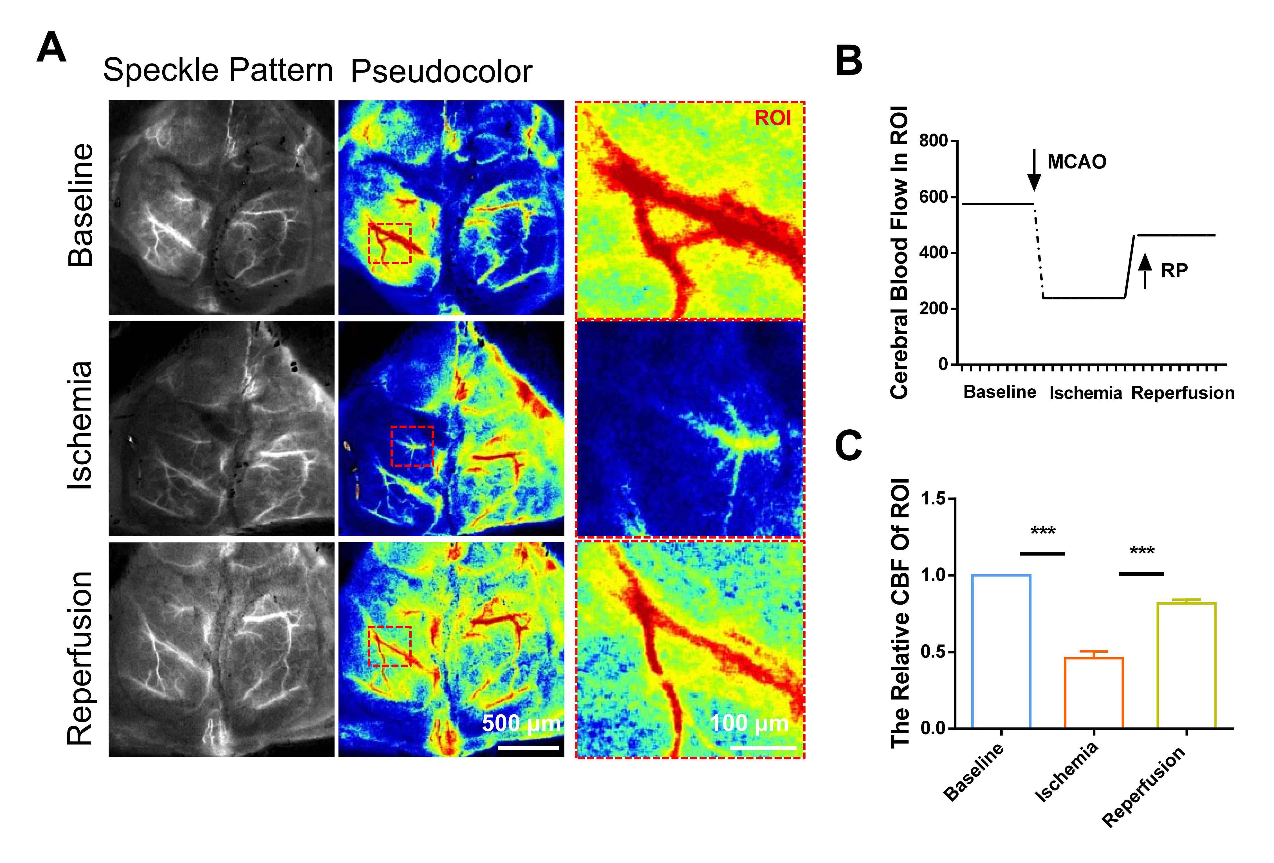
Figure S3 The laser speckle images and analyses. (A) Representative laser speckle. images before surgery (baseline), during ischemia for 2h, and reperfusion for 10 min, scale bar = =500μm. Designated Region of Interest (ROI) indicated by square frames were enlarged to show the details, the scale bar = 100 μm. (B) The CBF of the ROI area was calculated according to laser speckle images, RP means reperfusion. (C) CBF index =current CBF/baseline CBF. *** P<0.001, n=3
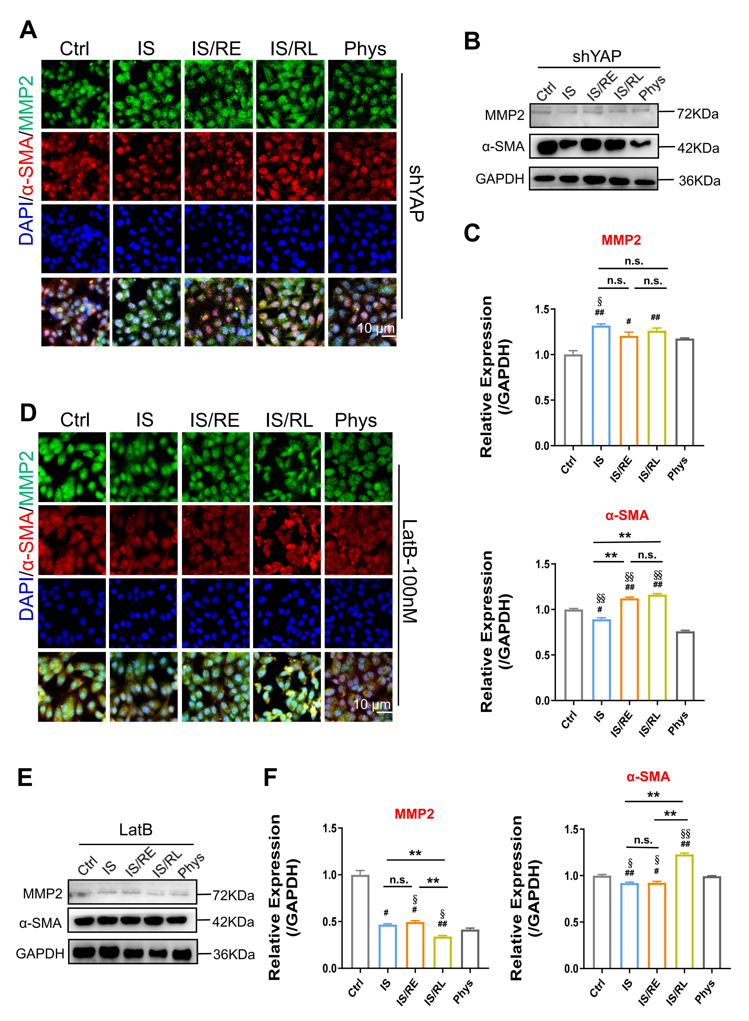
Figure S4 The expressions of mesenchymal marker MMP2 and α-SMA. The location of mesenchymal marker MMP2 (Green) and α-SMA (Red) in shYAP rBMECs (A) or treated with LatB (D). The expression of mesenchymal marker MMP2 and α-SMA in shYAP rBMECs (B) or treated with LatB (E) exposed to various FSS. Quantification of MMP2 and α-SMA expression level in shYAP rBMECs (C) or treated with LatB (F) based on image analysis of the Western blot bands. *, indicates group comparisons between the IS, IS/RE and IS/RL groups. #, indicates IS group, IS/RE group and IS/RL group respectively compared to Ctrl group. §, indicates IS group, IS/RE group and IS/RL group compared to Phys group, respectively. *, #, and § indicate P<0.05 denoted the statistical differences are significant; **, ## and §§ indicate P<0.01 denoted the statistical differences are high significance. Data were shown as means ± SD based on three different experiments (n = 3).

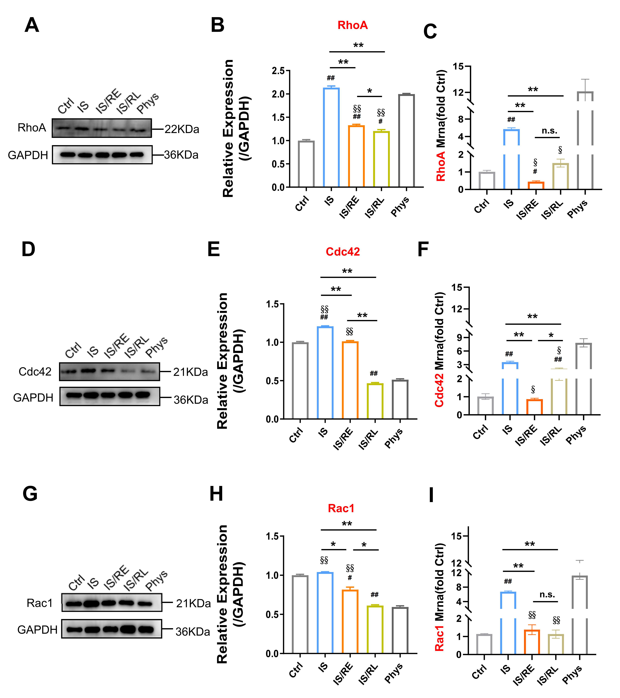
Figure S5 The expression of Rho GTPases in rBMECs exposed to FSS. (A) The protein and mRNA expression of RhoA (A), Cdc42 (B) and Rac 1 (C) in rBMECs exposed to FSS. Quantifification of RhoA (B), Cdc42 (E) and Rac 1 (H) expression level based on image analysis of the Western blot bands. Quantifification of RhoA (C), Cdc42 (F) and Rac 1 (I) mRNA level by qPCR.*, indicates group comparisons between the IS, IS/RE and IS/RL groups. #, indicates IS group, IS/RE group and IS/RL group respectively compared to Ctrl group. §, indicates IS group, IS/RE group and IS/RL group compared to Phys group, respectively. *, #, and § indicate P<0.05 denoted the statistical differences are significant; **, ## and §§ indicate P<0.01 denoted the statistical differences are high significance. Data were shown as means ± SD based on three different experiments (n = 3).

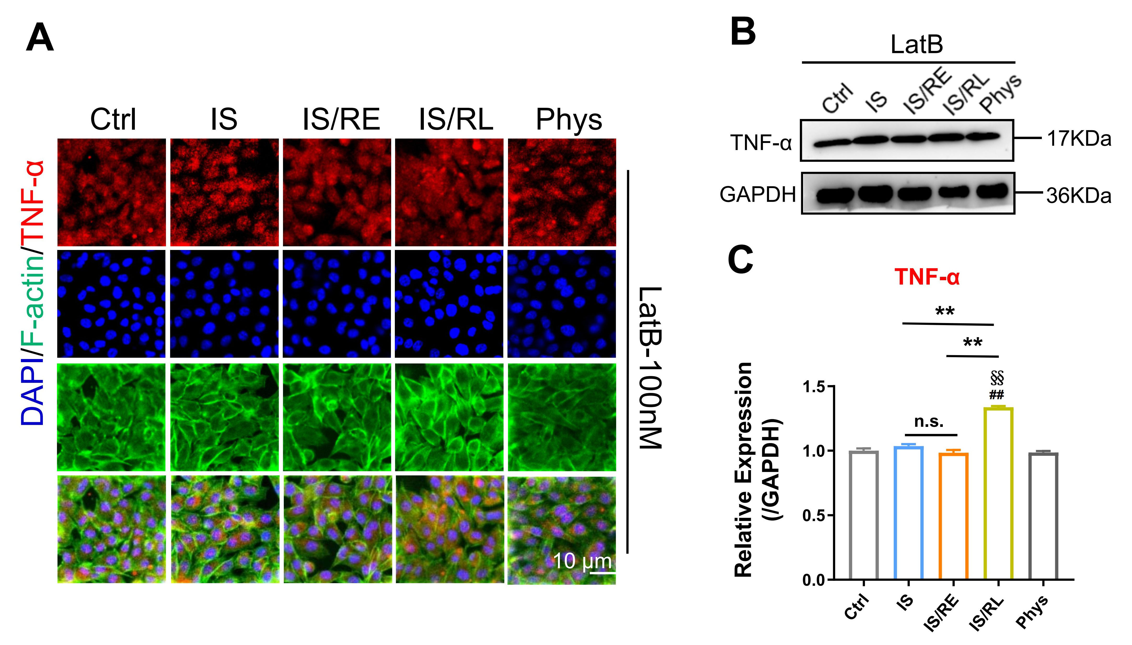
Figure S6 The distribution and expression of endogenic TNF-α in endothelial cells exposed to FSS. (A) The typical Confocal images of double immunofluorescence staining with TNF-α (Red) and F-actin (green) in rBMECs after LatB treatment in IS, IS/RE and IS/RL. Nuclei were labeled with DAPI (blue). The images captured by confocal microscopes (Scale bar: 10 mm). The images captured by confocal microscopes (Scale bar: 10 mm). （B）Western blotting analysis of TNF-α in rBMECs after LatB treatment in IS, IS/RE and IS/RL. (C) Quantification of TNF-α expression level by image analysis of the Western blot bands. *, indicates group comparisons between the IS, IS/RE, and IS/RL groups. #, indicates IS group, IS/RE group, and IS/RL group respectively compared to the Ctrl group. §, indicates IS group, IS/RE group, and IS/RL group compared to the Phys group, respectively. *, #, and § indicate P<0.05 denoted the statistical differences are significant; **, ## and §§ indicate P<0.01 denoted the statistical differences are high significance. Data were shown as means ± SD based on three different experiments (n = 3).

