 | Power PROTM XT | Matsunaga GT-06T | Exchange model 4070 | Scud Mate
 | 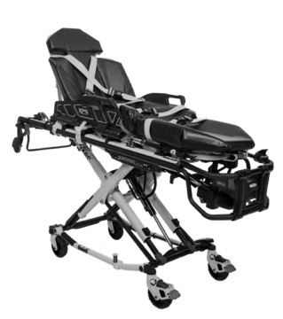 | 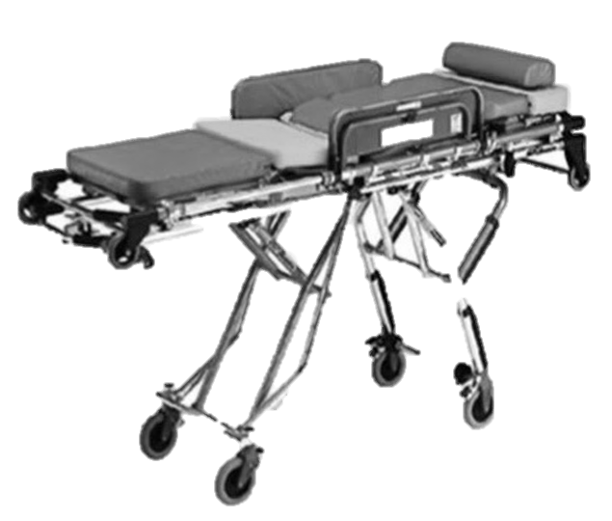 | 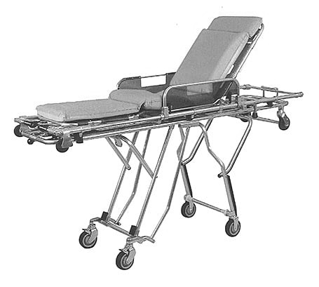 | 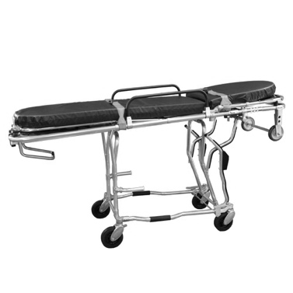
Maximum load | 318 kg | Undescribed | 159 kg | 181 kg
Highest position | 1,050 mm | Undescribed | 960 mm | 935 mm
Lowest position | 360 mm | Undescribed | 250 mm | 345 mm
Length | Standard: 2,060 mm | Fix | Fix | Standard: 1,960 mm
 | Minimum: 1,600 mm | 2,100 mm | 1,970 mm | Minimum: 1,760 mm
Width | 580 mm | 600 mm | 560 mm | 560 mm
Weight | 57 kg | 24.3 kg | 29 kg | 42.7 kg
Verified by | Group A, B, C  (n = 41) | Group A  (n = 15) | Group C  (n = 10) | Group B  (n = 16)
Supplementary Table 1. Characteristics of four types of stretchers

