Supplementary data
Byonic software PSMs coverage of AmelX and AmelY. Note, this data is before applying any data filter, as described in the methods section. For more information, see excel raw data files.
Male Modern

Male Modern AmelX
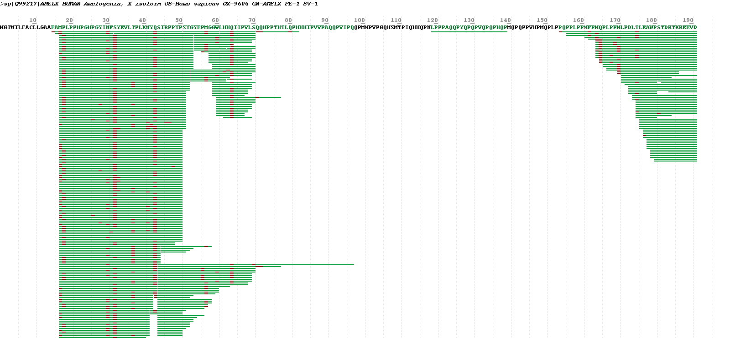

Male Modern AmelY
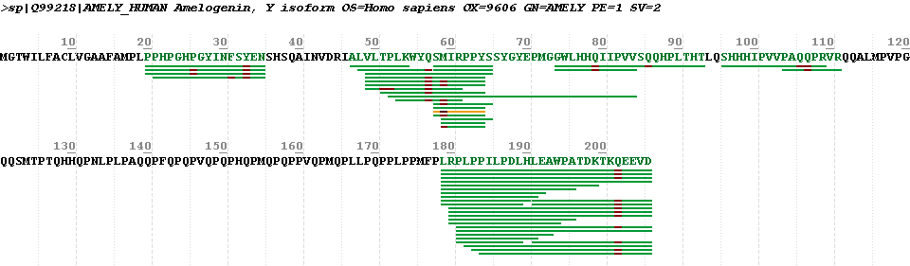

- Female Modern

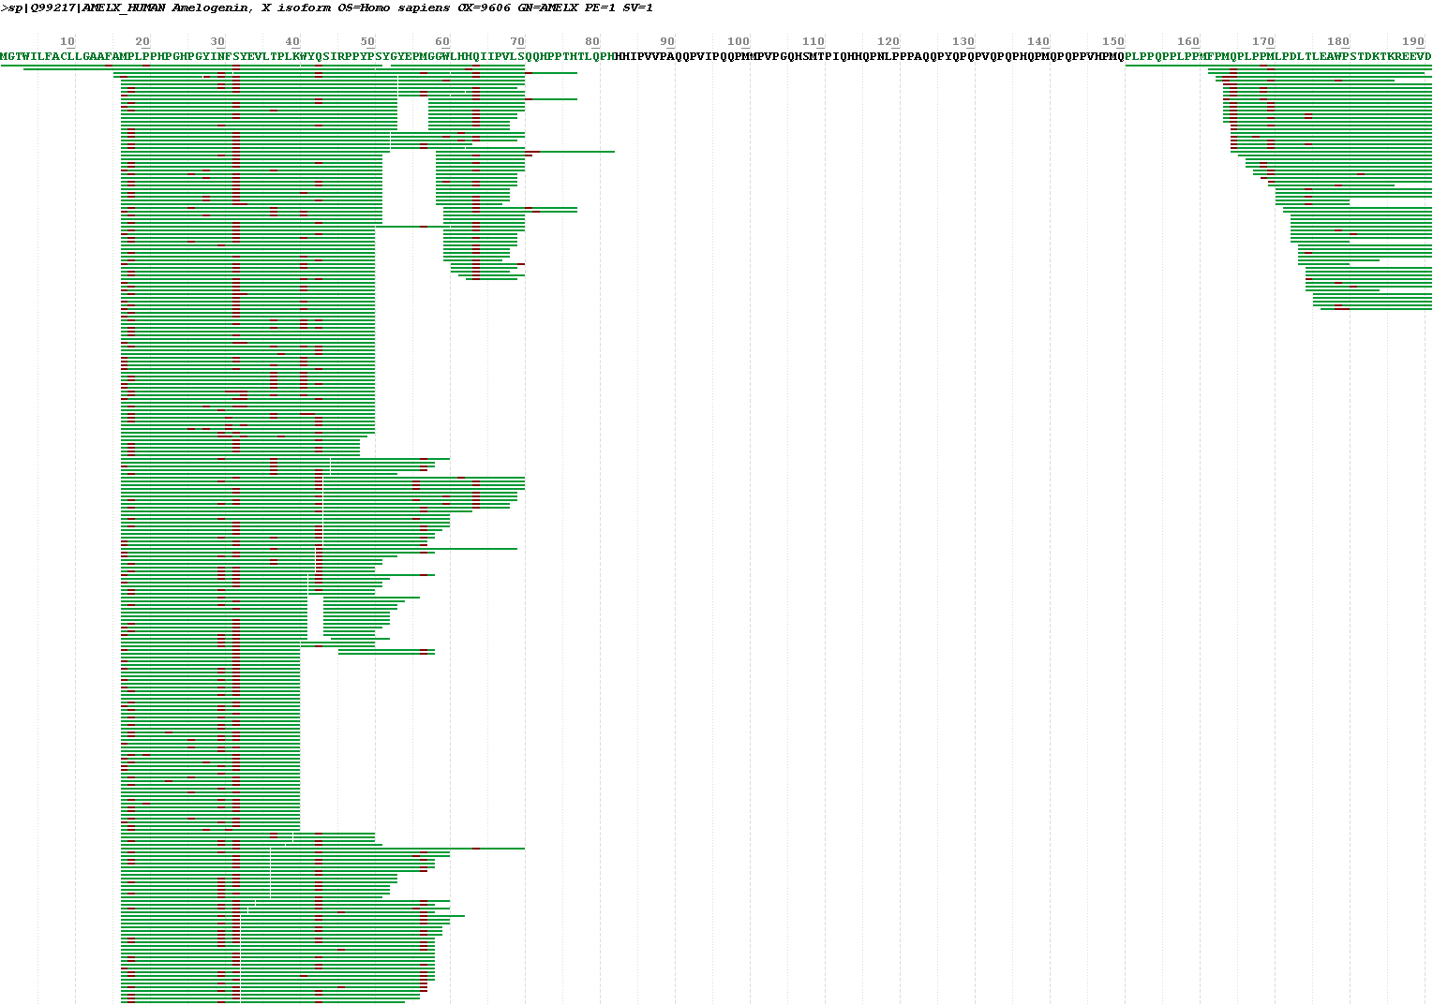
Female Modern AmelX

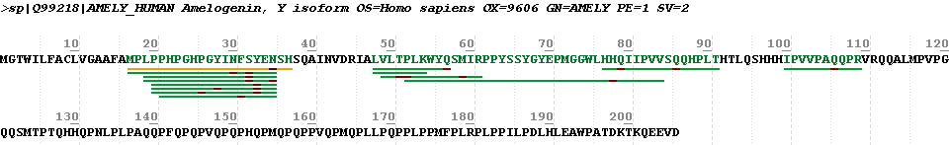
Female Modern AmelY
- Archaeology Sample
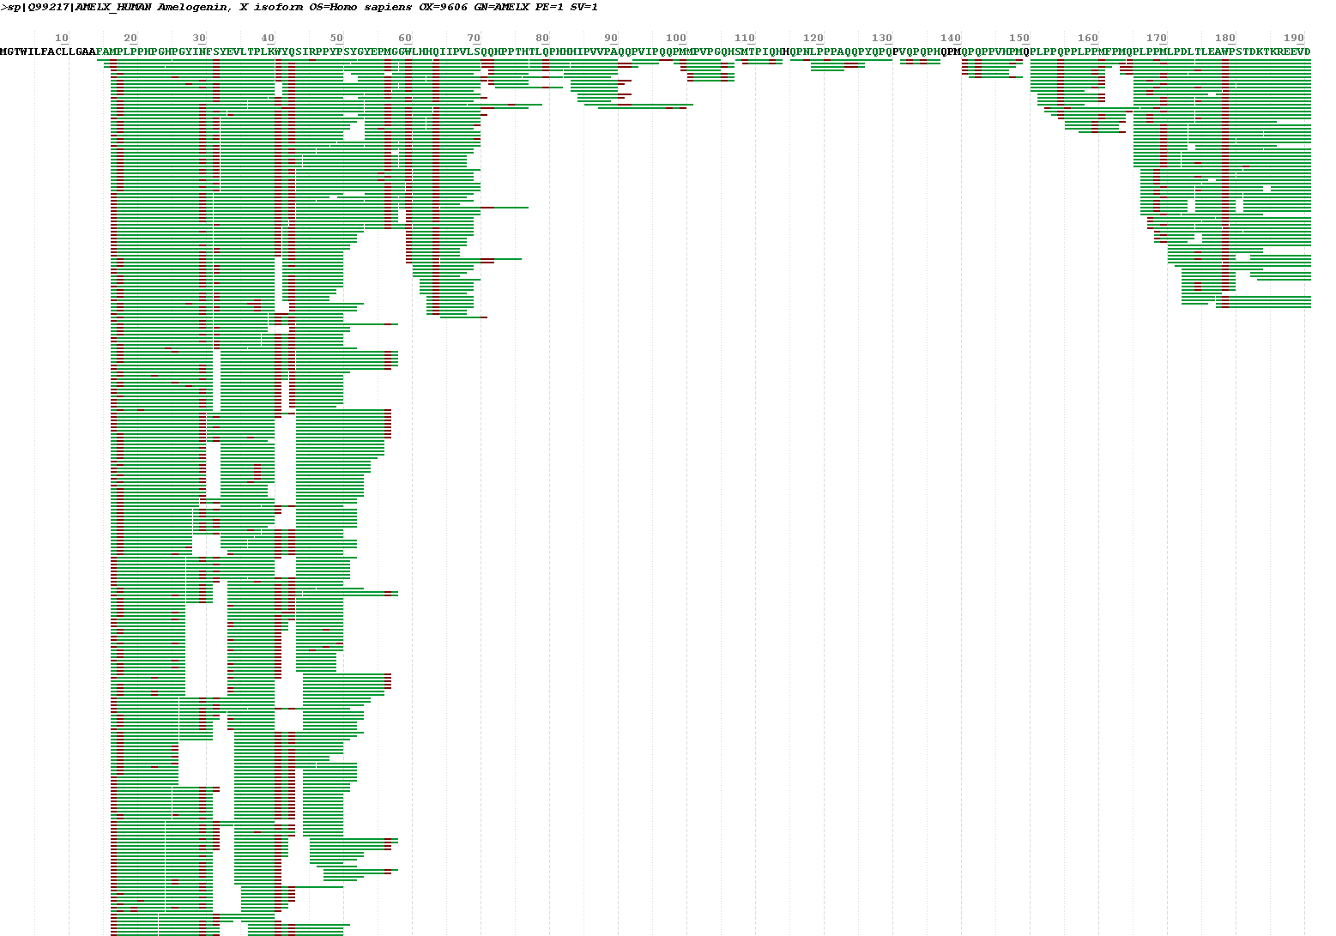
Archaeological Sample AmelX

Archaeological Sample AmelY
