Appendix A
Table A.1: Table for Comparative Assessment Of methane emission (Gg/year) for All Models and Simulations Data (2000-2036)
Year | Waste acceptance rate (Mg/year) | ZODM | FODM | MTM | SP | CAAC | CAAA | IC | IA | IW | Winter | Pre-monsoon | Monsoon | Post-Monsoon
2000 | 62129.8 | 2.53 | 0.00 | 0.00 | 0.00 | 0.00 | 0.00 | 0.00 | 0.00 | 0.00 | 0.00 | 0.00 | 0.00 | 0.00
2001 | 63545.8 | 2.58 | 0.55 | 0.07 | 0.18 | 0.34 | 0.14 | 0.16 | 0.08 | 2.07 | 0.04 | 0.11 | 0.38 | 0.13
2002 | 64961.8 | 2.64 | 1.01 | 0.20 | 0.35 | 0.68 | 0.28 | 0.32 | 0.16 | 3.15 | 0.08 | 0.22 | 0.73 | 0.25
2003 | 66377.8 | 2.70 | 1.40 | 0.41 | 0.52 | 1.01 | 0.42 | 0.48 | 0.25 | 3.73 | 0.12 | 0.33 | 1.04 | 0.38
2004 | 67793.8 | 2.76 | 1.73 | 0.69 | 0.68 | 1.33 | 0.56 | 0.64 | 0.33 | 4.07 | 0.16 | 0.44 | 1.31 | 0.50
2005 | 69209.8 | 2.81 | 2.01 | 1.04 | 0.83 | 1.64 | 0.70 | 0.79 | 0.41 | 4.28 | 0.20 | 0.54 | 1.56 | 0.62
2006 | 70625.8 | 2.87 | 2.25 | 1.37 | 0.98 | 1.94 | 0.84 | 0.94 | 0.50 | 4.44 | 0.24 | 0.64 | 1.79 | 0.73
2007 | 72041.8 | 2.93 | 2.47 | 1.67 | 1.12 | 2.24 | 0.99 | 1.09 | 0.58 | 4.56 | 0.28 | 0.74 | 1.99 | 0.85
2008 | 73457.8 | 2.99 | 2.65 | 1.94 | 1.26 | 2.53 | 1.13 | 1.23 | 0.66 | 4.67 | 0.32 | 0.84 | 2.18 | 0.96
2009 | 74873.8 | 3.05 | 2.82 | 2.18 | 1.39 | 2.81 | 1.27 | 1.38 | 0.75 | 4.77 | 0.36 | 0.94 | 2.35 | 1.07
2010 | 76289.8 | 3.10 | 2.97 | 2.40 | 1.52 | 3.09 | 1.41 | 1.52 | 0.83 | 4.87 | 0.40 | 1.03 | 2.51 | 1.18
2011 | 77705.8 | 3.16 | 3.10 | 2.58 | 1.65 | 3.36 | 1.56 | 1.66 | 0.92 | 4.96 | 0.44 | 1.12 | 2.66 | 1.28
2012 | 79121.8 | 3.22 | 3.22 | 2.74 | 1.77 | 3.63 | 1.70 | 1.80 | 1.00 | 5.06 | 0.48 | 1.21 | 2.80 | 1.39
2013 | 80537.8 | 3.28 | 3.33 | 2.86 | 1.88 | 3.89 | 1.85 | 1.94 | 1.09 | 5.15 | 0.52 | 1.30 | 2.92 | 1.49
2014 | 92163.7 | 3.75 | 3.44 | 2.95 | 2.00 | 4.15 | 1.99 | 2.07 | 1.17 | 5.25 | 0.56 | 1.39 | 3.04 | 1.59
2015 | 104354.2 | 4.24 | 3.62 | 3.02 | 2.14 | 4.46 | 2.16 | 2.23 | 1.27 | 5.68 | 0.61 | 1.50 | 3.22 | 1.71
2016 | 124951.0 | 5.08 | 3.89 | 3.11 | 2.30 | 4.82 | 2.35 | 2.42 | 1.38 | 6.31 | 0.67 | 1.62 | 3.45 | 1.85
2017 | 140553.2 | 5.72 | 4.28 | 3.24 | 2.52 | 5.28 | 2.58 | 2.65 | 1.52 | 7.30 | 0.73 | 1.78 | 3.78 | 2.03
2018 | 159065.6 | 6.47 | 4.74 | 3.44 | 2.77 | 5.80 | 2.85 | 2.91 | 1.68 | 8.32 | 0.81 | 1.95 | 4.16 | 2.23
2019 | 164288.7 | 6.68 | 5.28 | 3.71 | 3.05 | 6.40 | 3.15 | 3.22 | 1.85 | 9.44 | 0.90 | 2.15 | 4.60 | 2.47
2020 | 167929.1 | 6.83 | 5.77 | 4.05 | 3.33 | 7.00 | 3.46 | 3.52 | 2.03 | 10.17 | 0.98 | 2.36 | 5.02 | 2.70
2021 | 174248.1 | 7.09 | 6.20 | 4.43 | 3.61 | 7.59 | 3.77 | 3.82 | 2.22 | 10.66 | 1.07 | 2.56 | 5.41 | 2.93
2022 | 184143.2 | 7.49 | 6.61 | 4.84 | 3.88 | 8.18 | 4.08 | 4.13 | 2.40 | 11.11 | 1.16 | 2.76 | 5.79 | 3.16
2023 |  |  | 7.03 | 5.26 | 4.17 | 8.80 | 4.42 | 4.45 | 2.60 | 11.66 | 1.26 | 2.97 | 6.18 | 3.40
2024 |  |  | 5.76 | 5.46 | 3.91 | 8.38 | 4.33 | 4.28 | 2.55 | 5.79 | 1.24 | 2.84 | 5.38 | 3.26
2025 |  |  | 4.71 | 5.44 | 3.66 | 7.97 | 4.24 | 4.11 | 2.50 | 2.88 | 1.22 | 2.71 | 4.68 | 3.12
2026 |  |  | 3.86 | 5.18 | 3.42 | 7.58 | 4.16 | 3.95 | 2.45 | 1.43 | 1.20 | 2.59 | 4.08 | 2.98
2027 |  |  | 3.16 | 4.68 | 3.21 | 7.21 | 4.08 | 3.79 | 2.40 | 0.71 | 1.18 | 2.48 | 3.55 | 2.85
2028 |  |  | 2.59 | 3.93 | 3.00 | 6.86 | 4.00 | 3.64 | 2.35 | 0.35 | 1.16 | 2.37 | 3.09 | 2.73
2029 |  |  | 2.12 | 3.22 | 2.81 | 6.52 | 3.92 | 3.50 | 2.30 | 0.17 | 1.15 | 2.26 | 2.69 | 2.61
2030 |  |  | 1.73 | 2.56 | 2.63 | 6.20 | 3.84 | 3.36 | 2.26 | 0.09 | 1.13 | 2.16 | 2.34 | 2.50
2031 |  |  | 1.42 | 1.95 | 2.46 | 5.90 | 3.76 | 3.23 | 2.21 | 0.04 | 1.11 | 2.06 | 2.04 | 2.39
2032 |  |  | 1.16 | 1.41 | 2.31 | 5.61 | 3.69 | 3.11 | 2.17 | 0.02 | 1.09 | 1.97 | 1.78 | 2.29
2033 |  |  | 0.95 | 0.95 | 2.16 | 5.34 | 3.62 | 2.98 | 2.13 | 0.01 | 1.08 | 1.88 | 1.55 | 2.19
2034 |  |  | 0.78 | 0.58 | 2.02 | 5.08 | 3.54 | 2.87 | 2.08 | 0.01 | 1.06 | 1.80 | 1.35 | 2.10
2035 |  |  | 0.64 | 0.29 | 1.89 | 4.83 | 3.47 | 2.75 | 2.04 | 0.00 | 1.04 | 1.72 | 1.17 | 2.01
2036 |  |  | 0.52 | 0.10 | 1.77 | 4.60 | 3.41 | 2.65 | 2.00 | 0.00 | 1.03 | 1.64 | 1.02 | 1.92

Table A.2: Pearson correlation in between waste acceptance rate, ZODM, FODM and MTM models.
 |  | Waste acceptance rate | ZODM | FODM | MTM
Waste acceptance rate | Pearson Correlation | 1 | 1.000** | .920** | .859**
Waste acceptance rate | Sig. (2-tailed) |  | .000 | .000 | .000
Waste acceptance rate | N | 23 | 23 | 23 | 23
ZODM | Pearson Correlation | 1.000** | 1 | .920** | .859**
ZODM | Sig. (2-tailed) | .000 |  | .000 | .000
ZODM | N | 23 | 23 | 23 | 23
FODM | Pearson Correlation | .920** | .920** | 1 | .879**
FODM | Sig. (2-tailed) | .000 | .000 |  | .000
FODM | N | 23 | 23 | 37 | 37
MTM | Pearson Correlation | .859** | .859** | .879** | 1
MTM | Sig. (2-tailed) | .000 | .000 | .000
MTM | N | 23 | 23 | 37 | 37
**. Correlation is significant at the 0.01 level (2-tailed).

Table A.3: Pearson correlation in between k, L_{o} and model peak value

 |  | k | Lo | Peak value
k | Pearson Correlation | 1 | -.270 | .815*
k | Sig. (2-tailed) |  | .604 | .048
k | N | 6 | 6 | 6
Lo | Pearson Correlation | -.270 | 1 | .163
Lo | Sig. (2-tailed) | .604 |  | .758
Lo | N | 6 | 6 | 6
Peak value | Pearson Correlation | .815* | .163 | 1
Peak value | Sig. (2-tailed) | .048 | .758
Peak value | N | 6 | 6 | 6
*. Correlation is significant at the 0.05 level (2-tailed).

Table A.4: Pearson correlation in between waste acceptance rate, ZODM, FODM, MTM, SP, CAAC, CAAA, IC, IA, IW
 |  |  | Waste acceptance |  |  | ZODM | FODM |  | MTM |  | SP
Waste acceptance | Pearson Correlation |  | 1 |  |  | 1.000** | .503** |  | .161 |  | .003
Waste acceptance | Sig. (2-tailed) |  |  |  |  | .000 | .001 |  | .343 |  | .986
Waste acceptance | N |  | 37 |  |  | 37 | 37 |  | 37 |  | 37
ZODM | Pearson Correlation |  | 1.000** |  |  | 1 | .503** |  | .161 |  | .003
ZODM | Sig. (2-tailed) |  | .000 |  |  |  | .001 |  | .343 |  | .986
ZODM | N |  | 37 |  |  | 37 | 37 |  | 37 |  | 37
FODM | Pearson Correlation |  | .503** |  |  | .503** | 1 |  | .879** |  | .758**
FODM | Sig. (2-tailed) |  | .001 |  |  | .001 |  |  | .000 |  | .000
FODM | N |  | 37 |  |  | 37 | 37 |  | 37 |  | 37
MTM | Pearson Correlation |  | .161 |  |  | .161 | .879** |  | 1 |  | .881**
MTM | Sig. (2-tailed) |  | .343 |  |  | .343 | .000 |  |  |  | .000
MTM | N |  | 37 |  |  | 37 | 37 |  | 37 |  | 37
SP | Pearson Correlation |  | .003 |  |  | .003 | .758** |  | .881** |  | 1
SP | Sig. (2-tailed) |  | .986 |  |  | .986 | .000 |  | .000
SP | N |  | 37 |  |  | 37 | 37 |  | 37 |  | 37
CAAC | Pearson Correlation |  | -.096 |  |  | -.096 | .662** |  | .820** |  | .990**
CAAC | Sig. (2-tailed) |  | .570 |  |  | .570 | .000 |  | .000 |  | .000
CAAC | N |  | 37 |  |  | 37 | 37 |  | 37 |  | 37
CAAA | Pearson Correlation |  | -.282 |  |  | -.282 | .440** |  | .650** |  | .916**
CAAA | Sig. (2-tailed) |  | .091 |  |  | .091 | .006 |  | .000 |  | .000
CAAA | N |  | 37 |  |  | 37 | 37 |  | 37 |  | 37
IC | Pearson Correlation |  | -.160 |  |  | -.160 | .593** |  | .770** |  | .974**
IC | Sig. (2-tailed) |  | .345 |  |  | .345 | .000 |  | .000 |  | .000
IC | N |  | 37 |  |  | 37 | 37 |  | 37 |  | 37
IA | Pearson Correlation |  | -.282 |  |  | -.282 | .440** |  | .650** |  | .916**
IA | Sig. (2-tailed) |  | .091 |  |  | .091 | .006 |  | .000 |  | .000
IA | N |  | 37 |  |  | 37 | 37 |  | 37 |  | 37
IW | Pearson Correlation |  | .781** |  |  | .781** | .854** |  | .514** |  | .368*
IW | Sig. (2-tailed) |  | .000 |  |  | .000 | .000 |  | .001 |  | .025
IW | N |  | 37 |  |  | 37 | 37 |  | 37 |  | 37
 |  |  |  | CAAC | CAAA |  |  | IC |  | IA |  | IW
Waste acceptance |  | Pearson Correlation |  | -.096 | -.282 |  |  | -.160 |  | -.282 |  | .781**
 |  | Sig. (2-tailed) |  | .570 | .091 |  |  | .345 |  | .091 |  | .000
 |  | N |  | 37 | 37 |  |  | 37 |  | 37 |  | 37
ZODM |  | Pearson Correlation |  | -.096 | -.282 |  |  | -.160 |  | -.282 |  | .781**
 |  | Sig. (2-tailed) |  | .570 | .091 |  |  | .345 |  | .091 |  | .000
 |  | N |  | 37 | 37 |  |  | 37 |  | 37 |  | 37
FODM |  | Pearson Correlation |  | .662** | .440** |  |  | .593** |  | .440** |  | .854**
 |  | Sig. (2-tailed) |  | .000 | .006 |  |  | .000 |  | .006 |  | .000
 |  | N |  | 37 | 37 |  |  | 37 |  | 37 |  | 37
MTM |  | Pearson Correlation |  | .820** | .650** |  |  | .770** |  | .650** |  | .514**
 |  | Sig. (2-tailed) |  | .000 | .000 |  |  | .000 |  | .000 |  | .001
 |  | N |  | 37 | 37 |  |  | 37 |  | 37 |  | 37
Site-specific |  | Pearson Correlation |  | .990** | .916** |  |  | .974** |  | .916** |  | .368*
 |  | Sig. (2-tailed) |  | .000 | .000 |  |  | .000 |  | .000 |  | .025
 |  | N |  | 37 | 37 |  |  | 37 |  | 37 |  | 37
CAAC |  | Pearson Correlation |  | 1 | .963** |  |  | .996** |  | .963** |  | .253
 |  | Sig. (2-tailed) |  |  | .000 |  |  | .000 |  | .000 |  | .132
 |  | N |  | 37 | 37 |  |  | 37 |  | 37 |  | 37
CAAA |  | Pearson Correlation |  | .963** | 1 |  |  | .983** |  | 1.000** |  | .018
 |  | Sig. (2-tailed) |  | .000 |  |  |  | .000 |  | .000 |  | .918
 |  | N |  | 37 | 37 |  |  | 37 |  | 37 |  | 37
IC |  | Pearson Correlation |  | .996** | .983** |  |  | 1 |  | .983** |  | .175
 |  | Sig. (2-tailed) |  | .000 | .000 |  |  |  |  | .000 |  | .300
 |  | N |  | 37 | 37 |  |  | 37 |  | 37 |  | 37
IA |  | Pearson Correlation |  | .963** | 1.000** |  |  | .983** |  | 1 |  | .018
 |  | Sig. (2-tailed) |  | .000 | .000 |  |  | .000 |  |  |  | .918
 |  | N |  | 37 | 37 |  |  | 37 |  | 37 |  | 37
IW |  | Pearson Correlation |  | .253 | .018 |  |  | .175 |  | .018 |  | 1
 |  | Sig. (2-tailed) |  | .132 | .918 |  |  | .300 |  | .918
 |  | N |  | 37 | 37 |  |  | 37 |  | 37 |  | 37
**. Correlation is significant at the 0.01 level (2-tailed).

Table A.5: Methane emission rate for slowly and rapidly degradable organic waste by LandGEM-V-3.03

Year | Slowly Degradable (Gg/year) | Rapidly Degradable (Gg/year)
2000 | 0 | 0
2001 | 0.00348267 | 0.143086832
2002 | 0.00701006 | 0.281102027
2003 | 0.010581726 | 0.414340934
2004 | 0.014197226 | 0.543081703
2005 | 0.017856125 | 0.667586284
2006 | 0.021557991 | 0.788101374
2007 | 0.025302397 | 0.904859303
2008 | 0.029088918 | 1.018078871
2009 | 0.032917137 | 1.127966136
2010 | 0.036786637 | 1.234715156
2011 | 0.040697009 | 1.338508689
2012 | 0.044647846 | 1.439518848
2013 | 0.048638744 | 1.537907725
2014 | 0.052669306 | 1.633827971
2015 | 0.057311448 | 1.750936989
2016 | 0.062590738 | 1.8893013
2017 | 0.068972048 | 2.067043021
2018 | 0.076164438 | 2.270366133
2019 | 0.084322971 | 2.504483277
2020 | 0.092693104 | 2.736995435
2021 | 0.101184013 | 2.964351021
2022 | 0.109944645 | 3.193019264
2023 | 0.119172775 | 3.431159652
2024 | 0.117986986 | 3.231344469
2025 | 0.116812996 | 3.043165617
2026 | 0.115650687 | 2.865945448
2027 | 0.114499944 | 2.699045778
2028 | 0.11336065 | 2.541865588
2029 | 0.112232693 | 2.39383886
2030 | 0.111115959 | 2.254432538
2031 | 0.110010337 | 2.123144607
2032 | 0.108915716 | 1.999502291
2033 | 0.107831986 | 1.883060342
2034 | 0.10675904 | 1.773399445
2035 | 0.10569677 | 1.670124701
2036 | 0.104645069 | 1.57286421
2037 | 0.103603834 | 1.481267729
2038 | 0.102572958 | 1.395005412
2039 | 0.10155234 | 1.313766621
2040 | 0.100541878 | 1.237258809
2041 | 0.099541469 | 1.165206466
2042 | 0.098551015 | 1.097350124
2043 | 0.097570416 | 1.033445427
2044 | 0.096599574 | 0.973262251
2045 | 0.095638392 | 0.91658387
2046 | 0.094686774 | 0.863206181
2047 | 0.093744625 | 0.812936966
2048 | 0.092811851 | 0.765595203
2049 | 0.091888357 | 0.721010409
2050 | 0.090974053 | 0.679022031
2051 | 0.090068846 | 0.639478867
2052 | 0.089172646 | 0.602238517
2053 | 0.088285363 | 0.567166876
2054 | 0.087406909 | 0.534137648
2055 | 0.086537196 | 0.503031893
2056 | 0.085676136 | 0.473737596
2057 | 0.084823645 | 0.446149266
2058 | 0.083979635 | 0.420167556
2059 | 0.083144024 | 0.395698902
2060 | 0.082316727 | 0.372655192
2061 | 0.081497662 | 0.350953443
2062 | 0.080686747 | 0.330515506
2063 | 0.0798839 | 0.311267781
2064 | 0.079089042 | 0.293140957
2065 | 0.078302093 | 0.276069756
2066 | 0.077522974 | 0.259992705
2067 | 0.076751608 | 0.244851909
2068 | 0.075987916 | 0.230592844
2069 | 0.075231824 | 0.217164162
2070 | 0.074483255 | 0.204517506
2071 | 0.073742134 | 0.192607333
2072 | 0.073008388 | 0.181390755
2073 | 0.072281942 | 0.17082738
2074 | 0.071562725 | 0.160879168
2075 | 0.070850664 | 0.151510295
2076 | 0.070145688 | 0.142687022
2077 | 0.069447726 | 0.134377577
2078 | 0.06875671 | 0.126552036
2079 | 0.068072569 | 0.119182219
2080 | 0.067395236 | 0.112241587
2081 | 0.066724642 | 0.105705146
2082 | 0.066060721 | 0.099549357
2083 | 0.065403406 | 0.093752054
2084 | 0.064752631 | 0.088292359
2085 | 0.064108332 | 0.083150613
2086 | 0.063470443 | 0.078308298
2087 | 0.062838902 | 0.073747978
2088 | 0.062213644 | 0.06945323
2089 | 0.061594608 | 0.065408589
2090 | 0.060981731 | 0.061599489

Appendix B

Fig. B.1 Regression analysis of k and model peak value

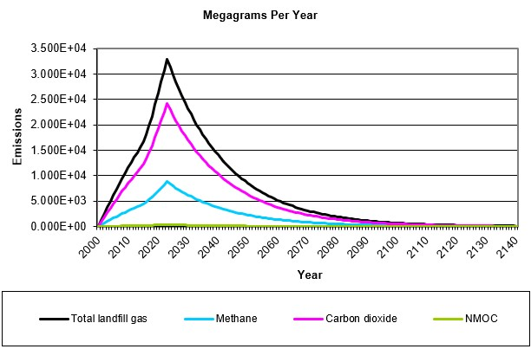
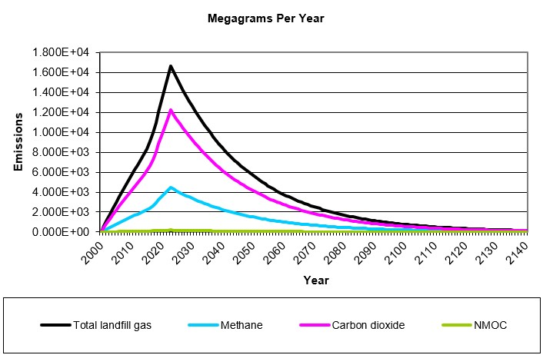
(c)
(a)

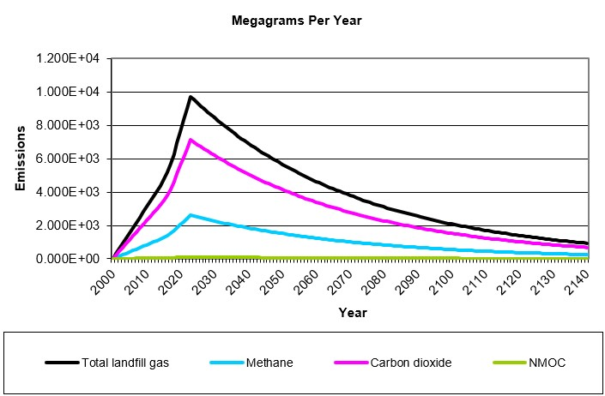
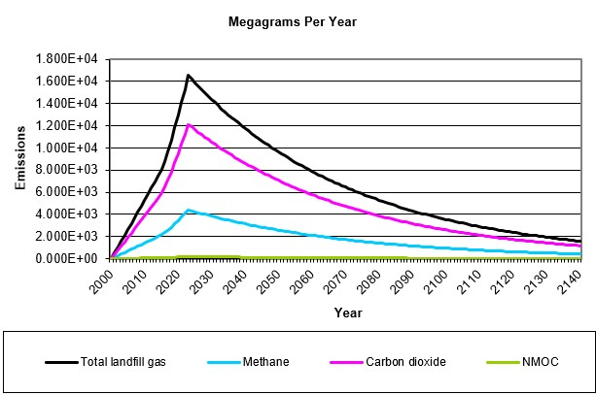
(d)
(b)

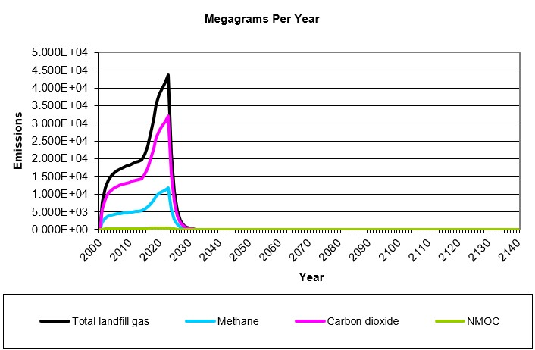
(e)

Fig. B.2 Predicted methane emission graph of Land-GEM-V-3.03 (a) CAAC (b) CAAA (c) IC (d) IA (e) IW

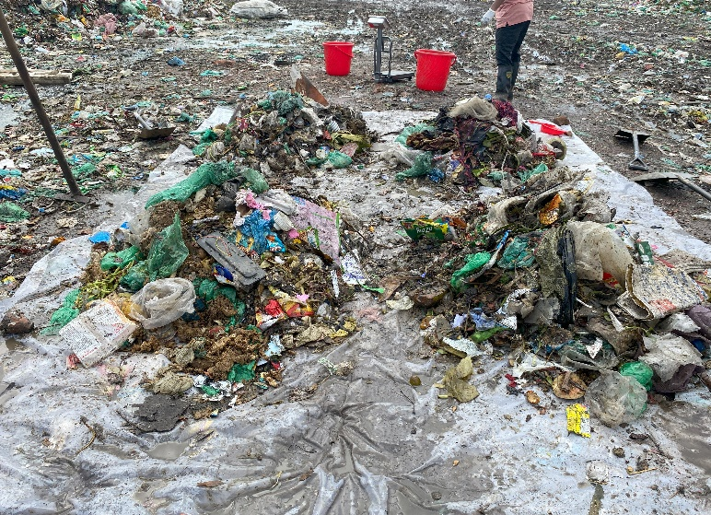
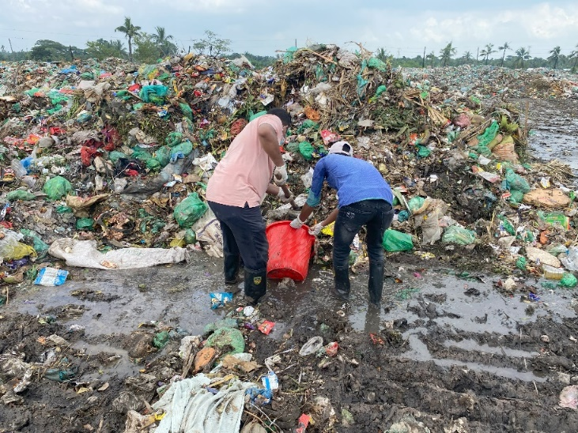

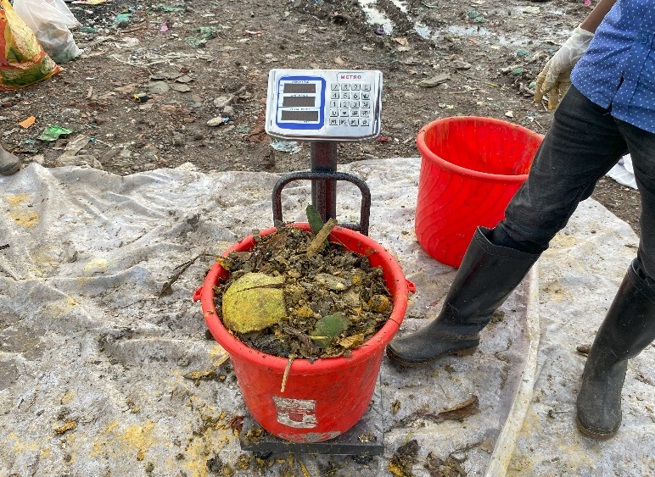

Fig. B.3 Waste characterizations at Rajbandh landfill by quartering and coning method
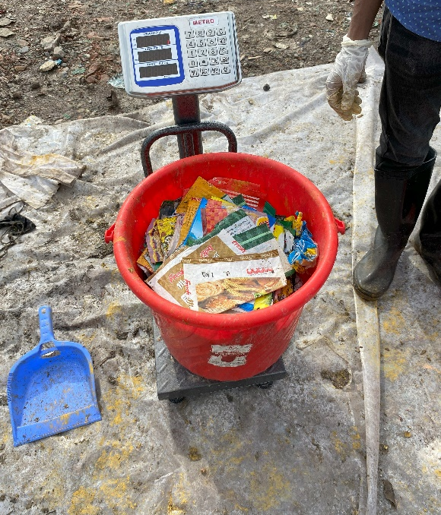

Location: Rajbandh Landfill Area
Date: 22-09-2022
Table B. 1 Waste Composition Data

Types | Composition | Average Weight (Kg) | Total average Weight (Kg) | % | Total %
Bio Waste | Food & Market Waste | 41.23 | 41.93 | 78.83 | 80.17
Bio Waste | Bones | 0.01 | 41.93 | 0.02 | 80.17
Bio Waste | Jute material | 0.69 | 41.93 | 1.32 | 80.17
Plastics | Foils | 0.15 | 5.02 | 0.29 | 9.60
Plastics | Containers | - | 5.02 | - | 9.60
Plastics | Bottle | - | 5.02 | - | 9.60
Plastics | Polythene packaging bag | 1.25 | 5.02 | 2.39 | 9.60
Plastics | Plastic Shopping bag | 2.41 | 5.02 | 4.61 | 9.60
Plastics | Broken Plastic | 0.21 | 5.02 | 0.40 | 9.60
Plastics | PVC table cover | 0.27 | 5.02 | 0.52 | 9.60
Plastics | Polystyrene | 0.06 | 5.02 | 0.11 | 9.60
Plastics | Nylon | 0.67 | 5.02 | 1.28 | 9.60
Paper and Cardboard |  | 0.31 | 0.31 | 0.59 | 0.59
Glass / Glass bottle |  | 1.08 | 1.08 | 2.07 | 2.07
Textiles | Clothes | 1.38 | 1.7 | 2.64 | 3.25
Textiles | shoes | 0.32 | 1.7 | 0.61 | 3.25
Electrical |  | 0.31 | 0.31 | 0.59 | 0.59
Metal |  | 0.15 | 0.15 | 0.29 | 0.29
Rubber |  | 0.45 | 0.45 | 0.86 | 0.86
Broken Yogurt pot |  | 0.82 | 0.82 | 1.57 | 1.57
Broken Tiles |  | 0.49 | 0.49 | 0.94 | 0.94
Medical Waste |  | 0.04 | 0.04 | 0.08 | 0.08
Others
Total |  | 52.3 | 52.3 | 100.00 | 100

Bulk Density: 0.547 kg/L

