Supplementary Materials

A. A brief introduction to POP and the related surgeries

A1. POP is a common female disease with serious consequences and a heavy healthcare burden
Pelvic Organ Prolapse (POP) is the descent of the female pelvic organs into or through the vagina, including anterior vaginal wall prolapse (cystocele, urethrocele, paravaginal defect), upper vaginal prolapse (uterine or vaginal vault), and posterior vaginal wall prolapse (rectocele or enterocele)⁵². POP is associated with significant negative impacts on the life quality of patients, including disturbing symptoms like vaginal bulging, pelvic pressure, vaginal bleeding or discharge, low backache, and the need to replace the prolapse to void or defecate ⁵³. According to the National Health and Nutrition Examination Survey, approximately 3% of women in the United States report symptoms of vaginal bulging³⁵. In China, this number increases to 9.6% reportedly ³⁶. The true prevalence of POP, however, could be much higher because many women do not seek medical attention for their symptoms. The critical impacts and high prevalence of POP pose a heavy healthcare burden. For example, more than 225,000 inpatient surgical procedures for pelvic organ prolapse were undertaken in the USA in 1997, resulting in an estimated cost of more than US$1 billion⁵². Because the peak incidence of POP symptoms is in women aged 70-79 years, it is conceivable that the morbidity will continue to rise as the population ages. As anticipated, the number of women experiencing POP will increase by approximately 50% in the United States by 2050.

A2. POP-Q scores serve as the major indicator of POP
To identify POP and quantitatively measure its severity, Pelvic Organ Prolapse Quantification (POP-Q) examination is established to provide objective and site-specific sores by measuring the Total Vaginal Length (TVL) at three specific anatomic positions in the pelvic cavity, i.e., point Ba, C, and Bp, as demonstrated in Figure S1 (A). As a standard measurement system for POP and pelvic floor dysfunction that is widely used internationally ⁵⁴, POP-Q examination is recommended before treatment to stage the extent of POP based on the most severely prolapsed vaginal segment ⁵⁵. Figure S1 (B) visualizes the logical rules to stage the extent of POP into five stages from stage 0 to stage 4, where stage 0 stands for no prolapse at all, stage 4 stands for vaginal eversion to within 2cm of its length, while stages 1-3 are intermediate stages with the severity of prolapse gradually increased. In clinical practice, the POP stage is an important assessment for POP, a key indication for treatment selection³⁵, and a critical index for evaluating the clinical effectiveness of surgical treatment⁵⁶. Documentation of the prolapse with the POP-Q allows an objective, validated, baseline measurement so that the surgeon has a preoperative comparator by which to measure postoperative anatomic success. The change in POP-Q scores before and after treatment is used to evaluate the effectiveness of procedures and to instruct procedure options. The “optimal anatomic outcome” or “cure” is generally defined as POP-Q stage 0 after receiving the treatment ⁵⁶.
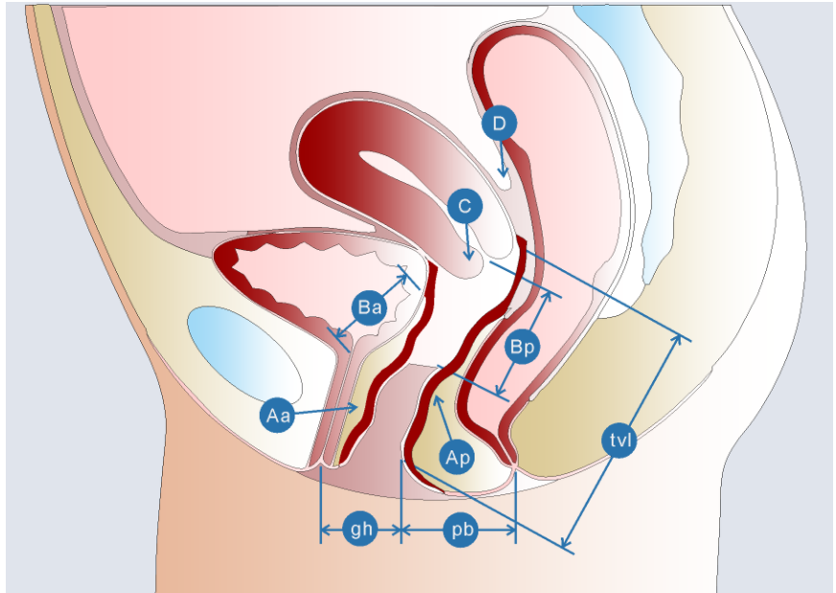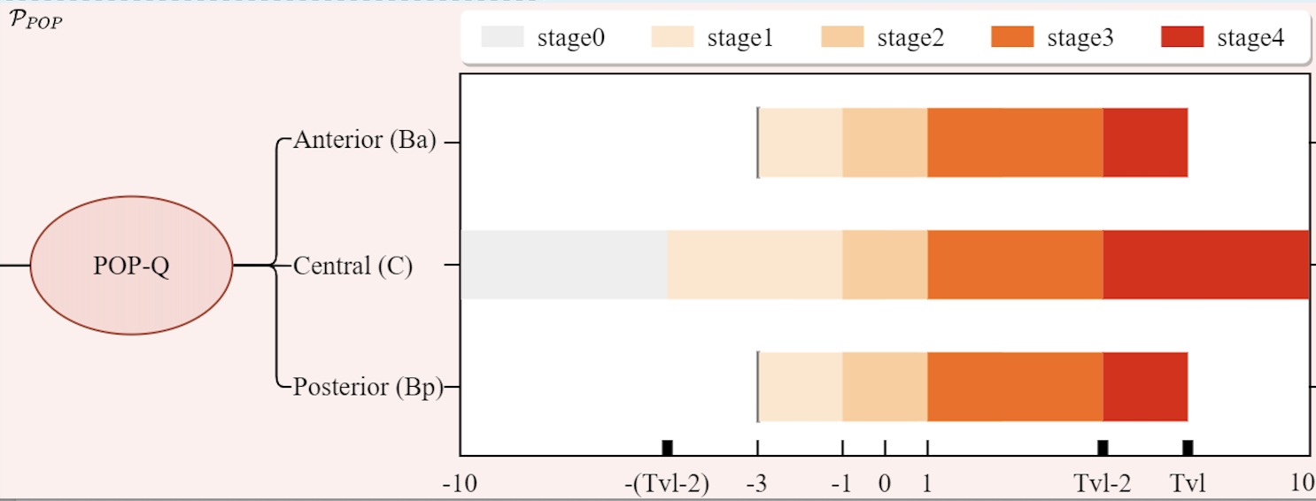
A. Anatomic position of POP-Q points B. POP stages based on POP-Q scores.
Figure S1. Graphical illustration of POP-Q points in the pelvic cavity and rules to claim POP stages based on POP scores. (A) A graphical illustration of the POP-Q system concerning points at three specific anatomic positions in the pelvic cavity: (1) point Ba to evaluate the prolapse extent of the anterior vaginal wall, (2) point C to evaluate the prolapse extent of the uterine or vaginal cuff, and (3) point Bp to evaluate the prolapse extent of the posterior vaginal wall. (B) POP stages based on POP scores. Stage 0: no prolapse; stage 1: the most distal prolapse is more than 1 cm above (inside) the hymen; stage 2: prolapse between 1 cm above and 1 cm below the hymen; stage 3: prolapse more than 1 cm beyond the hymen but no farther than (TVL–2) cm; and stage 4: vaginal eversion to within 2 cm of its length.

A3. Major surgical procedures for POP patients
Conservative management such as pessary and pelvic floor muscle training are primary treatments for POP patients³⁵. Failed or declined conservative treatments, women have a lifetime risk of 11% to 19% for undergoing POP surgery for anatomical and functional recovery⁵⁷, and a collection of surgical procedures are available, which can be roughly divided into two categories: the obliterative procedures and the reconstructive procedures ⁵⁸. The obliterative procedure refers to complete or partial colpocleisis. The reconstructive procedures utilize native tissue, e.g., Uterosacral Ligament Suspension (ULS) and Sacrospinous Ligament Fixation (SSLF), or biological graft, or synthetic mesh, e.g., anterior or posterior Trans-Vaginal Mesh (A/P-TVM) and Sacrocolpopexy (SC), to reconstruct the pelvic organ. Table S1 summarizes the 6 major surgical procedures available for POP patients.

Surgery | $$s_{1}$$ | $$s_{2}$$ | $$s_{3}$$ | $$s_{4}$$ | $$s_{5}$$ | $$s_{6}$$
Abbreviation | ATVM | PTVM | SC | ULS | SSLF | Colpocleisis
Full name | Anterior transvaginal mesh | Posterior transvaginal mesh | Sacrocolpopexy | Uterosacral ligament suspension | Sacrospinous ligament fixation | Complete/partial colpocleisis
Material | Mesh |  |  | Native tissue repair (NTR)
Approach | Transvaginal | Transvaginal | Laparoscopic/ transabdominal | Transvaginal/ laparoscopic | Transvaginal | Transvaginal
Effectiveness | To correct anterior wall, apical vaginal prolapse, or both. May be more effective than NTRs⁵⁹. | To correct posterior wall, apical vaginal prolapse, or both. May not be more effective than NTRs^{35, 59}. | To correct upper vaginal prolapse. Effective, low recurrent rate². | To correct upper vaginal prolapse, comparable to SSLF⁵⁰. | To correct upper vaginal prolapse, comparable to ULS⁵⁰. | Effective, low recurrent rate.
Safety | Higher rate of complications, >10% mesh complications^{2, 35}. |  | Higher rate of complications, Mesh complications (less than TVM). | Comparable to SSLF⁵⁰. | Comparable to ULS.⁵⁰ | Low rate of complications⁴⁹.
Economy | Expensive |  |  | Economical
Complexity | Complicated |  |  | Moderate
Feature | Suitable for severe or recurrent prolapse⁶⁰ or the elderly, or with medical comorbidities. Mesh-related complications³⁵ and the younger should avoid ³⁶. | Used in specific occasions due to controversy. | Suitable for the younger (<60 years, sexually active³⁶), severe (stage 3 or 4 prolapse), overweight (BMI >26), and recurrent ³⁵. | First choice for uterine /vault prolapse³⁷. | First choice for uterine /vault prolapse³⁷. | Vagina not reserved, women with significant comorbidities ³⁵.

A4. Personalized surgical treatment planning for POP is challenging
The compartmentalization of POP has led the patient to be referred to a single specialist such as a urologist, a gynecologist, or a colorectal surgeon. However, multi-compartmental disease is more common than an alteration of a single compartment alone, thus requiring a shared and integrated multidisciplinary approach from a team composed of different specialists⁴⁵. Such a situation leads to critical challenges in surgical treatment planning for POP patients. On the other hand, the selection of surgical treatment for a POP patient needs to consider multiple factors, including the site and severity of the prolapse and whether it’s recurring, the general health conditions and expectations of the patient, the preference and capabilities of the surgeon, and potential risks and medical cost for receiving the surgical treatment. Table S2 lists some key objective and subjective factors that may influent surgical treatment recommendations of surgeons to POP patients.
Covariate |  | Significance
Objective | Age | Basic feature, general health, and expectation related;  mesh procedures for elder (60+) patients, etc.
Objective | BMI | Basic feature, Effectiveness, and Surgery complexity related;  mesh procedures for heavier (BMI 26+) patients, etc.
Objective | POP-Q | Indication of prolapse severity;  The objective standard of “Effectiveness”
Subjective | Sexual life or vagina reservation | SC, SSLF, and ULS are recommended for sexually active patients, while the vagina will not be reserved in Colpocleisis
Subjective | Mesh aversion | Mesh-contradicted comorbidity or personal concerns affects mesh-related procedure choosing
Subjective | Cost-sensitive | Economy concern: cost of procedures varies
Subjective | Surgery complexity | Surgeon’s preference and capabilities related
Table S2. Objective and subjective factors that may influent surgical treatment recommendation of surgeons to POP patients.
Although experienced surgeons have their ways to process received information and make decisions in clinical practice, it is usually difficult to directly summarize their experiences into a self-contained intelligent system. Still, even experienced urogynecologists with different backgrounds sometimes can hardly reach a consensus, suggesting a highly multi-dimensional and complicated clinical scene. Most existing guidelines for POP summarize qualitative principles for selection of surgical type and timing, but cannot operably direct surgeons in a personalized way yet. For example, SC, SSLF, and ULS are all recommended by the ACOG guideline³⁵ for sexually active patients with primary symptomatic vaginal vault prolapse grading POP-Q stage 2 and above, while these three procedures have a significant difference in effectiveness, safety, sexual function influence, and cost, leaving no explicit or individual instruction to choose certain surgery for a particular patient. Such ambiguous indications in POP guidelines confront inexperienced surgeons to make decisions.
Some studies in the literature tried to back up the ambiguous indications in POP guidelines with more explicit ones. But, most of them always concluded that “procedure A is more efficient than B while having more complications and it should be balanced”, and didn’t provide any “balanced” solution⁵⁹. How to balance effectiveness, risk, and cost remains a puzzle. Several studies^{41, 42} used the Markov model to evaluate the cost-effectiveness of procedures, simultaneously taking effectiveness, complication, and cost into account. However, cost-effectiveness as the index is macroscopic and non-personalized, thus not practical and instructional in decision-making. In short, personalized surgical treatment planning for POP patients is still a critical challenge worth in-depth research in clinical practice⁶¹.

A5. The global shortage of medical resources for POP is a long-term challenge
The lack of explicit guidelines for personalized surgical treatment planning for POP results in the fact that we have to depend heavily on professional urogynecologists and experienced physicians to take effective care of POP patients. Unfortunately, however, professional urogynecologists and experienced physicians are in great shortage in most countries, even in the USA⁴⁰. Moreover, with the aging of the global population, we would expect more and more POP patients in the future and a larger gap between increasing demand and a limited supply of medical resources. In this situation, developing intelligent data-driven approaches for personalized surgical treatment recommendations becomes an inviting solution to alleviate the dilemma.

B. More details about the POP datasets
Table S3 lists the hospital-specific key characteristics of patients and the empirical distribution of surgeries in each of the involved datasets including $D_{s,t}$, $D_{s,v}$, $D_{m}$ and $D_{m,v}$. From the table, we can see the following facts. First, the key characteristics of patients are similar across hospitals, indicating different medical centers cover homogeneous patient populations. Second, the empirical distribution of surgeries varies significantly across hospitals, suggesting that different medical centers prefer different surgeries. And thus, third, different medical centers follow heterogeneous principles in surgery selection.

Table S3. Primary information of the involved datasets of POP patients.
Dataset | Hospital | Sample size |  | Sample distribution over surgical procedures  (number (percent)) |  |  |  |  |  |  | Background covariates  (mean± SD) |  |  | POP-Q  (median (P25, P75))
Dataset | Hospital | Sample size |  | $$s_{1}$$ | $$s_{2}$$ | $$s_{3}$$ | $$s_{4}$$ | $$s_{5}$$ | $$s_{6}$$ |  | Age | BMI |  | Ba | C | Bp
$$D_{s,t}$$  2015/1-2020/12 | $$H_{1}$$ | 799 |  | 250 (31.3%) | 25  (3.1%) | 113 (14.1%) | 165 (20.7%) | 115 (14.4%) | 131  (16.4%) |  | 59.46  ±10.79 | 24.60  ±3.04 |  | 3  (0, 5) | 3  (1, 4) | -1  (-2, 0)
$$D_{s,v}$$  2021/1-2022/8 | $$H_{1}$$ | 198 |  | 32  (16.2%) | 4  (2.0%) | 31  (15.7%) | 63  (31.8%) | 28  (14.1%) | 40  (20.2%) |  | 61.85  ±11.23 | 24.35  ±2.92 |  | 3  (0.9, 4) | 3  (1, 4) | -2  (-2, -1)
$$D_{m}$$  2021/9-2022/9 | $$H_{2}$$ | 139 |  | 7  (5.0%) | 0  (0.0%) | 3  (2.2%) | 62  (44.6%) | 1  (0.7%) | 66  (47.5%) |  | 65.50  ±10.09 | 24.88  ±3.44 |  | 4  (2, 6) | 3  (0,5.5) | -1  (-2, 0.5)
$$D_{m}$$  2021/9-2022/9 | $$H_{3}$$ | 35 |  | 25  (71.4%) | 0  (0.0%) | 0  (0.0%) | 0  (0.0%) | 7  (20.0%) | 3  (8.6%) |  | 62.92  ±12.01 | 24.25  ±2.96 |  | 5  (3, 6) | 5  (2.3,6) | 3  (0, 5)
$$D_{m}$$  2021/9-2022/9 | $$H_{4}$$ | 38 |  | 6  (15.8%) | 0  (0.0%) | 8  (21.1%) | 2  (5.3%) | 6  (15.8%) | 16  (42.1%) |  | 68.00  ±6.44 | 24.78  ±3.38 |  | 4  (2,6) | 3  (0,5.5) | -1  (-2,0.5)
$$D_{m}$$  2021/9-2022/9 | Total | 212 |  | 38  (17.9%) | 0  (0.0%) | 11  (5.2%) | 64  (30.2%) | 14  (6.6%) | 85  (40.1%) |  | 65.48  ±10.05 | 24.75  ±3.35 |  | 4  (2, 6) | 3  (0, 6) | -1  (-2, 2)
$$D_{m,v}$$  2021/1-2022/9 | $$H_{1}$$ | 47 |  | 7  (14.9%) | 2  (4.3%) | 12  (25.5%) | 14  (29.8%) | 4  (8.5%) | 8  (17.0%) |  | 59.40  ±11.54 | 24.21  ±2.90 |  | 3  (0.5,4) | 3  (1.5,4) | -2  (-2, -1)
$$D_{m,v}$$  2021/1-2022/9 | $$H_{2}$$ | 23 |  | 3  (13.0%) | 0  (0.0%) | 1  (4.3%) | 11  (47.8%) | 0  (0.0%) | 8  (34.8%) |  | 61.74  ±11.47 | 24.55  ±2.31 |  | 3  (2, 4) | 0  (-1,2.5) |  | -1  (-2,-0.5)
$$D_{m,v}$$  2021/1-2022/9 | $$H_{3}$$ | 18 |  | 13  (72.2%) | 0  (0.0%) | 0  (0.0%) | 0  (0.0%) | 2  (11.1%) | 3  (16.7%) |  | 69.94  ±6.54 | 24.37  ±3.37 |  | 3  (2,4.8) | 3.3  (2.3,5) | 1  (-1,2)
$$D_{m,v}$$  2021/1-2022/9 | $$H_{4}$$ | 12 |  | 4  (33.3%) | 0  (0.0%) | 2  (16.7%) | 3  (25%) | 2  (16.7%) | 1  (8.3%) |  | 61.33  ±6.54 | 24.08  ±3.41 |  | 3.5  (1,6) | 4  (1,6) | 2.5  (-0.3,4.3)
$$D_{m,v}$$  2021/1-2022/9 | Total | 100 |  | 27  (27.0%) | 2  (2.0%) | 15  (15.0%) | 28  (28.0%) | 8  (8.0%) | 20  (20.0%) |  | 62.07  ±10.86 | 24.30  ±2.89 |  | 3  (1.3, 4.9) | 3  (1, 5) | -1  (-2, 0.9)

