Supplementary Tables
Table S1 Comparison of Cr(VI) removal capacity of different microorganisms
Microorganisms | Isolation site | Mechanism of Chromium Removal | Efficiency | Time (hour) | Reference
Acinetobacter junii | Chromite mine waters of Sukinda valley | Biosorption | 35% (50 mg L⁻¹) | 3 | Paul et al. (2012)
Bacillus subtilis SS-1 | Soil form electroplating industry | Biosorption | 98.7% (100 mg L⁻¹) | 48 | Swapna et al. (2016)
Bacillus sp. CRB-B1 | Sludge from sewage treatment plants | Bioaccumulation and bioreduction | 89.64% (150 mg L⁻¹) | 24 | Tian et al. (2020)
Cellulosimicro-bium funkei strain AR6 | Soil in the leather factory | Bioaccumulation and bioreduction | 80.43% (250 mg L⁻¹) | 120 | Karthik et al. (2016)
Bacillus methylotrophicus | Tannery sludge | Biosorption and  bioreduction | 92.48 (95 mg L⁻¹) | 48 | Mala et al. (2015)
Lysinibacillus sp. HST-98 | Soil in a chromium chemical plant | Biosorption and bioreduction | 100% (100 mg L⁻¹) | 30 | Chen et al. (2020)
Acinetobacter haemolyticus | Cr(VI)-containing textile dye effluent | Biotransformation | 40%-60% (100 mg L⁻¹) | 48 | Ahmad et al. (2013)
Pseudomonas brenneri | Soil form coal mine | Biosorption and bioaccumulation | 96.3% (100 mg L⁻¹) | 120 | Banerjee et al. (2019)

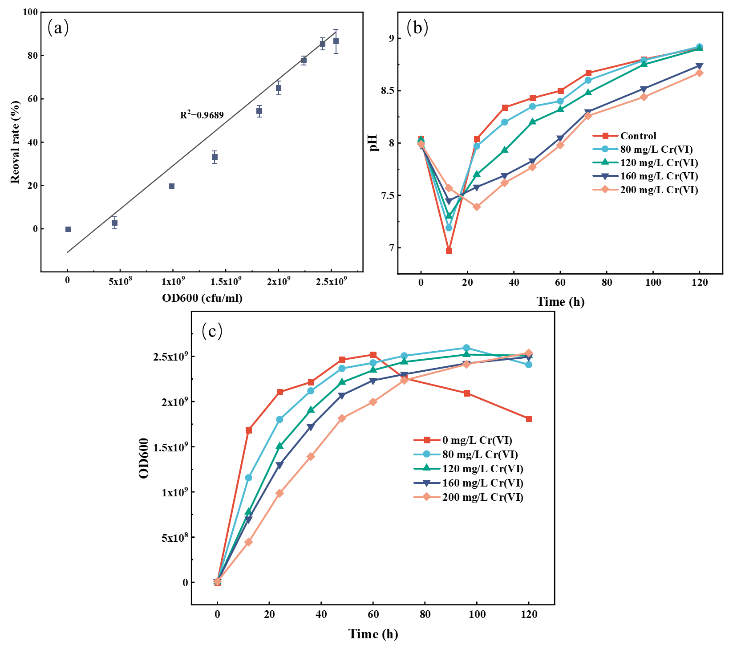
Figure S1(a) Correlation between Cr(VI) removal rate and bacterial count, pH changes(b) and bacterial count (c) of the system at different Cr(VI) concentrations.
Figure S2 XPS spectra of strain CR3 treated with 200 mg/L Cr(VI)

Figure S3 XRD analysis of strain CR3 treated with 200 mg/L Cr(VI)

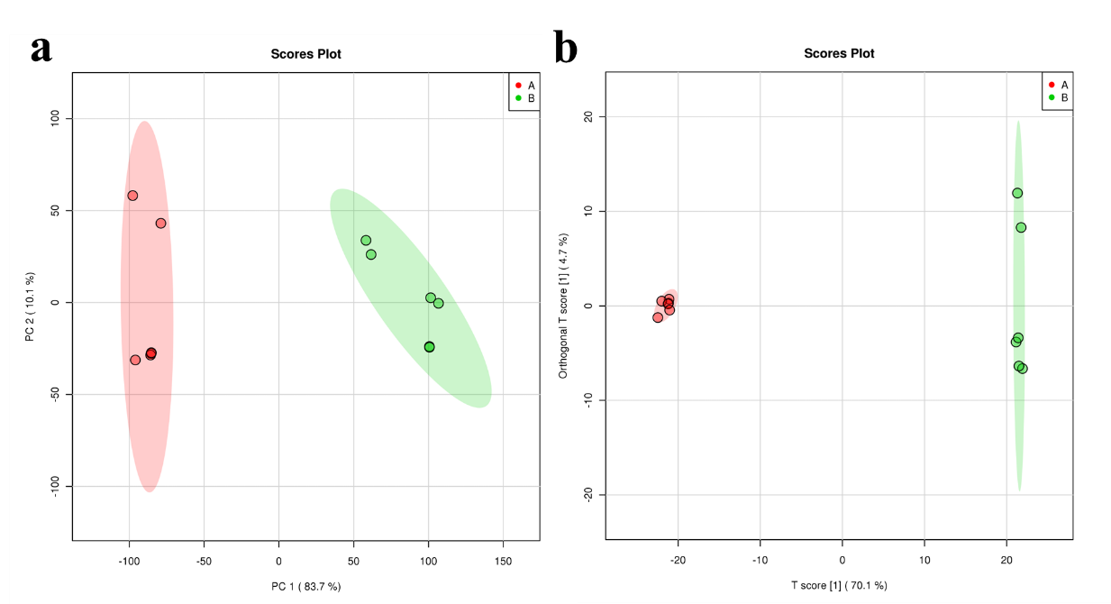
Figure S4 Compare the combined PCA and OPLS-DA plots

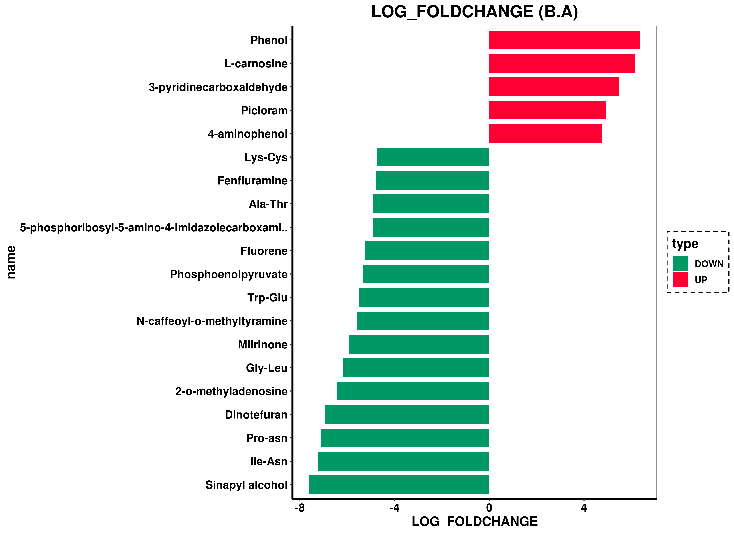
Figure S5 Histogram of differential metabolite ploidy between combinations.

