Supplementary Materials

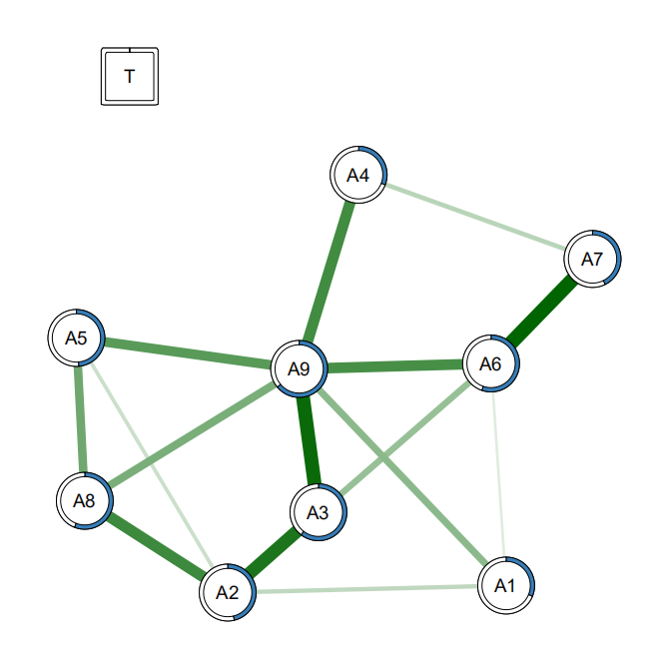
Figure S1. Regularized network of T0.
Note: T0 represents baseline assessment before training, T1 represents immediate post-training assessment, and T2, T3, T4, T5, T6 represent assessments at 1, 3, 6, 9, and 12 months after training, respectively. Nodes represent training interventions and EDA-S dimensions: self-control training (T), physical discomfort (A1), fatigue (A2), low processing fluency (A3), work burnout (A4), working memory decline (A5), emotion regulation disorders (A6), social withdrawal (A7), low perseverance (A8), and low self-efficacy (A9). The thickness of the edges represents the degree of correlation. Green edges indicate positive correlations, while red edges indicate negative correlations. The circle surrounding each node describes its predictability. Red edges between the binary intervention (T, square) nodes and symptom nodes indicate that the intervention group scores lower than the control group. Node size reflects the relative difference in intervention-induced changes since baseline, with smaller sizes indicating greater intervention effects.

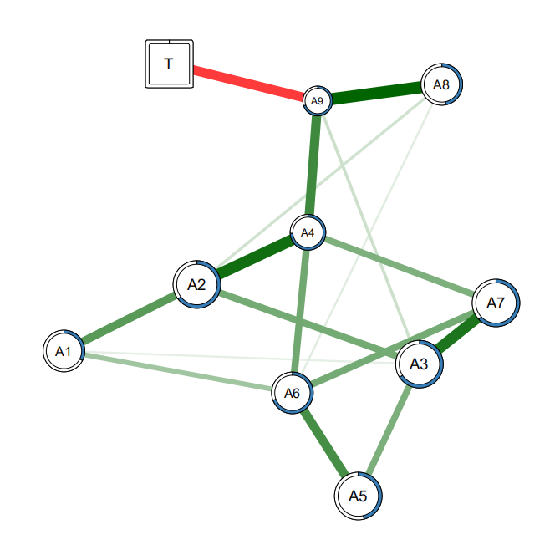
Figure S2. Regularized network of T1.
Note: T0 represents baseline assessment before training, T1 represents immediate post-training assessment, and T2, T3, T4, T5, T6 represent assessments at 1, 3, 6, 9, and 12 months after training, respectively. Nodes represent training interventions and EDA-S dimensions: self-control training (T), physical discomfort (A1), fatigue (A2), low processing fluency (A3), work burnout (A4), working memory decline (A5), emotion regulation disorders (A6), social withdrawal (A7), low perseverance (A8), and low self-efficacy (A9). The thickness of the edges represents the degree of correlation. Green edges indicate positive correlations, while red edges indicate negative correlations. The circle surrounding each node describes its predictability. Red edges between the binary intervention (T, square) nodes and symptom nodes indicate that the intervention group scores lower than the control group. Node size reflects the relative difference in intervention-induced changes since baseline, with smaller sizes indicating greater intervention effects.

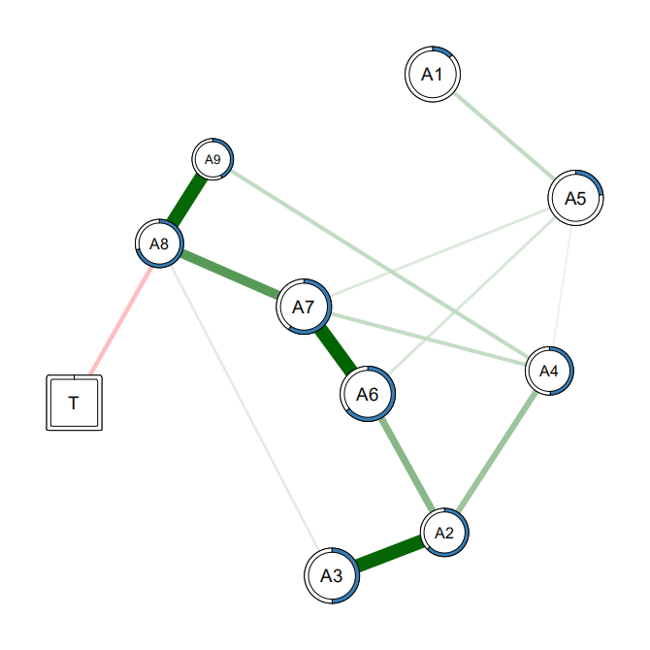
Figure S3. Regularized network of T2.
Note: T0 represents baseline assessment before training, T1 represents immediate post-training assessment, and T2, T3, T4, T5, T6 represent assessments at 1, 3, 6, 9, and 12 months after training, respectively. Nodes represent training interventions and EDA-S dimensions: self-control training (T), physical discomfort (A1), fatigue (A2), low processing fluency (A3), work burnout (A4), working memory decline (A5), emotion regulation disorders (A6), social withdrawal (A7), low perseverance (A8), and low self-efficacy (A9). The thickness of the edges represents the degree of correlation. Green edges indicate positive correlations, while red edges indicate negative correlations. The circle surrounding each node describes its predictability. Red edges between the binary intervention (T, square) nodes and symptom nodes indicate that the intervention group scores lower than the control group. Node size reflects the relative difference in intervention-induced changes since baseline, with smaller sizes indicating greater intervention effects.

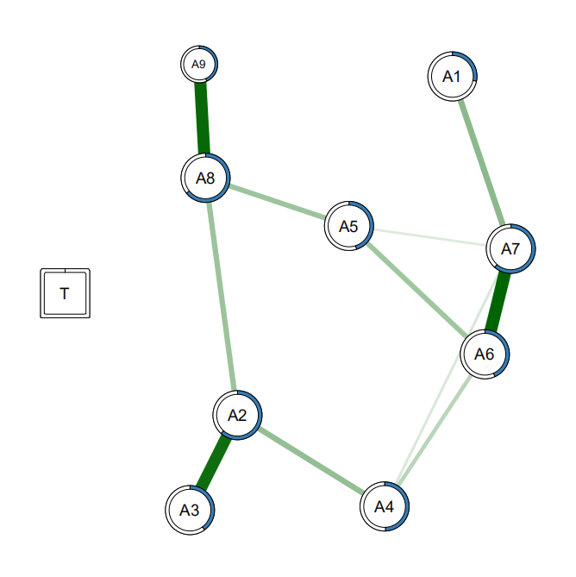
Figure S4. Regularized network of T3.
Note: T0 represents baseline assessment before training, T1 represents immediate post-training assessment, and T2, T3, T4, T5, T6 represent assessments at 1, 3, 6, 9, and 12 months after training, respectively. Nodes represent training interventions and EDA-S dimensions: self-control training (T), physical discomfort (A1), fatigue (A2), low processing fluency (A3), work burnout (A4), working memory decline (A5), emotion regulation disorders (A6), social withdrawal (A7), low perseverance (A8), and low self-efficacy (A9). The thickness of the edges represents the degree of correlation. Green edges indicate positive correlations, while red edges indicate negative correlations. The circle surrounding each node describes its predictability. Red edges between the binary intervention (T, square) nodes and symptom nodes indicate that the intervention group scores lower than the control group. Node size reflects the relative difference in intervention-induced changes since baseline, with smaller sizes indicating greater intervention effects.

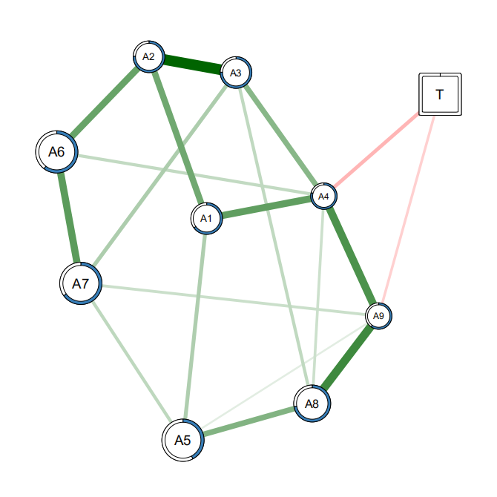
Figure S5. Regularized network of T4.
Note: T0 represents baseline assessment before training, T1 represents immediate post-training assessment, and T2, T3, T4, T5, T6 represent assessments at 1, 3, 6, 9, and 12 months after training, respectively. Nodes represent training interventions and EDA-S dimensions: self-control training (T), physical discomfort (A1), fatigue (A2), low processing fluency (A3), work burnout (A4), working memory decline (A5), emotion regulation disorders (A6), social withdrawal (A7), low perseverance (A8), and low self-efficacy (A9). The thickness of the edges represents the degree of correlation. Green edges indicate positive correlations, while red edges indicate negative correlations. The circle surrounding each node describes its predictability. Red edges between the binary intervention (T, square) nodes and symptom nodes indicate that the intervention group scores lower than the control group. Node size reflects the relative difference in intervention-induced changes since baseline, with smaller sizes indicating greater intervention effects.

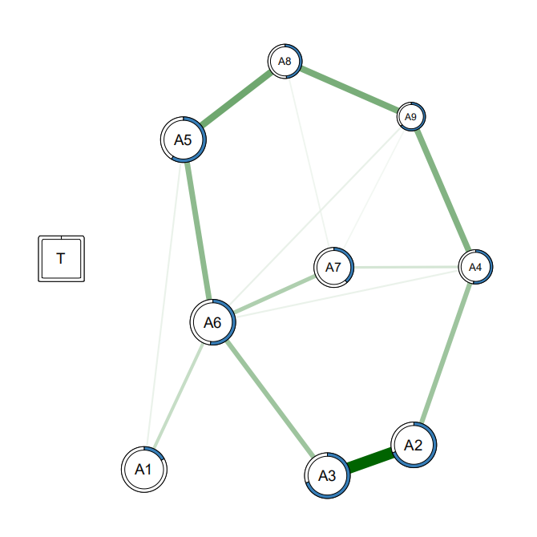
Figure S6. Regularized network of T5.
Note: T0 represents baseline assessment before training, T1 represents immediate post-training assessment, and T2, T3, T4, T5, T6 represent assessments at 1, 3, 6, 9, and 12 months after training, respectively. Nodes represent training interventions and EDA-S dimensions: self-control training (T), physical discomfort (A1), fatigue (A2), low processing fluency (A3), work burnout (A4), working memory decline (A5), emotion regulation disorders (A6), social withdrawal (A7), low perseverance (A8), and low self-efficacy (A9). The thickness of the edges represents the degree of correlation. Green edges indicate positive correlations, while red edges indicate negative correlations. The circle surrounding each node describes its predictability. Red edges between the binary intervention (T, square) nodes and symptom nodes indicate that the intervention group scores lower than the control group. Node size reflects the relative difference in intervention-induced changes since baseline, with smaller sizes indicating greater intervention effects.

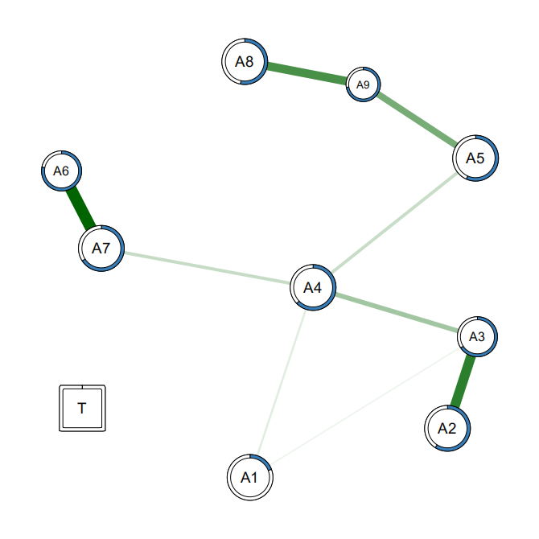
Figure S7. Regularized network of T6.
Note: T0 represents baseline assessment before training, T1 represents immediate post-training assessment, and T2, T3, T4, T5, T6 represent assessments at 1, 3, 6, 9, and 12 months after training, respectively. Nodes represent training interventions and EDA-S dimensions: self-control training (T), physical discomfort (A1), fatigue (A2), low processing fluency (A3), work burnout (A4), working memory decline (A5), emotion regulation disorders (A6), social withdrawal (A7), low perseverance (A8), and low self-efficacy (A9). The thickness of the edges represents the degree of correlation. Green edges indicate positive correlations, while red edges indicate negative correlations. The circle surrounding each node describes its predictability. Red edges between the binary intervention (T, square) nodes and symptom nodes indicate that the intervention group scores lower than the control group. Node size reflects the relative difference in intervention-induced changes since baseline, with smaller sizes indicating greater intervention effects.

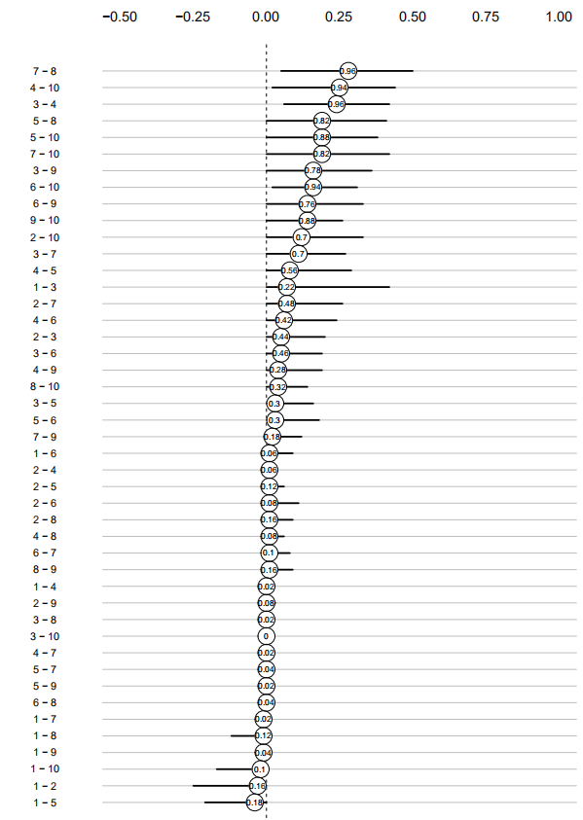
Figure S8. Bootstrapped sampling distribution of the edge weights of the regularized network of T0.

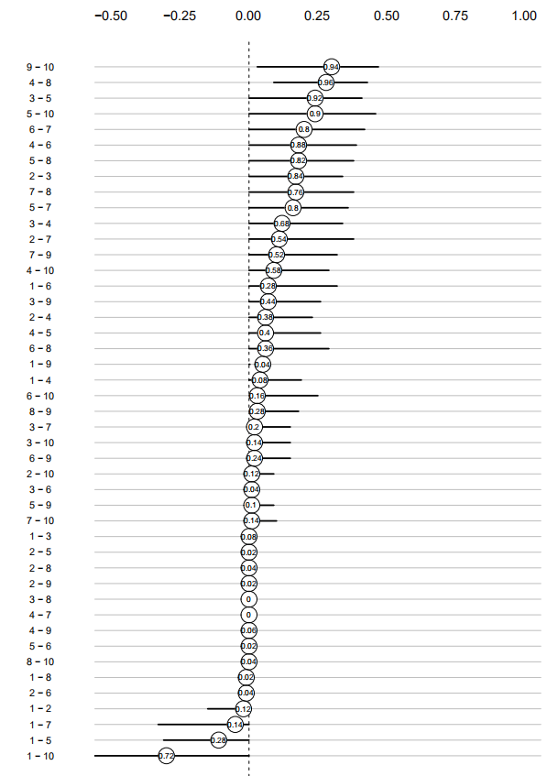
Figure S9. Bootstrapped sampling distribution of the edge weights of the regularized network of T1.
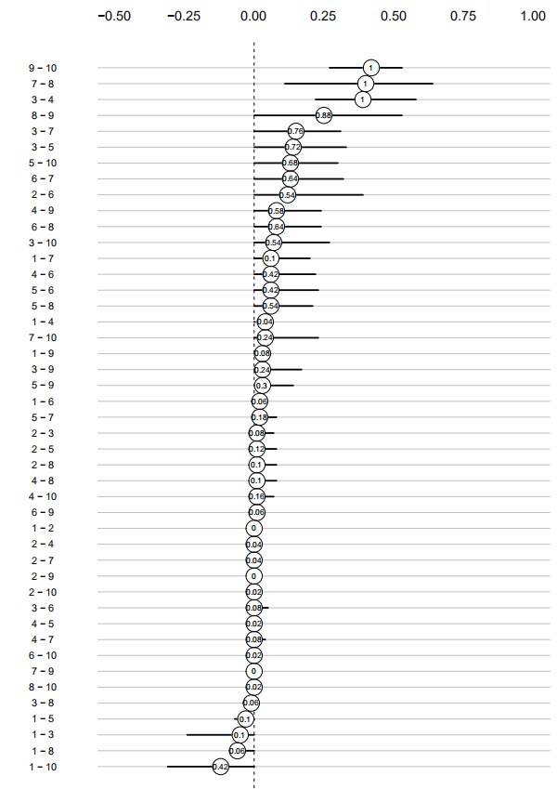
Figure S10. Bootstrapped sampling distribution of the edge weights of the regularized network of T2.
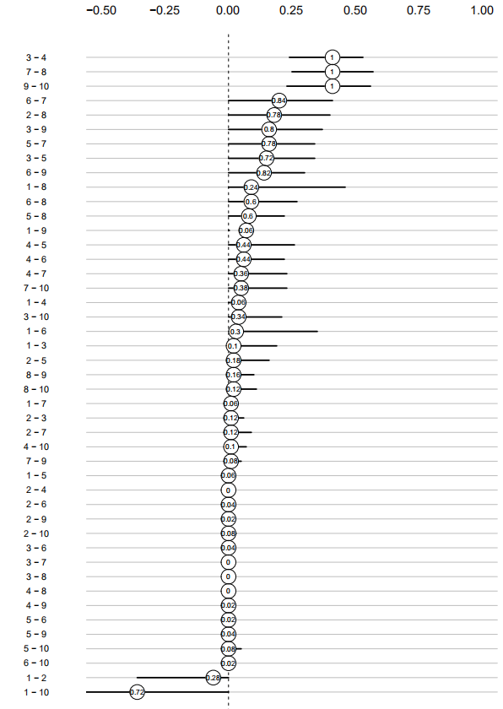
Figure S11. Bootstrapped sampling distribution of the edge weights of the regularized network of T3.
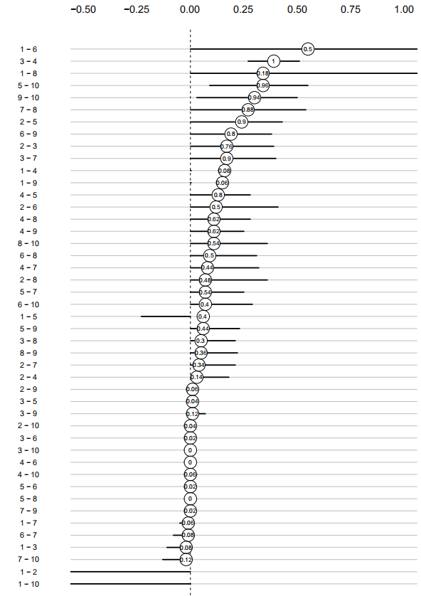
Figure S12. Bootstrapped sampling distribution of the edge weights of the regularized network of T4.
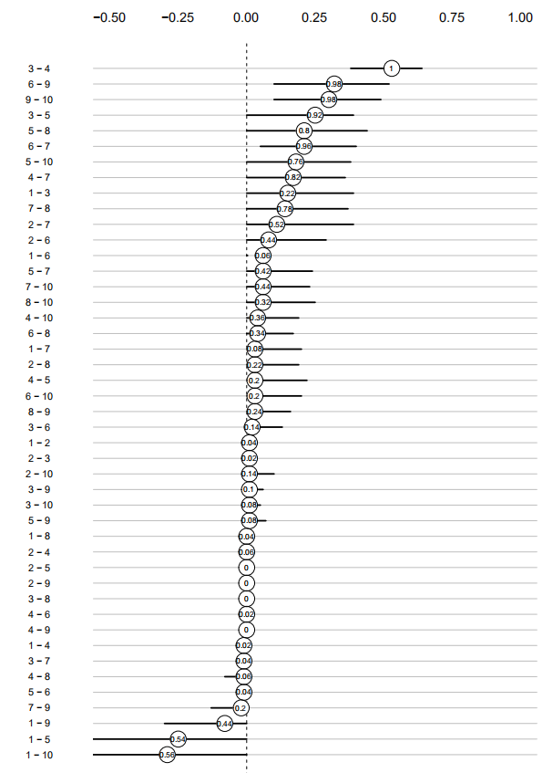
Figure S13. Bootstrapped sampling distribution of the edge weights of the regularized network of T5.
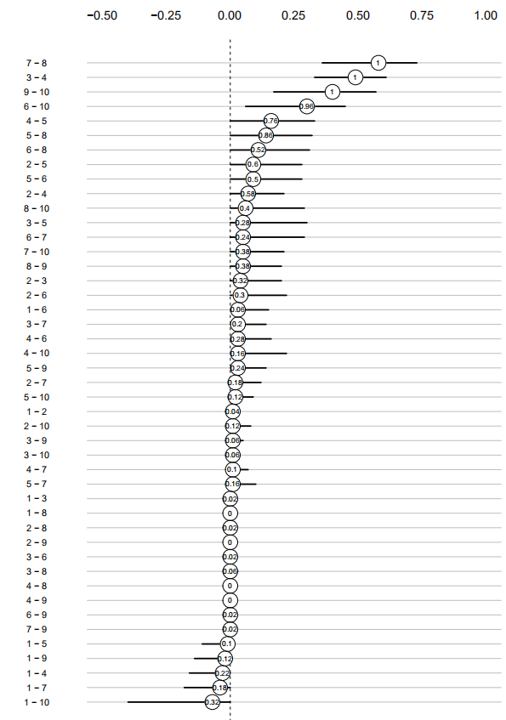
Figure S14. Bootstrapped sampling distribution of the edge weights of the regularized network of T6.

