Increased CO₂ Fixation Enables High Carbon-Yield Production of the Acrylic Acid Precursor 3-Hydroxypropionic Acid in Yeast
Ning Qin^{1, 9}, Lingyun Li^{1, 2, 9}, Xiaozhen Wan¹, Xu Ji¹, Yu Chen³, Chaokun Li⁴, Ping Liu⁵, Yijie Zhang¹, Weijie Yang¹, Junfeng Jiang⁶, Jianye Xia⁶, Shuobo Shi¹, Tianwei Tan¹, Jens Nielsen^{1, 2, 7, *}, Yun Chen^{2, *}, and Zihe Liu^{1, 8, *}
¹College of Life Science and Technology, Beijing Advanced Innovation Center for Soft Matter Science and Engineering, Beijing University of Chemical Technology, 100029 Beijing, China;
²Department of Biology and Biological Engineering, Chalmers University of Technology, SE412 96 Gothenburg, Sweden;
³CAS Key Laboratory of Quantitative Engineering Biology, Shenzhen Institute of Synthetic Biology, Shenzhen Institute of Advanced Technology, Chinese Academy of Sciences, Shenzhen 518055, China;
⁴Stem Cells and Metabolism Research Program, Faculty of Medicine, University of Helsinki, 00014 Helsinki, Finland;
⁵The State Key Laboratory of Chemical Resource Engineering, College of Chemical Engineering, Beijing University of Chemical Technology, 100029 Beijing, China;
⁶Tianjin Institute of Industrial Biotechnology, Chinese Academy of Sciences, Tianjin, 300308, China;
⁷BioInnovation Institute, Ole Maaløes Vej 3, DK2200 Copenhagen N, Denmark
⁸Lead contact
⁹These authors contributed equally: Ning Qin, Lingyun Li
*Correspondence: nielsenj@chalmers.se, yunc@chalmers.se, and zihe@mail.buct.edu.cn

Figure S1, Growth profiling of the WT strain, ARTp-STB5 strain, and TEF1p-STB5 strain. The control strain was QLW3, the STB5p::TEF1p strain was QLW4, and STB5p::ARTp strain was QLW5. The genotype was listed in Table S2. All data were presented as mean ± SD of biological triplicates.

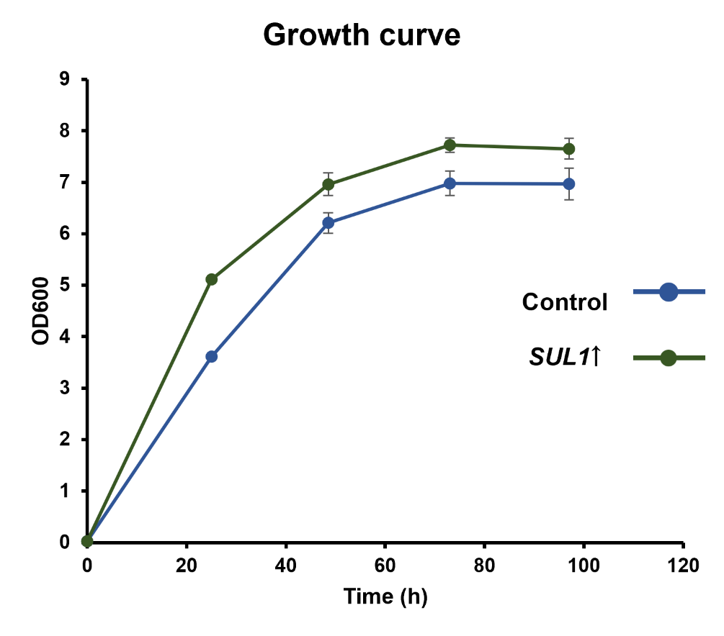
Figure S2, Overexpression of SUL1 contributed to the improved strain growth. The control strain was QLW3, the SUL1 overexpression strain was QLW8. The genotype was listed in Table S2. All data were presented as mean ± SD of biological triplicates.

Figure S3, Oxaloacetate (OAA) accumulation was observed after co-overexpression of STB5 and SUL1. Around 10.8 minutes, there is a high accumulation peak of the oxaloacetate (OAA), the oxaloacetate (OAA) detection method refer to the materials and methods section.
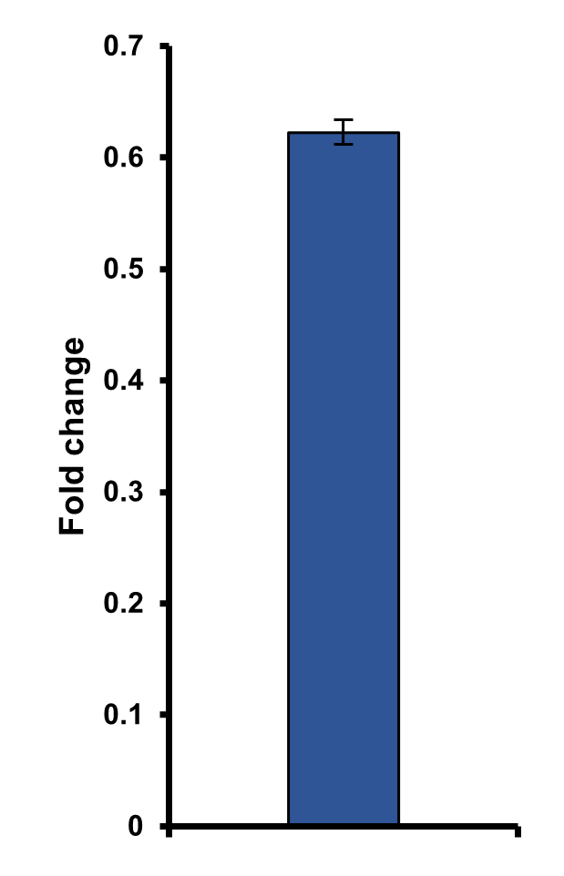
Figure S4, The expression level of HIS3 marker plasmid relative to URA3 marker plasmid.
The expression level of the HIS3 marker is approximately 0.62 times that of the URA3 marker. Abbreviations were defined in Table S1. All data were presented as mean ± SD of biological triplicates.

