Warfarin tautomers in solution: a structural, computational and thermodynamic study.

Daniel A. Osborne, Edward Danielyan, Khoi Hoang and Edward J. Valente.*
Department of Chemistry & Biochemistry, University of Portland, Portland, OR 97203

Supplementary Materials.

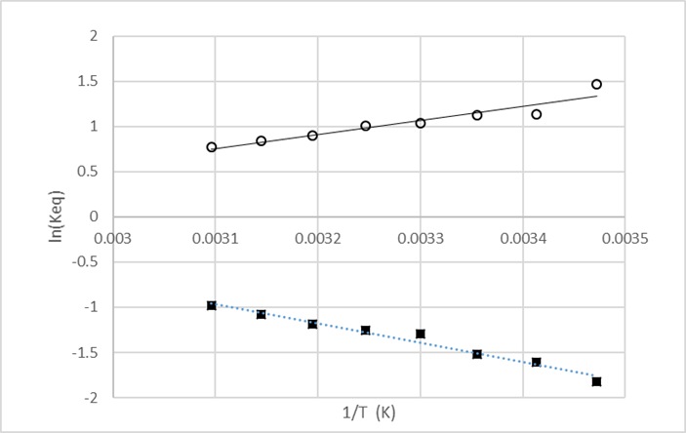

Figure S-1a. van’t Hoff analysis of (S)-warfarin open-cyclic equilibria in CDCl₃; K = [trans hemiketal] / [open], (■); for K = [open] / [cis hemiketal], (○).
In CDCl₃, methyl singlets (1a open δ 2.26, 1b trans δ 1.66, 1c cis δ 1.65) can be integrated by line-fitting. Methine-H multiplets are resolved (1a δ 4.70, 1b δ 4.15, 1c δ 4.24) and can be integrated.
For K = 1b / 1a = [trans hemiketal] / [open], (■), R² = 0.974, N= 8, slope = -ΔH/R = -2140/K ; ΔH = 17.8(12) kJ/mol; intercept = ΔS/R = 5.67/K; ΔS = +47.2(38) J/K.
For K = 1a / 1c = [open] / [cis hemiketal], (○), R² = 0.902, N = 8, slope = -ΔH/R = 1567/K ; ΔH = -13.0(18) kJ/mol; intercept = ΔS/R = 4.10/K; ΔS = -34.1(57) J/K.
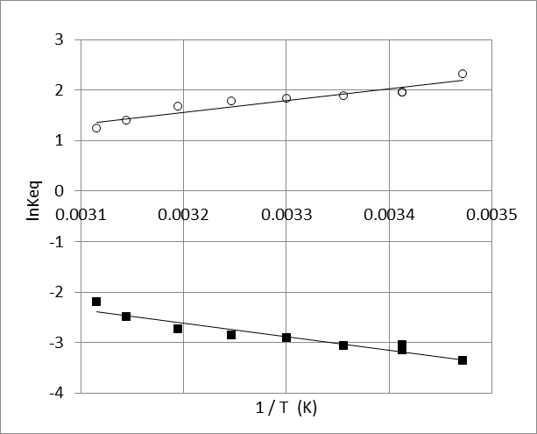

Figure S-1b. van’t Hoff analysis of (S)-warfarin open-cyclic equilibria in CD₃OD; K = 1b / 1a, [trans hemiketal] / [open], (■); for K = 1a / 1c [open] / [cis hemiketal], (○).
In CD₃OD, methyl singlets (open δ 2.16, trans δ 1.70, cis δ 1.63) can be integrated by line-fitting. Methine-H integrations agree for open vs. overlapped hemiketals.
For K = 1b / 1a = [trans hemiketal] / [open], (■) R² = 0.917, N= 9, slope = -ΔH/R = -2650/K ; ΔH = 22.0(25) kJ/mol; intercept = ΔS/R = 5.86/K; ΔS = 48.7(83) J/K.
For K = 1a / 1c = [open] / [cis hemiketal], (○), R² = 0.904, N = 8, slope = -ΔH/R = 2370/K ; ΔH = -19.7(24) kJ/mol; intercept = ΔS/R = -6.03/K; ΔS = -50.1(80) J/K.
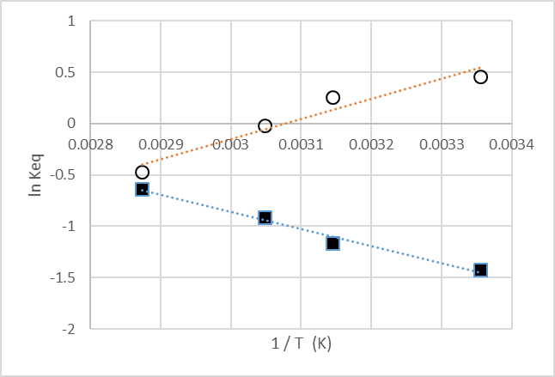

Figure S-1c. van’t Hoff analysis of (S)-warfarin open-cyclic equilibria in d₆-DMSO; K = 1b / 1a = [trans hemiketal] / [open], (■); for K = 1a / 1c = [open] / [cis hemiketal], (○).
In d₆-DMSO, open methyl singlet (δ 2.10) is overlapped with a cis hemiketal methylene H (H_{b} δ 2.15); cyclic hemiketal methyl singlets (δ 1.62, 1.58) can be integrated after line-fitting. Open form composition can be measured by integrating the resolved open methine-H (δ 4.91) relative to its sum with the strongly overlapped cyclic hemiketal methine-H multiplets (trans δ 4.00, cis δ4.01).
For K = 1b / 1a = [trans hemiketal] / [open], (■), R² = 0.985, N= 4, slope = -ΔH/R = -1663/K ; ΔH = 13.8(12) kJ/mol; intercept = ΔS/R = 4.13/K; ΔS = 34.4(38) J/K.
For K = 1a / 1c =[open] / [cis hemiketal], (○), R² = 0.940, N = 4, slope = -ΔH/R = 1947/K ; ΔH = -16.2(29) kJ/mol; intercept = ΔS/R = -5.98/K; ΔS = -49.8(90) J/K.

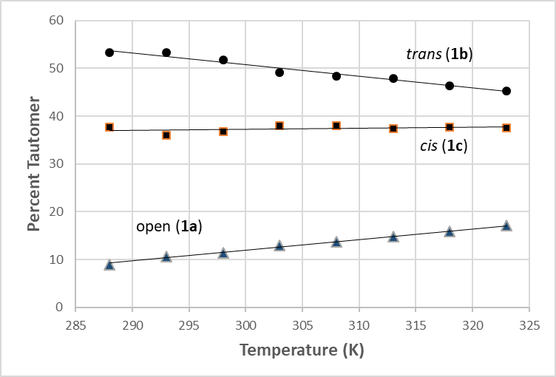

Figure S-2a. Composition of warfarin tautomers in CDCl₃ as a function of temperature.

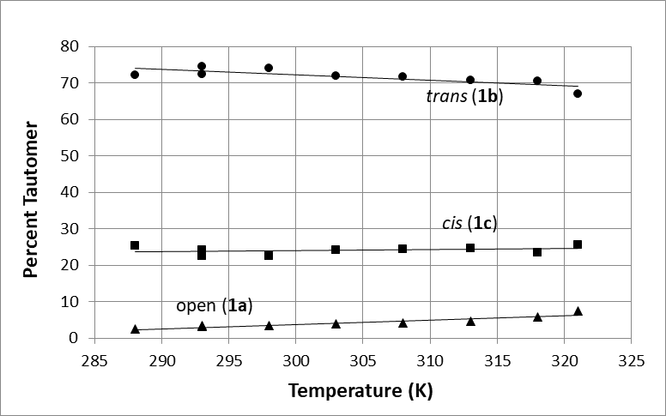

Figure S-2b. Composition of warfarin tautomers in CD₃OD as a function of temperature.

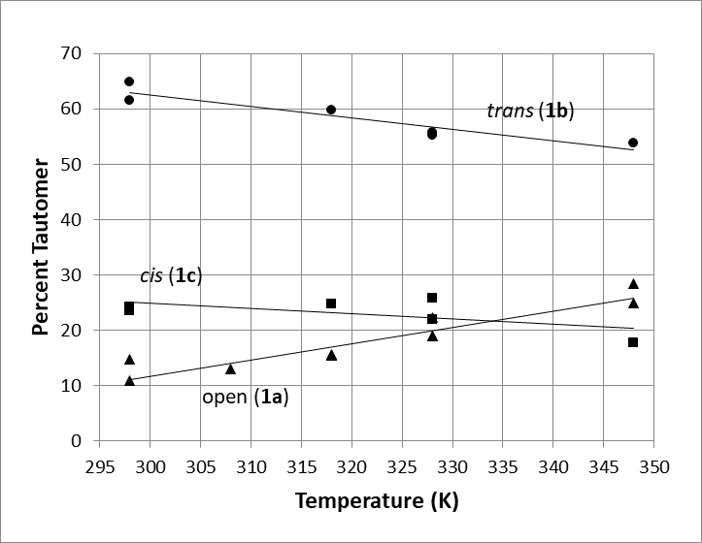

Figure S-2c. Composition of warfarin tautomers in d₆-DMSO as a function of temperature.

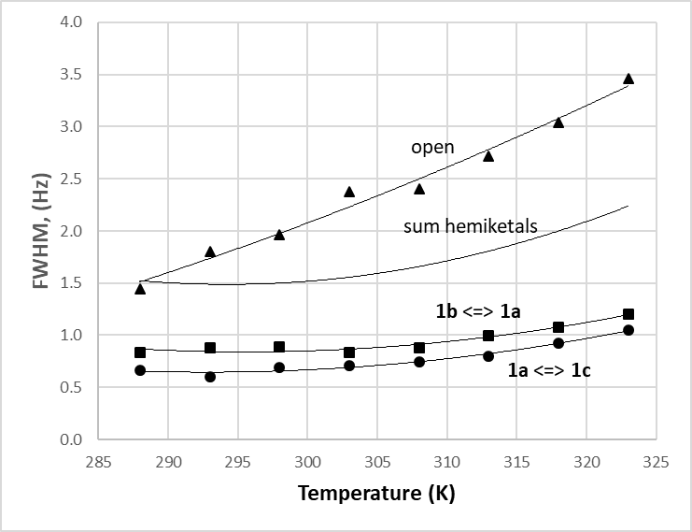

Figure S-3a. Linewidths (FWHM, Hz) in CDCl₃ for the two warfarin open ⇋ cyclic hemiketal reactions (●, ■), the sum of these linewidths, and the observed linewidths for the open tautomer (▲), as functions of temperature.

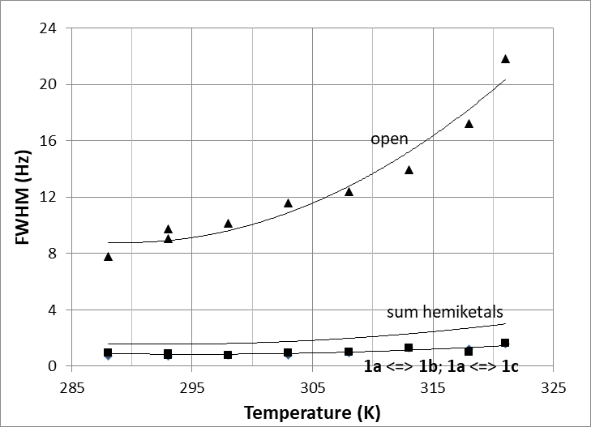

Figure S-3b. Linewidths (FWHM, Hz) in CD₃OD for the two warfarin open ⇋ cyclic hemiketal reactions (■, ●: very similar at this scale), the sum of these linewidths, and the observed linewidths for the open tautomer (▲), as functions of temperature.

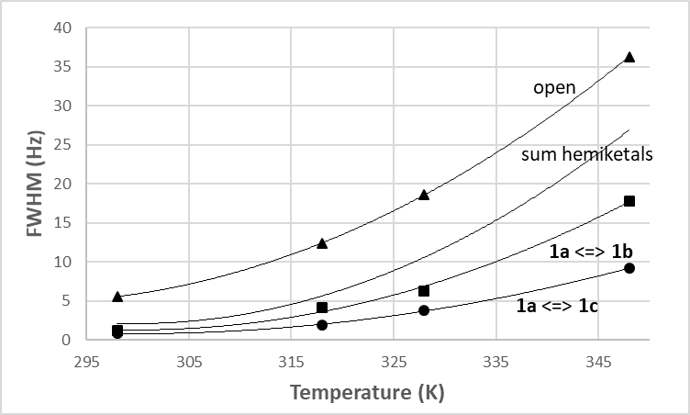

Figure S-3c. Linewidths (FWHM, Hz) in d₆-DMSO for the two warfarin open ⇋ cyclic hemiketal reactions (●, ■), the sum of these linewidths, and the observed linewidths for the open tautomer (▲), as functions of temperature.

Table S-1. Proportions of tautomers in warfarin analogs and derivatives by solvent and temperature (where reported) determined by NMR in prior studies. For cyclic forms, cis/trans R₉ to OH.

R₉ | R₅ | solvent | T (K) | cis | open | trans | Ref.
-C₆H₅ | -H | CDCl₃ | 310 | 40 | 15 | 45 | [26]
-C₆H₅ | -H | d₆-DMSO | 310 | 30 | 0 | 70 | [26]
-C₆H₅ | -H | d₆-DMSO | 300 | 28* | <2 | 70* | [34]
-C₆H₅ | -H | d₆-DMSO | n.r. | 27 | 9 | 64 | [27]
-C₆H₅ | -H | d₆-DMSO | n.r. | 30.8 | 0 | 69.2 | [14]
-C₆H₅ | -OH | CDCl₃ | 310 | 28 | 50 | 22 | [56]
-C₆H₅ | -OH | d₆-DMSO | n.r. | 0 | 100 | 0 | [27]
-CH₃ | -H | CDCl₃ | n.r. | 35 | 30 | 35 | [15]
-CH₃ | -OH | CDCl₃ | 310 | 15 | 80 | <5 | [56]
-cC₆H₁₁ | -H | CDCl₃ | n.r. | 0 | 75 | 25 | [16]

* - proportions for cis/trans forms reversed on reassessment of published spectrum.
(n.r. – not reported)
Table S-2a. Nuclear magnetic resonance. Carbon NMR chemical shifts for warfarin hemiketal tautomers (1b, 1c) and model trans and cis methyl ketals (4, 5, resp.), 298 K in CDCl₃.

compound → | 1b | 1c | 4 | 5
carbon ↓ | (trans) | (cis) | (trans) | (cis)
C2 | 161.53 | 162.27 | 161.12 | 161.87
C3 | 100.60 | 101.22 | 105.54 | 105.55
C4 | 159.02 | 159.80 | 158.17 | 158.94
C4a | 116.42 | 115.92 | 115.72 | 115.63
C5 | 122.75 | 123.09 | 122.37 | 122.54
C6 | 123.61 | 123.97 | 123.75 | 123.84
C7 | 131.51 | 132.03 | 131.53 | 131.74
C8 | 116.64 | 115.58 | 116.64 | 116.74
C8a | 152.83 | 152.96 | 153.06 | 152.99
C9 | 35.36 | 34.35 | 35.51 | 35.32
C10 | 42.64 | 40.09 | 43.44 | 39.81
C11 | 99.14 | 104.15 | 101.35 | 102.45
C12 | 28.04 | 27.59 | 22.27 | 22.45
C13 | 143.31 | 141.55 | 143.45 | 143.04
C14 | 128.61 | 127.01 | 127..07 | 128.09
C15 | 129.17 | 127.17 | 128.64 | 128.63
C16 | 127.08 | 126.47 | 126.46 | 127.39
C17 | - | - | 49.86 | 49.27

Table S-2b. Nuclear magnetic resonance. Carbon NMR chemical shifts for warfarin hemiketal tautomers (1b, 1c) and model trans and cis methyl ketals (4, 5, resp.), 298 K in d₆-DMSO).

compound → | 1b | 1c | 4 | 5
carbon ↓ | (trans) | (cis) | (trans) | (cis)
C2 | 160.75 | 161.21 | 161.20 | 160.48
C3 | 103.85 | 102.38 | 103.13 | 105.11
C4 | 159.30 | 159.90 | 158.81 | 158.32
C4a | 152.75 | 152.78 | 152.79 | 152.84
C5 | 123.18 | 123.12 | 122.93 | 122.86
C6 | 124.47 | 124.54 | 124.69 | 124.70
C7 | 132.42 | 132.50 | 132.62 | 132.57
C8 | 116.06 | 115.93 | 116.79 | 116.72
C8a | 116.62 | 116.70 | 115.54 | 115.54
C9 | 35.63 | 36.47 | 35.14 | 35.51
C10 | 43.28 | 41.95 | 42.89 | 39.55
C11 | 100.10 | 101.83 | 102.93 | 101.98
C12 | 27.66 | 26.23 | 22.43 | 22.20
C13 | 144.39 | 144.28 | 144.18 | 144.10
C14 | 127.50 | 127.75 | 127.88 | 127.55
C15 | 128.72 | 128.34 | 128.12 | 128.74
C16 | 126.41 | 126.11 | 125.97 | 126.50
C17 | - | - | 48.38 | 50.03

Table S-3. Side chain conformations of open (S)-warfarin, analogs, derivatives, enolates by diffraction and computational methods. Torsions about -60º (gauche conformer A, Scheme 4), ±180º (anti conformer B, Scheme 4). R = H.

Compounds | Torsion (º)  (C3-C9-C10-C11) | Method | Reference
Analogs & Derivatives
(±)-5-hydroxywarfarin* | -161.7 | X-ray, 293 K | [56]
(±)-p-nitrophenyl warfarin oxime* | -75.1 | X-ray, 173 K | [69]
(±)-p-methoxyphenacyl warfarin* | +164.6 | X-ray, 293 K | [70]
Methyl Ethers
(±)-warfarin-4-methyl ether (3, coumarin)*† | -55.4 | X-ray, 293 K | [26]
“ | -55.1 | X-ray, 110 K | this study
(S)-warfarin-2-methyl ether (4, chromone)† | -66.7 | X-ray, 110 K | this study
“ | -58.0 | “ | “
“ | -66.8 | “ | “
“ | -58.0 | “ | “
Enolates
(+)-quinidinium (S)-warfarinate | -51.9 | X-ray, 293 K | [11]
“ | -53.5 | “ | “
“ | -54.0 | “ | “
“ | -54.1 | “ | “
sodium (±)-warfarinate, isopropanol* | -68.3 | X-ray, 173 K | [71]
“ | -78.4 | “ | “
(S)-warfarinate/Cyt P450-2C9 | -54.0 | X-ray, 277 K | [9]
(S)-warfarinate/Vitamin K epoxide reductase | +164.8 | Xray, <273 K | [8]
(S)-warfarinate/Human Serum Albumin | -144.6 | X-ray, 295 K | [7]
(R)-warfarinate/Human Serum Albumin* | +159.7 | X-ray, 295 K | “
Computation
(S)-Warfarin, coumarin (1a), water | -62.07 | DFT / B3LYP | [34]
(S)-Warfarin, chromone (1d), water | -72.18 | “ | “
(S)-Warfarin, coumarin (1a), gas phase | -71.68 | DFT ‡ | this study
(S)-Warfarin, coumarin (1a), CHCl₃ | -71.93 | “ | “
(S)-Warfarin, coumarin (1a), DMSO | -71.25 | “ | “
(S)-Warfarin, chromone (1d), gas phase | -71.92 | “ | “
(S)-Warfarin, chromone (1d), CDCl₃ | -71.98 | “ | “
(S)-Warfarin, chromone (1d), DMSO | -71.74 | “ | “
* for (S) – enantiomer; † R = CH₃; . ‡ DFT- 06-2X hybrid functional (see Experimental).

