APPENDIX A: FACULTY SURVEY

In the past 6 months, what do you estimate to be the average percent of a simple* robotic case you allow residents to independently complete (resident is controlling the robotic console but you may be giving verbal coaching)? Please circle an answer below.

0-25% 26-50% 51-75% 76-100%

In the past 6 months, what do you estimate to be the average percent of a complex** robotic case you allow residents to independently complete (resident is controlling the robotic console but you may be giving verbal coaching)? Please circle an answer below.

0-25% 26-50% 51-75% 76-100%

What do you expect to be the average percent of a simple* robotic case a resident at the PGY-2 and PGY-3 level of training should complete? Please circle an answer below.

0-25% 26-50% 51-75% 76-100%

What do you expect to be the average percent of a simple* robotic case a resident at the PGY-4 and PGY-5 level of training should complete? Please circle an answer below.

0-25% 26-50% 51-75% 76-100%

What do you expect to be the average percent of a complex** robotic case a resident at the PGY-2 and PGY-3 level of training should complete? Please circle an answer below.

0-25% 26-50% 51-75% 76-100%

What do you expect to be the average percent of a complex** robotic case a resident at the PGY-4 and PGY-5 level of training should complete? Please circle an answer below.

0-25% 26-50% 51-75% 76-100%

*Simple cases include inguinal hernia repair, cholecystectomy and partial colectomy.
**Complex cases include LAR, APR, Whipple, hepatectomy, abdominal wall reconstruction/midline hernia repair, and esophagectomy.

APPENDIX B: RESIDENT PRE-STUDY SURVEY

What is your PGY level?
Please circle one of the following.

PGY-2 PGY-3 PGY-4 PGY-5

Have you completed the robotic training curriculum created by Dr. Meister?
Please circle one of the following:

Yes No

In the past 6 months, what do you estimate to be the average percent of a simple* robotic case you independently complete (you are controlling the console but may be receiving verbal coaching)? Please circle one of the following:

0-25% 26-50% 51-75% 76-100%

In the past 6 months, what do you estimate to be the average percent of a complex** robotic case you independently complete (you are controlling the console but may be receiving verbal coaching)? Please circle one of the following:

0-25% 26-50% 51-75% 76-100%

What do you expect to be the average percent of a simple* robotic case you (as a resident at your level of training) should complete? Please circle one of the following:

0-25% 26-50% 51-75% 76-100%

What do you expect to be the average percent of a complex** robotic case you (as a resident at your level of training) should complete? Please circle one of the following:

0-25% 26-50% 51-75% 76-100%

*Simple cases include inguinal hernia repair, cholecystectomy and partial colectomy.
**Complex cases include LAR, APR, Whipple, hepatectomy, abdominal wall reconstruction/midline hernia repair, and esophagectomy.

APPENDIX C: RESIDENT POST-CASE SURVEY
What is your PGY level?
Please circle one of the following.

PGY-2 PGY-3 PGY-4 PGY-5

What case did you participate in while utilizing the DaVinci robotic surgery platform?
Please check one of the following.
- Inguinal hernia repair
- Ventral hernia repair
- Cholecystectomy
- Partial colectomy
- LAR
- APR
- Whipple
- Hepatectomy
- Abdominal wall reconstruction/ventral hernia repair
- Esophagectomy
- Other (if other, please specify _________)

How much of the case do you feel you completed?
What is your estimated console participation time (the percentage of time you were controlled the robot with attending coaching or instructing)? Please answer this before viewing your post-case report on the My Intuitive App. Please circle one of the following.

0-25% 26-50% 51-75% 76-100%

How much of the case did you complete?
Four hours after completing your case, please look at the case report in the My Intuitive App and calculate roughly what percentage you completed. For example, in the following scenario, if you were on Console 1, you would have completed 75-100% of the case.
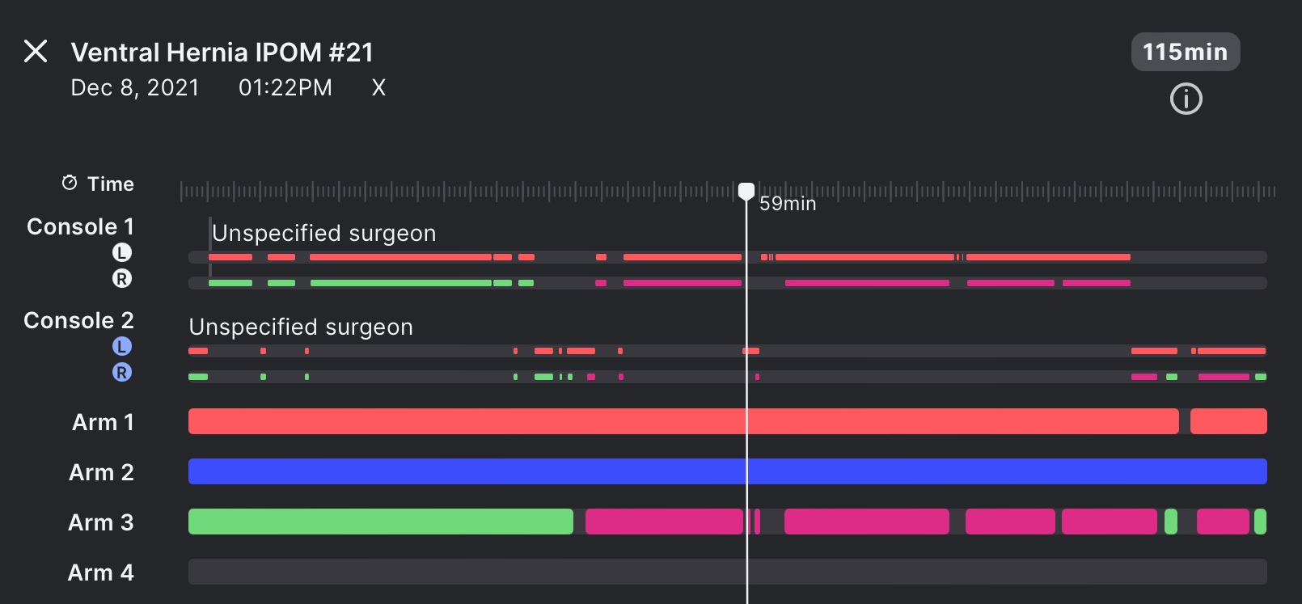
Please circle one of the following.

0-25% 26-50% 51-75% 76-100%

