Supplementary materials

The implications of lipids mobility, drug-enhancers (surfactants)-skin interaction and TRPV1 on licorice flavonoids permeability

Zhuxian Wang, Yi Hu, Yaqi Xue, Yufan Wu, Quanfu Zeng, Hongkai Chen, Yinglin Guo, Peiyi Liang, Chunyan Shen, Cuiping Jiang, Li Liu, Qun Shen, Hongxia Zhu*, Qiang Liu*

¹ School of Traditional Chinese Medicine, Southern Medical University, Guangzhou 510515, China.
# Zhuxian Wang and #Yi Hu contributed equally to this work.
*Corresponding author.
School of Traditional Chinese Medicine, Southern Medical University, 1838, North Guangzhou Avenue, Guangzhou, China 510515 (Hongxia Zhu and Qiang Liu)
Email address:gzzhx2012@163.com(Hongxia Zhu); liuqiang@smu.edu.cn (Qiang Liu);
Phone: +86-20-6278-9408 (Hongxia Zhu); +86-20-6164-8264 (Qiang Liu)

Method S1 HPLC analysis
HPLC (Agilent 1260, USA) equipped with C18 column (5 µm, 4.6 × 250 mm) and DAD detector was used for analysis. The HPLC methods were as follows. The mobile phase consisted of combinations of A (acetonitrile), B (methanol) and C (0.1% phosphate in water, v/v) at a flow rate of 1.0 mL/min with an elution gradient as follows: 0 min, 15% A and 75% C; 5 min, 22% A and 66% C; 10 min, 32% A and 54% C; 20 min, 45% A and 35% C; 20–30 min, 45% A and 35% C; 40 min, 15% A and 10% B. The detection wavelength was set at 300 nm, and the injection volume was 20 µL.

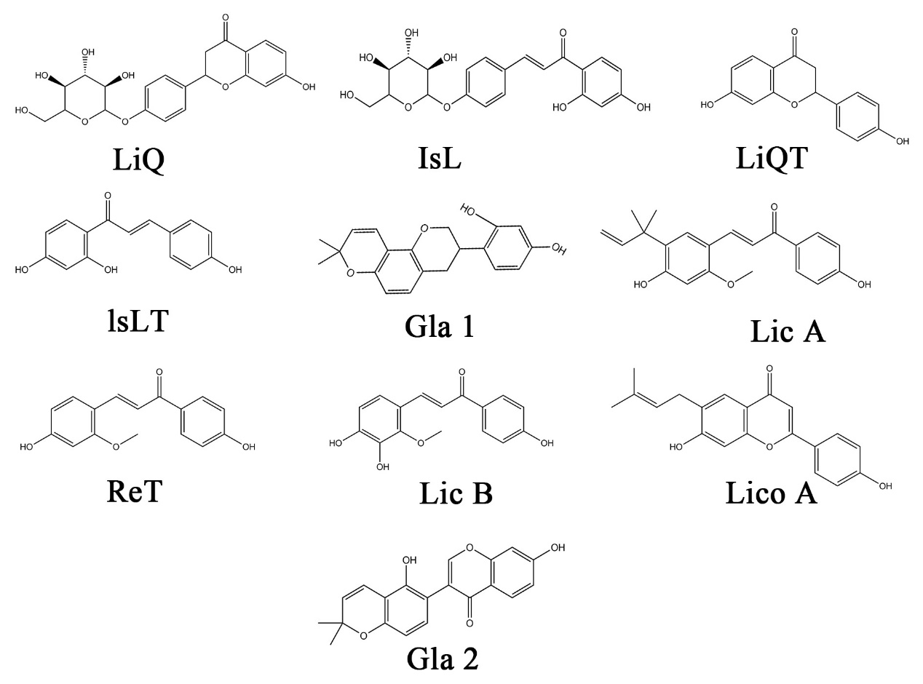
Figure S1 The chemical structure of 10 LFs compounds

Figure S2 The chemical structure of 7 enhancers

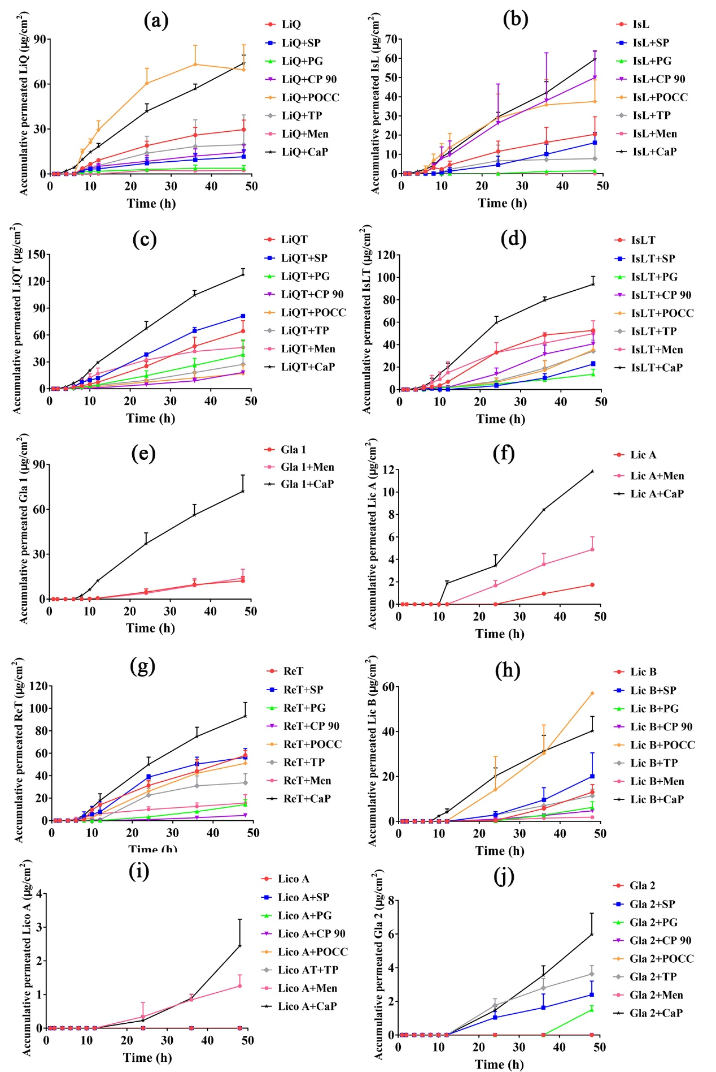

Figure S3 The in vitro permeation profile of ten LFs compounds through the porcine skin in the action of seven enhancers (mean±SD, n=4)

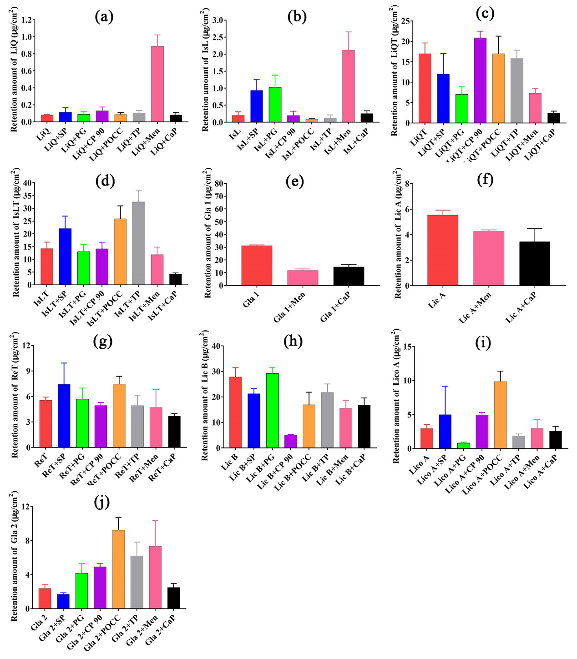
Figure S4 The skin retention amount of ten LFs compounds in the porcine skin in the action of seven enhancers (mean±SD, n=4)

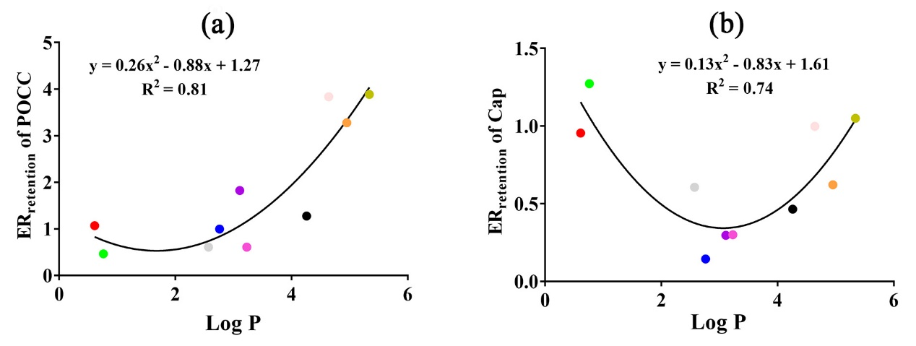
Figure S5 The correlation analysis showing a parabolic correlation between ER_{retention} or ER_{permeation} and the log P value of LFs compounds for POCC and CaP. (The dots from left to right represented LiQ, IsL, Lic B, LiQT, IsLT, ReT, Gla 1, Lico A, Lic A and Gla 2, respectively.)

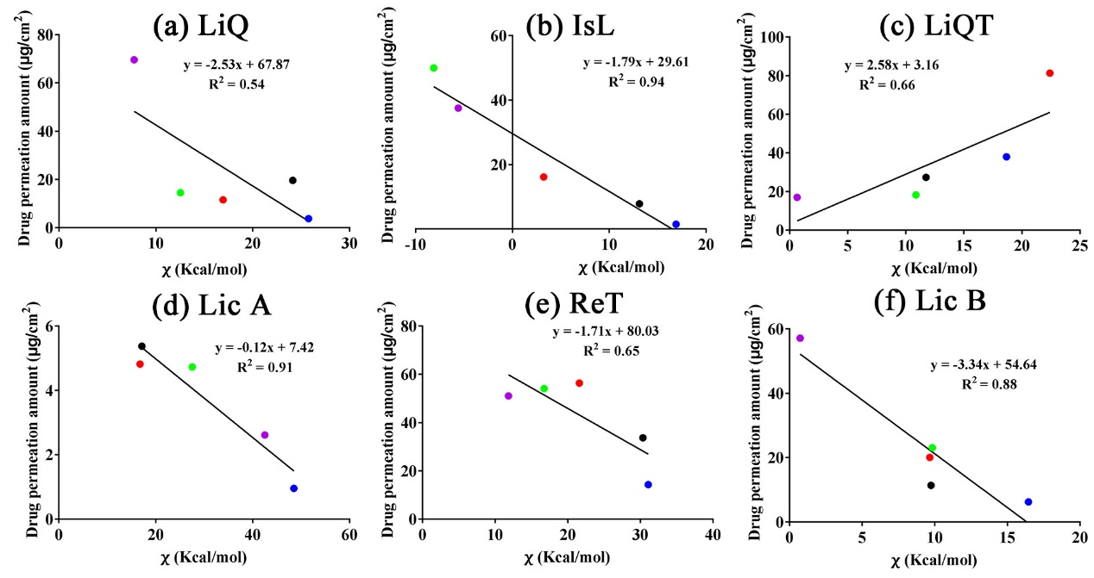
Figure S6 The linear negative relationship between drug permeation amount and χ values of drug-enhancer-skin systems. (LiQ (a), IsL (b), LiQT (c), Lic A (d), ReT (e), Lic B (f), Herein, the black dots, green dots, red dots, blue dots and purple dots represented TP, CP, SP, PG and POCC respectively.).

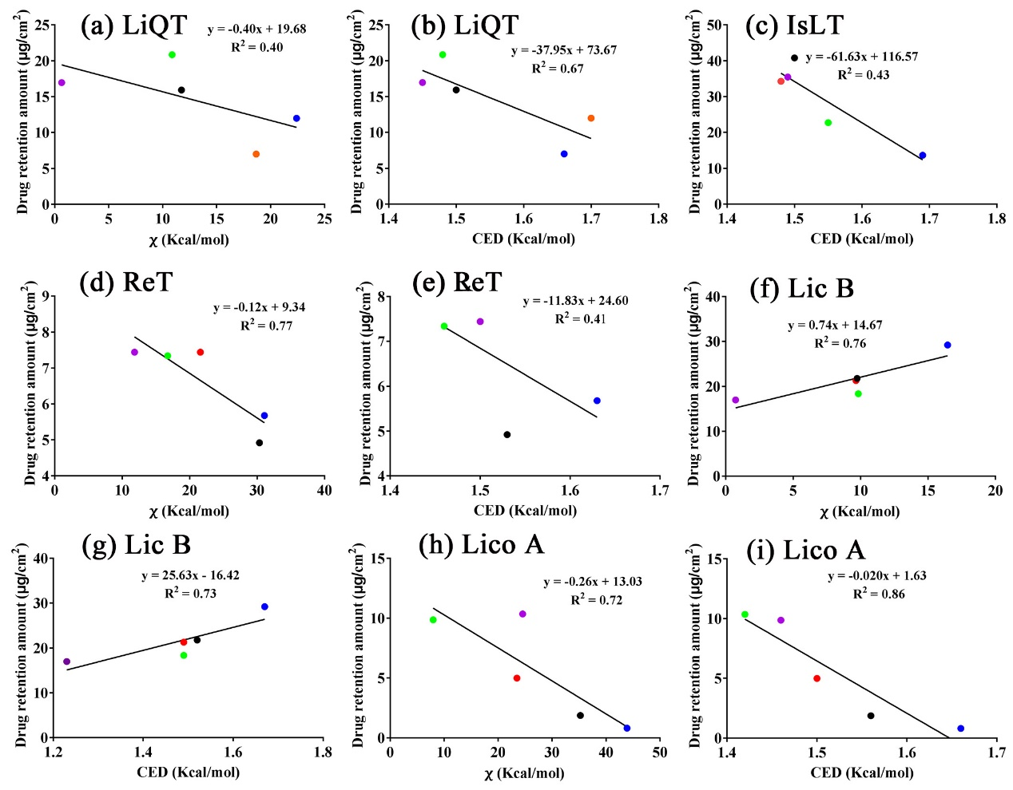

Figure S7 The linear negative relationship between drug retention amount and χ or CED values of drug-enhancer-skin systems. (LiQT (a, b), IsLT (c), ReT (d, e), Lic B (f, g), Lico A (h, i), Herein, the black dots, green dots, red dots, blue dots and purple dots represented TP, CP, SP, PG and POCC respectively.).

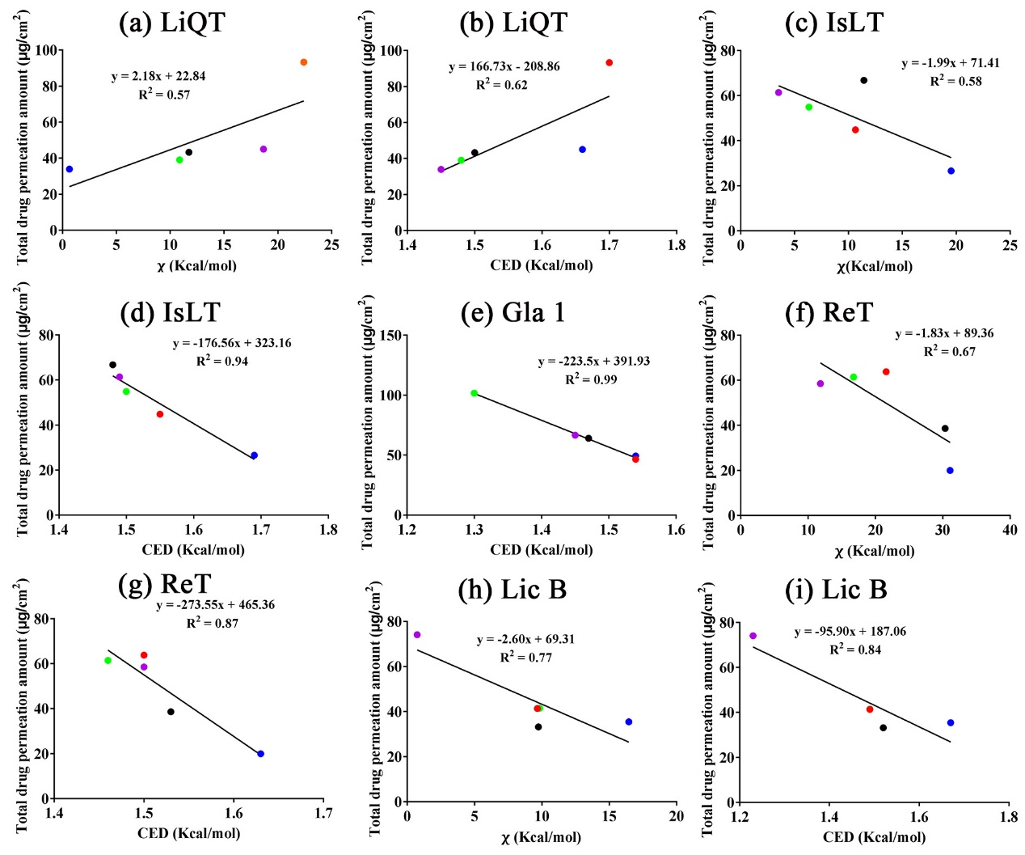
Figure S8 The linear negative relationship between total drug penetration amount and χ or CED values of drug-enhancer-skin systems. (LiQT (a, b), IsLT (c), ReT (d, e), Lic B (f, g), Lico A (h, i) .Herein, the black dots, green dots, red dots, blue dots and purple dots represented TP, CP, SP, PG and POCC respectively.).

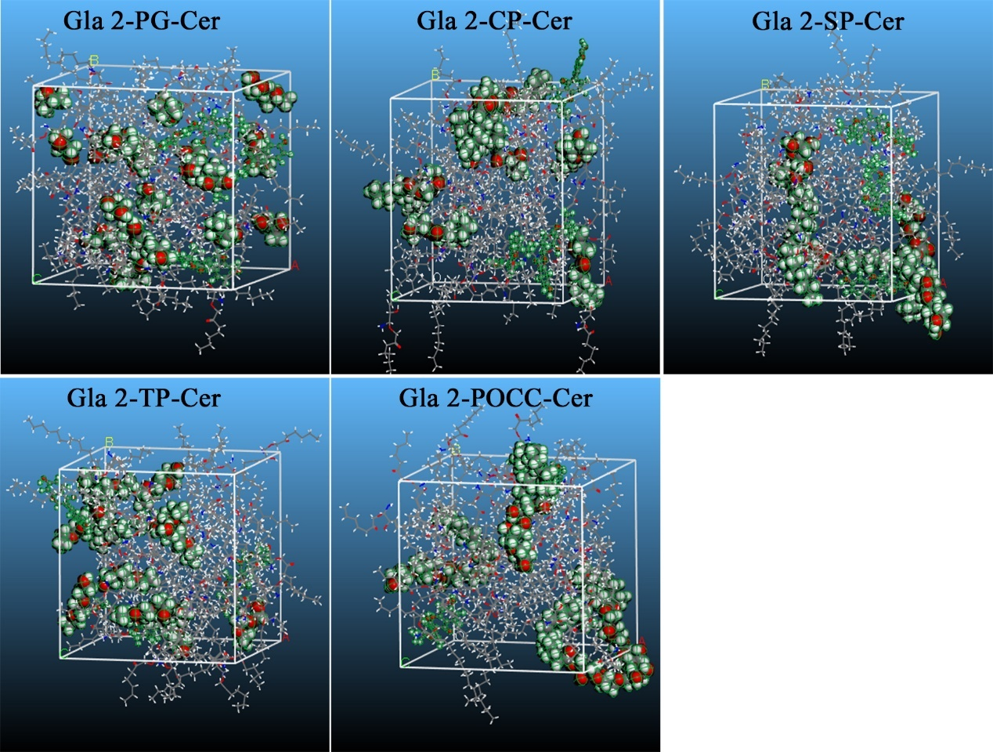
Figure S9 The snapshots of the Gla 2-enhancer-skin associations.

Table 1 The physicochemical parameters of different LFs compounds.

 | Molecular weight (M.W.) | Hydrogen bond donors | Hydrogen bond receptors | Polarizability | Log P | Polar surface area (Å)
LiQ | 418.40 | 5 | 9 | 40.5 | 0.61 | 146.0
IsL | 418.40 | 6 | 9 | 42.3 | 0.76 | 157.0
LiQT | 256.25 | 2 | 4 | 27.1 | 2.76 | 66.8
IsLT | 256.25 | 3 | 4 | 28.8 | 3.11 | 77.8
Gla 1 | 324.40 | 2 | 4 | 36.1 | 4.26 | 58.9
Lic A | 338.40 | 2 | 4 | 39.8 | 4.95 | 66.8
ReT | 270.28 | 2 | 4 | 30.7 | 3.23 | 66.8
Lic B | 286.28 | 3 | 5 | 31.5 | 2.57 | 87.0
Lico A | 322.40 | 2 | 4 | 36.2 | 4.64 | 66.8
Gla 2 | 336.30 | 2 | 3 | 35.9 | 5.34 | 76.0

The physicochemical parameters were obtained using advanced chemistry development (ACD/Labs) software V11.02

Table 2 The physicochemical parameters of 5 enhancers with different lipophilic nature
Enhancers | Molecular weight (Da) | Log P | Polarizability | Polar surface area(Å)
CP | 203.30 | 4.97 | 33.5 | 47.0
PG | 76.09 | -0.90 | 7.52 | 40.5
POCC | 726.90 | 6.21 | 74.8 | 269.0
SP | 428.60 | 6.06 | 47.3 | 96.0
TP | 134.20 | -1.08 | 13.8 | 39.0

The physicochemical parameters were obtained using advanced chemistry development (ACD/Labs) software V11.02

Table S3 The enhancing parameters including J_{ss}, T_{lag}, P, K and ER of POCC on different LFs compounds
Samples | Jss (μg/cm²/h) | T_{lag} (h) | K (10³) | P(cm²/h*10⁴) | ER
LiQ | 0.71±0.15 | 1.68±0.62 | 4.38±0.04 | 0.43±0.00
LiQ +POCC | 1.79±0.38 | 0.07±0.43 | 0.52±0.01 | 1.25±0.02 | 2.35
IsL | 0.47±0.21 | 2.44±0.17 | 1.11±0.00 | 0.08±0.00
IsL +POCC | 0.92±0.29 | 0.64±1.36 | 0.49±0.01 | 0.13±0.00 | 1.83
LiQT | 1.43±0.28 | 4.30±0.10 | 15.90±0.55 | 0.62±0.02
LiQT +POCC | 0.38±0.21 | 3.79±0.60 | 2.81±0.03 | 0.12±0.00 | 0.26
IsLT | 1.32±0.043 | 3.87±0.42 | 31.66±0.07 | 1.36±0.00
IsLT +POCC | 1.57±0.14 | 5.76±0.12 | 45.74±0.65 | 1.32±0.02 | 1.45
Gla 1 | 0.28±0.08 | 5.41±0.43 | 10.89±0.65 | 0.34±0.02
Gla 1+POCC | 0.55±0.12 | 6.07±0.32 | 15.04±0.19 | 0.41±0.01 | 2.18
Lic A | 0.03±0.00 | 7.21±0.01 | 1.96±0.07 | 0.05±0.00
Lic A +POCC | 0.10±0.040 | 7.28±0.74 | 3.03±0.12 | 0.07±0.00 | 3.09
ReT | 1.33±0.04 | 3.24±0.17 | 32.45±1.09 | 1.67±0.06
ReT +POCC | 1.22±0.29 | 4.54±0.50 | 31.18±0.09 | 1.14±0.00 | 0.88
Lic B | 0.24±0.043 | 7.23±0.15 | 1.19±0.08 | 0.03±0.00
Lic B +POCC | 1.17±0.17 | 6.45±1.10 | 3.51±0.07 | 0.09±0.00 | 4.39

