Supporting Information
REMOVAL OF RHODAMINE B AND METHYLENE BLUE USING RESIDUAL Onecarpus bacaba Mart FIBERS AS BIOSORBENT: KINETIC AND THERMODYNAMIC PARAMETERS
Eberlanny Moraes Rolim¹, Andreza Miranda Barata da Silva¹, Joel dos Santos Batista¹, Naiany Oliveira Serrão¹, Leticia Layer Oliver², Flávio Augusto de Freitas³, Gustavo Frigi Perotti¹, Dominique Fernandes de Moura do Carmo¹, Gustavo de Gusmão Celestino⁴, Paulo José Sousa Maia²
¹Instituto de Ciências Exatas e Tecnologia, Universidade Federal do Amazonas, Itacoatiara, Amazonas 69103128, Brasil
² Universidade Federal do Rio de Janeiro, Campus Macaé Professor Aloísio Teixeira, Polo Universitário, 27930-560, Macaé, Rio de Janeiro, Brasil
³Centro de Biotecnologia da Amazônia –CBA, Av. Gov. Danilo de Matos Areosa, 690 - Distrito Industrial I, Manaus - AM, 69075-351, Brasil
⁴Universidade Federal do Rio de Janeiro, Programa de Engenharia Metalúrgica e de Materiais/COPPE/LADPOL, Av. Horácio Macedo, 2030, Bloco F, 21941598 Rio de Janeiro, RJ, Brasil
*To whom correspondence should be addressed:
Paulo José Sousa Maia (pmldcb@gmail.com)
orcid.org/0000-0003-3101-3712

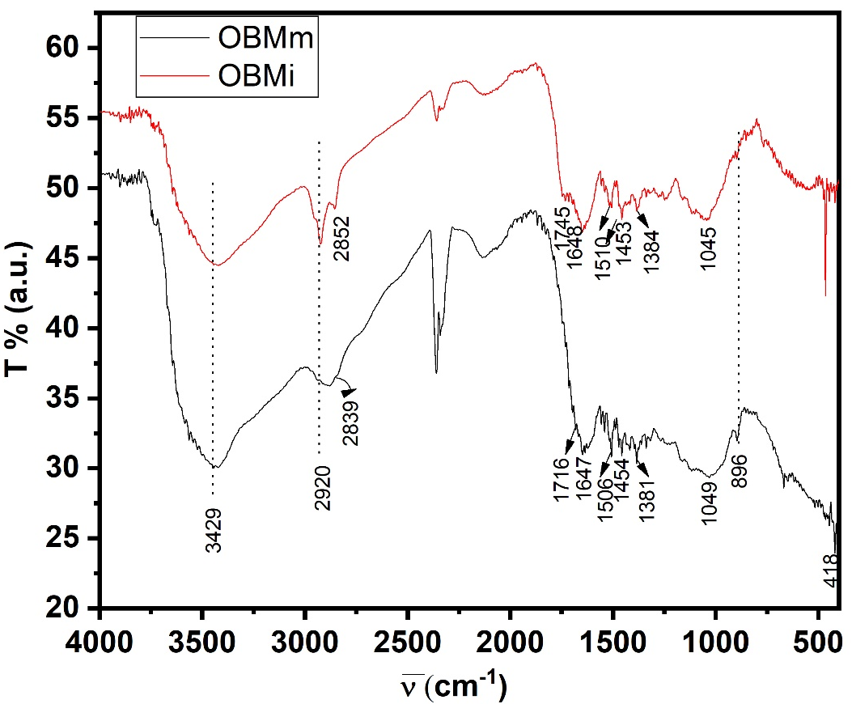
Figure S1. FTIR spectra for OBMi and OBMm.

Figure S2. ΔpH × pH_{f}; point of zero charge for OBMi/OBMm at pH 4.34 and 6.06, respectively (200 mg of the adsorbent, 25 mL of solution at 25 ºC).

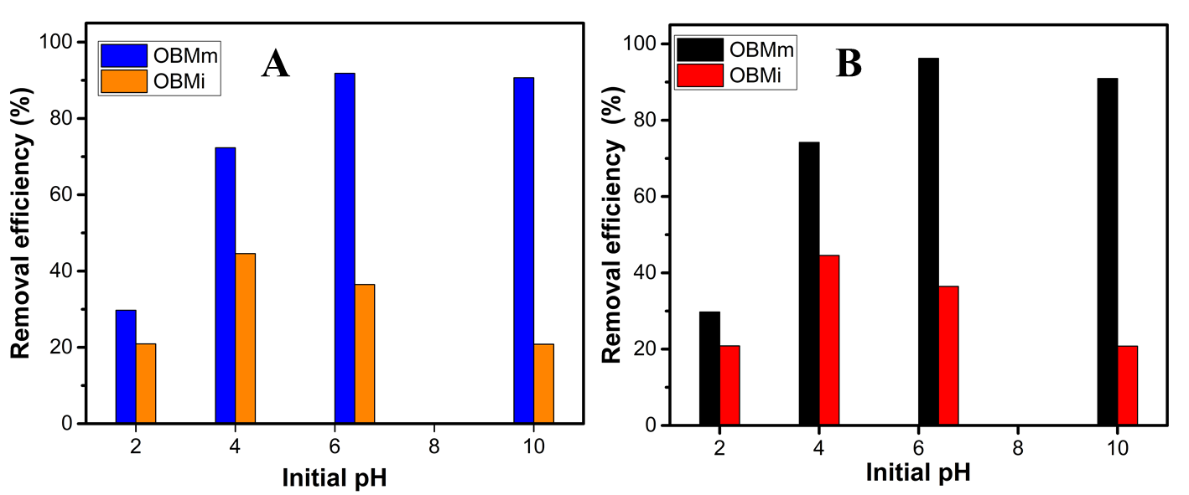
Figure S3. Effect of initial on adsorption of (A) RhB and (B) MB onto in natura (OBMi) and NaOH-modified (OBMm) Onecarpus bacaba Mart fibers.

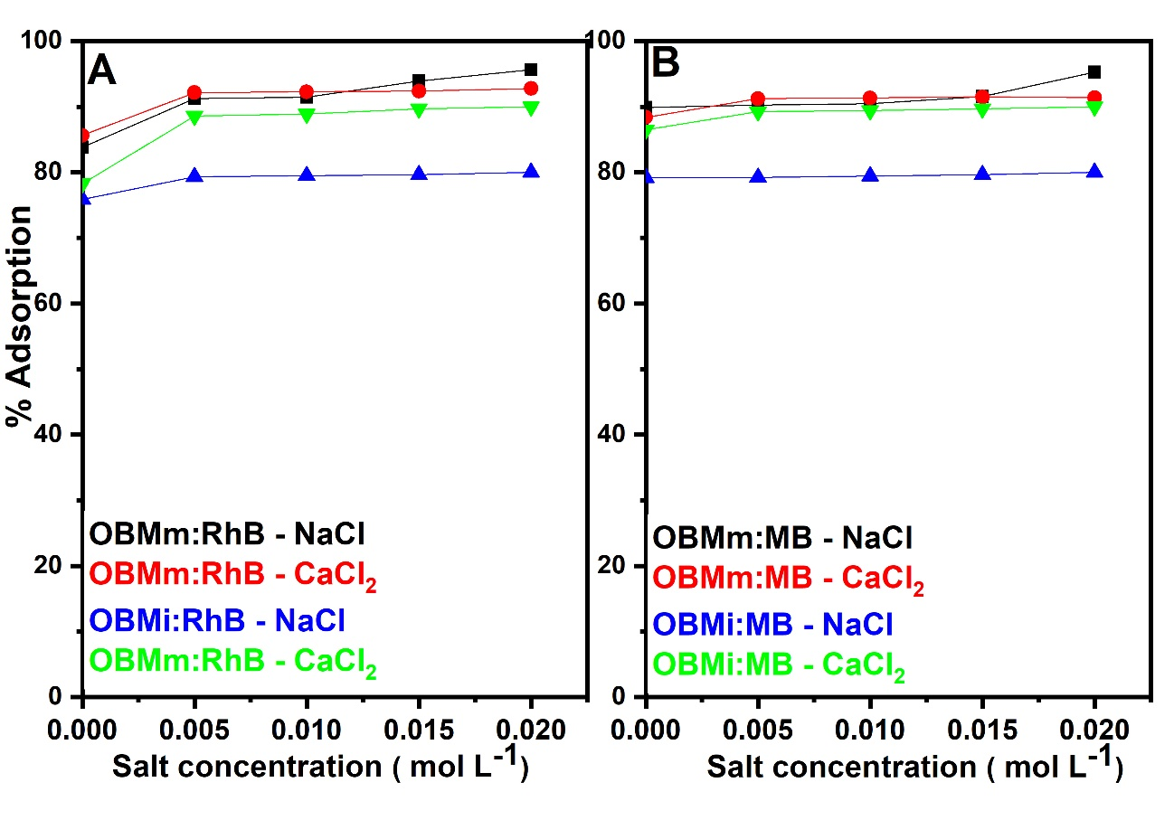
Figure S4. Effect of ionic strength on (A) MB and (B) RhB for OBMi and OBMm (adsorbent dosage = 200 mg, solution volume = 50 mL; contact time = 3 h; temperature = 298 K).

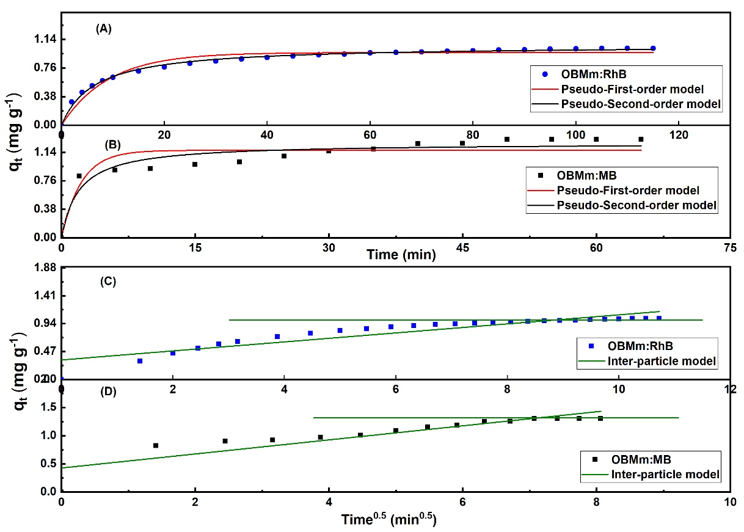
Figure S5. Adsorption kinetics for pseudo-first-order model and pseudo-second-order model analyses and experimental results: (A) OBMm:RhB and (B) OBMm:MB, and for the interparticle diffusion model: (C) OBMm:RhB and (D) OBMm:MB at 25 °C and pH 6.

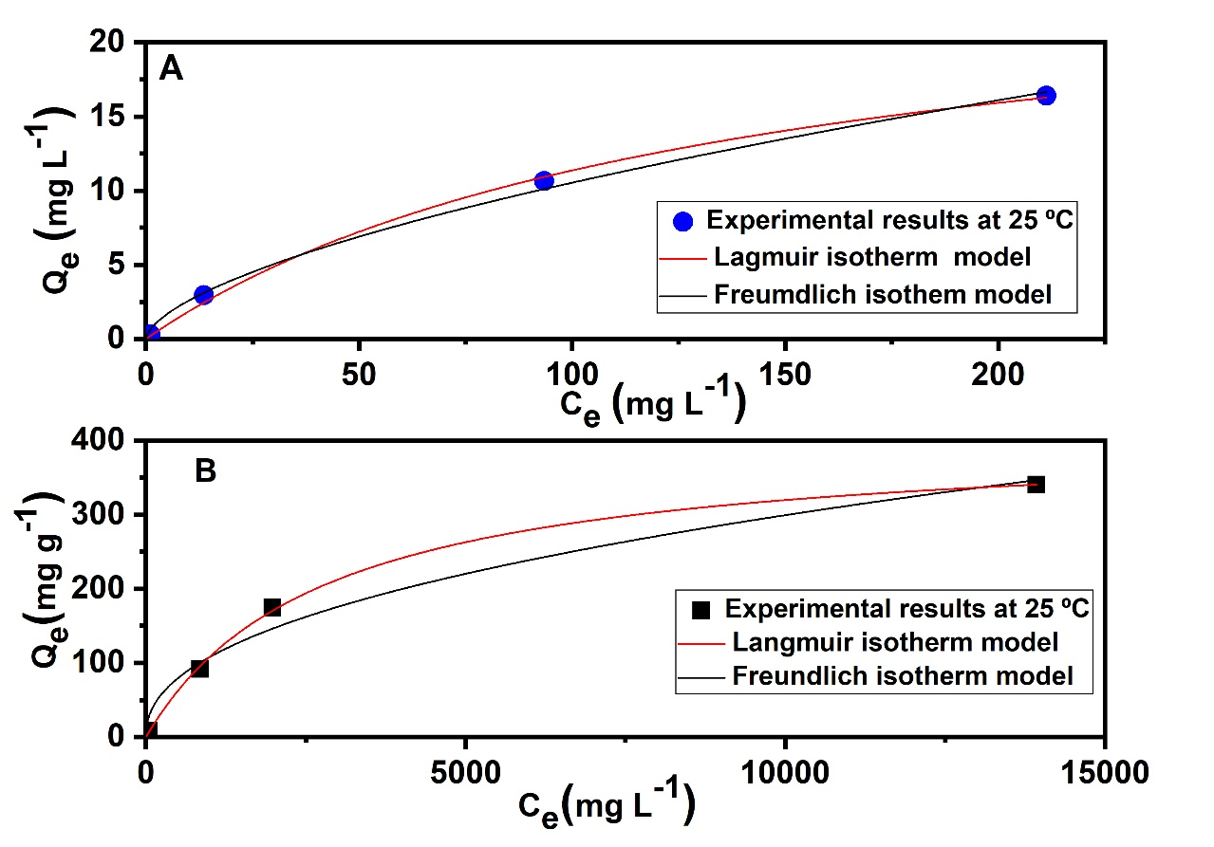
Figure S6: Adsorption isotherms and model fit for adsorption isotherm with adsorption isotherms at optimized conditions: (A) OBMm:MB and B) RhB on OBMm at 25 ºC.

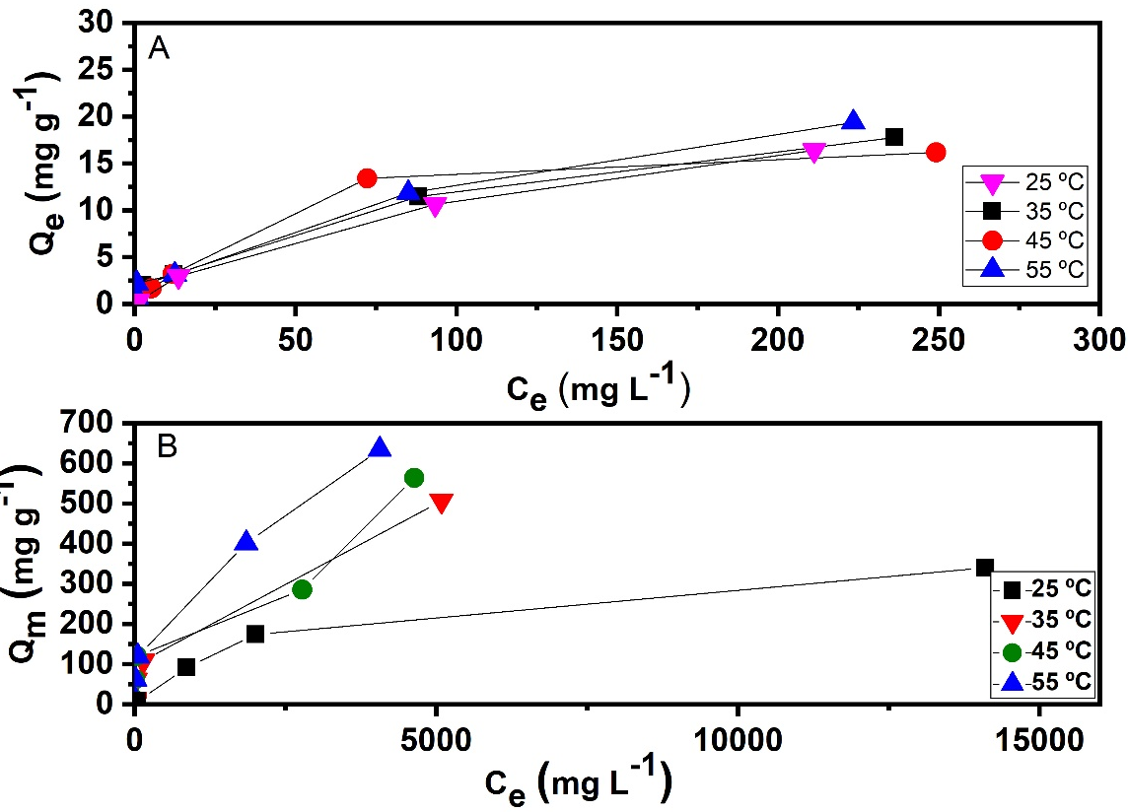
Figure S7. Adsorption isotherms and model fit for adsorption isotherm with adsorption isotherms at optimized conditions: (A) OBMm:MB and (B) OBMm:RhB at 25 ºC

