Supplementary information for
Transitioning to healthy and sustainable diets has high environmental and affordability trade-offs for developing countries
Zhongci Deng¹, Yuanchao Hu², Cai Li^{1,3}, Jingyu Wang¹, Pan He⁴, Zhen Wang^{1,5,*}, Brett A Bryan³

1 College of Resources and Environment, Huazhong Agricultural University, Wuhan 4300770, China.
2 School of Resources and Environmental Sciences, Wuhan University, Wuhan 430079, China.
3 School of Life and Environmental Sciences, Deakin University, Melbourne, Vic, Au
4 School of Earth and Ocean Sciences, Cardiff University, Cardiff, UK.
5 Interdisciplinary Research Center for Territorial Spatial Governance and Green Development, Huazhong Agricultural University, Wuhan 430070, China.

* Corresponding authors: Zhen Wang: sinoo@mail.hzau.edu.cn
Table of Contents
S1 Model of Production and its Impacts on the Environment (MAgPIE). 2
S2 Scenario design. 3
S3 Detailed information about water use in different dietary scenarios 5
S4 Food demand and Food price under different scenarios. 7
S5 Detailed characterizations of HUS, MED, and VEG scenarios. 8
S6 Result of completing the linear shifting by 2030. 11
S7 Result of fast transformation in the early stage. 13
S8 Result of slow transformation in the early stage. 15
S9 Additional supplementary information 17
Supplementary References 22

S1 Model of Production and its Impacts on the Environment (MAgPIE).
The Model of Production and its Impact on the Environment (MAgPIE)¹ is a modular open-source framework for modelling land systems and can be used for creating global and regional long-term scenarios of future food and agriculture. It combines economic approaches of a partial equilibrium model with (bio-)physical constraints at a clustered 0.5◦ resolution. Spatially explicit yield patterns and irrigation water availability are derived from the global gridded crop, vegetation and hydrology model LPJmL².
The demand for food is determined at the country level accounting for changes in population, demographic structure, body-weight distribution, and dietary composition³. The source code and a detailed documentations of MAgPIE are available online at https://github.com/magpiemodel/magpie; for this work model version 4.6.3¹ is used.
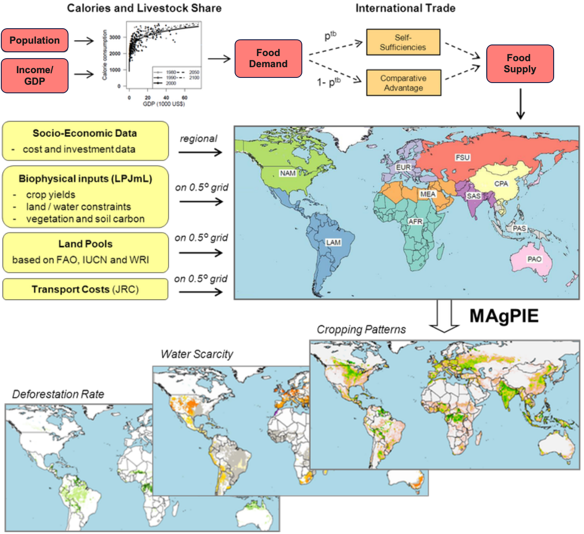
Figure S1. Simplified MAgPIE flowchart of key processes, reproduced from Potsdam Institute For Climate Impact Research, https://www.pik-potsdam.de/en/institute/departments/activities/land-use-modelling/magpie

S2 Scenario design.
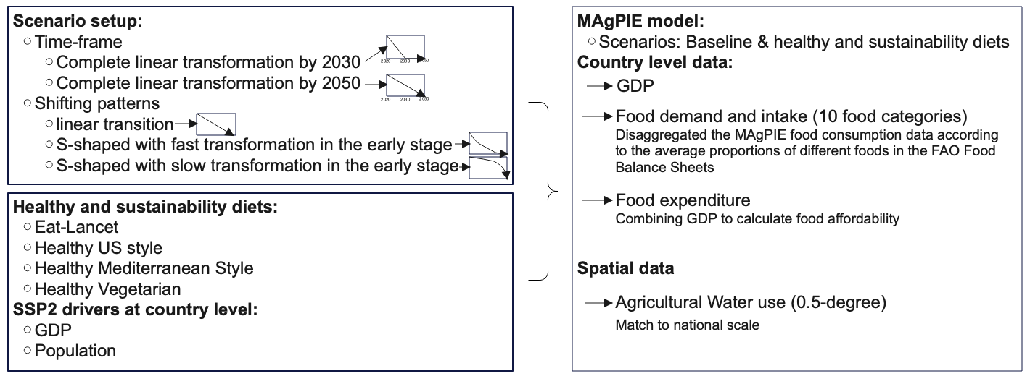
Figure S2: Flowchart summarizing the methodology used in this work

Table S1 Relation between MAgPIE and FAO food categories
Food group | MAgPIE Food categories | FAO Food categories
Oils | Oils | Animal fats  Vegetable oil
Vegetables | Others | Vegetables
Nuts | Others | Nuts
Fruit | Others | Fruits

Table S2 The Alternate Healthy Eating Index scoring method
Component | Criteria for minimum score (0) | Criteria for maximum score (10)
Vegetables,¹ servings/d | $$0$$ | $$≥5$$
Fruit,² servings/d | $$0$$ | $$≥4$$
Whole grains,³ servings/d | $$0$$ | $$6$$
Sugar & Sweeteners,⁴ servings/d | $$≥1$$ | $$0$$
Nuts and legumes,⁵ servings/d | $$0$$ | $$≥1$$
Red/processed meat,⁶ servings/d | $$≥1.5$$ | $$0$$
Trans Fat, % of energy | $$≥4$$ | $$≤0.5$$
Long-chain (n-3) fats (Omega-3 fat), mg/d | $$0$$ | $$250$$
PUFA, % of energy | $$≤2$$ | $$≥10$$
Total | $$0$$ | $90$
Abbreviations: PUFA, polyunsaturated fatty acid.
¹ 1 serving of vegetables equals to 65 g.
² 1 serving of fruit equals to 65 g.
³ 1 serving of whole grains equals to 40 g (1 cup cooked) of whole-grain cereal.
⁴ 1 serving of sugar-sweetened beverage equals to 226.8 g (8 oz).
⁵ 1 serving of nuts and legumes equals to 50 g of nuts/legumes/seeds.
⁶ 1 serving of red and/or processed meats equals to 100 g.

S3 Detailed information about water use in different dietary scenarios
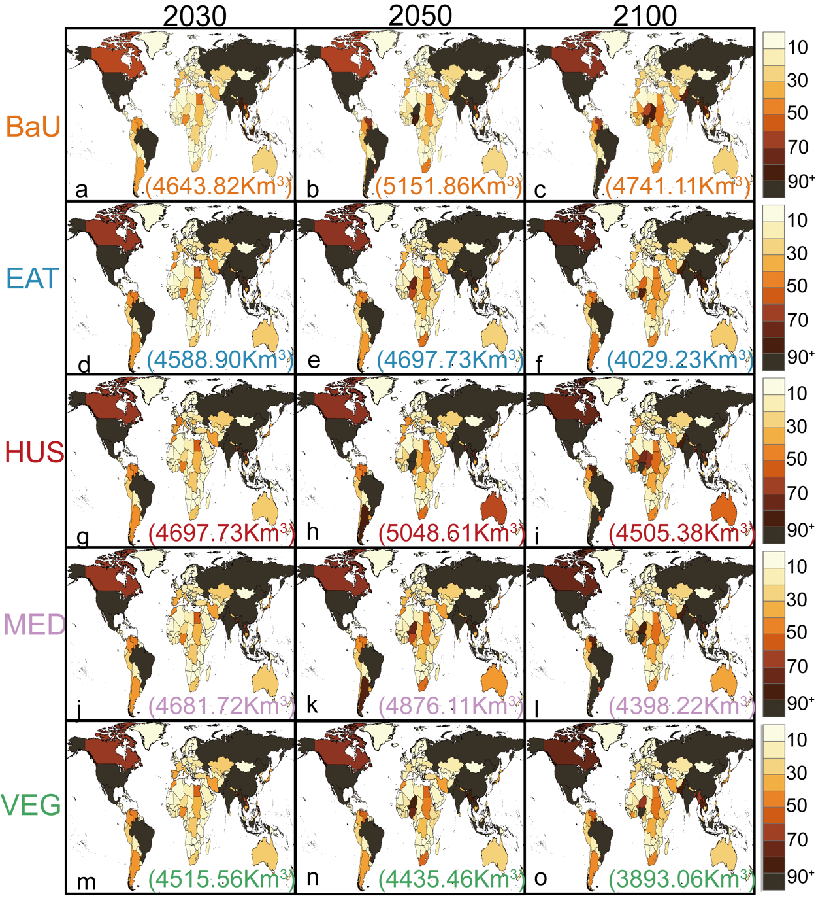
Figure S3. Spatial distribution of water use under different scenarios in 2030, 2050 and 2100.

Figure S4. Water use efficiency and irrigated area in different regions

S4 Food demand and Food price under different scenarios.
Figure S5. Food demand and food price under different scenarios.

S5 Detailed characterizations of HUS, MED, and VEG scenarios.
In the HUS scenario, due to the relatively higher meat and sugar consumption, up to 134 countries are projected to fall into quadrants II, III, and IV by 2030. This indicates that many countries will face trade-offs between water use and food affordability during the transition to the HUS scenario. Among these countries, 39 will experience improved dietary quality and affordability, but at the cost of increased water use. Several developed nations will also be affected. For example, France is projected to have trade-offs in water use (-64.04%). Additionally, 51 countries will face affordability trade-offs, where dietary shifts can enhance dietary quality and reduce water use but will elevate the share of food expenditure. African and Asian countries are expected to bear the brunt of affordability trade-offs, with an estimated increase in food expenditure by 46.68±37.89% and 66.28±43.64%, respectively. Notably, Burundi is projected to face the largest trade-off in food affordability, with a substantial decline of 159.69%. It is important to note that, in the HUS scenario, an additional 42 countries will only witness improvements in dietary quality, while encountering trade-offs in water use and affordability (Figure S6). These trade-offs can pose challenges for these countries during the dietary shift, potentially impeding their progress. Looking ahead, projections indicate that by 2100, an additional 60 countries will benefit from the dietary shift, achieving healthier dietary quality while simultaneously reducing water use and enhancing food affordability. But it needs to be emphasized that many countries will require a longer time to observe the benefits of dietary shifts in food affordability or water use due to more meat and sugar consumption. For example, it is evident that a significant number of African and Asian countries would not transition to quadrant I until after 2060 if they were to adopt the HUS diet. Additionally, countries such as the United States, China, and several European nations would not experience immediate enhancements in food affordability or reductions in water use compared to the EAT diet. Also, Furthermore, due to the higher consumption of meat and sugar, 74 countries in this scenario will still fall into quadrants II, III, and IV by 2100. This suggests that although these countries will witness improvements in dietary quality, trade-offs in food affordability or environmental sustainability will persist. In the HUS scenario for the year 2100, it is projected that three countries—North Korea, Trinidad and Tobago, and Sri Lanka—would experience synergies in dietary quality. However, these countries would still face trade-offs in terms of water use and food affordability, albeit to a lesser extent.
The MED and VEG scenarios are like the HUS and EAT scenarios, respectively. In the MED scenario, more countries than in the HUS scenario will face food affordability trade-offs due to higher fish consumption, and generally have a larger share of food expenditure. Of these, North Korea has the most obvious food affordability issue, with a decrease of 329.18%, although its dietary quality will be improved by 13.51% and no apparent change occurs in water use. Western Sahara, Iran, Saudi Arabia, and Venezuela will also face common trade-offs in both water use and food affordability. For the VEG scenario, countries with low legumes/nuts consumption may also face greater trade-offs in water use, with water use increases ranging from 0.03% to 81.46%. However, there are also positive aspects that the VEG scenario does not lead to trade-offs in food affordability for any country other than North Korea due to reduced meat and sugar consumption. This highlights the importance of a plant-based diet in reducing food costs.
For more detailed country-level data, please refer to supplementary data 1
Figure S6 Changes in country quadrants over time associated with the a) HUS, b) MED, and c) VEG diets.
Figure S7 Differences in total caloric needs relative to the BaU scenario for EAT diet.
Other dietary scenario results can refer to supplementary data 2
Figure S8 Water environmental flow violation volume in different scenario in 2100

S6 Result of completing the linear shifting by 2030.
We do not show the health effects of dietary shifts in the appendix because the timing and transition curves of dietary shifts do not affect the dietary quality results.
Figure S9. water use at global level over time (Result of completing the linear shifting by 2030)
National scale data can refer to Supplementary data 3.

Figure S10. Share of food expenditure in different dietary scenarios at the global level over time (Result of completing the linear shifting by 2030).
National scale data can refer to Supplementary data 4.

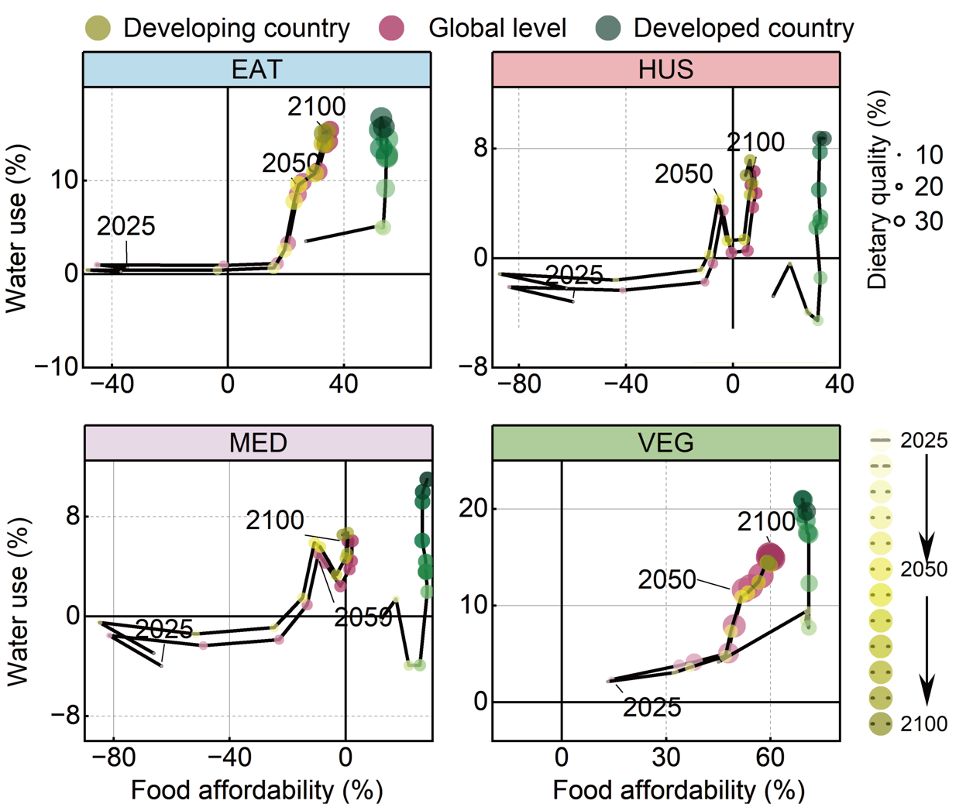 Figure S11. Synergies and trade-offs associated with different dietary transitions at global level over time (Result of completing the linear shifting by 2030).

S7 Result of fast transformation in the early stage.
Figure S12. water use at global level over time (Result of fast transformation in the early stage)
National scale data can refer to Supplementary data 5.

Figure S13. Share of food expenditure in different dietary scenarios at the global level over time (Result of fast transformation in the early stage).
National scale data can refer to Supplementary data 6.
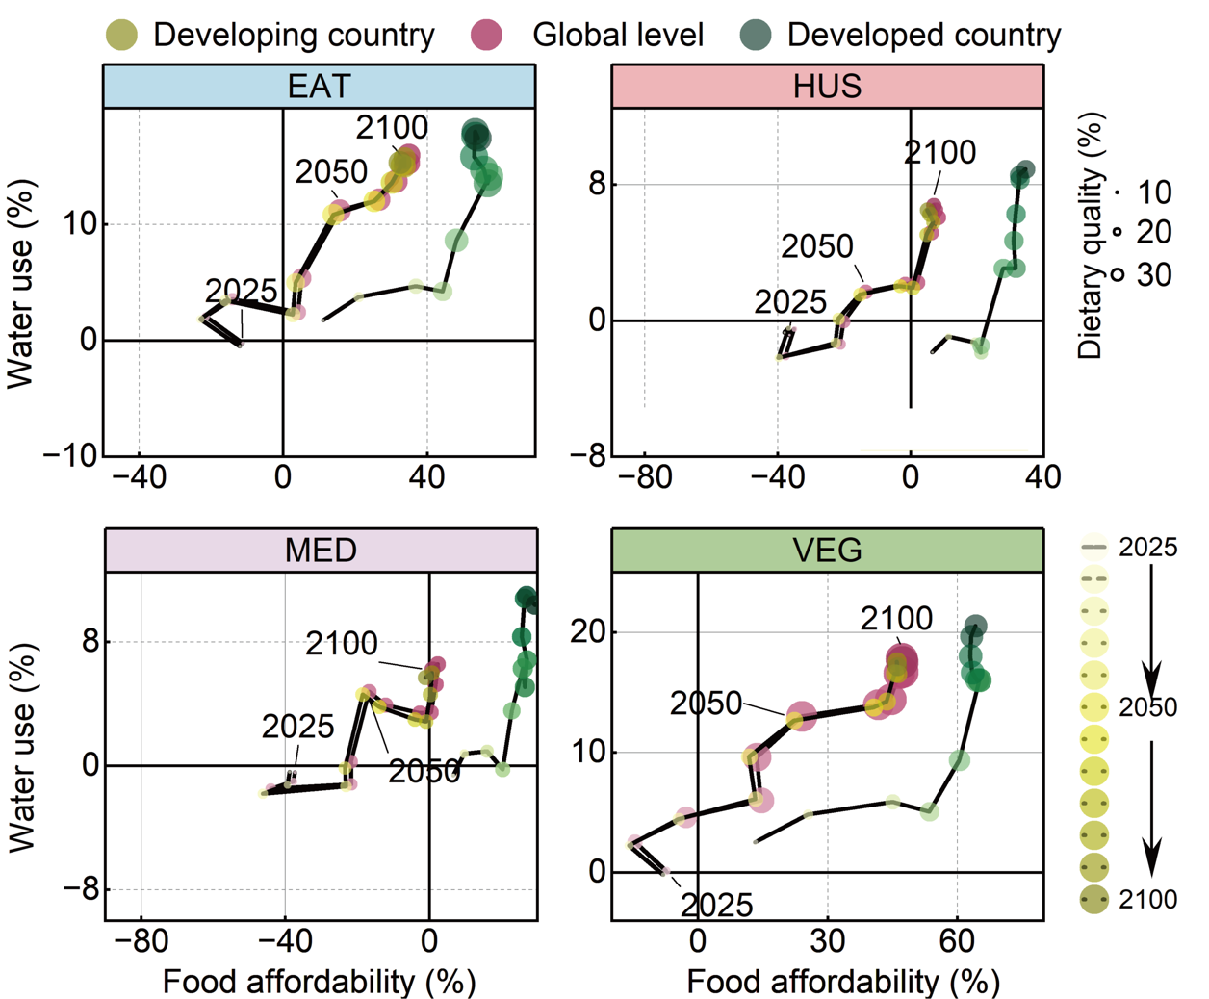 Figure S14. Synergies and trade-offs associated with different dietary transitions at global level over time (Result of fast transformation in the early stage).

S8 Result of slow transformation in the early stage.
Figure S15. water use at global level over time (Result of slow transformation in the early stage)
National scale data can refer to Supplementary data 7.

Figure S16. Share of food expenditure in different dietary scenarios at the global level over time (Result of slow transformation in the early stage).
National scale data can refer to Supplementary data 8.
Figure S17. Synergies and trade-offs associated with different dietary transitions at global level over time (Result of slow transformation in the early stage).

S9 Additional supplementary information
Table S3 Countries and abbreviations covered in this study
Country name | Abbreviation | Region
Senegal | SEN | Africa
Gambia | GMB | Africa
Mauritania | MRT | Africa
Western Sahara | ESH | Africa
Guinea-Bissau | GNB | Africa
Guinea | GIN | Africa
Sierra Leone | SLE | Africa
Mali | MLI | Africa
Liberia | LBR | Africa
Cote d Ivoire | CIV | Africa
Burkina Faso | BFA | Africa
Ghana | GHA | Africa
Togo | TGO | Africa
Niger | NER | Africa
Benin | BEN | Africa
Algeria | DZA | Africa
Nigeria | NGA | Africa
Cameroon | CMR | Africa
Gabon | GAB | Africa
Equatorial Guinea | GNQ | Africa
Namibia | NAM | Africa
Angola | AGO | Africa
Congo | COG | Africa
Congo the Democratic Republic of the | COD | Africa
Libya | LBY | Africa
Chad | TCD | Africa
Central African Republic | CAF | Africa
South Africa | ZAF | Africa
Botswana | BWA | Africa
Zambia | ZMB | Africa
Sudan | SDN | Africa
Zimbabwe | ZWE | Africa
Lesotho | LSO | Africa
Burundi | BDI | Africa
Rwanda | RWA | Africa
Tanzania United Republic of | TZA | Africa
Uganda | UGA | Africa
Mozambique | MOZ | Africa
Swaziland | SWZ | Africa
Malawi | MWI | Africa
Ethiopia | ETH | Africa
Egypt | EGY | Africa
Kenya | KEN | Africa
Eritrea | ERI | Africa
Somalia | SOM | Africa
Djibouti | DJI | Africa
Madagascar | MDG | Africa
Mauritius | MUS | Africa
French Southern Territories | ATF | Asia
China | CHN | Asia
India | IND | Asia
Nepal | NPL | Asia
Mongolia | MNG | Asia
Myanmar | MMR | Asia
Lao People's Democratic Republic | LAO | Asia
Thailand | THA | Asia
Cambodia | KHM | Asia
Viet Nam | VNM | Asia
Russian Federation | RUS | Europe
Korea Democratic People's Republic of | PRK | Asia
Greenland | GRL | Europe
Iceland | ISL | Europe
Spain | ESP | Europe
Ireland | IRL | Europe
Portugal | PRT | Europe
United Kingdom | GBR | Europe
France | FRA | Europe
Belgium | BEL | Europe
Netherlands | NLD | Europe
Norway | NOR | Europe
Luxembourg | LUX | Europe
Germany | DEU | Europe
Switzerland | CHE | Europe
Italy | ITA | Europe
Denmark | DNK | Europe
Austria | AUT | Europe
Sweden | SWE | Europe
Czech Republic | CZE | Europe
Croatia | HRV | Europe
Slovenia | SVN | Europe
Svalbard and Jan Mayen | SJM | Europe
Poland | POL | Europe
Bosnia and Herzegovina | BIH | Europe
Hungary | HUN | Europe
Slovakia | SVK | Europe
Reoublic of Montenegro | YUG | Europe
Serbia | SEB | Europe
Albania | ALB | Europe
Greece | GRC | Europe
Macedonia the former Yugoslav Republic of | MKD | Europe
Romania | ROM | Europe
Lithuania | LTU | Europe
Latvia | LVA | Europe
Finland | FIN | Europe
Estonia | EST | Europe
Bulgaria | BGR | Europe
Belarus | BLR | Europe
Turkey | TUR | Europe
Moldova Republic of | MDA | Europe
Cyprus | CYP | Europe
Iran Islamic Republic of | IRN | Africa
Ukraine | UKR | Europe
Georgia | GEO | Europe
Armenia | ARM | Europe
Azerbaijan | AZE | Europe
Kazakhstan | KAZ | Europe
Turkmenistan | TKM | Europe
Uzbekistan | UZB | Europe
Afghanistan | AFG | Asia
Tajikistan | TJK | Europe
Kyrgyzstan | KGZ | Europe
Mexico | MEX | Latin America
United States | USA | North America
Guatemala | GTM | Latin America
Ecuador | ECU | Latin America
El Salvador | SLV | Latin America
Honduras | HND | Latin America
Belize | BLZ | Latin America
Nicaragua | NIC | Latin America
Costa Rica | CRI | Latin America
Cuba | CUB | Latin America
Panama | PAN | Latin America
Peru | PER | Latin America
Colombia | COL | Latin America
Bahamas | BHS | Latin America
Jamaica | JAM | Latin America
Chile | CHL | Latin America
Haiti | HTI | Latin America
Brazil | BRA | Latin America
Argentina | ARG | Latin America
Venezuela Bolivarian Republic of | VEN | Latin America
Dominican Republic | DOM | Latin America
Bolivia Plurinational State of | BOL | Latin America
Paraguay | PRY | Latin America
Trinidad and Tobago | TTO | Latin America
Falkland Islands (Malvinas) | FLK | Latin America
Guyana | GUY | Latin America
Uruguay | URY | Latin America
Suriname | SUR | Latin America
French Guiana | GUF | Latin America
South Georgia and the South Sandwich Islands | SGS | Latin America
Morocco | MAR | Africa
Tunisia | TUN | Africa
Saudi Arabia | SAU | Africa
Israel | ISR | Africa
Jordan | JOR | Africa
Lebanon | LBN | Africa
Syrian Arab Republic | SYR | Africa
Iraq | IRQ | Africa
Yemen | YEM | Africa
Kuwait | KWT | Africa
Qatar | QAT | Africa
Oman | OMN | Africa
United Arab Emirates | ARE | Africa
Pakistan | PAK | Asia
Canada | CAN | North America
Puerto Rico | PRI | Latin America
Australia | AUS | Oceania
Japan | JPN | Asia
New Zealand | NZL | Oceania
Indonesia | IDN | Asia
Malaysia | MYS | Asia
Singapore | SGP | Asia
Brunei Darussalam | BRN | Asia
Philippines | PHL | Asia
Timor-Leste | TMP | Asia
Korea Republic of | KOR | Asia
Papua New Guinea | PNG | Asia
Solomon Islands | SLB | Asia
New Caledonia | NCL | Asia
Vanuatu | VUT | Asia
Fiji | FJI | Asia
Reunion | REU | Africa
Sri Lanka | LKA | Asia
Bangladesh | BGD | Asia
Bhutan | BTN | Asia

Supplementary References
1. Dietrich Jan Philipp B, Benjamin Leon, Weindl, Isabelle, et al. MAgPIE - An Open Source land-use modeling. Zenodo 2023.
2. Schaphoff S, von Bloh W, Rammig A, et al. LPJmL4 – a dynamic global vegetation model with managed land – Part 1: Model description. Geosci Model Dev 2018; 11(4): 1343-75.
3. Bodirsky BL, Dietrich JP, Martinelli E, et al. The ongoing nutrition transition thwarts long-term targets for food security, public health and environmental protection. Scientific Reports 2020; 10(1): 19778.

