Supplementary data (SD)
Fabrication and investigation of oxidized- β- Cyclodextrin nanoparticle as a novel class pH responsive drug delivery vehicle

Ayhan Bergal^{a,*} , Muberra Andac^{b}

ª Department of Nanoscience and Nanotechnology, Graduate School of Natural and Applied Sciences, Ondokuz Mayıs University, 55200, Kurupelit, Samsun, Turkey
^{b} Department of Chemistry, Faculty of Science and Literature, Ondokuz Mayıs University, 55200, Kurupelit, Samsun, Turkey

* Corresponding author.

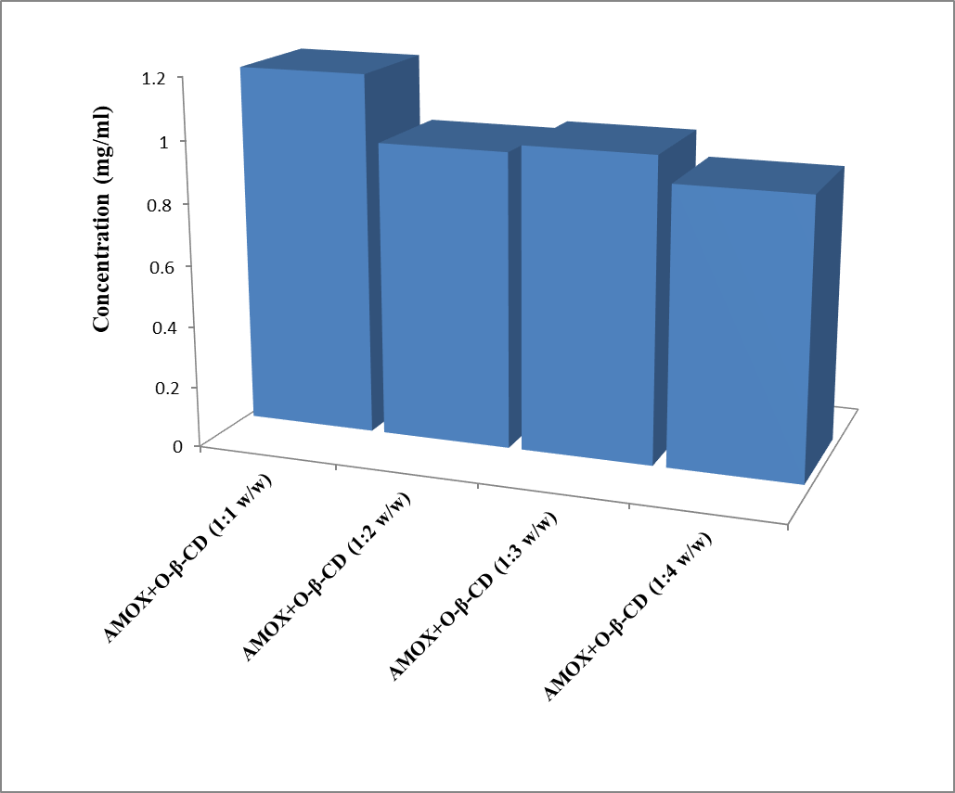
Fig SD1. Degree of complexation chart between AMOX drug and various concentrations of the O-β-CD in weight ratios of 1:1, 1:2, 1:3 and 1:4 (w/w).

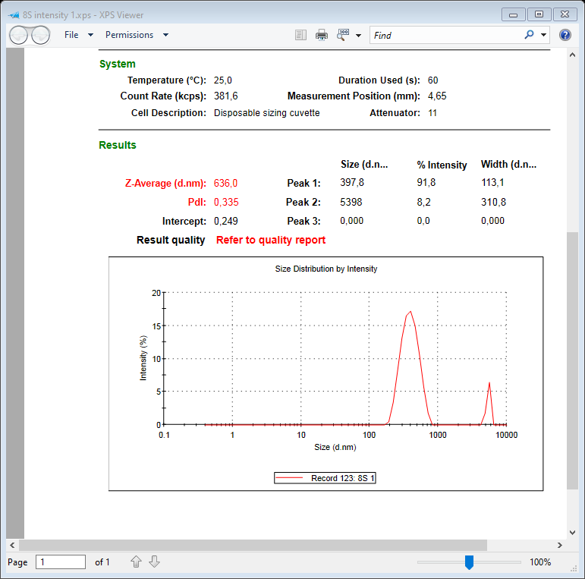
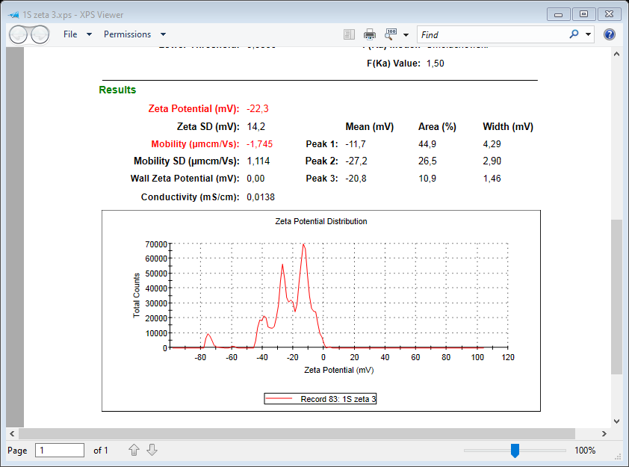
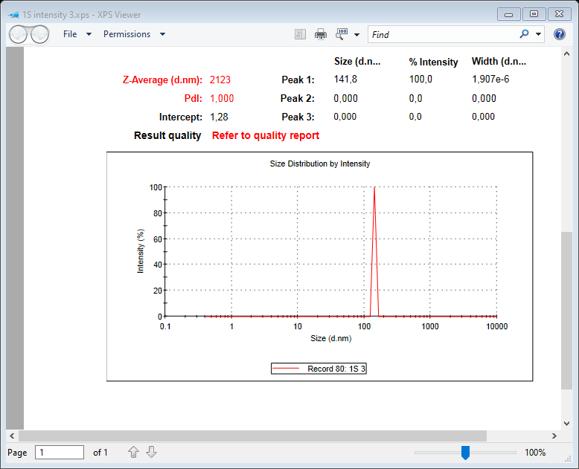
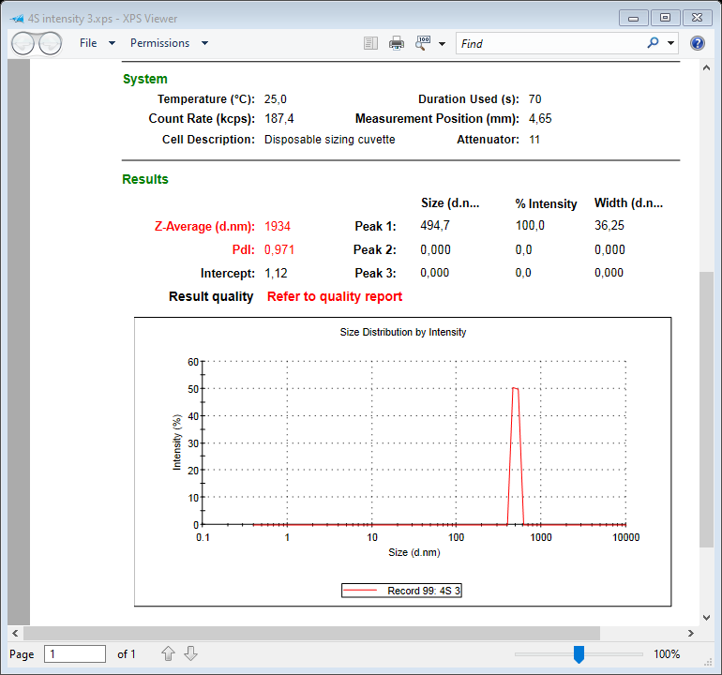
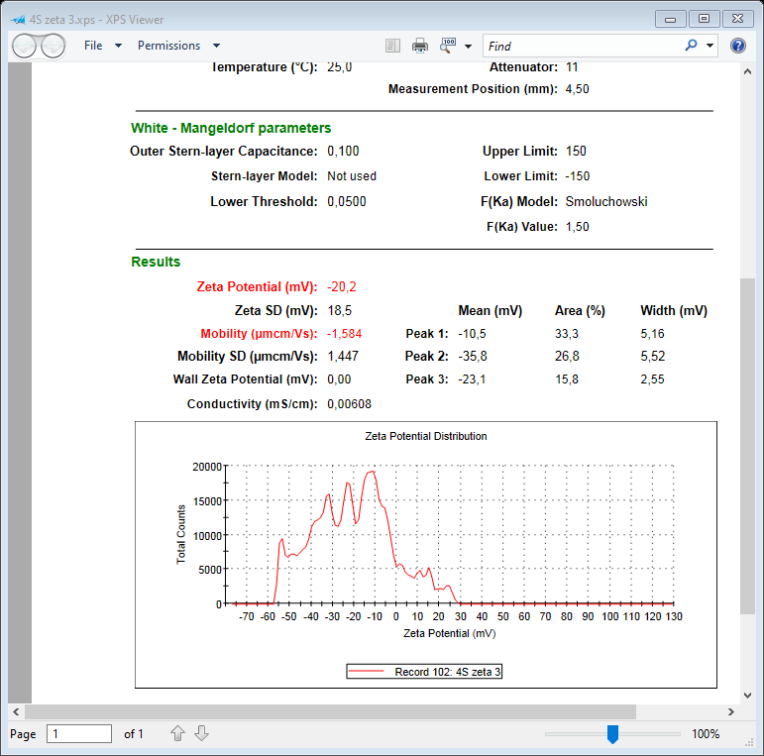
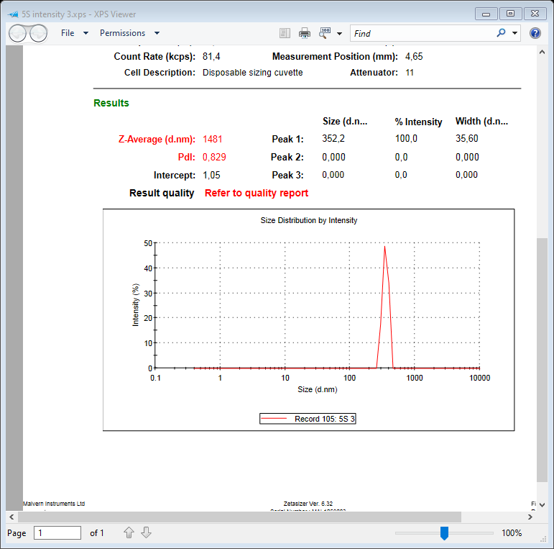
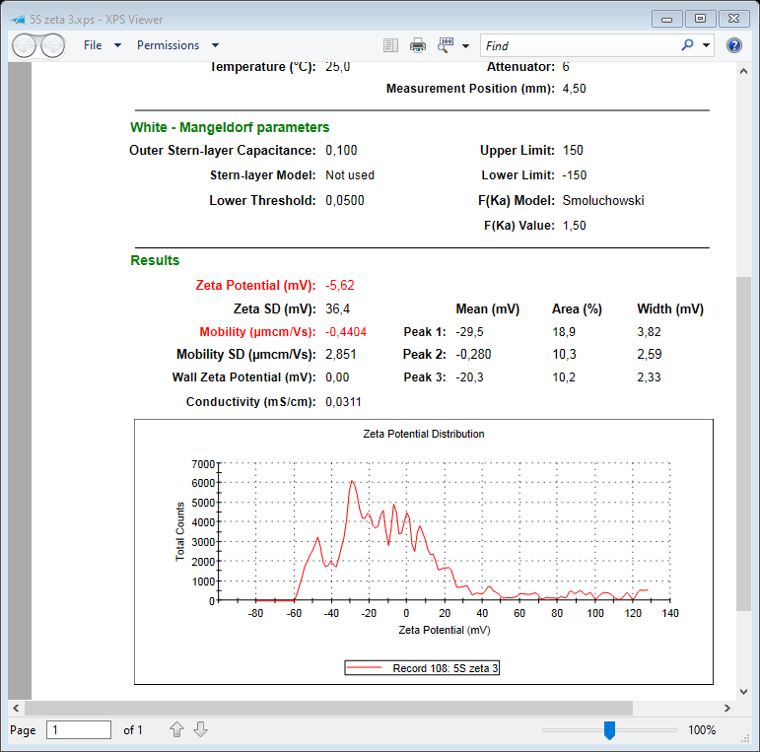
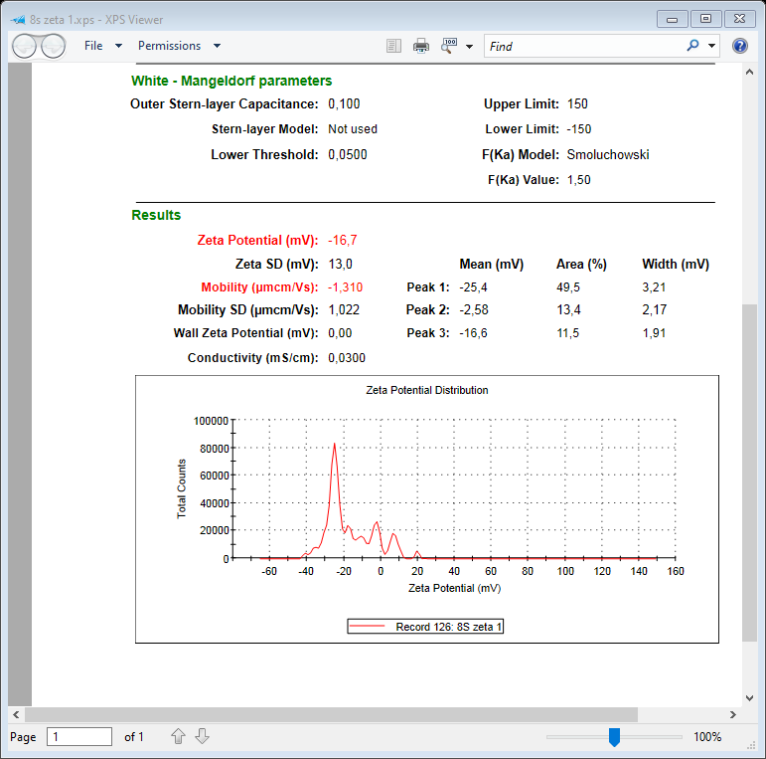
Size Distributions by Intensity Zeta Potential (ZP) Distribution (mV)

AMOX

β-CD

O-β-CD

AM- O-β-CD

Fig SD2. Particle size distribution by intensity and zeta potential measured by DLS technique of AMOX, β-CD, O-β-CD and physical mixture of AM-O- β- CD.

